**Lehninger Notes**

Chapter 2

**Hydrogen** **bond**- an electrostatic attraction between the oxygen atom of one water molecule and the hydrogen of another

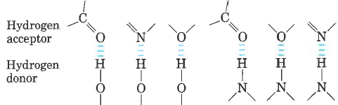

**Bond dissociation energy**- the energy required to break bond

**Hydrophilic**- water loving, compounds that dissolve easily in water

**Hydrophobic**- nonpolar molecules such as lipids and waxes which don’t dissolve in water easily

**Amphipathic**- contain regions that are polar (or charged) and regions that are nonpolar

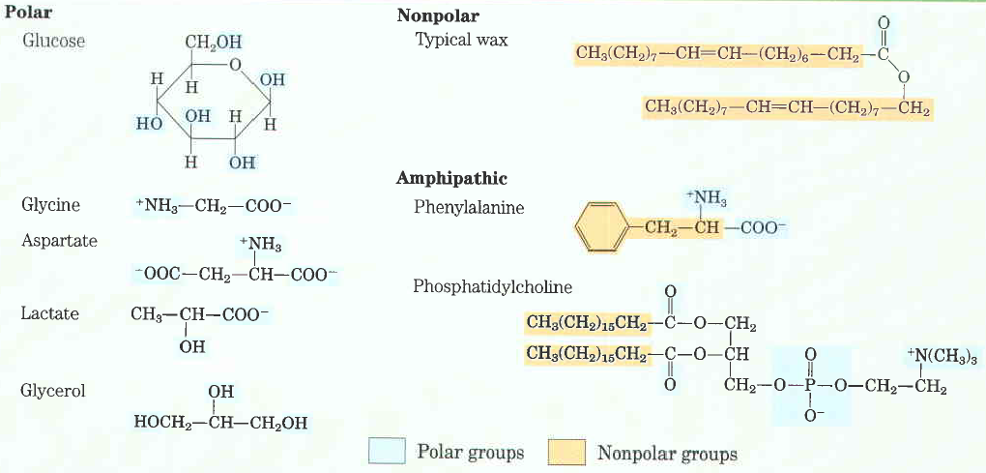

**Clathrates**- crystalline compounds of nonpolar solutes and water

**Micelles**- stable structures of arnphipathic compounds in water

**van der Waals interactions** – weak interactions between two dipoles

**Osmosis**- water movement across a semipermeable membrane driven by differences in osmotic pressure

**Isotonic**- equal osmolarity

**Hypertonic**- one with higher osmolarity than that of the cytosol, the cell shrinks as water moves out

**Hypotonic**- one with a lower osmolarity than the cytosol, the cell swells as water enters

pKa = log 1/Ka = - log Ka

**Buffers**- aqueous systems that tend to resist changes in pH when smalla mountso f acid (H+) or base (OH-) are added.

**Henderson-Hasselbalch equation**: 

**Condensation reaction**- the elements of water are eliminated

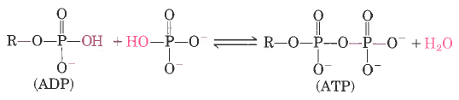

**Hydrolysis** **reaction**- cleavage accompanied by the addition of the element of water

Chapter 3

For all the common amino acids except **glycine**, **the α-carbon** isbonded to four different groups: **a carboxyl group, an amino group, an R group.**

The **α-carbon** atom is thus a chiral center.

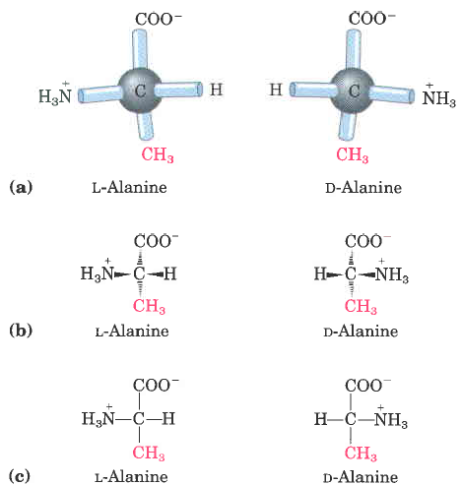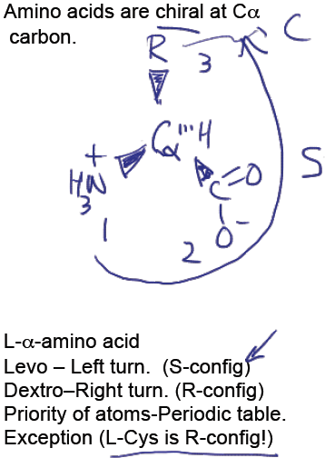

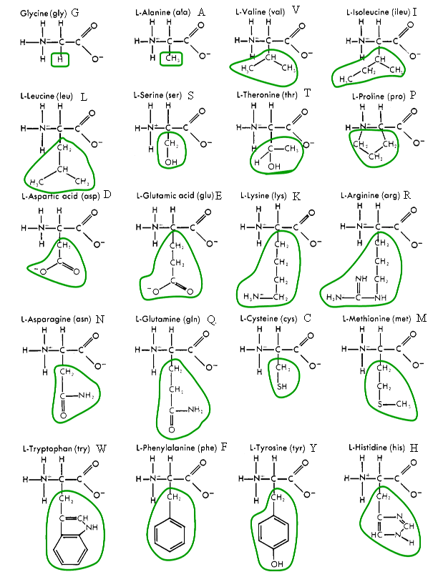

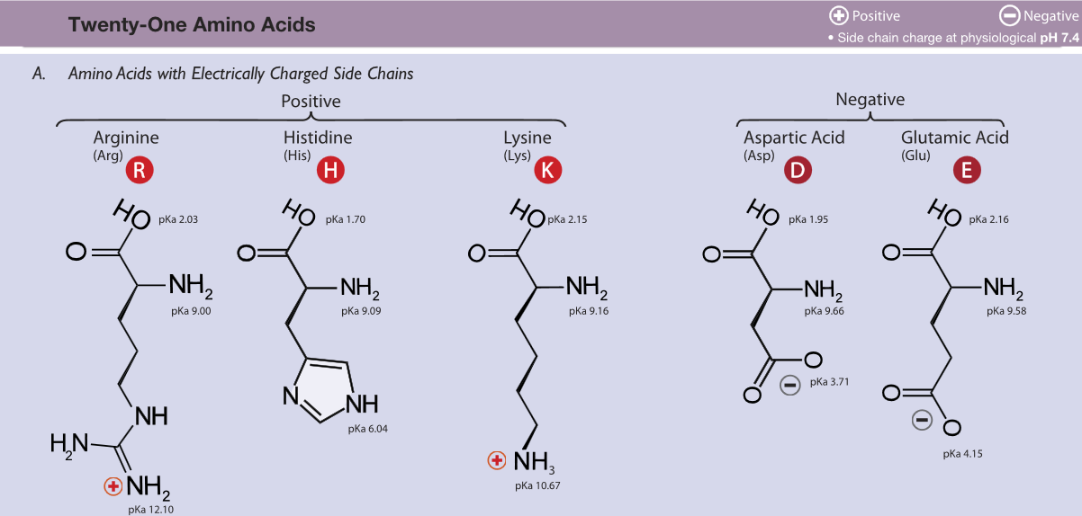

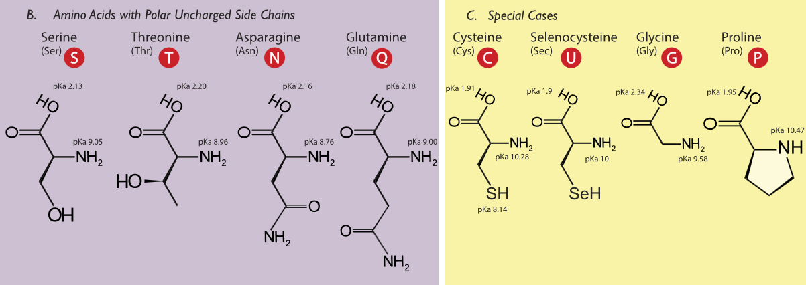

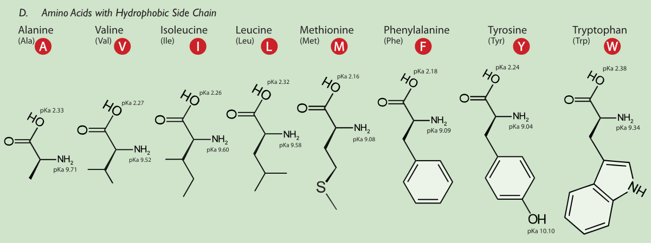

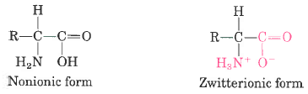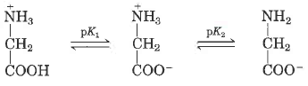

The characteristic pH at which the net electric charge is zero is called the isoelectric point or isoelectric pH, designated pI.

pI = 0.5 (pK1 + pK2), the average of two pKa values

**Peptide bond**- two amino acids covalently joined through a substituted amide linkage

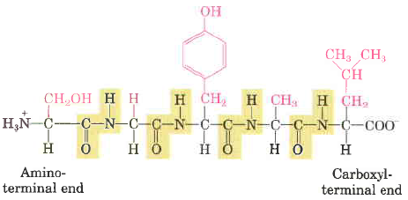

However, some proteins contain permanently associated chemical components in addition to amino acids; these are called conjugated proteins. The non-amino acid part of a conjugated protein is usually called its prosthetic group. Conjugated proteins are classified on the basis of the chemical nature of their prosthetic groups (Table 3-4); for example, lipoproteins contain lipids, glycoproteins contain sugar groups, and metalloproteins contain a specific metal.

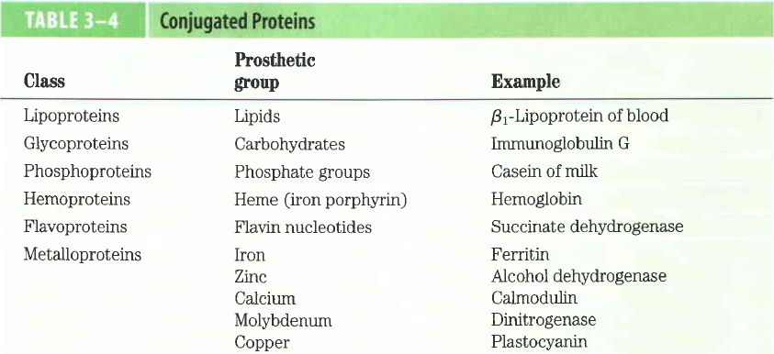

**Ion-exchange chromatography**- those with bound anionic groups are called cation exchangers, and those with bound cationic groups are called anion exchangers. The affinity of each protein for the charged groups on the column is affected by the pH. A negatively charged molecule would be retarded by the interaction with cation exchangers. A positively charged molecule would be retarded by the interaction with anion exchangers.

**Size exclusion chromatography**, also called gel filtration, separates proteins according to size. The solid phase consists of cross-linked polymer beads with engineered pores or cavities of a particular size. Large proteins cannot enter the cavities and so take a short and rapid path through the column.

**Affinity** **chromatography** is based on binding affinity. The beads in the column have a covalently attached chemical group called a ligand-a group or molecule that binds to a macromolecule such as a protein. When a protein mixture is added to the column, any protein with affinity for this ligand binds to the beads, and its migration through the matrix is retarded.

**Primary** **structure**- sequence of amino acid residues

**Secondary** **structure**- particularly stable arrangements of amino acid residues giving rise to recurring structural patterns

**Tertiary** **structure**- all aspects of the three-dimensional folding of a polypeptide

**Edman degradation** labels and removes only the amino-terminal residue from a peptide, leaving all other peptide bonds intact. Each reaction with the amino-terminal amino acid can go essentially to completion without affecting any of the other peptide bonds in the peptide. After removal and identification of the amino terminal residue, the new amino-terminal residue so exposed can be labeled, removed, and identified through the same series of reactions.

**Disulfide bonds** interfere with the sequencing procedure. If a cystine residue (Fig. 3-7) has one of its peptide bonds cleaved by the Edman procedure, it may remain attached to another polypeptide strand via its disulfide bond. Disulfide bonds also interfere with the enzymatic or chemical cleavage of the polypeptide.

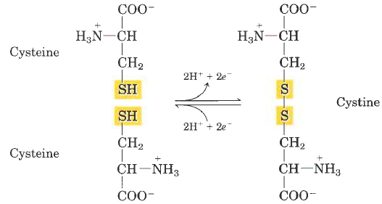

**Cleaving the Polypeptide Chain**

Several methods can be used for fragmenting the polypeptide chain. Enzymes called proteases catalyze the hydrolytic cleavage of peptide bonds. Some proteases cleave only the peptide bond adjacent to particular amino acid residues and thus fragment a polypeptide chain in a predictable and reproducible way.

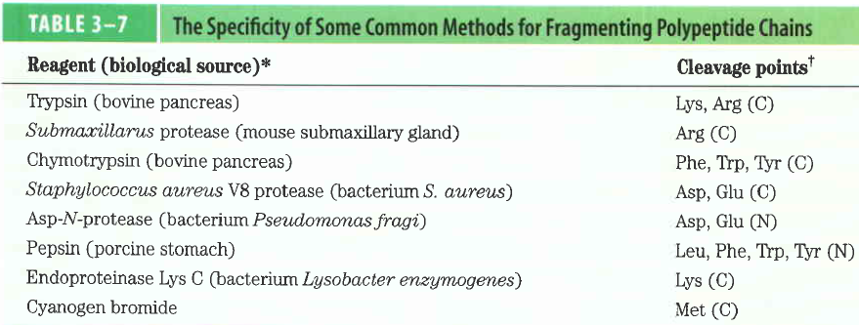

Chapter 4

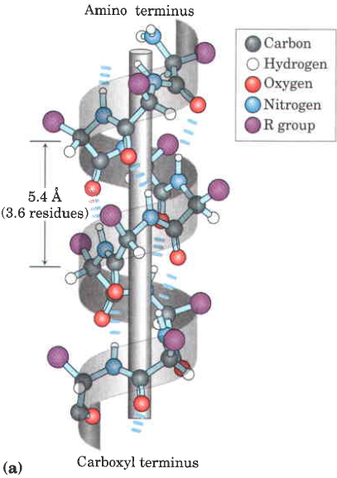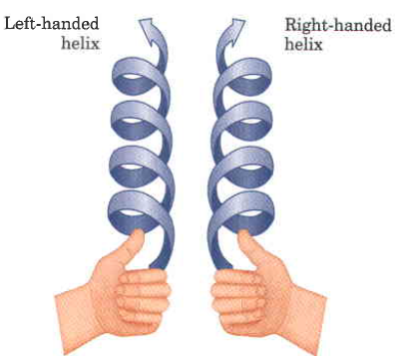

**five** types of constraints affect the stability of an a helix:

(1) intrinsic propensity of an amino acid residue to form an a helix;

(2) interactions between R groups, particularly those spaced three or four residues apart;

(3) bulkiness of adjacent R groups

(4) occurrence of Pro and Gly residues and

(5) interactions between amino acid residues at the ends of the helical segment and the electric dipole inherent to the a helix

**Beta sheets**

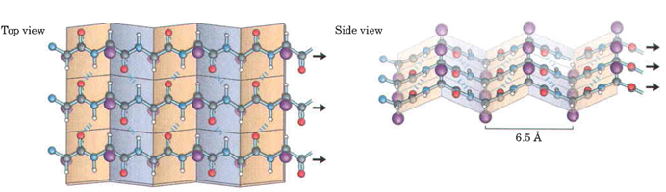

**Protein folding**

**HOW DOES THE PROTEIN STRUCTURE FORM?**

Most proteins function in the body when they are in an aqueous solution, so we will restrict our discussion to water soluble proteins. In this case, perhaps the most important thing occurring is not an interaction, but the lack of an interaction. Water, the solvent, is not able to form hydrogen bonds or dipole interactions with the ‘oily’ residues. Because of the lack of strong interactions, the ‘oily’ amino acids get pushed away from the water, and they end up inside the protein structure. On the other hand, the amino acids which can strongly interact with the water end up on the outside of the protein structure where they are partially surrounded by water molecules. Because of the lack of interactions with water, the ‘oily’ residues are said to be **hydrophobic** or water hating. They really don’t ‘hate’ water; water just prefers to interact with more polar molecules, so the ‘oily’ residues are excluded from water. The amino acids which can form dipole-dipole interactions or hydrogen bonds are called **hydrophilic,** or water loving. In general, hydrophobic amino acids are found inside the protein structure and hydrophilic amino acids are found on the outside of the protein structure; this is called the **hydrophobic effect** in protein folding. The ‘oily’ amino acids will interact with other ‘oily’ amino acids to give some structure to the protein. The polar and charged amino acids will interact with other polar and/or charged amino acids along with individual water molecules to build the rest of the protein structure. Once the protein has assumed its three dimensional structure (native structure), it is ready to carry out its function.

**IS THERE ANY WAY WE CAN AFFECT THE PROTEIN STRUCTURE?**

There are a variety of ways that we can disrupt a protein’s three-dimensional structure. We will investigate some of them today. First, we could add a small molecule in large quantity which will tie up all the water in hydrogen bonding. In this case, the amino acids on the outside of the protein won’t have their normal interactions with water, and they may move to interact with an amino acid which they would normally ignore. Second, we could add a detergent to our solution. A detergent is a molecule that has an ‘oily’ end and a polar end. The ‘oily’ end could interact with the ‘oily’ amino acids which are normally buried inside the protein and pull them out. The protein structure can also be altered by increases in temperature (thermal motion interferes with intermolecular interactions), changes in pH (charges are lost or gained at different parts of the protein), or mechanical shock. One example of permanently changing a protein structure by mechanical shock is beating egg whites to form the fluffy white foam. The clear liquid is actually a solution of albumin, a protein. The albumin is mechanically shocked or beaten until its structure changes and it is no longer water soluble Conversely, we can stabilize the three dimensional structure of the protein by adding ions such as sulfate or phosphate. The way these anions stabilize the structure isn’t entirely understood, but it appears to be due to an increase in surface tension. You can imagine that to make a protein dissolve in solution, you need to make a tiny cavity in the water for the protein. If it is relatively easy to make the cavity in the solution, the protein doesn’t need to be as tightly folded. On the other hand, if it is hard to make the cavity, such as in a solution of sulfate or phosphate ions, the cavity will be very small and the protein has to be folded very tightly to fit inside.

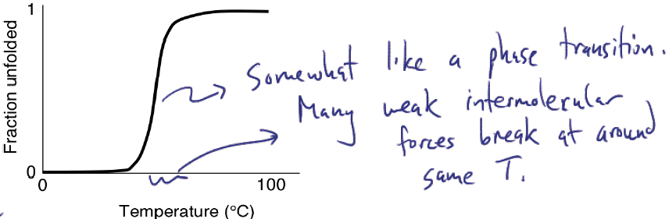

Each protein chain is either folded or unfolded, not ½ folded.

**Enzymes**

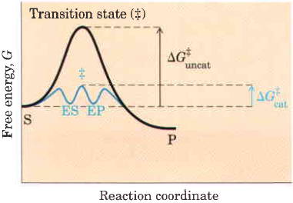

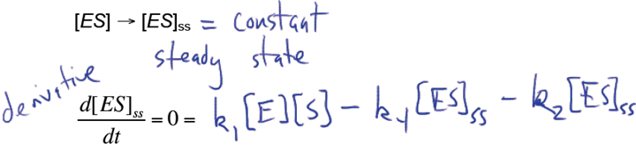

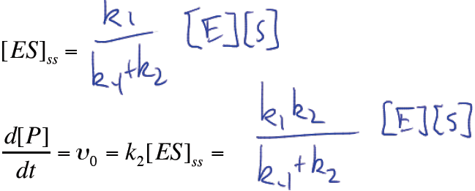

Page 209 of Lehninger