**Chemistry 112A First Midterm Review Sheet**

Nomenclature for alkanes

1. identify and name longest chain
2. name groups attached to the longest chain
3. number C’s of longest chain beginning with end closest to substituent
4. arrange substituents in alphabetical order

**Branching** decreases the stacking of alkanes, thus lowering the boiling point. **Symmetry** contributes to stacking.

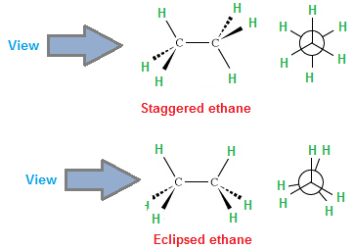 [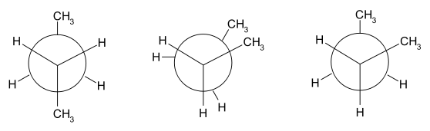](http://en.wikipedia.org/wiki/File:Anti_gauche.svg)

anti gauche

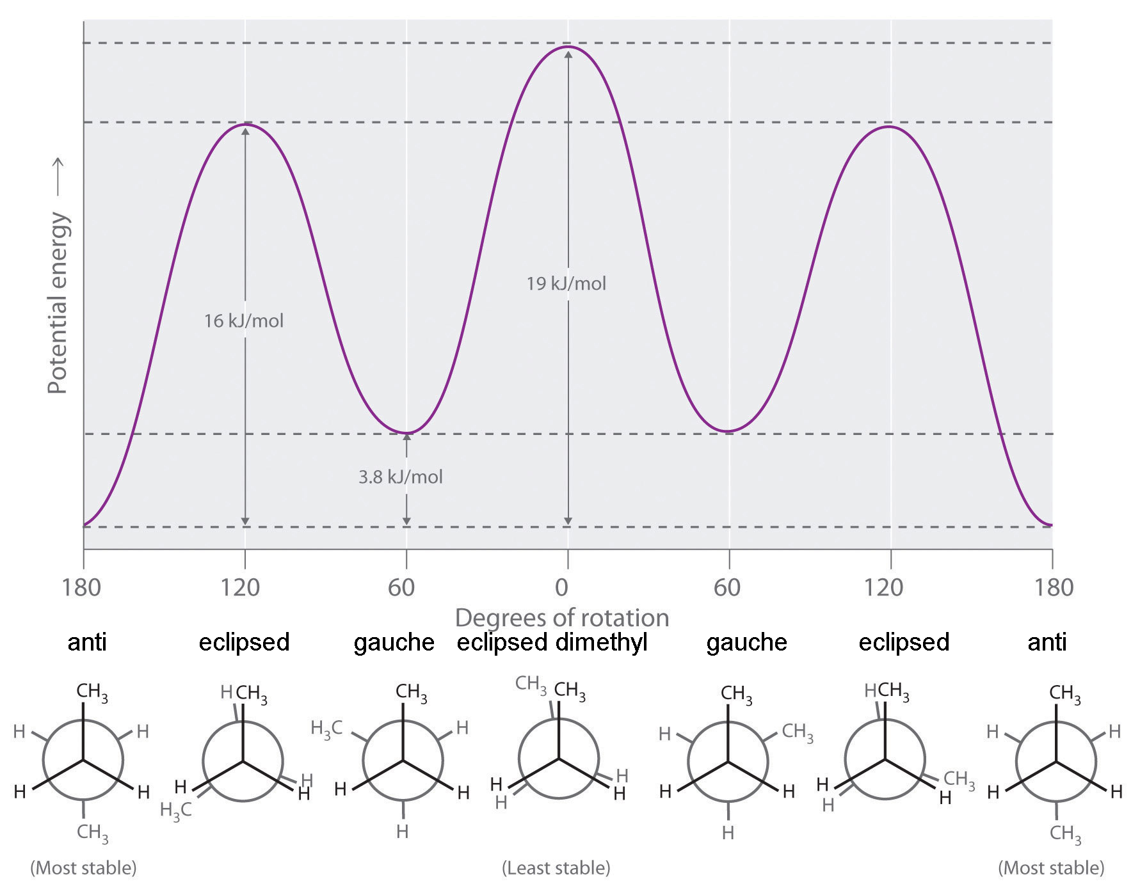

Bronsted acid- donate proton Bronsted base- give up proton

Lewis acid- accept electron pair Lewis base- donate electron pair

pKa values

|  |  |  |  |  |  |
| --- | --- | --- | --- | --- | --- |
| <0 | ~5 | ~10 | ~15 | ~35 | ~50 |
| HCl, HBr, HI, H2SO4, H3O+, CH3OH2+, RH2O+, RCOH+R | CH3COOH | RNH3+  Phenol | CH3OH  H2O | R2NH | RH |

General rules for the stability of anions

Stability of anions increases, pKa of the conjugate acid decreases (more acidic)

1. Across the row (electronegativity)
2. Down a column (increased size and polarizability)
3. With less negative charge on the same atom
4. With increasing resonance

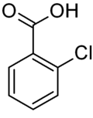more acidic than 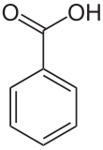because Cl is more electron withdrawing and stabilizes the anion

|  |  |
| --- | --- |
| A molecule or ion that **donates a pair of electrons** to form a new covalent bond is called a **nucleophile**. A **nucleophile** is the same thing as a **Lewis** **base**. | http://www.chem.ucla.edu/harding/tutorials/elec_nuc/elec_nuc_str03.GIF |
| A molecule or ion that **accepts a pair of electrons** to make a new covalent bond is called an.  An electrophile is the same thing as a **Lewis acid**.  Any molecule, ion or atom that is electron deficient in some way can behave as an electrophile. | http://www.chem.ucla.edu/harding/tutorials/elec_nuc/elec_nuc_str02.GIF |

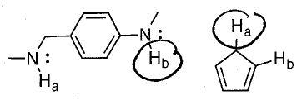

the circled hydrogen atoms are more acidic because the anions are stabilized by resonance.

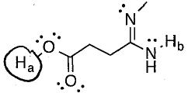 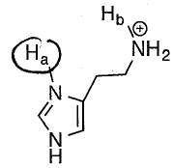

O is more electronegative than N sp2 hybridized NH is more acidic than sp3 hybridized NH

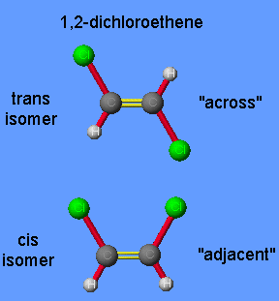 Alkene’s double bond is not rotatable. Sigma bond is **stronger** than pi bond.

E/Z nomenclature and CIP priority

|  |  |
| --- | --- |
| File:CIP priority diagram.png | E = entgegan ("trans") low and high on the same side.  H L  L H  Z = zusamen ("cis") high on one side, low on the other.  H H  L L  Atoms with higher atomic number have higher priority  Work outwards until the first point of difference |
| Double bonds counted as 2 carbons, triple as 3  Carbonyl C=O counted as C-O-C |

General trend of alkene stability

More substituted more stable than less substituted (hyperconjugation- the interaction of pi orbital and adjacent C-H or C-C bonding)

Trans more stable than cis (cis is destabilized by torsional strain)

Heat of formation more negative, more stable

Heat of combustion more negative, less stable

Acid/base properties

The stronger the bond, the more acidic it is. Bond strength: C2H6 < C2H4 < C2H2 Acidity: C2H6 < C2H4 < C2H2

 addition of hydrogen halide

Markovnikov’s rule

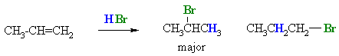

Hydride shift / Carbocation rearrangement

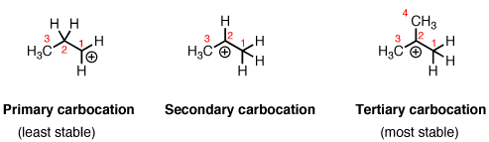

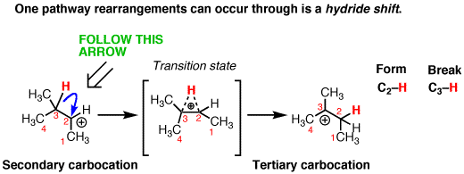

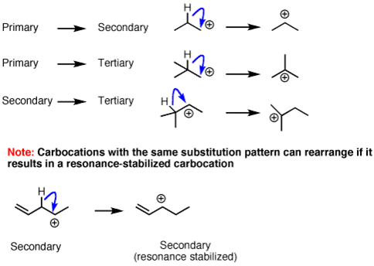

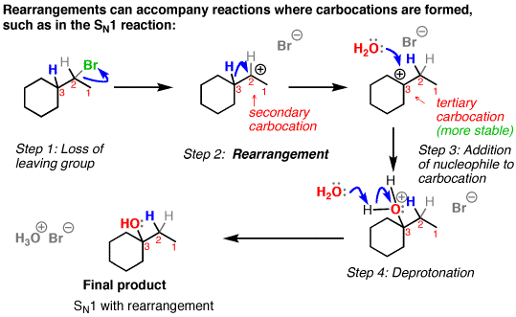

Alkyl shift

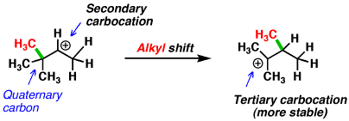

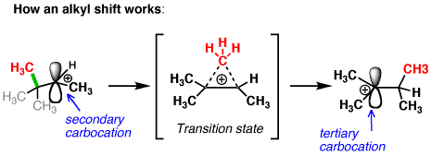

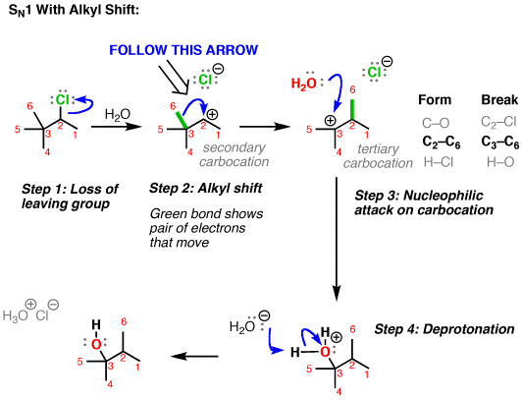

|  |  |
| --- | --- |
|  | http://jamesash.wpengine.netdna-cdn.com/wp-content/uploads/2011/09/Untitled-4-copy.jpg |
| The **higher hump** is the **rate-limiting transition state**  Every 1.36 kcal/mol change in delta G is a 10 fold change in k (or rate).  The **lower delta G** is, the **faster** the **reaction** is. | **Hammond’s postulate**  The structure of a transition state resembles that of the species nearest to it in free energy. The transition state of an endothermic reaction resembles the products, while that of an exothermic reaction resembles the reactants |

Hydration: the addition of water onto an alkene to form an alcohol

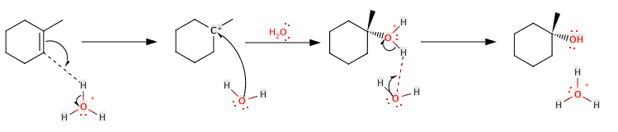

Catalyzed by a strong acid such as H2SO4 **dP/dt = k [alkene] [ H3O+]**

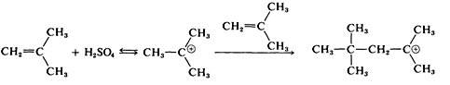 **polymerization**

**Alkene (pi bonding orbital) is Lewis base. Carbocation (empty p orbital) is Lewis acid.**

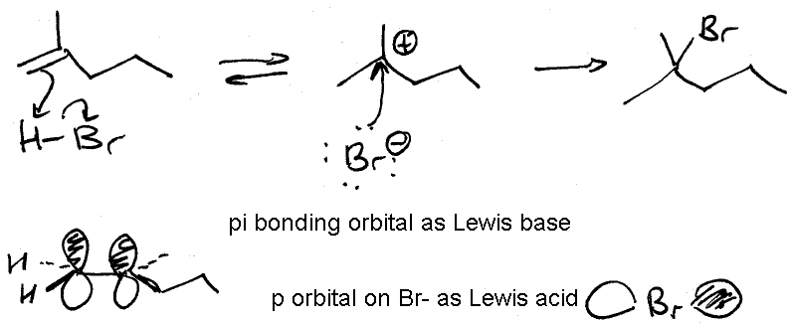

Hydrogenation: the addition of hydrogen onto an alkene to saturate a double bond

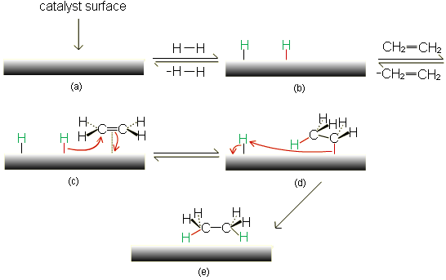mechanism

**Alkene reactivity**: mono > di > tri > tetra substituted

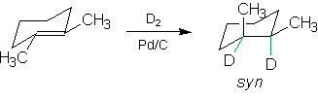 syn means that two are on the same side