**EE 40 Notes**

|  |  |
| --- | --- |
|  | **Voltmeter**: measures voltage without drawing current  **Ammeter**: measures current without dropping voltage  Open circuit, no path for current flow R = infinity  Short circuit, no voltage drop R = 0 |
| **Kirchhoff’s current law (KCL)**  \sum_{k=1}^n {I}_k = 0 http://upload.wikimedia.org/wikipedia/commons/thumb/4/46/KCL_-_Kirchhoff%27s_circuit_laws.svg/220px-KCL_-_Kirchhoff%27s_circuit_laws.svg.png  *i*2 + *i*3 = *i*1 + *i*4 | **Kirchhoff’s voltage law (KVL)**  http://upload.wikimedia.org/wikipedia/commons/thumb/4/40/Kirchhoff_voltage_law.svg/200px-Kirchhoff_voltage_law.svg.png  v1 + v2 + v3 - v4 = 0  add up voltages in a systematic clockwise movement  assign a positive sign to the voltage across an element if the (+) side |

i > 0 as entering the + side p>0 power delivered to device

i < 0 as entering the – side p<0 power supplied by device

**Branch**: single element, such as a resistor or source

**Node**: connection point between two or more branches

**Extraordinary** **node**: connection point between at least 3 branches

**Loop**: closed path in a circuit

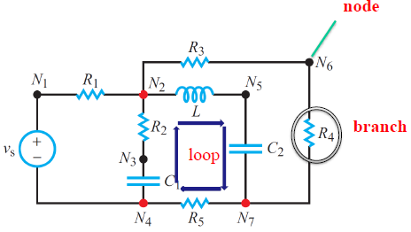

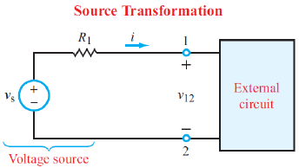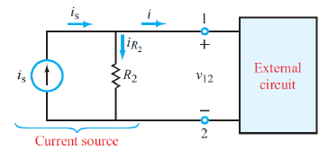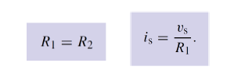

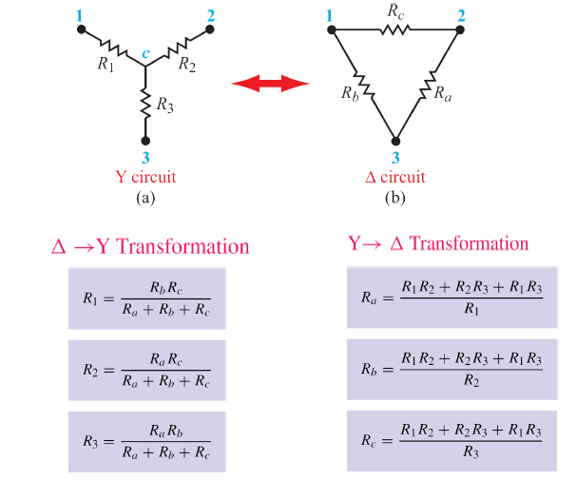

|  |  |
| --- | --- |
| File:Supernode in circuit analysis.svg | By viewing a voltage source on a wire as a point source voltage in relation to other point voltages located at various nodes in the circuit, relative to a ground node assigned a zero or negative charge, both VA and VB are super-nodes. VA has two unreferenced nodes, whereas VB has one referenced node (ground) and one unreferenced node.    1.5 = va/ 6 + 3.5 + vb/3  vb – va = 12 |

**Nodal analysis**

* Node voltages (voltages between each node and ground reference) are UNKNOWNS
* KCL equations at each UNKNOWN node constrain solutions (N KCL solutions for N Node Voltages)

**Mesh analysis**

**Step 1**

Identify all meshes, and assign each an unknown current. For convenience, use clockwise current

**Step 2**

Set up KVLs for each mesh

**Step 3**

Solve the resulting simultaneous equations

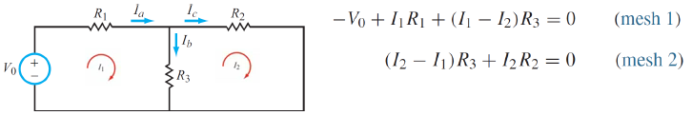

A supermesh results when two meshes have a current source (with or without a series resistor) in common.

Voltage across current source is unknown

Write KVL equation for closed loop that ignores branch with current source

Write KCL equation for branch with current source (auxiliary equation).

**Summary of mesh analysis**

* Mesh currents flowing in each mesh loop are UNKNOWNS
* KVL equations for each mesh loop constrain solutions (M KVL solutions for M mesh loops)

**Supermesh**

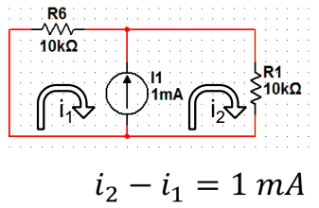a current source in between 2 loops

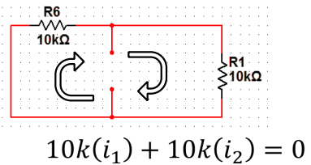write mesh equations as if circuit is like this

|  |  |
| --- | --- |
| **Inspection - Nodal**  All sources are independent current sources.  Set up a matrix for all the nodes, as follows:  [ G11 G12 … G1n] [ v1 = [i1  G21 G22 … G2n v2 i2  . . .  . . .  . . .  Gn1 Gn2 … Gnn  vn ] in]  Where Gkk = sum of all conductances connected to the node k. Conductance = 1 / resistance  Gkl = Glk = negative of conductances connecting nodes k and l, with k ≠ l  Ik = total of current sources entering node k (a negative sign applies to a current source leaving) | **Inspection – Mesh**  [ R11 R12 … R1n] [ i1 = [v1  R21 R22 … R2n i2 v2  . . .  . . .  . . .  Rn1 Rn2 … Rnn  in ] vn]  Where Rkk = sum of all resistances in mesh k  Rkl = Rlk = negative of the sum of all series shared between k and l (with k ≠ l)  Ik = current of mesh k  vik = total of all independent voltage sources in mesh k, with positive assigned to a voltage rise when moving around the mesh in a clockwise direction |

**Step 1**: Set all independent sources to 0 (by replacing voltage sources with short circuits and current sources with open circuits), except for source 1

**Step 2**: Apply the analysis technique of your choice to solve for the response v1 due to source 1

**Step 3**: Repeat for sources 2 through n, calculating in each case the response due to that one source acting along

**Step 4**: Sum to determine the total response v

Thevenin equivalent Norton equivalent

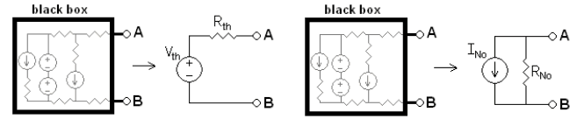

To find Vth, open (a) and (b) for the voltage between (a) and (b) without changing the circuit.

To find INO, short (a) and (b) and solve for the current flowing from (a) to (b) without changing the circuit.

If there are dependent sources, attach an imaginary source Vab between nodes (a) and (b), find the current Iab, going through this source in terms of Vab.

Req = Vab / Iab

RTH = RNo

The effective resistance for either equivalent circuit is equal to the resistance between (a) and (b) with:

◦ Independent current sources open

◦ Independent voltage sources shorted