**Materials Science and Engineering 151 Notes**

|  |  |
| --- | --- |
| **Homopolymers**  –AAAAAAAAAAAA  **Statistical (random) copolymers**  –ABABAABBABAAB  **Alternating copolymers**  –ABABABABABAB | **Blockcopolymers**  –AAAAABBBBBBBAAAAA  –sequences or blocks of each monomer  **Graft copolymers**  –blocks of one monomer are grafted as branches onto the other  –AAAAAAAAAAAAA  B B  B B |

|  |  |
| --- | --- |
| Isotactic   * Same side |  |
| Syndiotactic   * Alternating |  |
| Atatic   * random |  |

2 functional groups 🡪 linear chain

3 functional groups 🡪 branch chain

# of branch + 2 = # of end groups

**Synthesis**

|  |  |
| --- | --- |
| **Condensation**   * Molecules join by losing a molecule, such as water * step growth * monomers with functional groups: -OH, -COOH, -COCl, -NH2 * polyesters, polyacetals, polyamides, polyurethane | **Addition**   * repeat unit has the same composition as the monomer * chain growth * molecules bond to form a chain, no loss * PE, PVC, PTFE, PS, PMMA, Nylon-6, PP |

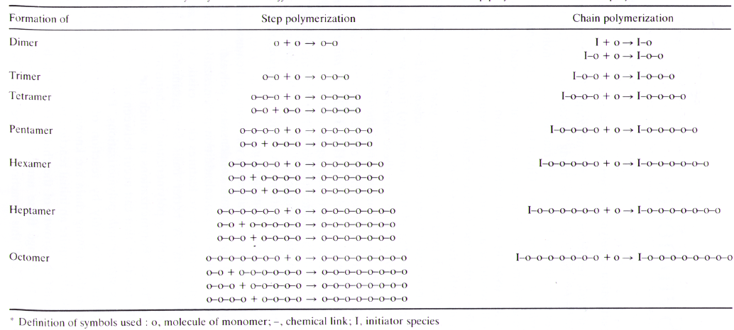

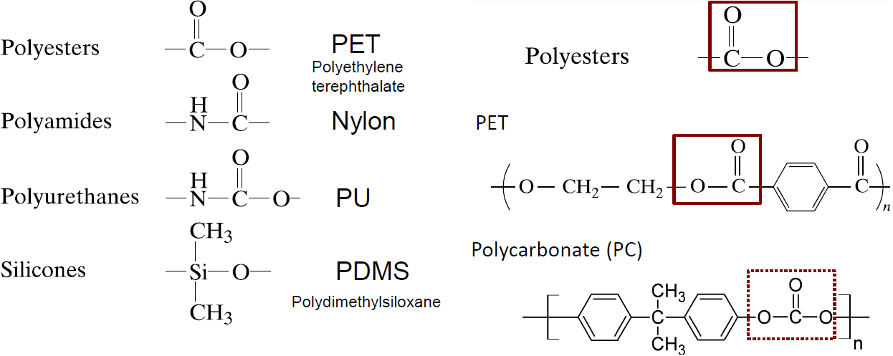

Degree of polymerization: N

Molar mass of monomer: Mmonomer = M0

Molar mass of polymer: MN = NM0

Molecule i with the degree of polymerization: Ni

Molecular weight of i-mer: Mi = NiM0

Number of i-mers ni

Total molecular weight niMi = niNiM0

Mole fraction of i-mer, x

Weight fraction of i-mer, w

Number average molecular weight:

Weight average molecular weight:

**PDI** is the polydispersity index of a polymer and is given by Mw/Mn , where Mw and Mn are the weight-average and number-average molecular weights, respectively. The PDI of a polymer indicates the spread or distribution of molecular mass.

If PDI > 1 polydisperse

If PDI < 1 monodisperse

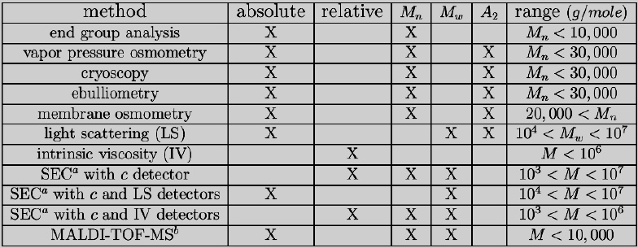

|  |  |
| --- | --- |
| xi, wi | SEC, MALDI |
| Mn | Osmotic pressure  Colligative properties  End group  Ebuilliometry |
| Mw | Light scattering  Sedimentation velocity |

**End-Group analysis**

1. End group is amenable to quantitative analysis
2. No. per chain is known
3. No interference from other groups
4. Sufficient concentration
5. Sensitivity decreases as chain length increases
6. Restricted to low molecular weight polymers, 10-10K

**Mass Spectroscopy**

* Small molecule of mass m is introduced into the gas phase in vacuum;
* The molecule acquires a net charge z;
* The ion gets accelerated with kinetic energy
* Larger masses take longer to reach the detector
* Time of flight (TOF) vs. m/z

**Gel Permeation Chromatography (GPC)** is a technique used to separate polymers based on their different sizes. Polymers are passed through a column packed with beds of porous gel. **Smaller polymers travel through more pores and retention time is therefore longer**. GPC trace peaks are divided into several **equidistant volume slices** and the molecular averages and can be calculated using the following equations, where h(M) is the slice height a molecular weight M.

When MALDI is performed on uncharged polymers, it is necessary to introduce a charge to the polymer by co-dissolving a salt into the polymer solution and complexing an ion onto the polymer. This process becomes increasingly difficult for less polar polymers. Therefore, MALDI cannot be used efficiently for polyethylene but it can be done on polyethylene glycol.

Mn and Mw **cannot be accurately determined** by a **MALDI** plot because the **intensity** of a particular peak cannot be **accurately correlated** to the **relative abundance** of that molecule in the sample. This is **because not all molecular weights desorbed to the same extent** within a given laser pulse and **not all molecular weights are equally likely to be ionized** once in the gas phase.

# of initial monomers

# of unreacted monomers

# of reacted monomers

Nn =

Extent of reaction,

**Step-growth kinetics**

Concentration of is constant in stationary state

Rate of ab formation

If rate of ab formation =

If rate of ab formation =

**Catalyzed step-growth reactions**

**p is the extent of reaction**

**Uncatalyzed step-growth reactions**

**Number average degree of polymerization**

**Weight average degree of polymerization**

**If stoichiometric imbalance,**

**Chain-growth polymerization**

# AIBN- Azobisisobutyronitrile

[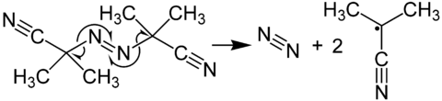](http://en.wikipedia.org/wiki/File:Formation_of_Radicals_from_AIBN.png)

**3 driving forces**

* Formation of nitrogen gas, a very stable molecule
* Formation of a stable radical; tertiary carbon radical stabilized by an adjacent electron-withdrawing cyano (-CN) group
* Increase in entropy due to a) 3 molecules formed and b) evolution of a gas

**Initiation** I 🡪 I\*

**Propagation** I\* + M 🡪 IM\* 🡪 IMM\* 🡪 P\*

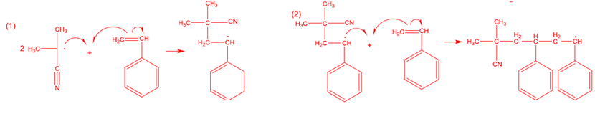

**Termination** Pi\* + Pj\* 🡪 Pi+j

**By disproportionation**

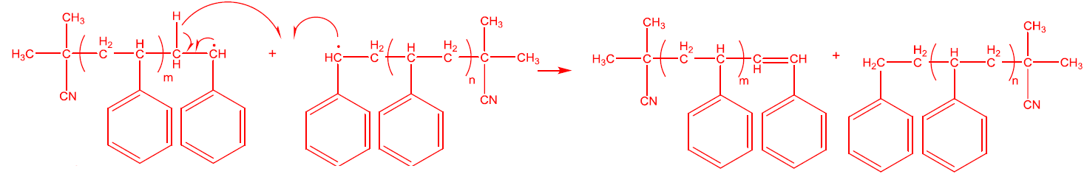

**By combination**

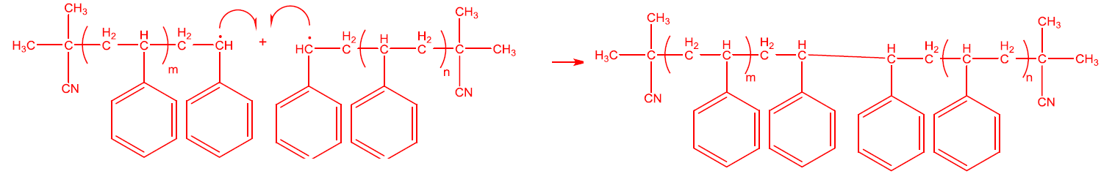

Rate of diffusion > rate of reaction

Rate of reaction > rate of diffusion

Stationary phase radical concentration

**Kinetic chain length**

Termination by disproportionation

Termination by combination

**Radical lifetime**

Tau is the time during which radical exists (average radical lifetime). Tau is roughly constant (1.8-2.3) over the first ~30% conversion to polymer. At higher conversion percentages, the polymer radicals are larger than that at lower conversions. This leads to a slight increase in the viscosity. Since the termination of active radical chains is diffusion limited, the rate constant of termination (kt) decreases as a result. This decrease in termination rate accounts for the increased lifetime observed for radicals at higher conversions. This is a rather mild example of the auto-acceleration, known as the Trommosdorff effect.

Before autoacceleration, chain termination by combination of two free radical chains is a very rapid reaction that occurs at very high frequency. However, when the growing polymer molecules - with active free radical ends - are surrounded in the highly viscous mixture consisting of a growing concentration of "dead" polymer, the rate of termination becomes limited by diffusion. With termination collisions restricted, the concentration of active polymerizing chains and simultaneously the consumption of monomer rises rapidly. Assuming abundant unreacted monomer, viscosity changes affect the macromolecules but do not prove high enough to prevent smaller molecules - such as the monomer - from moving relatively freely. Therefore, the propagation reaction of the free radical polymerization process is relatively insensitive to changes in viscosity. The decrease of termination reactions also allows radical chains to add monomer for longer time periods, raising the weight average molecular weight dramatically. However, the number average molecular weight only increases slightly, leading to broadening of the molecular weight distribution (high polydispersity index, very polydispersed product).

**Rates of polymerization**

**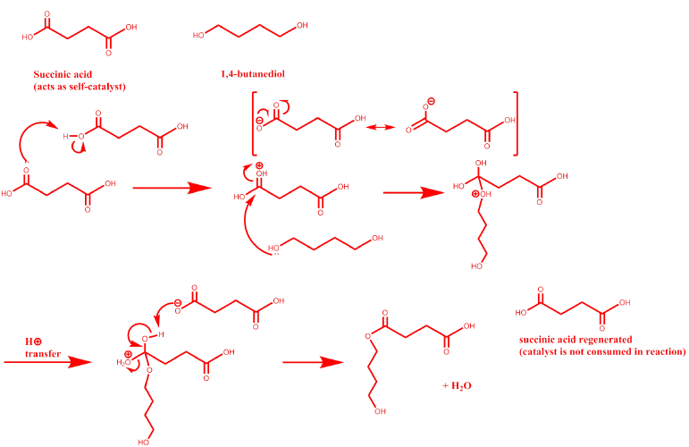**

**Distribution**

Step: p = extent of reaction

Chain: p = fraction of propagation steps

|  |  |  |
| --- | --- | --- |
| Chain growth | Disproportionation | Combination |
|  |  |  |
|  |  |  |
|  |  |  |
| PDI |  |  |

**Glassy polymers**

* The polymer chain is immobile and effectively frozen
* The polymer is rigid and brittle – like a solid
* The polymer has no long-range order
* Structurally looks like a liquid
* The polymer samples is optically transparent

**Amorphous (opposite to crystalline)**

* Random distribution of polymer chains in the matrix
* As the temperature increases, the sample goes from a glass through a rubber-like state until it becomes molten

**Glass transition temperature**, Tg, temperature the polymer transforms from a rubber (<Tg) to a glass (>Tg).

Glass transition

* Upon cooling, motions slow down.
  + Rubber-like state or in the melts, the chains are in relatively rapid motion
  + Till the available thermal energy is insufficient to overcome the rotational energy barriers, the chains are locked in the conformation at Tg
* Upon heating, segmental motion increases
  + In glassy state, chain motion is frozen
  + The chain segments move cooperatively when a transition from the glass to rubber-like state occurs

Tapplication < Tg < Tprocessing

**Typical polymers**

1. elastomers (rubbery) Tg < Troom, can be processed in room T.
2. thermal plastics Tg ~ 100 degrees C
3. engineering thermal plastics Tg > 200 degrees C

**Thermal expansion coefficient**

**Heat capacity**

**Isothermal compressibility**

|  |  |  |
| --- | --- | --- |
|  | | The shape of supercooled transition, or Tg, depends on the cooling rate |
| http://www.nature.com/pj/journal/v44/n8/images/pj2012123f1.jpg | **Occupied volume** – the actual volume of a sample, occupied by the molecules.  **Free volume** – the “elbow room” between molecules, required for molecules to undergo rotation and translational motion.  Free volume increases with increasing temperature and kinetic energy.  Below Tg  At Tg  Above Tg | |

Cyclic polymers occupy more volume than linear polymers, since , cyclic polymers have less free volume than linear polymers for any given temperature. Therefore, as temperature is lowered, the cyclic polymer will reach the critical free volume for glass transition at a higher temperature than linear polymers.

Wax is an oligomer of polyethylene, which means that wax molecules have much shorter chains than polyethylene and thus assume a more crystalline structure at room temperature. Polyethylene molecules have longer chain lengths and assume a semi-crystalline at room temperature. The high degree of crystallinity of wax makes it prone to brittle fracture, while semi-crystalline polyethylene behaves more like a ductile material.

**For polymers, f**low is controlled by free volume

**Vogel-Fulcher-Tammann-Hesse (VFTH) equation**

**Williams-Landel-Ferry (WLF) equation**

|  |  |
| --- | --- |
|  | Elastic returns to original state after strain is removed.  Viscous doesn’t return to original state after strain is removed, so it is permanently deformed.  Viscoelastic recovers to original state slowly. |
| http://upload.wikimedia.org/wikipedia/commons/thumb/1/18/Modulus_against_time_at_two_values_of_temperature.png/300px-Modulus_against_time_at_two_values_of_temperature.png | At lower T and longer time, the polymer could have a modulus that is the same as at higher T and shorter time.  So there is a **time-temperature superposition** |

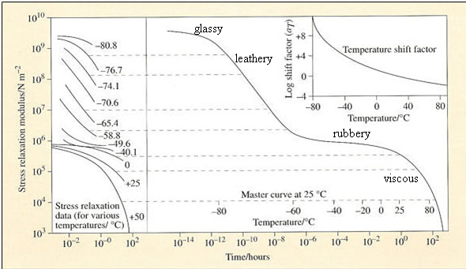

Time temperature superposition (TTS) shift factor

**How to measure Tg?**

**Static**

* monitor changes in the temperature dependence of an intensive property, such as density and heat capacity
* need to allow the sample to equilibrate and relax at each observation temperature
* leads to more consistent values

**Dynamic**

* often mechanical methods
* a rapid change in modulus is indicative of the Tg
* depends on the frequency of the applied force

1. **V-T (Dilatometry)**

|  |  |
| --- | --- |
| File:Tgdilatometric.gif | Following the polymer volume change as a function of temperature.  The change in volume of the liquid column is read from a graduated scale. Because mercury has a fairly constant rate of expansion over normal temperature ranges, the volume changes are directly related to temperature.  \alpha = \frac{1}{V} \biggl(\frac{\delta V}{\delta T} \biggr)_{P}\ |

1. **Cp (differential scanning calorimetry) DSC**

|  |  |
| --- | --- |
|  | Calorimetrically detect the change in heat capacity as temperature changes  Glass transition is accompanied by a change in the heat capacity.  3 factors that cause differences in measurement:   1. Different heating/cooling rates 2. Annealing time of polymer prior to measurement 3. Annealing temperature of polymer prior to measurement |

1. **Modulus (Dynamic Mechanical Analyzer) DMA**

|  |  |
| --- | --- |
|  | As the polymer sample is cooled through Tg, the motions of individual segments undergo a dramatic slowing down.  The local relaxation time is sensitive to Tg.  Rheometer to measure G’ and G’’ vs. temperature  G’ = elastic modulus  G’’ = viscous modulus  A large value of G’ in comparison of G’’ indicates pronounced elastic properties of the sample.  A rheometric measurement normally consists of a strain (deformation) or a stress analysis at a constant frequency combined with a frequency analysis.  The strain sweep gives information of the elastic modulus G’, the viscous modulus G’’ and the phase angle w. |

**Factors affecting Tg**

1. Dependence on chemical structure
   1. Flexible chain 🡪 lower Tg (easier to change conformation)
   2. **High** **backbone** **stiffness** is essential for **high** Tg
   3. The **larger** the rigid side-group, the **larger** the Tg
   4. Polymers with **weaker** **interactions** have **lower** Tg
2. Dependence on molecular weight
   1. Mainly due to the chain end
   2. Plasticizer, small molecular weight reduce Tg
3. Dependence on composition (for mixtures)

**Fox** **equation**:

|  |  |  |
| --- | --- | --- |
| **Temperature effect of mechanical properties** | Density  Rigid sidegroup  Interactions  Backbone stiffness  Chain ends, impurity  Free volume  Backbone flexibility | Tg  Directly  Directly  Directly  Directly  Inversely  Inversely  Inversely |

**Terminology relevant to mechanical properties**

|  |  |  |  |
| --- | --- | --- | --- |
| **Term** | **Significance** | | |
| Brittle fracture | Failure by rapid crack propagation without much deformation | | |
| Craze | Localized yielding consisting of microvoids interspersed with fabrils | | |
| Ductility | Ability to undergo substantial plastic deformation before failure | | |
| Engineering stress | Completely recoverable deformation | | |
| Hardness | Ability to withstand surface abrasion or indentation | | |
| Plastic deformation | Nonrecoverable deformation | | |
| Strain hardening | Stress increasing with strain during plastic deformation | | |
| Modulus | Stress divided by strain during small elastic deformation | | |
| Tensile strength | Tensile stress at a point of fraction | | |
| Toughness | Amount of energy absorbed during fracture | | |
| True stress | Force divided by instantaneous cross-sectional area | | |
| Yield point | Onset of plastic deformation | | |
| Yield strength | Magnitude of stress at the yield point | | |
|  | | A: brittle material  B: ductile material (plastically deforming)  C: Elastomeric (rubbery behavior)  Tensile strength (A>B>C)  Modulus (A>B>C)  Strain-to-break (C>B>A) |

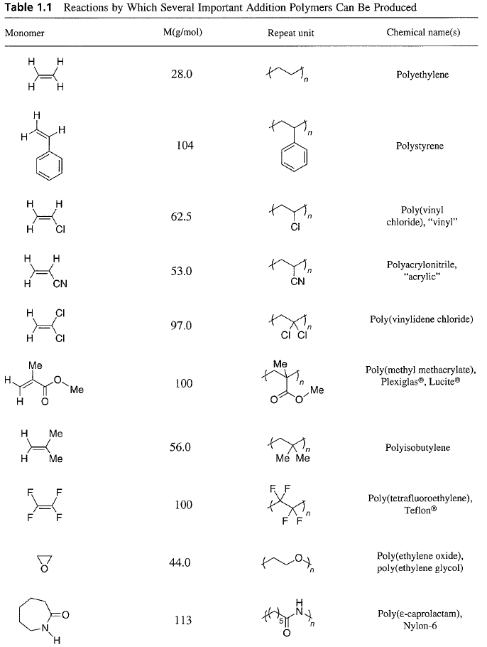

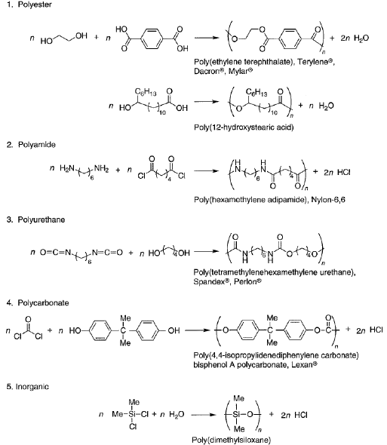

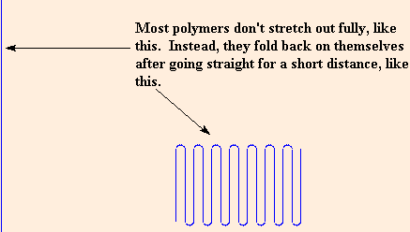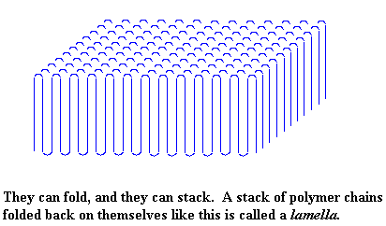

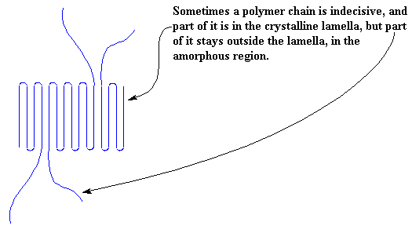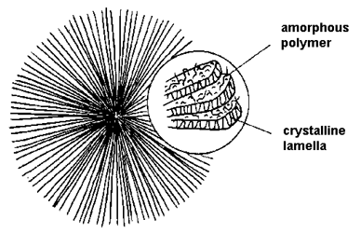spherulite

|  |  |
| --- | --- |
| **Property** | **Effect of increasing degree of crystallinity** |
| Strength | Generally increases |
| Stiffness | Generally increases |
| Toughness | Generally increases |
| Optical clarity | Generally decreases  Semicrystalline polymers are opaque because of the difference in refractive index of the amorphous and crystalline domains, which leads to scattering. Will depend on crystal size |
| Barrier properties | Increases  Small molecules cannot penetrate or diffuse through the crystalline domains. (food wrap, trash bags) |
| Solubility | Increases  Solvent molecules cannot penetrate or diffuse through the crystalline domains, which must be melted before the polymer dissolves |

|  |  |
| --- | --- |
|  | As the bulkiness of the substituents increases, the chains are prevented from coming into intimate contact in the crystal. The intermolecular forces that hold these crystals together are all London forces, and these become weaker as the crystals loosen up owing to the substituent bulkiness. **Accordingly, the value for the heat of fusion decreases down the table.** |
| As the bulkiness of the substituents increases, the energy barriers to rotation along the chain backbone increase. This decreases chain flexibility in the liquid formations and therefore have high entropies. If the flexibility is reduced, the entropy change on melting is less than it would otherwise be. **Accordingly, the entropy of fusion decreases moving down the table.**  Since , the observed behavior of this series of polymer may be understood as a competition between these effects. **For the smaller substituents, the effect on dominates and Tm decreases with bulk. For larger substituents, the effect on dominates and Tm increases with bulk.** | |

|  |  |
| --- | --- |
| **Dependence of Tm on lamellar thickness**  is the surface tension, energy per area  If = 0, regardless of particle size.  As  As | **Dependence of Tm on molecular weight** |

Primary nucleation

Critical nucleus

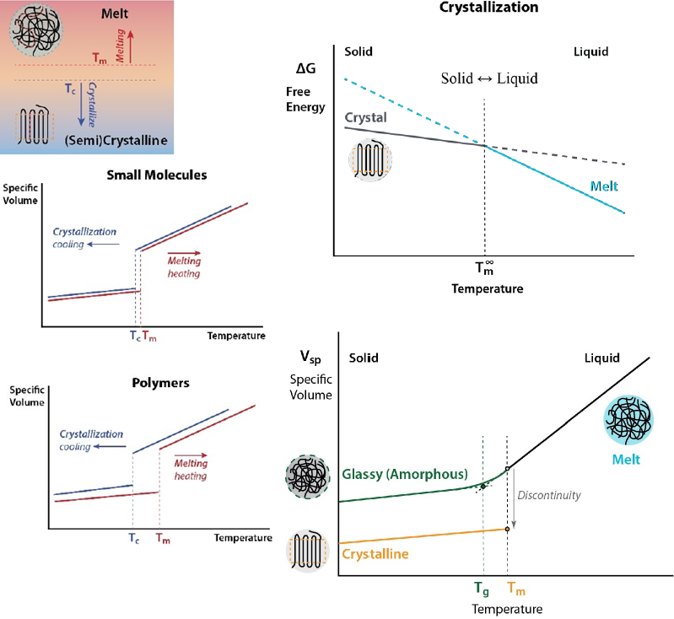

|  |  |
| --- | --- |
|  |  |

Contour length of a fully stretched chain

End-to-end vector,

Mean square end-to-end distance,

Root mean square end-to-end distance,

|  |  |  |  |
| --- | --- | --- | --- |
| Models | Freely jointed chain (FJC) | Freely rotating chain (FRC) | Hindered rotating chain (HRC) |
| Bond length | Fixed | Fixed | Fixed |
| Bond angle | Free | Fixed | Fixed |
| Rotation | Free | Free | Fixed |
|  | 1 |  |  |
|  | Ideal chain random walk.png |  |  |

**Persistence length**: how far we have to travel along the chain before it bends 90°

**Kuhn length**: how far we have to travel along the chain before it reverses direction

**Radius of gyration**: the average distance of all monomers from the center of mass

Expanded coil with self-avoiding walk (excluded volume), good solvent: v = 0.6

Molten polymer or in theta solvent, unperturbed coil with random walk: v = 0.5

Freely jointed chain of copolymers of A and B,

Stirling’s large N approximation

Binary mixing of A and B

|  |  |  |
| --- | --- | --- |
|  | Entropy of mixing | Free energy of mixing |
| Small-molecule blend |  |  |
| Polymer solution |  |  |
| Polymer blends |  |  |

Ternary solution

|  |  |  |
| --- | --- | --- |
| Polymer blend | Polymer solution, | Regular solution, |
|  |  |  |
|  |  |  |

**Assumptions of Flory-Huggins theory**

* There is no volume change on mixing, and are independent of concentration.
* is entirely the ideal combinatorial entropy of mixing.
* is entirely the internal energy of mixing.
* Both and are computed assuming entirely random mixing.
* The interactions are short-ranged (nearest neighbors only), isotropic, and pairwise additive.
* The local concentration is always given by the bulk average composition (the mean-field assumption).

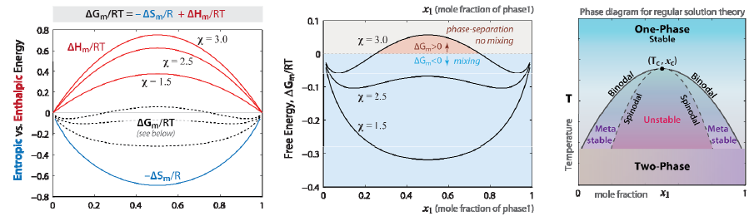

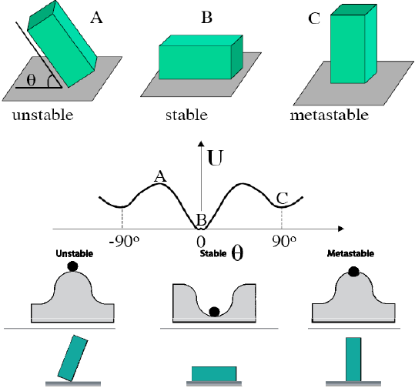

If the y-intercept is negative, then a second virial coefficient is needed.

|  |  |  |
| --- | --- | --- |
|  |  |  |
|  | at all temperature. No phase separation. | UCST. As T increases, decreases, favoring mixing. |
|  | If , LCST. As T decreases, decreases, favoring mixing.  If , then at all temperature. No phase separation. | If , UCST. As T increases, decreases, favoring mixing.  If , then at all temperature. No homogenous phase and no critical point. |

Flory-Rehner Theory:

100% elongation means

Entropy change:

Force:

Stress (nominal/engineering):

Stress (true):

Modulus of elasticity:

* Young’s modulus is related to the shear modulus: for incompressible materials (Poisson’s ratio v = 0.5). True sterss and engineering stress both yield the modulus at the small-deformation limit (
* The cross-section area normal to the load direction contracts by 1/
* The modulus increases with temperature due to its entropic origin.
* The modulus is dependent on the crosslink density (, but independent of functionalities of the crosslinks.
* The number of effective strands per volume, , can be replaced with the molecular weight between the crosslinks, Mx.

Front factor in terms of Mx

Front factor with end effects