**Physics 7B Final Review Sheet**

|  |  |  |  |  |
| --- | --- | --- | --- | --- |
| **Process** | **Constant** | **1st law of thermodynamics** | **W, Q, and U** | **S** |
| Isothermal | T | ΔT = 0 ΔEint=0, Q = W |  | R ln (V2 / V1) R ln (P1 / P2) |
| Isobaric | P | Q = ΔEint + W = ΔEint + PΔV | W = n\,R\,\Delta T  \Delta U = n\,c_V\,\Delta T | CP ln (T2 / T1) |
| Isovolumetric | V | ΔV = 0, W = 0, Q = ΔEint | \Delta U = n\,c_V\,\Delta T | CV ln (T2 / T1) |
| Adiabatic | Q = 0 | ΔEint = -W | P V^{\gamma} = \operatorname{constant} \qquad  \gamma = {C_{P} \over C_{V}} = \frac{f + 2}{f},  W = P_1 V_1^\gamma \frac{V_2^{1-\gamma}-V_1^{1-\gamma}}{1-\gamma} | CV ln (T2 / T1) + R ln (V2 / V1) |

Q = nCVΔT volume constant

Q = nCPΔT pressure constant

http://hyperphysics.phy-astr.gsu.edu/hbase/thermo/imgheat/hcon1.gif conduction http://hyperphysics.phy-astr.gsu.edu/hbase/thermo/imgheat/stef3.gif radiation


v_{\text{rms}} = \sqrt{\langle v^2 \rangle} = \sqrt{\frac{3 k_B T}{m}} = \sqrt{\frac{3 R T}{M}},


First law of thermodynamics

W=Q_1-Q_2. Wout = Qin - Qout

Second law of thermodynamics

e = Wout / Qin <= ecarnot = 1 – Tc/Th = 1 – Qc/Qh

|  |  |
| --- | --- |
| Boltzmann distribution  http://hyperphysics.phy-astr.gsu.edu/hbase/quantum/imgqua/dismb3.gif |  |

Gauss’s law



Gaussian Surface

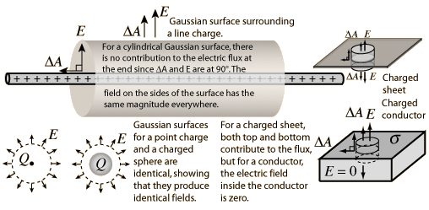

Line of charge

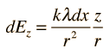

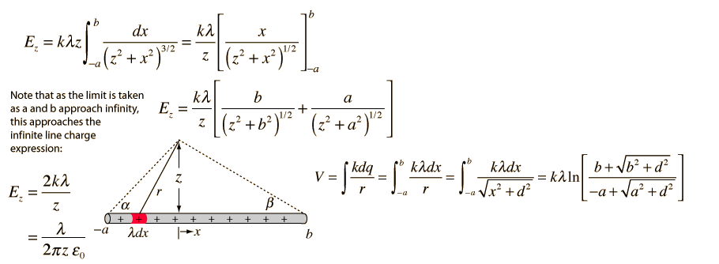

Charged disk

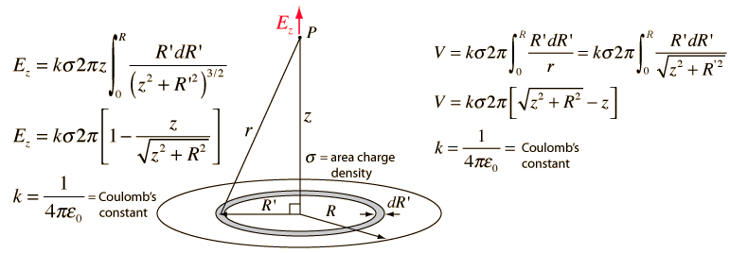

Ring of charge

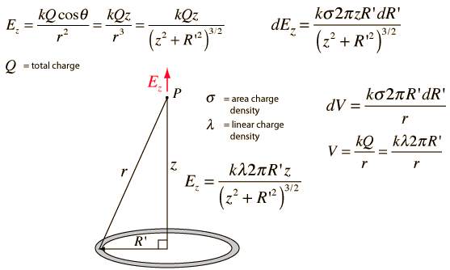

Circuits

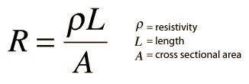 Electrical conductivity = σ = 1/ρ

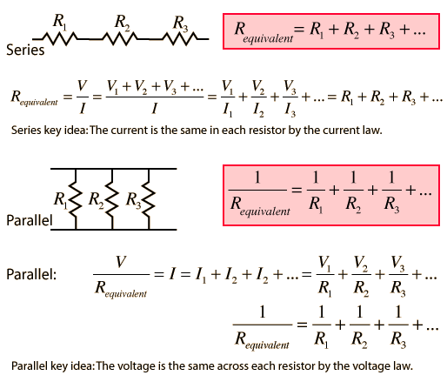

Kirchoff’s rule

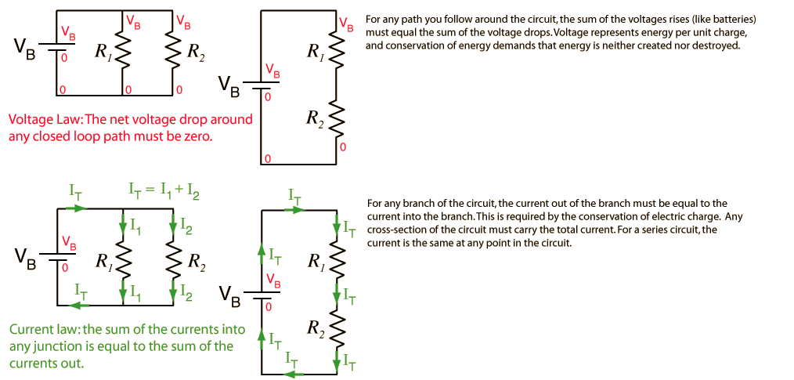

Capacitors

|  |  |  |
| --- | --- | --- |
| Parallel plate |  |  |
| Spherical | http://hyperphysics.phy-astr.gsu.edu/hbase/electric/imgele/csph.gif | http://hyperphysics.phy-astr.gsu.edu/hbase/electric/imgele/csph2.gif  http://hyperphysics.phy-astr.gsu.edu/hbase/electric/imgele/csph3.gif  http://hyperphysics.phy-astr.gsu.edu/hbase/electric/imgele/csph4.gif |
| Cylindrical | http://hyperphysics.phy-astr.gsu.edu/hbase/electric/imgele/ccyl3.gif | http://hyperphysics.phy-astr.gsu.edu/hbase/electric/imgele/ccyl4.gif  http://hyperphysics.phy-astr.gsu.edu/hbase/electric/imgele/ccyl5.gif  http://hyperphysics.phy-astr.gsu.edu/hbase/electric/imgele/ccyl6.gif |

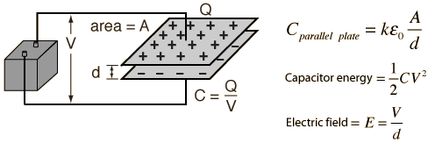

Dielectrics

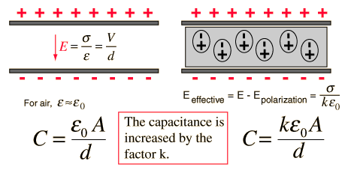

RC circuits

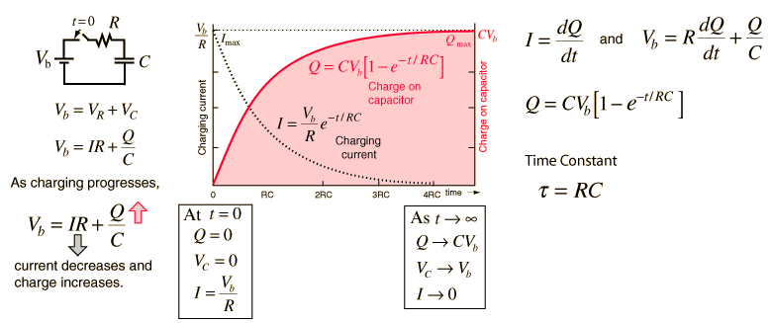

Lorentz force

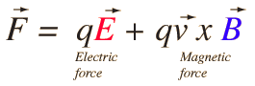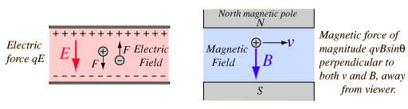

Ampere’s law

\oint_C \mathbf{B} \cdot \mathrm{d}\boldsymbol{\ell} = \mu_0 \iint_S \mathbf{J} \cdot \mathrm{d}\mathbf{S} = \mu_0I_\mathrm{enc}   F_m = 2 k_A \frac {I_1 I_2 } {r} 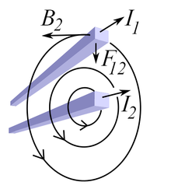

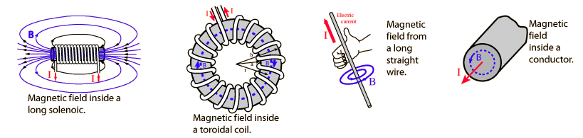

Biot-Savart Law

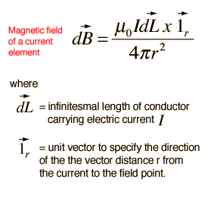 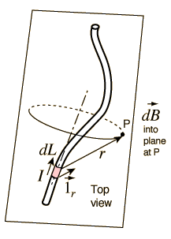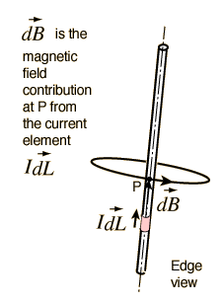

|  |  |
| --- | --- |
|  | http://hyperphysics.phy-astr.gsu.edu/hbase/magnetic/imgmag/loopc2.gif  http://hyperphysics.phy-astr.gsu.edu/hbase/magnetic/imgmag/loopc3.gif |
|  | http://hyperphysics.phy-astr.gsu.edu/hbase/magnetic/imgmag/loopa2.gif  http://hyperphysics.phy-astr.gsu.edu/hbase/magnetic/imgmag/loopa3.gif |
| http://hyperphysics.phy-astr.gsu.edu/hbase/magnetic/imgmag/loopa4.gif | |

Lenz’s law

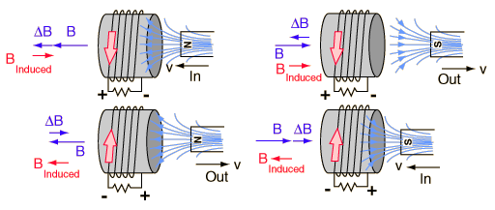

Faraday’s law

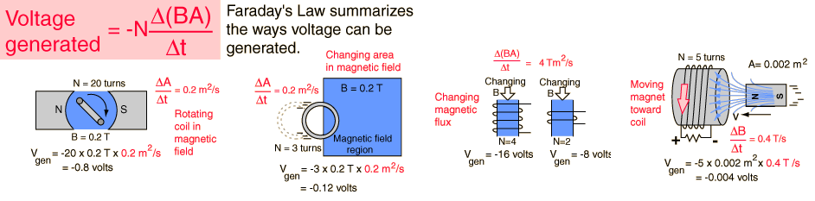

Motional EMF

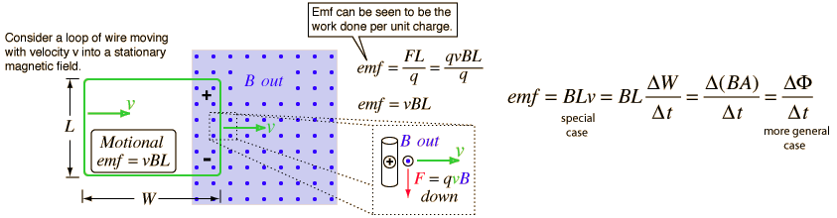

Inductance

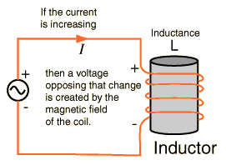 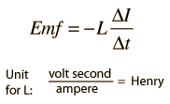

|  |  |
| --- | --- |
| http://hyperphysics.phy-astr.gsu.edu/hbase/magnetic/imgmag/indcur3.gif | http://hyperphysics.phy-astr.gsu.edu/hbase/magnetic/imgmag/indcur4.gif  http://hyperphysics.phy-astr.gsu.edu/hbase/magnetic/imgmag/indcur5.gif  http://hyperphysics.phy-astr.gsu.edu/hbase/magnetic/imgmag/indcur6.gif  http://hyperphysics.phy-astr.gsu.edu/hbase/magnetic/imgmag/indcur7.gif  http://hyperphysics.phy-astr.gsu.edu/hbase/magnetic/imgmag/indcur8.gif |

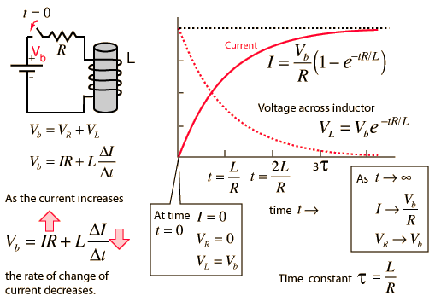

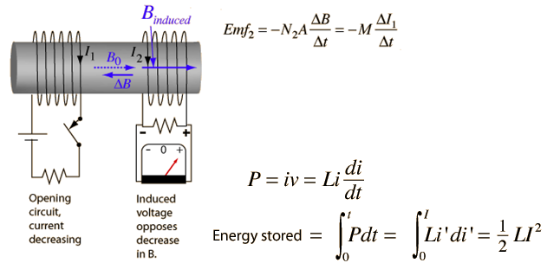

.

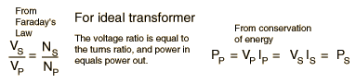

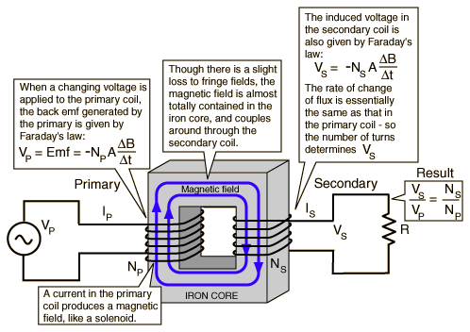

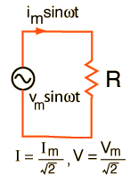

LC circuits

