|  |  |  |
| --- | --- | --- |
|  | Electric | Magnetic |
| Field | **E** | **B** |
| Potential | **V** | **-----------------** |
| Force | **FE = Q(E + U x B)** | **FM = IL x B** |
| Point | **E = q / 4πε0r** | **-----------------** |
| Line | **E = λ / 2πε0r** | **B = B = μ0I / 2πr** |
| Plane | **E = σ / 2ε0** | **B = nμ0I** |
| Device | **C = Aε0 / d** | **L =** |
| Voltage | **V = q/C** | **V = -LBv** |
| Energy | **UE = ½ CV2** | **UM = ½ LI2** |
| Dipole | **P = qd U = -p • E**  **Τ = p x E** | **μ = IA U = -μ • B**  **τ = μ x B** |
| Maxwell | **E • dA = qenclosed / ε0**  **ℇ = -dфe / dt** | **B • dA = 0**  **B • dl = μ0I** |

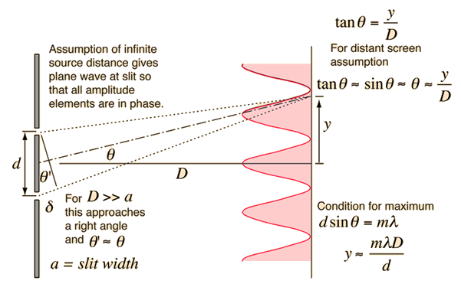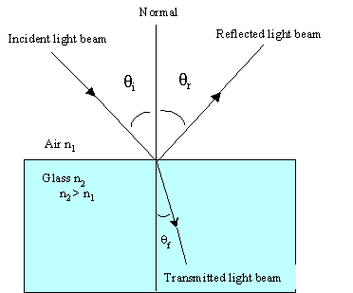

Double Slit Diffraction

Refraction/

Reflection

Mirror Ray Tracing

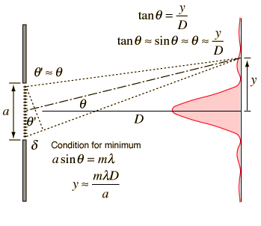

Single slit diffraction

