

APP & MLDM Project

on

Financial sector and services

in

mutual funds

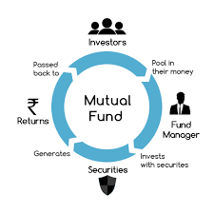

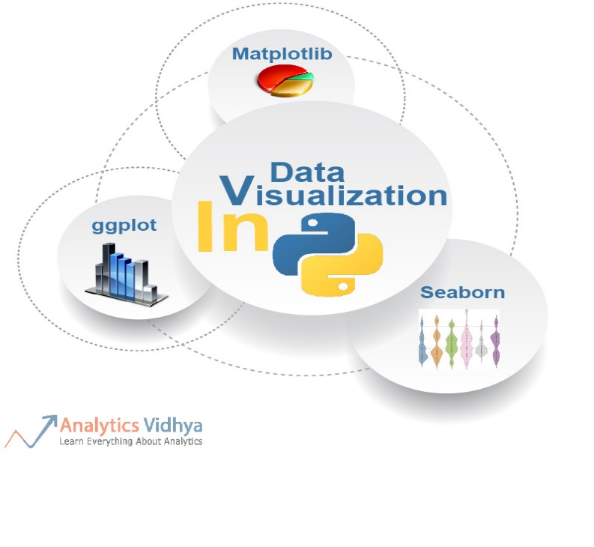

**Submitted To: Mr. Sandeep Goyal, Mr. Nitin Arvind Shelke Submitted By :Nikita Marwaha (502204095) Sanya Gupta(502204196)**

Abstract

This project examines the application of machine learning algorithms and models in the financial sector to facilitate predictions and decision-making. The

study explores the historical development of mutual funds, particularly their launch in 1963 by Unit Trust of India (UTI) and the subsequent market monopoly until 1987. The project addresses the challenges and implications arising from the use of mutual funds in the financial sector and their impact on economic growth. Mutual funds, which pool money from multiple investors, invest in various securities such as stocks, bonds, and short-term debt, thereby creating diversified portfolios.

Key words : ML Algorithms , Investment , Growth

#### Introduction

Predictive modelling is one application of machine learning in mutual funds. On the basis of previous financial data, ML algorithms can be trained to forecast future market movements, stock prices, or asset performance. These prediction models can help fund managers make informed investment decisions and modify portfolio allocations in response to predicted market conditions Furthermore, ML algorithms can be utilised to optimise portfolios. ML algorithms can recommend optimal asset allocations within a mutual fund's portfolio by analysing historical data, market patterns, and risk considerations. These algorithms take into account a variety of characteristics, such as risk tolerance, investment objectives, and market conditions, to create portfolios that try to maximise profits while

Another application of machine learning is sentiment analysis and news sentiment monitoring. To evaluate investor sentiment and identify potential repercussions on market conditions, ML systems can analyse news articles, social media feeds, and other textual data. This data can assist mutual fund managers in making timely choices and adjusting investment strategies as needed.

Furthermore, machine learning techniques can be used to automate portions of mutual fund operations such as data processing, risk assessment, and compliance monitoring. Automation can improve operational efficiency, minimise human error, and give fund managers more time to focus on more strategic duties.

It is crucial to note, however, that the employment of ML in mutual funds also offers obstacles. The quality and relevance of ML models are quite important.

#### Related Work

|  |  |  |  |  |
| --- | --- | --- | --- | --- |
| Ref | Methodology used | Data set used | Performance Parameter | Limitations/+  Points |
| **1.Bin li**  **2.Alberto G Rossi** | Machine learning | Name:  Selecting Mutual Funds From The Stock They Hold | Significant predictability using machine learning. | Mutual fund in real time by combining individual fund holdings and large number (94) to compute fund level characteristics.  Largely funds exposed positively and negatively  Fund performance is non-linear.  These non-linear and interaction proves important for BRT method of machine learning.  Finally detect significant predictability using ML the fund characteristics that matters in predicting fund returns and functional relation between fund characteristics and fund performance are time varying. |
|  |  |  |  |  |
| **1.Ron Kaniel**  **2.Zihan Lin**  **3.Markus Pelger 4.Stijn Van Nieuwerburgh** | Machine Learning | Name:  MACHINE-LEARNING THE SKILL OF MUTUAL FUND MANAGERS | Fund Flow and Fund Momentum | Evaluating by using Cross out sample and conditional modelling in time series.  Compare the prediction and trading benefits using machine learning algorithm.  Prediction weighted portfolio for assessing better investment . |
| **1.Rohan Arora**  **2.Chen Fan**  **3.Guillaume**  **Ouellet Leblanc** | Machine Learning | Liquidity Management of Canadian Corporate Bond Mutual Funds: | 68% out of sample  11% logistic classification | Use of standard linear model was difficult because of the large variety of features and styles and the risk of events that funds face.  Horizontal and vertical slicing is done on decision tree. |
| **1. Alan Zhang** | Machine Learning | Uncovering Mutual Fund Private Information | Greater accuracy for funds with riskier portfolio. | Applied NLP model of machine learning to predict future fund performance.  Funds with Textual Fund Information attract greater capital inflows.  It is better than traditional numerical data to develop promising applications. |
| **1.Xiaofei Chen**  **2.Shujun Ye**  3.**Chao Huang** | Machine Learning | Cluster-Based Mutual Fund Classification and Price Prediction Using Machine  Learning for Robo-Advisors | Robo-Advisors | It aims to improve the accuracy and timeliness of fund classification through the use of machine learning algorithms, that is, Gaussian hybrid clustering algorithm.  A deep learning-based prediction model is implemented to predict the price movement of fund classes based on the classification results. |
| **1.Pei-Ying Hsu**  **2.Chiao Ting Chen**  **3. Chin-Chou**  **4.Szu hao Huang** | Deep Learning | Explainable mutual fund Recommendation system developed based on knowledge graph embeddings | The proposed knowledge graph- based personalised system exhibited high accuracy and interpretability. | With the proposed structure they learned some information that could not be learned using traditional deep learning.  They obtained some possible recommendations based on the knowledge graph structure.  Conducted some case studies to demonstrate the effectiveness of the  developed model. |
| **1.Si Cheng**  **2.Ruichang Lu**  **3.Xiaojaun Zhang** | Machine Learning | Why should investors care about Mutual Funds Ratings | The quantitative rating generated by machine learning proves good. | The analyst rating outperform funds, while quantitative rating does not.  Analyst report contains incremental soft information predicting fund performance.  Finally investors do not follow analyst rating, instead they chase quantitative rating. |

#### PROPOSED METHODOLOGY

Research methodology means The Primary Activity of the Strategy or Architectural design Theory of models and Problem – solver in order to analyse or conduct a research for systematic gathering of data. We are working on Mutual funds dataset. Mutual funds are the medium (Debt) – long term investment (equity). Mutual funds holds NAV (Net Asset Value) as a unit it helps to know the performance of the company/ industry whether the company is in bull or bear period in the financial market to forecast the best suitable strategy.

To analyse, forecast and to know the future of the trend in the market we have applied supervised learning techniques under Machine Learning for better outcomes of dataset. Linear regression model has been applied in the dataset as it holds out numerical values. Regression and decision tree are

implemented to evaluated the model’s performance Following steps are implemented to find the accuracy of mutual funds.

**Regression**

Regression model works on continuous series in output or target column, the variable are of independent and of dependent nature. It helps in forecasting a response using predictor. Supervised learning technique is used.

In regression performance matrix there are two algorithms

1. R2score (max) Through this model we got 36.0990 as the performance response
2. MSE (min) errors Through this model we got 0.0014 as the performance response.

We have imported sk learn library for model creation. Fit method is used to get mean and standard deviation of the values.

Slope(.coef) recognized by R^2 . A Larger R^2 better fits in the model

Intercept (intercept) (0.1116).

For model training x train and y train are used.

For prediction of the model x test is used to predict output : y pred

For evaluating the performance y predict and y test are implied .

Regression line equation : Y= m*x + c

M = slope

Y = dependent variable

C= intercept

X= independent variable

**Decision Tree**

A decision tree is a non-parametric supervised learning algorithm, which is utilized for both classification and regression tasks. It has a hierarchical, tree structure, which consists of a root node, branches, internal nodes and leaf nodes

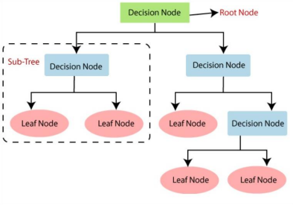

The decisions or the test are performed on the basis of features of the given dataset.

In this as we have applied linear regression model because our data is numerical and not categorical, but to apply decision tree model in this data set we have converted independent variable that is to get to know either this mutual fund scheme belong to ‘Direct Plan’ and ‘Regular’.

Have used two popular technique of Attribute Selection Measure or splitting measure that is Information Gain and Gini Index.

Information Gain

Information Gain is used to determine which feature/attribute gives us the maximum

information about a class.

It is based on the concept of entropy, which is the degree of uncertainty, impurity or disorder.

### Experimental Analysis

For experiment analysis we have used python and have applied data visualization on different variables by using Pandas, Numpy , Scikit-learn, Matplot and seaborn library. We have taken mutual funds dataset from Money control. The time period is from 2012 to 2022. The dataset contains different types of schemes names , their nature , rank , category and ratees from 2012 to 2022. Following are the visualizations of the data.

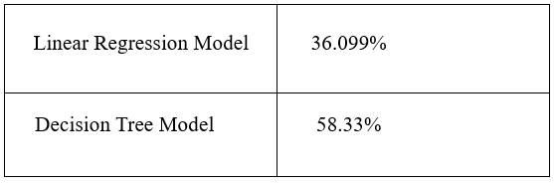

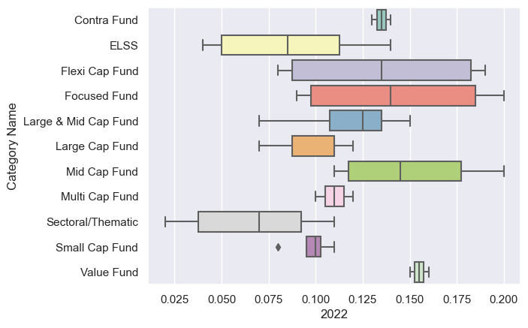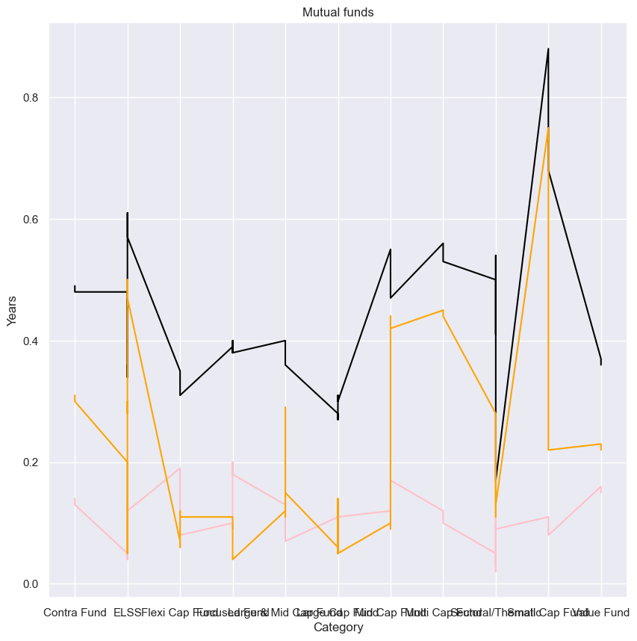

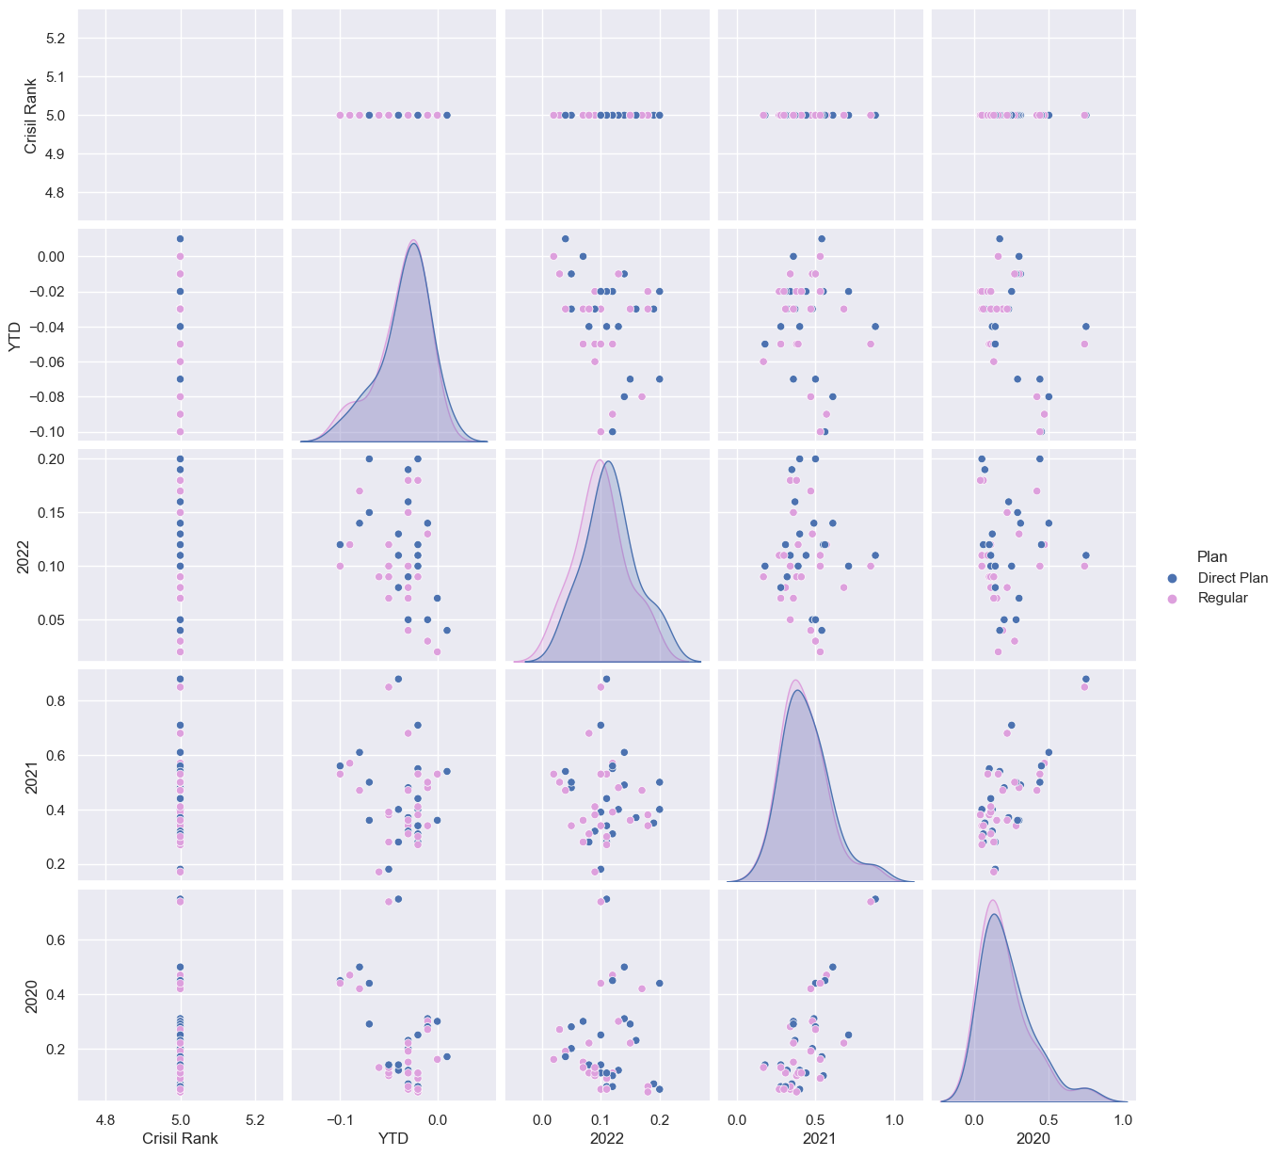

#### Conclusion

In summary, the integration of machine learning techniques in mutual funds opens up new opportunities to enhance investment strategies, optimize portfolios, and improve decision-making processes. By leveraging the power of ML, mutual fund managers can gain

valuable insights, make more informed investment decisions, and potentially deliver better outcomes for investors.

#### References

1. <https://papers.ssrn.com/sol3/papers.cfm?abstract_id=3737667>
2. <https://papers.ssrn.com/sol3/papers.cfm?abstract_id=3977883>
3. <https://www.bankofcanada.ca/2019/02/staff-analytical-note-2019-7/>
4. <https://papers.ssrn.com/sol3/papers.cfm?abstract_id=3713966>
5. <https://www.hindawi.com/journals/cin/2021/4984265/>
6. <https://dl.acm.org/doi/abs/10.1007/s10489-021-03136-1>
7. <https://papers.ssrn.com/sol3/papers.cfm?abstract_id=3702749>
8. <https://scholar.google.com/scholar?hl=en&as_sdt=0%2C5&q=reserach+paper+on+mutual+funds+&btnG=>
9. <https://www.moneycontrol.com/mutual-funds/find-fund/annual-returns?&amc=IIFLMF,BIRMUTF,AXMF,ANZGRMUTF,BAXMF,BOBMUF,CANMUTF,DSPMLMF,EDELWMF,TEMMUFT,HDFCMUTF,HSBCMUTF,PRUICM,IDBIMF,IDFMF,ILFSMF,INDIABMF,LIMF,ITIMF,JMMTFN,KMFLAMC,LICAMCL,MAHMF,MIRAEMF,MOMF,PEERMF,RELCAPM,NJMF,PMF,PPFMF,ESCOMUF,QMF,SAMCOMF,SBIMUTF,SHMF,SUNMUTF,TATMUTF,TAUMUTF,TMF,UKBCMF,UTIMUTFD,YESMF&invtype=Equity&category=Equity%20-%20ETF%2FIndex,Multi%20Cap%20Fund,Large%20Cap%20Fund,Large%20%26%20Mid%20Cap%20Fund,Mid%20Cap%20Fund,Small%20Cap%20Fund,ELSS,Dividend%20Yield%20Fund,Sectoral%2FThematic,Contra%20Fund,Focused%20Fund,Value%20Fund,Flexi%20Cap%20Fund&rank=1,2&MATURITY_TYPE=OPEN%20ENDED&SHOWAUM=Y&ASSETSIZE=100>