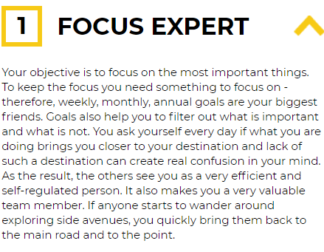**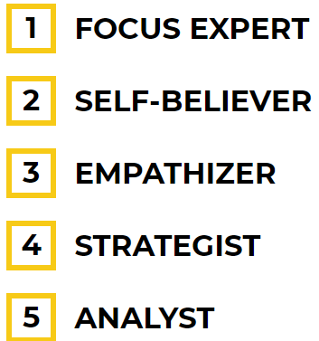Monday 29th June 2020**

**Strength Finder**

Write a good summary

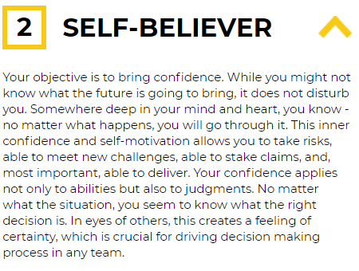

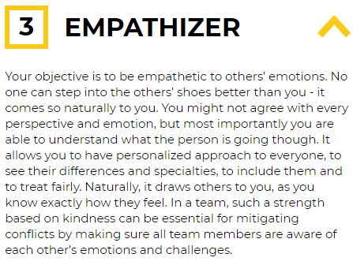

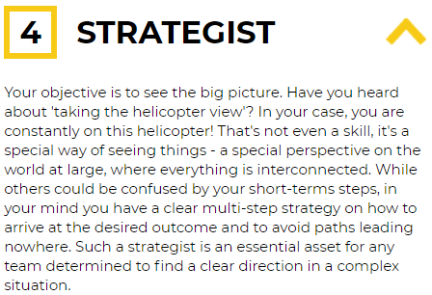

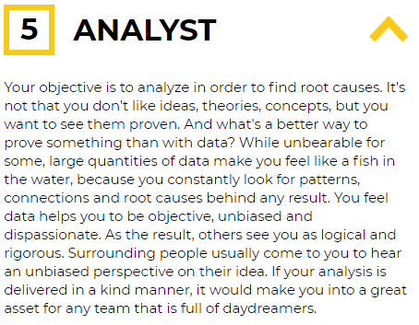

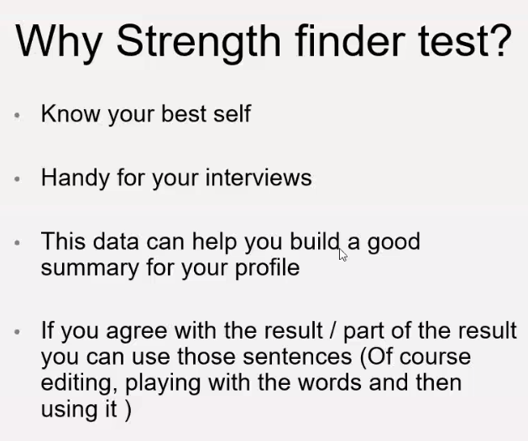

**https://high5test.com/test/main-test-result/ODM2MjY5/**

|  |  |
| --- | --- |
| Strength | Weakness |
| * **Technical Experience – Aerospace Engineering, analytical way of thinking** * Determined – persevere in challenging situations * Hard-working * Communication skills – active listening, negotiate, empathetic 5 years of retail * **Project Management** * **Data Analysis** * **People skills** * **Motivated** | * Technical language in object-oriented coding in Python but have passion in technology and do have a technical background in SIMULINK and MATLAB * Lack of Industry experience – listen, absorb as much information * Presentation skills – industry level |
| Opportunity | Threats |
| * Network more – even during * Gain experience in the industry * Utilise a creative way of thinking – constantly changing, you * Enhance personal development | * Competition in my field * Changing client attitude toward company * Uncertainty during lockdown * Trends within DevOps |

**Strengths**

I am **confident and communicative within team environment** whilst also having the capability and strengths to work independently, all skills developed from studies and experience.

**Analytical thinking** is observing and researching a problem or topic to develop more complex ideas about it. Your analytical thinking should result in additional knowledge, solutions or ideas related to the problem or topic.

The process usually involves several steps:

* Identifying a topic, problem or issue
* Gathering information
* Developing solutions or furthering your understanding of the topic
* Testing solutions or new ideas based on what you’ve learned
* Post-analysis, or reviewing what solutions worked, or assessing your new knowledge

**Weakness**

**Opportunity**

**Threats**

**Johari Window**

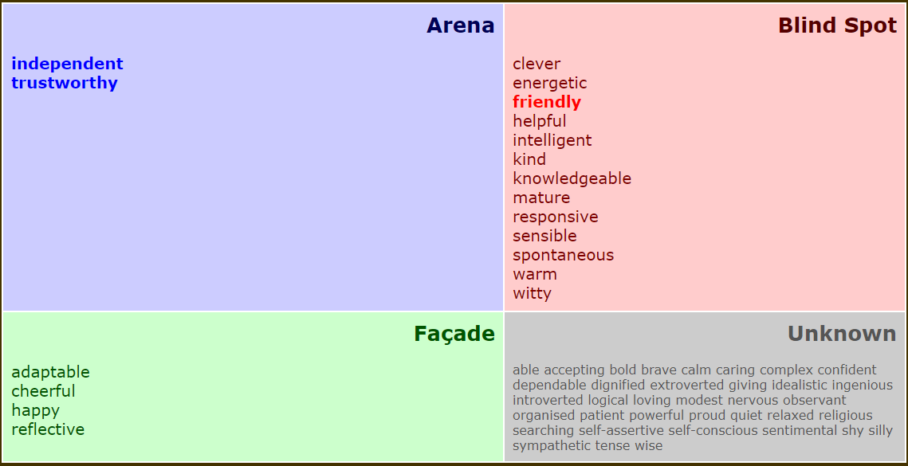

* Trustworthy- Able to share personal things and can be trusted to be kept to myself
* Spontaneous- You're always up for something no matter what/when it is –
* Knowledgeable - You know lots of facts on various topics
* Independent - Lived at Uni for 4 years that takes independence
* Witty – thinks of witty banter quickly
* Helpful: Always willing to help finish tasks set
* Trustworthy: Can trust to follow out tasks, speak in confidence too and know you can trust him
* Friendly: Always cheerful and happy, friendly to staff and customers and approachable
* Clever: in certain subjects of interest is very bright and clever, especially with the university subject he studied.
* Responsive -readily active
* Independent - because he lived away for four years without asking much help from me
* Clever because he graduated from university with 2.1
* Sensible – Responsible and knows to work out

Mature – committed to long term goals

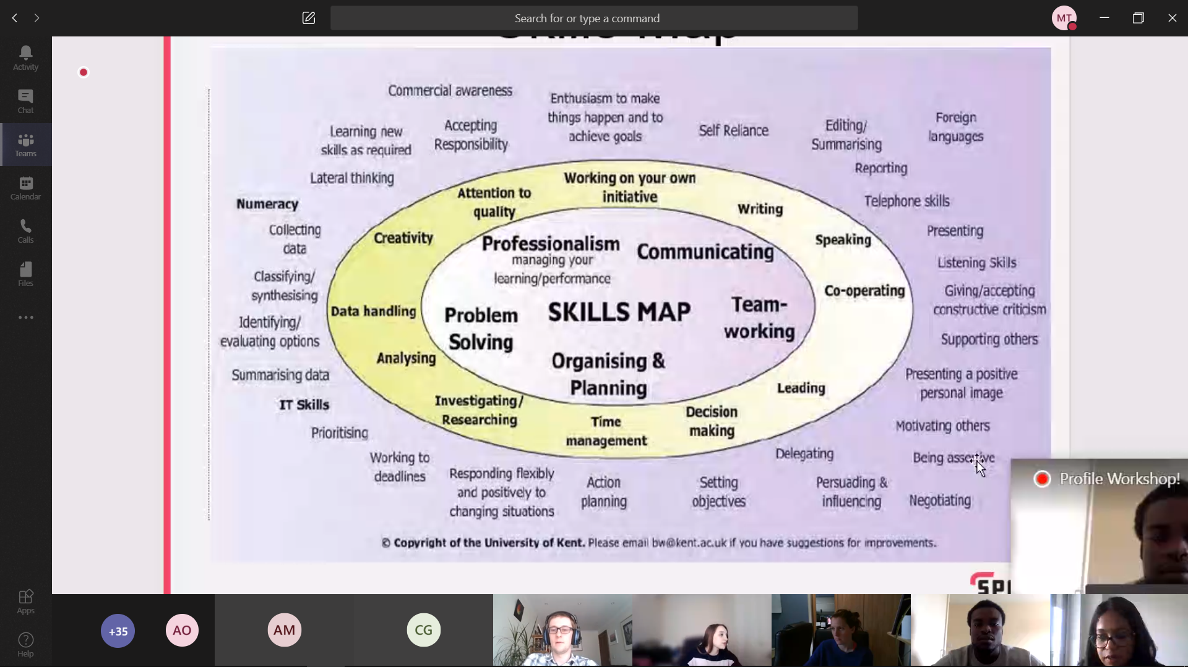

Trasnferable skills

* Initiative
* Plannign
* Teamwork
* Communicatoin
* Problem solving