|  |  |
| --- | --- |
| 1.1 | Write a query that lists all Customers in either Paris or London. Include Customer ID, Company Name and all address fields |



|  |
| --- |
| Answer |

|  |  |
| --- | --- |
| 1.2 | List all products stored in bottles |



|  |
| --- |
| Answer |

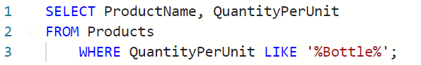

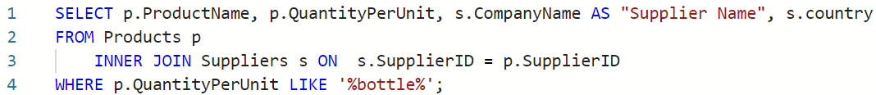

|  |  |
| --- | --- |
| 1.3 | List all products stored in bottles |

|  |
| --- |
| Answer |

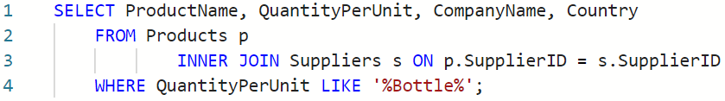

|  |  |
| --- | --- |
| 1.4 | Write an SQL Statement that shows how many products there are in each category. |

