Create a database called "contacts"

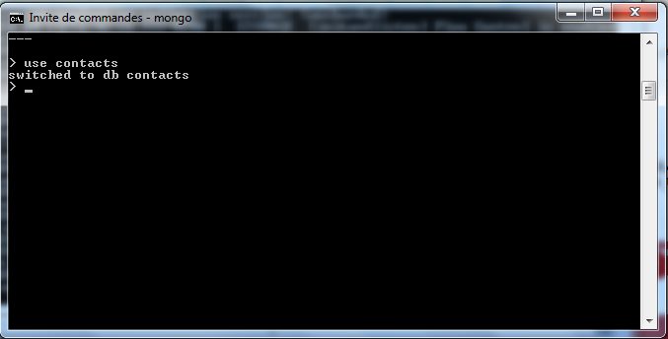

Create a collection called "contactlists"

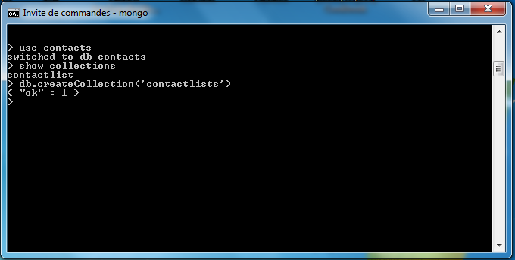

Display all the contactlist

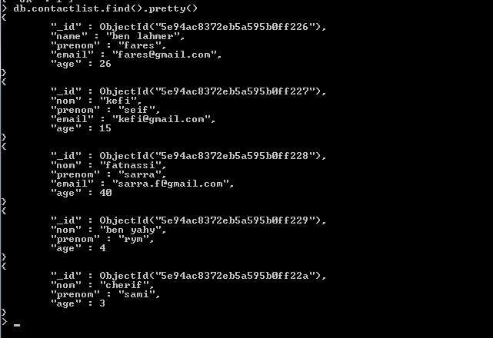

Display all the information about only one person using his id

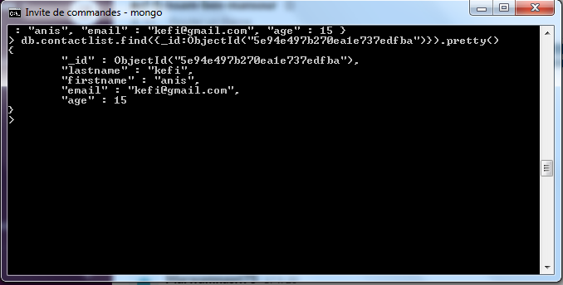

Display all the contact list having age>18

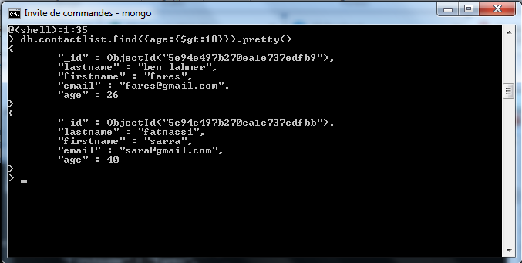

Display all the contact list having age>18 and name' containing "ah"

Change the contact first name of "kefi Seif" by' "Kefi Anis"

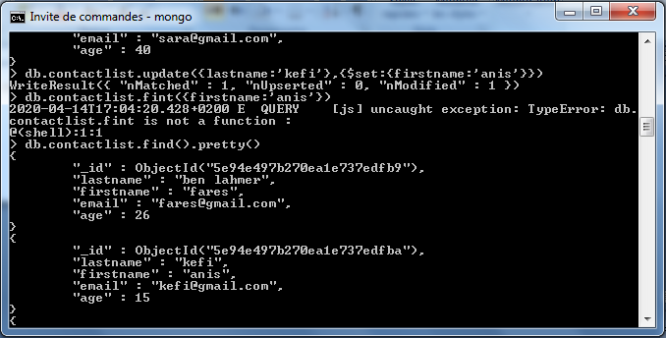

Delete the the contact list having age < 5

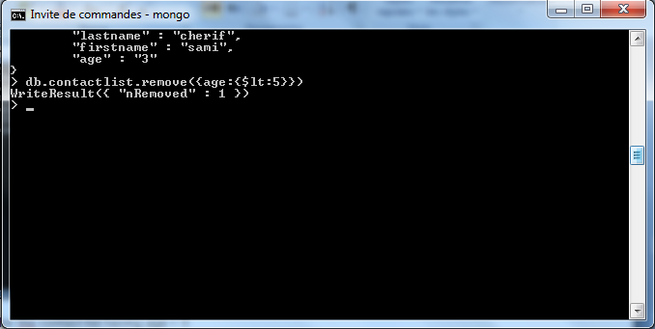

Display all the contact list

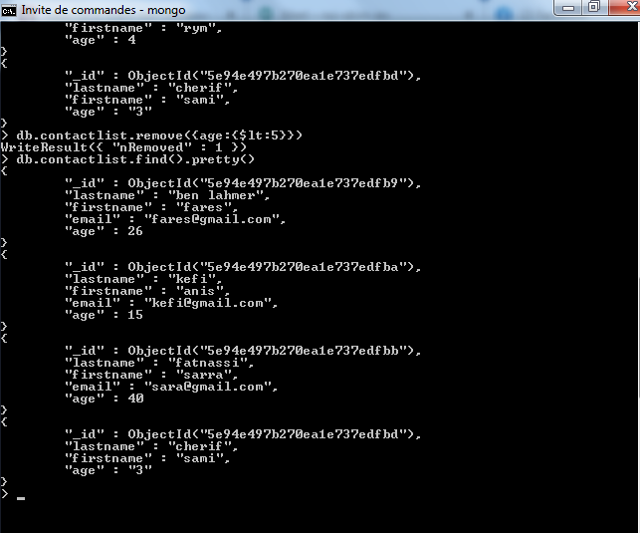

git init

git add .

git commit -m "first commit"

git remote add origin https://github.com/marwamnasri/mongodb.git

git push -u origin master