What is node.js?

Node.js is a JavaScript runtime environment. Sounds great, but what does that mean? How does that work?

The Node run-time environment includes everything you need to execute a program written in JavaScript.

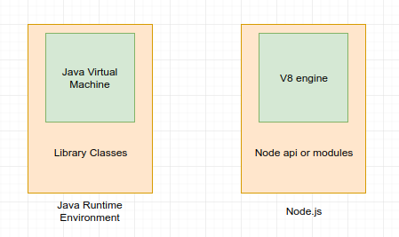

If you know Java, here’s a little analogy.

Node.js came into existence when the original developers of JavaScript extended it from something you could only run in the browser to something you could run on your machine as a standalone application.

Now you can do much more with JavaScript than just making websites interactive.

JavaScript now has the capability to do things that other scripting languages like Python can do.

Both your browser JavaScript and Node.js run on the V8 JavaScript runtime engine. This engine takes your JavaScript code and converts it into a faster machine code. Machine code is low-level code which the computer can run without needing to first interpret it.

Node.js tutorial provides basic and advanced concepts of Node.js. Our Node.js tutorial is designed for beginners and professionals both.

Node.js is a cross-platform environment and library for running JavaScript applications which is used to create networking and server-side applications.

Our Node.js tutorial includes all topics of Node.js such as Node.js installation on windows and linux, REPL, package manager, callbacks, event loop, os, path, query string, cryptography, debugger, URL, DNS, Net, UDP, process, child processes, buffers, streams, file systems, global objects, web modules etc. There are also given Node.js interview questions to help you better understand the Node.js technology.