Dot Product
written by Gary Simmons

One of the most useful Formula's in 3D graphics programming is the Dot Product. It can be used for Back face Culling and for calculating lighting for programmers creating their own lighting engine. The Dot Product can be used to perform Back face Culling way back in World space (oh yes) to discard many polygons, meaning they don’t have to be transformed into View space or Screen space saving a lot of time and processing power.
OK, so I’ve sold the idea of the Dot Product to you, but what is it?
What is it?
Unlike the Cross Product, when you perform the Dot Product on two Vectors, the result is not a third Vector. Instead, it is a scalar Value. In other words, just a single number. But what does this single number tell us. It just so happens, that this value is actually the Cosine of the Angle between the two Vectors, Scaled by the lengths of the Vectors.
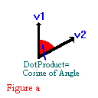
This can be written like so:- Note V1 & V2 are both Vectors & |V1| & |V2| donates the Vector's length
Cos_angle=DotProduct(V1,V2) / |V1| * |V2|
In other words, to find the Cosine of the angle between V1 & V2 we must first perform the Dot Product on them and then Divide the Result by the length of V1 multiplied by the Length of V2.
The length of a Vector is calculated as Follows:-Note V1 is a Vector
VectorLength=SQRT( (V1. x*V1. x) + (V1. y*V1. y) + (V1. z*v1. z) );
Note that Finding the Cosine of the angle, is even simpler if both V1 and V2 are Unit Vectors(They both have length of 1). In this case we can do away with the scaling of the Vector Lengths because the result of |V1|*|V2| will always be one. So, if we have two Unit Vectors , we can rewrite the above formula like so:-
Finding the Cosine of the angle with two Unit Vectors:-
Cos_angle=DotProduct(V1,V2);<
Once we have Cos_angle , we can find the actual angle between the two Vectors with the help of the Inverse Cosine (or ArcCosine) function. This function takes the Cosine of an Angle and returns the Actual Angle in radians.
Finding the Actual Angle in Radians:-
ActualAngle = acos (Cos_angle);
Ok. I Like It. How Do I Do One
OK , so how do we perform a Dot Product. The DotProduct of two Vectors V1 & V2 (V1lV2) can be calculated as follows:-
V1lV2 = V1. x*V2. x + V1. y*V2. y + V1. z * V2. z
And there we have it. One Dot Product with fries, and a large Fanta. But what is good for. OOOHHHH Back face Removal in WORLD space, calculating the intensity of lighting & collision detection, among other things.
Using the Dot Product for Backface Removal in World Space
In any 3D scene, there are lots and lots of polygons that should not be drawn because they are facing away from the viewer. You can remove these back faces in screen space by using the Cross Product but this is quite wasteful. The reason for this is that in order to test the polygon's using the Cross Product alone, every polygon in the scene has to go through the View Transformation and the Perspective Projection matrices before you decide you don’t want to display them. This is a little crazy don’t you think? By the time you have decided that you don’t want them, you have already done all the work to display them, only to discard them at the last minute.
The Dot Product is the Cosine of the angle between two Vectors, scaled by the magnitudes of those Vectors. Magnitudes are always positive, so the sign of the Dot Product is enough to determine whether a polygon is facing the viewer or not. Look at figure b)
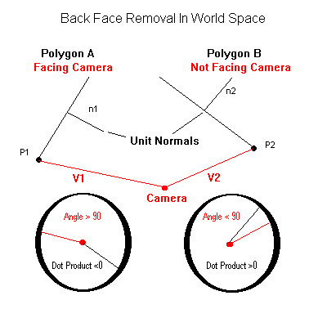

Figure B shows a diagram of two Polygons A & B along with their respective Normals (n1 & n2) describing the way they are facing. V1 and V2 are the Vectors from the viewpoint to any point(vertex) in the polygon. To make this clearer lets go through this step by step, starting with Polygon A. We are going to test if it is visible to the viewer. We must: -
- Calculate a Vector from the Viewpoint position to the position of any Vertex in the Polygon. Any vertex in the polygon will do. In Figure B, the vertices I have used are labelled p1 & p2.
VECTOR v1=p1-view_pos;
- Calculate the Dot Product of this new Vector v1 and the Normal of the Polygon n1
float result=DotProduct(v1,n1);
If you are unsure how to generate a Polygon Normal see Cross Product.
- If the result is negative, the polygon is facing the viewer and should be drawn. If the result is positive the polygon is not facing the viewer and should be discarded. If the result is 0, the polygon is edge on to the viewer and can be treated as either.
The Dot Product works by taking the source point of each vector and bringing them together and then calculating the cosine of the angle between them. To better understand this look at the inset (diagram in the circle) below polygon a in the diagram. This shows how the two vectors are bought together to share the same origin and shows the Normal of the polygon and the vector from the camera to p1 are bought together to create an angle between them that is larger than 90 degrees. This means the Dot Product returns a Negative number and also means that the polygon IS facing the Viewer.
Polygon B on the other hand is another story. When polygon normal and the vector from the camera to p2 are moved to the same origin you can see from the inset diagram below polygon b that the angle created is less than 90 degrees. The Dot Product returns Positive in this case meaning that the polygon is facing away from the viewer and so should be Back Face culled.
IMPORTANT NOTE:
The Crucial thing to understand from the above diagram is that that BOTH vectors are moved to the same ORIGIN by the Dot Product operation. Look at the two Inset diagrams above and make sure that you understand how the Polygon Normal Vector and the Direction vector from the camera to the point on the plane(p1 or p2) are bought together to share the same origin.
I understand from my own experience that for the less mathematical people out there this can be difficult to grasp. I am indeed one of those people that could not get any form of Trig into my head. When people explained it to me, they still assumed I understood more mathematics than I did. I feel the best way to learn anything is to play around with some code. So lets write a Back face checker function just to show how easy it is. This way, even if you don’t understand it fully, at least you have the code for your own applications.
Code for Check Backface Function. Note:- returns true if face is a backface and should not be drawn.
bool check_backface(VECTOR p1,VECTOR normal,VECTOR viewpos)
{
VECTOR v1;
v1. x=p1. x-viewpos. x; // calculate the vector from the camera position to any point on the polygon
v1. y=p1. y-viewpos. y;
v1. z=p1. z-viewpos. z
float result=DotProduct(v1,normal) ; // now Dot v1 with the polygon normal
if (result>0. 0)
{
return true; // yep,this is a backface. Return true to signify that we wish to lose it.
}
else
{
return false; // This polygon is facing the viewer so return false. We DONT want to remove it.
}
}
Its hard to believe that that is it, but it is. This little function here allows you to lose a lot of polygons quite early on in the transformation process. The bit I found hard to believe at first is that in the above code, the parameter p1, can be any vertex in the polygon because all the vertices of a Polygon lie on the same Plane. So just sending vertex[0] in the polygon structure will suffice.
Using the Dot Product for Collision Detection

Distance from a Point to a Plane
One of the really great things about the Dot Product is the outcome of one of the Vectors being a UNIT Vector (has a length of 1) and the other Vector being a NON UNIT Vector. As we’ve already discovered, the Dot Product of Two UNIT Vectors is the Cosine of the angle between them. If one of the Vectors is a NON UNIT Vector, the outcome of the Dot Product is the cosine of the angle between them, multiplied by the length of the NON UNIT Vector. If this is hard to grasp look at figure c);
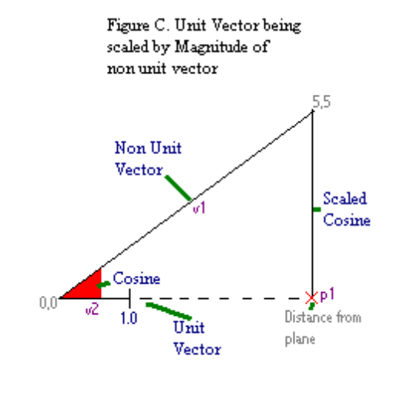
As you can see, the NON UNIT (v1) vector forms the HYPOTENUSE of a right angled triangle, and (v2) forms the Adjacent leg but at a length of 1. 0. Now consider that COSINE is really just the length of the Adjacent leg of a right Triangle (and that all sides of similar triangles scale equally) we see that the result of the Dot Product of any vector with a unit vector is the Length of the first vector PROJECTED on to the
Unit vector. In other words, in the above diagram, the length of v1 is Projected onto v2 and this results the Length of the Adjacent side (0,0 to p1). Now imagine that the OPPOSITE leg of the triangle is a plane in which a polygon lies & the (5,5) coordinate in the graph above is any point on that plane (Any vertex that is in the polygon will do ). V1 is the direction vector from the viewpoint to the vertex at pos 5,5. Also think of Vector v2 as the polygon or plane normal and think of point (0,0) as the position of the viewer. The result of the Dot Product is the Distance from that plane (p1). This does not tell us the distance to the polygon mind you, only the distance to the infinite plane in which it lies. But if this distance is a large number then you obviously are not near the polygon either.
Are you confused? Well if so lets examine the math for ourselves, to see it comes out right. We can see in the simple demonstration above that the point (0,0) is a distance of 5 away from the plane (p1). So we can see that the Polygons Plane (p1) is a distance of 5 from Viewer Position (0,0) with our own eyes. This is obvious. So lets see if our Dot Product gives us the same result.
We have two Vectors like so:-
VECTOR v1=(5. 0 , 5. 0 , 0. 0); //The non unit vector forming the hypotenuse. This Vector is describing the direction from the viewpoint(0,0) to any vertex in the polygon (5,5) like so. Vertex[0]-viewpos
VECTOR v2=(1. 0 , 0. 0 , 0. 0 ); // Unit vector. This is the Plane or Polygon Normal
float p1=DotProduct(v1,v2); // p1=distance to the plane
The result is 5. This is correct and is in fact all you have to do to calculate a distance from a plane. But why is it right? Lets rip it apart a little bit so we know exactly why this works.
If we get the length of v1 like so,
lenght = sqrt (5*5,0*0,5*5); // we get the answer 7. 0710678.
This is the length of Vector v1. We can spot quite easily in the figure C. ) that the angle above is infact 45 degrees because it climbs in equal steps up each axis (x & y);But to check it is 45 degrees we can divide the result of our Dot Product which was 5, by the length of the non unit vector. Like so:-
5 / 7. 0710678=0. 7071067; //This gives us the cosine of the angle
float angle=acos(0. 7071067)=0. 7853981; // 0. 78539181 radians = 45 degrees
So you can see that the Dot Product comes up with its result by doing the opposite.
The Dot Product finds the cosine of the angle and multiplies it by the length of the NON UNIT Vector v1.
DotProduct=cos_angle=0. 7071067(cosine of 45 degrees) * 7. 0710678 (length of v1) =5;
Intersecting a line through a Plane
So we now know how to calculate the distance from a Point to a Plane, but how do we check if a RAY or LINE has intersected a plane. We want to be able to cast out a Ray from any point and have it return the exact coordinates that the Intersection occurred. Well guess what? WE CAN.
There are a few things we need to know before we continue. To define a plane in 3d Space we need 3 vertices. We have to construct two Vectors from the triangle edges these vertices create and perform a Cross Product on them to calculate the normal to the plane in which they lie. See Cross Product for more info.
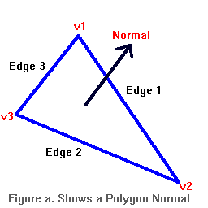
You can see below that v1,v2 & v3 make up a plane. To calculate the Normal of that plane, we first need two Vectors that lay on the plane. Any two edges of the triangle will do nicely. We then perform the Cross Product on these two Vectors and result is a Vector that describes the Normal, like so: -
Calculate normal to a plane
Vector edge1=v2-v1;
Vector edge3=v3-v1;
Vector Normal=CrossProduct(edge1,edge2);
Now lets have a go and see if we can take a line or a ray (a Start point and an End point) and see if it does intersect a plane of a polygon.
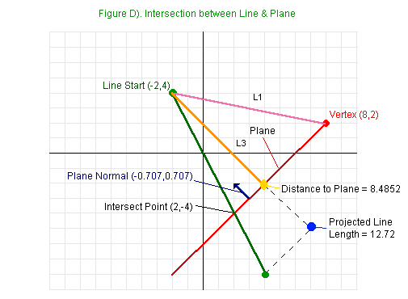
We'll start of with the Line Origin (for this example well say that this the position of the viewpoint in a scene) at (-2,4) and cast a ray or line out (the direction in which the camera is looking) to the Line's End at coordinates (4,-8). For the sake of this demonstration we will assume that we already generated the Polygon Normal as described above using the Cross Product, and the plane lies at 45 degrees in the -x and y direction (the pane is the RED line in figure d.). This would generate a Polygon Normal Vector (-0. 707,0. 707,0. 0);
First we must find the Distance to the plane from our line origin (viewpoint) as shown in figure d as the ORANGE line L3. We covered how to do this earlier but just to recap, we calculate Vector L1 (the PINK Line) by subtracting the Line Origin from any point in the polygon (we have called this point Vertex in figure d). This works because all the vertices with a polygon lie within the same plane as each other so any vertex will do. After we have the Vector L1 we then calculate the Dot Product of L1 and the Surface Normal. This gives us the cosine of the angle between the two Vectors scaled by the length of line L1. This gives us line L3 (the ORANGE line, which makes up the Adjacent side of the triangle), which is the Distance to the plane. As you can see above the Plane makes up the Opposite side of the triangle. The Code to do this is simple: -
Find Distance to Plane
VECTOR L1=vertex-linestart;
Distance_to_plane=DotProduct(L1,Normal); // =8. 4852 which is correct so far according to figure d.
Now we do virtually the same thing again except this time we calculate the Direction Vector of the Ray or Line (the GREEN line in figure d.) by subtracting the Line Starting point from the Line Ending point and by performing a Dot Product on the resulting Vector with the Polygon Normal. Once again the result is the cosine of the angle between the two Vectors scaled by the Direction Vector to form the Adjacent leg of a triangle and returns the lines projected length (BLUE Dot). Shown below: -
Calculate the Projected Line Length
VECTOR line_direction=(lineend-linestart); // gives us a vector of (6, -12)
float linelength=DotProduct(line_direction,Normal);// linelength=-12. 72 which is correct. Trace the line down with you finger on figure d.)
This projected line length shows us what the original line would look like if it had been rotated around and aligned with the polygon normal. Now we divide the distance to the plane by the line length to get the ratio between them. This really gives you a kind of percentage down the line you have to travel to reach the intersection. The percentage is between 0 and 1, for example 0. 5 would intersect you at linelength*0. 5, which would be exactly half way down the line. If the result > 1(over 100% percent of the length) then the line does not reach the plane. On the other hand, if the result is negative then the plane is behind the start of the line. Lets see the code: -
float percentage = - Distance_to_Plane / linelength;
// =0. 66667 or 66 percent of the way down the line. Lets try that and see if its right.
intersect. x=linestart. x+line_direction. x*percentage;
// = - 2 + 6 * 0. 66667 = - 2 + 4= 2(X)
intersect. y=linestart. y+line_direction. y*percentage;
// = 4 + - 12 * 0. 66667 = 4 + - 8 = -4(Y)
intersect. z=linestart. z_line_direction. z*percentage;
// = 0 + 0 * 0. 66667 =0 (Z) not being used in this example
IntersectPoint is returned as being ( 2 , -4 , 0 ). There you have it.
Ok then , lets write our Ray Intersect function:-
bool Get_Intersect (VECTOR linestart,VECTOR lineend,VERTEX vertex,VECTOR normal,VECTOR * intersection)
{
VECTOR direction,L1;
float linelength,dist_from_plane,percentage;
// calculate the lines direction vector (Green line in figure d)
direction. x=lineend. x-linestart. x;
direction. y=lineend. y-linestart. y;
direction. z=lineend. z-linestart. z;
linelength=DotProduct(direction,normal);
// This gives us the line length (the blue dot L3 + L4 in figure d)
if (fabsf(linelength)<0. 00001)
// check it does not = 0 with tolerance for floating point rounding errors
{
return false;
//=0 means the line is parallel to the plane so can not intersect it
}
L1. x=vertex. x-linestart. x; // calculate vector L1 (the PINK line in figure d)
L1. y=vertex. y-linestart. y;
L1. z=vertex. z-linestart. z;
dist_from_plane=DotProduct(L1,normal);
// gives the distance from the plane (ORANGE Line L3 in figure d)
percentage=dist_from_plane/linelength;
// How far from Linestart , intersection is as a percentage of 0 to 1
if (percentage<0) // The plane is behind the start of the line
{
return false;
}
else
if (percentage>1) // The line does not reach the plane
{
return false;
}
// add the percentage of the line to line start
intersection->x=linestart. x+direction. x*percentage;
intersection->y=linestart. y+direction. y*percentage;
intersection->z=linestart. z+direction. z*percentage;
return true ; // ooh yes we have hit a plane;
}
And that’s it. We can now test for an intersection between a line and a plane. Take time to read the above sections a couple of times over if you don’t understand it right away, it makes perfect sense after you have grasped the whole Dot Product thing. Study figure d) and follow it along with the code so you can see what’s happening each step of the way and you will grasp it in the end.

But have we hit a Polygon or just its Plane?
Well, as you know, just because we have a point of intersection with a plane, doesn’t mean we have an intersection with a polygon. We have only collided with the infinite plane on which the polygon lies. In fact, the point of intersection could be far, far away from the polygon, so we need to check if our point is indeed, inside the polygon. But how?
Well we already know, that performing the Dot Product on two UNIT Vectors returns the cosine of the angle between those Vectors. So take a look at figure e and figure f and ill take you through it: -
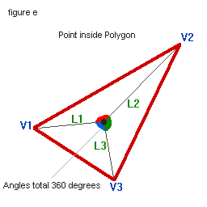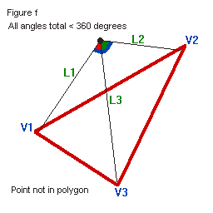
First we create three direction Vectors from the Hit Point to each Vertex. In the above diagrams I have used a triangle primitive so we need three Vectors. L1 , L2 & L3. (You don’t have to use a triangle, a square , hexagon or any primitive will be fine but just create as many Vectors as there are Vertices in the polygon).
Now normalize all the Vectors so they each have a length of 1. (UNIT Vectors )
Now we step through each Vector and perform the Dot Product on it, with the following Vector eg. ) DotProduct( L1 , L2 ) DotProduct( L2 , L3 ) DotProduct( L3 , L1 ). The Result of each Dot Product is the Cosine of the angle between them, so we perform an Inverse Cosine function (acos) on the result of each Dot Product to get the angle between them.
We loop through and total up all three angles (red, blue & green in the above diagrams) and if it totals 360 degrees (a Circle or 6. 28 radians) then we are in the polygon and have hit it. If you look at figure e) you can see that the three colored angles make up a circle. Figure f's colored angles on the other hand do not form a circle (total_angles< 360 degrees or <6. 28 radians) because the hit point is outside the polygon.
Above we wrote a function to test for a collision with the polygons plane.
Now lets write a function to see if the returned intersection point has actually hit the Polygon using the methods described above:-
bool hit_polygon (VECTOR plane_intersection , POLYGON triangle)
{
VECTOR Lines[triangle. Number_Of_Vertices];
float total_angles,result,vlength;
for (int a=0;triangle. Number_Of_Vertices>a;a++) // Loop through all the vertices in Polygon
{
Lines[a]. x=plane_intersection. x-triangle. vertex[a]. x; // Get direction Vector from intersection to vertex[a]
Lines[a]. y=plane_intersection. y-triangle. vertex[a]. y;
Lines[a]. z=plane_intersection. z-triangle. vertex[a]. z;
vlength=sqrt( (Lines[a]. x*Lines[a]. x)+(Lines[a]. y*Lines[a]. y)+(Lines[a]. z*Lines[a]. z) ); // Nomralize Vectors
Lines[a]. x=(lines[a]. x/vlength);
Lines[a]. y=(lines[a]. y/vlength);
Lines[a]. z=(lines[a]. z/vlength); // Vectors normalized
}
total_angles=0. 0; // lets start couting those angles
for (int a=0;a < triangle. Number_Of_Vertices-1;a++)
{
total_angles= total_angles+acos(dotproduct(Lines[a],Lines[a+1]));
// Loop through and calcuate the angles between each Vector
}
total_angles= total_angles+acos(dotproduct(Lines[Number_Of_Vertices-1],Lines[0]));
// Last Vector done out side loop. ( L2 , L0 )
if (fabsf (total_angles-6. 28)<0. 01)
// lets take 6. 28 radians(360 degrees) away from total_angles and if its Zero (with tolerence) weve hit it
{
return true;
}
return false; // we have not hit the polygon
}
That ends this tutorial on the Dot Product and I hope you find the Dot Product as Amazing as I do. One formula that unlocks so many possibilities

