Marawan El Sharkawi

CSCI 301-Section 1

#cs301175

Project 3

**Test**

**Tests for Maze Path Finder:**

The following script file tests and illustrates the Maze Path Finder program. It shows the input processes required by the user, displays the maze then displays the maze with all possible paths found. There are four runs of the program each showing how the program behaves regards user input and maze path finding.

First run (If the user wrote a wrong file name):

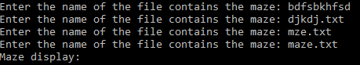

Second run (Finding the path for a maze with 16 rows and 16 columns):

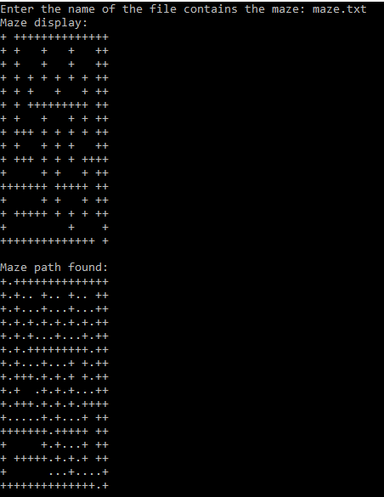

Third run (Finding the path for a maze with 20 rows and 20 columns):

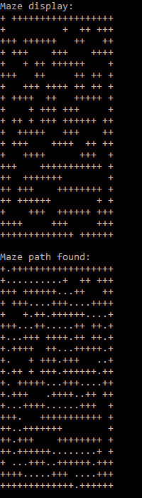

Forth run (Finding the path for a maze with 22 rows and 76 columns):

