Marawan El Sharkawi

CSCI 301-Section 1

#cs301175

Project 3

**User Document**

Recursion is a technique in programming which allows a function to call itself. It is one of the ways to make repeated computations. A recursive function passes a smaller version of the problem to a new function of itself then it uses the results returned from all the functions it has called to determine the solution of the main problem. This program reads a maze from a file displays it then find paths from its start to its end using recursion.

The program creates an ifstream variable for the file the user will input, two integer variables one to hold the number of the rows of the maze and the other to hold the number of columns of the maze, and a maze two-dimensional array. The program then calls the openFile() function and passes the ifstream variable as its parameters then calls readFile() function and passes the ifstream variable, the maze variable and the two integer variables as its parameters. Next, the program closes the file contains the maze after the readFile() function is done with its work, after that it calls display() function and passes the maze variable and the two integer variables as its parameters. The final step is to assign the dimension of the start position of the maze through the two-dimensional array then to call the pathFinder() function which will find the paths through the maze and print out the maze with the paths found.

The program name is main.cpp; to compile and link it, simply enter:

g++ main.cpp

then enter: a.out

The program will run automatically, then respond to the program prompts to enter the name of the file contains the maze then press enter.

For example, if the file contain the maze called maze.txt, the following exchange will run the program on this file:

Enter the name of the file which contains the maze: maze.txt

The program will automatically read the content of the file and display it then it will display the maze with the path the program found, the output will be:

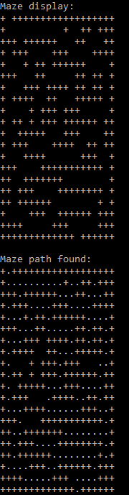

Then the program will terminate.