Marawan El Sharkawi

CSCI 301-Section 1

#cs301175

Project 5

**Test**

**Tests for List program:**

The following script file tests and illustrates the List program. It shows the input processes required by the user, displays the program responds to the various options that user can choose from. There are eleven runs of the program each showing how the program behaves regards user input.

First run (If the user wrote an option not from the list):

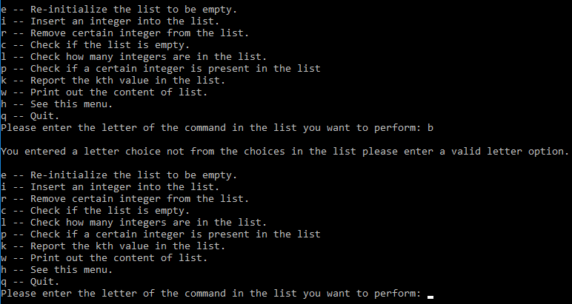

Second run (Re-initialize the list to be empty):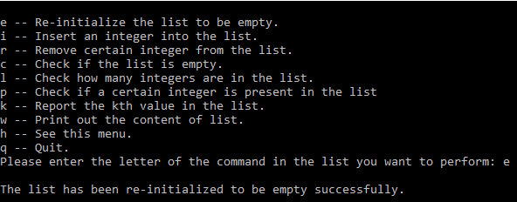

Third run (Insert an integer into the list):

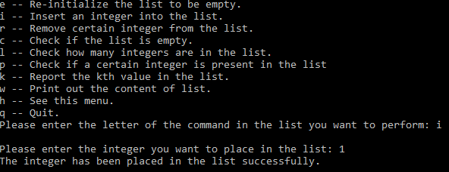

Fourth run (Remove certain integer from the list):

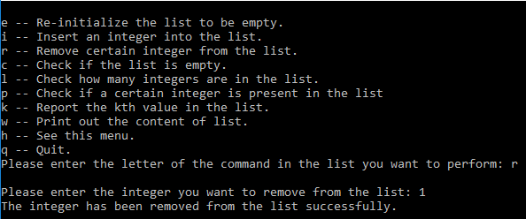

Fifth run (Check if the list is empty):

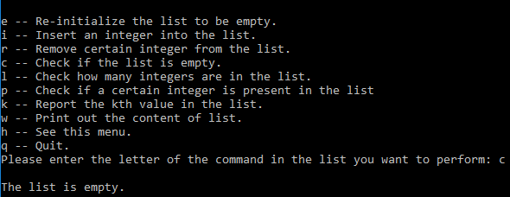

Sixth run (Check how many integers are in the list):

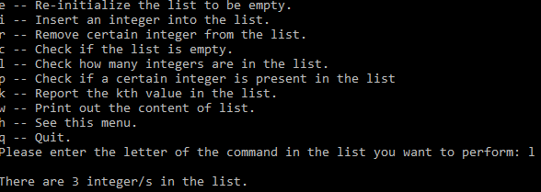

Seventh run (Check if a certain integer is present in the list):

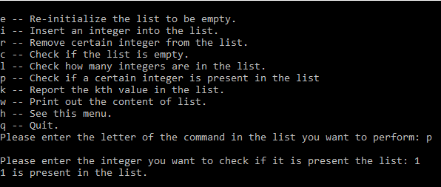

Eighth run (Report the kth value in the list):

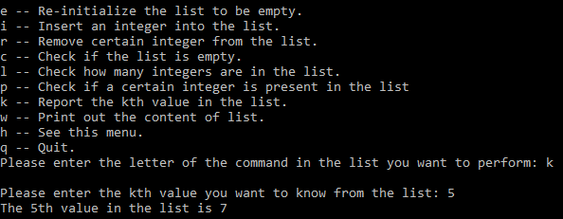

Ninth run (Print out the list):

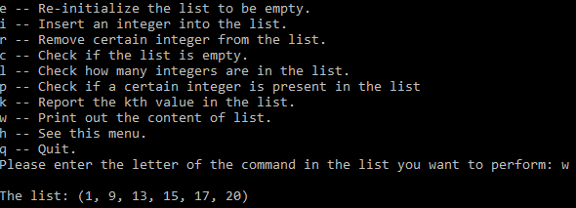

Tenth run (Print out the menu options):

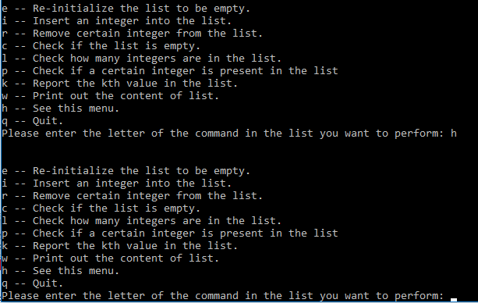

Eleventh run (If the user wrote an option not from the list):

