Web Scraper - Free Web Scraping (Google Extension)

* [Demo](https://www.webscraper.io/web-scraper-first-time-install)

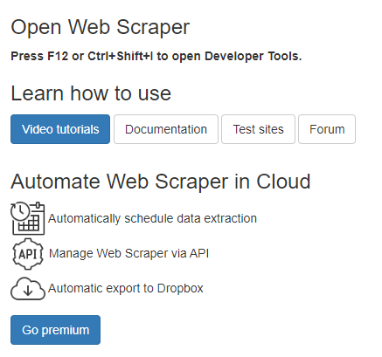

* [Pricing](https://www.webscraper.io/pricing)

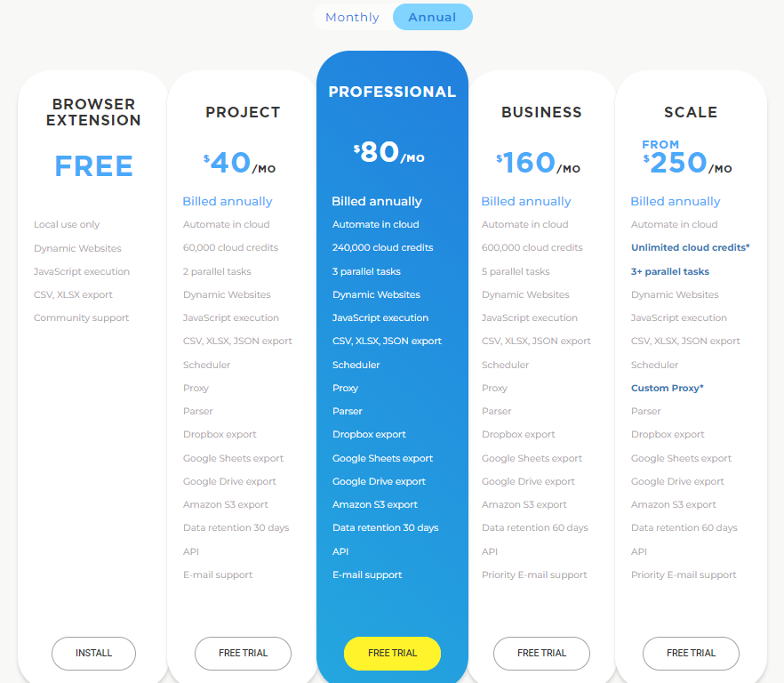

Rapid Miner Application for predictions

* [Demo](https://rapidminer.com/platform/)

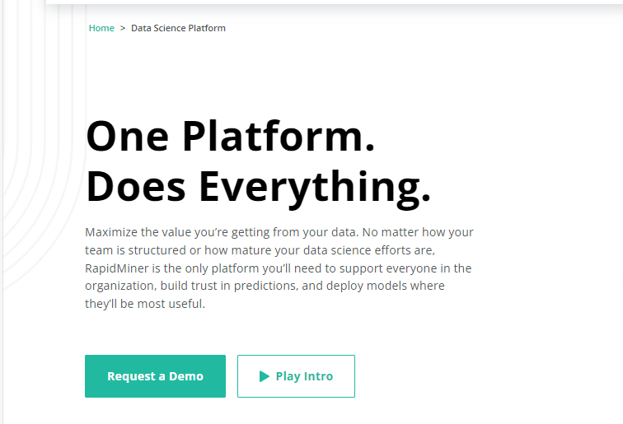

* [Pricing](https://rapidminer.com/pricing/#pricing_request)

