Faculty of Engineering and Technology
Department of Computer and Informatics Engineering

Predictive Modelling of SpaceX Falcon9 First stage
Landing Success

Submitted in partial fulfillment of the requirement of degree of bachelor in Informatics Engineering
BY

Mohammad Marwan Albaroudi

Supervised By

Dr. Nader Bitar

Senior Project I
2025-2026

Abstract:
The abstract is a full summary of all the chapters of the thesis. It includes one or two sentences as introduction. Focus on the problem statements and objectives. Write two or three sentences about theoretical study or analysis and methods or procedures used. Write two or three sentences about implementation. Finally, write about experiments, results and findings. This section will include a short description of the results of your study. In other words, what did you learn through your research?

Table of Contents
Abstract: 2
List of figures: 4
List of tables: 5
Table of Abbreviations 6
Acknowledgement: 7
Chapter 1 Introduction 8
1.1 Background: 8
1.2 Problem Statement: 9
1.3 Objectives 9
Chapter 2 Methodology (OR) Theoretical study / analysis 10
2.1 Introduction 10
2.2 Prototype Components / System phases or subsystems 10
2.2.1 Component AAA 10
2.2.2 Component AAA vs Component BBB 11
2.2.4 The speech recognition system 16
2.2.4.1 Android 16
2.3 Conclusion 17
Chapter 3 Implementation, Testing and Results 17
3.1 Processing steps 19
3.1.1 Procedure 19
3.2 TESTING 22
Chapter 4 Conclusion 23
4.3 Future Scope 23
Appendix – Code 24
References 25
شكر : 27
الملخص: 28

List of figures:
Figure 1 Alignment 8
Figure 2 basic block diagram 10
Figure 3 Arduino Uno 12
Figure 4 LilyPad Arduino 12
Figure 5 RedBoard 12
Figure 6 Bluetooth module 14
Figure 7 HC-06 15
Figure 8 architecture 17
Figure 9 robot car in front 18
Figure 10 robot car from beside 18
Figure 11 Schema 18
Figure 12 BLOCKDIAGRAM 19
Figure 13 FlowChart 21

List of tables:
Table 1 Arduino vs Raspberry PI 12
Table 2 Comparing between different Arduino microcontrollers [6] 13
Table 3 HC-06 Pin Configuration 15
Table 4 Testing result 22

Table of Abbreviations
CPU | Central Processing Unit
APP | Application
AI | Artificial Intelligence
MCU | Micro Controller
OTP | One Time Programmable
OTPROM | One Time Programmable Read Only Memory
RAM | Random-Access Memory
DSP | Digital Signal Processor
USB | Universal Serial Bus
OS | Operating System
TTL | Transistor Transistor Logic
SPP | Serial Port Profile
HTC | High Tech Computer
AMR | Android Meets Robots
AVR | Audio/Video Receiver
Wi-Fi | Wireless Fidelity
GPS | Global Positioning System
LED | Light Emitting Diode
ICSP | In Circuit Serial Program
EEPROM | Electrically Erasable Programmable Read Only Memory
SRAM | Static Random-Access Memory
SR | Speech Recognition
ASR | Automatic Speech Recognition
STT | Speech to Text
WER | Word Error Rate
SWER | Single Word Error Rate
CSR | Command Success Rate
PLP | Perceptual Linear Prediction
LPC | Linear Predictive Coding
HMM | Hidden Markov Model
DTW | Dynamic Time Warping
ANN | Artificial Neural Networks
FFNN | Feed-Forward Neural Network
RNN | Recurrent Neural Network
BP | Back Propagation
FHSS | Frequency Hopping Spread Spectrum
VCC | Voltage Common Collector
GND | Ground

Acknowledgement:
I would like to take this opportunity to express my sincere gratitude towards…
.

Chapter 1 Introduction

1.1 Background:
Highlight the importance and background of the project

Important: All text must be aligned as justified


Figure 1 Alignment

1.2 Problem Statement:
Why you do this project. What are the problems it solves? What are the requirement or needs for it?

1.3 Objectives
To achieve the main target of the project, the following objectives are considered:
- Steps of solving the problem

Chapter 2 Methodology (OR) Theoretical study and design (OR) System analysis

2.1 Introduction

Figure 1 shows a basic block diagram of the system: The proposed system does so and so ….. Here in this part you give an overview of the proposed systems. In the next sections you describe the details and options / alternative of each block. You highlight your choices and justify why you choose them

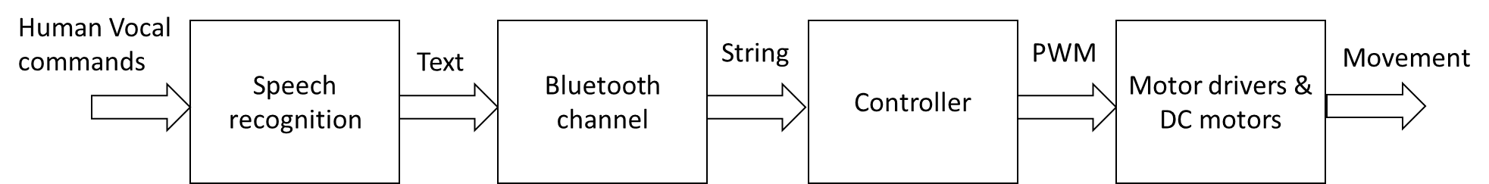
Figure 2 basic block diagram

2.2 Prototype Components / System phases or subsystems

2.2.1 Component AAA
Example 1: If you are building a robot, write about microcontroller types and alternative options [1]: For example:
There are different types of microcontrollers and from different companies. The list includes PIC family, Atmega family, ARM family and many others, n this project ATMega328 is used because its specification is quite enough for the needed specifications of the system. Is a high-performance Atmel 8-bit AVR RISC-based microcontroller combines 32KB ISP flash memory with read-while-write capabilities, 1KB EEPROM, 2KB SRAM, 23 general purpose I/O lines, 32 general purpose working registers, three flexible timer/counters with compare modes, internal and external interrupts, serial programmable USART, a byte-oriented 2-wire serial interface, SPI serial port, 6-channel 10-bit A/D converter (8-channels in TQFP and QFN/MLF packages), programmable watchdog timer with internal oscillator, and five software selectable power saving modes. The device operates between 1.8-5.5 volts [2].
The ATMega328 is relatively cheap and it is very popular in market because it is the chip used in Arduino Uno development boards..
Microcontrollers are usualy used as a part of complete platforms. Platforms like Arduino, Raspberry pi are quite popular platform for prototyping. In the next section we discuss the advantages and disadvantages of both platforms,

Example 2: If you design a hotel booking system write about mobile application and different operating systems for example. Different programming languages or designing platform.
For example:
Mobile applications (Apps) were originally intended for productivity assistance such as email, calendar, and contact databases, but the public demand for apps caused rapid expansion into other areas such as mobile games, factory automation, GPS and location-based services, order-tracking, and ticket purchases, so that there are now millions of apps available. Many apps require Internet access. Apps are generally downloaded from app stores, which are a type of digital distribution platforms. the term "app", short for "software application", has since become very popular; in 2010, it was listed as "Word of the Year" by the American Dialect Society.
Apps are broadly classified into three types: native apps, hybrid apps and web apps. Native applications are designed specifically for a mobile operating system, typically IOS or Android. Web apps are written in HTML5 or CSS and typically run through a browser. Hybrid apps are built using web technologies such as JavaScript, CSS, and HTML5 and function like web apps disguised in a native container. This project can be implemented using a Native application or web application. In the next section we discuss the advantages and disadvantages of both types,…..

2.2.2 Component AAA vs Component BBB
Raspberry Pi and Arduino are quite different boards. Each board has its own advantages and disadvantages. [3].
Table 1 highlights some main differences between…...
Table 1 Arduino vs Raspberry PI
SL | Raspberry Pi | Arduino
1
2
3

Don’t for get to add references when you get information about your choices [4]
Don’t give a lot of information about devices like arduino because we all know what is arduino. If we need details we can search the net so just focus on main properties that make you choose this device or that…. [5]
When you put a figure you should explain about it in your manuscript. For example you mention: As we see in Figure 3 and Figure 4there are two main types of …..
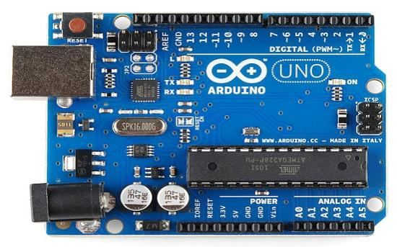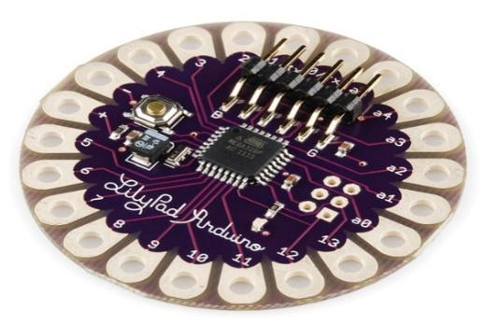
Figure 3 Arduino Uno
Figure 4 LilyPad Arduino

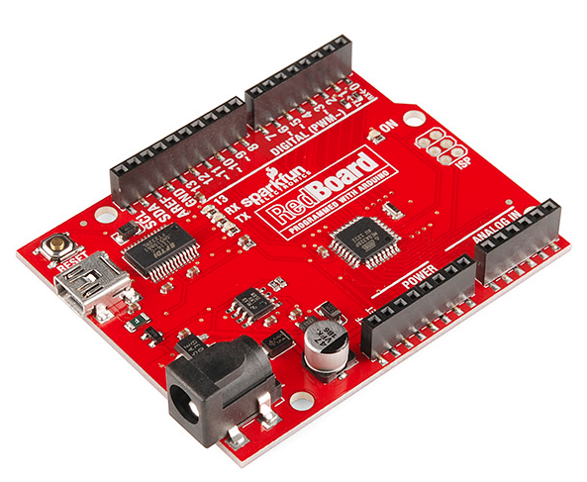
Figure 5 RedBoard

As we have mentioned before the Arduino family is big; and having lots of options to choose from, we had to make a little research, so that we understand each one and their features. Table 2 briefly mentions the common types of Arduinos and their features.

Table 2 Comparing between different Arduino microcontrollers [6]
Arduino Name | Main Features
Arduino Uno | Easy to use 14 digital I/O, 6 analog inputs, USB connection (which can power it), dedicated power jack, a reset button. Can be powered with AC-to-DC adapter or a battery.
Arduino Mega (Uno’s big brother) | 54 digital I/O, 16 analog inputs. Same features as the Arduino Uno
Lilypad | Washable & smooth back allow it to be sewed onto clothes. Huge connecting pads.
RedBoard | Uses Mini-B cable, stable due to USB or FTDI, flat back which allow it to b easily installed onto projects. 16 digital I/O pins, 6 analog inputs

Although the RedBoard is more stable and has more pins than the Uno, but the Arduino Uno is much simpler and compact. It is cheaper and sufficiently meets the uses we are aiming for.

2.2.3 Module XXX / Package / library
To transfer data from the mobile phone to the arduino, a Bluetooth module is needed. A Bluetooth module is usually a hardware component that provides a wireless product to work with the computer; …….. .
Figure 14 shows the model of used Bluetooth module,
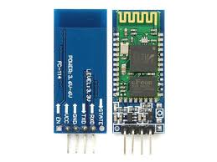
Figure 6 Bluetooth module
These small size Bluetooth TTL transceiver modules are designed for serial communication (SPP - serial port profile). It allows your target device to both send or receive TTL data via Bluetooth technology without connecting a serial cable to your computer. The modules with the HC-03 and HC-05 firmware are the Master and Slave integrated Bluetooth serial modules with firmware which allows you to modify master and slave mode at any time. HC-03 is industrial grade products, HC-05 are commercial grade products [7].
The modules with the HC-04 and HC-06 firmware are the modules which are factory set to be Master or Slave modules. Master and slave mode cannot be switched from the factory setting. HC-04 is an industrial grade product; HC-06 is a commercial grade product. The modules with the HC-09 firmware are replacements for the HC-06 and HC-07 modules [8].

2.2.3.1 Bluetooth module HC-06
HM-06 is a Bluetooth module designed for establishing short range wireless data communication between two microcontrollers or systems. The module works on Bluetooth 2.0 communication protocol and it can only act as a slave device. This is cheapest method for wireless data transmission and more flexible compared to other methods and it even can transmit files at speed up to 2.1Mb/s.
HC-06 uses frequency hopping spread spectrum technique (FHSS) to avoid interference with other devices and to have full duplex transmission. The device works on the frequency range from 2.402 GHz to 2.480GHz [9].


Figure 7 HC-06

Table 3 HC-06 Pin Configuration
pin | Name | Function
1 | Key | The pin state determines whether the module works in AT command mode or normal mode  [High=AT commands receiving mode(Commands  response mode), Low or NC= Bluetooth module normally working]
2 | VCC | +5V Positive supply needs to be given to this pin for powering the module
3 | GND | Connect to Ground
4 | TXD | Serial data is transmitted by module through this pin (at 9600bps by default), 3.3V logic
5 | RXD | Serial data is received by module through this pin (at 9600bps by default),3.3V logic
6 | State | The pin is connected to the LED on the board to represent the state of the module

HC-06 Features and Electrical characteristics [10].
- Bluetooth protocol: Bluetooth V2.0 protocol standard
- Power Level: Class2(+6dBm)
- Band: 2.40GHz—2.48GHz, ISM Band
- Receiver sensitivity: -85dBm
- USB protocol: USB v1.1/2.0
- Modulation mode: Gauss frequency Shift Keying
- Safety feature: Authentication and encryption
- Operating voltage range:+3.3V to +6V
- Operating temperature range: -20ºC to +55ºC
Operating Current: 40mA

2.2.4 The speech recognition system
To convert the vocal commands to textual order an android mobile phone with suitable applications is used. The specification of the speech recognision system is explained the the following sections.

2.2.4.1 Android
Android is an ………. [11]

2.2.4.2 Android meet robot
It is the android application which ……… [12].

2.2.4.3 Working mechanism
The working mechanism of the robot is based on the information passed from the android mobile phone via Bluetooth …Figure 17 shows…

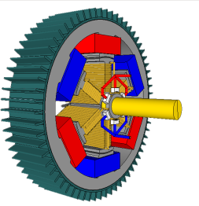
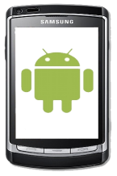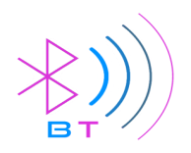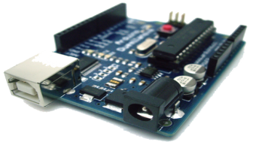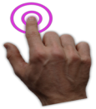
Touch
Android App
Arduino uno 3
DC Motors
Voice
Figure 8 architecture

2.3 Conclusion
Summary of available tools and your choices with reasons.

Chapter 3 Implementation, testing and results

In this chapter the final product after assembling and connecting all the components that have been discussed and mentioned above, is described. Figures 23 shows the built robot car, the schematic and detailed physical block diagram.
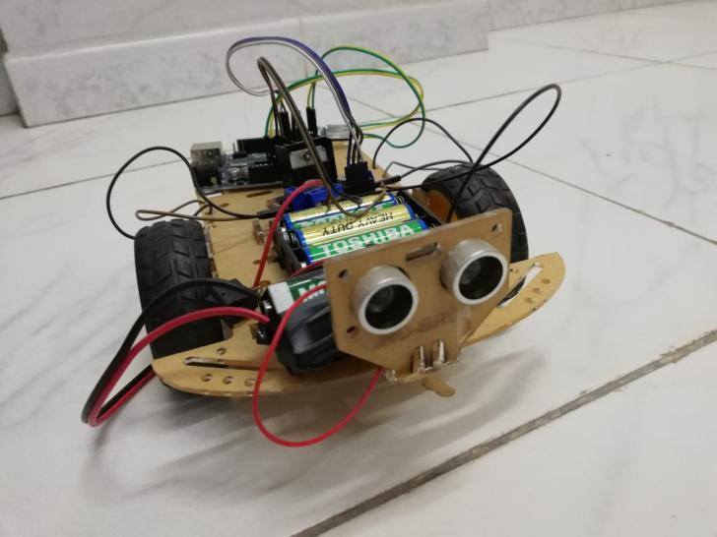
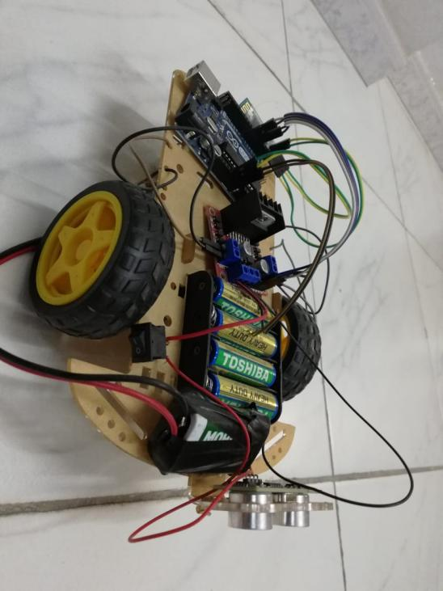

Figure 9 robot car in front

Figure 10 robot car from beside

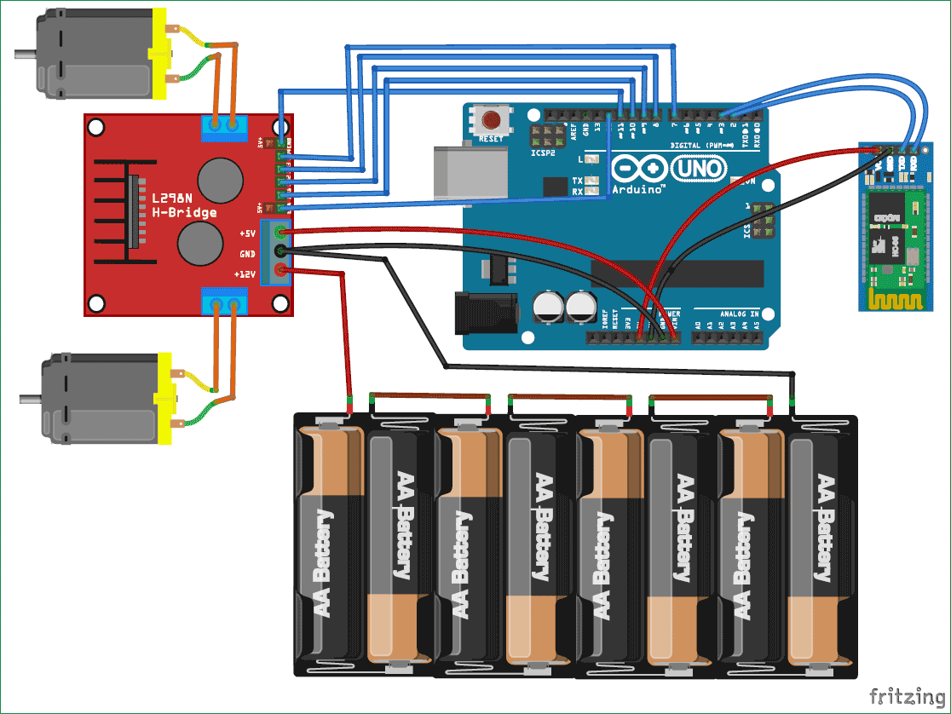
Figure 11 Schema
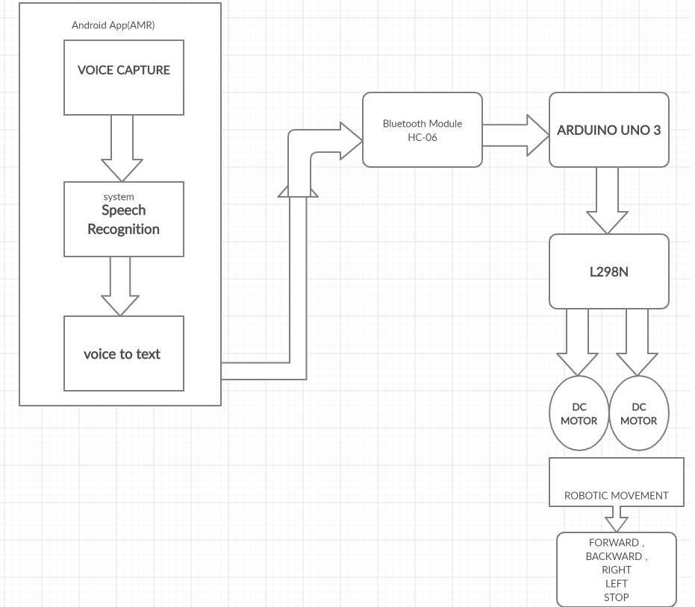
Figure 12 BLOCKDIAGRAM

3.1 Processing steps
As shown in figure 24, the dc motors are connected to to l298n h-bridge, and connected the Bluetooth module hc-06 where the TXD connected to RX in Arduino and RXD to TX in Arduino. And the VCC to 5v and GND to ground. And in1, in2, in3 and in4 in the l298n connected to digital inputs 4, 5, 6 and 7 respectively in the Arduino. And from Arduino vin connected to 5v slot in l298n and GND from Arduino to GND in l298n and connected the positive wire of the battery 9v to 12v slot in l298n and the negative wire to GND in l298n.

3.1.1 Procedure
Here are the steps for how to use android application to control the robotic vehicle.
- Open AMR The Voice
- Check once you get started with the application, the Bluetooth of the mobile is automatically enabled.
- Click on “connect robot” option present in options menu.
- Now select HC-06 to get paired with the module. After pairing it is ready to use.
- Click the Mic Icon to start speaking
- When you speak “Go ahead” your speech gets recognized and converted into text. That text is transferred to robot through Bluetooth HC-06.
- The robot receives the string, decodes it and compares it with the Instructions that are described in the program and moves the robot in forward direction.
- The same in the case for the other commands.
- As per command given from android app, motor is drive in up, down, left, right and stop in this way

The bellow figure shows the flow chart of the procedure steps
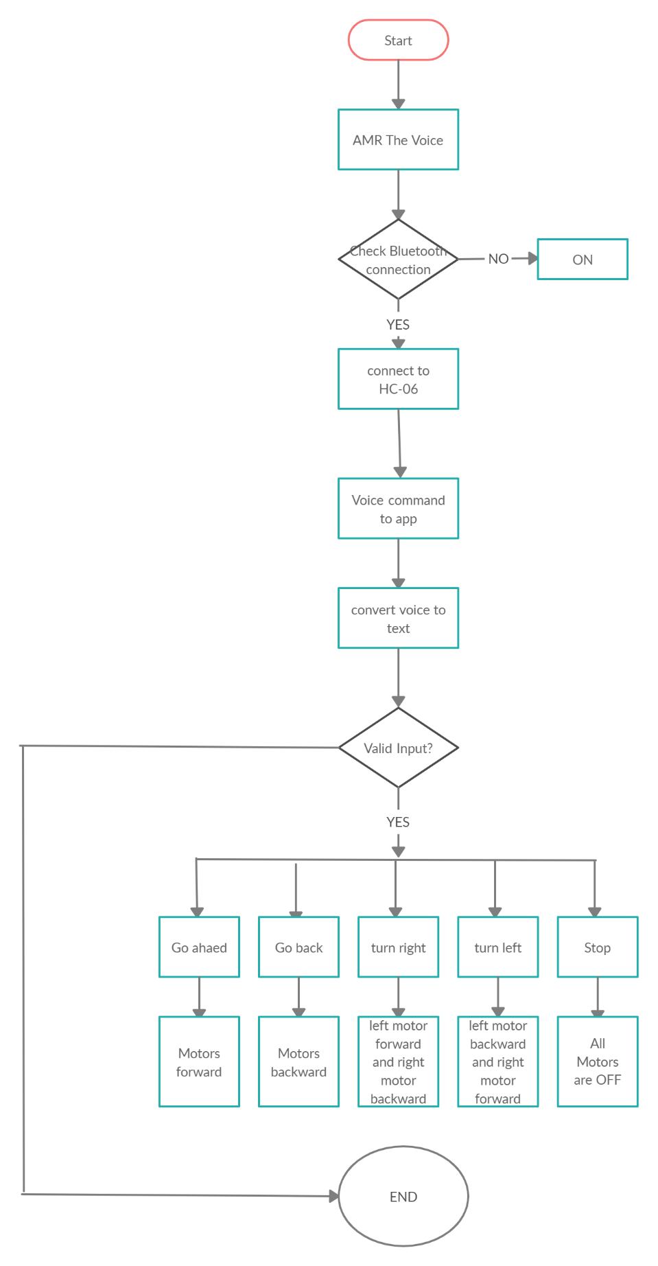
Figure 13 FlowChart

3.2 Testing
From the following commands our robot response is .
Table 4 Testing result
COMMAND | ROBOT MOVEMENT

Add statistics like confusion matrix and calculate recall, precision…

Chapter 4 Conclusion

A highly reliable and easy system to accomplish a purpose design specific task such as distribution of medicine and food to the bed ridden patients specially in infected & inaccessible areas of the hospitals and medical Centre have been reported. The on-board intelligence helps providing situational awareness a basic requirement of the system to be operated by voice / tele confined for ascertaining a majority of other tasks in open loop environment. The operation by voice command could best be used for handicapped.
The outcome of the thesis is a simple robot which is controlled by a smart android phone& also receives the voice commands. This thesis aims to provide simple guidelines for people interested in building robots. As mentioned earlier, the project has been carried out several times and the aim of this thesis is to familiarize the students with fundamentals of Arduino and Android to build anything possible. Although the thesis projects very little about the robot’s use in real world, but with the help of guidelines and the abundance of resources the outcome could be very beneficial for many people in the world. People with physical limitations such as handicapped people could use the feature to their wheel chair from this thesis to compensate their abilities

4.3 Future scope
The purpose of this robot is to help people for transferring goods in a dangers area and to keep in safe during the corona virus COVID-19. So, to do this. I’ll program ultrasonic sensor that keeps the robot in the guidance with avoiding obstacles. And I will develop a mobile application using MIT APP INVENTOR instead of using AMR the Voice.

Appendix – Code

const int LEFTF = 7; // left forward wheel intilize
const int LEFTB = 6; // left backward wheel intilize
const int RIGHTB = 5; // right backward wheel intilize
const int RIGHTF = 4; // right forward wheel intilize
String voice;
void setup() {
Serial.begin(9600); // start the communication with bluetooth
pinMode (LEFTF, OUTPUT);
pinMode (LEFTB, OUTPUT);
pinMode (RIGHTB, OUTPUT);
pinMode (RIGHTF, OUTPUT);
// put your setup code here, to run once:

}

void loop() {

}

References

[1] F. C. P. David Calcutt, 8051 Microcontrollers, 2004.
[2] "https://en.wikipedia.org/wiki/ATmega328," ATMega328, 10 may 2020.
[3] jayant, "arduino vs rasbperry pi," https://circuitdigest.com/article/arduino-vs-raspberryp-pi-difference-between-the-two.
[4] arduino, http://arduino.cc/en/.
[5] Ben, what is Arduino, Sparkfun, learn.sparkfun.com/tutorials/what-is-an-arduino/all#whats-on-the-board.
[6] A. comparison, https://learn.sparkfun.com/tutorials/arduino-comparison-guide/all?print.
[7] hc-05, "https://www.electronicwings.com/sensors-modules/bluetooth-module-hc-05-".
[8] H.-0. HC-04, "http://smarpl.com/content/bluetooth-module-hc04hc06-configuration-tool".
[9] hc-06, "https://components101.com/wireless/hc-06-bluetooth-module-pinout-datasheet".
[10] L. Guangzhou HC Information Technology Co., Bluetooth HC-06 Datasheet.
[11] android, "https://en.wikipedia.org/wiki/Android_(operating_system)#:~:text=Android%20is%20a%20mobile%20operating,such%20as%20smartphones%20and%20tablets.&text=Some%20well%20known%20derivatives%20include,wearables%2C%20both%20developed%20by%20Google.".
[12] a. m. robot, "https://amr-voice.en.aptoide.com/app".
[13] H. Automation, "https://en.wikipedia.org/wiki/Home_automation".
[14] T. S. ,. K. Masato Nishimori, Voice Controlled Intelligent Wheelchair, 17-20 Sept. 2007.
[15] https://learn.sparkfun.com/tutorials/what-is-an-arduino/all, "Arduino".
[16] servomotor, "https://components101.com/servo-motor-basics-pinout-datasheet".
[17] L298n, "https://opencircuit.shop/Product/L298N-motor-driver-module-H-Bridge".
[18] A. family, "https://learn.sparkfun.com/tutorials/what-is-an-arduino/all".
[19] e. a. Wilson, "Servo Motor - Types and Working Principle", Electronics Hub, www.electronicshub.org/servo-motors/., 24 Dec. 2017.
[20] ANN, http://www.jclinepi.com.
[21] A. advantages, http://www.researchgate.net.
[22] http://en.wikipedia.org/wiki/Artificial_neural_network.
[23] J. Tebelskis, Speech Recognition using Neural Networks, May 1995.
[24] S. Recognition, http://en.wikipedia.org/wiki/Speech_recognition..
[25] National Institute of Standards and Technology, The History of Automatic Speech Recognition Evaluation.
[26] L. X. ,. K. C. B. R. Deng Y., ''Continuous Feature Adaptation for Non-Native Speech Recognition, Li X. , Kwan C.,Raj B.,Stern R., ''Continuous Feature Adaptation for Non-Native Speech Recognition'', International Journal of Computer, Information Science and Engineering, No:6, 2007..
[27] SP, http://en.wikipedia.org/wiki/Speech_recognition..
[28] Arduino, arduino software http://arduino.cc/en/Main/Software.
[29] "ANN," http://en.wikipedia.org/wiki/Artificial_neural_network.

شكر :
أود أن أعبر من خلال هذه الفرصة عن امتناني الصادق....

الملخص:
نكتب هنا ملخص عن كل فصول الاطروحة جملة أو جملتين مقدمة مع تلخيص المشكلة وأهداف المشروع، جملتين أو ثلاثة عن الفكرة النظرية والأدوات المستخدمة، جمليتين أو ثلاثة عن التنفيذ، جملة أو جملتين عن التجريب والنتائج.

كلية الهندسة والتكنلولوجيا
قسم هندسة الحاسوب و المعلوماتية

"توقع نجاح هبوط صاروخ Falcon9 الخاص ب SpaceX"

قُدِّم هذا المشروع كجزء من متطلبات نيل شهادة البكالوريوس في الهندسة المعلوماتية

اعداد
محمد مروان أيمن البارودي

بإشراف
د.نادر بيطار

مشروع التخرج الأول
2025-2026

