
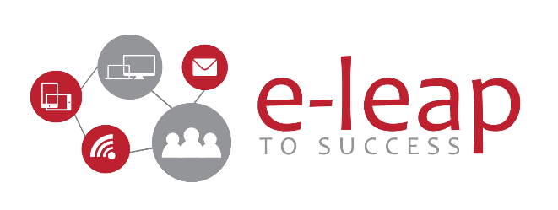

E-Learning Program

Employee Induction E-Learning Program

- Six interactive SCORM courses: HSE · HR · Operations & My Care · RCM · Quality · IT (EHR)

Presented To

Human Capital Department
Learning & Development

My Clinic (عيادتي)
Jeddah, Kingdom of Saudi Arabia

Proposal date: 14-10-2026
Proposal Ref# e2026-MC01 Rev.01

Revision Sheet

REVISION NUMBER | DATE OF REVISION | REVISION DESCRIPTION
00 | 14-10-2026 | Initial proposal
01 | 14-10-2026 | Narration updated to ~60 min from the finished scripts; RCM scenario count 4 (total 26); two guide characters (Noor and Dr. Omar) and two narration voices added; full draft storyboards now prepared

Non-Disclosure & Confidentiality Agreement

This document contains proprietary and confidential information. All data submitted to MY CLINIC is provided in reliance upon its consent not to use or disclose any information contained herein except in the context of its business dealings with LEAP TO SUCCESS. The recipient of this document agrees to inform its present and future employees and partners who view or have access to the document's content of its confidential nature.

The recipient agrees to instruct each employee that they must not disclose any information concerning this document to others except to the extent that such matter are generally known to, and are available for use by, the public. The recipient also agrees not to duplicate or distribute or permit others to duplicate or distribute any material contained herein without LEAP TO SUCCESS express written consent.

LEAP TO SUCCESS retains all title, ownership and intellectual property rights to the material and trademarks contained herein, including all supporting documentation, files, marketing material, and multimedia.

*****BY RECEIPT OF THIS DOCUMENT, THE RECIPIENT AGREES TO BE BOUND BY THE AFOREMENTIONED STATEMENT******

Table of Contents
Revision Sheet 2
Non-Disclosure & Confidentiality Agreement 3
About Leap to Success™ 5
Contact Information 5
Executive Summary 8
Needs 8
Our Approach: What L2S Will Do 9
Work Already Completed (Discovery) 9
Course Catalogue 11
Course 1 — Health, Safety & Environment (HSE) 12
Course 2 — Welcome On Board: HR Essentials 14
Course 3 — Who Does What: Operations & My Care 16
Course 4 — RCM: Documentation, Coding & EBP Benefits 17
Course 5 — Clinical Governance: Quality, Patient Safety & Risk 19
Course 6 — IT: EHR Consultation Workflow 21
Deliverables 23
Scope of Work 23
Project Phases 25
Production Volume by Course 25
Roles and Responsibilities 26
Assumptions 26
Investment 28
Terms of Payment 28
Proposal Validity 29
Deployment Start 29
Approval 30

About Leap to Success™

Leap To Success™ is a consulting, learning, and development company established in 2012 located in Dubai, United Arab Emirates delivering its services all over the Gulf region. The name of our company describes how we work with our customers, we work collaboratively with our customers to help them make the LEAP towards success and growth.
Unlike the conventional way, we deliver our services by considering customers’ tailored needs and specific long-term strategic goals in the delivery process, and not only the requirements of a job description.
Leap To Success™ focuses on providing high-quality learning services by ensuring that our experts carry comprehensive consultations with our customers in order to guarantee that the training and content meet the requirements.

Contact Information

LEAP TO SUCCESS FZ LLC

Level 14, Boulevard Plaza Tower 1
Emaar Boulevard PO Box 5000012
Dubai, United Arab Emirates

+971.4.368.0915 (Fixed Line)
+971.4.455.8556 (Fax Line)
info@l2s.net (Email)

www.l2s.net

Some of Our Success Partners
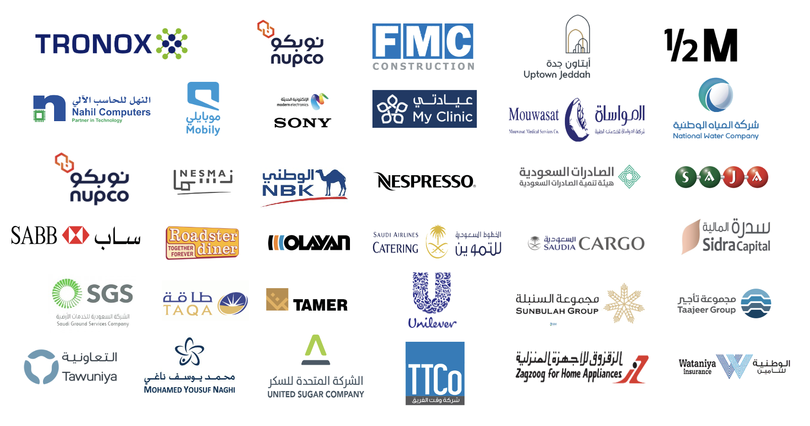
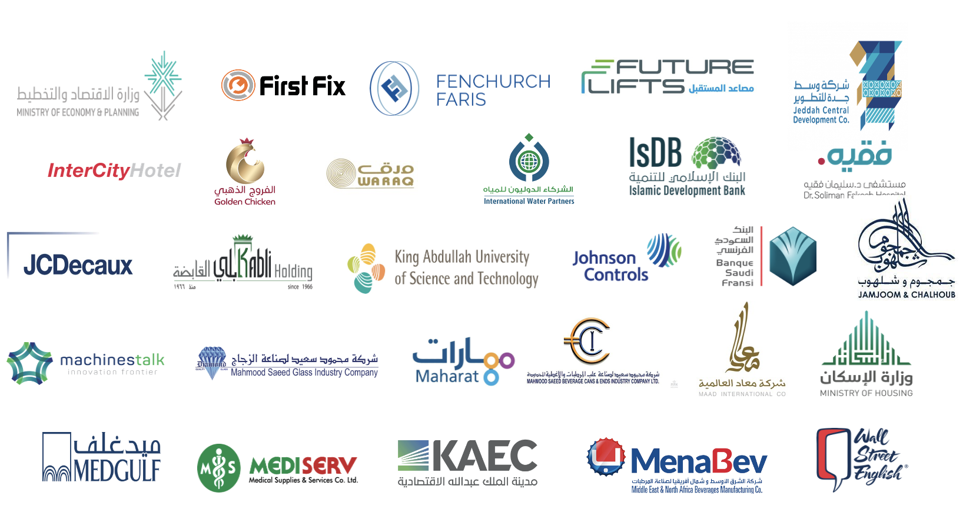

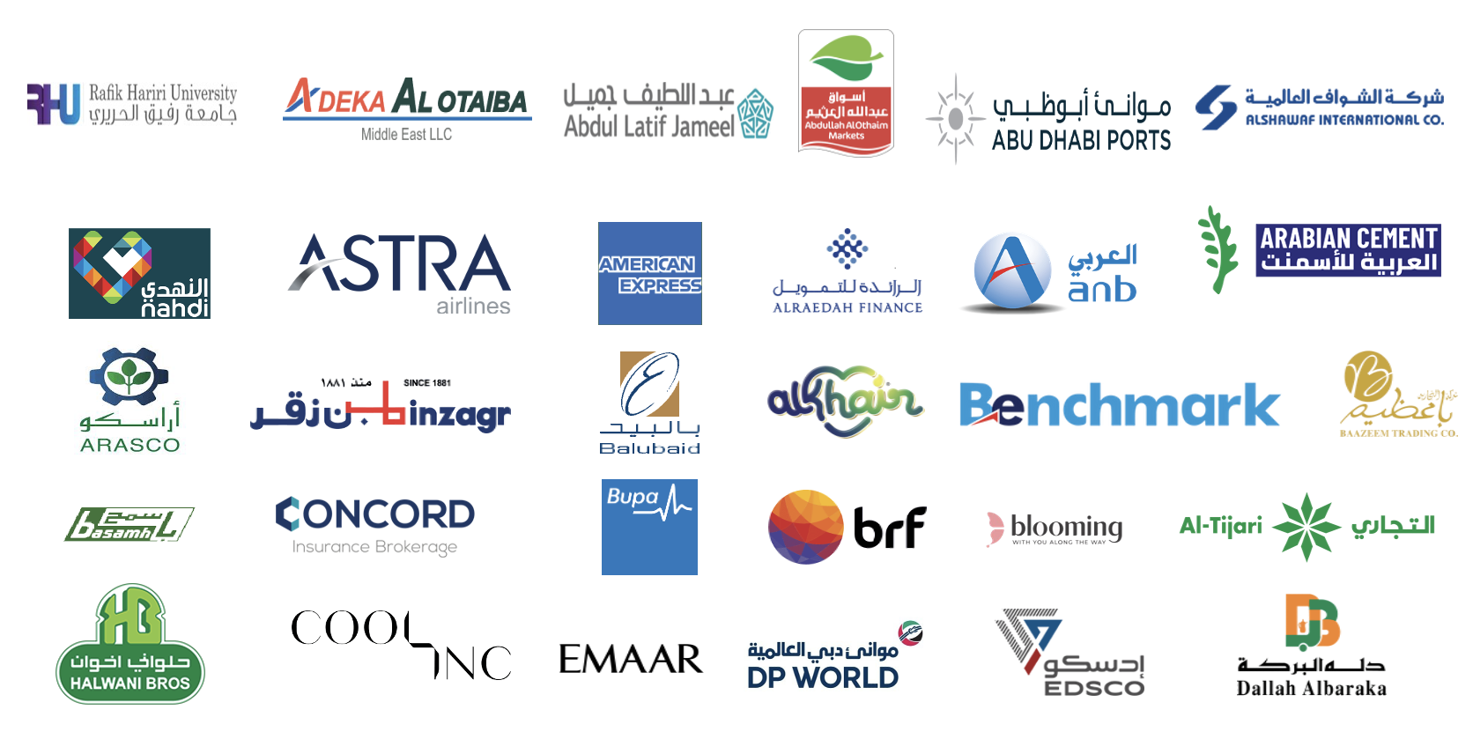

Executive Summary
MY CLINIC (عيادتي) currently delivers its new-employee induction as a full-day classroom programme supported by slide decks, PDF manuals, a speaker script and two recorded videos. MY CLINIC has asked L2S to turn this material into interactive e-learning courses that every new employee can complete online, at their own pace, with progress and results tracked in the Learning Management System (LMS).
Before writing this proposal, L2S reviewed every file in MY CLINIC's induction folder: two Health & Safety manuals (96 pages), three PowerPoint decks (82 slides), one Word speaker script and two videos (17.5 minutes, reviewed through more than 200 screenshots). For each course we have already prepared a phased production plan with learning objectives, a full screen-by-screen draft storyboard (all 207 screens), a narration script, an asset list, build settings and test cases. This proposal is based on that analysis, so the scope, effort and price below reflect the real content, not an estimate.
L2S proposes to design, develop, test and deliver six bespoke induction courses:
- Health, Safety & Environment (HSE) — ~90 min of learner time
- Welcome On Board: HR Essentials — ~45 min of learner time
- Who Does What: Operations & My Care — ~15 min of learner time
- RCM: Documentation, Coding & EBP Benefits — ~45 min of learner time
- Clinical Governance: Quality, Patient Safety & Risk — ~25 min of learner time
- IT: EHR Consultation Workflow — ~25 min of learner time
Together, the six courses contain about 207 interactive screens, 95 scored activities, 26 scenarios, games and guided simulations, about 60 minutes of professional narration in two voices and close to 4 hours of learner seat time. Each course is priced at USD 1,500, for a total investment of USD 9,000.

Needs
L2S understands the needs of MY CLINIC to be:
- Replace a full day of classroom induction with self-paced online courses that new staff can complete in their first week, at any branch and from any device.
- Give every branch the same, accurate message on safety, HR policy, patient safety, documentation and systems.
- Prove competence, not just attendance: scored practice, pass marks and per-objective results that support CBAHI survey readiness.
- Turn passive slides and videos into realistic practice: fire and spill emergencies, patient identification, leave requests, claim documentation and the EHR consultation workflow.
- Keep sensitive data out of training: no patient identifiers, anonymised claim data and role-based (not name-based) organisation charts.
- Make the courses easy to update when policies, codes or systems change.

Our Approach: What L2S Will Do
L2S will act as the instructional design and development partner for the whole programme. We will lead every phase, from source analysis to LMS launch, and work with MY CLINIC's subject-matter experts (SMEs) at defined review points. Our approach is built on the following principles:
- Action Mapping. We start from what staff must do on the job (announce the right emergency code, identify a patient with two identifiers, code a specific diagnosis, complete a consultation in the EHR) and build every activity around those actions. Content that does not support an action becomes a reference job aid, not a slide.
- Scenario-based, hands-on practice. Learners make decisions and see the consequences: a Code Red drill, a spill triage, a “leave desk” of colleagues' requests, a claim to rework, a step-by-step EHR simulation on a test patient.
- One idea per screen. Clean, minimalist screens in the MY CLINIC brand. Key words on screen; the explanation is in the narration.
- Professional narration with captions. Every narrated screen has captions and a transcript.
- Two guide characters. Noor, a senior nurse, and Dr. Omar, a family physician, guide learners through every course: they welcome, give tips, host the scenarios and close each module, with one consistent voice each across the whole programme.
- Accessibility. Designed to WCAG 2.2 AA: keyboard operable, alt text on every meaningful image, colour never the only cue (important for emergency codes, NFPA diamonds and risk matrices).
- Standards and tracking. SCORM 1.2 or SCORM 2004 packages with completion, score, objective-level and question-level reporting, tested in SCORM Cloud and in MY CLINIC's LMS.
- Quality gates at every stage. Automated validation of storyboards, narration and packages, plus SME approval before any media is produced.
- Privacy by design. No real patient data, staff data or claim numbers. EHR and Oracle screens are re-captured on test accounts.

Work Already Completed (Discovery)
The following source analysis is complete and is included in this proposal at no extra cost to MY CLINIC:
Source file | Size | What L2S extracted
Health & Safety 1.pdf | 65 pages, 9 modules | Full text and every page reviewed; 9 FMS plans, 11 emergency codes, RACE/PASS, hazmat, radiation and laser content mapped to activities
Health & Safety 2.pdf | 31 pages, mostly visual | Every page reviewed; hazard picture, bilingual code poster, evacuation tools, spill kits and chemical register turned into practice activities
HR.pptx | 62 slides | All text and images; values, 7C strategy, ethics, patients' rights, leave, GOSI, overtime, Oracle, Qiwa and Mumaris content
Operations & My Care Structure.pptx | 6 slides | Activities and org charts; plan to teach roles and routing, not names
RCM script (.docx) | 16 sections | Documentation, ICD-10, defensive medicine and rejection-cause content
RCM 2026 deck (.pptx) | 14 slides | New EBP added and amended benefits; rejection log (to be anonymised)
Quality, Safety & Risk video | 8 min 56 s, narrated | 107 screenshots, 10-second narration log; five-part content rebuilt as interactive screens
IT video | 8 min 38 s, silent | 104 screenshots, on-screen text log; workflow mapped into 7 guided simulations

During this review L2S also logged 80 course-level questions and 14 programme-level decisions for MY CLINIC's SMEs, for example the Code Orange spill threshold (the two Health & Safety files disagree), the real emergency extensions (the slides show a placeholder), branch names, the regulator's name (CCHI vs CHI) and several HR policy figures. These are resolved in Phase 0 so that every fact in the courses is correct.
L2S also found that about one minute of the IT video shows a real patient's record and contact details. That video will not be used. The EHR course will be built on new screenshots of a test patient, and L2S recommends MY CLINIC restricts sharing of the original file.

Course Catalogue
Summary of the six courses (all figures are planned, based on the completed source analysis):
# | Course | Built from | Audience | Seat time | Screens | Scored activities | Price (USD)
1 | Health, Safety & Environment (HSE) | H&S 1 (65 pp) + H&S 2 (31 pp) | All new staff | ~90 min | 80 | 37 | 1,500
2 | Welcome On Board: HR Essentials | HR deck (62 slides) | All new employees | ~45 min | 36 | 15 | 1,500
3 | Who Does What: Operations & My Care | Operations deck (6 slides) | Front-line, PX & clinical staff | ~15 min | 13 | 4 | 1,500
4 | RCM: Documentation, Coding & EBP Benefits | RCM script + RCM 2026 deck (14 slides) | Physicians, dentists, RCM staff | ~45 min | 36 | 17 | 1,500
5 | Clinical Governance: Quality, Patient Safety & Risk | Quality video (8 min 56 s) | All clinical staff | ~25 min | 22 | 11 | 1,500
6 | IT: EHR Consultation Workflow | IT video (8 min 38 s, silent) | Physicians & clinical staff | ~25 min | 20 | 11 | 1,500
 | Total | 8 source files |  | ~4 hours | 207 | 95 | 9,000

Course 1 — Health, Safety & Environment (HSE)
Item | Details
Format | Two SCORM packages: Part 1 “Facility Management & Safety” (knowledge, ~55 min) and Part 2 “Safety in Practice Lab” (hands-on practice, ~35 min)
Audience | All new staff, clinical and non-clinical, in their first week
Source | Health & Safety 1.pdf (65 pages, aligned to CBAHI, MOH codes and ISO 45001) and Health & Safety 2.pdf (31 pages)
Pass mark | 80%, completion = all screens viewed and pass mark reached
Price | USD 1,500

Learning objectives — on completion, learners will be able to:
- Name the eight CBAHI Facility Management & Safety plans and what each one protects.
- Apply the AREC cycle and the hierarchy of controls to a workplace hazard, and estimate risk as likelihood × impact.
- Match each MOH emergency code to its meaning and follow the common response pattern.
- Respond to a fire using RACE and PASS, choosing the correct extinguisher, evacuation type and evacuation tool.
- Read GHS pictograms, the NFPA diamond and the department chemical register; decide on Code Orange; use the spill kit; segregate waste.
- Apply security, utility and biomedical equipment rules (ID, visitors, emergency sockets, out-of-service tagging).
- Stay safe near radiation and lasers using ALARA, dose-limit bands and laser classes.
Course structure:
- Part 1: Welcome · The eight FMS plans · Occupational Health & Safety · Emergency codes · Fire safety · Hazardous materials & waste · Security · Utilities · Medical equipment · Radiation & laser · Capstone & completion checklist
- Part 2: Spot the hazard · Code Red drill · Evacuation · Extinguishers · Spills · Labels & chemical register · Hospital regulations
Key interactive activities:
- Explore the eight plans, the fire equipment in a clinic corridor and a treatment room's utilities (clickable illustrations).
- Sort RACE, PASS, the hierarchy of controls and the spill-kit procedure into the right order.
- Decision scenarios: a trailing cable in a waiting area, a night-shift fire, three spills, an overdue infusion pump.
- “Code Red drill” branching game: rescue, the alarm call script, contain, extinguish or evacuate, evacuation chair, assembly point.
- Store-room hazard hunt with six hidden hazards, then a risk-scoring exercise.
- Drag-and-drop: extinguisher classes, evacuation tools, waste bins, allowed vs prohibited items.
- “Chemical store lockout” escape room using the NFPA diamond, the chemical register, eyewash time and the Code Orange rule.
- Capstone game “One shift, three plans” that combines fire, hazmat and biomedical decisions.
Assessment and tracking:
37 scored activities feed a results breakdown by objective, so each learner and the Safety & Security Manager can see which plan needs another look. Question-level results are reported to the LMS.
Course-specific deliverables:
- 2 SCORM packages
- Bilingual (English/Arabic) emergency-code flashcards
- Completion checklist (evacuation route, assembly point, nearest eyewash, safety liaison, acknowledgement)
Production volume:
≈80 screens · 37 scored activities · 8 scenarios, games and escape rooms · ≈26 diagrams and illustrations (fire triangle, NFPA diamond, GHS set, floor plan, ALARA, scenario scenes) · ≈23 minutes of narration · 26 course-specific test cases.
Inputs needed from MY CLINIC:
- Confirmed Code Orange threshold and the facility's emergency-code sheet with real extensions
- Waste-bin colours, emergency-socket colour and the Radiation Safety Officer's confirmation of dose bands
- Photos of an eyewash station, spill kits and an extinguisher label; one anonymised chemical register
- Safety & Security Manager, Biomedical Engineering and RSO reviews

Course 2 — Welcome On Board: HR Essentials
Item | Details
Format | One SCORM package (~45 min)
Audience | All new employees, day 1–3; first course in the induction path
Source | HR.pptx (62 slides): company story, values, strategy, ethics, patients' rights and HR policies
Pass mark | 70%
Price | USD 1,500

Learning objectives — on completion, learners will be able to:
- Link MY CLINIC's purpose, four values and 7C strategy to everyday actions in their role.
- Apply the code of ethics and patients' rights and responsibilities to workplace situations.
- Decide whether a leave request is eligible and how many days apply (annual, sick, exam, scientific, Hajj, compassionate, maternity, work injury).
- Calculate a GOSI deduction and an overtime payment.
- Use the right system for each HR task (Oracle, intranet, Qiwa, Mumaris) and submit a leave request in Oracle.
- Apply ID card, dress-code, contract and resignation rules.
Course structure:
- Welcome · Values & strategy · Our clinic (history, branches, leadership, awards) · Ethics & patients' rights · Your leave · Pay & social insurance · Systems & licences · ID, benefits & dress code · Contracts & leaving · Close
Key interactive activities:
- Icebreaker poll and values-in-action matching.
- Ethics decision scenario: a conflict of interest in a supplier evaluation.
- Sort patient rights vs patient responsibilities.
- “The leave desk”: handle four colleagues' leave requests correctly.
- Adaptive practice on leave rules — it gives extra questions only to learners who need them.
- Worked examples then practice for GOSI (e.g. 585 SAR) and overtime calculations.
- Guided Oracle simulation: request annual leave step by step (test account).
- Task-to-system matching and dress-code sorting by role.
Assessment and tracking:
15 scored activities with results by objective. Detailed tables (leave entitlements, GOSI, overtime) move into a downloadable HR Quick Reference, so the course focuses on applying the rules.
Course-specific deliverables:
- 1 SCORM package
- HR Quick Reference PDF (2 pages)
- Link to the onboarding satisfaction survey
Production volume:
≈36 screens · 15 scored activities · 4 scenarios, simulations and adaptive practice · ≈11 visual sets (values and 7C icons, branch map, dress-code illustrations, Oracle screenshots) · ≈12 minutes of narration · 12 course-specific test cases.
Inputs needed from MY CLINIC:
- Confirmation of HR policy figures (sick-leave pay bands, compassionate leave, overtime eligibility, ID penalty, GOSI rates)
- Official branch names and codes; consent for any leadership photos
- An Oracle test account for screenshots
- Head of Human Capital review

Course 3 — Who Does What: Operations & My Care
Item | Details
Format | One SCORM package (~15 min)
Audience | Front-line, patient-experience and clinical staff
Source | Operations & My Care Structure.pptx (6 slides)
Pass mark | 70%
Price | USD 1,500

Learning objectives — on completion, learners will be able to:
- Distinguish the activities owned by Operations from those owned by My Care.
- Route common patient requests to the right team and role, first time.
- Explain the main roles and abbreviations (PXO, coordinators, DMP, CHP, HHC and others).
Course structure:
- The patient journey · Operations · My Care · Practice: right team, first time
Key interactive activities:
- Clickable patient journey showing which team leads at each stage.
- Role-based organisation charts, redrawn without names or headcounts (names stay in the live directory).
- Sort 10 activity cards between Operations and My Care.
- “Who do I call?” scenario with four real-style patient requests.
Assessment and tracking:
4 scored activities with results by objective.
Course-specific deliverables:
- 1 SCORM package
- Two redrawn role-based organisation charts
Production volume:
≈13 screens · 4 scored activities · 1 routing scenario · ≈6 diagrams and scenes · ≈4 minutes of narration · 8 course-specific test cases.
Inputs needed from MY CLINIC:
- Confirmed reporting lines and abbreviations
- Routing rules for the scenario
- Director of Operations and My Care Manager review

Course 4 — RCM: Documentation, Coding & EBP Benefits
Item | Details
Format | Two SCORM packages: Part A “Documentation & ICD-10 Coding That Gets Approved” (~25 min) and Part B “New EBP Benefits & Claim-Rejection Analysis” (~20 min)
Audience | Physicians and dentists; RCM and insurance-approval staff (Part B)
Source | RCM speaker script (.docx) and RCM 2026 slide deck (14 slides)
Pass mark | 80%
Price | USD 1,500

Learning objectives — on completion, learners will be able to:
- Document a complete, medically necessary clinical picture.
- Select a specific, covered ICD-10 code, using a provisional diagnosis when justified.
- Avoid defensive medicine and unjustified early repetition of tests.
- Classify claim rejections by cause and rework a rejected claim correctly.
- Distinguish the benefits added and amended by the new EBP and apply their limits, exclusions and pre-authorisation rules.
Course structure:
- Part A: Why it matters · Documentation strategy · ICD-10 coding · Defensive medicine & ordering · Rejections & coverage · “Fix the note”
- Part B: What changed · Benefits in practice · Reading rejections · Practice & close
Key interactive activities:
- Weak vs strong note side-by-side (same treatment, different claim outcome).
- Sort the full clinical picture; match symptoms to specific supported diagnoses.
- Sort ICD-10 codes the policy does not cover as a primary diagnosis.
- Joint-pain case scenario on initial work-up vs justified full panel.
- “Fix the note” case game with three realistic consultation notes.
- Sort added vs amended EBP benefits; match each benefit to its limit or condition.
- Classify an anonymised, rebuilt rejection log and rework a rejected claim.
- Adaptive “Covered or not?” practice with 15 patient requests.
Assessment and tracking:
17 scored activities with results by objective. The question bank can also be exported in QTI 2.1 format for reuse in other assessment tools.
Course-specific deliverables:
- 2 SCORM packages
- “Clear, strong, defensible” physician desk checklist (PDF)
- One-page EBP benefits summary (PDF)
- QTI 2.1 question-bank export
Production volume:
≈36 screens · 17 scored activities · 4 scenarios, games and adaptive practice · ≈10 visuals and 2 job aids · ≈11 minutes of narration · 16 course-specific test cases.
Inputs needed from MY CLINIC:
- Regulator name (CCHI or CHI) and the policy effective date
- Repeat-test intervals and coverage rules to confirm
- Coding lead sign-off of every ICD-10 code; the official EBP document
- Anonymised rejection examples approved by the Data Protection Officer

Course 5 — Clinical Governance: Quality, Patient Safety & Risk
Item | Details
Format | One SCORM package (~25 min)
Audience | All clinical staff (recommended for all staff)
Source | Quality, Safety and Risk Orientation video (8 min 56 s)
Pass mark | 80%
Price | USD 1,500

Learning objectives — on completion, learners will be able to:
- Classify quality measures as structure, process or outcome, and order the FOCUS-PDCA cycle.
- Apply the six International Patient Safety Goals, including the two-identifier rule.
- Score a risk on the 5×5 matrix and choose a response (reduce, transfer, accept, avoid).
- Distinguish critical incidents, adverse events and near misses within a just, non-punitive culture.
- Report an incident through the correct channel within 24 hours.
Course structure:
- Welcome · The quality standard · Six patient safety goals · Risk management · Incidents · Reporting · Close
Key interactive activities:
- Anonymous “speak up” reflection to open the course.
- Sort quality measures into structure, process and outcome; order FOCUS-PDCA.
- Explore the six safety goals; “Which Mohammed?” patient-identification scenario.
- Match daily practices to the six goals; order the five moments of hand hygiene.
- Risk-matrix worked example, risk scoring and response matching.
- Iceberg classification of six events; end-of-shift near-miss reporting scenario.
Assessment and tracking:
11 scored activities with results by objective. The original video carries a third-party watermark and a machine-transcribed narration, so L2S will rebuild the content with new visuals and new narration based on a corrected transcript and MY CLINIC's policies.
Course-specific deliverables:
- 1 SCORM package
- New narration script based on the corrected transcript
Production volume:
≈22 screens · 11 scored activities · 2 scenarios · ≈8 diagrams and illustrations (quality model, six pillars, wristbands, risk matrix, iceberg) · ≈7 minutes of narration · 9 course-specific test cases.
Inputs needed from MY CLINIC:
- IPSG policy wording, the corporate risk matrix and the incident-reporting policy
- Confirmation of the 24-hour rule and the falls-band colour
- Quality Director and Patient Safety Officer review
- Optional: a 60-second in-house “speak up” clip from the Quality Director

Course 6 — IT: EHR Consultation Workflow
Item | Details
Format | One SCORM package (~25 min) of guided simulations
Audience | Physicians and clinical staff who document consultations in the EHR
Source | IT video (8 min 38 s, silent screen recording) — used only as a workflow reference
Pass mark | 80%
Price | USD 1,500

Learning objectives — on completion, learners will be able to:
- Open a consultation and complete the mandatory fields.
- Add a primary diagnosis using ICD-10 code or name search.
- Place medication, lab and package orders linked to the assessed diagnosis.
- Produce the consultation summary, send education by SMS, and make an internal referral with follow-up.
- Put the complete nine-step consultation workflow in the correct order.
Course structure:
- The workflow · Open & document · Diagnosis · Orders · Summary & education · Referral & finish
Key interactive activities:
- Seven guided click-and-type simulations on a test patient: open the consultation, add the E11 diagnosis, medication order, lab package through the Form Wizard, consultation summary, SMS education, internal referral and follow-up.
- Find the mandatory fields on the consultation form.
- Questions on non-formulary items and why every order must link to a diagnosis (connects to the RCM course).
- Sort the full workflow into order.
Assessment and tracking:
11 scored activities with results by objective. Every step works with sound off: instructions are on screen and each screenshot has alt text.
Course-specific deliverables:
- 1 SCORM package
- EHR consultation quick-reference card (PDF)
Production volume:
≈20 screens · 11 scored activities · 7 guided simulations · ≈35 new screenshots captured on a test patient · ≈5 minutes of narration · 10 course-specific test cases.
Inputs needed from MY CLINIC:
- A test environment, a test patient and a 2-hour screen-capture session with the EHR lead
- EHR version and confirmed button names
- Pharmacy-approved drug examples and the clinical disclaimer
- Data Protection Officer check of every screenshot

Deliverables
- Six interactive e-learning courses in English, delivered as eight SCORM packages (HSE and RCM each have two parts), with a total seat time of about 4 hours.
- For each course:
  - Approved storyboard (screen-by-screen, Word/PDF)
  - Narration script, audio files, captions and transcript
  - Asset pack: diagrams, illustrations and screenshots with editable sources and a rights/provenance record
  - QA report with test results and the signed-off approval record
- Job aids: HR Quick Reference, physician documentation desk checklist, EBP benefits summary, EHR quick-reference card, bilingual emergency-code cards.
- QTI 2.1 export of the scored questions for reuse in other assessment tools.
- LMS upload and testing: L2S will upload the packages to MY CLINIC's LMS (or hand them to the LMS administrator), test launch, scoring, completion and resume, and provide a short administrator guide for assigning courses and pulling reports.
- MY CLINIC LMS administrator will be able to:
  - Assign courses and set the learning time frame
  - Generate completion, score and objective-level reports
  - Monitor the progress of each trainee
- Post-launch support: 30 days of defect fixes after final delivery.

Scope of Work
- Language:
  - English (Arabic version available as an option, quoted separately)
- Target audience:
  - All new employees; RCM and EHR courses target physicians and clinical staff
- Seat time:
  - About 4 hours in total; 15 to 90 minutes per course; learners can pause and resume
- Interactivity:
  - High interactivity: branching scenarios, games, an escape room, guided software simulations, drag-and-drop, sorting, adaptive practice and knowledge checks with feedback
  - Responsive HTML5 (desktop, tablet and mobile browsers); no Flash
- Narration:
  - Professional English narration on narrated screens in two consistent voices (the guides Noor and Dr. Omar), with captions and transcripts
- Standards:
  - SCORM 1.2 or SCORM 2004 (4th edition), chosen to match MY CLINIC's LMS
  - Accessibility designed to WCAG 2.2 AA
- Branding:
  - MY CLINIC brand colours, fonts and logo, in a clean minimalist style
- Reviews:
  - Up to two review rounds at each approval stage (objectives, storyboard, narration and media, built course)

Project Phases
The following table summarises the phases L2S will go through and the points at which L2S and MY CLINIC will work together. All six courses move through the same phases; courses are staggered so that SME reviews are spread out.
Activities | L2S role | MY CLINIC role | Description | Duration
Phase 0 — Kick-off & Source Lock | Yes | Yes | Kick-off meeting; confirm LMS, SCORM version, brand guide and SME owners. Resolve the 80 course questions and 14 programme decisions. Collect photos, test accounts and policy confirmations. | Weeks 1–2
Phase 1 — Action Mapping & Objectives | Yes | Review | Define the business goal, on-the-job actions, learning objectives, assessment map and seat-time budget for each course. | Week 2
Phase 2 — Storyboard & Visual Design | Yes | Review & approve | Write screen-by-screen storyboards (~207 screens), scenario and game scripts with feedback, and question banks. Create the brand theme, visual style and the two guide characters, Noor and Dr. Omar. Automated storyboard checks. | Weeks 3–4
Phase 3 — Narration & Media Production | Yes | Approve voice & visuals | Write narration (~60 min, two voices) and the pronunciation guide; produce voice, captions and transcripts. Produce diagrams and illustrations, capture EHR and Oracle screens on test accounts, and design the job aids. | Weeks 4–6
Phase 4 — Development & Build | Yes | Preview review | Build the 8 SCORM packages; configure scoring, objectives, completion rules and tracking. Run automated course checks and share preview links. | Weeks 5–7
Phase 5 — QA, LMS Testing, Pilot & Delivery | Yes | Yes | Run 81 course-specific test cases plus the common checklist (accuracy, privacy, accessibility, scoring). Test in SCORM Cloud and MY CLINIC's LMS. Pilot with 5–8 new starters, fix issues, final sign-off and handover. | Weeks 7–9

Production Volume by Course
The table shows the amount of work planned in each course:
Course | Screens | Scored activities | Scenarios, games & simulations | Diagrams, images & screens | Narration (min) | Test cases
Health, Safety & Environment (HSE) | 80 | 37 | 8 | 26 | 23 | 26
Welcome On Board: HR Essentials | 36 | 15 | 4 | 11 | 12 | 12
Who Does What: Operations & My Care | 13 | 4 | 1 | 6 | 4 | 8
RCM: Documentation, Coding & EBP Benefits | 36 | 17 | 4 | 10 | 11 | 16
Clinical Governance: Quality, Patient Safety & Risk | 22 | 11 | 2 | 8 | 7 | 9
IT: EHR Consultation Workflow | 20 | 11 | 7 | 35 | 5 | 10
Total | 207 | 95 | 26 | 96 | 62 | 81

Roles and Responsibilities
Role | Responsibility
L2S Project Lead & Instructional Designer | Single point of contact; source analysis, action mapping, objectives, storyboards, scenario scripts, narration scripts; runs every review and the project plan
L2S E-Learning Developer | Builds the SCORM packages, interactions, scoring and tracking; LMS upload and testing
L2S Media Designer | Brand theme, diagrams, illustrations, screenshots, job aids and voice production
L2S QA | Test cases, accessibility checks, SCORM Cloud and LMS testing, pilot support
MY CLINIC Project Sponsor (Human Capital) | Approves scope, coordinates SMEs, signs off each course
MY CLINIC SMEs | Safety & Security Manager, Head of Human Capital, Director of Operations, RCM lead, Quality Director, EHR lead: answer Phase 0 questions and review content within 5 working days
MY CLINIC LMS Administrator & DPO | LMS access and settings; Data Protection Officer checks screenshots and anonymised data

Assumptions
The following assumptions were made when preparing this proposal:
- The courses are built from the eight source files in MY CLINIC's induction folder. New topics (for example Clinical Risk or Infection Control, which appear on the HR agenda but have no source material) are not included.
- MY CLINIC is responsible for the accuracy of policy content; SMEs confirm the open questions in Phase 0 and review each stage within 5 working days.
- Up to two review rounds per approval stage. Changes after a stage is signed off are handled as a change request.
- Narration uses a professional English synthetic voice. A human voice actor, filming or the Arabic version are optional services.
- MY CLINIC provides its brand guide, photos where needed, an Oracle test account and an EHR test environment with a test patient.
- MY CLINIC's LMS supports SCORM 1.2 or SCORM 2004. LMS licences and hosting are not included.
- No real patient, staff or claim data will appear in any course.
- The price is a one-time development fee for use with MY CLINIC employees; there is no per-learner fee for courses hosted on MY CLINIC's LMS.

Investment
We declare this proposal binding and free of errors or omissions. Due diligence has been performed in order to ensure compliance with your requirements and address your practical needs.
LEAP TO SUCCESS FZ LLC offers to provide services in accordance with this Proposal and the cost for completion of this Project is as described in the below summary:
# | Description | Unit | Price USD | Total Price USD
1 | Health, Safety & Environment (HSE) — design, development, narration, testing and LMS delivery | 1 course | 1,500 | 1,500
2 | Welcome On Board: HR Essentials — design, development, narration, testing and LMS delivery | 1 course | 1,500 | 1,500
3 | Who Does What: Operations & My Care — design, development, narration, testing and LMS delivery | 1 course | 1,500 | 1,500
4 | RCM: Documentation, Coding & EBP Benefits — design, development, narration, testing and LMS delivery | 1 course | 1,500 | 1,500
5 | Clinical Governance: Quality, Patient Safety & Risk — design, development, narration, testing and LMS delivery | 1 course | 1,500 | 1,500
6 | IT: EHR Consultation Workflow — design, development, narration, testing and LMS delivery | 1 course | 1,500 | 1,500
 | Total (6 courses) |  |  | USD 9,000

Optional services (not included; quoted on request):
- Arabic version of the courses
- Human voice talent for narration
- A narrated, captioned EHR walkthrough video
- Hosting on the L2S Learning Management System
- Annual content update package (policy, code and system changes)

Terms of Payment
The fees mentioned above are payable as follows:
- 50% upon proposal acceptance
- 30% upon approval of the storyboards (end of Phase 2)
- 20% upon final delivery of the SCORM packages
- The stated amount is exclusive of VAT, Withholding Tax and other duties, taxes, and transfer-related charges which if applicable are payable by MY CLINIC in addition to the stated amount.

Proposal Validity
This proposal shall be valid for 15 days from the date of receipt.

Deployment Start
Leap to Success FZ LLC will hold the kick-off meeting within one (1) week of proposal approval and expects to complete the project in about nine (9) to ten (10) weeks, provided MY CLINIC's SME reviews are returned within five (5) working days.

Approval
MY CLINIC reviewed the proposal Reference# e2026-MC01 dated 14 - October - 2026 and found it in line with their requirements, and therefore below finds approval for the proposal.
In testament therewith, we affix the signature of our designated representative as a sign of our approval and acceptance of this proposal.
_______________________________ _____________________
MY CLINIC DATE
_______________________________ _____________________
LEAP TO SUCCESS FZ LLC DATE

