

**WEB SERVICES TECHNOLOGY**

**Design and implement Hospital Management System Rest APIs**

**Part 2**

Name: Marwan Issa – 1170704

Dr. Mohammad Kharmah

* **Nurse**: This resource represents the nurses working in the hospital. It includes information such as nurse ID, name, contact details, qualifications, shift timings, and any other relevant details related to nursing staff management.
* **Ward**: This resource represents the different wards or units within the hospital, such as ICU (Intensive Care Unit), general ward, pediatric ward, etc. It contains information about the ward ID, name, capacity, availability, and other details to effectively manage patient admissions and assign them to appropriate wards.
* **Medication**: This resource represents the medications and drugs used within the hospital. It includes information such as medication ID, name, dosage, instructions, stock availability, expiration dates, and any other relevant details for managing medication inventory and prescribing them to patients.
* **Lab Test**: This resource represents the various laboratory tests conducted for patients. It includes information such as test ID, name, description, associated department or specialty, test results, and any other necessary details related to conducting and interpreting lab tests.

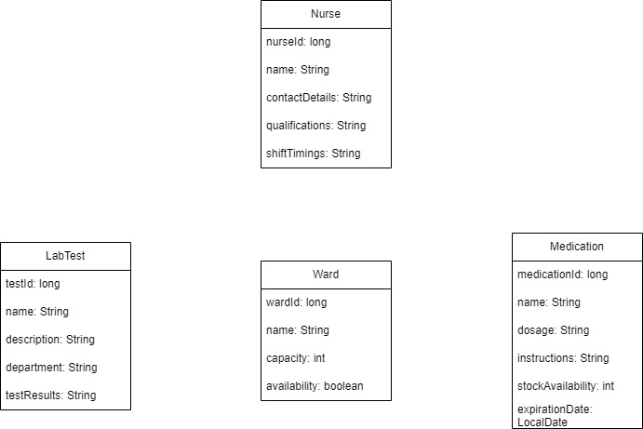

|  |  |  |  |  |  |
| --- | --- | --- | --- | --- | --- |
| HTTP Method | URL path | HTTP state code | Description | Sample Requst | Sample Respons |
| POST | <http://localhost:8080/>  nurses | 200 | Add nurse | { "name": "Maya Ali", "contactDetails": "mayaali@gmail.com", "qualifications": "Registered Nurse", "shiftTimings": "Morning Shift" } | { "id": 1, "name":  "Maya Ali",  "contactDetails":  "mayaali@gmail.com",  "qualifications":  "Registered Nurse",  "shiftTimings":  "Morning Shift" } |
| GET | <http://localhost:8080/>  nurses | 200 | GET ALL nurse | - | [{"id":1,"name":"Maya Ali"  ,"contactDetails":  "mayaali@gmail.com"  ,"qualifications"  :"Registered Nurse",  "shiftTimings":"Morning Shift"}] |
| GET | <http://localhost:8080/>  nurses/1 | 200 | GET BY ID | - | {"id":1,"name":"Maya Ali",  "contactDetails":  [mayaali@gmail.com](mailto:mayaali@gmail.com)  ,"qualifications":"Registered  Nurse","shiftTimings":"  Morning Shift"} |
| PUT | <http://localhost:8080/>  nurses/1 | 200 | Update value | {  "name": "Maya Osama",  "contactDetails": "mayaali@gmail.com",  "qualifications": "Registered Nurse",  "shiftTimings": "Morning Shift"  } | {"id":1,"name":"Maya Osama"  ,"contactDetails":  [mayaali@gmail.com](mailto:mayaali@gmail.com)  ,"qualifications":  "Registered Nurse",  "shiftTimings":"Morning Shift"} |
| DELET | <http://localhost:8080/>  nurses/1 | 200 | Delete | - | - |

**NURSES Module**

|  |  |  |  |  |  |
| --- | --- | --- | --- | --- | --- |
| HTTP Method | URL path | HTTP state code | Description | Sample Requst | Sample Respons |
| POST | <http://localhost:8080/>  medications | 200 | Add  Medications | {  "name": "Panadol",  "dosage": "500mg",  "instructions": "Take after lunch",  "stockAvailability": 43,  "expirationDate": "2024-1-31"  } | {"id":1,"name":"Paracetamol",  "dosage":"500mg",  "instructions":"Take 1 tablet every 6 hours",  "stockAvailability":50,  "expirationDate":"2023-12-31"} |
| GET | <http://localhost:8080/>  medications | 200 | GET ALL Medications | - | [{"id":1,"name":"Paracetamol",  "dosage":"500mg"  ,"instructions":"Take 1 tablet every 6 hours",  "stockAvailability":50  ,"expirationDate":"2023-12-31"}] |
| GET | <http://localhost:8080/>  medications /1 | 200 | GET BY ID | - | {"id":1,"name":"Paracetamol",  "dosage":"500mg",  "instructions":"Take 1 tablet every 6 hours",  "stockAvailability":50,  "expirationDate":"2023-12-31"} |
| PUT | <http://localhost:8080/>  medications /1 | 400 | Update value | {  "name": "Daramol",  "dosage": "500mg",  "instructions": "Take after lunch",  "stockAvailability": 43,  "expirationDate": "2024-1-31"  } | {"timestamp":"2023-05-23T19:39:40.638+00:00",  "status":400,  "error":"Bad Request",  "path":"/medications/1"} |
| DELET | <http://localhost:8080/>  nurses/1 | 200 | Delete | - | - |

**Medications Module**

|  |  |  |  |  |  |
| --- | --- | --- | --- | --- | --- |
| HTTP Method | URL path | HTTP state code | Description | Sample Requst | Sample Respons |
| POST | <http://localhost:8080/>  wards | 200 | Add wards | {  "name": "XRAY",  "capacity": 15,  "availability": true  } | {"id":1,"name":"XRAY",  "capacity":15,  "availability":true} |
| GET | <http://localhost:8080/>  wards | 200 | GET ALL wards | - | [{"id":1,"name":"XRAY",  "capacity":15,  "availability":true}] |
| GET | <http://localhost:8080/>  wards/1 | 200 | GET BY ID | - | {"id":1,"name":"XRAY",  "capacity":15,  "availability":true} |
| PUT | <http://localhost:8080/>  wards/1 | 200 | Update value | {  "name": "XRAY",  "capacity": 15,  "availability": false  } | {"id":1,"name":"XRAY",  "capacity":15,  "availability":false} |
| DELET | <http://localhost:8080/>  wards/1 | 200 | Delete | - | - |

**Model Ward**

|  |  |  |  |  |  |
| --- | --- | --- | --- | --- | --- |
| HTTP Method | URL path | HTTP state code | Description | Sample Requst | Sample Respons |
| POST | <http://localhost:8080/>  wards | 200 | Add wards | {  "name": "B12 Test",  "description": "A test to to find avg for B12 in body",  "department": "Pathology"  } | {"id":1,  "name":"B12 Test",  "description":"A test to to  find avg for B12 in body",  "department":"Pathology",  "testResults":null} |
| GET | <http://localhost:8080/>  wards | 200 | GET ALL wards | - | [{"id":1,  "name":"B12 Test",  "description":"A test to to  find avg for B12 in body",  "department":"Pathology",  "testResults":null}] |
| GET | <http://localhost:8080/>  wards/1 | 200 | GET BY ID | - | {"id":1,  "name":"B12 Test",  "description":"A test to to find avg for B12 in body","department":"Pathology",  "testResults":null} |
| PUT | <http://localhost:8080/>  wards/1 | 200 | Update value | {  "name": "B12 Test",  "description": "A test to to find all for B12 in body",  "department": "Pathology"  } | {"id":1,  "name":"B12 Test",  "description":"A test to to find all for B12 in body","department":"Pathology",  "testResults":null} |
| DELET | <http://localhost:8080/>  wards/1 | 200 | Delete | - | - |

**Model LabTest**

The system allows for the efficient management of nurses, wards, medications, and lab tests within the hospital.

the system enables operations such as creating, reading, updating, and deleting data related to these resources and aims to streamline hospital operations, including staff management, patient admissions, medication inventory, and lab testing processes.