Database Project
Social Media Platform Database

Team Members
- Marwan Ahmed
- Youssef Abdullah
- Mohamed Omar
- Karim Gamal
- Mostafa Ahmed
- Amir Emad

Supervised By
TA: ………………..

- The Project’s Idea(Main Scenario):
In our social media platform designed to facilitate meaningful connections and interactions among users while offering robust privacy and security features.
Here's an outline of its main scenario:

- User registration process
- Profile creation
- Privacy setting
- Content sharing
- Connecting with others

- Requirements Phase:
- Inputs:
- Marwan Ahmed and Youssef Abdullah: used the Brainstorming method.

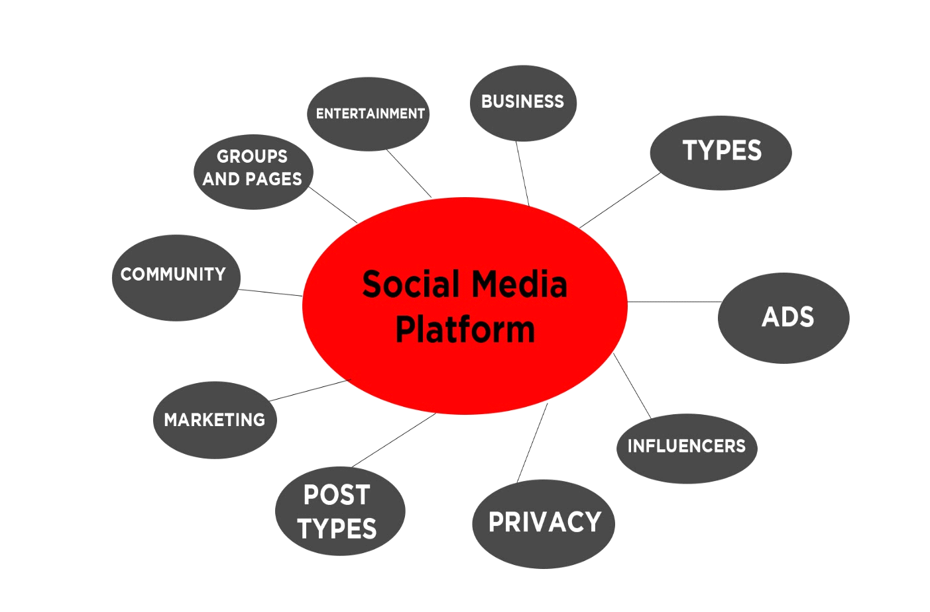
Explaining the content of spider diagram:
1. Types:
1. General Social networks: Facebook- Twitter Threads.
2. Visual Social networks: Instagram - Pinterest – Snapchat.
3- Professional networks: LinkedIn.

4- Microblogging Platforms: Twitter - Tumblr –Threads.

5- Video Sharing platforms: YouTube - Tiktok.

6. Messaging apps: WhatsApp - messenger – telegram.

7. Social Commerce platforms: Instagram -Facebook (Market Place)

- Community types:

1. Social media Management: engaging with followers.
2. Digital marketing Community: Digital marketing Professionals.
3. Entrepreneurship: Business owners, like Elon Musk.
4. Education and training Community: Educators, Students, Coaches and trainers.

3. Posts Types:

1. Trend and Innovations: discuss current trends and Innovations.
2. News posts: like BBC, Sky news.
3. Photos, Videos, reels.
4. User Guide and Tips: advising users on a specific content.
4 .User Profile Types:
1. Personal Profiles: Standard Profiles used by individuals to represent themselves on the Social media platforms.
2. Business profiles: created by brands and organizations to promote their products and Services.

3. Influencer profiles: Focus on Specific Topics and content, they may have sponsors.

4. Creator Profiles: such as artist, photographers, writers and musicians.

5. Educational profiles: to Share educational content.

5. Entertainment: This encompasses the various forms of media and content provided to users for enjoyment and engagement on the platform. In the database, entertainment data could include information about videos, music tracks, articles, games, memes, and other types of content shared or hosted on the platform.

6. Groups and Pages: These are features that allow users to form communities around shared interests, groups and pages data would include information about the group or page such as its name, description, members, administrators, posts, events, and settings. It also includes relationships between users and groups/pages, such as membership, following, liking, or managing.
7. Privacy: This refers to the settings and mechanisms that allow users to control who can see their content, who can interact with them, and what information is shared with third parties.

- Karim Gamal and Mohamed Omar: Used the internet method for obtaining the data.
Using Google Search:
The important data about the individual using the platform:
1 - User Data: This includes user profiles, usernames, email addresses, passwords (usually encrypted), profile pictures, and any other relevant information users provide during registration.
2 - Content Data: This encompasses posts, photos, videos, comments, likes, shares, and any other content users generate or interact with on the platform.
3 - Relationship Data: This involves information about the connections between users, such as friend lists, followers, following, groups, and networks.
4 - Activity Data: This comprises logs of user activities on the platform, including login/logout times, post creation times, interactions with content (likes, comments, shares), and any other actions users take.
5 - Metadata: This includes additional information about the data stored in the database, such as timestamps, geotags, hashtags, and other descriptive attributes that help organize and categorize content.
6 - Analytics Data: Many social media platforms collect data for analytics purposes, such as user engagement metrics, demographics, popular trends, and user behavior patterns.
7 - Security and Access Control: Components related to user authentication, authorization, and data security measures to protect user privacy and prevent unauthorized access to sensitive information.
These components collectively form the foundation of a social media platform's database, enabling the platform to function effectively and provide users with a seamless experience while also ensuring the security and privacy of user data.

Using internet videos:
The important Features about the platform: to make the platform more interactive, users should:
1 - Upload media: like photos, videos and posts to share their day or hobbies.
2 - Interact with others media: by comments, likes and sharing.
3 - Making content and interacting with people watching it: and these contents maybe free or paid and that depends on the publisher of the content, it’s also important to make contact between the publisher and the viewers to take feedbacks.
4 - Feed/Newsfeed: This is where users see updates from people or pages they follow. It usually displays posts, images, videos, and other content in a chronological sorted order.
5 - Notifications: Users receive notifications for various activities, such as likes, comments, mentions, friend requests, and event invites.
Notifications keep users informed about interactions and updates related to their account.

- Mostafa Ahmed and Amir Emad: used Document Analysis for information gathering.

Introduction:
In the ever-evolving landscape of digital interaction, social media platforms play a pivotal role in connecting individuals globally. This document stems from a meticulous analysis of requirements and data dynamics, aiming to lay the groundwork for a cutting-edge social media platform.

Through document analysis, we've distilled essential insights into user interactions, content creation, and relationship management. This serves as a prelude to the subsequent development phase, outlining the foundational steps in crafting a robust database schema aligned with the envisioned platform features.

As we embark on this journey, our focus is on encapsulating the essence of social connectivity, ensuring our platform exceeds user expectations in the dynamic realm of online interaction.

- Based on this, we found that:-

At the first step of creating a database for a social media platform, you need to define the requirements and understand the data that your platform will handle. Here's a more detailed breakdown of the initial steps:

1. Define Requirements:
- Identify the key features and functionalities of your social media platform. Common features include user profiles, posts, comments, likes, follows, etc.
- Consider the types of media your platform will support (text, images, videos).
- Determine the relationships between different entities (e.g., users, posts, comments).

2. User Stories:
- Create user stories to understand how different types of users will interact with your platform. This will help in identifying the data and actions needed.

3. Data Modeling:
- Develop a conceptual data model that represents the entities, attributes, and relationships in your social media platform. Use tools like Entity-Relationship Diagrams (ERD) to visualize the structure.

4. Entity Identification:
- Identify the main entities in your system. These might include User, Post, Comment, Like, Follow, etc.

5. Attribute Definition:
- Define the attributes for each entity. For example, a User entity might have attributes like username, email, password, profile picture, etc.

6. Relationships:
- Define the relationships between entities. For instance, a User entity may have a "posts" relationship with the Post entity.

7. Normalization:
- Consider normalization to organize your data efficiently and reduce redundancy. Normalize the data model if needed, ensuring that data is stored in the most logical way.

8. Document Requirements:
- Document your findings and decisions. This documentation will be helpful for communication with your development team and for future reference.

9. Feedback and Validation:
- Share your data model and requirements with stakeholders and development team members to gather feedback and ensure that your model aligns with the platform's goals.

10. Revise and Iterate:
- Based on feedback and validation, revise your data model and requirements. Iterate on this process until you have a solid understanding of the data structure your social media platform will require.

- Processing:
At the beginning of any social media platform, there must be an important knowledge of what will be the project about and how to link all the gathered information to build a successful project. Consequently here's a brief of the collected information.
1. Types of Social Media Platforms:
1. General Social networks: Facebook- Twitter Threads.
2. Visual Social networks: Instagram - Pinterest – Snapchat.
3- Professional networks: LinkedIn.
4- Microblogging Platforms: Twitter - Tumblr –Threads.
5- Video Sharing platforms: YouTube - Tiktok.
6. Messaging apps: WhatsApp - messenger – telegram.
7. Social Commerce platforms: Instagram -Facebook (Market Place)
2. Community types:

1. Social media Management: engaging with followers.
2. Digital marketing Community: Digital marketing Professionals.
3. Entrepreneurship: Business owners, like Elon Musk.
4. Education and training Community: Educators, Students, Coaches and trainers.

3. Integrity of the user:
The main entities in your system. These might include User, Post, Comment, Like, Follow, etc.
Define the attributes for each entity. For example, a User entity might have attributes like username, email, password, profile picture, etc.

4. User Data: This includes user profiles, usernames, email addresses, passwords (usually encrypted), and profile pictures, and any other relevant information users provide during registration.
5. Content Data: This encompasses posts, photos, videos, comments, likes, shares, and any other content users generate or interact with on the platform.
6. Activity Data: This comprises logs of user activities on the platform, including login/logout times, post creation times, interactions with content (likes, comments, shares), and any other actions users take.
7. Metadata: This includes additional information about the data stored in the database, such as timestamps, geotags, hashtags, and other descriptive attributes that help organize and categorize content.

8. Privacy: This refers to the settings and mechanisms that allow users to control who can see their content, who can interact with them, and what information is shared with third parties.

9. Security and Access Control: Components related to user authentication, authorization, and data security measures to protect user privacy and prevent unauthorized access to sensitive information.
These components collectively form the foundation of a social media platform's database, enabling the platform to function effectively and provide users with a seamless experience while also ensuring the security and privacy of user data.

- Used Methods:
Interviewing, searching, brainstorming.
- Used Tools/Apps:
Word, Google and Videos on YouTube.
- Person’s Name:

- Outputs:
A Social Media Platform is designed and run by a Platform Company. the company has its unique Name, Address, and Tax registration.

On the platform Users register by first providing their personal information such as: first and last Names, Date of Birth, Gender, Address and Phone Number. Then, they choose a unique UserName that gets assigned a specific UserID, after that they verify the account through Email and create a strong Password for future singe-ins, Finishing the registration process the users now can browse the platform.

The users can join various Groups and Pages with unique Topics and Interests , these groups and pages each has a unique Name , Type , Services ,and Promotions .

Users can also post photos, videos, threads ,etc. to share their opinions and interests with others. Each post gets assigned: a unique PostID to work as an identifier, a UserID to reference the user who made it, a Timestamp with the date and exact time of when it was posted, a MediaType describing the type of media posted accordingly e.g., text, image, video. On the post there will be the Content and the MediaURL or media file referenced attached to the post.

Users can interact with these posts by Liking, Commenting, or even liking comments. Likes and comments also get assigned a LikeID and CommentID. They also have the PostID as reference to the post being liked or commented on. As well as the UserID who made the comment or like. And a Timestamp indicating when was the action taken.

Users can interact with other users by forming Friendships , each friendship gets assigned a FrienshipID to work as identifier . it'll also have both UserIDs and a Timestamp to indicate when the friendship was formed.

After forming the friendship the two users now can connect with each other and send each other Messages . These messages each has a unique MessageID, both the SenderID and the RecieverID, the message Contents, and finally a Timestamp with the date and exact time it was sent and received and even opened.

The way the platform gets monetization is through sponsored advertisement through which a Sponsor with a Name, Location, Products and Resources pays the platform company to get his/her products publicity and traffic. Another way of advertisement can be through Influencers with high follower count or famous personal and public figures .Influencers for example have their information stored on the platform . information such as their Name, Content, Promotions, and IncomeDetails.

- Analysis Phase:
- Inputs:
A Social Media Platform is designed and run by a Platform Company. the company has its unique Name, Address, and Tax registration.

On the platform Users register by first providing their personal information such as: first and last Names, Date of Birth, Gender, Address and Phone Number. Then, they choose a unique UserName that gets assigned a specific UserID, after that they verify the account through Email and create a strong Password for future singe-ins, Finishing the registration process the users now can browse the platform.

The users can join various Groups and Pages with unique Topics and Interests , these groups and pages each has a unique Name , Type , Services ,and Promotions .

Users can also post photos, videos, threads ,etc. to share their opinions and interests with others. Each post gets assigned: a unique PostID to work as an identifier, a UserID to reference the user who made it, a Timestamp with the date and exact time of when it was posted, a MediaType describing the type of media posted accordingly e.g., text, image, video. On the post there will be the Content and the MediaURL or media file referenced attached to the post.

Users can interact with these posts by Liking, Commenting, or even liking comments. Likes and comments also get assigned a LikeID and CommentID. They also have the PostID as reference to the post being liked or commented on. As well as the UserID who made the comment or like. And a Timestamp indicating when was the action taken.

Users can interact with other users by forming Friendships , each friendship gets assigned a FrienshipID to work as identifier . it'll also have both UserIDs and a Timestamp to indicate when the friendship was formed.

After forming the friendship the two users now can connect with each other and send each other Messages . These messages each has a unique MessageID, both the SenderID and the RecieverID, the message Contents, and finally a Timestamp with the date and exact time it was sent and received and even opened.

The way the platform gets monetization is through sponsored advertisement through which a Sponsor with a Name, Location, Products and Resources pays the platform company to get his/her products publicity and traffic. Another way of advertisement can be through Influencers with high follower count or famous personal and public figures .Influencers for example have their information stored on the platform . information such as their Name, Content, Promotions, and IncomeDetails.

- Processing:
Extraction Process
Entities:
Regular entities:
- Platform Company
- User
- Post
- Comment
- Like
- Message
- Groups/Pages

Weak entities:
- Influencers
- Sponsors
Attributes:
Regular entities:

Platform Company:
- Name: simple.
- Location: complex.
- Tax registration: PK.

USER:
- UserID: PK Attribute.
- UserName: Composed.
- Name(F,S): Composite Attribute.
- Birth Date: Simple and Stored/Base Attribute.
- Number: Single/Simple.
- Gender: Single/Simple/Stored/Base Attribute.
- Address: Simple Attribute.
- Email: Simple.
- Bio : Simple (Optional).
- Privacy Methods(Password): multivalued.
- Profile Picture : URL / Reference.

Post :
- PostID (Primary Key): Unique identifier for each post.
- UserID (Foreign Key): Reference to the user who created the post.
- Content: Text content of the post.
- MediaType: Type of media included in the post (e.g., text, image, video).
- MediaURL: URL or reference to the media file attached to the post.
- Timestamp: Date and time when the post was created.

Comment:
- CommentID (Primary Key): Unique identifier for each comment.
- PostID (Foreign Key): Reference to the post being commented on.
- UserID (Foreign Key): Reference to the user who made the comment.
- Content: Text content of the comment.
- Timestamp: Date and time when the comment was posted.

Like:
- LikeID (Primary Key): Unique identifier for each like.
- PostID (Foreign Key): Reference to the post being liked.
- CommentID (Foreign Key): Reference to the comment being liked (nullable).
- UserID (Foreign Key): Reference to the user who liked the post or comment.
- Timestamp: Date and time when the like was given.
Friendship(Relational Attribute):
- FriendshipID (Primary Key): Unique identifier for each friendship.
- UserID1, UserID2 (Foreign Keys): References to the users who are friends.
- Timestamp: Date and time when the friendship was established.

Message:
- MessageID (Primary Key): Unique identifier for each message.
- SenderID, ReceiverID (Foreign Keys): References to the users involved in the conversation.
- Content: Text content of the message.
- Timestamp: Date and time when the message was sent.

GROUPS/PAGES:
- Name: simple.
- Type: simple.
- Interests: multivalued.
- Services: multivalued.
- Promotion: computed.

Weak entities:
Sponsors:
- Name: simple.
- Integrity: PK.
- Locations: complex.
- Products and Resources: multivalued.

Influencer:
- Name: composed/simple.
- Content: composed.
- Promotion: computed.
- Income: computed.

Relationships:
DEGREE:
Unary Relationship
User – Posts
User – Comments
User – Likes
Post – Comments
Post – Likes
Comments – Likes
Binary Relationships
User – User (Friendship)
User – Groups/Pages
Platform Company – Sponsor
Platform Company – Influencer
Sponsor – Influencer
User - Influencer
User – Message
Groups/Pages – Post
Recursive Relationship
Group – Posts

Relationships
Number of Entities |  | Name of Relationship | Degree of Relationship
E1 | E2
User | Post | Shares | Binary
User | Comments | Makes | Binary
User | Likes | Leaves | Binary
User | User | Contacts | Unary
User | Groups/Pages | Join | Binary
User | Influencer | Follows | Unary
User | Message | Sends | Unary
Post | Comments | Has | Binary
Post | Likes | Has | Binary
Comment | Likes | Has | Binary
Platform Company | Sponsor | Advertise | Unary
Platform Company | Influencer | Pays | Unary
User | User | Follow | Binary
Groups/Pages | Post | Have | Binary

Cardinality:
User (m) ---------Post--------- (m) Post
User (m) ---------Make--------- (m) Comment
User (m) ---------Leave--------- (m) Like
User (1) ---------Contacts--------- (1) User
User (m) ---------Follow--------- (m) User
User (m) ---------Join--------- (m) Groups/Pages
User (m) ---------Follow--------- (m) Influencer
User (1) ---------Send--------- (m) Message
Post (1) ---------Has--------- (m) Comment
Post (1) ---------Has--------- (m) Like
Comment (1) ---------Has--------- (m) Like
PlatformCompany(1)-------Has-------(m) Sponsor
PlatformCompany(1)-------Pay-------(m) Influencer
Groups/Pages(1)------Has-----(m) Post

Cardinality
Number of Entities |  | Name of Relationship | Cardinality
E1 | E2
User | Post | Shares | M : M
User | Comments | Makes | M : M
User | Likes | Leaves | M : M
User | User | Contacts | 1 : 1
User | Groups/Pages | Join | M : 1
User | Influencer | Follows | 1 : M
User | Message | Sends | 1 : M
Post | Comments | Has | 1 : M
Post | Like | Has | 1 : M
Comment | Like | Has | 1 : M
Platform Company | Sponsor | Advertise | 1 : M
Platform Company | Influencer | Pays | 1 : M
User | User | Follow | M : M
Groups/Pages | Post | Have | 1 : M

Participation:
Total and Partial Participation :
User (partial-may) -----Post----- (total-must)
Post User (partial-may)---Make--(total-must) Comment
User (partial-may)-------Leave-----(total-must) Like
User (partial-may)---Contacts---( partial-may) User
User (partial-may)------Follow---(partial-may) User
User(partial-may)----Join----(total-must) Groups/Pages
User (partial-may)------Follow------(total-must) Influencer
User (partial-may) -------Send--------(total-must) Message
Post (partial-may) --------Has--------(total-must) Comment
Post (partial-may) --------Has--------(total-must) Like
PlatformCompany(total-must)---Has---(partial-may) Sponsor
PlatformCompany(partial-may)--Pay--(partial-may) Influencer
Groups/Pages (partial-may)---Has---(partial-may) Post

Participations
Number of Entities |  | Name of Relationship | Type of Participations
E1 | E2
User | Post | Shares | Partial : Total
User | Comments | Makes | Partial : Total
User | Likes | Leaves | Partial : Total
User | User | Contacts/Follow | Partial : Partial
User | Groups/Pages | Join | Partial : Total
User | Influencer | Follows | Partial : Total
User | Message | Sends | Partial : Total
Post | Comments | Has | Partial : Total
Post | Like | Has | Partial : Total
Comment | Like | Has | Partial : Total
Platform Company | Sponsor | Advertise | Total : Partial
Platform Company | Influencer | Pays | Partial : Partial
Groups/Pages | Post | Have | Partial : Partial

Used Methods:
Processing/Converting Method.
Used Tools/Apps:
Google Draw and Adobe Photoshop
Person’s Name:
System Analyst

- Outputs:

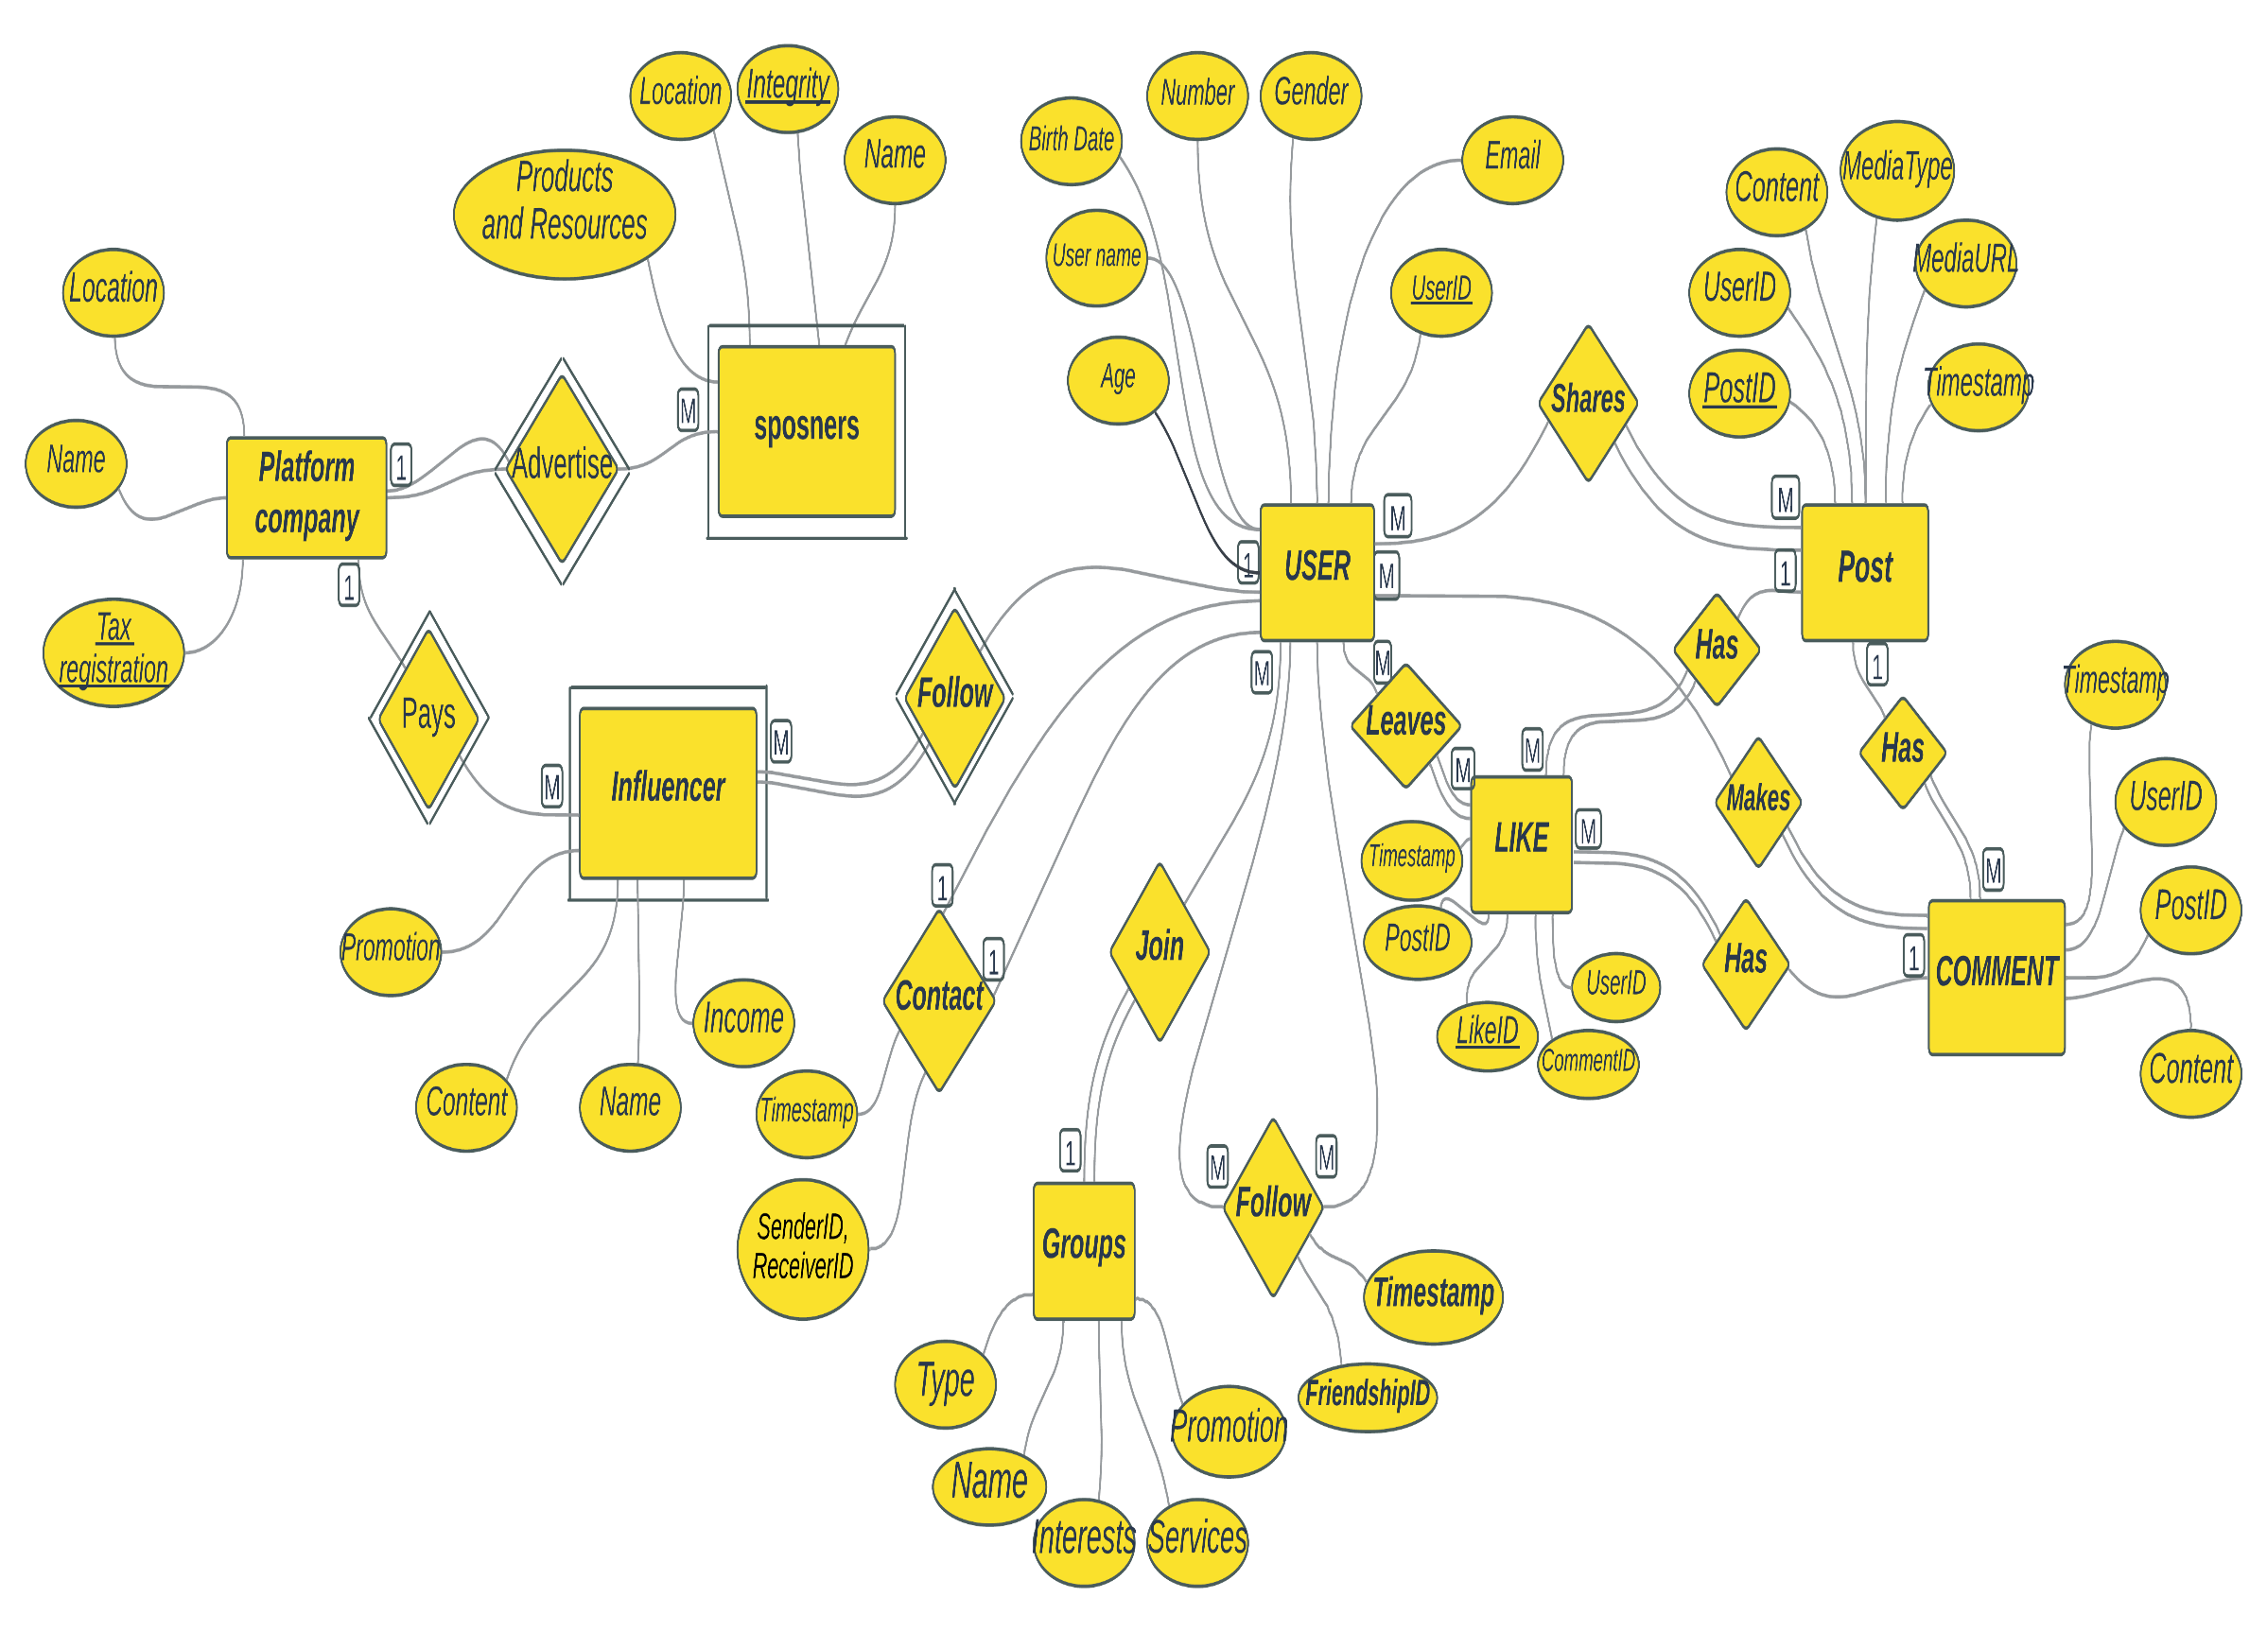

- Design Phase (Part 1: Creating Schema):
- Inputs:

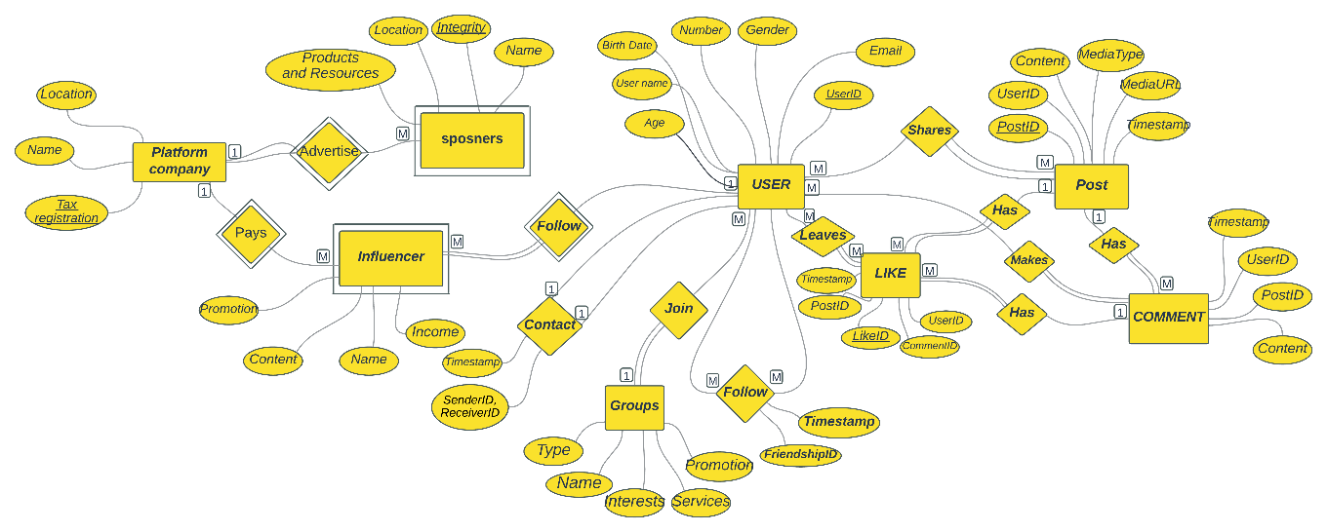

- Processing:
Applying on the ERD the Mapping rules.

1.Mapping Regular Entities:
Platform Company:
Tax_Registration | Name | Location

User:
UserID | U_N | F,S_Name | B_Date | N# | Gend. | Add. | Email | Bio | P_Methods | PFP

Post:
PostID | UserID | P_Content | M_Type | M_URL | T_Stamp

Comment:
C_ID | Post_ID | User_ID | C_Content | T_Stamp

Like:
Like_ID | Post_ID | Comm_Id | User_Id | T_Stamp

Friendship(Relational_Attribute):
Friendship_ID | UserID1,UserID2 | T_Stamp

Message:
Message_ID | S_ID , R_ID | M_Content | T_Stamp

Groups/Pages:
Name | Type | Interests | Services | Promotion

2.Mapping Weak Entities:
Sponsors:
Com_Tax_R | S_Name | Integrity | Locations | Products_Resources

Influencer:
Com_Tax_Reg | Name | Content | Promotion | Income

3.(1:1)(TP – PP) Relationship:
User (PP)-------------Contacts----User (PP)
U s e r _ U s e r
UserID | UserID | SenderID, RevieverID | T_Stamp

U s e r
UserID | U_N | F,S_Name | B_Date | N# | Gend. | Add. | Email | Bio | P_Methods | PFP

U s e r
UserID | U_N | F,S_Name | B_Date | N# | Gend. | Add. | Email | Bio | P_Methods | PFP

4.(1:M) Relationship:

User (1) ---------Send--------- (m) Message
M e s s a g e
Message_ID | S_ID , R_ID | M_Content | T_Stamp | UserID

U s e r
UserID | U_N | F,S_Name |  | B_Date | N# | Gend. | Add. | Email | Bio | P_Methods | PFP

Post (1) ---------Has--------- (m) Comment
C o m m e n t
C_ID | Post_ID | User_ID | C_Content | T_Stamp | PostID

P o s t
PostID | UserID | P_Content | M_Type | M_URL | T_Stamp

Post (1) ---------Has--------- (m) Like
L i k e
Like_ID | Comm_Id | User_Id | T_Stamp | PostID

P o s t
PostID | UserID | P_Content | M_Type | M_URL | T_Stamp

Comment (1) ---------Has--------- (m) Like
L i k e
Like_ID | Comm_Id | User_Id | T_Stamp | Comment_ID

C o m m e n t
Comment_ID | Post_ID | User_ID | C_Content | T_Stamp

PlatformCompany(1)-------Has-------(m) Sponsor
S p o n s o r s
Com_Tax_R | S_Name | Integrity | Locations | Products_Resources | Tax_R

P l a t f o r m C o m p a n y
Tax_Registration | Name | Location

PlatformCompany(1)-------Pay-------(m) Influencer
I n f l u e n c e r
Com_Tax_Reg | Inf_Name | Content | Promotion | Income

P l a t f o r m C o m p a n y
Tax_Registration | Name | Location

Groups/Pages(1)------Has-----(m) Post
P o s t
PostID | UserID | P_Content | M_Type | M_URL | T_Stamp | G/P_Name

G r o u p s/P a g e s
G/P_Name | Type | Interests | Services | Promotion

5.(M:M) Relationship:

User (m) ---------Post--------- (m) Post
UserID | U_N | F,S_Name | B_Date | N# | Gend. | Add. | Email | Bio | P_Methods | PFP
U s e r

U s e r_P o s t
UserID | PostID
PostID | UserID | P_Content | M_Type | M_URL | T_Stamp

P o s t

User (m) ---------Make--------- (m) Comment
U s e r
UserID | U_N | F,S_Name | B_Date | N# | Gend. | Add. | Email | Bio | P_Methods | PFP

U s e r_C o m m e n t
UserID | Comment_ID

C o m m e n t
Comment_ID | Post_ID | User_ID | C_Content | T_Stamp

User (m) ---------Leave--------- (m) Like
UserID | U_N | F,S_Name | B_Date | N# | Gend. | Add. | Email | Bio | P_Methods | PFP
U s e r

U s e r_L i k e
UserID | Like_ID

L i k e
Like_ID | Comm_Id | User_Id | T_Stamp

User (m) ---------Follow--------- (m) User
UserID | U_N | F,S_Name | B_Date | N# | Gend. | Add. | Email | Bio | P_Methods | PFP
U s e r

UserID | UserID
U s e r

UserID | U_N | F,S_Name | B_Date | N# | Gend. | Add. | Email | Bio | P_Methods | PFP
U s e r

User (m) ---------Join--------- (m) Groups/Pages
U s e r
UserID | U_N | F,S_Name | B_Date | N# | Gend. | Add. | Email | Bio | P_Methods | PFP

U s e r_G r o u p s/P a g e s
UserID | G/P_Name

G r o u p s/P a g e s
G/P_Name | Type | Interests | Services | Promotion

User (m) ---------Follow--------- (m) Influencer
U s e r
UserID | U_N | F,S_Name | B_Date | N# | Gend. | Add. | Email | Bio | P_Methods | PFP

U s e r_I n f l u e n c e r
UserID | Com_Tax_Reg | Inf_Name

I n f l u e n c e r
Com_Tax_Reg | Inf_Name | Content | Promotion | Income

6.Multivalued Attributes:
Sponsors entity and location as multivalued attribute:
S p o n s o r s
Com_Tax_R | S_Name | Integrity | Products_Resources

S P O_L o c a t i o n
Com_Tax_R | Location

- Used Methods:
Mapping Method.
- Used Tools/Apps:
Word or Microsoft Visio or E draw max or other app or tool that support the normalized ERD’s notations.
- Person’s Name:
DB Designer.
- Outputs:
DB Schema.
. 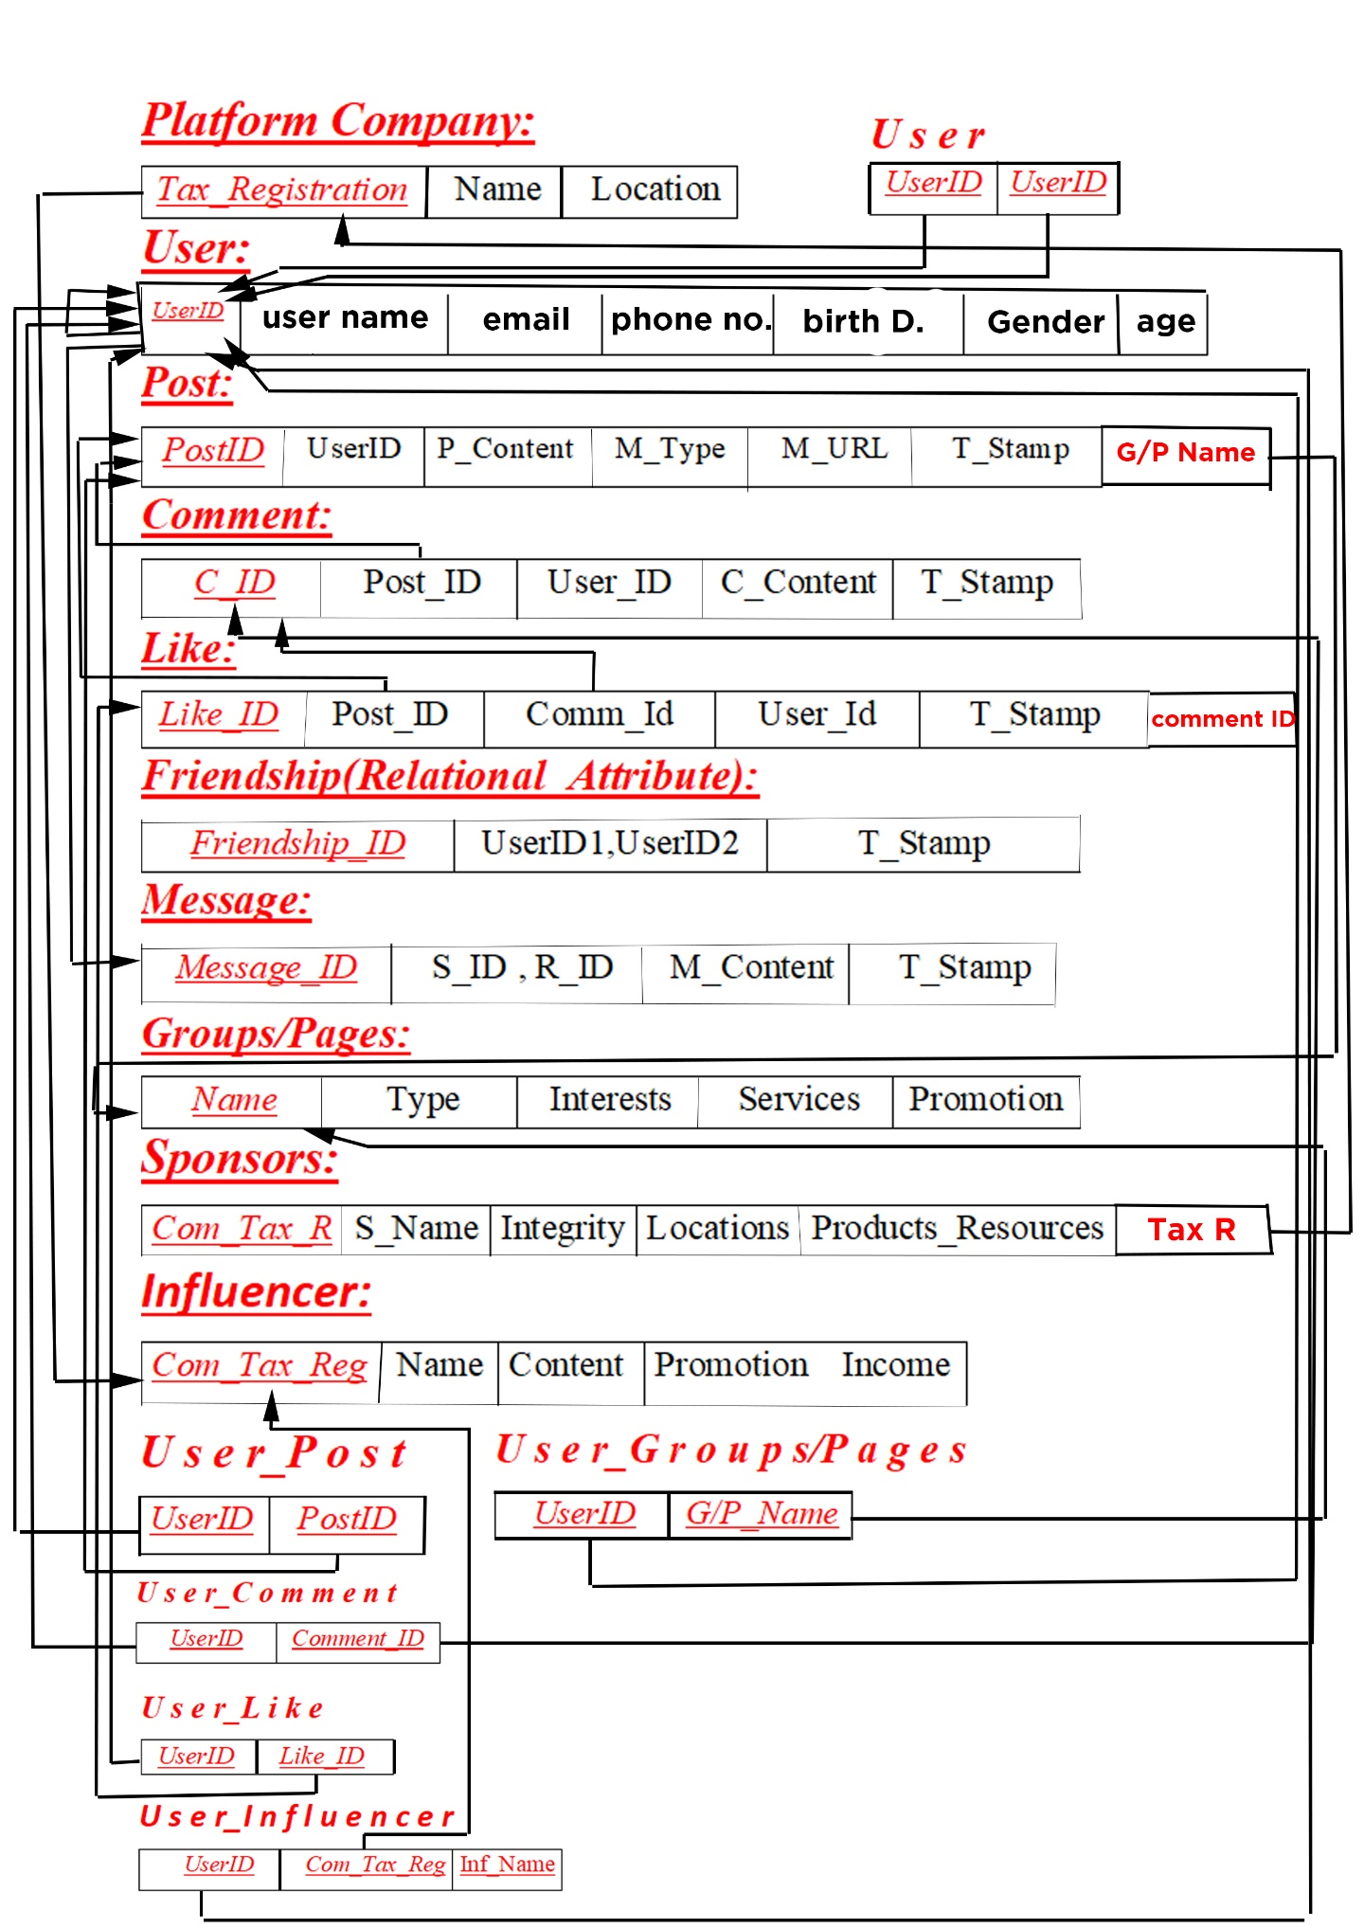

- Design Phase (Part 2: Normalization):
- Inputs:
- 

- Processing:
Applying on the DB schema the normalization rules (first, second and third) normal forms, Put/write here all normalization rules and steps that will be applied on DB schema.
- Used Methods:
Normalization Method.
- Used Tools/Apps:
Word or Microsoft Visio or E draw max or other app or tool that support the normalized DB schema’s notations.
- Person’s Name:
DB Designer.
- Outputs:
Normalized DB Schema.



- Implementation Phase:
- Inputs:
- 

- Processing:
Using DBMS (Microsoft SQL Server) for creating the normalized DB schema.
Put/write here all steps for creating the normalized DB schema.
- Used Methods:
Implementation or development method.
- Used Tools/Apps:
DBMS (Microsoft SQL Server).
- Person’s Name:
DB Developer.
- Outputs:
DB Script for Ur system.
Put/write here the DB script.

- App/User Interface Phase: (Bonus)
- Containing the forms and business logic(Code) for Ur system.

