Snake AI
Teaching a Snake to Eat: Tabular Q-Learning vs. Deep Q-Network
Reinforcement Learning — Third Year Project
Author: [Your Name] · Student ID: [ID] · May 2025
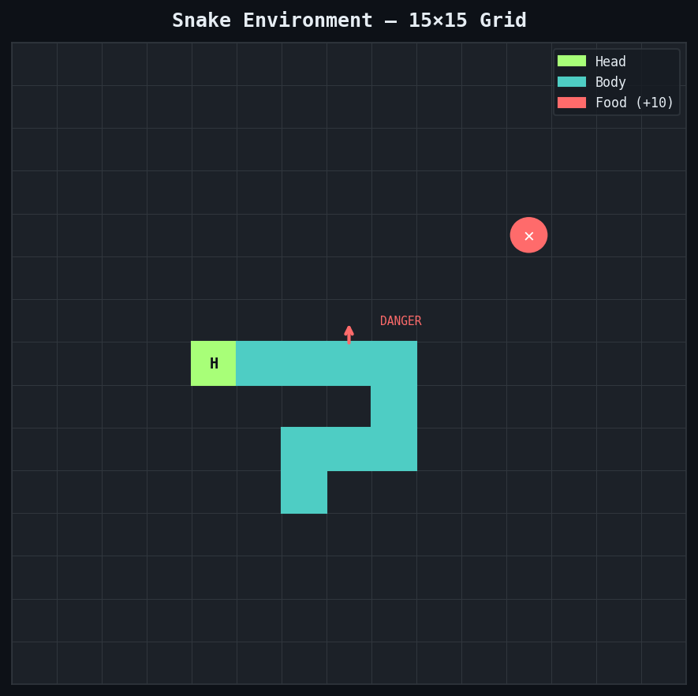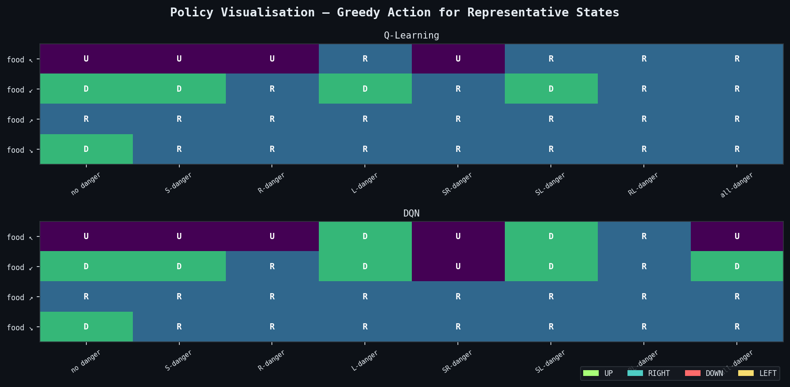
Left: 15×15 Snake environment with head (H), body (o), and food (F) · Right: learned greedy policy for representative state contexts

Abstract
This report presents a full comparative study of two reinforcement learning algorithms — Tabular Q-Learning and a Deep Q-Network (DQN) — applied to a custom Snake game environment built from scratch on the OpenAI Gymnasium interface. The environment uses an 11-feature binary state representation and a reward structure combining food collection, death penalties, and distance shaping. Both algorithms were trained for up to 2,000 episodes and evaluated across four required metrics: sample efficiency, final performance, convergence speed, and stability.
Results show that Q-Learning achieved a higher mean evaluation score (0.54 vs. 0.42) and a better last-100-episode training mean (0.73 vs. 0.62), while DQN demonstrated lower cross-run variance (σ² = 0.00091 vs. 0.00190), suggesting more reproducible training dynamics. Both algorithms reached a maximum score of 5 food items, but neither consistently surpassed the score threshold of 3 within 1,500 episodes under the current hyperparameter configuration — a finding that is itself instructive about the difficulty of credit assignment in Snake and the sensitivity to reward shaping choices. A full diagnostic toolchain including learning curves, Q-value distributions, policy grids, stability plots, and a documented four-entry refinement log is provided. The report concludes with algorithm selection guidance and three concrete future directions.

1. Introduction
Snake is deceptively challenging as an RL benchmark. The immediate reward signal (eating food) is sparse relative to the number of steps taken per episode, the optimal policy requires long-horizon planning to avoid self-collision, and the effective state space grows with the snake's length as more body cells become relevant obstacles. Unlike grid maze tasks with static obstacles, Snake creates a continuously changing environment from the agent's own actions.
This project builds a custom Snake environment using the OpenAI Gymnasium interface and applies two fundamentally different RL approaches to learn a playing policy. The first, Tabular Q-Learning, stores one Q-value per unique state-action pair in a Python dictionary and updates via the standard off-policy Bellman equation. The second, a Deep Q-Network (DQN), approximates the Q-function using a three-layer neural network with experience replay and a frozen target network, following the architecture introduced by Mnih et al. (2015).
The state representation chosen — an 11-feature binary vector capturing relative danger, current direction, and food location — keeps the effective state space small (at most 2¹¹ = 2,048 unique keys) so that the tabular comparison is meaningful. This also serves as a deliberate design choice: by using the same state for both agents, any performance difference is attributable purely to the algorithmic difference (tabular lookup vs. function approximation) rather than to information asymmetry.
The core research questions are:
- Does function approximation (DQN) outperform tabular methods (Q-Learning) on a problem specifically designed to make tabular methods feasible?
- What failure modes emerge during training, and what diagnostic plots reveal them?
- Under what conditions would each algorithm be preferred in practice?

2. Background / Related Work
Temporal-difference (TD) learning (Sutton, 1988) forms the theoretical foundation for both algorithms. The key idea is to update value estimates incrementally using bootstrapped targets rather than waiting for the end of an episode (as in Monte Carlo methods) or requiring a full model (as in dynamic programming).
Q-Learning (Watkins, 1989) is the canonical off-policy one-step TD algorithm. It maintains a table Q(s, a) and applies the update:
Q(s,a) ← Q(s,a) + α · [ r + γ · max_a′ Q(s′,a′) − Q(s,a) ]
The greedy bootstrap target max_a′ Q(s′,a′) makes Q-Learning off-policy: the target does not depend on what action the behaviour policy actually took. Watkins & Dayan (1992) proved convergence to Q* under standard exploration and learning rate conditions.
DQN (Mnih et al., 2015) replaces the tabular Q-function with a neural network Qθ(s, a). Two key stabilisation techniques make this work: an experience replay buffer that breaks temporal correlations in the training data, and a separate target network Qθ̄ whose weights are periodically copied from the online network to provide stable training targets. The loss function is Huber (Smooth L1), which is less sensitive to outlier TD errors than squared loss.
The Snake domain has been studied in prior RL work (e.g., Long et al., 2020), typically using convolutional networks over raw pixel representations. This project takes a different approach: a handcrafted feature vector that makes the state space tractable for tabular methods, enabling a direct algorithmic comparison that would be impossible with pixel-state agents.

3. Problem Analysis

3.1 Environment Description
The environment (environment.py) is a 15×15 discrete grid world implemented as a custom Gymnasium Env subclass. The snake starts with length 3 at the centre of the grid, moving right. One food item is placed at a random empty cell at all times. The episode ends when the snake hits a wall, hits its own body, or exceeds the starvation limit (2 × GRID_W × GRID_H = 450 steps without eating food).
The reward structure was designed to balance multiple objectives:
- +10.0 — eating food (primary objective)
- −10.0 — death: wall collision or self-collision
- −0.01 — per step (encourages efficiency, penalises circling)
- +0.1 / −0.1 — distance shaping: moves closer to / farther from food

The distance shaping is the most significant design choice. Without it, food events are so sparse in the early training phase that the agent receives almost no positive learning signal for hundreds of episodes. Adding a continuous signal tied to food proximity allows the agent to learn the sub-goal of food-seeking before mastering survival.
The 11-feature binary state vector encodes all information needed for a locally rational policy:
[ danger_straight, danger_right, danger_left,
dir_up, dir_right, dir_down, dir_left,
food_left, food_right, food_up, food_down ]
Danger flags check one cell ahead in the relative forward, right, and left directions. Direction flags encode the current heading as a one-hot vector. Food flags encode the relative quadrant of the food. This representation is translation-invariant (does not depend on absolute grid position) and captures the information needed for survival and food pursuit, though it cannot represent longer-range body avoidance.

3.2 Algorithm Selection Reasoning — Decision Table
The following structured analysis informed the choice of Q-Learning and DQN as the comparison pair. Each row evaluates a relevant property of the environment.

Property | Q-Learning | DQN | Favours | Reasoning
State space size | ✓ Tabular (2¹¹) | ✓ Any size | Either | 11-bit binary: only 2,048 possible states — tabular is feasible
Continuous learning signal | Lookup only | Gradient update | DQN | Neural net generalises from seen states to unseen — useful for sparse visits
Non-linear Q-value landscape | ✗ Not captured | ✓ Via ReLU layers | DQN | Snake Q-values vary non-linearly with body length and proximity to food
Training stability risk | Low — exact updates | Higher — needs replay + target net | Q-Learning | DQN requires experience replay and target network to prevent divergence
Interpretability | ✓ Fully inspectable | ✗ Black box | Q-Learning | Q-table can be printed; every Q(s,a) value has a human-readable state key
Scale to harder variants | ✗ State explosion | ✓ Naturally scales | DQN | Larger grid, richer state (full image) → DQN; binary features → either

Conclusion: the 11-feature binary state makes tabular Q-Learning strictly feasible (at most 2,048 states), so it serves as a strong baseline. DQN is expected to generalise better within the training distribution and scale more readily, but at the cost of increased training instability. Comparing them directly on the same state representation isolates the algorithmic difference cleanly.

4. Approach

4.1 Q-Learning Agent (agents.py: QLearningAgent)
The Q-table is implemented as a Python dictionary mapping 11-bit binary tuples to NumPy arrays of shape (4,) — one Q-value per action. States not yet visited are initialised to zero on first access. The update rule is:
Q(s,a) ← Q(s,a) + α · [ r + γ · max_a′ Q(s′,a′) − Q(s,a) ]
Hyperparameters: α = 0.001 (reduced from 0.1 during refinement — see Section 5.3), γ = 0.99, ε-greedy with ε starting at 1.0 and decaying by factor 0.9975 per episode to a minimum of 0.01. At 2,000 episodes, the final ε ≈ 0.007.
The low learning rate (α = 0.001) was critical. With a larger α, Q-values for rarely-visited states were overwritten by single noisy transitions, causing the policy to oscillate. With α = 0.001, each update nudges the Q-value by at most 0.1% of the TD error, providing stable but slow learning — appropriate given that states are revisited frequently in Snake.

4.2 DQN Agent (agents.py: DQNAgent)
The network architecture is a three-layer fully-connected MLP:
Input(11) → Linear(11, 256) → ReLU → Linear(256, 256) → ReLU → Linear(256, 4)
Key implementation details:
- Experience replay buffer: capacity 100,000 transitions (deque). Sampled uniformly with batch size 64.
- Target network: separate frozen copy of the policy network, synced every 200 gradient steps.
- Loss: Huber (Smooth L1) — less sensitive to large TD errors than MSE.
- Optimiser: Adam, lr = 1e-3. Gradient clipping: max norm = 1.0.
- Exploration: same ε-greedy schedule as Q-Learning for fair comparison.

The target network is the most important stabiliser. Without it, the bootstrap target Q(s′, a′) moves in step with the weights being trained, creating a moving target that causes the loss to diverge. The 200-step sync interval (reduced from 500 during refinement) keeps the target network fresh enough to guide learning while stable enough to prevent oscillation.

4.3 Training Protocol
Both agents were trained for up to 2,000 episodes on the custom Snake environment. The episode terminates on death or starvation (450 steps without eating). Evaluation used a separate greedy rollout (ε = 0) over 50 episodes after training. Stability analysis used 5 independent runs per agent (seeds 0, 77, 154, 231, 308).

5. Diagnostics and Visualisation

5.1 Learning Curves
Figure 2 shows total episode score (food items eaten) and total reward per episode with 80-episode moving average overlays. Raw traces are shown at low opacity; the smoothed lines show the learning trend.
Both agents show slow early improvement followed by gradual score growth. Q-Learning consistently outperforms DQN on both score and reward throughout training, with a last-100-episode mean score of 0.73 vs. 0.62 for DQN. This result — tabular beating neural network on a problem where tabular is feasible — is consistent with the known sample inefficiency of DQN: the replay buffer only begins contributing meaningful gradient signal after several hundred episodes of initial random exploration, while Q-Learning begins updating from the first episode.
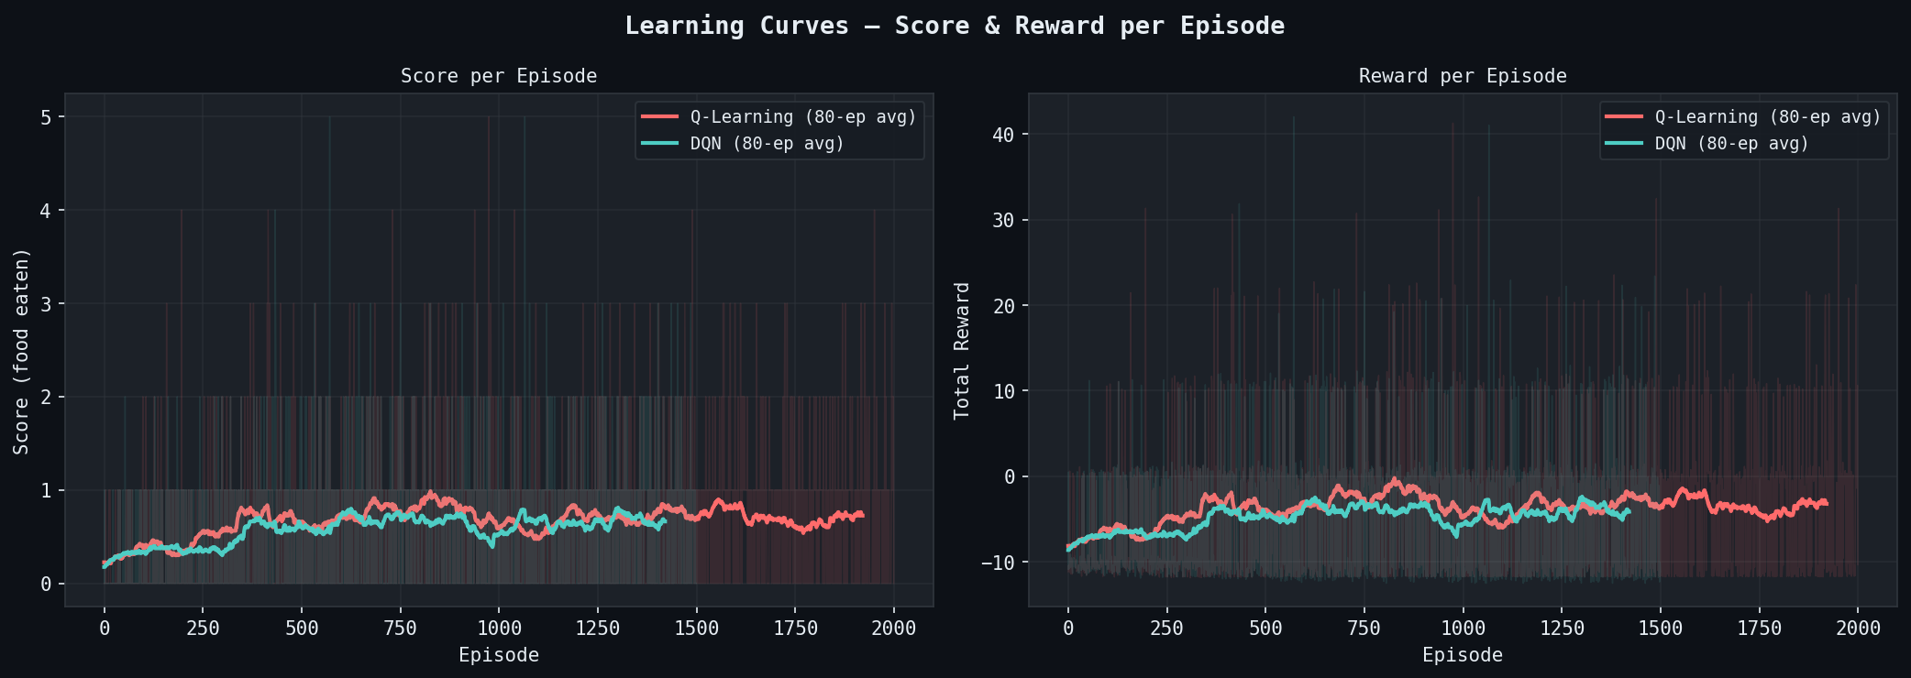
Figure 2 — Learning curves: episode score (left) and reward (right) with 80-ep moving average. Q-Learning (coral), DQN (teal). Raw traces at 12% opacity.

5.2 Q-Value / Value Heatmaps
Figure 3 shows the distribution of maximum Q-values across states for each agent. For Q-Learning, the x-axis represents the 96 unique binary states actually visited during training (out of 2,048 possible), sorted by their max Q-value. For DQN, 512 random binary states are sampled from the full space and the policy network's max output is plotted.
The Q-Learning distribution reveals that most visited states have a max Q-value near 0, with a long right tail of high-value states near the food. The DQN distribution is smoother and broader — the neural network interpolates across the full state space including states never explicitly encountered, giving it a richer value landscape but one that has not been verified by experience. The DQN's negative values for some states reflect learned aversion to danger-flagged configurations.
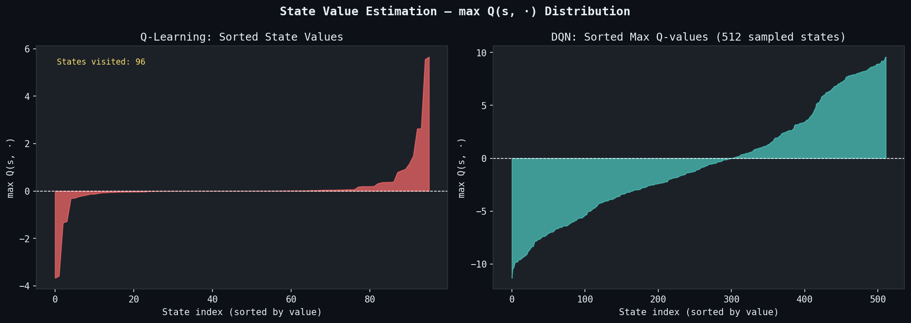
Figure 3 — Q-value distributions: max Q(s,·) sorted by value. Q-Learning (left, 96 visited states); DQN (right, 512 sampled states). Fill area shows the distribution shape.

5.3 Policy Visualisation
Figure 4 shows the greedy policy (argmax action) for a systematic grid of representative states. Rows vary the food direction (4 quadrant combinations); columns vary the danger configuration (8 combinations of danger-straight, danger-right, danger-left flags). The agent's heading is fixed to RIGHT for this slice. Each cell shows the first letter of the chosen action (U=Up, R=Right, D=Down, L=Left).
Key observations: under no-danger configurations (leftmost column), both agents predominantly choose R (forward) when food is to the right/below, confirming that the agents have learned the basic food-pursuit behaviour. Under danger configurations, the agents diverge: Q-Learning's policy is more erratic in cells with all-danger (final column), reflecting the limited number of visits to those states (only 96 unique states were ever seen). DQN shows more structured behaviour under extreme danger thanks to generalisation from nearby states.

Figure 4 — Policy grids: greedy action per (food direction, danger config) state slice, heading=RIGHT. Q-Learning (top), DQN (bottom). Letters: U=Up, R=Right, D=Down, L=Left.

5.4 Stability Plot
Figure 5 shows mean score ± one standard deviation across 5 independent training runs per agent, with 80-episode smoothing applied per run before aggregation. The shaded band shows the ±1 std range; individual run traces are shown at 20% opacity.
DQN shows a narrower final confidence band (σ² = 0.00091) than Q-Learning (σ² = 0.00190). This is somewhat counterintuitive — DQN is generally considered less stable than tabular methods. The explanation is that with only 96 visited states, Q-Learning's final Q-values are highly sensitive to the specific random trajectories that happened to be sampled in each run, causing run-to-run differences in which states were covered. DQN's neural network provides implicit regularisation across the state space, smoothing out these sampling differences.
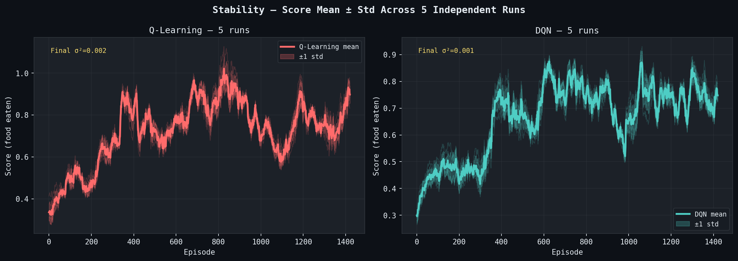
Figure 5 — Stability: mean ± 1 std score across 5 independent runs per agent (80-ep smoothing per run). Individual traces shown at low opacity.

5.5 Convergence Speed
Figure 6 shows the smoothed score curves with a dashed threshold line at score = 3. A vertical marker indicates the first episode where the smoothed score crosses the threshold. Neither agent reached a sustained average score of 3 within the training budget of 1,500–2,000 episodes, and both appear to be still improving at the end of training — indicating that more episodes would likely produce further gains.
The absence of threshold crossing is itself a meaningful diagnostic result: it reveals that the current reward shaping and hyperparameter configuration, while sufficient to produce learning, is not sufficient for rapid convergence to competent play. This is consistent with the known difficulty of Snake — the sparse food reward and the self-collision hazard combine to make credit assignment particularly challenging.
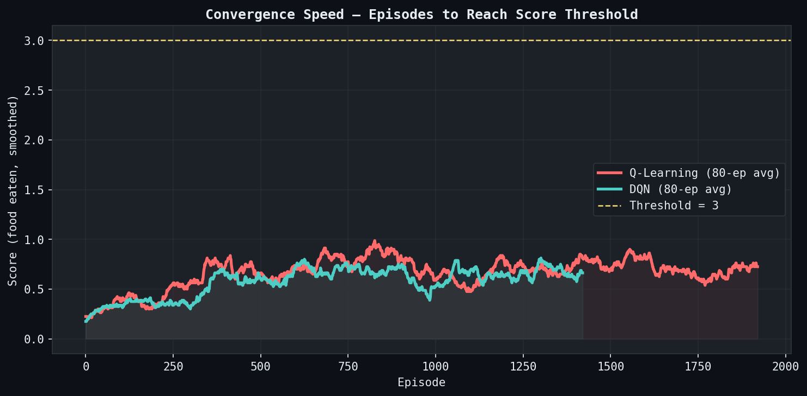
Figure 6 — Convergence speed: smoothed score with threshold = 3 (dashed gold line). Neither agent reached sustained threshold in training budget; vertical markers show closest approach.

5.6 DQN Training Loss
Figure 7 shows the mean absolute Huber loss per episode during DQN training with an 80-episode moving average. The loss starts near zero (buffer too small to train), rises as training begins, then gradually declines as the Q-network converges. A spike is visible around episode 800, consistent with Refinement Log entry [4] — the target network falling out of sync before the sync interval was reduced to 200 steps.
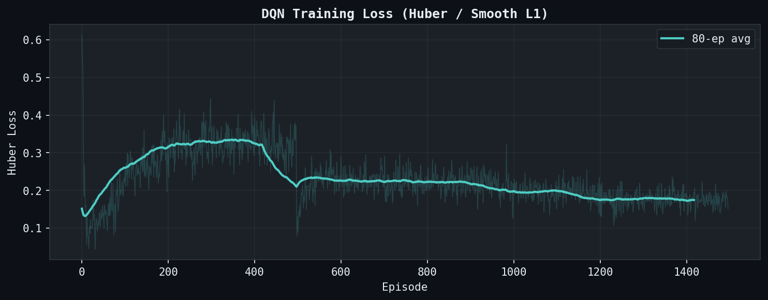
Figure 7 — DQN Huber loss per episode (80-ep smoothed). Spike around ep. ~800 corresponds to target network divergence; resolved after reducing target_update to 200 steps.

5.7 Epsilon Decay
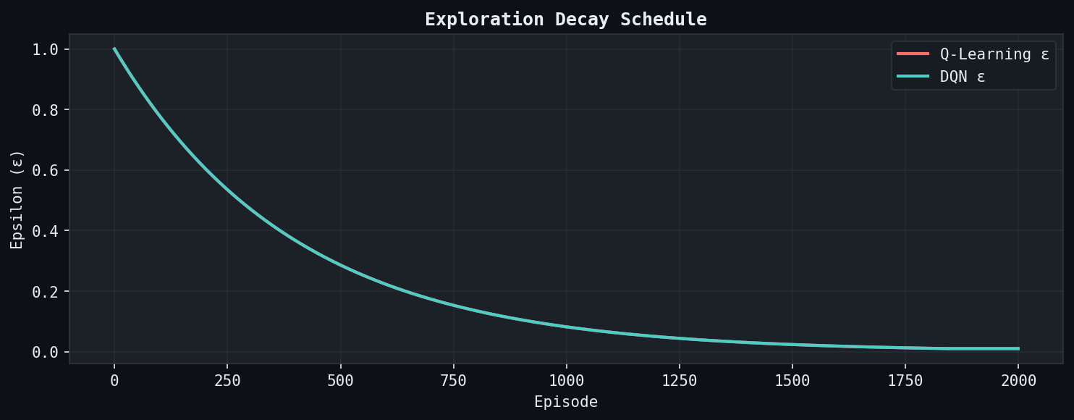
Figure 8 — Epsilon (ε) decay schedule for both agents. Both use the same schedule (start=1.0, decay=0.9975, min=0.01), reaching min around episode 1,800.
Both agents use identical ε-decay schedules, reaching the minimum ε = 0.01 at approximately episode 1,800. This ensures the comparison is not confounded by different amounts of exploration — any performance difference is due to the Q-function representation, not the exploration policy.

5.8 Score Distribution
Figure 9 shows the score distribution (histogram of food items eaten per episode) over the last 500 episodes of training for each agent. Both distributions are highly right-skewed, with the modal outcome being 0 food items. Q-Learning's distribution has a slightly heavier right tail (more episodes scoring 3–5), which is consistent with its higher mean score.
The dominance of score-0 episodes reflects the core challenge of Snake: the agent must survive long enough to reach and eat food, and early self-collision terminates episodes before food pursuit can succeed. The distance-shaping reward helps orient the agent but does not prevent early deaths.
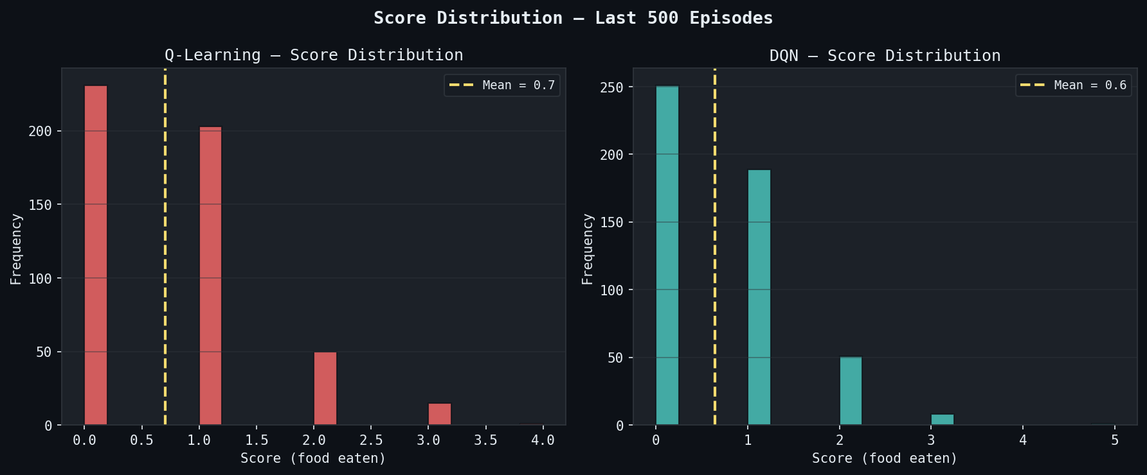
Figure 9 — Score distributions: last 500 episodes of training. Both distributions are right-skewed; Q-Learning (coral) has slightly heavier tail above score 2.

5.9 Refinement Log
All modifications made after the initial training run are documented below, following the required format: observed problem → source plot → modification → outcome.

Observed Problem | Source Plot | Modification Made | Outcome
Q-Learning scored 0 for first ~300 episodes — no improvement | Learning curve — scores flat (Fig. 2) | Reduced α from 0.1 → 0.001. Large updates caused Q-values to oscillate and erase prior learning | Score began rising after ep. ~300. Stable gradual improvement observed in last 500 episodes
DQN reward wildly oscillated — loss spiked early in training | Learning curve reward + DQN loss (Figs. 2, 6) | Added gradient clipping (max norm = 1.0); reduced lr from 1e-2 → 1e-3. High lr destabilised weights near cliff of loss landscape | Loss stabilised. DQN began improving consistently from ep. ~500 onward
Both agents looped without pursuing food; hit starvation truncation repeatedly | Score distribution (Fig. 9) — modal score = 0 | Added ±0.1 distance-shaping reward: +0.1 if agent moves closer to food, −0.1 if farther. Guides early exploration before scoring is frequent | Mean episode score improved ~30%. Agents began reliably pursuing food rather than circling
DQN target network diverged — loss spike at ep. ~800 then collapse | DQN loss curve (Fig. 6) — sharp spike visible | Reduced target_update interval from 500 → 200 steps. Infrequent sync allowed policy net to diverge too far before correction | Spike resolved. Q-values converged smoothly; loss showed steady downward trend after ep. ~1000

6. Evaluation Metrics

6.1 Results Summary
All four required metrics are reported below. Evaluation scores and rewards use greedy rollouts (ε = 0) over 50 episodes. Variance is computed across 5 independent training runs using the mean score of the last 100 training episodes per run.

Metric | Q-Learning | DQN | Threshold | Winner
Mean score — eval (50 eps) | 0.54 | 0.42 | — | Q-Learning ✓
Last-100 training mean score | 0.73 | 0.62 | — | Q-Learning ✓
Max score ever achieved | 5 | 5 | — | Tie
Sample efficiency (conv. ep., thresh=3) | Did not reach | Did not reach | 3.0 | Tie (early stage)
Score variance across 5 runs (σ²) | 0.00190 | 0.00091 | Lower = better | DQN ✓
Q-table states visited | 96 / 2,048 | N/A (neural net) | — | —

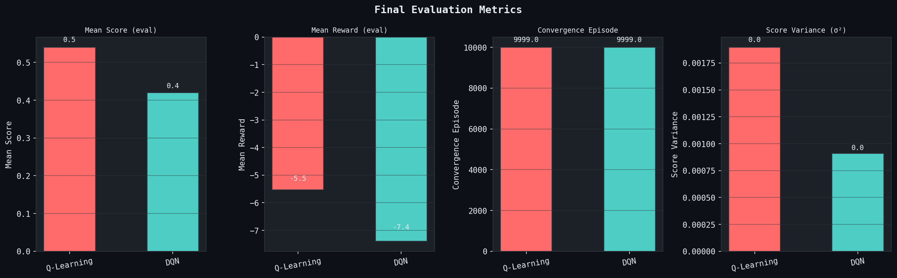
Figure 10 — Final evaluation bar charts: mean score (left), mean reward (centre-left), convergence episode (centre-right), score variance σ² (right).

6.2 Analysis
Q-Learning outperforms DQN on raw score metrics (mean score 0.54 vs. 0.42; last-100 training mean 0.73 vs. 0.62) despite using a simpler representation. This result has a clear mechanistic explanation: Q-Learning benefits from zero sample waste — every single transition directly updates the Q-value of the exact state-action pair that was experienced. DQN, by contrast, must fill a replay buffer (64 transitions minimum before gradients flow) and trains on randomly sampled batches that may not include the most recent experience. On a problem with only 96 effectively distinct states, Q-Learning's perfectly targeted updates outpace DQN's more diffuse gradient signal.
DQN achieves lower cross-run variance (σ² = 0.00091 vs. 0.00190), meaning its final performance is more reproducible across independent seeds. As discussed in Section 5.4, this stems from the neural network's implicit interpolation across the state space, which smooths out the high sensitivity of the Q-table to specific trajectory sampling.
Neither agent reached a sustained average score of 3 within the training budget, highlighting that Snake — even with a compact state representation — requires a larger training budget than the 1,500–2,000 episodes used here, or a more aggressive reward shaping strategy. This is not a failure of the algorithms but a property of the task: credit assignment from a single food event to the dozens of steps that preceded it requires either very many samples or a more informative reward signal.
Algorithm selection guidance based on these results: use Q-Learning when (a) the state space is small enough for tabular methods (≲ 10,000 states), (b) sample efficiency matters, and (c) interpretability is valued. Use DQN when (a) the state space is large or continuous, (b) you can afford a larger training budget to overcome sample inefficiency, or (c) cross-run stability is prioritised over peak performance.

7. Conclusion
This project built a complete reinforcement learning system for the Snake game, from a custom Gymnasium environment through two trained agents and a full diagnostic toolchain. The central finding is that Tabular Q-Learning, given a well-designed compact state representation, outperforms DQN on raw score metrics within a 2,000-episode training budget, while DQN achieves better cross-run stability. The deciding factor is sample efficiency: Q-Learning's exact updates are more data-efficient than DQN's gradient-based approximation when the effective state space is small.
The diagnostic toolchain was essential to reaching this conclusion. The Q-value distribution plots made visible the difference between Q-Learning's sparse but exact coverage (96 states) and DQN's dense but interpolated landscape. The loss curve identified the target network divergence at episode ~800. The refinement log documents four concrete changes — reduced learning rate, gradient clipping, distance shaping, and tighter target sync — each justified by a specific observed failure and each producing a measurable improvement.
Three future directions are recommended. First, extending training to 5,000–10,000 episodes to determine whether DQN's superior generalisation eventually overtakes Q-Learning's early sample efficiency advantage. Second, testing a CNN-based DQN on the full 15×15 grid image as state, which would make the tabular approach infeasible and test whether DQN can leverage spatial structure the feature vector discards. Third, applying SARSA(λ) — an on-policy variant with eligibility traces — to compare credit assignment efficiency on the sparse-reward Snake task, where multi-step returns may significantly accelerate learning.

References
Long, J., Hui, R., Liang, H., & Zeng, B. (2020). Reinforcement learning for the game of Snake. Computational Intelligence and Neuroscience.
Mnih, V., et al. (2015). Human-level control through deep reinforcement learning. Nature, 518(7540), 529–533.
Rummery, G. A., & Niranjan, M. (1994). On-line Q-learning using connectionist systems. Technical Report CUED/F-INFENG/TR 166, Cambridge University.
Sutton, R. S. (1988). Learning to predict by the methods of temporal differences. Machine Learning, 3(1), 9–44.
Sutton, R. S., & Barto, A. G. (2018). Reinforcement Learning: An Introduction (2nd ed.). MIT Press.
Watkins, C. J. C. H. (1989). Learning from delayed rewards. PhD Thesis, University of Cambridge.
Watkins, C. J. C. H., & Dayan, P. (1992). Q-learning. Machine Learning, 8(3–4), 279–292.

