Week 1 Submission — M6 Robotics Simulation / ROS 2
Dual Robotic Arm Autonomous Chess System
M6 — Youssef Sameh (ROS 2, URDF/Xacro, Gazebo, RViz)
Status labels used in this report: Verified = executed on the author’s local ROS 2 Jazzy machine and supported by the terminal output / RViz screenshot recorded in §15 · Verified (sandbox) = executed in a non-ROS sandbox only (Xacro expansion and structure script) · Verified — placeholder model = the pipeline works, but it proves only the placeholder arm/board, not the final design · Not yet verified = implemented, no evidence yet · Requires team input = depends on another member’s data. Facts taken from the project documents are marked (project); my engineering choices are marked (proposal); every number in the model is a PLACEHOLDER.

1. Introduction
The project builds two identical robotic arms that play chess on one shared board (project). The simulation pipeline defined in the proposal is CAD → Mesh → URDF/Xacro → ROS 2 → Gazebo → RViz (project). Week 1 asks for research, then an initial URDF/Xacro structure, Gazebo environment and RViz setup, with a clear next step for Week 2.

2. M6 Role
M6 owns URDF/Xacro, Gazebo + RViz, ROS 2 control, testing kinematics/trajectories in simulation. M6 receives geometry from M1 and FK/IK, trajectory and control from M3/M4/M5, and delivers a validated simulation plus robot state and joint commands to M10 (project, Team Structure).

3. Week 1 Objectives
Official M6 submission: (1) URDF/Xacro structure, (2) initial Gazebo environment, (3) initial RViz setup, written in the Research / ROS 2 Structure / URDF-Xacro / Gazebo / RViz / Dependencies / Blockers / References format (project). Deliberately not done this week: CAD conversion, real inertia, ros2_control, chess pieces (Weeks 2-4) (project plan).

4. URDF Research
URDF is an XML description of a robot as a tree of links (rigid bodies with visual, collision, inertial properties) and joints (fixed, revolute, continuous, prismatic…) giving parent/child relation, origin, axis, limits and dynamics. It must be a tree with a single root, unique names and SI units. Each link has a frame; TF is derived from the joint chain. Gazebo requires valid mass/inertia; planners and controllers use limits. For our robot, the URDF will hold links, joints, limits, visual, collision, mass, inertia and frames per arm (project, Proposal §12). DOF and geometry are not yet specified, so a generic 5-revolute-joint arm is used (placeholder). Details: docs/01_research.md §A.

5. Xacro Research
Xacro adds properties, math, macros, arguments, conditionals and includes to URDF. Using it avoids duplicating two full arm descriptions and lets M1/M3 data be changed in one file. Decision (proposal): one reusable chess_arm macro with a prefix parameter and an *origin block, instantiated twice (robot1_, robot2_); placeholders isolated in arm_params_placeholder.xacro; launch-time arguments robot1_enabled, robot2_enabled, sim_gazebo, use_meshes. Details: §B of the research file.

6. Gazebo Research
Gazebo Harmonic (gz-sim 8) with ros_gz is the Gazebo/ROS pairing with binary packages for ROS 2 Jazzy per the ros_gz repository (proposal); the simulation was run locally through the Jazzy ros_gz packages (local installation: Gazebo Sim 8.15.0, i.e. Harmonic, from gz sim --version). It provides physics, collision, joints, sensors, plugins and worlds. The proposal uses Gazebo for physics, joint movement, collision detection, motion testing, chess-piece manipulation and two-robot interaction (project, Proposal §13). Week 1 needs only world + physics + spawning + basic joint hold; controllers, pieces and collision tests are later (table in research §C).

7. RViz Research
RViz 2 visualises ROS data: RobotModel (from /robot_description), TF, Fixed Frame, Grid, and sensor displays; joint motion is driven by /joint_states. Proposal uses RViz for TF visualization, robot model visualization, coordinate-frame debugging, sensor visualization and ROS 2 debugging (project). Initial config: Fixed Frame world, Grid, RobotModel, collision RobotModel (off), TF.

8. ROS 2 Package Structure
Implemented (files written). Workspace dual_chess_ws/src with dual_chess_description, dual_chess_gazebo, dual_chess_bringup (all ament_cmake). Future: dual_chess_control (M6+M5, Week 3); interfaces/kinematics/vision/chess packages belong to M10/M3/M7/M8. Names must be aligned with M10, who creates the project’s ROS 2 package structure in Week 1 (project) — Requires team input. Tree and per-package table: docs/02_architecture.md.
dual_chess_ws/src/
├── dual_chess_description/ {package.xml, CMakeLists.txt, urdf/, rviz/, launch/, meshes/, scripts/}
├── dual_chess_gazebo/ {package.xml, CMakeLists.txt, worlds/, config/, launch/}
└── dual_chess_bringup/ {package.xml, CMakeLists.txt, launch/}

9. Initial URDF/Xacro Architecture
Implemented. One combined description dual_chess with root world: board_link → board_surface → board_a1 / board_h8, and two arms mounted on world. Each arm: base_link → joint1 (Z) → link1 → joint2 (Y) → link2 → joint3 (Y) → link3 → joint4 (Y) → link4 → joint5 (Z) → link5 → gripper_link → tcp_link. - PLACEHOLDER: 5 revolute joints, axes, link sizes, joint limits (|q| up to 2.8 rad on joint 1, narrower elsewhere), effort 10 N·m, velocity 1 rad/s, masses, primitive inertia, gripper box, TCP at gripper tip. All require M1/M3/M4/M2 data. - Mirroring: Robot 2 is a 180° rotated copy at the opposite side; the proposal says “mirrored coordinate frames” — Requires team input (M1/M3). - Meshes: folder layout and use_meshes:=true switch prepared; STL/DAE from M1 replace primitives with no change to the macro structure. - Two-robot separation: every link/joint carries its prefix (robot1_*, robot2_*), so no names collide (robot1_joint1 vs robot2_joint1, robot1_base_link vs robot2_base_link). Namespaces apply to the command topics (/robot1/..., /robot2/...); /joint_states and TF are shared on purpose (one robot_state_publisher, one TF tree). - Evidence: Xacro expansion for 6 argument combinations and a structure checker (unique names, single root, connected, limits) ran in a non-ROS sandbox (Verified (sandbox)): both robots → 21 links / 20 joints / 10 revolute. The default and Gazebo variants were also processed locally by robot_state_publisher during launch, and the local TF tree contains exactly the expected frames (§15). check_urdf (urdfdom) also parses the expanded URDF successfully (§15, Appendix A).

10. Initial Gazebo Environment
Implemented; Verified locally (placeholder model) — see §15. chess_world.sdf: DART physics (1 ms step), gravity, sun, 10×10 m ground plane. Board and both robots come from the URDF and are spawned by gazebo.launch.py (ros_gz_sim create), keeping one source of truth for placement. ros_gz_bridge carries /clock, /joint_states and /robotN/jointM/cmd_pos. Chess pieces and ros2_control are Week 3.
Scope of the joint control (important): the per-joint hold/command mechanism (gz JointPositionController in use_velocity_commands mode, speed-limited to the placeholder arm_velocity_limit) is a temporary, simulation-level Week 1 stand-in whose only purpose is to keep the arms upright and let the pipeline be exercised. It is not the project’s control architecture. The final ROS 2 control / PID / stepper-motor architecture belongs to later integration (M5 control design, M9 electronics, M6 ros2_control + gz_ros2_control, Week 3 onward) and will replace these plugins.

11. Initial RViz Setup
Implemented; Verified locally via display.launch.py and simulation.launch.py — see §15. rviz/dual_chess.rviz (Fixed Frame world, Grid, RobotModel, collision RobotModel disabled by default, TF) is loaded by both display.launch.py (robot_state_publisher + joint_state_publisher_gui + rviz2, for RViz-only work) and simulation.launch.py (RViz driven by Gazebo joint states). The screenshot shows blue Robot 1 and orange Robot 2 on opposite sides of the board, the a1 (red) and h8 (green) markers, TF axes, Global Status OK. The RViz-only launch display.launch.py was also run locally: the joint_state_publisher_gui sliders move each robot1_/robot2_ joint (Figure 2).

12. Dependencies
Week 1 proceeds with clearly marked placeholders, so none of the items below stops the Week 1 deliverables. They are inputs M6 will consume when other members’ work arrives.
Coordination needed now (Week 1)
From | Needed | Why
M10 | ROS 2 package structure/names, topic/service/action list | M10 owns the package skeleton; M6’s three package names and the command topics should match it
Expected from other members’ Week 1 outputs (to be integrated in Week 2; placeholders in place)
From | Needed | Replaces
M1 | DOF/joint configuration, initial link dimensions + base size | 5-DOF placeholder arm, link sizes (arm_params_placeholder.xacro, joint list in arm.macro.xacro)
M3 | Coordinate frames (joint axes, TCP, board↔robot transform, mirror convention) | joint axes, TCP, board frame convention, Robot 2 placement
M4 | Initial joint limits | placeholder limits
M2 | Board square size/thickness, gripper concept/dimensions | board and gripper placeholders
Required later (by design, not Week 1 blockers)
From | Needed | When
M1 | Final CAD meshes (STL/DAE, metres, link-frame origin, collision meshes) and mass properties | Week 2
M4 / M9 | Velocity/torque limits, motor torque/speed, workspace/base distance | Week 2
M5 | Control architecture (PID structure, stepper interface) for ros2_control | Week 2-3
M2 | Chess-piece dimensions | Week 3
M7 | Camera placement (optional simulated camera) | Week 3+
M8 | Board-state / square naming convention | Week 3

13. Blockers
No blocker prevents the Week 1 M6 deliverables. Open coordination items: 1. Package naming/structure with M10 (M10 owns the package skeleton) — to be agreed; renaming my three packages is cheap if needed. 2. Inputs from M1/M2/M3/M4 (§12) — currently placeholders. Becomes a blocker for Week 2 only if these are not delivered in time. 3. Mirrored-frame convention (rotated copy vs reflected geometry) — decision for M1/M3. 4. Controller/interface type for the stepper actuators (project) — M5, needed before the Week 3 ros2_control work; not needed for Week 1.

14. Initial Implementation
Files delivered: three ROS 2 packages (description, gazebo, bringup), 8 Xacro files, world SDF, bridge YAML, RViz config, three launch files, structure-check script, README with commands, verification and troubleshooting guides. See README and docs/.

15. Verification
Environment: local ROS 2 Jazzy machine of the author. Evidence = terminal output and RViz screenshot captured during local execution of ros2 launch dual_chess_bringup simulation.launch.py and follow-up commands.
Item | Status | Evidence
Workspace builds and launches from the install space | Verified | simulation.launch.py started gazebo, robot_state_publisher, ros_gz_bridge and rviz2; robot_state_publisher: Robot initialized
Xacro processed with both robots + Gazebo plugins (sim_gazebo:=true) | Verified | same launch log (xacro runs inside the launch file)
Xacro expansion for all argument variants; structure check (unique names, one root, connected, limits; 21 links / 20 joints / 10 revolute) | Verified (sandbox) | non-ROS sandbox, xacro 2.1.1
Gazebo world launches, model spawns, physics runs | Verified — placeholder model | log: Entity creation successful; /joint_states streams 13 entries (10 revolute robot1_joint1..5, robot2_joint1..5 + 3 fixed) at sim time 41 s; positions stay 0 (arms hold). First run showed frame errors caused by board_link lacking an <inertial>; fixed in board.macro.xacro, after which the model streams joint states and responds to commands
Joint command path (temporary controller, §10) | Verified — placeholder model | /robot1/joint1/cmd_pos 0.6 → robot1_joint1 = 0.6; /robot2/joint2/cmd_pos 0.4 → robot2_joint2 = 0.4000024; uncommanded joints ≈ 0 (robot1_joint5 ≈ 0, robot2 joint3/4 < 2e-6)
Two-robot separation (prefixes, command namespaces, no name collisions) | Verified | joint names above; commanding Robot 2 did not move Robot 1; TF frames below
TF tree | Verified | view_frames: 20 frames below world — board_link → board_surface → board_a1/board_h8, robot1_base_link … robot1_tcp_link, robot2_base_link … robot2_tcp_link; single tree
RViz (via simulation.launch.py) | Verified | screenshot (Figure 1): both arms + board, a1/h8 markers, TF display, Global Status OK, pose follows Gazebo joint states
RViz-only launch display.launch.py (joint sliders) | Verified | screenshot (Figure 2): RViz + joint_state_publisher_gui with sliders for robot1_/robot2_ joints, arms posed by the sliders, Global Status OK
check_urdf (urdfdom parser) | Verified | Successfully Parsed XML; root world with 3 children (board_link, robot1_base_link, robot2_base_link); full chains to each tcp_link (Appendix A)
Gazebo GUI: ground, board, both arms, entity tree | Verified — placeholder model | screenshot (Figure 3): ground_plane, sun, dual_chess in the entity tree, board with a1/h8 markers, both arms; gz model --list → ground_plane, dual_chess; Gazebo Sim 8.15.0 (Appendix A)
use_meshes:=true | Not testable until M1 meshes exist (switch prepared) | —
Limitation of all verification above: it proves the software pipeline (Xacro → TF → RViz → Gazebo → bridge) using the placeholder 5-DOF arm, placeholder board/layout and temporary joint controller. It does not validate any final mechanical, kinematic or control design; that depends on M1/M2/M3/M4/M5/M9 (§12).

16. Next Steps
- Agree package names/interfaces with M10; confirm board frame and mirroring with M3.
- Receive M1 DOF/dimensions → edit arm_params_placeholder.xacro and the joint list in arm.macro.xacro.
- Week 2: import M1 meshes, CAD mass/inertia, collision meshes, M4 limits; verify both robots in Gazebo + RViz.
- Week 3: replace hold plugins with ros2_control (with M5), add board squares and pieces.

17. References
- ROS 2 Jazzy documentation — https://docs.ros.org/en/jazzy/
- ROS 2 Jazzy tutorials: URDF — https://docs.ros.org/en/jazzy/Tutorials/URDF/URDF-Main.html
- ROS 2 Jazzy: “Using Xacro to Clean Up a URDF File” — https://docs.ros.org/en/jazzy/Tutorials/URDF/Using-Xacro-to-Clean-Up-a-URDF-File.html
- URDF XML specification — http://wiki.ros.org/urdf/XML
- Xacro documentation — http://wiki.ros.org/xacro · source: https://github.com/ros/xacro
- Gazebo Sim 8 (Harmonic) API reference, Joint Controllers (JointController, JointPositionController, JointStatePublisher) — https://gazebosim.org/api/sim/8/jointcontrollers.html ; JointPositionController (use_velocity_commands, cmd_max) — https://gazebosim.org/api/sim/8/classgz_1_1sim_1_1systems_1_1JointPositionController.html
- ros_gz (ROS 2 ↔ Gazebo packages; Jazzy/Harmonic pairing table) — https://github.com/gazebosim/ros_gz ; ros_gz_bridge (Jazzy) — https://docs.ros.org/en/jazzy/p/ros_gz_bridge/
- SDFormat specification — http://sdformat.org/spec
- RViz User Guide (Jazzy) — https://docs.ros.org/en/jazzy/Tutorials/Intermediate/RViz/RViz-User-Guide/RViz-User-Guide.html
- tf2 tutorials (Jazzy) — https://docs.ros.org/en/jazzy/Tutorials/Intermediate/Tf2/Tf2-Main.html
- REP 103 (units/conventions) — https://www.ros.org/reps/rep-0103.html · REP 105 (frames) — https://www.ros.org/reps/rep-0105.html
- ros2_control (Jazzy) — https://control.ros.org/jazzy/index.html · gz_ros2_control: https://github.com/ros-controls/gz_ros2_control
- Project documents: Week 1 Tasks; Chess Robot Team Structure & 5-Week Plan; Dual Robotic Arm Autonomous Chess System Project Proposal.

Appendix A — Evidence
Figure 1 — RViz driven by Gazebo (simulation.launch.py), arms posed by commands to /robot1/joint1/cmd_pos and /robot2/joint2/cmd_pos.
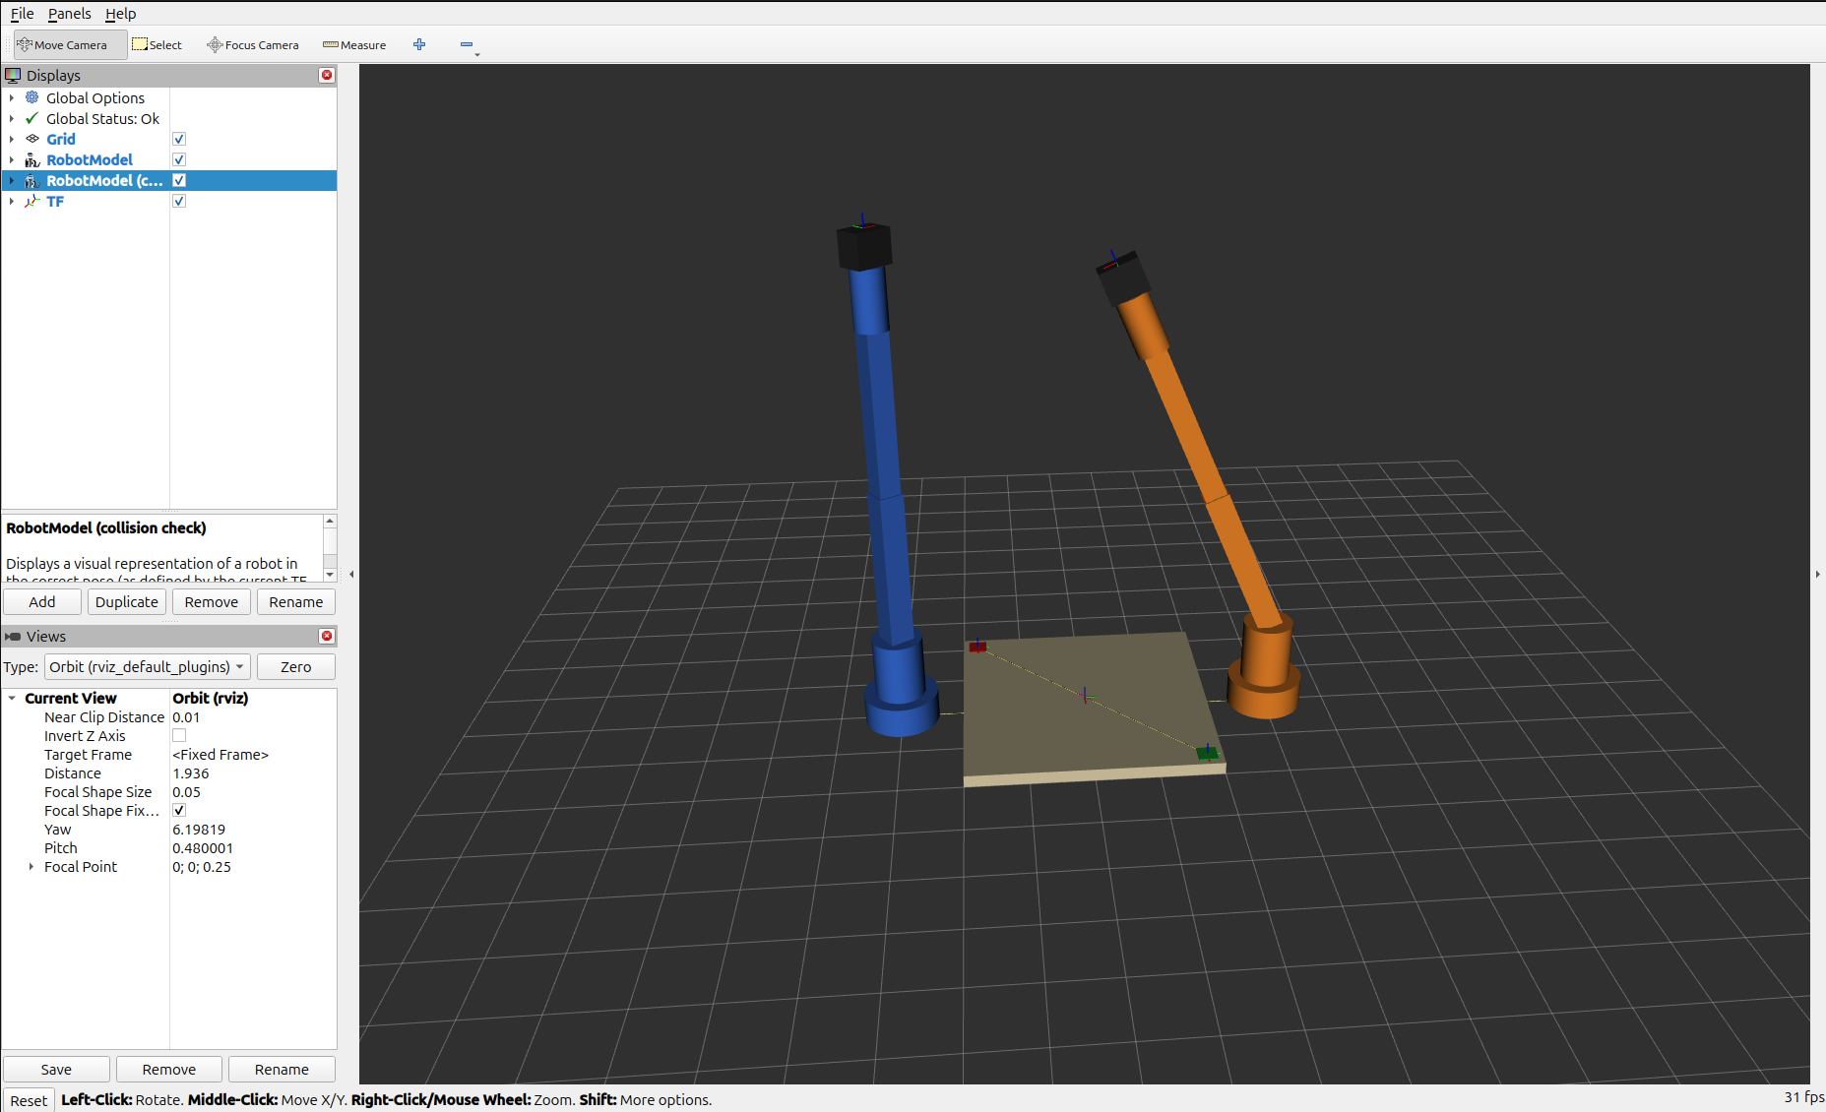
Figure 1: RViz with Gazebo joint states
Figure 2 — RViz-only launch (display.launch.py) with joint_state_publisher_gui sliders.
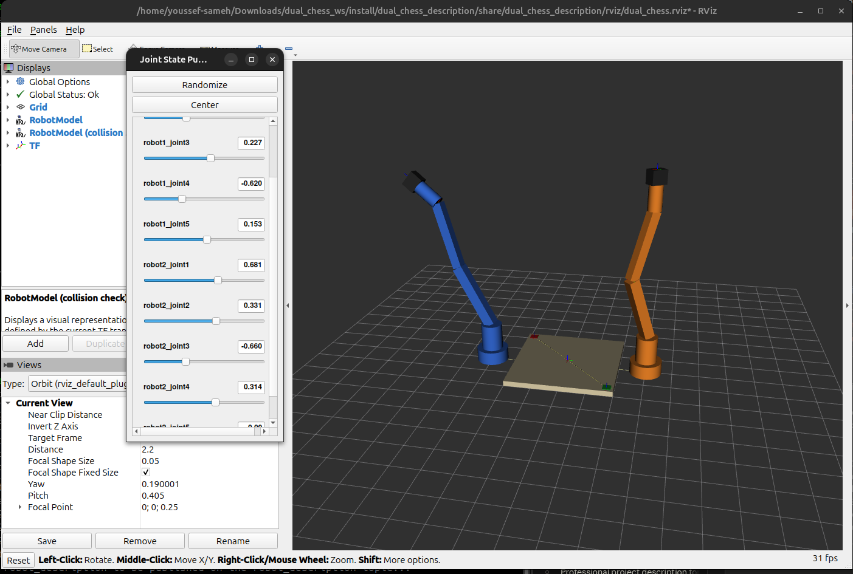
Figure 2: RViz with joint sliders
Figure 3 — Gazebo Sim (Harmonic) with chess_world.sdf: ground plane, sun, board and both arms (dual_chess).
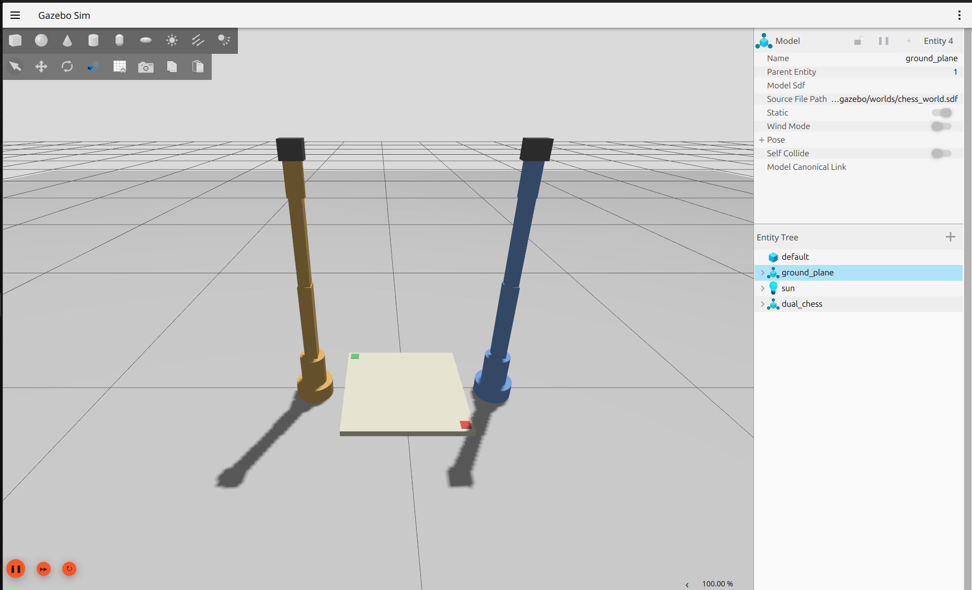
Figure 3: Gazebo world
check_urdf output (expanded dual_chess.urdf.xacro, local):
robot name is: dual_chess
---------- Successfully Parsed XML ---------------
root Link: world has 3 child(ren)
child(1): board_link
child(1): board_surface
child(1): board_a1
child(2): board_h8
child(2): robot1_base_link
child(1): robot1_link1 -> link2 -> link3 -> link4 -> link5 -> robot1_gripper_link -> robot1_tcp_link
child(3): robot2_base_link
child(1): robot2_link1 -> link2 -> link3 -> link4 -> link5 -> robot2_gripper_link -> robot2_tcp_link
(chains abbreviated; the full tree printed by check_urdf lists each link as a nested child.)
Gazebo (local): gz model --list → ground_plane, dual_chess (world chess_world); gz sim --version → Gazebo Sim, version 8.15.0.
TF (local): ros2 run tf2_tools view_frames — one tree rooted at world; 20 frames: board_link, board_surface, board_a1, board_h8, and robotN_base_link, robotN_link1..5, robotN_gripper_link, robotN_tcp_link for N = 1, 2. (Generated PDF: frames_2026-10-06_00.01.13.pdf.)

