Name: Marwan Ahmed Abd El-Azim Mahmoud El lithy
Section: 40
B.N: 885
Date : 12/06/2021

Topic: Artificial Intelligence
Application Brief :
AI ( Artificial intelligence ) is the simulation of human intelligence in machines that are programmed to think like humans and mimic their actions. The term may also be applied to any machine that exhibits traits associated with a human mind such as learning and problem-solving.
I chose this application ( Artificial intelligence ) because we can see how much impact does it have on out daily life , from that small press when you`re trying to turn on your phone to that fictional google assistant that`s trying to organize your day and helps you with your tasks .
In addition to that , AI is the future of all machines , it`s the way towards more efficient , progressive , productive and for the most important , safe systems of technological machines . Of course we shouldn`t leave robots and AI control us , but we should let it help us progress and make our life easier and much better .
Screenshots :
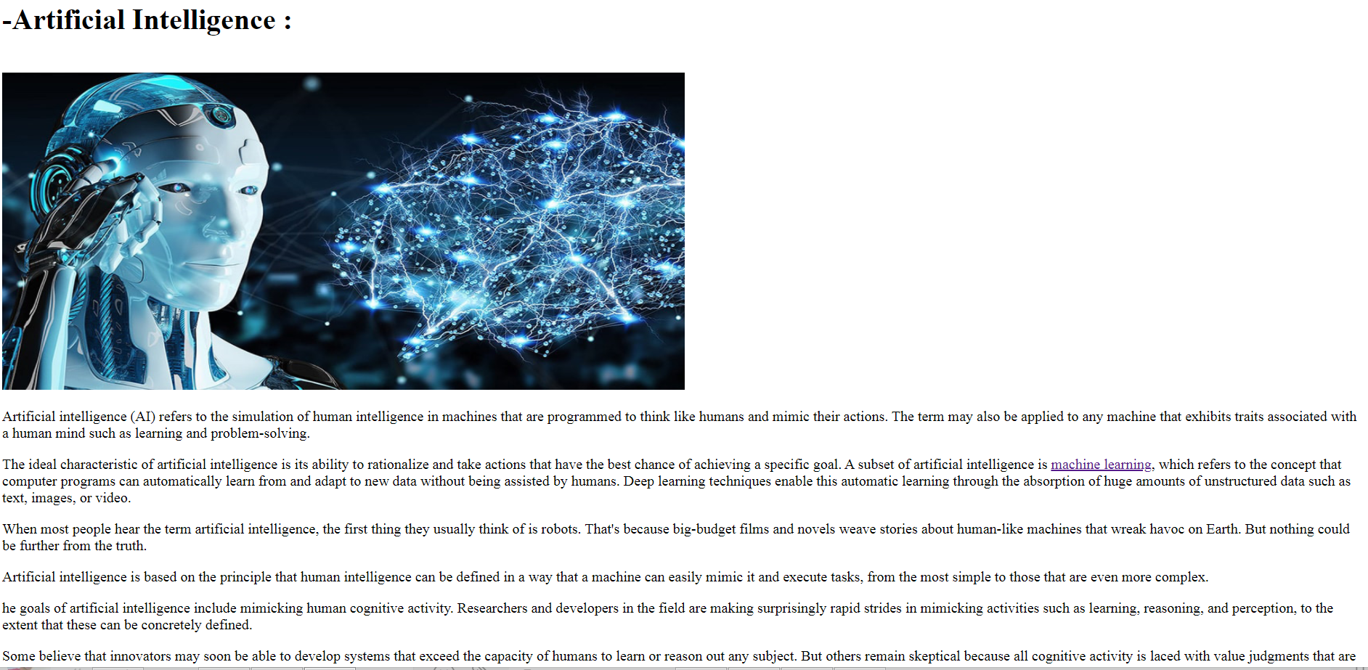
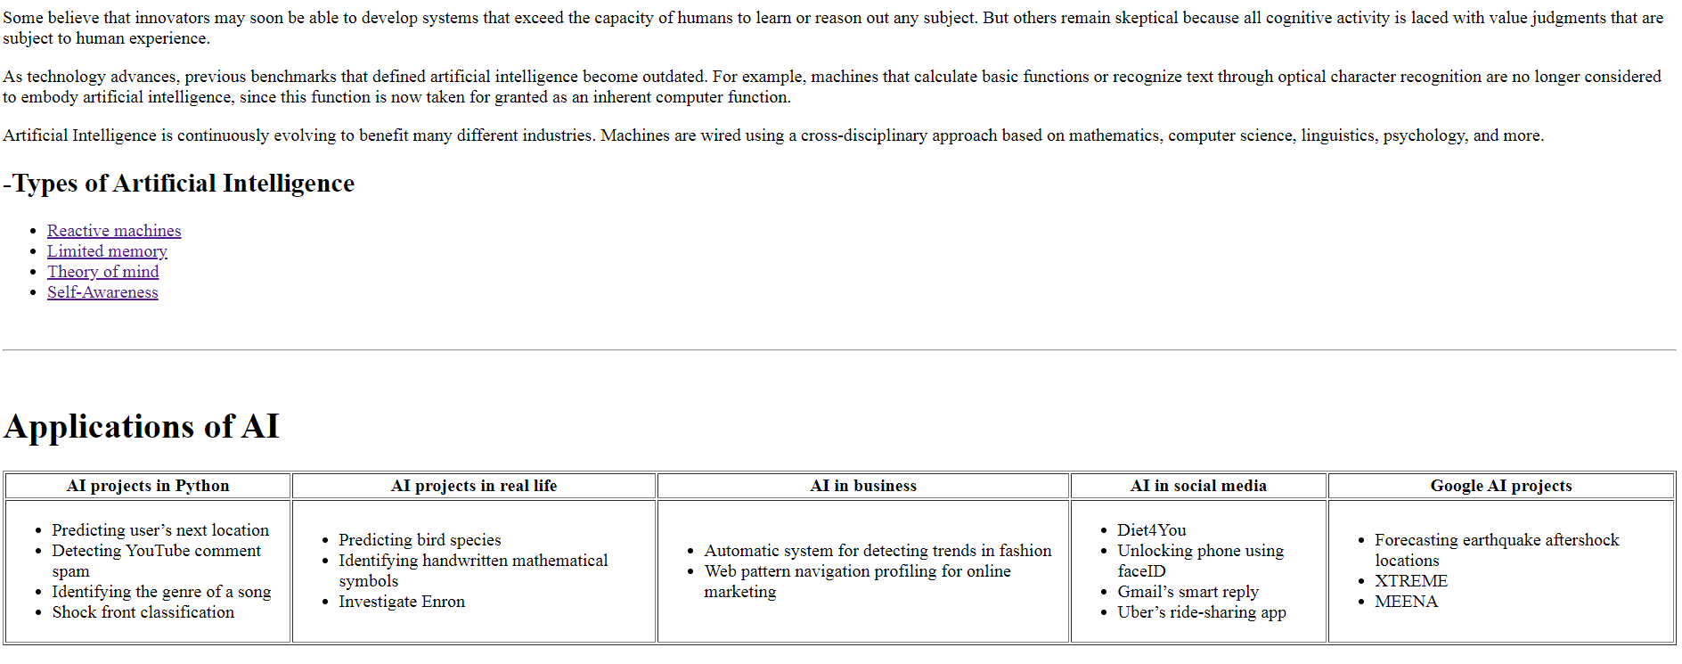

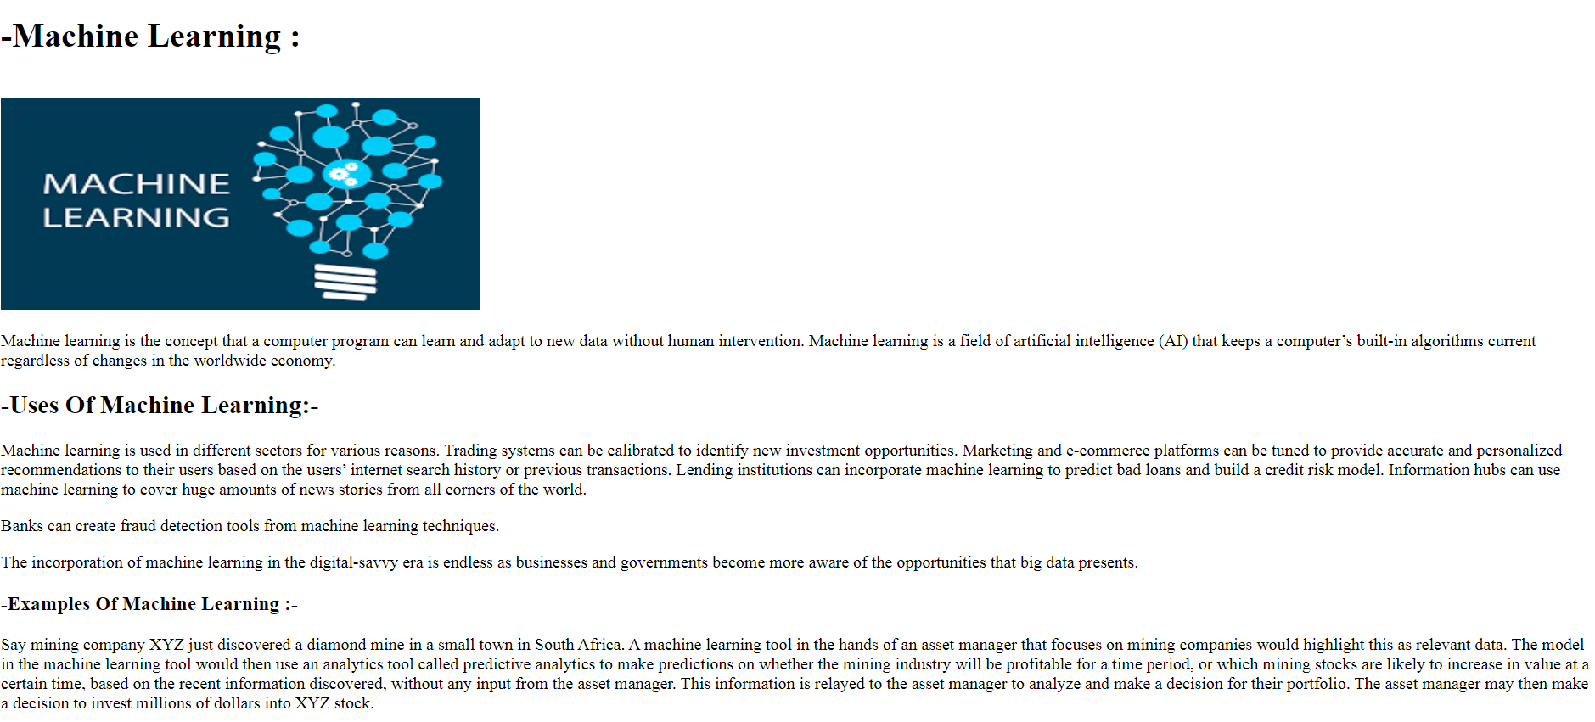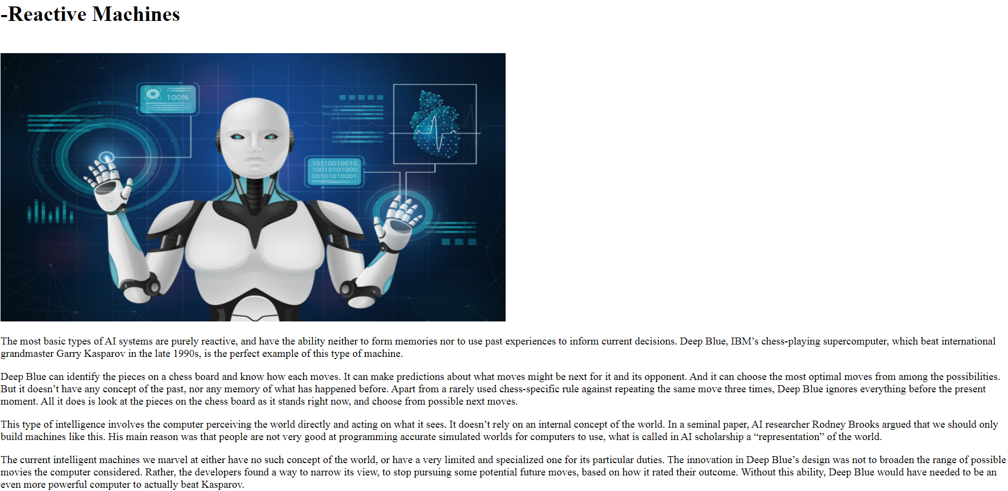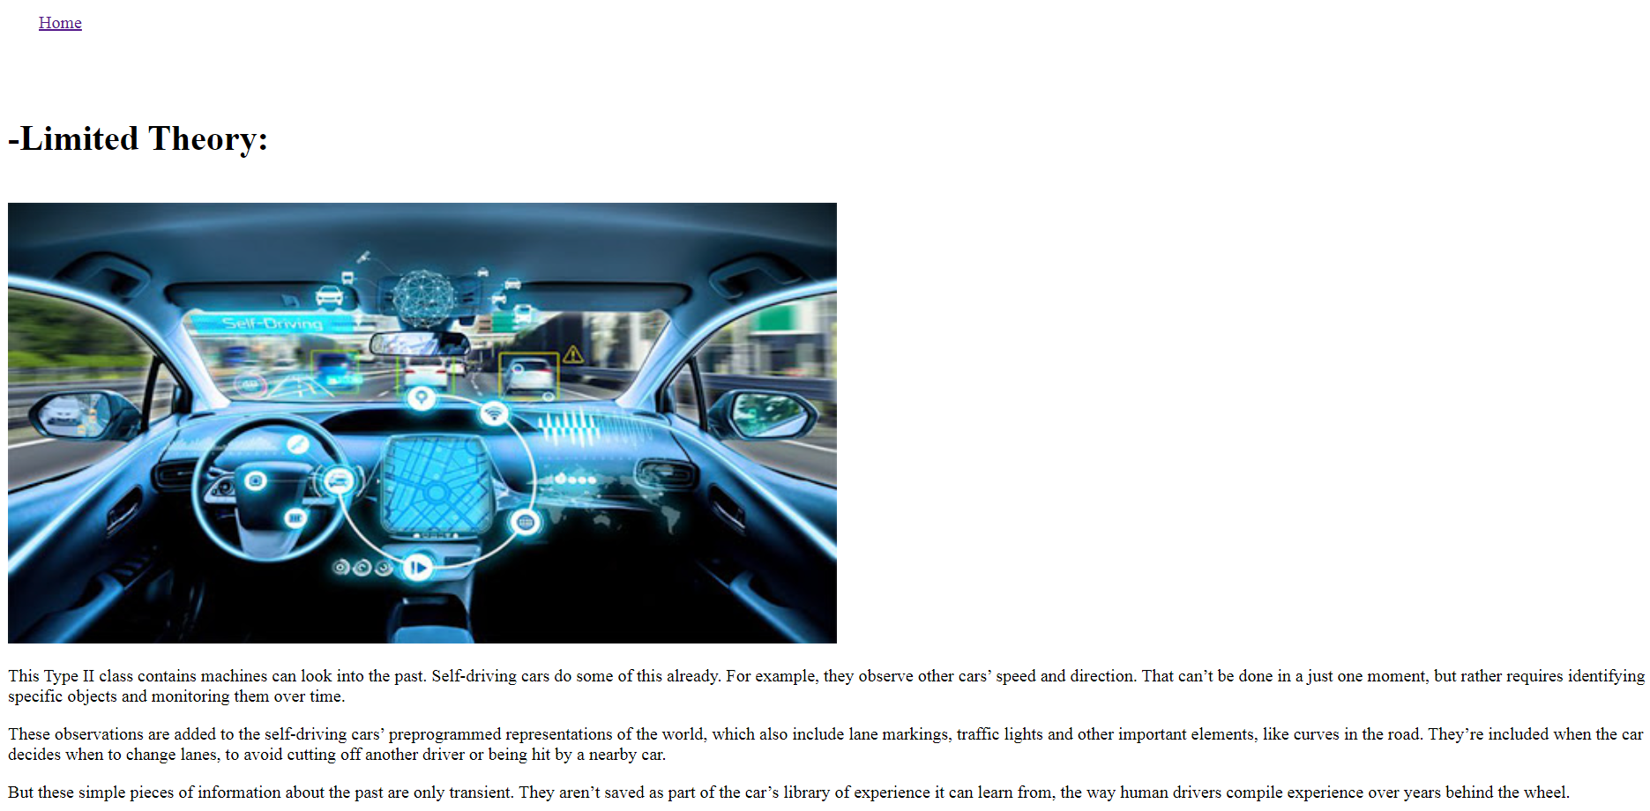
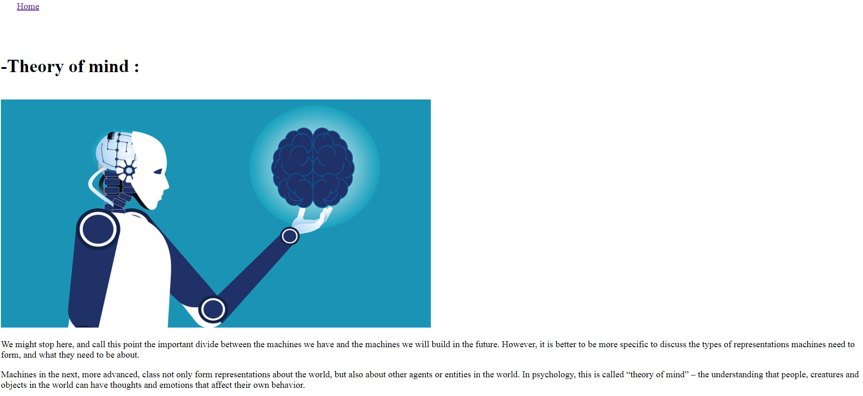
Source Code :
