Journal of Cyber Security and Risk Auditing

https://www.jcsra.thestap.com/






Title of the manuscript (16 font size, Bold, Align left and Times New Roman)

Almaha Adel Almuqren ¹

¹ Department name, Name of University, City, Postal code, Country (The font size should be 10, the font type is Times New Roman and italic)

A R T I C L E I N F O

Article History
Received: 17-03-2025 Revised: 30-05-2025 Accepted: 11-08-2025
Published: 12-08-2025

Vol.2025, No.3

DOI:

*Corresponding author. Email:

Orcid:

This is an open access article under the CC BY 4.0 license (http://creativecommons.org/licenses/by/4.0/ ).
Published by STAP Publisher.

A B S T R A C T

- The font size should be 10.
- The font type is Times New Roman

Keywords: Keyword 1; Keyword 2; Keyword 3; Keyword 4 and Keyword 5.

How to cite the article

- Introduction (Heading 1) font size 11, font type is Times New Roman.
- The font size should be 10.
- The font type is Times New Roman.

- Literature Review (Heading 2) font size 11, font type is Times New Roman.

IoT Architecture (font size 11, font type is Times New Roman and italic)

- The font size should be 10.
- The font type is Times New Roman.

- Figures must be numbering.
- Figures must be Bold.

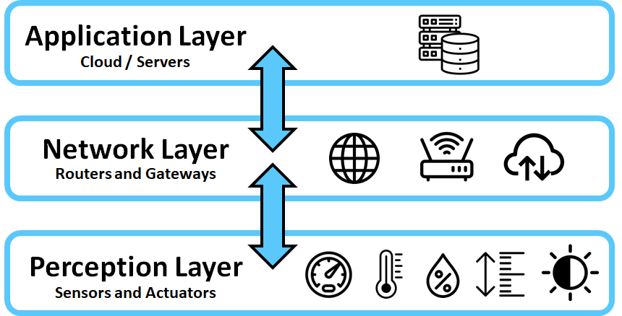

Figure 1. IoT architecture with 3-layers.

(A) Application layer

According to [11], application layer is responsible for delivering different services depending on the information stored on different servers for different applications such as smart health, smart cities, and smart homes.

(B) Network layer

, (1)
Where i, j is the pixel index, weight determined by guided graph G, which is completely independent from the input image.

2.2 Cyber Attacks on IoT

(A) Malicious Code Injection Attack

The attacker attacks a node by physically infiltrating it with malicious code, which allows the attacker to seize control of the IoT network.

(B) Phishing attack

Sensitive information can be obtained by an attacker using an infected email or website to impersonate the user's confirming identity.

(C) Spyware and Worms

3. Research Methodology

In this study, to achieve the research objectives, we used a Systematic Literature Review (SLR) as shown in Figure 3.

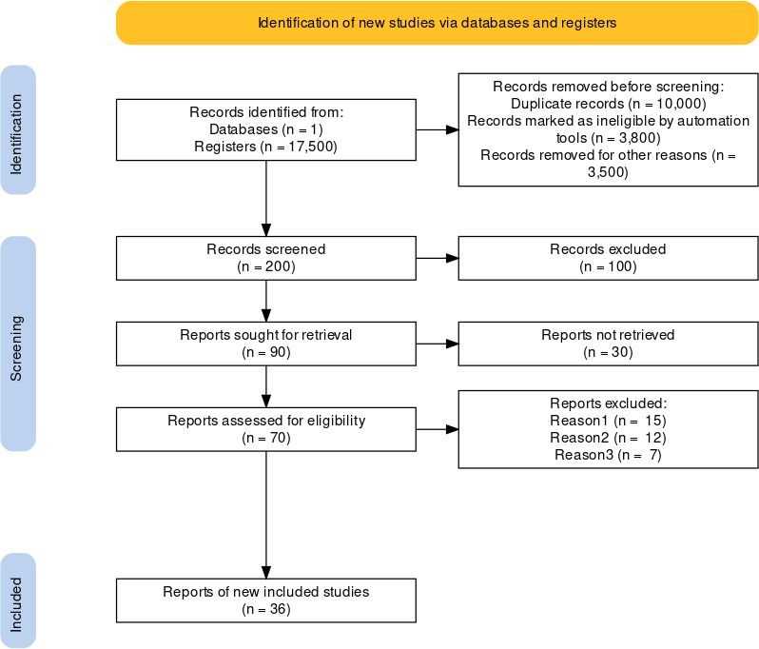

Figure 3. PRMISA methodology.

4. Analysis and Findings

As we mentioned in the preceding section, we analyzed the main threats in IoT based on three layers of IoT architecture including application layer, network layer and perception layer.

4.1 Findings of Classification of Threats and Attacks in Application Layer

Based on the analysis of the literature review, we categorized cyber threats and attacks in application layer of IoT into technical threats, as presented in Table 1.

- Tables must be numbering.
- Figures must be Bold.

Table 1. Classification of Threats and Attacks in Application Layer

Layer | Type of threats and attacks | Description
Application layer | Malicious Code Attacks [7],[6] | Attacks through running malicious codes.
 | Cross-Site Scripting Attack [8] | Attacker runs malicious codes on the web browser of the victim by adding malicious code on legitimate websites thus allowing him to tamper the application.
 | Botnet [9] | The hacker hijacks network of devices by Botnet and can control them from a single access point.

5. Conclusion

- The font size should be 10.
- The font type is Times New Roman.

Corresponding author

Vugar Abdullayev
abdulvugar@mail.ru

Acknowledgements
Not applicable.

Funding
No funding.

Contributions
V.A; A.K; N.R; M.A; Conceptualization, V.A; A.K; N.R; M.A; Investigation, V.A; A.K; N.R; M.A; Writing (Original Draft), V.A; A.K; N.R; M.A; Writing (Review and Editing) Supervision, V.A; A.K; N.R; M.A Project Administration.

Ethics declarations
This article does not contain any studies with human participants or animals performed by any of the authors.

Consent for publication
Not applicable.

Competing interests
All authors declare no competing interests.

References (APA format) and should be cited as numbers [1] in the main text

- Yang, Y., Wu, L., Yin, G., Li, L., & Zhao, H. (2017). A survey on security and privacy issues in Internet-of-Things. IEEE Internet of things Journal, 4(5), 1250-1258.
- Rejeb, A., Rejeb, K., Treiblmaier, H., Appolloni, A., Alghamdi, S., Alhasawi, Y., & Iranmanesh, M. (2023). The Internet of Things (IoT) in healthcare: Taking stock and moving forward. Internet of Things, 22, 100721.
- Sengupta, J., Ruj, S., & Bit, S. D. (2020). A comprehensive survey on attacks, security issues and blockchain solutions for IoT and IIoT. Journal of network and computer applications, 149, 102481.
- Hassija, V., Chamola, V., Saxena, V., Jain, D., Goyal, P., & Sikdar, B. (2019). A survey on IoT security: application areas, security threats, and solution architectures. IEEe Access, 7, 82721-82743.

Biographies (Required)


Author A. Description about the author A (in 5-6 lines). Email should be provided at the end. mail@email.com
（All authors must provide an email address.）


Author B. Description about the author A (in 5-6 lines). Email should be provided at the end. mail@email.com
（All authors must provide an email address.）

