Concussion networks

Method

Statistical analysis
All analyses were conducted using R (R Core Team, 2024), version 4.4.0.

Between networks
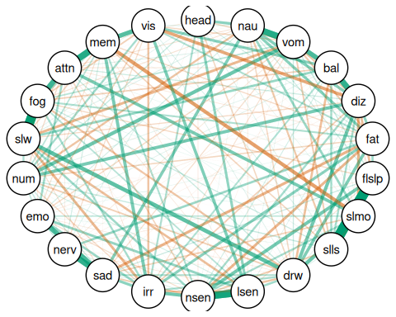

References
R Core Team. (2024). R: A language and environment for statistical computing. R Foundation for Statistical Computing. https://www.R-project.org/

