Concussion networks

# Method

## Statistical analysis

All analyses were conducted using R (R Core Team, 2024), version 4.4.0.

## Between networks

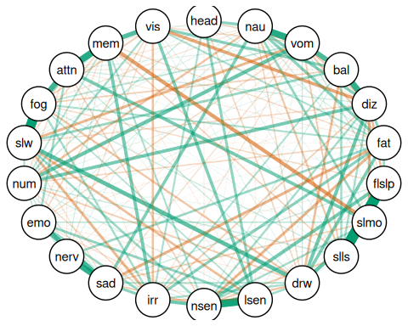

# References

R Core Team. (2024). *R: A language and environment for statistical computing*. R Foundation for Statistical Computing. <https://www.R-project.org/>