Assignment 01

Marwin Carmo

library(ggplot2)  
library(kableExtra)

mydata <- read.csv("../data/mydata.csv")

# Question 1

The dataset comprises longitudinal data from a sample of 227 participants suffering rom insomnia complaints who completed repeated assessments of insomnia severity, anxiety, and depression at three distinct occasions: baseline (T1), 6 weeks (post-treatment; T2), and 6 months (follow-up; T3). Each participant was randomized to one of three groups: (a) ACT-I; *n* = 76, (b) CBT-I; *n* = 76, or (c) Wait List; *n* = 75. In total, there were 173 (76%) female participants, and the mean age was 40.6 years (SD = 10.2).

# Question 2

For the time varying variables, we can look at Insomnia Severity. Higher scores mean more insomnia symptoms.

# Question 3

sel_data <- mydata[, c("record_id", "redcap_event_name", "insomina_severity")]  
  
  
mydata2_wide <- reshape(sel_data,  
 timevar = "redcap_event_name",  
 idvar = "record_id",  
 direction = "wide")  
  
psych::describe(mydata2_wide[, c(2,3,4)]) |>   
 kable(digits=2)

**Table 1.** Summary statistics for Insomnia Severity scores at T1, T2, and T3.

|  | *n* | Mean | SD | Min | Max | Range | Skew | Kurtosis | SE |
| --- | --- | --- | --- | --- | --- | --- | --- | --- | --- |
| ISI T1 | 227 | 19.30 | 4.08 | 8 | 28 | 20 | -0.15 | -0.51 | 0.27 |
| ISI T2 | 199 | 12.38 | 5.82 | 0 | 28 | 28 | 0.13 | -0.40 | 0.41 |
| ISI T3 | 191 | 12.19 | 6.13 | 1 | 28 | 27 | 0.24 | -0.72 | 0.44 |

cor(mydata2_wide[, c(2,3,4)], use = "complete.obs") |>   
 kable(digits=2)

**Table 2.** Pearson correlation between Insomnia Severity scores at T1, T2, and T3.

|  | ISI T1 | ISI T2 | ISI T3 |
| --- | --- | --- | --- |
| ISI T1 | 1.00 | 0.44 | 0.51 |
| ISI T2 | 0.44 | 1.00 | 0.77 |
| ISI T3 | 0.51 | 0.77 | 1.00 |

# Question 4

mydata |>   
 tidyr::pivot_longer(cols = insomina_severity:anxiety,  
 names_to = "symptom", values_to = "score") |>   
 dplyr::filter(symptom != "insomina_severity") |>   
 ggplot(aes( x = redcap_event_name, y = score, group = record_id)) +  
 geom_point() +   
 geom_line() +  
 facet_wrap("symptom") +  
 labs(x = "Time", y = "Insomnia Severity") +  
 scale_x_continuous(breaks = c(1,2,3)) +  
 theme_minimal()

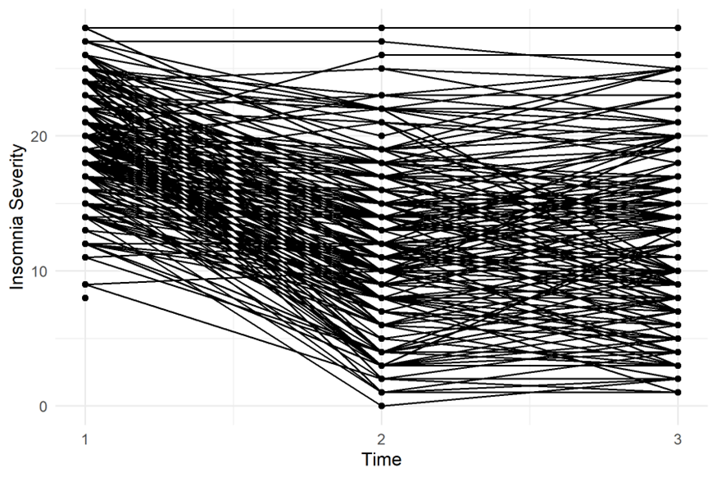

**Figure 1.** Individual trajectories of Insomnia Severity scores for the 227 participants across T1, T2, and T3.