Important Notes:

1. General Introduction (name, bio, work)
2. Skills set (graphic designing, programming)
3. Projects
4. Contact information (contacts, emails, social platform)
5. Appreciation message

Goal:

1. Futuristic theme ()
2. 3d model interactive

Feature:

1. Dark mode

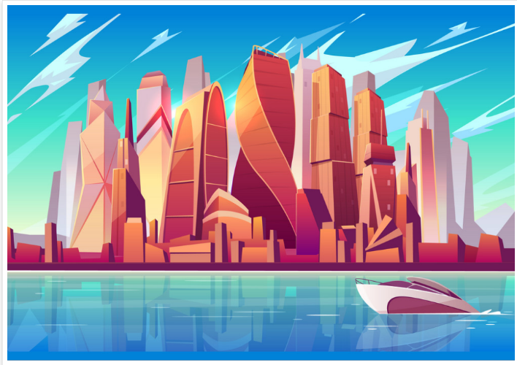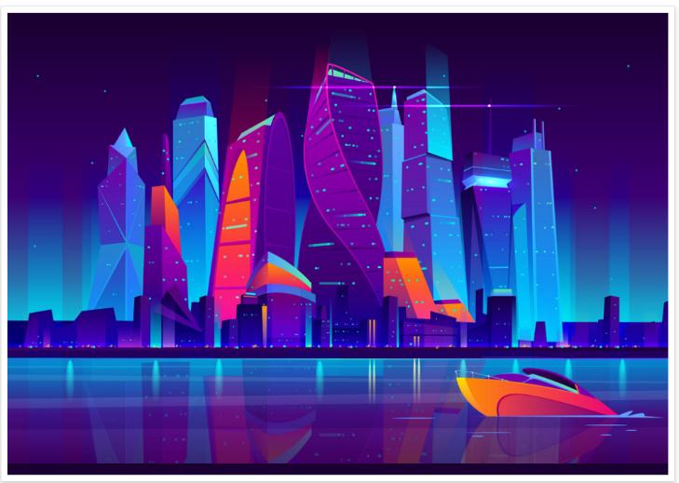 Reference Picture: