**Project Plan**

For my Project I am going to make a website for a fictional Spearfishing company in Hawaii. It is going to be specific for the Big island of Hawaii and I will be pulling my json file info for the weather report of the Big Island which will be located on the third page of my site. Listed below are the core parts of my project that I hope to accomplish to make this a meaningful learning experience.

**Project Purpose**

This spearfishing site has two objectives. The first is to educate all interested persons about what exactly spearfishing is and good safety practice techniques from beginner to advances. The second purpose is of course to pull in some income. This site is an extension of our business that provides and sells top of the line spearfishing gear and rents out gear to the ever-growing population of tourist interested in the thrill of hunting fish. We are trying to attract more customers and are setting up our site for our loyal members to be in a community that shares their drive and adrenaline for the next big catch.

**The Audience**

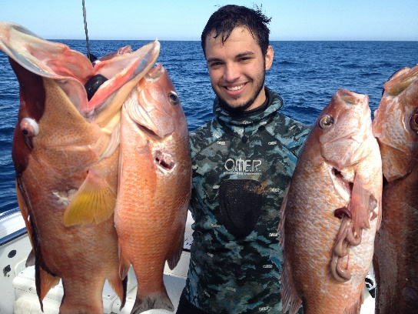

Fictional Name: David Palu

Occupation:

* Pool builder

Demographics:

* 25years old
* Married
* Father of 4 children

Goals and tasks:

* Enjoy life and spend time with family
* Provide for family the best ways possible
* Building relationships with friends and family
* Always looking for new adventures in life

Environment:

* David works out often with best friend Melvin (who is a spear fisher) and David is in good physical shape
* Has grown up in a family of four brothers and always looking for new thrills
* Works 40-50 hour weeks M-F and always takes family out on weekends to the beach

Quote:

“The better the spear the bigger the catch”

We are looking to excite our local customers first because they are the continual shoppers. Then the audience we are starting to attract are the tourist and hope that their business will begin to pour our way as we provide the gear needed to fit the thrill they desire.

**Web Pages**

1. **Home page**- will have a brief description of what spearfishing is, logo, Navigation bar, and advertisement and quick link for our gear. Will also have a video of someone spearfishing.
2. **Gear site** – promos of our latest and best available gear with our professional advice to pick the best gear for you and your next hunt.
3. **Location and weather site**- gives top locations on the island for spearfishing and a daily weather update so you don’t go rushing into a storm’ but can plan for that perfect dive trip you are always looking for. Use our site and never again have switch between sites to get all the up to date weather and diving location reports.
4. **Safety and technique**- all the best safety practices for diving and the techniques that will help go from holding your breath at 20 seconds to 1 minute or more. Plus, our professional tips on how to catch fish effectively.
5. **Catch of the week**- a page for customers to email their best videos for everyone to see. Also for them to see each week’s winners who will get a prize for best catch and best shot.

**Wireframe Sketches**

Small Home Small Gear Small Location

Site title

Site title

Site title

Nav Bar

Nav Bar

Nav Bar

spears

fins

Masks

video

Spearfishing descript.

Name summary link

Name summary link

Accs

knives

suits

Name summary link

Gear pics and quick link

Name summary link

foot

guide

foot

foot

Small Safety Small Catch

Site title

Site title

Nav Bar

Nav Bar

Email

Breathing

Best catch video and info

Equip/ shooting

Best shot video and info

surroundings

foot

foot

Medium Home Medium Gear

Site title

Site title

Nav Bar

Nav Bar

Spear icon link

Fins icon link

Mask icon link

Spearfishing descript.

Video

Knives icon link

Acces. Icon link

Suit icon link

Gear pics and quick link

Guide

foot

foot

Medium Location Medium safety

Site title

Site title

Nav Bar

Nav Bar

Breathing

Name summary link

Equipment and shooting

Name summary link

Surroundings

Name summary link

foot

foot

Name summary link

Medium Catch

Site title

Nav Bar

Email

Best catch video and info

Best shot video and info

foot

Large Home

Large Home old plan

Large Home old plan

Site title

Nav Bar

Spearfishing Description

video

Gear pics and quick link

footer

Large Gear old plan

Site title

Nav Bar

Pic

Spear icon link

fins icon link

Mask icon link

Acces. icon link

knives icon link

suit icon link

Guide

footer

Large Location old plan

Site title

Nav Bar

Name summary link

Name summary link

Name summary link

Name summary link

footer

Large Safety old plan

Site title

Nav Bar

Surroundings

Equipment and shooting

Breathing

footer

Large Catch old plan

Site title

Nav Bar

Email

Best catch video and info

Best catch video and info

Runner up catch video and info

Runner up catch video and info

footer

Changes

I made changes to all of the site plans for my large screens for transition purposes. I feel it is smoother in the new plan going form the medium screen to the large screen. Below are the new plans for the large screens.

Notifications

* I have 2 json files and they are used on the “weather” and “weekly video” pages.
* The “weekly video” page holds both of my HTML5 videos.
* My responsive images are the icons for the “gear page”.

Large Home Large Gear

Site title

Site title

Nav Bar

Nav Bar

Spear icon link

Fins icon link

Mask icon link

Spearfishing descript.

Video

Knives icon link

Acces. Icon link

Suit icon link

foot

foot

Guide

Gear pics and quick link

Large Location Large safety

Site title

Site title

Nav Bar

Nav Bar

Name summary

Breathing

Name summary

Equipment and shooting

Name summary

Name summary

Surroundings

foot

foot

Large Catch

Site title

Nav Bar

Email

Best catch video and info

Best shot video and info

foot

**Usability Concepts**

* Font size/spacing is easy to read- Font size will be legible an of a clear font- family to make reading as easy as possible.
* Images have appropriate ALT tags-Alt tags will be descriptive so when there is a page reader for anyone with visual disabilities they will even understand what is going on.
* Main navigation is easily identifiable- all pages will have the same navigation link at the top so travel between pages will be fast and easy.
* Links are consistent & easy to identify- links will be in blue color as to identify what is a link and if it is an Icon it will have a small caption for a link
* Major headings are clear & descriptive and HTML page titles are explanatory- Headings and titles will be large and descriptive to explain what is going on in each page and paragraph.
* Main copy is concise & explanatory- Content will be easy to understand so users are not wondering what each page is about.
* Clear path to contact information/ Clear path to company information- Both will be in the footer and possibly top right corner of page so users can contact easily whether at the beginning or end of a page