**Project Plan**

For my Project I am going to make a website for a fictional Spearfishing company in Hawaii. It is going to be specific for the Big island of Hawaii and I will be pulling my json file info for the weather report of the Big Island which will be located on the third page of my site. Listed below are the core parts of my project that I hope to accomplish to make this a meaningful learning experience.

**Project Purpose**

This spearfishing site has two objectives. The first is to educate all interested persons about what exactly spearfishing is and good safety practice techniques from beginner to advances. The second purpose is of course to pull in some income. This site is an extension of our business that provides and sells top of the line spearfishing gear and rents out gear to the ever-growing population of tourist interested in the thrill of hunting fish. We are trying to attract more customers and are setting up our site for our loyal members to be in a community that shares their drive and adrenaline for the next big catch.

**The Audience**

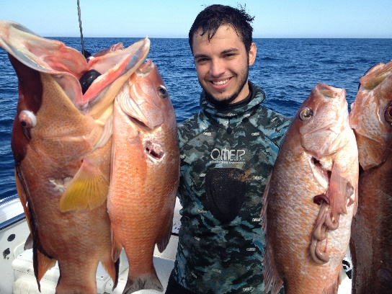

Fictional Name: David Palu

Occupation:

* Pool builder

Demographics:

* 25years old
* Married
* Father of 4 children

Goals and tasks:

* Enjoy life and spend time with family
* Provide for family the best ways possible
* Building relationships with friends and family
* Always looking for new adventures in life

Environment:

* David works out often with best friend Melvin (who is a spear fisher) and David is in good physical shape
* Has grown up in a family of four brothers and always looking for new thrills
* Works 40-50 hour weeks M-F and always takes family out on weekends to the beach

Quote:

“The better the spear the bigger the catch”

We are looking to excite our local customers first because they are the continual shoppers. Then the audience we are starting to attract are the tourist and hope that their business will begin to pour our way as we provide the gear needed to fit the thrill they desire.

**Web Pages**

1. **Home page**- will have a brief description of what spearfishing is, logo, Navigation bar, and advertisement and quick link for our gear. Will also have a video of someone spearfishing.
2. **Gear site** – promos of our latest and best available gear with our professional advice to pick the best gear for you and your next hunt.
3. **Location and weather site**- gives top locations on the island for spearfishing and a daily weather update so you don’t go rushing into a storm’ but can plan for that perfect dive trip you are always looking for. Use our site and never again have switch between sites to get all the up to date weather and diving location reports.
4. **Safety and technique**- all the best safety practices for diving and the techniques that will help go from holding your breath at 20 seconds to 1 minute or more. Plus, our professional tips on how to catch fish effectively.
5. **Catch of the week**- a page for customers to email their best videos for everyone to see. Also for them to see each week’s winners who will get a prize for best catch and best shot.

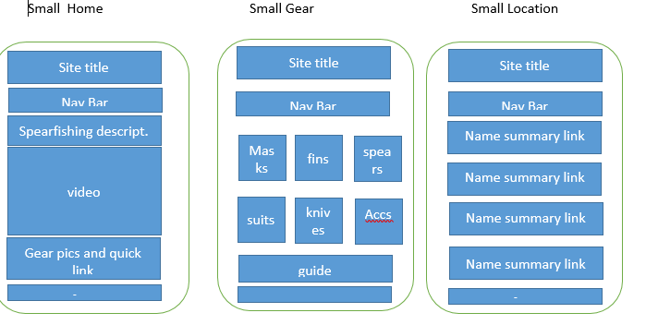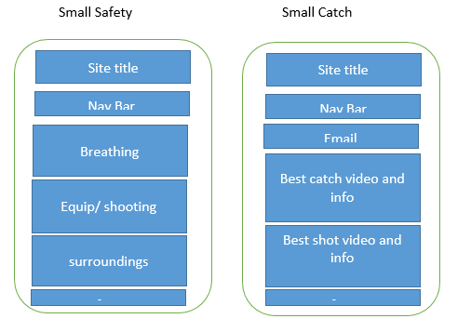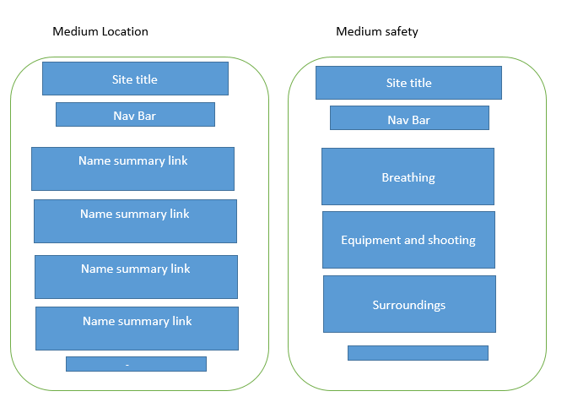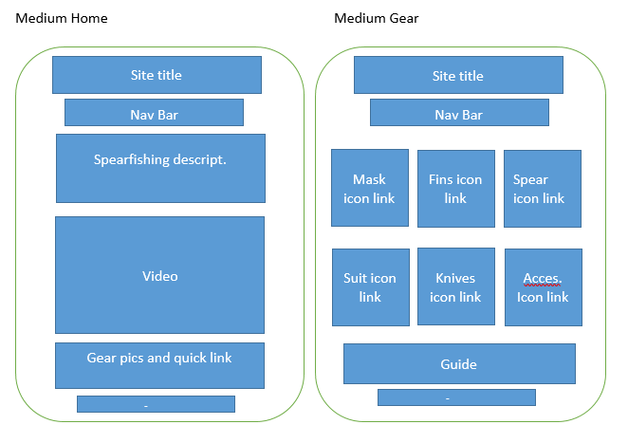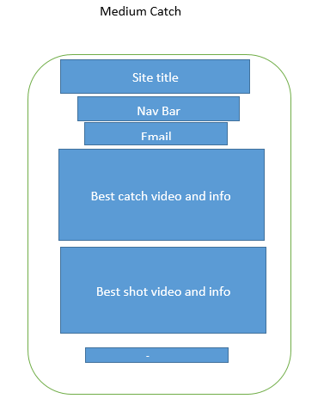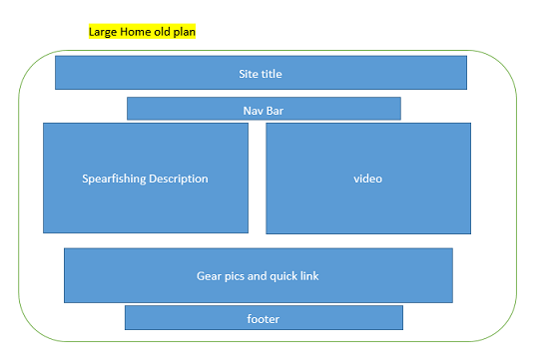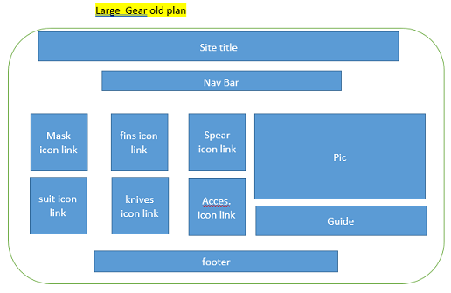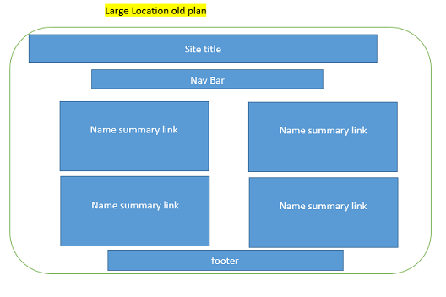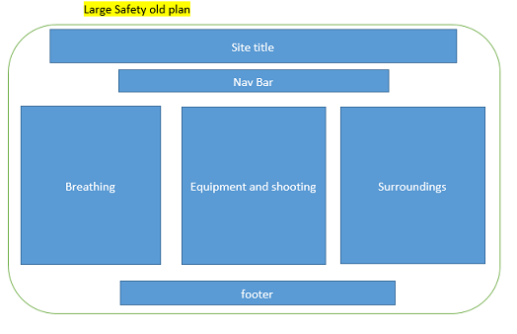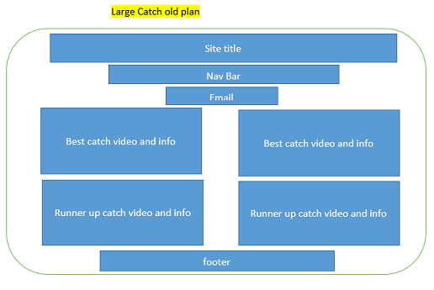

I made changes to all the large screen site plans for transition purposes. I feel it is smoother in the new plan going form the medium screen to the large screen. Below are the new plans for the large screens.

Notifications

* I have 2 json files and they are used on the “weather” and “weekly video” pages.
* The “weekly video” page holds both of my HTML5 videos.
* My responsive images are the icons for the “gear page”.

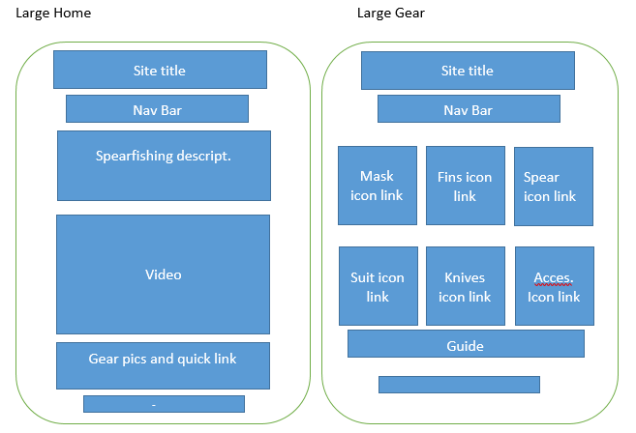

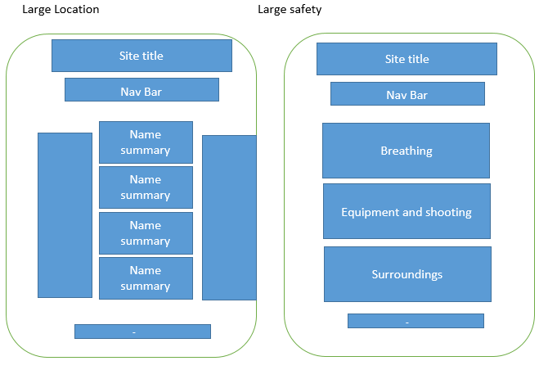

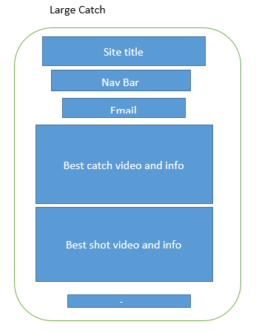

**Usability Concepts**

* Font size/spacing is easy to read- Font size will be legible an of a clear font- family to make reading as easy as possible.
* Images have appropriate ALT tags-Alt tags will be descriptive so when there is a page reader for anyone with visual disabilities they will even understand what is going on.
* Main navigation is easily identifiable- all pages will have the same navigation link at the top so travel between pages will be fast and easy.
* Links are consistent & easy to identify- links will be in blue color as to identify what is a link and if it is an Icon it will have a small caption for a link
* Major headings are clear & descriptive and HTML page titles are explanatory- Headings and titles will be large and descriptive to explain what is going on in each page and paragraph.
* Main copy is concise & explanatory- Content will be easy to understand so users are not wondering what each page is about.
* Clear path to contact information/ Clear path to company information- Both will be in the footer and possibly top right corner of page so users can contact easily whether at the beginning or end of a page