HAYES COUNTY WATER SUSTAINABILITY ANALYSIS BY

MARWON HARIDI

GIST

426008497

*Sustainability Calculations*

*Input Factors & Calculations*

*Python Scripting*

*Project Significance*

*Methodology Sources*

*Data and Numerical Modeling*

*Appendix & References*

BRYAN PONZIO

GIST

527007867

*Project Objectives*

*Management Solutions*

*Nature of the Problem*

*Sourced Data*

*Land Classification & Recharge Rates*

*Model Calibration*

*Conclusion*

*Appendix & References*

GEOG 476

GIS Practicum

Texas A&M University

Copyright 2022

1. INTRODUCTION

A growing problem in Texas is the rapidly growing concerns regarding water scarcity and measures being taken to reduce it. As it is right now, the amount of people globally that are affected by water scarcity has jumped from 0.24 billion in the 1900’s to 3.8 billion in the 2000’s (Kummu et al. 2016). One of the reasons that this has occurred is that the total freshwater consumption per year during the 2000’s was 4 times the amount as the total freshwater consumption per year in the 1900’s (Kummu et al. 2016). One of the main reasons that consumption has increased is due to the explosive population growth that occurred, resulting in around a 4 times increase from the 1900’s to the 2000’s (Kummu et al. 2016). Another reason for the increase in water scarcity is due to the growing human induced environmental issues arising, such as climate change and increasing global temperatures, leading to a more arid environment in some areas, such as Texas (Banner et al. 2010).

1.1 PROJECT OBJECTIVES

The task of being able to characterize and quantify the Earth systems and forcing factors involved in modeling and predicting water sustainability in an area to determine if an area’s water cycle is sustainable is a complex and multifaceted problem. The problems at hand are population increase, climate change, water resource supply issues, and how these interact and are interrelated with each other. As the world around us is always changing due to climatic and anthropogenic factors, we need to be able to accurately grasp how much these factors are affecting the area's sustainability. This will be done through delivering inputs of the water table and making it a realistic assessment of the situation at hand, which will be done by using agreed upon constants for some data points and factors as well as data collection of the area for things such as population growth and precipitation. With this, the project will then have the ability to best account for the factors contributing to changes in water sustainability.

Once forcing factors on sustainability are quantified and accounted for, this can then be implemented into a model to where predictions can be made on the future water sustainability in the area. The scope of this project is to locate the range of how sustainability in the study area will be 50 years in the future. Within this model simulation, its goal is to best represent reality in the area as well as possible beyond limitations and assumptions, characterizing as well as possible with mathematical equations and constants. In order to circumvent said limitations, the utilization of constants can assist in representing the 3D aspect of the model. Now that water resource sustainability in the study space is quantified and accounted for within the simulation, the goal is to now evaluate the situation then deliver what decisions can be made to improve the situation. Anywhere near mass balance allows for the area to be sustainable, a negative factor shows the area is not sustainable, and a positive factor indicates more water is going into the system than water leaving. Once this is delivered, it can then be evaluated what management decisions need to be made in order to keep mass balance in the system.

1.2 PROJECT SIGNIFICANCE

Human induced environmental issues combined with the natural climate change that occurs has put a large amount of stress on water resources around the world (Banner et al. 2010). This pressure has led to climate prediction becoming more unpredictable and a higher amount of uncertainty predicting changes in precipitation (Banner et al. 2010). Available freshwater sources are also diminishing in quantity as some areas are drying out due to rising global temperatures and others are being polluted and made unfit for consumption (Banner et al. 2010). Due to all of these factors and the overall importance of accessible freshwater, the increase in scarcity of available freshwater is becoming a huge issue that needs to be dealt with soon. In this project this topic will be explored regarding the area of Hayes County in Texas where both the water scarcity and the reasons behind are assessed and possible solutions will be constructed based on the findings.

2. LITERATURE REVIEW

2.1 NATURE OF THE PROBLEM

Being able to assess an area’s groundwater resource sustainability through building a spatiotemporal simulation over 50 years is an important task to assure resource availability for the population in our selected area of Hays County, Texas. The nature of groundwater sustainability in all areas, among Hays County’s groundwater pumping is exceeding naturally occurring recharge amounts, and this is adversely affecting human and environmental systems (Miller, Milman, Kiparsky, 2021). Climate change adds urgency to this, due to more extreme climatology effects such as extreme droughts and floods. (Miller, Milman, Kiparsky, 2021). We are able to see how forcing factors can affect groundwater in models from other literature, like how forcing factors can change like how precipitation is averaged by month (Sahoo, & Jha, 2017) rather than getting yearly totals as our model presents. This makes our precipitation model uniquely address issues on how data accumulation is synthesized and utilized to produce meaningful information from forcing factor data.

2.2 METHODOLOGY SOURCES

In our study, a core aspect of our methodology is obtaining relevant data and analyzing it to produce values needed for the sustainability index models. We make use of different equations to calculate the input factors, the output factors, and the sustainability indices. Similar studies regarding water sustainability have used this same approach in order to solve their issues with sustainability, shown through numeric modeling in the Mahanadi Delta in India. The study that does this goes over groundwater sustainability in the Mahanadi delta region in India through the use of numeric modeling (Sahoo & Jha, 2017). In their study they employ models obtained through similar calculations in regards to rainfall using 21 years of rainfall data. The study also employed testing the models to current values at the time, which indicated that the models had a certain degree of accuracy (Sahoo & Jha, 2017). Another study employed calculations and models to come up with their own sustainability indices to evaluate groundwater sustainability in California (Thomas, 2018). In the study they employed many different numerical models to calculate the total water storage per year, taking into account factors such as changes in soil moisture, surface water storage, snow water equivalent, and groundwater (Thomas, 2018). They then were able to use those metrics as well as some other numeric calculations such as reliability, resistance, and vulnerability to create their own sustainability indices (Thomas, 2018). While the sustainability indices used in the study vary from the ones used in this study, the approaches used are similar where data was taken and input and output factors were calculated to formulate a sustainability index.

Many studies regarding sustainability of water have made use of and relied heavily on GIS technologies to aid in their research. A study regarding the sustainability of drinking water in Tabriz city, Iran made use of multiple GIS technologies and strategies to aid in coming up with possible solutions to their problem (Feizizadeh et al., 2021). Their problem is similar enough to ours that we can use it to justify aspects of our approach. Our studies are similar in that both are dealing with water sustainability over time in a fixed area that is struggling with decreasing available water sources and making use of GIS technologies and strategies to analyze and come up with solutions to it (Feizizadeh et al., 2021). Other Studies also focus on similar topics to ours, such as a study focusing on overall regional sustainability over Victoria, Australia (Graymore et al., 2009) and environmental sustainability regarding university campuses (Alshuwaikhat et al., 2017). While these studies deal with different topics, they all make use of GIS practices of modeling future water sustainability that we are employing in our study. Some of them are employing criteria based modeling by using land cover maps (Graymore et al., 2009) (Feizizadeh et al., 2021), and some are using DEMs to compute water flow (Feizizadeh et al., 2021). While these studies share similarities with ours in how GIS technologies are used, ours differentiates itself by focusing on a much larger temporal scale and incorporating land cover types for water recharge areas, which using this gives us a much more accurate representation of reality. Studies explain how our modeling is unique in utilizing land cover and land use in groundwater analysis; that land cover and land use impacts on changes to subsurface hydrology, especially recharge of aquifers is not well studied, and spatially distributed hydrologic models have advantages that can account for spatial patterns of the hydrological impact of land use and land cover (Zomlot et al 2017).

2.3 MANAGEMENT SOLUTION SOURCES

Being able to retain information delivered from the model and be able to produce relevant solutions to keep the area sustainable is important. There are universal management practices that are used among all study areas, but there is literature specific to our study area of Hays County and the Trinity Aquifer. These include; drought curtailments; implementing simple and representative drought declaration methodologies using specific recharge areas (Jacob’s Well) as triggers for when to implement strategies. Next is education and conservation; effective communication to the public when conservation needs to take place, and conservation strategies including watering schedules. Practices can also include infrastructure efficiency practices; reducing line loss and other infrastructure problems that may waste groundwater when being pumped. (Gary et al. 2019). Adaptive management is another thing that can be learned from in literature and applied. This isan approach characterized by feedback loops and the willingness to adjust assumptions, objectives, management actions, and outputs (Sophocleous 2005). The most important aspect of adaptive management is having the capacity to initiate and maintain long-term monitoring programs (Sophocleous 2005). In other words being agile to be ready to implement these management strategies at a moment's notice.

3. METHODOLOGY

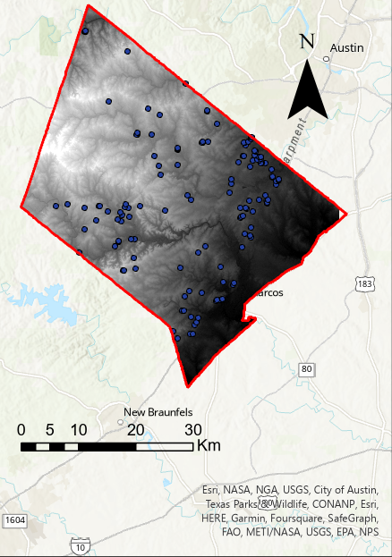

3.1 DATA

Population data over the years of 1970-2020 was collected from the US Census and precipitation data over the same time period was gathered from a weather station located on Blanco River near Kyle, TX and were cleaned and stored in an excel document to be used for producing models in the study. This data was utilized for tracking historical data to predict future changes in climate over the study area. 30x30M DEM and Landsat9 data was obtained from the USGS and was cleaned and masked to fit Hays county and saved as an ArcGIS feature Layer. Well location and depth data was obtained from TCEQ in the form of an ArcGIS feature layer. All of these featured layers were then put into a singular ArcGIS project and used to produce the models (Fig. 1). *Fig. 1 Hays County DEM map with well data*

3.2 NUMERICAL MODELING

*3.2.1 Input System Characterization*

Spectral imagery was utilized to produce a land cover map to then generate recharge in the study area that regulates how much precipitation makes its way into the aquifer system. The land cover map was generated by downloading Landsat 8 spectral data recorded on October 19, 2022. Land cover types were then generated by utilizing an ISO Cluster Unsupervised Classification tool which located 8 land cover classes based on statistical differences in the spectral characteristics of pixels in the map (Fig. 2). Once classes are determined by the algorithm, each class was given a land type based on relevant literature who used similar classes (Graymore et al., 2009) along with utilizing NDVI imagery and best judgment to best characterize reality. This table represents the recharge rate for each land cover type (Table 1). These recharge rates were then multiplied by the precipitation rate for each individual pixel which produced the recharge rate for each pixel and computing the total precipitation water volume.

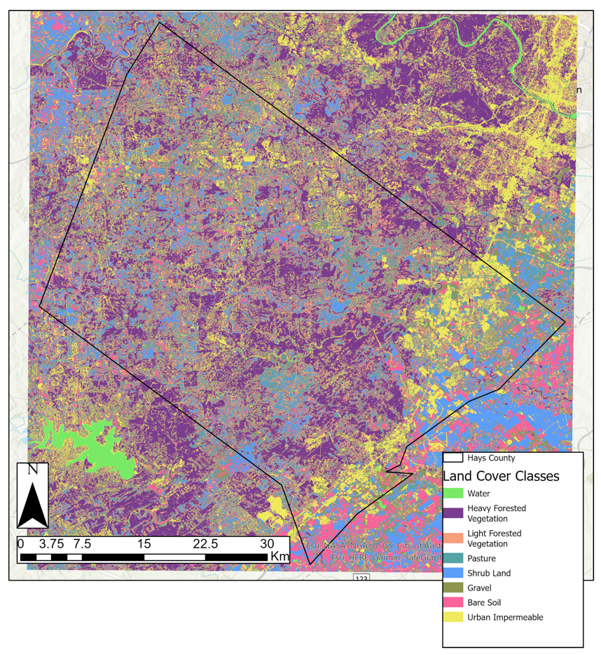

*Fig. 2. Hays County land cover map classified by land cover types.*

|  |  |
| --- | --- |
| **Land Cover Type** | **Recharge Rate** |
| Water | 1 |
| Heavy Forested Vegetation | .75 |
| Light Forested Vegetation | .85 |
| Pasture | .9 |
| Shrub Land | .8 |
| Gravel | .7 |
| Bare Soil | .95 |
| Urban Impermeable | 0 |

*Table 1. Recharge rates for each land cover type in land cover map.*

Using this past data, a linear slope equation was formed and used to predict the annual rainfall amount over the next 50 years (Equ. 1, equations found in appendix). In this equation, *y* is the predicted annual precipitation in meters for that year and *x* is the amount of years after 1970. The water table altitude was then computed by taking the minimum altitude in the area (*zMin*) in meters and adding 5 meters to it to account for it most likely being a river, quantified in equation 2 in the appendix (Equ. 2). The unconfined aquifer base (Equ. 3) is then calculated by subtracting 1000 meters from the water table altitude (*Zw)*. Map algebra is then used to calculate the base water volume where *LW* equals the grid size used for the DEM, (*Zw  - zMin*) is the water table altitude - the unconfined aquifer base in meters, and *Φp* is a constant for the aquifer porosity (Equ. 4.1). The equation is then modified to calculate the input of water per year with the *P*(*t*) representing precipitation for that year in meters and *RV* which represents the recharge value for the pixel (Equ. 4.2). Then the depth of water is calculated per year by dividing the input of precipitation by the planimetric size of the study area in meters2 and then divided again by the porosity to account for porosity (Equ. 4.3). Lastly time is then accounted for when calculating the water table by adding the porosity corrected water height and the previous year’s water table altitude (*Zw*(*t*)) (Equ. 5).

*3.2.2 Output System Characterization*

Population data was collected from 1970 - 2020 and was used to create a model to predict population growth in Hays county over the next 50 years. An exponential relationship was created using this past data where *y* is the total estimated population for that year and *x* is the total number of years after 1970 (Equ. 6). This equation takes our exponential relationship and binds to our total number of years. Water requirements for the population were then calculated per year where *p0* is the estimated population for that year and *Wp* indicates the total amount of water needed per person in liters (Equ. 7). Well discharge was then accounted for where *Nw* is equal to the number of wells, *QWell(t)* is the pump discharge in liters, and *Wi* is equal to 1 or 0 depending on if the well is dry (Equ. 8). After that the total water output is calculated where *Hp* is equal to total well discharge for the year, *Ap* is equal to planimetric area, and *Φp* represents the aquifer porosity (Equ. 9). Lastly the water table is reevaluated where represents the total water inputted into the system and represents the total amount of water outputted by the system (Equ. 10).

3.3 CALIBRATION AND SUSTAINABILITY

Being able to characterize sustainability is multifaceted and can be difficult to represent in a system. In order to represent a sustainability index in the model the first step is calibration in order to have confidence in the success of running the model. Calibration was first done by testing the inputs of the system. Land cover calibration was done by checking satellite imagery and all bands of landsat imagery, then determining how accurate the land cover map is. As for recharge, all recharge values per pixel were changed to uniform, then random to test if they produced expected results. This was also done with altering the water table and aquifer base, making it a uniform value that was lower than expected, then higher than expected, to test expected values through the simulation. Population and precipitation were calibrated based upon conditions expected by us; keeping them constant to see if simulation results were still producing positive or negative sustainability if these factors were changed or unchanged.

To produce the sustainability index, the system input equations were inputted for each year from 0 to 50 to compute the sustainability index for water (*Sw(t)*) (Equ. 11), which the water volume over time (*V(t)*)will be needed (Equ. 12). Then the sustainability index for population growth and human shelter will be calculated (Equ. 13), with As represents land cover shelter area (urban impermeable recharge) and A’ represents the area given the increase of the number of people. Now that the sustainability of population growth and precipitation change are accounted for each *x* year 0-50, the overall sustainability index can be computed by assigning a weight of 0.8 to the precipitation sustainability index and 0.2 to the population sustainability index (Equ. 14).

3.4 MANAGEMENT SOLUTIONS AND SIMULATIONS

After sustainability is computed and able to be quantified over time, we can then look into management solutions and simulate what can be changed in the study area in order to keep water sustainability intact into the future. The first scenario is land cover, and changing land cover to upkeep with the rising population in the future, changing the square feet of urban area per person. The first simulation with no land cover changes to urban impermeable land cover, second with an underestimated amount of land cover change to urban area, and lastly with an overestimated urban land cover to judge which is the most accurate way to represent reality and keeping sustainability. Water wells are also adjusted to characterize management solutions. Water wells are manipulated by making wells deeper and adding more wells into the study area from simulation to simulation to analyze what changes keep the aquifer as sustainable as possible. These changes can give us context on how sustainability should be altered and find the best way to keep the area sustainable.

4. RESULTS AND DISCUSSION

4.1 SIMULATION RESULTS

With the population data and precipitation data modeled as well as the well discharge rate and recharge amount, calculated, the water table was computed over the next 50 years. A base of 164(m) was used for the water table and over all three precipitation scenarios showed an increase in the table. The base precipitation model as well as the +2 standard deviation model both exhibit almost a linear relationship while the -2 standard deviation precipitation model starts to show more of an exponential relationship, where the curve is starting to flatten out (Fig. 3). This is probably due to the precipitation input being lower for the -2 standard deviation model causing it to approach the well discharge at the time. If another 50 years were calculated, the -2 standard deviation model would probably start showing an exponential decline in the water table as well as both the base model and the +2 standard deviation model would probably start to follow the same trend. The max value obtained from the model after the 50 year simulation was approximately 186m, 225m, and 263m for the -2 standard deviation model, the standard model, and the +2 standard deviation model respectfully.

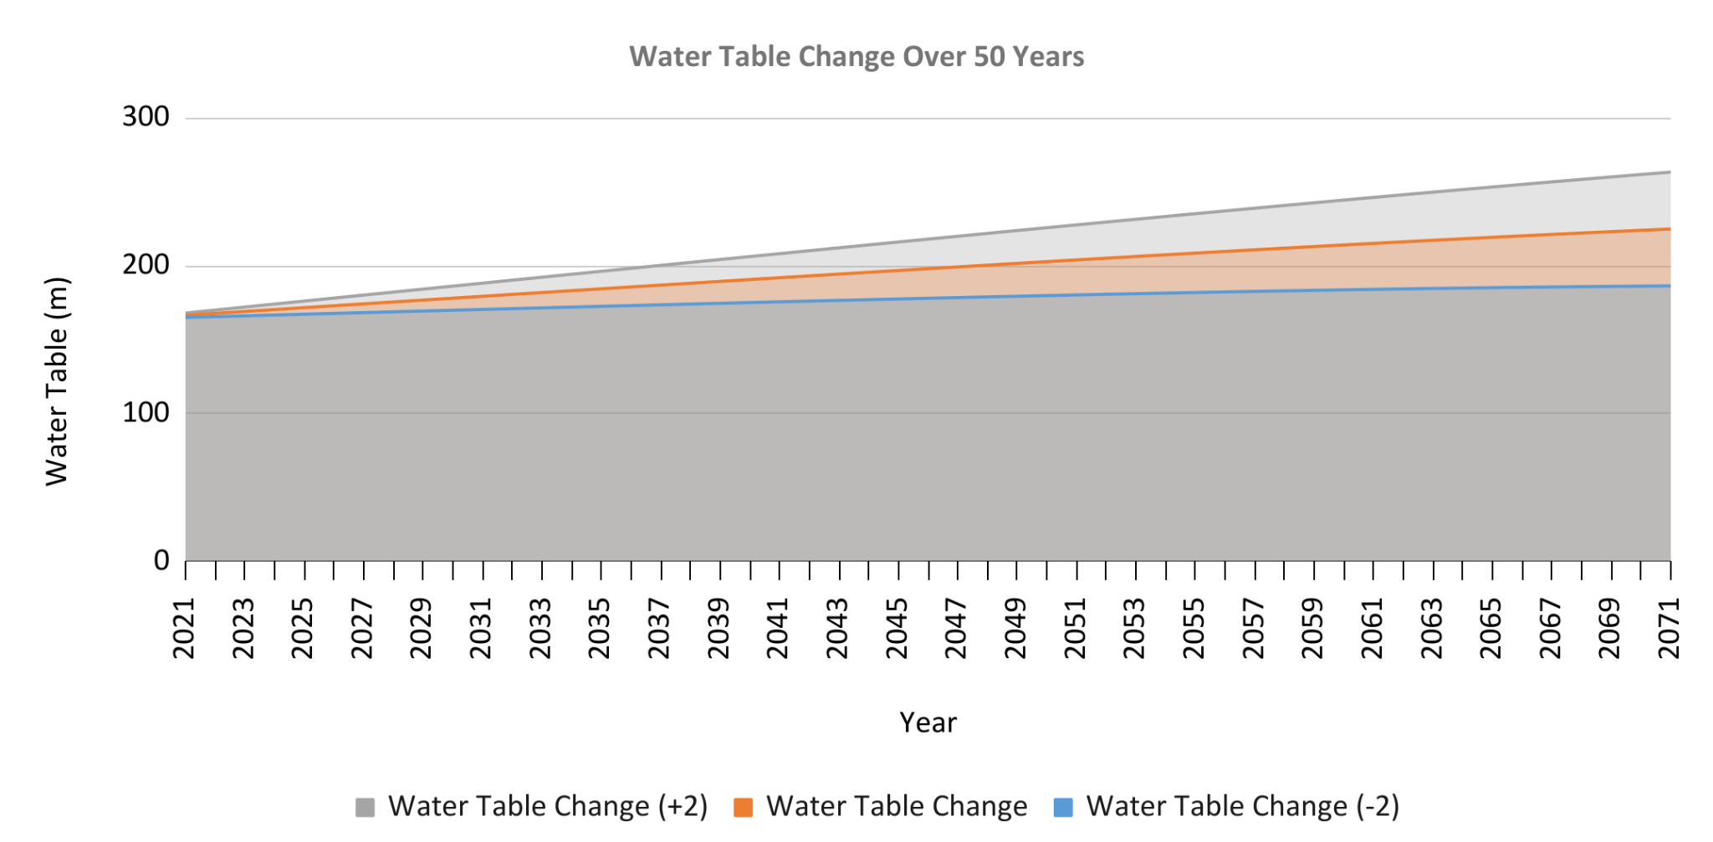

*Fig 3. Predicted water table height (m) change over the next 50 years in Hays County, accounting for +/- 2 Stdev precipitation.*

The precipitation sustainability model shows similar trends between the -2 standard deviation model, the base model, and the +2 standard deviation model, with different nuances between them. Both the base model and the -2 standard deviation model started and continued to be negative, indicating that the situation is already not sustainable, while the +2 standard deviation model starts positive and stays positive throughout the 50 years, indicating that the situation would be sustainable (Fig. 4). While the +2 standard deviation model shows positive sustainability, it is starting to exhibit an exponential relationship downwards near the last 10 years of the model. Both the other models exhibit this trend earlier with the -2 standard deviation model exhibiting it the earliest and the most extreme at around halfway through the model (Fig. 4). The -2 standard deviation model also starts with a much lower sustainability index than the other 2 models at around -0.503 while the other 2 models start at -0.143 and 0.078. The difference between the -2 standard deviation model and the base model is also much larger at a difference of 0.360 compared to the difference between the base model and the +2 standard deviation model with a difference of 0.065. This shows that the -2 standard deviation model start conditions are much less sustainable than the other 2 models, which cause it to become more unsustainable over the same period as the other 2 models.

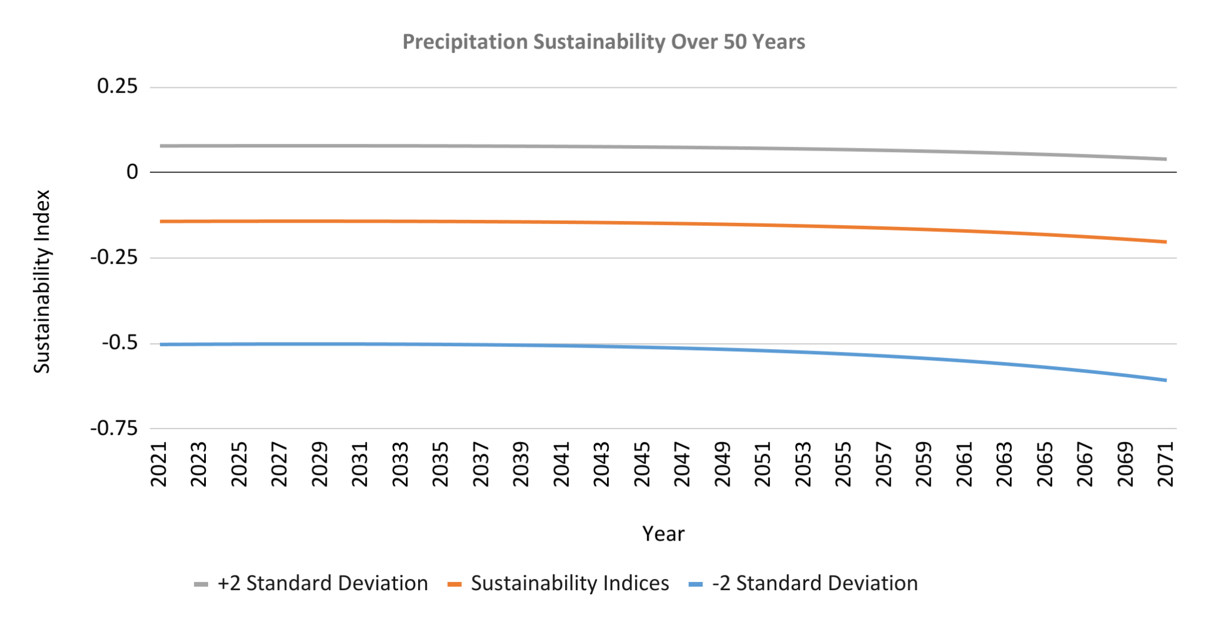

*Fig 4. Predicted precipitation sustainability index over the next 50 years in Hays County, accounting for +/- 2 Stdev precipitation.*

The population sustainability model remains positive throughout the full 50 year model, starting at a strong positive value of .923, but follows an exponential trend downwards for the full 50 years as well (Fig. 5). A land cover shelter of 100km2 was used as it is around 1/15th of the total area of Hays County and with that amount of land given for human shelter, the model was able to maintain a positive sustainability index through the whole 50 years. While the population sustainability remains positive in the next 50 years, the curve indicates that in the next 50 years it will probably become unsustainable unless more area is allocated to housing.

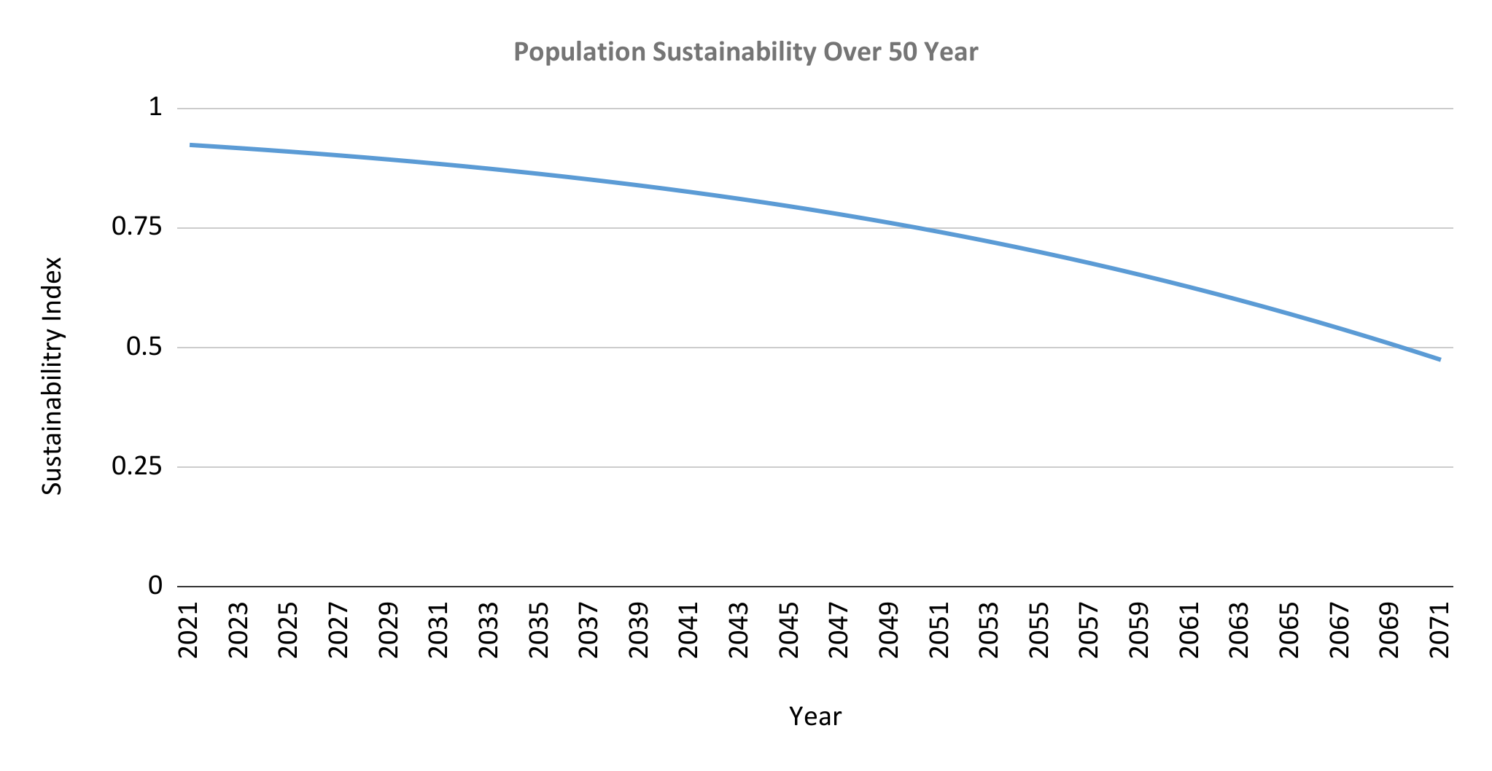

*Fig 5. Predicted population sustainability index over the next 50 years in Hays County.*

The overall sustainability model shows a similar trend to the precipitation sustainability model where all 3 forcing factor scenarios are on an exponential trend downwards towards being unsustainable (Fig. 6). This is most likely due to how much heavier the precipitation index was weighted compared to the population index. Both the base model and the +2 standard deviation model start out with positive sustainability indexes, where the base model becomes unsustainable in around the last 10 years of the model while the +2 standard deviation model remains sustainable for the whole model (Fig. 6). The -2 standard deviation model starts negative and remains negative for the entirety of the model. These trends indicate that Hays County might be sustainable for the majority of the next 50 years if favorable conditions are met, but it is heading towards becoming unsustainable and unfavorable conditions could expedite it.

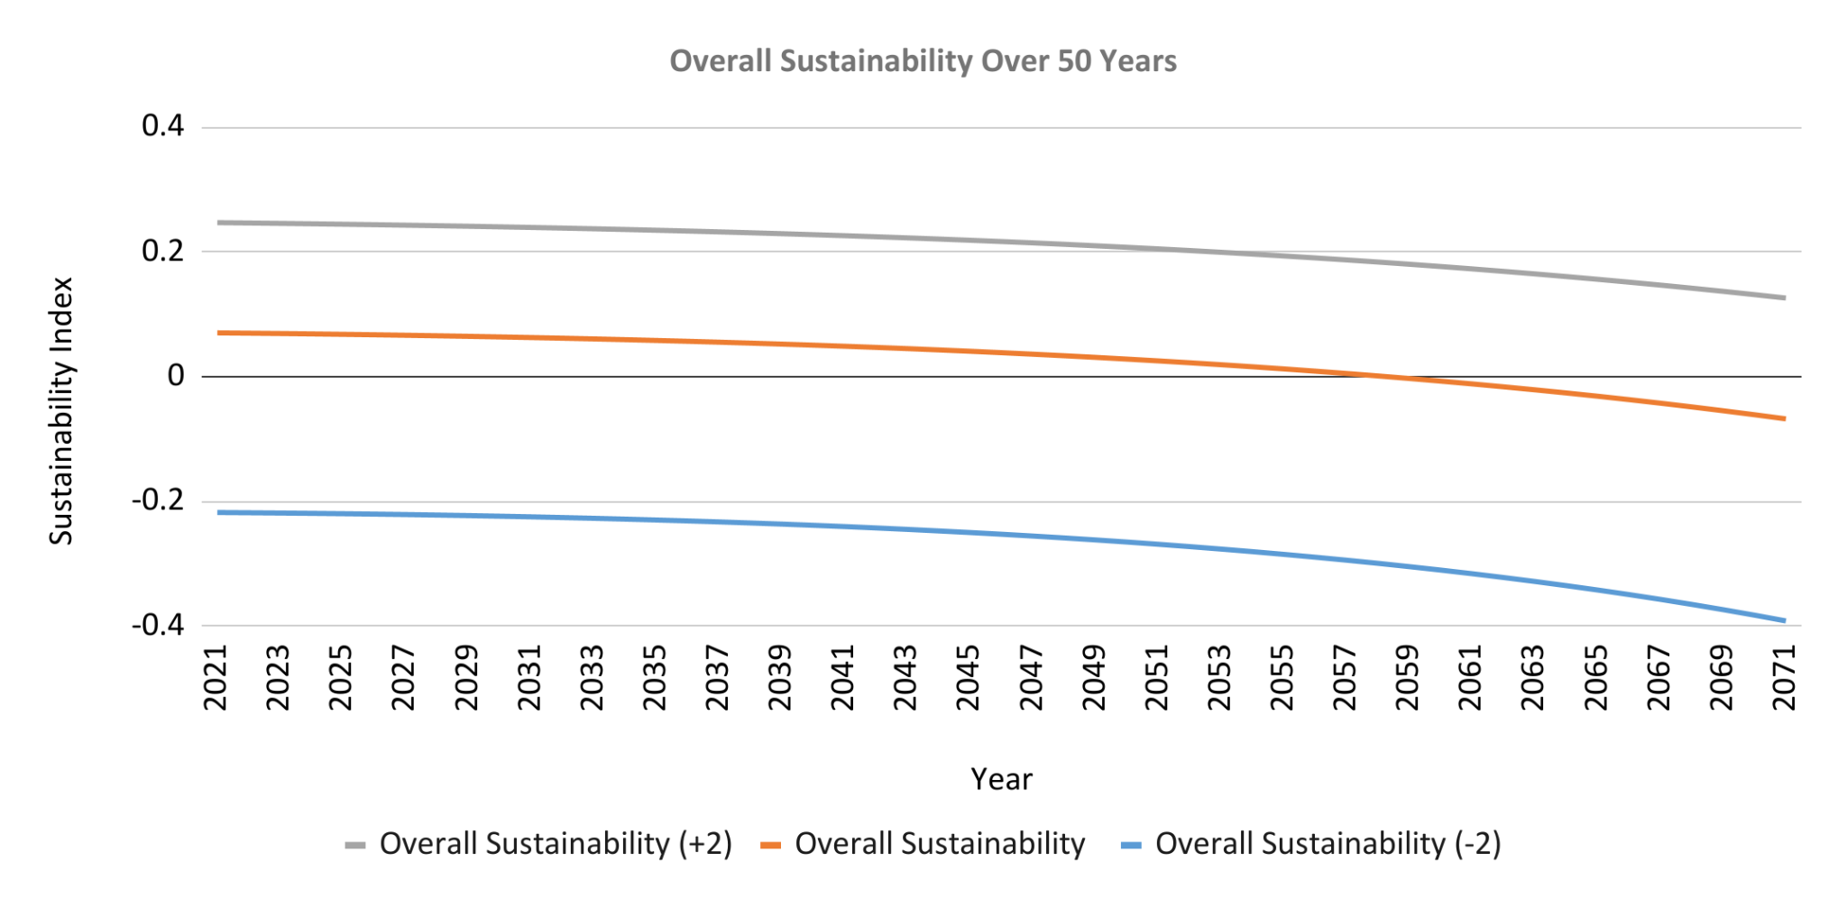

*Fig 6. Overall sustainability Index over the next 50 years in Hays County, accounting for +/- 2 Stdev precipitation.*

4.2 MANAGEMENT SCENARIOS

After seeing the results visualized within sustainability indices we can then look into what we can change to keep Hays County sustainable with their resources. The first management scenario not listed in found references is being able to create housing that allows better sustainability with respect to land cover. Our computations assumed that within our study area, new humans over time needed 93m2 of area for 6 humans’ capacity of living. If this number were to decrease, having less urban area needed for humans to survive, such as building higher apartment complexes, or more walkable cities without needing large roads or highways can allow for a higher recharge rate for our land cover and allow more water into the water table (Gary et al. 2019). This was run multiple ways and values were altered during calibration and helped visualize if city planners were aware of land cover recharge rate, this could be accounted for as population increases over time. Another management scenario discussed is to alter water well properties and further monitor water well activity. Being able to better monitor well activity of wells allows planners to manipulate depth of wells based on the water table, or add and remove wells to drain from the aquifer (Sophocleous 2005). Once these water well properties are manipulated (as shown in our simulation) this can alter how the water table is drained and remains sustainable over the next 50 years. These scenarios are important to be discussed because it can help put into context where sustainability is now based on how accurately we can represent reality, and once reality is represented in the future these scenarios can be planned to set out how stakeholders can make the best decisions for citizens in the county.

5. CONCLUSIONS

To conclude on the outcome of the project, there is an overall negative trend in sustainability towards the future. As our model moves into the near future sustainability seems possible, but as the results compound on each other over the year’s results become less and less able to stay sustainable up to the 50 year mark. If precipitation comes at a generous amount above current averages, our models have predicted that the area is sustainable for this near future time period of 5-15 years, but will then head towards becoming unsustainable at a fast rate past that point towards the 50 year predicted future. Reality was represented in a reasonably accurate way with the data, processing power, time, and resources available, as representing reality in the best way possible is the main goal. Discussed ways to improve is to use a more robust model for precipitation prediction, as discussed earlier. This more accurate prediction could come from machine learning implementation to formulate precipitation models, or implementing an artificial neural network. Another helpful tool we could have used to better represent reality was to have more accurate well discharge data. This could have given us a better understanding of the water table in the area while not generalizing what is discharged from wells. Synthesizing these together, along with comparing and seeing what is unique against existing literature, has given us a strong grasp on how sustainability can be predicted in Hays County the next 50 years, with the goal of keeping the area sustainable for the human population.

7. APPENDIX

**Equation 1**

*y = 0.0013x + 0.844 [m]*

**Equation 2**

*Zw = zmin + 5.0 [m]*

**Equation 3***Zb  = Zw - 1000 [m]*

**Equation 4.1**

*= LW(Zw - Zb)Φp [m3]*

**Equation 4.2**

*Vw*(*t*) *= RV [m3]*

**Equation 4.3**

*Hp(t) = [m3]*

**Equation 5**

*Zw (t + 1) = Zw(t) + Hp(t) [m3]*

**Equation 6***y = 27016e0.0437x*

**Equation 7**

*p(t)Wp365 [L]*

**Equation 8**

*Qw(t) = [m^3]*

**Equation 9**

*[L]*

**Equation 10**

*[m]*

**Equation 11**

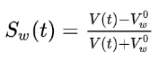

**Equation 12**



**Equation 13**



**Equation 14**



8. REFERENCES

Kummu, M., Guillaume, J. H., de Moel, H., Eisner, S., Flörke, M., Porkka, M., Siebert, S., Veldkamp, T. I., & Ward, P. J. (2016). The world’s road to water scarcity: Shortage and stress in the 20th century and pathways towards Sustainability. *Scientific Reports*, 6(1). https://doi.org/10.1038/srep38495

Banner, J. L., Jackson, C. S., Yang, Z.-L., Hayhoe, K., Woodhouse, C., Gulden, L., Jacobs, K., North, G., Leung, R., Washington, W., Jiang, X., & Castell, R. (2010). Climate Change Impacts on Texas Water: A White Paper Assessment of the Past, Present and Future and Recommendations for Action. *Texas Water Journal*, *1*(1), 1–19. https://doi.org/10.21423/twj.v1i1.1043

Alshuwaikhat, H., Abubakar, I., Aina, Y., Adenle, Y., & Umair, M. (2017). The development of a GIS-based model for Campus Environmental Sustainability Assessment. *Sustainability*, *9*(3), 439. https://doi.org/10.3390/su9030439

Feizizadeh, B., Ronagh, Z., Pourmoradian, S., Gheshlaghi, H. A., Lakes, T., & Blaschke, T. (2021). An efficient GIS-based approach for sustainability assessment of urban drinking water consumption patterns: A study in Tabriz City, Iran. *Sustainable Cities and Society*, *64*, 102584. https://doi.org/10.1016/j.scs.2020.102584

Gary, M. O., Hunt, B. B., Smith, B. A., Watson, J. A., & Wierman, D. A. (2019, July 31). *Evaluation for the development of a jacob's Well Groundwater Management Zone in Hays County, Texas*. Evaluation for the Development of a Jacob’s Well Groundwater Management Zone in Hays County, Texas. Retrieved October 10, 2022, from https://bseacd.org/2019/07/evaluation-for-the-development-of-a-jacobs-well-groundwater-management-zone-in-hays-county-texas/

Graymore, M. L. M., Wallis, A. M., & Richards, A. J. (2009). An index of regional sustainability: A GIS-based multiple criteria analysis decision support system for progressing sustainability. *Ecological Complexity*, *6*(4), 453–462. https://doi.org/10.1016/j.ecocom.2009.08.006

Sahoo, S., & Jha, M. K. (2017). Numerical groundwater-flow modeling to evaluate potential effects of pumping and recharge: Implications for sustainable groundwater management in the Mahanadi Delta region, India. *Hydrogeology Journal*, *25*(8), 2489–2511. https://doi.org/10.1007/s10040-017-1610-4

Sophocleous, M. (2005). Groundwater recharge and sustainability in the High Plains Aquifer in Kansas, USA. *Hydrogeology Journal*, *13*(2), 351–365. https://doi.org/10.1007/s10040-004-0385-6

Thomas, B. F. (2018). Sustainability indices to evaluate groundwater adaptive management: A case study in California (USA) for the Sustainable Groundwater Management Act. *Hydrogeology Journal*, *27*(1), 239–248. https://doi.org/10.1007/s10040-018-1863-6

Zomlot, Z., Verbeiren, B., Huysmans, M., & Batelaan, O. (2017). Trajectory analysis of land use and land cover maps to improve spatial–temporal patterns, and impact assessment on groundwater recharge. *Journal of Hydrology*, *554*, 558–569. https://doi.org/10.1016/j.jhydrol.2017.09.032