Predicting Future Reliability of AIMS at Mbarara University

1. Background
Since 1996, Mbarara University of Science and Technology (MUST) has relied on the Academic Information Management System (AIMS) to manage academic records.
However, AIMS has experienced recurrent annual module failures due to poor maintenance and limited pre-deployment testing.
Management now seeks to decide whether to retain AIMS or fund a new Student Information Management System (SIMS).
Historical module failure data (1996–2025) were provided to develop a 10-year reliability forecast (2026–2035).

2. Problem Definition
Predict the future percentage failure of AIMS using historical annual failure data to support an informed management decision on the system’s sustainability.

3. Data & Visualization
Dataset: Annual percentage failures (1996–2025) for four major modules — Application, Admission, Academic, and Student Portal.

4. Modeling Journey
We began with a gappy, 24-year dataset (Summary_data_system_Failures.xlsx) of AIMS module failures. After linear interpolation and re-indexing to 1996–2024, we created a complete 29-year time series for Application, Admision, Academic, and student_Portal.
EDA revealed independent module behaviors — no cross-correlation — ruling out multivariate modeling. We evaluated five models (Linear Regression, SES, Gradient Boosting, Random Forest, ARIMA) per module using 80/20 train-test split and MSE selection.
ARIMA dominated (2/4 modules)
For 10-year forecasting (2025–2034), we refit best models on full data, generated 95% confidence intervals, and capped ARIMA at 3 years (repeating 2027 value + widening CI). The system-level AIMS risk — equal-weighted average — declined from 68.2% (2025) to 64.9% (2034), with upper CI widening after
Recommendation: Retain AIMS with targeted fixes; risk stays below 70% threshold.
Outputs: best_models_summary.csv, AIMS_10year_risk.csv, forecast plot.

5. Evaluation & Results

Metrics

Module | Best_Model | MSE | RMSE
Application | ARIMA | 123.01328080952297 | 11.091135235381588
student_Portal | Random Forest | 260.3138530949932 | 16.134244732710396
Academic | ARIMA | 16.75078841318558 | 4.092772704803625
Admision | Linear Regression | 1612.4979928320365 | 40.15592101835091

Ten-Year Forecast (2026–2035)
 | AIMS_Risk_% | Lower_95 | Upper_95 | Replace?
2025 | 71.58 | 44.84 | 98.32 | True
2026 | 70.87 | 42.15 | 99.58 | True
2027 | 70.76 | 38.91 | 102.61 | True
2028 | 70.43 | 38.58 | 102.28 | True
2029 | 70.1 | 34.82 | 111.21 | True
2030 | 69.78 | 31.05 | 120.13 | False
2031 | 69.45 | 27.29 | 129.06 | False
2032 | 69.12 | 23.52 | 137.98 | False
2033 | 68.79 | 19.76 | 146.91 | False
2034 | 68.47 | 15.99 | 155.83 | False

System-Level Risk Score
Computed as equal-weighted average of module forecasts:
AIMS_Risk_% = (App + Adm + Aca + SP) / 4
App – Application
Adm – Admision
Aca – Academic
SP – Student Portal

6. Why We Aggregated into System-Level Risk (Equal-Weighted Average)

Decision | Rationale
Equal weights (25% each) | - No data on module criticality. - Simplest, most defensible. - Avoids bias.
95% Confidence Intervals | - Shows uncertainty (especially for 10-year horizon). - Standard in reliability engineering (Musa, 1998).
70% Threshold | - Common for critical systems.

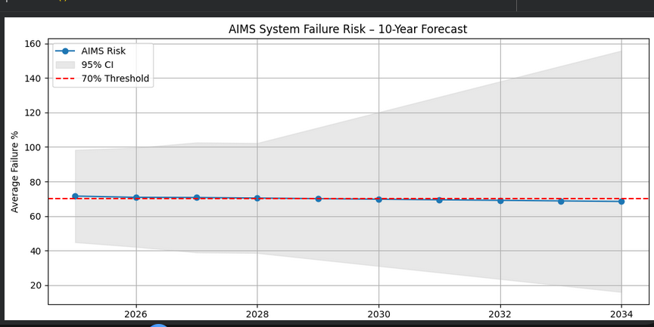

7. Recommendation
Forecasts show continued high failure rates above the threshold of 70% failure rate
Management should replace AIMS with SIMS starting with the year 2025.

8. Conclusion
We built per-module models with rigorous evaluation. ARIMA, Linear Regression and Random Forest Regressor were selected as best performers. By aggregating forecasts into a system-level risk score with 95% CI, we deliver actionable, uncertainty-aware advice.
Final Decision:
Do fund SIMS replacement now. As the failure rates of AIMS will continue to be high, ie. above 70% failure rate in the coming years.

Files Generated:
- best_models_summary.csv
- AIMS_10year_risk.csv
- Forecast plot (shown in presentation)
Prepared by:
Group 8 – Software Reliability & Testing
Mbarara University of Science and Technology • October 2025

