Hypothesis:

Historical spindle whorls have been discovered across a wide range of geographies and periods. They have been made from many different materials, have had different dimensionality, weights and degree of ornamentation. It has been previously suggested that different weights of whorl correspond to different types of thread being produced.

In drop spinning the thread must be able to support the weight of the whorl, spindle and accumulating cop of thread and it has been suggested that heavier whorls show that the thread could support at least that much weight, and further suggested that this corresponds to higher classes of thread and fabric. This hypothesis does not apply to supported, held or ‘twiddled’ spindles.

The ‘mass means class’ hypothesis does not consider the geometrical effects of mass distribution. Two whorls of the same mass but comprised of a sphere and a flat disc will have different spin properties. Faster spinning whorls, all things being equal, would be more stable in use and allow a skilled weaver to produce more thread per spinning session. Different types of thread (eg wool vs flax) might require different amounts of twist per length of spun thread, which would lead to different whorl spin properties being preferred.

In engineering terms, the spin property discussed in this paper is the Moment of Inertia (I). Mass and weight will be used carefully, with a preference towards using weight to describe vertical forces dues to gravity, in accordance with common archaeological practice. For simplicity, the Moment of Inertia discussed will be taken planar around the central axis of the spindle (Iz). The true situation in drop spinning is more complex as the spindle must be at a slight angle to fit around the supporting thread, and that angle will change as the size of the cop builds up. Data on the diameter of the spindle can be inferred from the hole in whorl, but the length of the used spindle, and the desired maximum mass of cop cannot be deduced from the whorl.

The Iz of a a solid cylinder is:

Iz = mr2  = hπr4

where m = cylinder mass, r is the cylinder radius and h is the cylinder height

If this relationship is used to create a hypothetical population of constant density, solid cylindrical whorls, selecting for equal weight or equal Iz gives different looking populations (see below). Artisan requirements, such as a minimum weight to keep the spindle upright, seeking to reduce central hole boring effort and material specific dimensions to keep the whorl robust would constrain the design space.

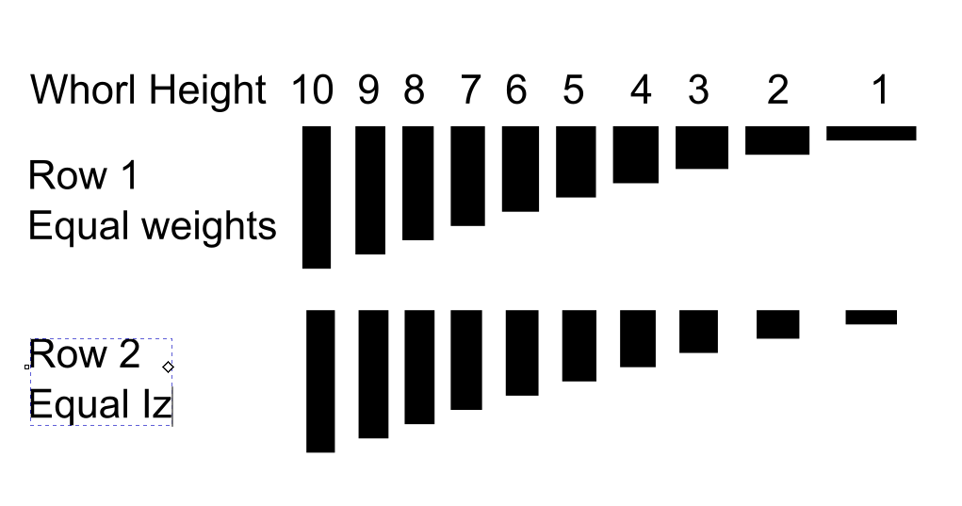

If whorls were cylindrical, the Iz could be calculated from database information on diameter and mass. Most whorls are not cylinders, with central holes of different bores, cross sections of different types (lenticular, toroid, hollow, ect) and irregularity, surface carving and historic damage. The technology chain to account for this geometric complexity has recently matured, and this paper seeks to establish and disseminate methods to allow accurate Iz calculations for whorls.

**Available Data**

https://finds.org.uk/database/search/results/objecttype/SPINDLE+WHORL

There are 8494 entries on PAS for Object type: SPINDLE WHORL

7556 of these have the weight recorded and 7049 of these have images. 6665 have both.

18 of these have 3d content. The weight of the 18 have a median matching that of the wider data set, and may be taken as broadly representative:

Proposed multi stream workflows:

1. Using the existing 3d data and open source software, calculate the Iz of the 18 whorls
2. Using the cross section photos on PAS for the same whorls, estimate the Iz, and measure the error if using the cross section photo alone.
3. If appropriate, extend to the 6000+ whorls with mass and imagery data on PAS.
4. Demonstrate 3d model capture using photogrammetry and open source software to support 3d data production by volunteers from find archives.

Methodology for 1.

The following method is considered for working with existing 3d mesh data:

Arbitrary nonconvex mesh volume calculation by signed volume of tetrahedrons is a standard process first published in 1984. It requires a closed mesh with the inside/outside faces correctly set. The method finds the volume of the tetrahedron defined by the triangle in the mesh surface, and an arbitrary origin point. It assigns a positive sign to that volume if the normal of the triangle in the mesh is pointing towards the origin and a negative sign otherwise. (<https://stackoverflow.com/questions/1406029/how-to-calculate-the-volume-of-a-3d-mesh-object-the-surface-of-which-is-made-up>). A simplified 2d version of this algorithm applied to a complex whorl cross section showing positive volumes in blue and negative volumes in red is shown below. 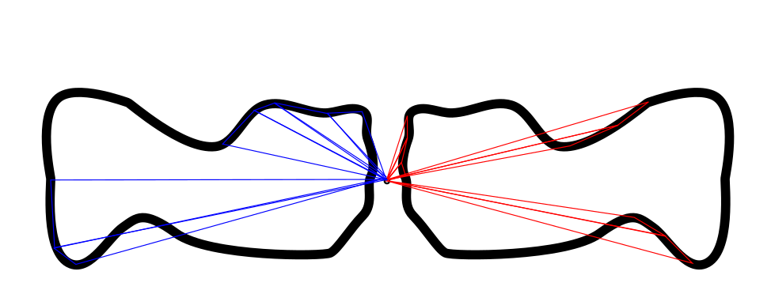

This method can be adapted to calculate the Moment of Inertia directly. By setting the origin at the geometrical centre of the mesh, Rn can be said to be the plan distance of the node from the origin. By warping the mesh by shifting nodes vertically as a function of Rn2 the calculated volume of the warped mesh is now equal to the Iz of the original mesh. The warping makes the increased importance of mass at the outside edge of the whorl clear (see below, for one half or a cross section). Happily, the same effect minimises any error in harder to measure bored hole through the centre of the whorl.

Using the given mass data, the material density can be checked and the Iz can be calculated.

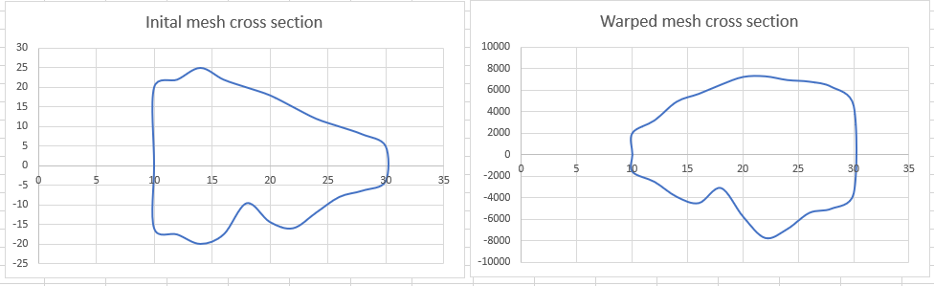

Methodology for 2 and 3.

The PAS database has many whorls without 3d data (yet), but with good imagery such as below.

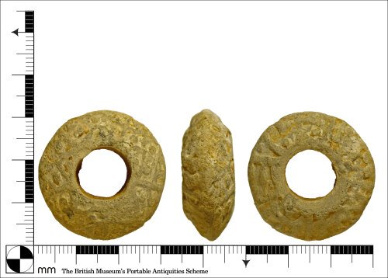

The proposed method is to use pixel reading scripts to scale the image, and from the plan view calculate the bored hole inner diameter, and from the side view build up a line by line cross section, and calculate Iz by treating each line as a hollow cylinder. This is likely to overestimate volume in the area around the central hole, as any chamfer is hidden in the side image. The overestimated central volume for a known mass is likely to reduce the estimated Iz slightly below the true value.