## What is RAG?

LLMs, although capable of generating text that is both meaningful and grammatically correct, these LLMs suffer from a problem called hallucination. Hallucination in LLMs is the concept where the LLMs confidently generate wrong answers, that is they make up wrong answers in a way that makes us believe that it is true. This has been a major problem since the introduction of the LLMs. These hallucinations lead to incorrect and factually wrong answers. Hence Retrieval Augmented Generation was introduced.

In RAG, we take a list of documents/chunks of documents and encode these textual documents into a numerical representation called vector embeddings, where a single vector embedding represents a single chunk of document and stores them in a database called vector store. The models required for encoding these chunks into embeddings are called encoding models or bi-encoders. These encoders are trained on a large corpus of data, thus making them powerful enough to encode the chunks of documents in a single vector embedding representation.

## Explain Semantic Chunking

In order to abide by the context window of the LLM , we usually break text into smaller parts / pieces which is called chunking.

Different chunking methods:

* Fixed size chunking
* Recursive Chunking
* Document Specific Chunking
* Semantic Chunking
* Agentic Chunking

Semantic chunking involves taking the embeddings of every sentence in the document, comparing the similarity of all sentences with each other, and then grouping sentences with the most similar embeddings together. By focusing on the text’s meaning and context, Semantic Chunking significantly enhances the quality of retrieval. It’s a top-notch choice when maintaining the semantic integrity of the text is vital.

The hypothesis here is we can use embeddings of individual sentences to make more meaningful chunks. Basic idea is as follows :-

1. *Split the documents into sentences based on separators(.,?,!)*
2. *Index each sentence based on position.*
3. *Group: Choose how many sentences to be on either side. Add a buffer of sentences on either side of our selected sentence.*
4. *Calculate distance between group of sentences.*
5. *Merge groups based on similarity i.e. keep similar sentences together.*
6. *Split the sentences that are not similar.*

## What Is a Knowledge Graph?

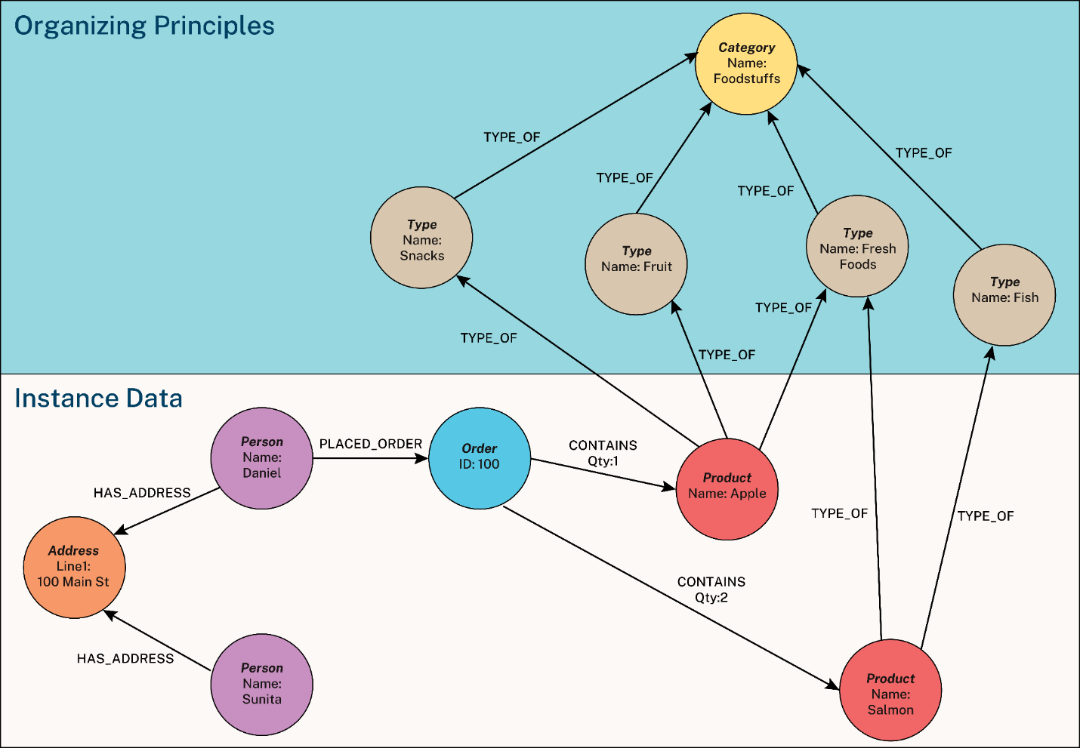

A [knowledge graph](https://neo4j.com/use-cases/knowledge-graph/) is an organized representation of real-world entities and their relationships. It is typically stored in a graph database, which natively stores the relationships between data entities.Entities in a knowledge graph can represent objects, events, situations, or concepts. The relationships between these entities capture the context and meaning of how they are connected.

Now that you understand how knowledge graphs organize and access data with context, let’s look at the building blocks of a knowledge graph data model. The definition of knowledge graphs varies depending on whom you ask, but we can distill the essence into three key components: nodes, relationships, and organizing principles.

***Nodes*** denote and store details about entities, such as people, places, objects, or institutions. Each node has a (or sometimes several) label to identify the node type and may optionally have one or more properties (attributes). Nodes are also sometimes called *vertices*.

***Relationships*** link two nodes together: they show how the entities are related. Like nodes, each relationship has a label identifying the relationship type and may optionally have one or more properties. Relationships are also sometimes called *edges*.

**Organizing Principles** are a framework, or schema, that organizes nodes and relationships according to fundamental concepts essential to the use cases at hand. Unlike many data designs, knowledge graphs easily incorporate multiple organizing principles.

In [**generative AI**](https://neo4j.com/generativeai/)applications**,** knowledge graphs capture and organize key domain-specific or proprietary company information. Knowledge graphs are not limited to structured data; they can handle less organized data as well.

In [**Fraud Detection and Analytics**,](https://neo4j.com/use-cases/fraud-detection/) the knowledge graph represents a network of transactions, their participants, and relevant information about them.

## What is NLU?

 NLU stands for Natural Language Understanding. It is a subdomain of NLP that concerns making a machine learn the skills of reading comprehension. A few applications of NLU include Machine translation (MT), Newsgathering, and Text categorization. It often goes by the name Natural Language Interpretation (NLI) as well.

## What do you know about Latent Semantic Indexing (LSI)?

LSI is a technique that analyzes a set of documents to find the statistical coexistence of words that appear together. It gives an insight into the topics of those documents.

LSI is also known as Latent Semantic Analysis.

## What is perplexity in NLP?

In general, perplexity is a measurement of how well a probability model predicts a sample. In the context of Natural Language Processing, perplexity is one way to evaluate language models.

A language model is a probability distribution over sentences: it’s both able to generate plausible human-written sentences (if it’s a good language model) and to evaluate the goodness of already written sentences. Presented with a well-written document, a good language model should be able to give it a higher probability than a badly written document, i.e. it should not be “perplexed” when presented with a well-written document.

Thus, the perplexity metric in NLP is a way to capture the degree of ‘uncertainty’ a model has in predicting (i.e. assigning probabilities to) text.

The probability of a generic sentence *W*, made of the words *w1*, *w2*, up to *wn*, can be expressed as the following:

P(W) = P(w1, w2, …, wn)

This can be done by normalizing the sentence probability by the number of words in the sentence. Since the probability of a sentence is obtained by multiplying many factors, we can average them using the [geometric mean](https://en.wikipedia.org/wiki/Geometric_mean).

Let’s call *Pnorm(W)*the normalized probability of the sentence *W*. Let *n* be the number of words in *W*. Then, applying the geometric mean:

Pnorm(W) = P(W) ^ (1 / n)

Perplexity can be computed also starting from the concept of [Shannon entropy](https://en.wikipedia.org/wiki/Entropy_(information_theory)). Let’s call *H(W)* the entropy of the language model when predicting a sentence *W*. Then, it turns out that:

PP(W) = 2 ^ (H(W))

## Briefly describe the N-gram model in NLP

 N-gram model is a model in NLP that predicts the probability of a word in a given sentence using the conditional probability of n-1 previous words in the sentence. The basic intuition behind this algorithm is that instead of using all the previous words to predict the next word, we use only a few previous words.

## What is the Markov assumption for the bigram model?

 The Markov assumption assumes for the bigram model that the probability of a word in a sentence depends only on the previous word in that sentence and not on all the previous words.

## What do you understand by word embedding?

In NLP, word embedding is the process of representing textual data through a real-numbered vector. This method allows words having similar meanings to have a similar representation.

## What is an embedding matrix?

A word embedding matrix is a matrix that contains embedding vectors of all the words in a given text.

## List a few popular methods used for word embedding.

Following are a few methods of word embedding.

1. One-hot
2. BOW
3. TF-IDF
4. Word2Vec:

* CBOW
* Skip-gram

1. Glove

## For correcting spelling errors in a corpus, which one is a better choice: a giant dictionary or a smaller dictionary, and why?

Initially, a smaller dictionary is a better choice because most NLP researchers feared that a giant dictionary would contain rare words that may be similar to misspelled words. However, later it was found (Damerau and Mays (1989)) that in practice, a more extensive dictionary is better at marking rare words as errors.

## Do you always recommend removing punctuation marks from the corpus you’re dealing with? Why/Why not?

No, it is not always a good idea to remove punctuation marks from the corpus as they are necessary for certain NLP applications that require the marks to be counted along with words.

For example: Part-of-speech tagging, parsing, speech synthesis.

## What is a hapax/hapax legomenon?

The rare words that only occur once in a sample text or corpus are called hapaxes. Each one of them is called an hapax or hapax legomenon (greek for ‘read-only once’). It is also called a singleton.

## What is a collocation?

A collocation is a group of two or more words that possess a relationship and provide a classic alternative of saying something. For example, ‘strong breeze’, ‘the rich and powerful’, ‘weapons of mass destruction.

## What do you understand by regular expressions in NLP?

Regular expressions in natural language processing are algebraic notations representing a set of strings. They are mainly used to find or replace strings in a text and can also be used to define a language in a formal way.

## Define the term parsing concerning NLP

Parsing refers to the task of generating a linguistic structure for a given input. For example, parsing the word ‘helping’ will result in **verb**-pass + **gerund**-ing.

Simply speaking, parsing in NLP is the process of determining the syntactic structure of a text by analyzing its constituent words based on an underlying grammar (of the language).

See this example grammar below, where each line indicates a rule of the grammar to be applied to an example sentence “Tom ate an apple”.

## What is *BLEU*?

* **BLEU** is the abbreviation for *bilingual evaluation understudy*.
* **BLEU** is used for evaluating the quality of *machine translated* text.
* A text is considered higher quality the similar it is to a professional human translator.
* **BLEU**'s is always between 0 and 1. The value of 1 is for the most similar text to the target text.
* A **BLEU** score of 0.5 is considered *high quality*, while a score of >0.6 is considered better than humans. Anything less than 0.2 is not understandable and does not give the gist of the translation well.

## What Is Semantic Analysis?

Simply put, semantic analysis is the process of drawing meaning from text. It allows computers to understand and interpret sentences, paragraphs, or whole documents, by analyzing their grammatical structure, and identifying relationships between individual words in a particular context.

It’s an essential sub-task of Natural Language Processing (NLP) and the driving force behind [machine learning](https://monkeylearn.com/machine-learning/) tools like chatbots, search engines, and text analysis.

## Natural Language Toolkit (NLTK)

NLTK is the main library for building Python projects to work with human language data. It gives simple to-utilize interfaces to more than 50 corpora and lexical assets like WordNet, alongside a set-up of text preprocessing libraries for tagging, parsing, classification, stemming, tokenization and semantic reasoning wrappers for NLP libraries and an active conversation discussion. NLTK is accessible for Windows, Mac OS, and Linux. The best part is that NLTK is a free, open-source, local area-driven venture. It has some disadvantages as well. It is slow and difficult to match the demands of production usage. The learning curve is somehow steep. Some of the features provided by NLTK are;

* Entity Extraction
* Part-of-speech tagging
* Tokenization
* Parsing
* Semantic reasoning
* Stemming
* Text classification

## GenSim

Gensim is a famous python library for natural language processing tasks. It provides a special feature to identify semantic similarity between two documents by the use of vector space modelling and the topic modelling toolkit. All algorithms in GenSim are memory-independent concerning corpus size it means we can process input larger than RAM. It provides a set of algorithms that are very useful in natural language tasks such as Hierarchical Dirichlet Process(HDP), Random Projections(RP), Latent Dirichlet Allocation(LDA), Latent Semantic Analysis(LSA/SVD/LSI) or word2vec deep learning. The most advanced feature of GenSim is its processing speed and fantastic memory usage optimization. The main uses of GenSim include Data Analysis, Text generation applications (chatbots) and Semantic search applications.GenSim highly depends on SciPy and NumPy for scientific computing.

## SpaCy

SpaCy is an open-source python Natural language processing library. It is mainly designed for production usage- to build real-world projects and it helps to handle a large number of text data. This toolkit is written in python in Cython which’s why it much faster and efficient to handle a large amount of text data. Some of the features of SpaCy are shown below:

* It provides multi trained transformers like BERT
* It is way faster than other libraries
* Provides tokenization that is motivated linguistically In more than 49 languages
* Provides functionalities such as text classification, sentence segmentation, lemmatization, part-of-speech tagging, named entity recognition and many more
* It  
  has 55 trained pipelines in more than 17 languages.

## Hashing Vecrtorizer

[Hashing Vectorizer](http://scikit-learn.org/stable/modules/generated/sklearn.feature_extraction.text.HashingVectorizer.html) converts text to a matrix of occurrences using the “hashing trick” Each word is mapped to a feature and using the hash function converts it to a hash. If the word occurs again in the body of the text it is converted to that same feature which allows us to count it in the same feature without retaining a dictionary in memory.

## Lemmatization

[Lemmatization](http://scikit-learn.org/stable/modules/feature_extraction.html) is a process by which inflected forms of words are grouped together to be analyzed as a single aspect. It is a way of using the intended meaning of a word to determine the “lemma”. It is largely depending on correctly finding “intended parts of speech” and the true meaning of a word in a sentence, paragraph, or larger documents. Examples of Lemmatization are that “run” is a base form for words like “running” or “ran” or that the word “better” and “good” are in the same lemma so they are considered the same.

## Stemming

[Stemming](http://scikit-learn.org/stable/modules/feature_extraction.html) is quite similar to Lemmatization in that it groups words together, but unlike lemmatization it takes a word and refers it back to its base or root form. In fact, on the best examples I’ve come across to describe it involves refereeing Stemming back to its base form. “Stems”, “Stemming”, “Stemmed”, “and Stemtization” are all based on the single word “stem”.

## Part of Speech Tagging

Each word has its own role in a sentence. For example,’Geeta is dancing’. Geeta is the person or ‘Noun’ and dancing is the action performed by her, so it is a ‘Verb’.Likewise, each word can be classified. This is referred as POS or Part of Speech Tagging.

1. **Rule-based POS tagging**: The rule-based POS tagging models apply a set of handwritten rules and use contextual information to assign POS tags to words. These rules are often known as context frame rules. One such rule might be: “If an ambiguous/unknown word ends with the suffix ‘ing’ and is preceded by a Verb, label it as a Verb”.
2. **Transformation Based Tagging:** The transformation-based approaches use a pre-defined set of handcrafted rules as well as automatically induced rules that are generated during training.
3. **Deep learning models**: Various[Deep learning](https://www.mygreatlearning.com/blog/what-is-deep-learning/) models have been used for POS tagging such as Meta-BiLSTM which have shown an impressive accuracy of around 97 percent.
4. **Stochastic (Probabilistic) tagging**: A stochastic approach includes frequency, probability or statistics. The simplest stochastic approach finds out the most frequently used tag for a specific word in the annotated training data and uses this information to tag that word in the unannotated text. But sometimes this approach comes up with sequences of tags for sentences that are not acceptable according to the grammar rules of a language. One such approach is to calculate the probabilities of various tag sequences that are possible for a sentence and assign the POS tags from the sequence with the highest probability. Hidden Markov Models (HMMs) are probabilistic approaches to assign a POS Tag.

## Dependency Parsing

In a sentence, the words have a relationship with each other. The one word in a sentence which is independent of others, is called as **Head /Root** word. All the other word are dependent on the root word, they are termed as **dependents**.

Dependency Parsing is the method of analyzing the relationship/ dependency between different words of a sentence.

Usually, in a sentence, the verb is the head word.

You can access the dependency of a token through token.dep_ attribute.

token.dep_ prints dependency tags for each token

What is the meaning of these dependency tags ?

* nsubj :Subject of the sentence
* ROOT: The headword or independent word,(generally the verb)
* prep: prepositional modifier, it modifies the meaning of a noun, verb, adjective, or preposition.
* cc and conj: Linkages between words. For example: is, and, etc…
* pobj : Denotes the object of the preposition
* aux : Denotes it is an auxiliary word
* dobj : direct object of the verb
* det : Not specific, but not an independent word.

## Named Entity Recognition

Suppose you have a collection of news articles text data. What if you want to know what companies/organizations have been in the news? How will you do that?

Take another case of text dataset of information about influential people. What if you want to know the names of influencers in this dataset ?

NER is the technique of identifying named entities in the text corpus and assigning them pre-defined categories such as ‘ person names’ , ‘ locations’ ,’organizations’,etc..

It is a very useful method especially in the field of claasification problems and search egine optimizations.

NER can be implemented through both nltk and spacy`.

## What is Extractive Text Summarization and Generative Text Summarization

Extractive Text Summarization is the traditional method, in which the process is to identify significant phrases/sentences of the text corpus and include them in the summary.

The summary obtained from this method will contain the key-sentences of the original text corpus.

You can notice that in the extractive method, the sentences of the summary are all taken from the original text. There is no change in structure of any sentence.

Generative text summarization methods overcome this shortcoming. The concept is based on capturing the meaning of the text and generating entirely new sentences to best represent them in the summary.

## NLP Pipeline

NLP Pipeline is a set of steps followed to build an end to end NLP software.

Before we started we have to remember this things pipeline is not universal, Deep Learning Pipelines are slightly different, and Pipeline is non-linear.

1. Data Acquisition

In the data acquisition step, these three possible situations happen.

A. Public Dataset – If a public dataset is available for our problem statement.  
B. Web Scrapping –  Scrapping competitor data using beautiful soup or other libraries  
C. API – Using different APIs. eg. Rapid API

2. Text Preprocessing

So Our data collection step is done but we can not use this data for model building. we have to do text preprocessing.   
**Steps**–  
1. Text Cleaning – In-text cleaning we do HTML tag removing, emoji handling, Spelling checker, etc  
2. Basic Preprocessing — In basic preprocessing we do tokenization(word or sent tokenization, stop word removal, removing digit, lower casing.  
3. Advance Preprocessing — In this step we do POS tagging, Parsing, and Coreference resolution.

3. Featured Engineering

Feature Engineering means converting text data to numerical data. but why it is required to convert text data to numerical data, because our machine learning model doesn’t understand text data then we have to do feature engineering. This step is also called Feature extraction from text.

## Bag of Words (BoW):

The BoW model captures the frequencies of the word occurrences in a text corpus.

Bag of words is not concerned about the order in which words appear in the text; instead, it only cares about which words appear in the text.

Let’s understand how BoW works with an example. Consider the following phrases:

Document 1: Cats and dogs are not allowed

Document 2: Cats and dogs are antagonistic

Bag of words will first create a unique list of all the words based on the two documents. If we consider the two documents, we will have seven unique words.

‘cats’, ‘and’, ‘dogs’, ‘are’, ‘not’, ‘allowed’, ‘antagonistic’

Each unique word is a feature or dimension.

Now for each document, a feature vector will be created. Each feature vector will be seven-dimensional since we have seven unique words.

Document1 vector: [1 1 1 1 1 1 0]

Document2 vector: [1 1 1 1 0 0 1]

## N-Grams:

An N-Gram is a sequence of N-words in a sentence. Here, N is an integer which stands for the number of words in the sequence.

For example, if we put N=1, then it is referred to as a uni-gram. If you put N=2, then it is a bi-gram. If we substitute N=3, then it is a tri-gram.

The bag of words does not take into consideration the order of the words in which they appear in a document, and only individual words are counted.

In some cases, the order of the words might be important.

N-grams captures the context in which the words are used together. For example, it might be a good idea to consider bigrams like “New York” instead of breaking it into individual words like “New” and “York”

Consider the sentence “I like dancing in the rain”

See the Uni-Gram, Bi-Gram, and Tri-Gram cases below.

UNIGRAM: ‘I’, ‘like’, ‘dancing’, ‘in’, ‘the’, ‘rain’

BIGRAM: ‘I like’, ‘like dancing’, ‘dancing in’, ‘in the’, ‘the rain’

TRIGRAM: ‘I like dancing’, ‘like dancing in’, ‘dancing in the’, ‘in the rain’

## Term Frequency, Inverse Document Frequency(TF-IDF):

This is the most popular way to represent documents as feature vectors. TF-IDF stands for Term Frequency, Inverse Document Frequency.

TF-IDF measures how important a particular word is with respect to a document and the entire corpus.

**Term Frequency:**

Term frequency is the measure of the counts of each word in a document out of all the words in the same document.

TF(w) = (number of times word w appears in a document) / (total number of words in the document)

For example, if we want to find the TF of the word cat which occurs 50 times in a document of 1000 words, then

TF(cat) = 50 / 1000 = 0.05

**Inverse Document Frequency:**

IDF is a measure of the importance of a word, taking into consideration the frequency of the word throughout the corpus.

It measures how important a word is for the corpus.

*IDF(w) = log(total number of documents / number of documents with w* *in it)*

For example, if the word cat occurs in 100 documents out of 3000, then the IDF is calculated as

IDF(cat) = log(3000 / 100) = 1.47

Finally, to calculate TF-IDF, we multiply these two factors – TF and IDF.

*TF-IDF(w) = TF(w) x IDF(w)*

TF-IDF(cat) = 0.05 * 1.47 = 0.073

## word2vec

It is not a singular algorithm, rather, it is a family of model architectures and optimizations that can be used to learn word embeddings from large datasets. Embeddings learned through word2vec have proven to be successful on a variety of downstream natural language processing tasks.

These papers proposed two methods for learning representations of words:

* **Continuous bag-of-words model**: predicts the middle word based on surrounding context words. The context consists of a few words before and after the current (middle) word. This architecture is called a bag-of-words model as the order of words in the context is not important.
* **Continuous skip-gram model**: predicts words within a certain range before and after the current word in the same sentence. A worked example of this is given below.

## Skip-gram and negative sampling

While a bag-of-words model predicts a word given the neighboring context, a skip-gram model predicts the context (or neighbors) of a word, given the word itself. The model is trained on skip-grams, which are n-grams that allow tokens to be skipped (see the diagram below for an example). The context of a word can be represented through a set of skip-gram pairs of (target_word, context_word) where context_word appears in the neighboring context of target_word.

Consider the following sentence of eight words:

The wide road shimmered in the hot sun.

The context words for each of the 8 words of this sentence are defined by a window size. The window size determines the span of words on either side of a target_word that can be considered a context word. Below is a table of skip-grams for target words based on different window sizes.

The training objective of the skip-gram model is to maximize the probability of predicting context words given the target word. For a sequence of words *w1, w2, ... wT*, the objective can be written as the average log probability



where c is the size of the training context. The basic skip-gram formulation defines this probability using the softmax function.

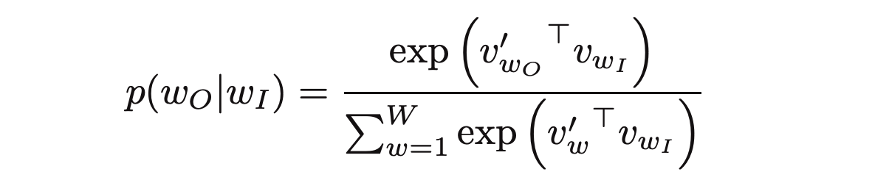

where *v* and *v'* are target and context vector representations of words and *W* is vocabulary size.

Computing the denominator of this formulation involves performing a full softmax over the entire vocabulary words, which are often large (105-107) terms.

The [noise contrastive estimation](https://www.tensorflow.org/api_docs/python/tf/nn/nce_loss) (NCE) loss function is an efficient approximation for a full softmax. With an objective to learn word embeddings instead of modeling the word distribution, the NCE loss can be [simplified](https://papers.nips.cc/paper/5021-distributed-representations-of-words-and-phrases-and-their-compositionality.pdf) to use negative sampling.

The simplified negative sampling objective for a target word is to distinguish the context word from num_ns negative samples drawn from noise distribution *Pn(w)* of words. More precisely, an efficient approximation of full softmax over the vocabulary is, for a skip-gram pair, to pose the loss for a target word as a classification problem between the context word and num_ns negative samples.

A negative sample is defined as a (target_word, context_word) pair such that the context_word does not appear in the window_size neighborhood of the target_word. For the example sentence, these are a few potential negative samples (when window_size is 2).