Part 1
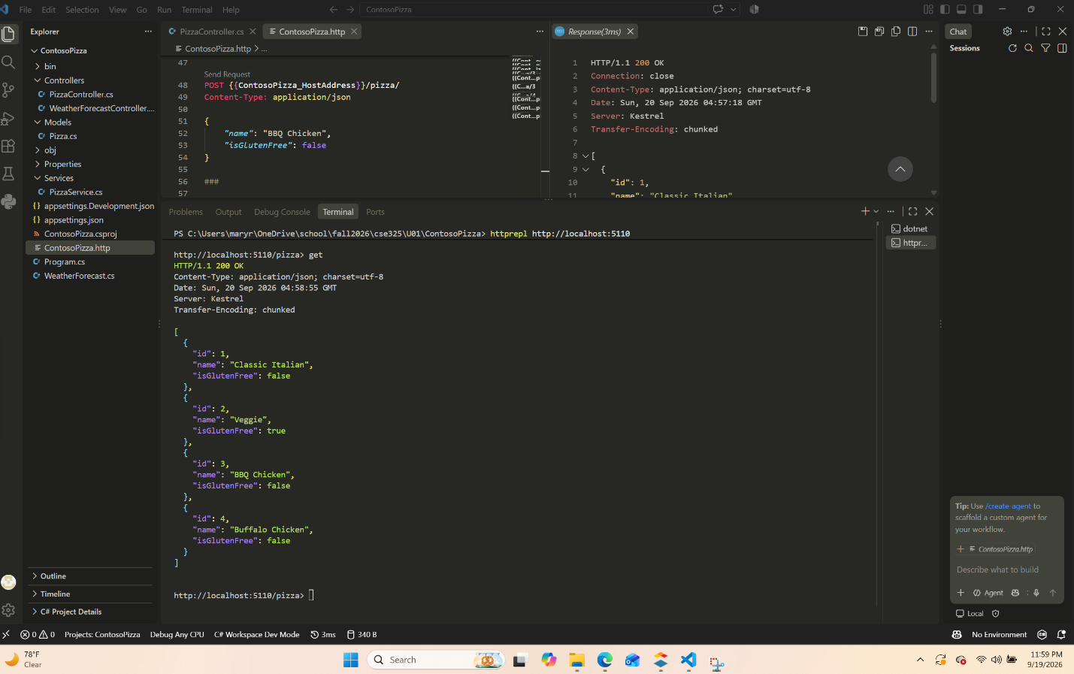
Part 2
void CompileSalesSummary(IEnumerable<string> salesFiles,string storesDirectory,string reportFile)
{
double salesTotal = 0;

List<string> summaryDetails = new List<string>();

foreach (var file in salesFiles)
{
string sJson = File.ReadAllText(file);

SalesData? data = JsonConvert.DeserializeObject<SalesData?>(sJson);

double fileTotals = data?.Total ?? 0;

salesTotal += fileTotals;

string fileName = Path.GetRelativePath(storesDirectory, file);

summaryDetails.Add( $"{fileName}: {fileTotals:C2}");
}

string reportContent =
$"Sales Summary Report\n" + $"--------------------------\n" + $"Total Sales: {salesTotal:C2}\n\n" + $"Details:\n" + $"{string.Join("\n", summaryDetails)}";

File.WriteAllText(reportFile, reportContent);
}

I really struggled with this part, I reread it several times but that does work . What would you recommend to get a better understanding of this section? The other sections were pretty okay but this one I felt like I was drowing.

