Project Summary and Conclusions:

In surveying how to best assess hospital quality, the table "Timely and Effective Care" is the most robust for a general assessment. We want to assess highest average % across as many of these measures as possible.

First query measures that are the 'most widely reported' across all hospitals(sort descending)
Examine these measures against reference table from Hospital.CSV documentation to understand the nature of the measure:
- measure should be based on 100% scale with higher = better
  - e.g. exclude measures such as "PC_01, percent of newborn deliveries scheduled too early"
- exclude measures based on total minutes (but should examine if more time for project)

- Decision point: After exploring the data, measures after the 15th "most widely reported" measure (that met above 3 criteria) drastically cut the result set, due mostly to sample size requirement of 100. Assessing across 16 or more measures seemed to unfairly disqualify high-volume, highly-rated hospitals and yieled results where top 10 finalists average scores were not even above 90% (i.e. using more than top 15 measures elminated too many contenders)
- This is an example of finding the right balance of robust criteria vs. over-specifying the criteria

Thus Top 15 measures were chosen (see table of top 15 measures at bottom)

Other criteria to qualify as Top Hospital:
- Emergency Department Volume should be significant
  - exclude low volumne (equates to less than 50 people a day)
  - exclude volume not available
- Scores should not have a footnote(as all footnotes are disclaimers that compromise the data sample)
- Score should not be null
Verify that at least a significant number of hospitals meet above criteria (104 hospitals met this criteria)

Next consider 'poor care' tables : 1) Complications 2) Hospital Associated Infections 3) Readmissions and Deaths
If top contenders meet national average or better than national average on a given metric, this does not impact their status as high quality finalists.
However, if top contenders have 'worse than national average' across more than 33% of their stated measures, they should be removed from high quality hospital finalists. We don't know if location, socio-economic environment, or just coincidental death rate have influenced these metrics.

Complications table had 7 measures; >33% == more than 2 measures
Infections table had 36 measures; >33% ==more than 12 measures
Readmissions/Deaths table had 14 measures >33%= more than 4 measures

The results (table at bottom) show top 10 significantly sized hospitals that have consistently high average scores across 15 different measures.
Results in table at bottom.

Top States:
Usethe same process to select top measures for Timely & Effective Care and find highest average score across these Top 15 measurements, organize and sort by state with highest avg score across 15 top measures

Procedure Variability:
Use all measures (not the previously identified top 15 measures).
Exclude all measures that are based on total minutes or based on lower score is better
Limit to medium, large or very large hospitals
Limit to sample size > 100
Limit to footnote is blank
Limit to score is not zero or NULL

Patient surveys:
I used file=" HCAHPS – Hospital" as opposed to " hvbp_hcahps_05_28_2015".
- Though it might seem obvious to use the former, needed to explore all patient survey-related data.
- Could not find much documentation the latter.
- The measurements were similar, but afterlooking at a few examples for pain managment, there seemed to be no correlationbetween the two tables , see below.

Criteria:
- Number of Completed Surveys = 300 or more
- Survey Response Rate Percent Footnote = blank
- Hospital must be in large hospital Reference table

- Results will show that highest scored surveys are for smallest hospitals, but these were not in my qualifying criteria for top hospiatals

- Without applying any Emergency room volume criteria, the data shows that Top 100 surveyed hosptials all are SMALL or SIZE NOT AVAIL

Find intersection between 2 tables:
TOPHOSP (has 104 top hospital finalists)
TOP100SURV (has 100 top surveys)

- Provider= 390203, Doylestown Hospital, PA is the only hospital in the top 10 providers that is among the to 100 Patient surveys.
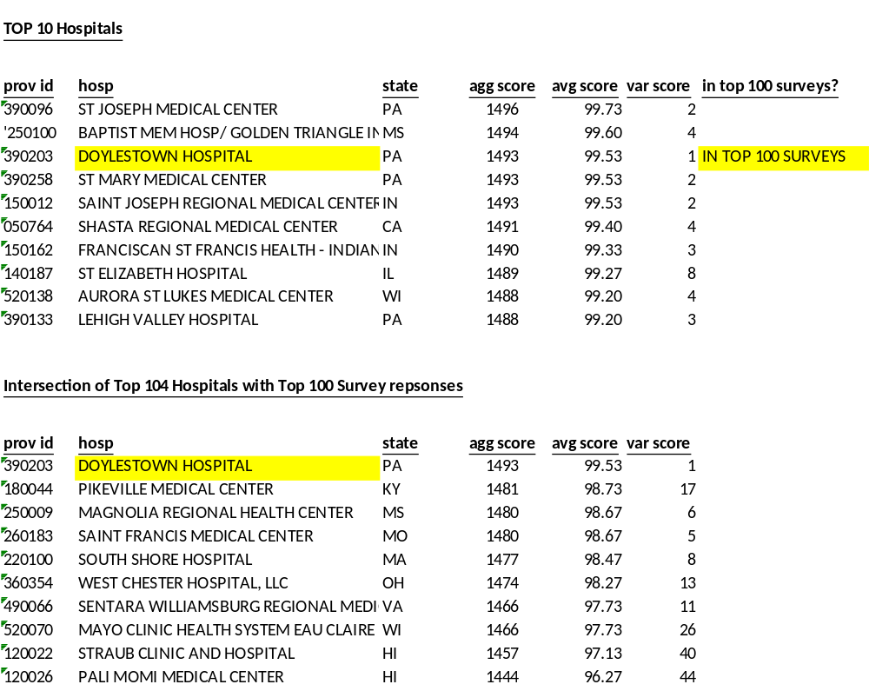
Appendix

Example of no correlation between HVBP HCAHPS and HCAHPS tables
From hvbp_hcahps_05_28_2015 |  |  | From HCAHPS - Hospital
Provider Number | Pain Management Achievement Points |  | Provider ID | Pain management - star rating
10001 | 0 out of 10 |  | 10001 | 2
10006 | 0 out of 10 |  | 10006 | 4
10007 | 0 out of 10 |  | 10007 | 1
10011 | 0 out of 10 |  | 10011 | 3
10016 | 0 out of 10 |  | 10016 | 3
10021 | 0 out of 10 |  | 10021 | 4
10023 | 0 out of 10 |  | 10023 | 3
10038 | 0 out of 10 |  | 10038 | 2
