



Title

Audiogram Analyzer
نموذج ذكاء اصطناعي لتقييم السمع

Prepared By
Faculty of AI Engineering Faculty of Medicine

Leen Roumani Mohammad Alhussein
Marya Ibrahim

Supervised by

Dr. Mouhib Alnoukari
Eng. Anas Abdulaziz Dr.Louei Nahas

المستخلص
يُعدّ فقدان السمع من أكثر الإعاقات الحسية انتشاراً في العالم، إذ تشير تقديرات منظمة الصحة العالمية إلى أن أكثر من 1.5 مليار شخص يعانون من درجة ما من ضعف السمع. وقد طوّرنا في المرحلة الأولى من هذا المشروع تطبيق "محلّل السمع" (Audiogram Analyzer)، وهو نظام جوّال لإجراء اختبار السمع بالنغمات النقية عبر التوصيل الهوائي والعظمي، يعتمد على خوارزمية هيوزن-ويستلاك وخوارزمية العرض المتدرّج المتكيّف (GPC)، ويصنّف درجة فقدان السمع ونوعه (توصيلي، حسي عصبي، مختلط).
غير أنّ معرفة درجة الفقدان ونوعه لا تكفي لتوجيه المريض؛ فالسؤال الأهم بالنسبة له وللطبيب العام هو: ما السبب المحتمل لنقص السمع؟ يهدف هذا الجزء من المشروع إلى بناء نموذج طبي ذكي يقترح الأسباب الأكثر احتمالاً لنقص السمع (مثل الشيخوخة، والضجيج، وأمراض الأذن الوسطى، وتصلّب الأذن، وداء منيير، والفقدان غير المتناظر الذي يستدعي الإحالة) اعتماداً بشكل أساسي على شكل مخطط السمع (الأوديوغرام)، مع الاستفادة من العمر وأسئلة سريرية قصيرة اختيارية.
يقترح التقرير بنية هجينة قابلة للتفسير تتكوّن من: وحدة لاستخراج السمات السمعية (متوسط العتبات، الميل، عمق الثلمة عند 4 كيلوهرتز، الفجوة الهوائية-العظمية، عدم التناظر)، وقاعدة معرفة سريرية مبنية على الإرشادات الطبية المعتمدة، ومصنّف تعلّم آلي احتمالي معايَر، وطبقة دمج تُخرج أعلى ثلاثة أسباب محتملة مع درجة الثقة وتفسير واضح، وتنبيهات إحالة عاجلة عند وجود علامات خطر. ويتضمن التقرير الدراسة النظرية، والمشكلة العلمية والأهداف، ومراجعة لأحدث الدراسات (State of the Art)، وفكرة الحل مع المخطط الصندوقي ومخططات التدفق، وخطة البيانات والتقييم والعمل.
الكلمات المفتاحية: الأوديوغرام، سبب فقدان السمع، الشيخوخة السمعية، فقدان السمع الناجم عن الضجيج، نظام دعم القرار السريري، التعلّم الآلي القابل للتفسير.

Abstract
Hearing loss is one of the most prevalent sensory disabilities worldwide, affecting more than 1.5 billion people according to the World Health Organization. In the first phase of this project we developed the Audiogram Analyzer, a mobile pure-tone audiometry system that measures air- and bone-conduction thresholds using the Hughson–Westlake procedure and an adaptive Graduated Presentation Control (GPC) staircase, and that classifies the degree and type (conductive, sensorineural, mixed) of hearing loss.
Degree and type alone, however, do not tell a patient or a non-specialist clinician what is most likely causing the loss, and therefore what to do next. This phase extends the system with a medical decision-support model that suggests the most probable cause of hearing loss, such as ageing (presbycusis), noise exposure, middle-ear pathology, otosclerosis, Ménière's disease, or an asymmetric loss that requires referral, based primarily on the shape of the audiogram, supported by age and a short optional clinical questionnaire.
This report presents the theoretical foundations of the work, the scientific problem and objectives, a state-of-the-art review, and the proposed solution. The solution is a hybrid, explainable architecture composed of an audiometric feature extractor (pure-tone averages, slopes, 4 kHz notch depth, air–bone gap, interaural asymmetry), a guideline-derived clinical knowledge base, a calibrated probabilistic machine-learning classifier, and a fusion layer that outputs the top three probable causes with confidence values, human-readable explanations, and red-flag referral advice. Block diagrams, flowcharts, the data strategy, the evaluation plan, and the work plan for the remainder of the project are also provided.
Keywords: Audiogram Interpretation, Hearing Loss Etiology, Presbycusis, Noise-Induced Hearing Loss, Clinical Decision Support, Explainable Machine Learning.

Table of Contents
Chapter 1: Theoretical Study 1
1-1 The Auditory System and Mechanisms of Hearing Loss 2
1-1-1 Anatomy and Physiology of Hearing 2
1-1-2 Types of Hearing Loss by Site of Lesion 2
1-2 Pure-Tone Audiometry and the Audiogram 3
1-2-1 Air and Bone Conduction Testing 3
1-2-2 Reading the Audiogram 3
1-2-3 Threshold Search Procedures Implemented in the System 4
1-3 Quantitative Description of an Audiogram 5
1-3-1 Degree of Hearing Loss 5
1-3-2 Type of Hearing Loss (Air–Bone Gap) 6
1-3-3 Configuration (Shape) of the Audiogram 6
1-3-4 Symmetry Between Ears 6
1-4 Etiologies of Hearing Loss and Their Audiometric Signatures 7
1-4-1 Age-Related Hearing Loss (Presbycusis) 9
1-4-2 Noise-Induced Hearing Loss 9
1-4-3 Conductive Pathologies of the Outer and Middle Ear 10
1-4-4 Otosclerosis 10
1-4-5 Ménière's Disease 10
1-4-6 Sudden and Asymmetric Sensorineural Hearing Loss 11
1-4-7 Ototoxic Hearing Loss 11
1-4-8 Hereditary and Congenital Patterns 11
1-4-9 Summary of Audiometric Signatures 11
1-5 Clinical Decision Support Systems 12
1-5-1 Knowledge-Based (Rule-Based) Reasoning 12
1-5-2 Data-Driven Reasoning 13
1-5-3 Hybrid and Explainable Systems 13
1-6 Machine Learning Foundations for the Etiology Model 13
1-6-1 Problem Formulation 13
1-6-2 Candidate Classification Algorithms 13
1-6-3 Handling Small and Imbalanced Medical Datasets 14
1-6-4 Probability Calibration and Abstention 14
1-6-5 Model Explainability 15
1-6-6 Evaluation Metrics 15
1-7 Chapter Summary 15
Chapter 2: Scientific Problem, Objectives, and State of the Art 16
2-1 Project Context 17
2-2 Scientific Problem 17
2-2-1 Problem Statement 17
2-2-2 Why the Problem Is Scientifically Challenging 17
2-2-3 Research Questions 18
2-3 Project Objectives 18
2-3-1 Main Objective 18
2-3-2 Specific Objectives 19
2-3-3 Scope and Limitations 19
2-4 State of the Art 19
2-4-1 Automated and Machine-Learning Audiometry 20
2-4-2 Rule-Based Audiogram Description Systems 20
2-4-3 Data-Driven Audiogram Classification 20
2-4-4 Etiology and Phenotype Inference from the Audiogram 21
2-4-5 Consumer and Screening Applications 21
2-4-6 Comparative Analysis 22
2-5 Research Gap and Expected Contribution 22
Chapter 3: Proposed Solution 24
3-1 Solution Idea 25
3-2 System Block Diagram 25
3-3 Etiology Inference Module Block Diagram 26
3-4 Flowcharts 27
3-4-1 End-to-End Workflow Flowchart 27
3-4-2 Etiology Inference Algorithm Flowchart 29
3-5 Detailed Design of the Inference Core 31
3-5-1 Target Classes 31
3-5-2 Feature Set 31
3-5-3 Clinical Knowledge Base 32
3-5-4 Machine-Learning Classifier 33
3-5-5 Fusion and Decision Logic 33
3-5-6 Explanation and Output Format 34
3-6 Data Strategy and Model Training Pipeline 35
3-7 Integration with the Existing System 36
3-7-1 Backend Changes 36
3-7-2 Frontend Changes 36
3-7-3 Planned Updates to the Testing Module 36
3-8 Evaluation Plan and Success Criteria 37
3-9 Ethical, Safety, and Regulatory Considerations 37
3-10 Work Plan for the Remainder of the Project 38
3-11 Chapter Summary 38
References 39

List of Figures
Figure 1-1: Hughson–Westlake versus GPC presentation sequences (simulated with the project code) 5
Figure 1-2: Illustrative typical audiometric patterns of common hearing-loss etiologies (schematic values; shaded band = normal range) 8
Figure 3-1: System block diagram of the Audiogram Analyzer with the new Etiology Inference Module 26
Figure 3-2: Block diagram of the Etiology Inference Module 26
Figure 3-3: End-to-end workflow flowchart 28
Figure 3-4: Flowchart of the etiology inference algorithm 30
Figure 3-5: Data and model training pipeline 35

List of Tables
Table 1-1: Degree-of-loss scales (PTA at 0.5, 1, 2, 4 kHz) 6
Table 1-2: Audiometric and clinical signatures of the target etiologies 12
Table 1-3: Candidate classifiers for the etiology model 14
Table 2-1: Comparison of related work with the proposed model 22
Table 3-1: Output classes of the etiology model 31
Table 3-2: Audiometric and contextual features 31
Table 3-3: Initial knowledge-base rules 33
Table 3-4: Planned REST endpoints 36
Table 3-5: Evaluation metrics and target values 37
Table 3-6: Sprint plan for Phase 2 38

List of Abbreviations
Abbreviation | Full Term
ABG | Air–Bone Gap
AC / BC | Air Conduction / Bone Conduction
ARHL | Age-Related Hearing Loss (Presbycusis)
CDSS | Clinical Decision Support System
CLB | Coles–Lutman–Buffin (NIHL diagnostic guidelines)
dB HL | Decibels Hearing Level
ECE | Expected Calibration Error
ENT | Ear, Nose and Throat (Otolaryngology)
GBM | Gradient Boosting Machine
GPC | Graduated Presentation Control (adaptive staircase used in this project)
HW | Hughson–Westlake
KB | Knowledge Base
ML | Machine Learning
NHANES | National Health and Nutrition Examination Survey
NIHL | Noise-Induced Hearing Loss
OME | Otitis Media with Effusion
PTA | Pure-Tone Average
RF | Random Forest
SHAP | SHapley Additive exPlanations
SNHL | Sensorineural Hearing Loss
SSNHL | Sudden Sensorineural Hearing Loss
WHO | World Health Organization
XAI | Explainable Artificial Intelligence

Chapter 1: Theoretical Study

This chapter presents the theoretical knowledge on which the second phase of the Audiogram Analyzer project is built and which the team will rely on throughout implementation. It starts with the physiology of hearing and the way hearing is measured, then explains how an audiogram is described quantitatively (degree, type, configuration and symmetry). The core of the chapter is Section 1-4, which links the most common causes of hearing loss to their characteristic audiometric signatures, because these signatures are the medical basis of the proposed etiology model. The chapter closes with the decision-support and machine-learning concepts used to turn those signatures into a reliable, explainable prediction.

1-1 The Auditory System and Mechanisms of Hearing Loss

1-1-1 Anatomy and Physiology of Hearing
The peripheral auditory system is divided into three parts. The outer ear (pinna and ear canal) collects sound and channels it to the tympanic membrane. The middle ear, an air-filled cavity containing the ossicular chain (malleus, incus and stapes), acts as an impedance-matching transformer that transfers airborne vibration efficiently into the fluid-filled inner ear through the oval window. The inner ear contains the cochlea, a fluid-filled spiral in which the basilar membrane is tuned tonotopically: high frequencies are analysed at the base of the cochlea and low frequencies at the apex. Outer hair cells amplify low-level vibration, inner hair cells transduce it into neural signals, and the stria vascularis maintains the endocochlear potential that powers this process. The auditory nerve then carries the signal to the brainstem and cortex.
This tonotopic organisation is the key to audiogram interpretation: damage to a particular cochlear region produces threshold elevation at the corresponding frequencies. For example, the basal turn, which encodes high frequencies, is the most vulnerable to ageing and to noise, which explains why both conditions primarily affect the high-frequency part of the audiogram.

1-1-2 Types of Hearing Loss by Site of Lesion
Hearing loss is classified by the site of the lesion into three main types:
- Conductive hearing loss: sound transmission through the outer or middle ear is impaired (e.g., cerumen impaction, otitis media with effusion, tympanic membrane perforation, otosclerosis), while the cochlea is normal. Because a purely mechanical attenuation cannot exceed roughly 60 dB, conductive losses are mild to moderately severe.
- Sensorineural hearing loss (SNHL): the lesion is in the cochlea (sensory) or the auditory nerve (neural). Ageing, noise, ototoxic drugs, Ménière's disease, genetic factors and vestibular schwannoma are typical causes. SNHL is usually permanent.
- Mixed hearing loss: a combination of a conductive component and a sensorineural component in the same ear.
Determining the type is therefore the first step of etiological reasoning: it immediately divides the possible causes into two large families (middle-ear versus cochlear/neural causes).

1-2 Pure-Tone Audiometry and the Audiogram

1-2-1 Air and Bone Conduction Testing
Pure-tone audiometry determines the hearing threshold, defined as the lowest level at which a pure tone is detected in about 50% of presentations, at standard octave and inter-octave frequencies from 250 Hz to 8000 Hz (ASHA, 2005; ISO 8253-1, 2010). Levels are expressed in decibels hearing level (dB HL), a scale referenced to the average threshold of young otologically normal listeners, so that 0 dB HL represents normal hearing at every frequency.
Air-conduction (AC) testing presents tones through headphones and assesses the whole auditory pathway. Bone-conduction (BC) testing presents vibration through a bone oscillator placed on the mastoid, bypassing the outer and middle ear and stimulating the cochlea directly. The difference between AC and BC thresholds is the air–bone gap (ABG), which quantifies the conductive component of a loss. In the current Audiogram Analyzer implementation, AC is tested at 250, 500, 1000, 2000, 4000 and 8000 Hz, and BC is tested at 250–4000 Hz whenever the AC pure-tone average exceeds 25 dB HL.

1-2-2 Reading the Audiogram
The audiogram plots frequency on a logarithmic horizontal axis and hearing level on an inverted vertical axis, so that poorer hearing appears lower on the chart. By convention the right ear is drawn with red circles (O) and the left ear with blue crosses (X); unmasked bone conduction is shown with angle brackets (< for right, > for left). Four properties are read from the chart: the degree (how much), the type (where), the configuration (shape across frequency) and the symmetry (comparison between ears). The first two are already computed by the Phase-1 system; the last two are the main additional information that this phase exploits to infer etiology.

1-2-3 Threshold Search Procedures Implemented in the System
Hughson–Westlake (HW) procedure. The modified Hughson–Westlake method (Carhart & Jerger, 1959) is the clinical standard for manual audiometry. The tone level is decreased by 10 dB after every response and increased by 5 dB after every miss ("down 10, up 5"); the threshold is the lowest level at which the listener responds on at least two of three ascending presentations. In the project code (hughson_westlake.py) this rule is implemented with configurable start levels (−10 dB HL for screening, 30 dB HL when a hearing loss is suspected) and per-frequency maximum output limits for bone conduction.
Graduated Presentation Control (GPC). GPC is the project's adaptive alternative strategy (gpc_engine/core.py). It works in two phases. In the coarse phase the level changes in 10 dB steps in both directions, allowing a rapid approach to the threshold region, which is especially useful when the start level is far below the listener's threshold. After the first response reversal the engine switches to the fine phase, which applies the same −10/+5 dB rule as HW. The threshold criterion is identical (at least two responses out of three presentations at the same level), so both procedures converge to the same clinical definition of threshold while GPC needs fewer presentations when the starting level is far from the threshold. Figure 1-1 shows the actual output of the two implementations for a simulated listener with a true threshold of about 37 dB HL starting at −10 dB HL: HW needs 17 presentations and GPC needs 12, and both report 40 dB HL.
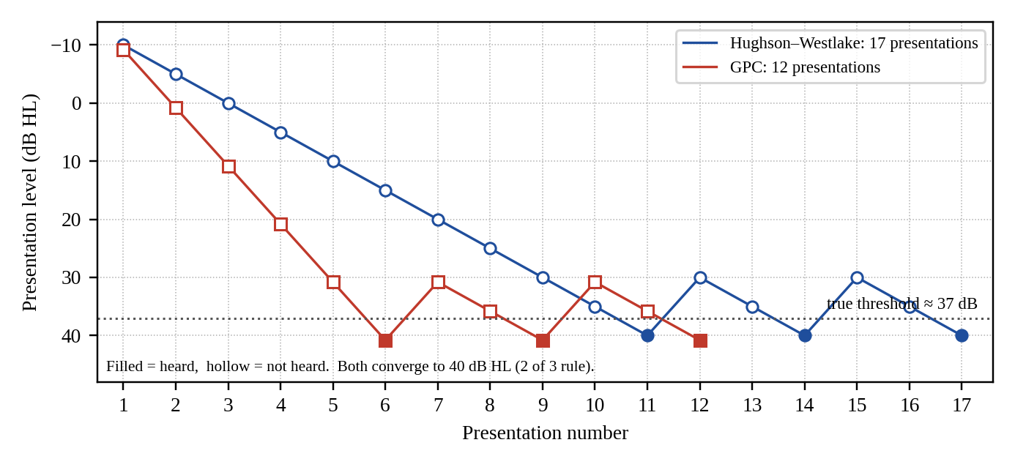
Figure 1-1: Hughson–Westlake versus GPC presentation sequences (simulated with the project code)
Note. in the Phase-1 report the acronym GPC was expanded as "Gaussian Process Classification". A review of the implemented source code shows that the deployed engine is the deterministic coarse-to-fine staircase described above, named Graduated Presentation Control. This report therefore uses that definition consistently. Gaussian-process methods are discussed separately in Section 1-6 only as one candidate classifier for the new etiology model.

1-3 Quantitative Description of an Audiogram

1-3-1 Degree of Hearing Loss
The degree of hearing loss is summarised by the pure-tone average (PTA), the mean AC threshold over a set of frequencies. The Audiogram Analyzer uses the four-frequency average of 500, 1000, 2000 and 4000 Hz and the widely used scale derived from Clark (1981) shown in Table 1-1. The World Health Organization's 2021 grading, which uses the same four frequencies in the better ear but stricter boundaries, is given for comparison, because the etiology model will report both for international consistency (WHO, 2021).
Table 1-1: Degree-of-loss scales (PTA at 0.5, 1, 2, 4 kHz)
Category | System scale (dB HL) | WHO 2021 grade (dB HL)
Normal | −10 to 25 | < 20
Mild | 26 to 40 | 20 to < 35
Moderate | 41 to 55 | 35 to < 50
Moderately severe | 56 to 70 | 50 to < 65
Severe | 71 to 90 | 65 to < 80
Profound | 91 and above | 80 to < 95
Complete / total | — | ≥ 95

1-3-2 Type of Hearing Loss (Air–Bone Gap)
The type of loss is determined by comparing AC and BC thresholds frequency by frequency. A significant ABG (in clinical practice ≥ 10–15 dB averaged over 0.5–2 kHz) with normal BC indicates a conductive loss; elevated BC with no significant ABG indicates SNHL; elevated BC with a significant ABG indicates a mixed loss. The current implementation (classification.py) applies these rules with an average-gap threshold of 10 dB and a BC-PTA normality limit of 25 dB HL. These outputs become input features of the etiology model.

1-3-3 Configuration (Shape) of the Audiogram
Configuration describes how the threshold varies with frequency, and it is the single most informative property for etiology. Standard descriptors include: flat (thresholds within about 20 dB across frequencies); gradually sloping (thresholds worsen progressively toward high frequencies); steeply sloping or precipitous (a sharp drop above a certain frequency); rising (worse at low frequencies, typical of Ménière's disease and some conductive losses); notched (a localised dip, typically at 3–6 kHz, with recovery at 8 kHz, typical of noise exposure); and trough or "cookie-bite" (worst at mid frequencies, often hereditary). Because experts frequently disagree when labelling configuration subjectively, rule-based systems such as AMCLASS (Margolis & Saly, 2007) and data-driven classifiers (Charih et al., 2020) were developed to make these descriptions reproducible; the proposed model adopts numeric shape features instead of subjective labels (Section 3-5-2).

1-3-4 Symmetry Between Ears
Most acquired bilateral conditions, such as presbycusis and occupational noise exposure, produce roughly symmetrical audiograms. A clinically significant asymmetry is therefore a warning sign that may indicate unilateral pathology, including retrocochlear lesions such as vestibular schwannoma. There is no single universal definition; a commonly used clinical rule is an interaural difference of 15 dB or more at two or more adjacent frequencies, and Margolis and Saly (2008) validated an automated asymmetry rule against expert judges. In the proposed model, asymmetry is both a feature and a red-flag trigger for referral.

1-4 Etiologies of Hearing Loss and Their Audiometric Signatures
Different pathologies damage different structures, so they tend to produce different audiogram patterns. The relationship is probabilistic rather than deterministic: one pattern may be compatible with several causes, and two causes frequently coexist (for example, noise damage superimposed on presbycusis). This is why the proposed model outputs a ranked list of probable causes with confidence values instead of a single diagnosis. Figure 1-2 illustrates the typical patterns described in this section.
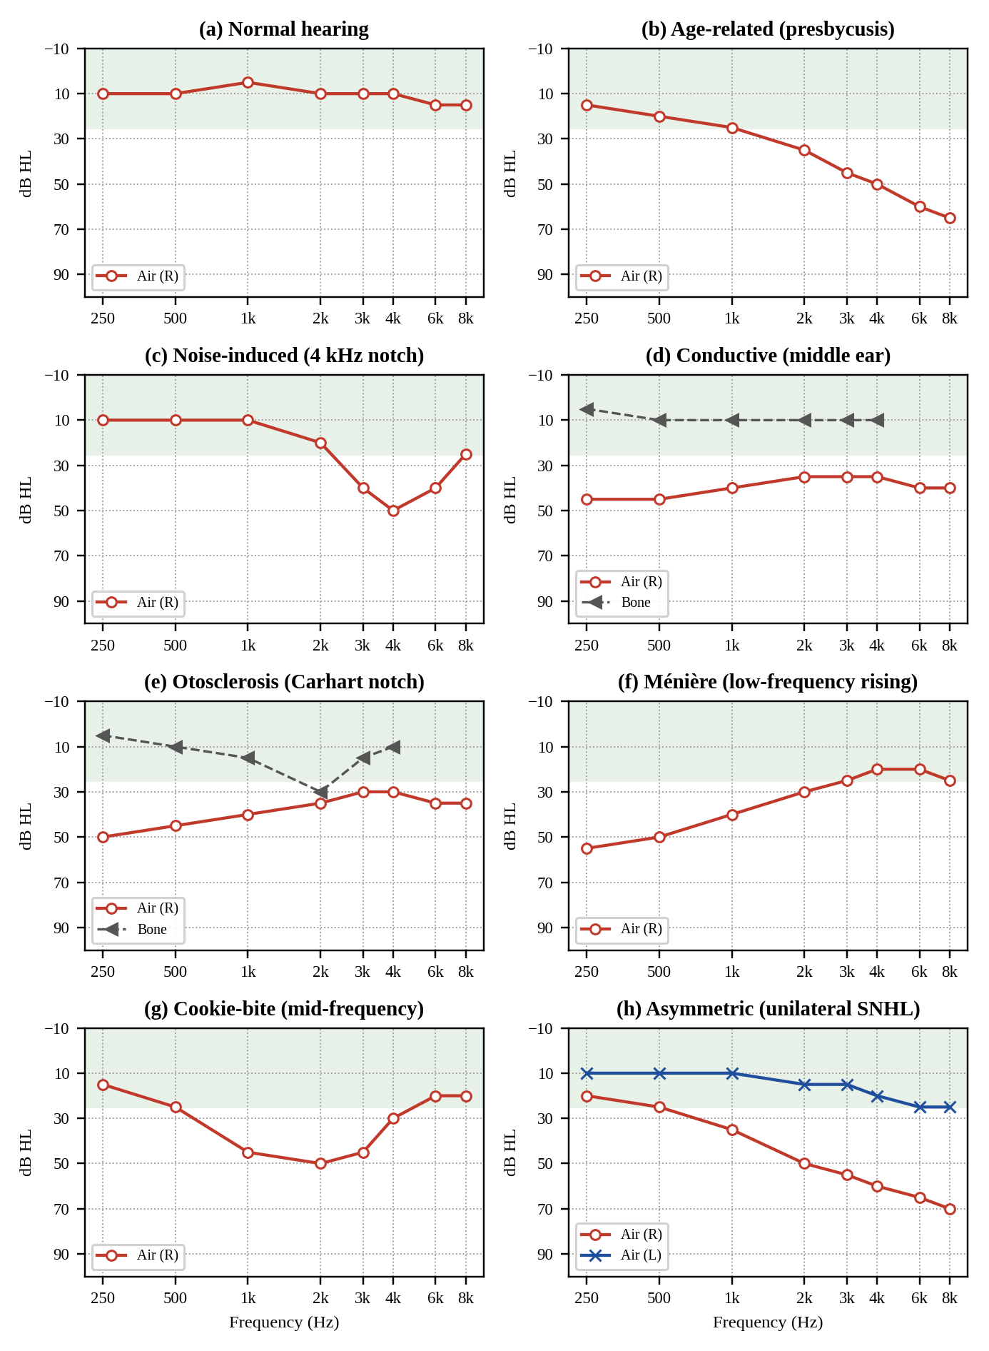
Figure 1-2: Illustrative typical audiometric patterns of common hearing-loss etiologies (schematic values; shaded band = normal range)

1-4-1 Age-Related Hearing Loss (Presbycusis)
Presbycusis is the most common cause of SNHL in adults (Gates & Mills, 2005). It is typically bilateral, symmetrical and gradually sloping, beginning at the highest frequencies and progressing toward the speech frequencies with age. Schuknecht and Gacek (1993) described sensory, neural, strial (metabolic) and cochlear-conductive forms. Building on animal models, Dubno et al. (2013) defined four human audiometric phenotypes, older-normal, metabolic (mild low-frequency loss with a gentle high-frequency slope), sensory (near-normal low frequencies with a steep high-frequency loss) and metabolic + sensory, and showed that supervised machine-learning classifiers can assign new audiograms to these phenotypes with probabilities. A longitudinal study of 343 older adults (686 ears) then showed that phenotypes remain stable for most ears over several years, with transitions mostly toward metabolic forms as age increases (Vaden et al., 2017). An important practical tool is the international standard ISO 7029 (2017), which gives the statistical distribution of hearing thresholds as a function of age and sex; comparing a patient's thresholds with the age-expected median allows the model to judge whether a loss is "compatible with age" or exceeds what ageing alone would explain.

1-4-2 Noise-Induced Hearing Loss
Prolonged or intense noise damages the outer hair cells in the cochlear region that responds to about 3–6 kHz. The resulting audiogram shows a characteristic notch (or "bulge") that is usually deepest at 4 kHz, with better thresholds at 8 kHz, and it is usually bilateral. The American College of Occupational and Environmental Medicine notes that occupational NIHL rarely exceeds about 75 dB HL at high frequencies or 40 dB HL at low frequencies (Kirchner et al., 2012). The Coles–Lutman–Buffin (CLB) guidelines formalise the diagnosis with three requirements: high-frequency hearing impairment (R1), a potentially hazardous amount of noise exposure (R2), and an identifiable high-frequency notch or bulge (R3), together with modifying factors such as age compatibility and asymmetry (Coles et al., 2000). The notch criterion requires the thresholds at 3, 4 and/or 6 kHz to be at least 10 dB worse than at 1 or 2 kHz and at 6 or 8 kHz. Moore et al. (2022) proposed alternative guidelines aimed at military and impulse noise. Two practical lessons follow for the project. First, notch detection needs the 3 kHz and 6 kHz test frequencies, which the current test protocol does not yet include (Section 3-7-3). Second, an audiogram alone cannot prove noise causation; the exposure history (R2) must come from the patient, which motivates the short questionnaire.
It should also be noted that noise can damage auditory nerve synapses without elevating pure-tone thresholds ("hidden hearing loss"; Kujawa & Liberman, 2009). Such damage is invisible on the audiogram and is outside the scope of an audiogram-based model.

1-4-3 Conductive Pathologies of the Outer and Middle Ear
Cerumen impaction, otitis media with effusion (OME), chronic otitis media and tympanic membrane perforation all produce a conductive pattern: normal BC thresholds with an ABG. The AC configuration is often flat or slightly worse at low frequencies, and the magnitude is typically mild to moderate. These conditions are often treatable, so recognising a conductive pattern and recommending an ENT examination is one of the most clinically valuable outputs of the model. Without otoscopy and tympanometry, which a phone cannot perform, the specific middle-ear cause cannot be identified from the audiogram, so the model reports this class as "conductive / middle-ear pathology" rather than naming a single disease.

1-4-4 Otosclerosis
Otosclerosis is abnormal bone remodelling that fixes the stapes footplate. It typically presents in young and middle-aged adults as a progressive conductive or mixed loss that is often worse at low frequencies (a stiffness-dominated pattern), frequently bilateral. Its classic marker is the Carhart notch: an apparent depression of BC thresholds that is greatest at about 2 kHz, caused by the loss of the ossicular contribution to bone-conducted sound rather than by true cochlear damage (Carhart, 1950). The combination "conductive loss + BC dip at 2 kHz + age 20–50" is therefore a strong rule for this class.

1-4-5 Ménière's Disease
Ménière's disease is an inner-ear disorder associated with endolymphatic hydrops. The diagnostic criteria of the Bárány Society require episodic vertigo together with audiometrically documented low- to medium-frequency SNHL in the affected ear and fluctuating aural symptoms such as tinnitus or fullness (Lopez-Escamez et al., 2015). The audiogram is typically unilateral and rising (or peaked at mid frequencies) in early stages, becoming flatter as the disease progresses. Liu et al. (2025) showed that a light gradient-boosting model using engineered pure-tone features reached 87% accuracy and an AUC of 0.95 for diagnosing Ménière's disease, with low-frequency thresholds (notably 250 Hz), the whole-frequency mean and standard deviation, and the audiogram peak as key features. Since vertigo cannot be seen on an audiogram, the model combines the low-frequency pattern with an optional vertigo question.

1-4-6 Sudden and Asymmetric Sensorineural Hearing Loss
Sudden sensorineural hearing loss (SSNHL) is defined as a loss of at least 30 dB over at least three consecutive frequencies occurring within 72 hours, and it is considered an otological emergency because early treatment improves outcomes (Chandrasekhar et al., 2019). Asymmetric SNHL without an obvious cause requires investigation to exclude retrocochlear pathology such as vestibular schwannoma. These conditions cannot be diagnosed by an app, but they can be flagged. The model therefore treats unexplained asymmetry and self-reported sudden onset as red flags that override the probability ranking and trigger urgent-referral advice.

1-4-7 Ototoxic Hearing Loss
Certain drugs, notably platinum-based chemotherapy (e.g., cisplatin) and aminoglycoside antibiotics, can damage the cochlea. Ototoxic loss usually starts at the highest frequencies and is bilateral, so it can resemble presbycusis. ASHA (1994) defines a significant ototoxic change relative to a baseline audiogram (≥ 20 dB at one frequency, ≥ 10 dB at two adjacent frequencies, or loss of response at three consecutive frequencies). Because the definition depends on a baseline and on drug history, the model handles ototoxicity as a modifier: when the patient reports exposure to such drugs and the history module of the app contains an earlier audiogram, the longitudinal change is evaluated.

1-4-8 Hereditary and Congenital Patterns
Genetic hearing loss can produce many configurations, but the mid-frequency trough ("cookie-bite") pattern is classically associated with hereditary forms. A cookie-bite pattern in a younger patient, especially with a positive family history, is therefore reported as "hereditary pattern suggested" with a recommendation for specialist assessment. This class has low prevalence and will be handled mainly by rules rather than learned from data.

1-4-9 Summary of Audiometric Signatures
Table 1-2 summarises the discriminating information for each etiology. It is the medical foundation of the knowledge base and of the feature set designed in Chapter 3.
Table 1-2: Audiometric and clinical signatures of the target etiologies
Etiology | Type | Typical configuration | Laterality | Supporting non-audiometric cues
Presbycusis | SNHL | Gradually sloping, high frequencies first | Bilateral, symmetric | Age ≥ 50; loss consistent with ISO 7029 norms
Noise-induced | SNHL | Notch at 3–6 kHz (usually 4 kHz), recovery at 8 kHz | Usually bilateral | Occupational, military or recreational noise; tinnitus
Middle-ear (OME, perforation, wax) | Conductive | Flat or low-frequency, ABG present | Uni- or bilateral | Ear fullness, discharge, recent infection
Otosclerosis | Conductive / mixed | Low-frequency conductive; BC dip at 2 kHz (Carhart notch) | Often bilateral | Age 20–50; family history
Ménière's disease | SNHL | Low-frequency rising or peaked; fluctuating | Usually unilateral | Episodic vertigo, tinnitus, aural fullness
Sudden / asymmetric SNHL | SNHL | Any; asymmetric between ears | Unilateral | Sudden onset (≤ 72 h) → urgent referral
Ototoxic | SNHL | High-frequency, progressive | Bilateral | Cisplatin or aminoglycoside exposure; baseline change
Hereditary | SNHL | Mid-frequency trough (cookie-bite) | Bilateral | Younger age; family history

1-5 Clinical Decision Support Systems
A clinical decision support system (CDSS) is software that uses patient data and medical knowledge to produce patient-specific assessments or recommendations that support, rather than replace, clinical judgement. Two broad reasoning paradigms exist, and the proposed solution combines them.

1-5-1 Knowledge-Based (Rule-Based) Reasoning
Knowledge-based systems encode expert knowledge as explicit rules of the form IF condition THEN conclusion, often with a certainty or weight. Their advantages are transparency (every conclusion can be traced to the rules that fired), no need for training data, and direct alignment with published guidelines such as the CLB criteria for NIHL or the ASHA criteria for ototoxicity. Their weaknesses are rigidity at decision boundaries, difficulty in combining many weak cues, and the effort needed to maintain large rule sets. AMCLASS, for instance, used well over a hundred manually written rules to describe audiograms (Margolis & Saly, 2007).

1-5-2 Data-Driven Reasoning
Data-driven systems learn the mapping from inputs to outputs from labelled examples. They capture complex interactions between features and produce graded probabilities, but they need representative labelled data, may learn spurious correlations, and are less transparent. In medicine, a purely data-driven model trained on a small dataset is also at risk of being confidently wrong on rare but dangerous cases.

1-5-3 Hybrid and Explainable Systems
Hybrid systems use rules where medical knowledge is explicit and safety-critical (for example, red flags), and learning where patterns are graded and multi-factorial (for example, separating presbycusis from noise damage in an older patient with a shallow notch). Explainable AI (XAI) techniques add a justification to every prediction, which is essential for user trust and for the supervising physician's review. This hybrid, explainable approach is adopted in the proposed design.

1-6 Machine Learning Foundations for the Etiology Model

1-6-1 Problem Formulation
Etiology inference is formulated as a multi-class probabilistic classification problem. For a patient described by a feature vector x (derived from both ears' thresholds, age and optional answers), the model estimates the posterior probability P(k | x) for each etiology class k in a set of K classes. The output is the ranked list of classes rather than only the most probable one, and the model is allowed to abstain ("indeterminate pattern") when its confidence is too low.
ŷ = argmax_k P(k | x), subject to max_k P(k | x) ≥ τ (otherwise: abstain)

1-6-2 Candidate Classification Algorithms
Because audiometric data are tabular, low-dimensional (tens of features) and the available datasets are small to medium in size, classical machine-learning models are more appropriate than deep networks, a conclusion also reported for related audiometric tasks (Liu et al., 2025; Charih et al., 2020). Table 1-3 lists the candidates that will be compared experimentally.
Table 1-3: Candidate classifiers for the etiology model
Algorithm | Principle | Strengths for this task | Limitations
Multinomial logistic regression | Linear model of log-odds with softmax output | Interpretable coefficients; well calibrated; strong baseline | Cannot capture non-linear shape interactions
Random Forest (Breiman, 2001) | Ensemble of decision trees on bootstrap samples | Robust on small tabular data; handles non-linearity; feature importance | Probabilities need calibration
Gradient boosting (XGBoost / LightGBM) | Sequential trees fitting residual errors | Often best accuracy on tabular data (Chen & Guestrin, 2016) | Over-fits small data if not regularised
Support Vector Machine | Maximum-margin boundary in kernel space | Good with few samples | Probabilities only via Platt scaling; less interpretable
Gaussian Process Classifier | Bayesian kernel method placing a GP prior on a latent function (Rasmussen & Williams, 2006) | Principled uncertainty estimates; suits small datasets | O(n³) training cost; limited to a few thousand samples
k-Nearest Neighbours | Vote of the most similar audiograms | Intuitive ("similar past cases") | Sensitive to scaling and irrelevant features

1-6-3 Handling Small and Imbalanced Medical Datasets
Etiology datasets are typically imbalanced: presbycusis and normal hearing are common, while otosclerosis or Ménière's disease are rare. Without correction a model can achieve high accuracy simply by ignoring rare classes. The planned countermeasures are class-weighted training, oversampling techniques such as SMOTE applied only to the training folds (Chawla et al., 2002), knowledge-guided synthetic audiograms used for training but never for testing, and the use of macro-averaged metrics that weight every class equally. Validation splits will be made at the patient level, because the two ears of the same person are correlated and splitting them across training and test sets would leak information.

1-6-4 Probability Calibration and Abstention
A model is well calibrated when, among all cases to which it assigns 70% probability, about 70% are correct. Calibration matters because the app displays confidence values to users. Tree ensembles are often miscalibrated, so post-hoc calibration (Platt scaling or isotonic regression) will be applied on a validation set, and calibration will be measured with the Expected Calibration Error (Guo et al., 2017):
ECE = Σ_m ( |B_m| / n ) · | acc(B_m) − conf(B_m) |
where the predictions are grouped into M confidence bins B_m. A calibrated model also makes the abstention threshold τ meaningful: τ can be chosen to guarantee a target precision on the cases where the model does answer.

1-6-5 Model Explainability
Two complementary explanation mechanisms will be used. The knowledge base provides a rule trace (for example: "4 kHz threshold is 25 dB worse than 2 kHz and 15 dB worse than 8 kHz, which meets the noise-notch criterion"). For the ML component, SHAP values (Lundberg & Lee, 2017) quantify how much each feature pushed the prediction toward or away from each class. The app will translate the top contributions into short bilingual sentences understandable by non-specialists.

1-6-6 Evaluation Metrics
The model will be evaluated with: per-class sensitivity (recall) and specificity; precision; the macro-averaged F1-score; top-3 accuracy (whether the true cause appears in the three causes shown); the confusion matrix to reveal systematic confusions (for example presbycusis versus noise); the one-versus-rest ROC-AUC; ECE for calibration; and Cohen's kappa (κ) for agreement with expert audiologists and ENT physicians. For the red-flag function, sensitivity is the priority metric because a missed sudden or asymmetric loss is the most harmful error.
F1_k = 2 · Precision_k · Recall_k / (Precision_k + Recall_k), Macro-F1 = (1/K) Σ_k F1_k

1-7 Chapter Summary
This chapter established that the audiogram carries four kinds of information (degree, type, configuration and symmetry) and that the configuration and symmetry, combined with age, are strongly associated with specific etiologies. It reviewed the threshold procedures implemented in the system and corrected the meaning of GPC, described the audiometric signatures of eight etiology groups with their guideline sources, and presented the decision-support and machine-learning concepts (hybrid reasoning, probabilistic classification, calibration, explainability and evaluation metrics) needed to build a trustworthy etiology model.

Chapter 2: Scientific Problem, Objectives, and State of the Art

2-1 Project Context
Phase 1 delivered a working mobile audiometry system: a React Native (Expo) client with a bilingual interface and offline storage, and a Django REST Framework backend that manages test sessions, runs the Hughson–Westlake threshold procedure (with GPC available as an alternative strategy through the Strategy design pattern), computes the PTA-based degree of loss, automatically triggers bone-conduction testing when the PTA exceeds 25 dB HL, determines the type of loss from the air–bone gap, and renders the combined audiogram. The system therefore answers the questions "how much?" and "where?". Phase 2 addresses the next question that every patient asks: "why?".

2-2 Scientific Problem

2-2-1 Problem Statement
Given a pure-tone audiogram (air conduction for both ears and, where measured, bone conduction), the patient's age and, optionally, a few answers to clinical questions, the problem is to estimate the most probable causes of the hearing loss, ranked with calibrated confidence and accompanied by a medically grounded explanation, and to detect patterns that require urgent or specialist referral, using a model that can run inside a mobile health application and be understood by non-specialist users.
The practical motivation is strong. The WHO estimates that more than 1.5 billion people live with some degree of hearing loss and projects that nearly 2.5 billion will be affected by 2050, while access to audiologists and ENT specialists is severely limited in low- and middle-income settings (WHO, 2021). Many causes are preventable (noise) or treatable (middle-ear disease, sudden SNHL when treated early). An app that tells a user "your pattern is typical of noise damage, protect your hearing" or "your pattern suggests a middle-ear problem, see an ENT doctor" turns a screening result into actionable guidance.

2-2-2 Why the Problem Is Scientifically Challenging
- Many-to-one mapping: different causes can produce similar audiograms (e.g., presbycusis and ototoxicity), and the same cause can produce different audiograms at different stages (e.g., Ménière's disease). The problem is inherently uncertain and must be solved probabilistically.
- Coexisting causes: older adults often have noise damage superimposed on age-related loss, which blurs the notch; the model must reason about combinations rather than force a single label.
- Scarcity of labelled data: large public audiometric datasets (such as NHANES) contain thresholds and questionnaires but not confirmed diagnoses, while clinical datasets with ENT-confirmed etiologies are small, private and imbalanced.
- Limited measurement context: a smartphone audiometer cannot perform otoscopy, tympanometry or speech tests, uses uncalibrated consumer headphones, and does not apply masking; the model must be robust to measurement noise and must not over-interpret small differences.
- Safety and trust: a medical suggestion must be explainable, must never miss red flags, and must clearly state that it is not a diagnosis.

2-2-3 Research Questions
- RQ1: Which audiometric features (configuration, notch, air–bone gap, symmetry, age-normalised loss) best discriminate the common etiologies of hearing loss?
- RQ2: Does a hybrid model that fuses guideline-derived rules with a calibrated ML classifier outperform each component alone in macro-F1 and top-3 accuracy?
- RQ3: How much do age and a short optional questionnaire improve discrimination compared with the audiogram alone?
- RQ4: How well does the model agree with expert clinicians (Cohen's κ) and how well calibrated are its confidence values?

2-3 Project Objectives

2-3-1 Main Objective
To design, implement and evaluate an explainable hybrid decision-support model, integrated into the Audiogram Analyzer, that infers the probable cause of hearing loss mainly from the audiogram pattern, ranks the top three causes with calibrated confidence, and flags cases that require referral.

2-3-2 Specific Objectives
- Build a clinical knowledge base of audiometric rules for eight etiology groups, derived from published guidelines and reviewed by the medical members of the team and the supervisors.
- Implement an automatic audiometric feature-extraction module (at least 18 features per patient) from the thresholds stored by the existing system.
- Assemble a training and evaluation dataset by combining public audiometric data, anonymised clinical audiograms with confirmed diagnoses, and knowledge-guided synthetic audiograms (training only).
- Train, compare and calibrate at least four classifiers and select the best by macro-F1 on patient-level cross-validation.
- Design the fusion and abstention logic and the red-flag rules, targeting red-flag sensitivity of at least 95%.
- Integrate the model into the backend as a new REST endpoint and into the mobile app as a questionnaire screen and a "probable cause" result card in Arabic and English.
- Evaluate the complete system against expert judgement on a held-out real dataset and with clinical case vignettes.
- Update the test protocol to add 3 kHz and 6 kHz air-conduction thresholds, which are needed for reliable noise-notch detection.

2-3-3 Scope and Limitations
The model is a screening-level decision-support tool, not a diagnostic device. It addresses adult and adolescent users with acquired or long-standing hearing loss and does not cover infant hearing screening, central auditory processing disorders, or hidden hearing loss. Its outputs are expressed as "pattern consistent with ..." and are always accompanied by a recommendation to consult a specialist when hearing loss is present. Clinical validation will be limited to the data that can be obtained within the project period, and regulatory certification is outside the scope of a graduation project.

2-4 State of the Art
This section reviews the most relevant recent work along five lines: machine-learning audiometry, rule-based audiogram description, data-driven audiogram classification, etiology and phenotype inference from the audiogram, and consumer screening applications. The Phase-1 report already reviewed mobile audiometry applications in detail, so the focus here is on audiogram interpretation.

2-4-1 Automated and Machine-Learning Audiometry
Song et al. (2015) introduced machine-learning audiometry that models the whole audiogram as a continuous function of frequency using Gaussian-process classification, selecting each next tone actively to maximise information. This line of work shows that ML can speed up threshold estimation, but it concerns how to measure the audiogram, not how to interpret it. In the Audiogram Analyzer, measurement is performed by the HW and GPC staircases; the present phase adds interpretation.

2-4-2 Rule-Based Audiogram Description Systems
Margolis and Saly (2007) developed AMCLASS, a rule-based system that classifies audiograms by configuration, severity, site of lesion and symmetry to produce standardised descriptions, and later validated its asymmetry rules against expert judges (Margolis & Saly, 2008). In the medicolegal domain, the CLB guidelines provide explicit numeric criteria for diagnosing NIHL (Coles et al., 2000), and Moore et al. (2022) proposed an alternative set aimed at military noise. These works prove that audiometric knowledge can be formalised as rules, but they describe the audiogram or address a single etiology; they do not rank multiple etiologies.

2-4-3 Data-Driven Audiogram Classification
Charih et al. (2020) built a data-driven system for mobile audiometry that classifies configuration, severity and symmetry from expert-annotated audiograms, after showing high intra- and inter-rater agreement among three audiologists; the goal was to give non-experts a concise description. Crowson et al. (2020) developed AutoAudio, a deep convolutional network that classifies audiogram images into normal, conductive, mixed and sensorineural types, trained on about one thousand clinical audiogram reports, with mixed losses being the most frequently misclassified. Elkhouly et al. (2023) improved data-driven audiogram classifiers through normalisation and multi-stage feature selection, and Kassjański et al. (2022) applied neural networks to raw audiometry data series for patient referral. Parthasarathy et al. (2020) applied unsupervised segmentation to a large clinical cohort and found that conventional categories left a substantial portion of audiograms unclassified, highlighting the value of data-driven phenotypes. Collectively, these studies classify the type, degree or shape of loss; none of them outputs a ranked etiology for a mobile user.

2-4-4 Etiology and Phenotype Inference from the Audiogram
The closest work to this project concerns specific etiologies. Dubno et al. (2013) and Vaden et al. (2017) classified the audiograms of older adults into metabolic and sensory phenotypes of presbycusis using supervised classifiers trained on exemplar audiograms derived from animal models, demonstrating that audiogram shape carries etiological information. Liu et al. (2025) trained five classical ML models on engineered pure-tone features to diagnose Ménière's disease and found that a light gradient-boosting model performed best (87% accuracy, AUC 0.95), with low-frequency thresholds among the key features. For noise, Chen et al. (2021) reviewed the contributions and limitations of ML for predicting NIHL, mostly from exposure data. Abdala et al. (2025) showed that a random-forest model can separate NIHL from presbycusis with high accuracy when otoacoustic-emission measurements are added to age and audiogram shape, which confirms the difficulty of this distinction with the audiogram alone and the value of additional cues. Each of these studies targets one etiology or one age group, uses clinic-grade equipment, and does not provide a multi-etiology ranking with red-flag logic.

2-4-5 Consumer and Screening Applications
Screening apps such as hearWHO, Mimi, uHear and hearScreen (reviewed in the Phase-1 report) report a pass/refer outcome or a hearing score and sometimes the degree of loss. None of them provides etiological guidance or combines bone-conduction results, configuration analysis and age norms into an explained recommendation.

2-4-6 Comparative Analysis
Table 2-1: Comparison of related work with the proposed model
Work | Input | Task / output | Method | Multi-etiology ranking | Explainable / mobile
Song et al. (2015) | Live responses | Threshold estimation | Gaussian-process active learning | No | Partly / No
AMCLASS (2007, 2008) | AC + BC thresholds | Configuration, severity, site, symmetry | Expert rules | No | Yes / No
Charih et al. (2020) | AC thresholds | Configuration, severity, symmetry | Supervised ML (trees) | No | Partly / Yes
AutoAudio (2020) | Audiogram image | Normal / conductive / mixed / SNHL | Deep CNN | No | Partly / No
Dubno (2013); Vaden (2017) | AC thresholds (older adults) | Presbycusis phenotypes | QDA and ML classifiers | No (one etiology) | Yes / No
Liu et al. (2025) | AC thresholds | Ménière's disease yes / no | LightGBM and others | No (one etiology) | Partly / No
Abdala et al. (2025) | OAEs + age + shape | NIHL vs presbycusis | Random forest | No (two classes) | Partly / No
Proposed model | AC + BC, age, optional history | Top-3 etiologies + red flags | Rules + calibrated ML fusion | Yes (8 groups) | Yes / Yes

2-5 Research Gap and Expected Contribution
The review reveals a clear gap: existing systems either measure the audiogram, describe it (degree, type, shape), or detect one specific etiology with clinic-grade data. No reviewed system combines configuration, bone-conduction, symmetry and age-normalised information into a ranked, calibrated and explained multi-etiology suggestion with safety red flags inside a mobile audiometry application. The expected contributions of this phase are:
- A formalised, guideline-traceable knowledge base that maps audiometric signatures to eight etiology groups.
- A hybrid inference method that fuses rule evidence with calibrated ML probabilities and abstains when uncertain.
- An end-to-end mobile implementation that links the measurement layer (HW / GPC), the description layer (degree / type) and the new interpretation layer, with bilingual explanations.
- An empirical evaluation of the contribution of each information source (audiogram, age, questionnaire) and of agreement with clinicians.

Chapter 3: Proposed Solution

3-1 Solution Idea
The proposed solution adds an Etiology Inference Module to the existing Audiogram Analyzer. After a patient completes the air-conduction test for both ears (and bone conduction when indicated), the backend already holds the thresholds, the degree and the type of loss. The new module converts these thresholds into a set of clinically meaningful features, evaluates them against a knowledge base of medical rules, obtains class probabilities from a trained ML classifier, and fuses both sources into a ranked list of the three most probable causes, each with a confidence value and an explanation. Safety rules run first and can override the ranking with urgent-referral advice.
The design follows four principles: (1) audiogram-first: the model works with thresholds alone and uses age and questionnaire answers only to refine the result; (2) safety-first: red flags are deterministic rules that cannot be outvoted by the ML component; (3) explainability: every output carries the reasons behind it; and (4) honest uncertainty: the model reports confidence and abstains when the pattern is ambiguous.

3-2 System Block Diagram
Figure 3-1 shows the updated system architecture. The new or modified components are highlighted in orange. The existing three-layer client–server architecture is preserved: the mobile client handles presentation and offline storage, the Django backend hosts the business logic, and the data layer stores users, sessions and results. The Etiology Inference Module sits after the existing degree and type classifier, reads the versioned model artifact and rule set, stores each assessment in the database, and returns its result to the new result card in the app.
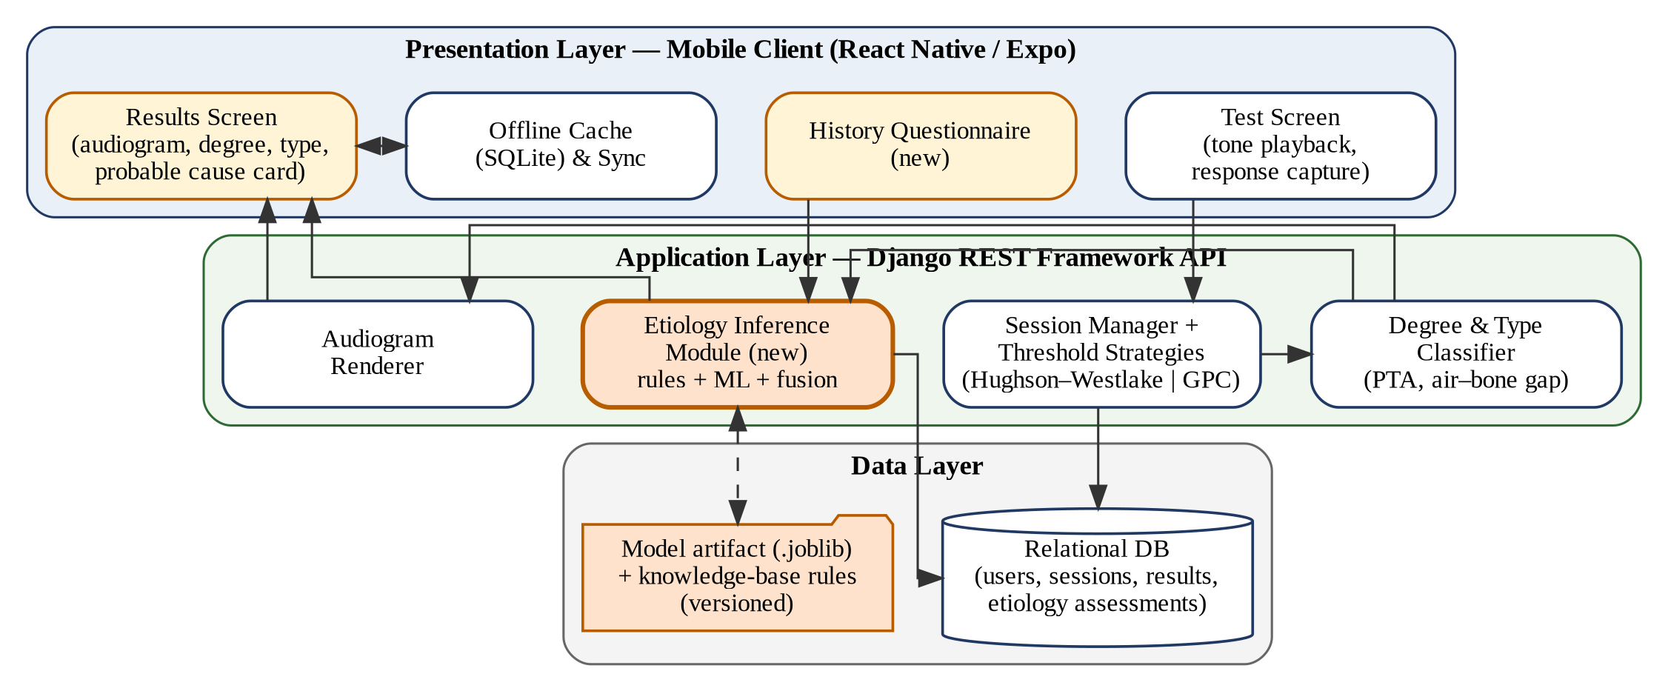
Figure 3-1: System block diagram of the Audiogram Analyzer with the new Etiology Inference Module

3-3 Etiology Inference Module Block Diagram
Figure 3-2 details the internal structure of the module, which is organised as a pipeline of five blocks.
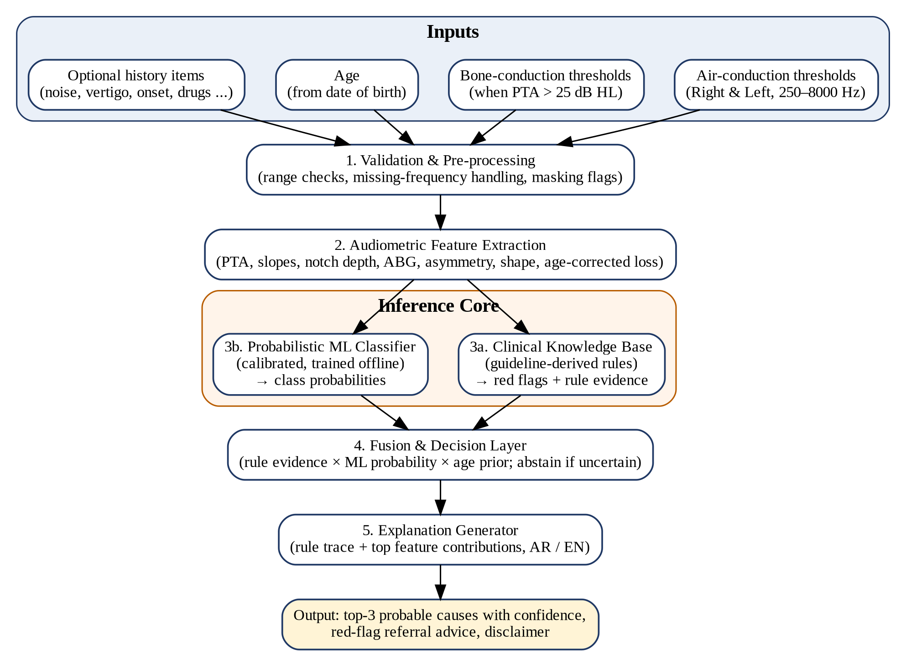
Figure 3-2: Block diagram of the Etiology Inference Module
- Validation and pre-processing: checks that each ear has enough valid thresholds (at least five, including 0.5–4 kHz), clips values to the valid range, interpolates a single missing inter-octave frequency when its neighbours exist, and records data-quality flags (for example, BC not tested).
- Feature extraction: computes the feature vector described in Section 3-5-2 for each ear and for the interaural comparison.
- Inference core: the knowledge base (3a) produces red flags and an evidence score for each cause; the ML classifier (3b) produces calibrated probabilities. The two run independently on the same features.
- Fusion and decision: combines both sources with an age-dependent prior, applies the abstention threshold, and ranks the causes.
- Explanation generator: builds a short bilingual explanation from the fired rules and the strongest SHAP contributions, and attaches the standard disclaimer.

3-4 Flowcharts

3-4-1 End-to-End Workflow Flowchart
Figure 3-3 shows the complete user workflow from login to the stored etiology result. The test part (left branch of the flowchart) reuses the Phase-1 logic, including automatic bone-conduction testing when the PTA exceeds 25 dB HL. The new steps are the optional history questionnaire, the etiology inference and the red-flag decision.
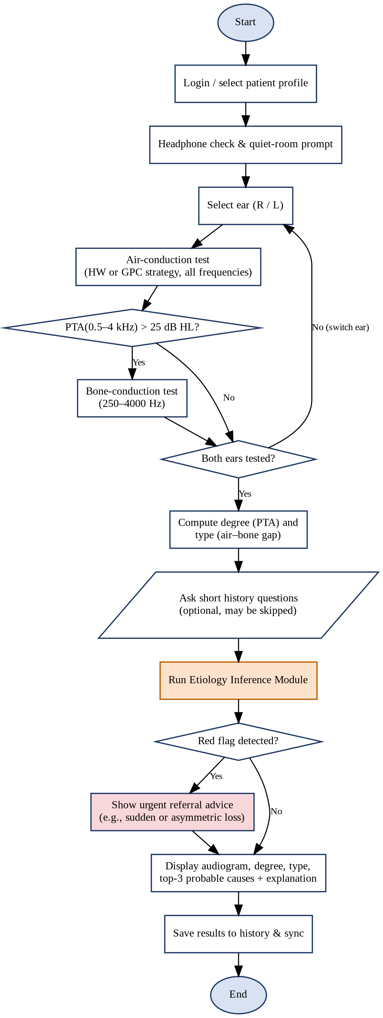
Figure 3-3: End-to-end workflow flowchart

3-4-2 Etiology Inference Algorithm Flowchart
Figure 3-4 shows the decision logic inside the module. Insufficient data stops the process with a request to repeat the test. Normal hearing on both ears is reported directly. Otherwise red-flag rules are evaluated first, then the rule evidence and ML probabilities are fused; if the best fused score does not reach the confidence threshold τ, the result is labelled "indeterminate pattern" with a recommendation for clinical assessment.
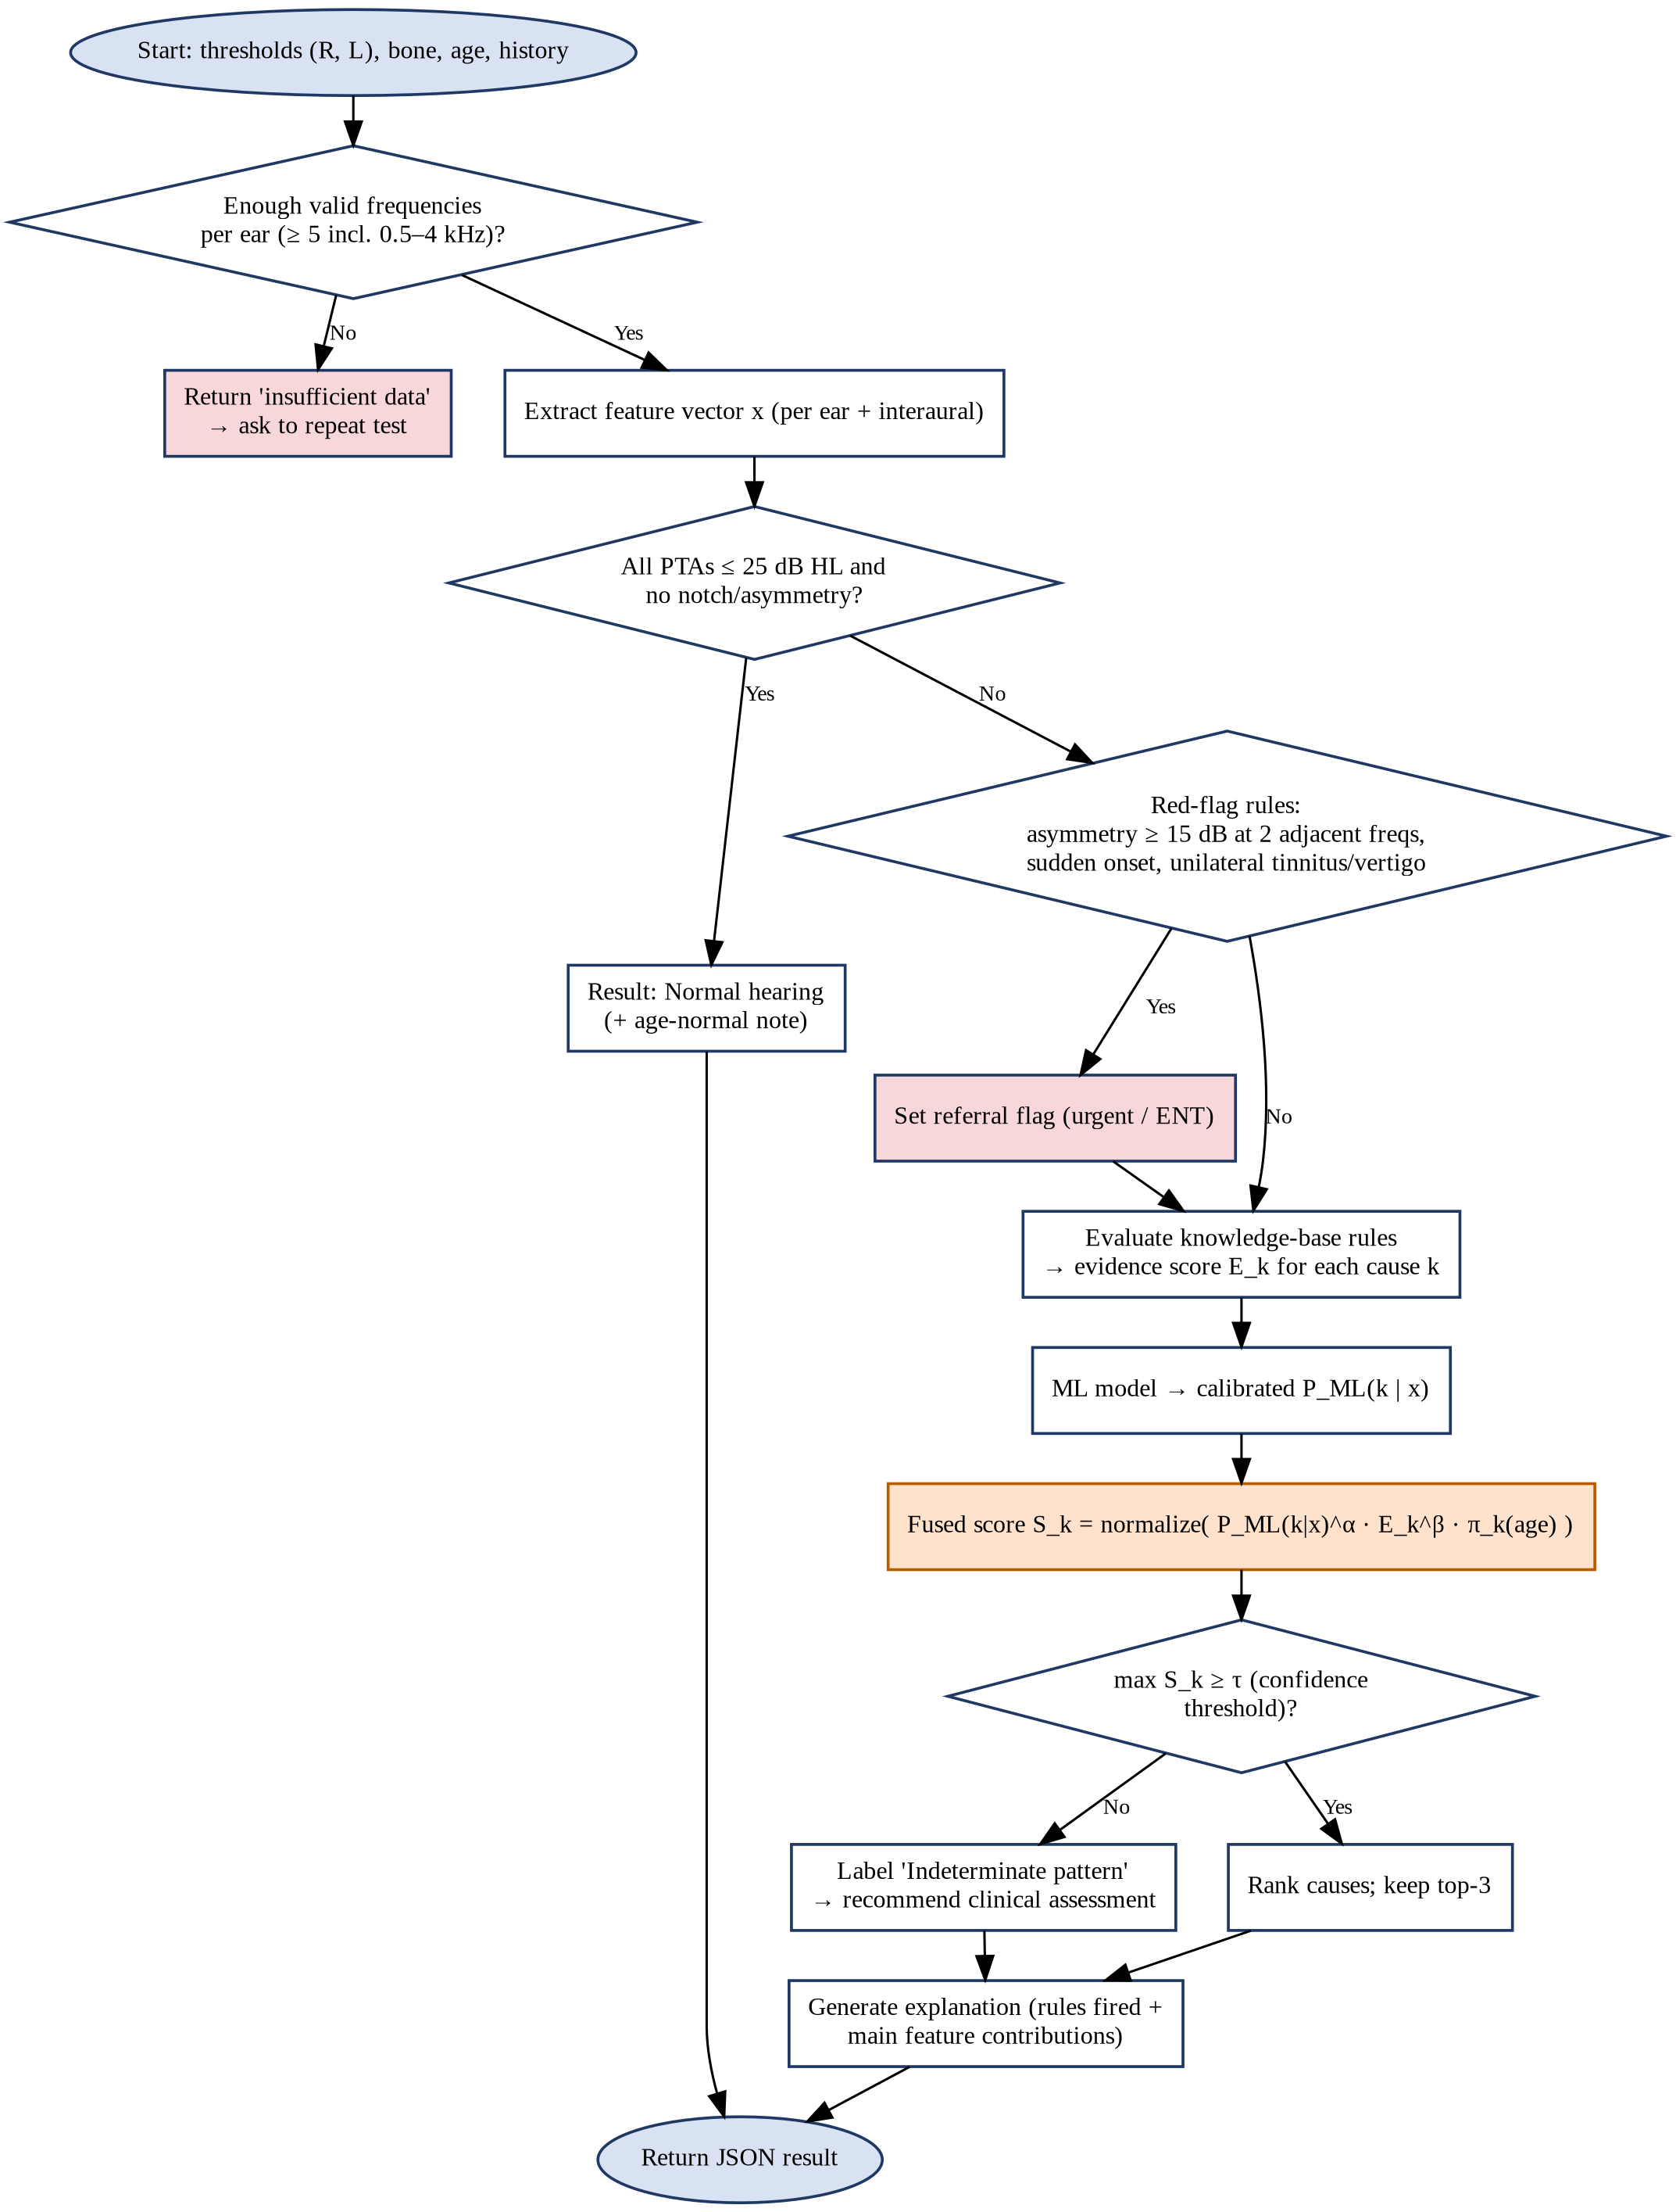
Figure 3-4: Flowchart of the etiology inference algorithm

3-5 Detailed Design of the Inference Core

3-5-1 Target Classes
The output space consists of nine labels: eight etiology groups and one abstention label. The groups were chosen to be (a) clinically actionable, (b) distinguishable at least partially from the audiogram, and (c) covered by published criteria.
Table 3-1: Output classes of the etiology model
Code | Class (patient-facing label) | Recommended action shown to the user
C0 | Normal hearing | No action; periodic re-test
C1 | Age-related pattern (presbycusis) | Hearing-aid assessment if speech is affected
C2 | Noise-induced pattern | Hearing protection; occupational assessment
C3 | Conductive / middle-ear pattern | ENT examination (often treatable)
C4 | Otosclerosis-suggestive pattern | ENT / otology referral
C5 | Ménière-suggestive (low-frequency) pattern | ENT referral; vestibular assessment
C6 | Asymmetric / sudden-loss pattern (red flag) | Urgent ENT referral (sudden: within days)
C7 | Hereditary (mid-frequency) pattern | Audiology / genetics consultation
C8 | Indeterminate / mixed causes | Full clinical audiological assessment

Ototoxic loss is not a separate learned class because it cannot be separated from presbycusis without drug history and a baseline; it is handled as a rule-based modifier that adds an "ototoxic contribution possible" note when the questionnaire indicates exposure and the history shows a significant change (ASHA, 1994).

3-5-2 Feature Set
Thresholds are denoted T(f) in dB HL. Features are computed per ear (R and L) and then summarised as the worse ear, the better ear and the interaural difference. Table 3-2 lists the planned features and the clinical reason for each.
Table 3-2: Audiometric and contextual features
# | Feature | Definition | Clinical purpose
1 | PTA4 | Mean T at 0.5, 1, 2, 4 kHz | Degree of loss
2 | LF-PTA | Mean T at 0.25, 0.5, 1 kHz | Low-frequency involvement (Ménière, conductive)
3 | HF-PTA | Mean T at 3 (or 2), 4, 6, 8 kHz | High-frequency involvement (age, noise)
4 | Slope | HF-PTA − LF-PTA (dB) | Sloping vs flat vs rising configuration
5 | Regression slope | Linear fit of T vs log2(f) (dB/octave) | Robust shape descriptor
6 | Notch depth | T(4k) − max(T(1k or 2k), T(8k)) using CLB-style logic | Noise notch (CLB R3)
7 | 8 kHz recovery | T(4k or 6k) − T(8k) | Separates noise notch from age slope
8 | Mid-trough depth | Mean T(1k, 2k) − mean(T(250), T(8k)) | Cookie-bite pattern
9 | Peak position | Frequency of the best threshold | Ménière peaked/rising patterns
10 | Threshold SD | Standard deviation across frequencies | Flatness; Ménière feature
11 | ABG mean | Mean (AC − BC) over 0.5, 1, 2 kHz | Conductive component
12 | LF-ABG ratio | ABG at 0.25–0.5 kHz vs at 2–4 kHz | Stiffness (otosclerosis) pattern
13 | Carhart index | BC(2k) − mean(BC(1k), BC(4k)) | Carhart notch (otosclerosis)
14 | BC-PTA | Mean BC at 0.5, 1, 2 kHz | Cochlear reserve
15 | Asymmetry max | Max interaural difference over adjacent-frequency pairs | Red flag; unilateral disorders
16 | Asymmetry PTA | |PTA4(R) − PTA4(L)| | Laterality
17 | Age-excess loss | Mean T − ISO 7029 median for age and sex | Loss beyond ageing
18 | Age | Years, from date of birth | Prior for presbycusis / otosclerosis
19–23 | History items (optional) | Noise exposure, vertigo, sudden onset, ototoxic drugs, family history | Refine CLB R2, Ménière, SSNHL, ototoxicity, hereditary

3-5-3 Clinical Knowledge Base
Each rule produces either a red flag or an evidence score E_k in the range 0–1 for a class k (1 = criterion fully met). Graded scores are obtained with a linear ramp around each threshold instead of a hard cut-off, which reduces sensitivity to measurement error of ±5 dB. Table 3-3 shows the initial rule set. All numeric limits are initial values taken from the cited guidelines; they will be reviewed with the medical supervisor before implementation and tuned on the validation set.
Table 3-3: Initial knowledge-base rules
ID | Condition (summary) | Conclusion | Source
R1 | PTA4 ≤ 25 dB HL in both ears, no notch, no asymmetry | C0 evidence | Clark (1981); WHO (2021)
R2 | T(3/4/6k) ≥ 10 dB worse than T(1/2k) and than T(6/8k) | C2 evidence (strong if noise history = yes) | Coles et al. (2000)
R3 | Bilateral, symmetric, slope ≥ 20 dB, no ABG, age ≥ 50 | C1 evidence | Gates & Mills (2005)
R4 | Loss within ISO 7029 range for age and sex | Increase C1, decrease C2 | ISO 7029 (2017)
R5 | ABG mean ≥ 15 dB and BC-PTA ≤ 25 dB HL | C3 evidence | ASHA (2005)
R6 | Conductive/mixed + Carhart index ≥ 10 dB + age 20–55 | C4 evidence | Carhart (1950)
R7 | Unilateral SNHL with LF-PTA ≥ HF-PTA + 10 dB | C5 evidence (strong if vertigo = yes) | Lopez-Escamez et al. (2015)
R8 | Interaural difference ≥ 15 dB at ≥ 2 adjacent frequencies, not explained by conductive component | RED FLAG → C6 | Margolis & Saly (2008)
R9 | Sudden onset (≤ 72 h) reported with any loss | URGENT RED FLAG → C6 | Chandrasekhar et al. (2019)
R10 | Mid-trough depth ≥ 15 dB, bilateral, age < 50 | C7 evidence | Clinical literature
R11 | Ototoxic drug = yes and history shows ≥ 20 dB change at one frequency or ≥ 10 dB at two adjacent | Ototoxicity note (modifier) | ASHA (1994)
R12 | ABG ≥ 15 dB and BC-PTA > 25 dB HL | Mixed: combine C3 with SNHL classes | ASHA (2005)

3-5-4 Machine-Learning Classifier
The ML component is trained offline on the feature vectors described above and exported as a versioned artifact (.joblib) loaded once by the backend. The candidate models are those in Table 1-3; a tree ensemble (random forest or gradient boosting) is the expected choice given the size and tabular nature of the data, with multinomial logistic regression as the interpretable baseline and the Gaussian-process classifier as the uncertainty-aware alternative. Model selection uses stratified, patient-grouped five-fold cross-validation with macro-F1 as the primary criterion; hyper-parameters are tuned by randomised search inside the training folds only. The selected model is calibrated with isotonic regression (or Platt scaling for small classes) on a separate validation split. Implementation will use scikit-learn (Pedregosa et al., 2011), which must be added to the backend requirements because it is not used by the Phase-1 code.

3-5-5 Fusion and Decision Logic
For each class k the fused score combines the calibrated ML probability, the rule evidence and an age-dependent prior:
S_k = [ P_ML(k | x)^α · (ε + E_k)^β · π_k(age) ] / Σ_j [ P_ML(j | x)^α · (ε + E_j)^β · π_j(age) ]
Here α and β weight the two sources (tuned on validation data, initially α = β = 1), ε is a small constant (e.g., 0.05) that prevents a class with no rule support from being eliminated completely, and π_k(age) is the prior prevalence of class k for the patient's age band, estimated from the training data. The decision procedure is then:
- If R9 fires (sudden onset), return C6 with "urgent" priority, regardless of other scores.
- If R8 fires (unexplained asymmetry), add C6 as a flagged result shown at the top, and continue ranking the remaining causes.
- If max_k S_k < τ, return C8 (indeterminate) together with the two best candidates as "possible".
- Otherwise return the top three classes ordered by S_k, with confidence levels mapped to bands (high ≥ 0.70, moderate 0.40–0.70, low < 0.40).
When the ML artifact is unavailable (for example, in an early release), the module degrades gracefully by setting α = 0 and using the rules and priors alone, so the feature remains functional and explainable.

3-5-6 Explanation and Output Format
The module returns a structured JSON object that the app renders in the selected language. An example for a 58-year-old patient with a bilateral 4 kHz notch and reported workplace noise is shown below.
{
"assessment_id": 214,
"model_version": "etiology-1.0.0",
"red_flags": [],
"top_causes": [
{"code": "C2", "label_en": "Noise-induced pattern", "confidence": 0.71, "band": "high",
"reasons_en": ["Notch at 4 kHz: 25 dB worse than 2 kHz, recovers by 15 dB at 8 kHz",
"Both ears similar", "Reported long-term workplace noise"]},
{"code": "C1", "label_en": "Age-related pattern", "confidence": 0.22, "band": "low",
"reasons_en": ["Age 58; mild high-frequency slope"]},
{"code": "C8", "label_en": "Other / mixed causes", "confidence": 0.07, "band": "low"}
],
"advice_en": "Use hearing protection in noise and consult an audiologist.",
"disclaimer_en": "This is a screening suggestion, not a medical diagnosis."
}

3-6 Data Strategy and Model Training Pipeline
Data availability is the main risk of this phase, so a three-source strategy is planned (Figure 3-5).
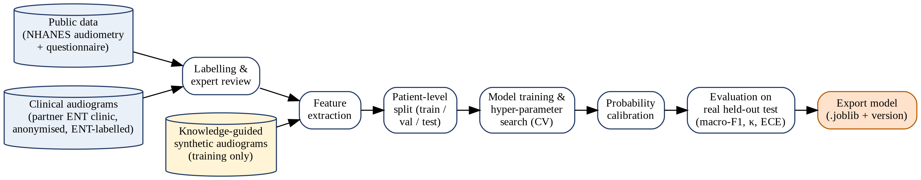
Figure 3-5: Data and model training pipeline
- Public audiometric data (NHANES): the U.S. National Health and Nutrition Examination Survey publishes air-conduction thresholds (0.5–8 kHz, including 3 and 6 kHz) together with age and questionnaire data on noise exposure (National Center for Health Statistics, n.d.). It contains no confirmed diagnoses, so it will be used to learn age norms and priors and to create weak labels for normal, age-related and noise-related patterns by applying the knowledge-base rules with conservative thresholds. Bone conduction is not available in this source.
- Clinical audiograms with confirmed diagnoses: anonymised audiograms with ENT-confirmed etiologies will be requested from a partner clinic through the Faculty of Medicine. These records are the only source of ground truth for the conductive, otosclerosis and Ménière classes and are reserved primarily for validation and testing. Collection requires approval from the responsible ethics committee and the removal of all personal identifiers.
- Knowledge-guided synthetic audiograms: for rare classes, synthetic audiograms will be generated from the class templates of Table 1-2, starting from an age- and sex-appropriate ISO 7029 baseline and adding class-specific shape components and random measurement noise of ±5 dB. Synthetic data are used only to balance the training set and are never included in validation or test sets, so reported performance always reflects real audiograms.
If the clinical dataset turns out to be very small, the fallback plan is to evaluate the ML component on NHANES-derived classes and to evaluate the full system on a set of clinical case vignettes (realistic audiograms with known diagnoses) independently labelled by the medical supervisor and at least one additional clinician, measuring agreement with Cohen's κ.

3-7 Integration with the Existing System

3-7-1 Backend Changes
A new Django application named etiology will be added alongside the existing users and audio_engine applications, following the same layered structure. It will contain features.py (feature extraction), rules.py (knowledge base), model_service.py (loading and calling the ML artifact), fusion.py (decision logic) and explain.py (bilingual explanations). A new EtiologyAssessment model will store the patient, references to the air and bone sessions of both ears, the age at test, the questionnaire answers (JSON), the computed features (JSON), the result (JSON), the model version and a timestamp, so every suggestion is reproducible and auditable. Table 3-4 lists the planned endpoints, which reuse the existing JWT authentication and role permissions.
Table 3-4: Planned REST endpoints
Method | Endpoint | Description | Access
POST | /api/etiology/assess/ | Run the model on the latest completed sessions of both ears (or given session IDs) with optional answers | Patient (own data), audiologist
GET | /api/etiology/<id>/ | Retrieve a stored assessment with explanation | Owner, audiologist
GET | /api/etiology/history/ | List the patient's previous assessments | Owner, audiologist
GET | /api/etiology/questions/ | Return the bilingual questionnaire definition | Authenticated users

3-7-2 Frontend Changes
On the mobile side, a short questionnaire screen (five yes/no/unknown questions, skippable) will be shown after both ears are tested, and the existing result screen will gain a "Probable cause" card displaying the top three causes with confidence bars, the expandable explanation, the advice, any red-flag banner and the disclaimer. Results will be cached in SQLite and synchronised by the existing sync service, and the history screen will show previous assessments.

3-7-3 Planned Updates to the Testing Module
- Add 3000 Hz and 6000 Hz to the air-conduction frequency list. The current list (250, 500, 1000, 2000, 4000, 8000 Hz) cannot resolve notches centred at 3 or 6 kHz, which the CLB criterion uses. The extra two frequencies add roughly one minute per ear.
- Wire the GPC strategy into the session flow. The session manager currently always uses Hughson–Westlake, and the factory branch that should create the GPC strategy passes constructor arguments that the GPC class does not accept. This will be corrected so that GPC can be selected and compared experimentally.
- Store test-quality metadata (strategy used, number of presentations, response consistency) so that the etiology module can lower its confidence for unreliable tests.

3-8 Evaluation Plan and Success Criteria
Table 3-5: Evaluation metrics and target values
Aspect | Metric | Target
Overall discrimination | Macro-F1 on real held-out audiograms | ≥ 0.75
Usefulness of ranking | Top-3 accuracy | ≥ 0.90
Safety | Red-flag sensitivity (asymmetric / sudden cases) | ≥ 0.95
Agreement with clinicians | Cohen's κ vs expert labels | ≥ 0.60 (substantial)
Confidence quality | Expected Calibration Error | ≤ 0.05
Ablation | Δ macro-F1: audiogram only vs + age vs + questionnaire | Reported (RQ3)
Hybrid benefit | Rules only vs ML only vs fusion | Fusion best (RQ2)
Performance | Server inference time per assessment | < 200 ms
Usability | Users correctly understand the result card (task test + SUS) | ≥ 80% / SUS ≥ 70

Unit tests will cover every feature and rule with hand-computed audiograms (including the patterns of Figure 1-2), integration tests will cover the new endpoints, and the evaluation results will be reported in the final report with confusion matrices and reliability diagrams.

3-9 Ethical, Safety, and Regulatory Considerations
- Every output is phrased as a pattern suggestion and carries a disclaimer that it is not a diagnosis; the app always recommends professional assessment when hearing loss is detected.
- Red flags are rule-based and cannot be suppressed by the ML component; the urgent message for sudden loss is shown first and cannot be dismissed without acknowledgement.
- Clinical data are anonymised before use, stored securely, and used only with ethics approval; patient data inside the app remain protected by the existing JWT and role-based access control.
- Known limitations (uncalibrated headphones, no masking, no otoscopy) are communicated to users, and the model lowers its confidence when test quality is poor.

3-10 Work Plan for the Remainder of the Project
Table 3-6: Sprint plan for Phase 2
Sprint | Duration | Main tasks | Deliverables
S1 | Weeks 1–2 | Finalise target classes and rules with the medical supervisor; request clinical data and ethics approval; download and prepare NHANES | Approved rule table; data request
S2 | Weeks 3–4 | Implement feature extraction and knowledge base; add 3 kHz and 6 kHz to the test; fix GPC wiring | features.py, rules.py, unit tests
S3 | Weeks 5–6 | Build training dataset (weak labels + synthetic); train and compare classifiers; calibration | Model comparison report; model v1
S4 | Weeks 7–8 | Fusion and explanation layers; REST endpoints and database model | Working /api/etiology endpoints
S5 | Weeks 9–10 | Questionnaire screen and probable-cause card (AR/EN); offline sync | Updated mobile app
S6 | Weeks 11–12 | Evaluation on clinical data and vignettes; expert agreement; usability test | Evaluation results
S7 | Weeks 13–14 | Fixes, final report and presentation | Final report and demo

3-11 Chapter Summary
This chapter presented the proposed solution: a hybrid, explainable Etiology Inference Module integrated into the existing architecture. The block diagrams and flowcharts define the components and the decision logic; the feature set and knowledge base translate the theory of Chapter 1 into computable criteria; the fusion formula combines rules, calibrated ML probabilities and age priors while preserving deterministic safety rules; and the data strategy, integration plan, evaluation criteria and sprint plan define how the solution will be implemented and validated in the remainder of the project.

References
References are formatted in APA 7th edition style.
[1] Abdala, C., et al. (2025). Distinguishing between presbycusis and noise-induced hearing loss with a joint-otoacoustic emission profile. Ear and Hearing.
[2] American Speech-Language-Hearing Association. (1994). Guidelines for the audiologic management of individuals receiving cochleotoxic drug therapy. ASHA, 36(Suppl. 12), 11–19.
[3] American Speech-Language-Hearing Association. (2005). Guidelines for manual pure-tone threshold audiometry. ASHA.
[4] Breiman, L. (2001). Random forests. Machine Learning, 45(1), 5–32.
[5] Carhart, R. (1950). Clinical application of bone conduction audiometry. Archives of Otolaryngology, 51(6), 798–808.
[6] Carhart, R., & Jerger, J. F. (1959). Preferred method for clinical determination of pure-tone thresholds. Journal of Speech and Hearing Disorders, 24(4), 330–345.
[7] Chandrasekhar, S. S., Tsai Do, B. S., Schwartz, S. R., et al. (2019). Clinical practice guideline: Sudden hearing loss (update). Otolaryngology–Head and Neck Surgery, 161(1_suppl), S1–S45.
[8] Charih, F., Bromwich, M., Mark, A. E., Lefrançois, R., & Green, J. R. (2020). Data-driven audiogram classification for mobile audiometry. Scientific Reports, 10, 3962.
[9] Chawla, N. V., Bowyer, K. W., Hall, L. O., & Kegelmeyer, W. P. (2002). SMOTE: Synthetic minority over-sampling technique. Journal of Artificial Intelligence Research, 16, 321–357.
[10] Chen, F., Cao, Z., Grais, E. M., & Zhao, F. (2021). Contributions and limitations of using machine learning to predict noise-induced hearing loss. International Archives of Occupational and Environmental Health, 94, 1097–1111.
[11] Chen, T., & Guestrin, C. (2016). XGBoost: A scalable tree boosting system. In Proceedings of the 22nd ACM SIGKDD International Conference on Knowledge Discovery and Data Mining (pp. 785–794).
[12] Clark, J. G. (1981). Uses and abuses of hearing loss classification. ASHA, 23(7), 493–500.
[13] Coles, R. R. A., Lutman, M. E., & Buffin, J. T. (2000). Guidelines on the diagnosis of noise-induced hearing loss for medicolegal purposes. Clinical Otolaryngology, 25(4), 264–273. https://doi.org/10.1046/j.1365-2273.2000.00368.x
[14] Crowson, M. G., Lee, J. W., Hamour, A., Mahmood, R., Babier, A., Lin, V., Tucci, D. L., & Chan, T. C. Y. (2020). AutoAudio: Deep learning for automatic audiogram interpretation. Journal of Medical Systems, 44(9), 163.
[15] Dubno, J. R., Eckert, M. A., Lee, F.-S., Matthews, L. J., & Schmiedt, R. A. (2013). Classifying human audiometric phenotypes of age-related hearing loss from animal models. Journal of the Association for Research in Otolaryngology, 14(5), 687–701.
[16] Elkhouly, A., et al. (2023). Data-driven audiogram classifier using data normalization and multi-stage feature selection. Scientific Reports, 13. https://doi.org/10.1038/s41598-022-25411-y
[17] Gates, G. A., & Mills, J. H. (2005). Presbycusis. The Lancet, 366(9491), 1111–1120.
[18] Guo, C., Pleiss, G., Sun, Y., & Weinberger, K. Q. (2017). On calibration of modern neural networks. In Proceedings of the 34th International Conference on Machine Learning (pp. 1321–1330).
[19] International Organization for Standardization. (2010). ISO 8253-1: Acoustics — Audiometric test methods — Part 1: Pure-tone air and bone conduction audiometry. ISO.
[20] International Organization for Standardization. (2017). ISO 7029: Acoustics — Statistical distribution of hearing thresholds related to age and gender. ISO.
[21] Kassjański, M., Kulawiak, M., & Przewoźny, T. (2022). Development of an AI-based audiogram classification method for patient referral. In Proceedings of the 17th Conference on Computer Science and Intelligence Systems (FedCSIS), Annals of Computer Science and Information Systems, 30.
[22] Kirchner, D. B., Evenson, E., Dobie, R. A., Rabinowitz, P., Crawford, J., Kopke, R., & Hudson, T. W. (2012). Occupational noise-induced hearing loss: ACOEM Task Force on Occupational Hearing Loss. Journal of Occupational and Environmental Medicine, 54(1), 106–108.
[23] Kujawa, S. G., & Liberman, M. C. (2009). Adding insult to injury: Cochlear nerve degeneration after "temporary" noise-induced hearing loss. Journal of Neuroscience, 29(45), 14077–14085.
[24] Liu, X., Guo, P., Wang, D., Hsieh, Y. L., Shi, S., Dai, Z., Wang, D., Li, H., & Wang, W. (2025). Applications of machine learning in Meniere's disease assessment based on pure-tone audiometry. Otolaryngology–Head and Neck Surgery, 172(1), 233–242.
[25] Lopez-Escamez, J. A., Carey, J., Chung, W.-H., et al. (2015). Diagnostic criteria for Menière's disease. Journal of Vestibular Research, 25(1), 1–7.
[26] Lundberg, S. M., & Lee, S.-I. (2017). A unified approach to interpreting model predictions. In Advances in Neural Information Processing Systems 30 (pp. 4765–4774).
[27] Margolis, R. H., & Saly, G. L. (2007). Toward a standard description of hearing loss. International Journal of Audiology, 46(12), 746–758.
[28] Margolis, R. H., & Saly, G. L. (2008). Asymmetric hearing loss: Definition, validation, and prevalence. Otology & Neurotology, 29(4), 422–431.
[29] Moore, B. C. J., Lowe, D. A., & Cox, G. (2022). Guidelines for diagnosing and quantifying noise-induced hearing loss. Trends in Hearing, 26.
[30] National Center for Health Statistics. (n.d.). National Health and Nutrition Examination Survey: Audiometry data documentation. Centers for Disease Control and Prevention. https://www.cdc.gov/nchs/nhanes/
[31] Parthasarathy, A., Romero Pinto, S., Lewis, R. M., Goedicke, W., & Polley, D. B. (2020). Data-driven segmentation of audiometric phenotypes across a large clinical cohort. Scientific Reports, 10, 6704.
[32] Pedregosa, F., Varoquaux, G., Gramfort, A., et al. (2011). Scikit-learn: Machine learning in Python. Journal of Machine Learning Research, 12, 2825–2830.
[33] Rasmussen, C. E., & Williams, C. K. I. (2006). Gaussian processes for machine learning. MIT Press.
[34] Schuknecht, H. F., & Gacek, M. R. (1993). Cochlear pathology in presbycusis. Annals of Otology, Rhinology & Laryngology, 102(1 Pt 2), 1–16.
[35] Song, X. D., Wallace, B. M., Gardner, J. R., Ledbetter, N. M., Weinberger, K. Q., & Barbour, D. L. (2015). Fast, continuous audiogram estimation using machine learning. Ear and Hearing, 36(6), e326–e335.
[36] Vaden, K. I., Jr., Matthews, L. J., Eckert, M. A., & Dubno, J. R. (2017). Longitudinal changes in audiometric phenotypes of age-related hearing loss. Journal of the Association for Research in Otolaryngology, 18(2), 371–385.
[37] World Health Organization. (2021). World report on hearing. WHO.

