# **Nustro**

# NUST Café’s Guide with Reviews and Pictures

# App Documentation

# Group Members

## Maryam Farooq 299778

## Ajwad Masood 321564

## Saad Aamir 290527

**Introduction**

NUSTRO is a mobile application designed to provide information about cafes located within the NUST University campus. It allows users to explore various cafes, view their menus, read reviews, and contribute their own reviews. The app utilizes the Flutter framework for cross-platform development and integrates Firebase for user authentication and database management.

This documentation serves as a comprehensive guide to understanding the features, architecture, and usage of the NUSTRO app.

1. **Features**

**Splash Screen**



**User Authentication**

* Sign up and create an account using your name, email address, and password.
* Log in to your account to access personalized features and data.
* Secure authentication powered by Firebase Authentication.

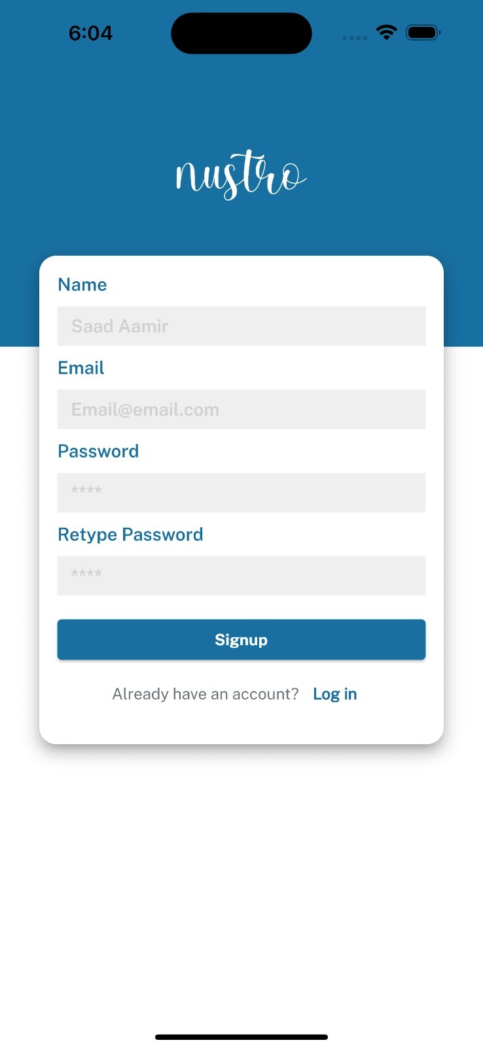

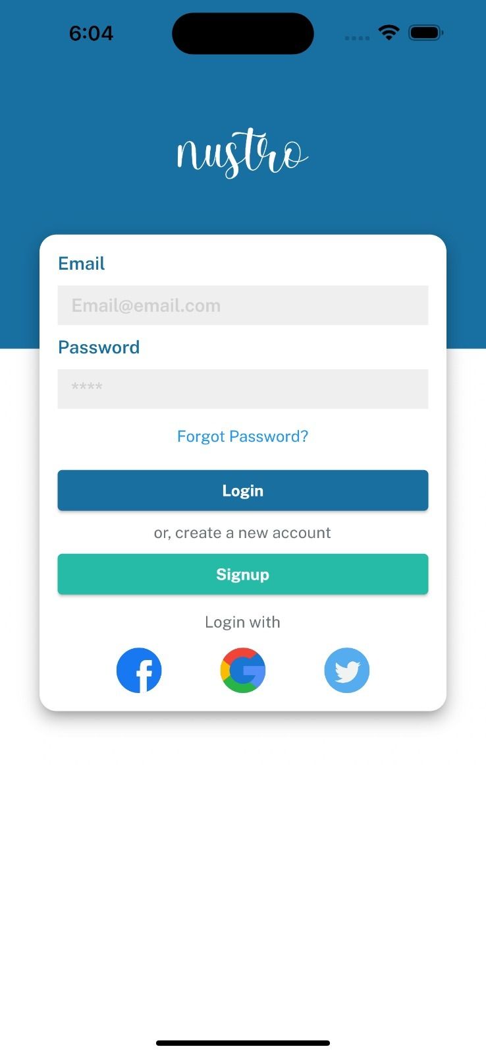

**Cafe Exploration**

* Browse a list of cafes available within the NUST University campus.
* Search for specific cafes using the search bar.
* View essential information about each cafe, such as name and rating.
* Explore the type of food offered by each cafe.

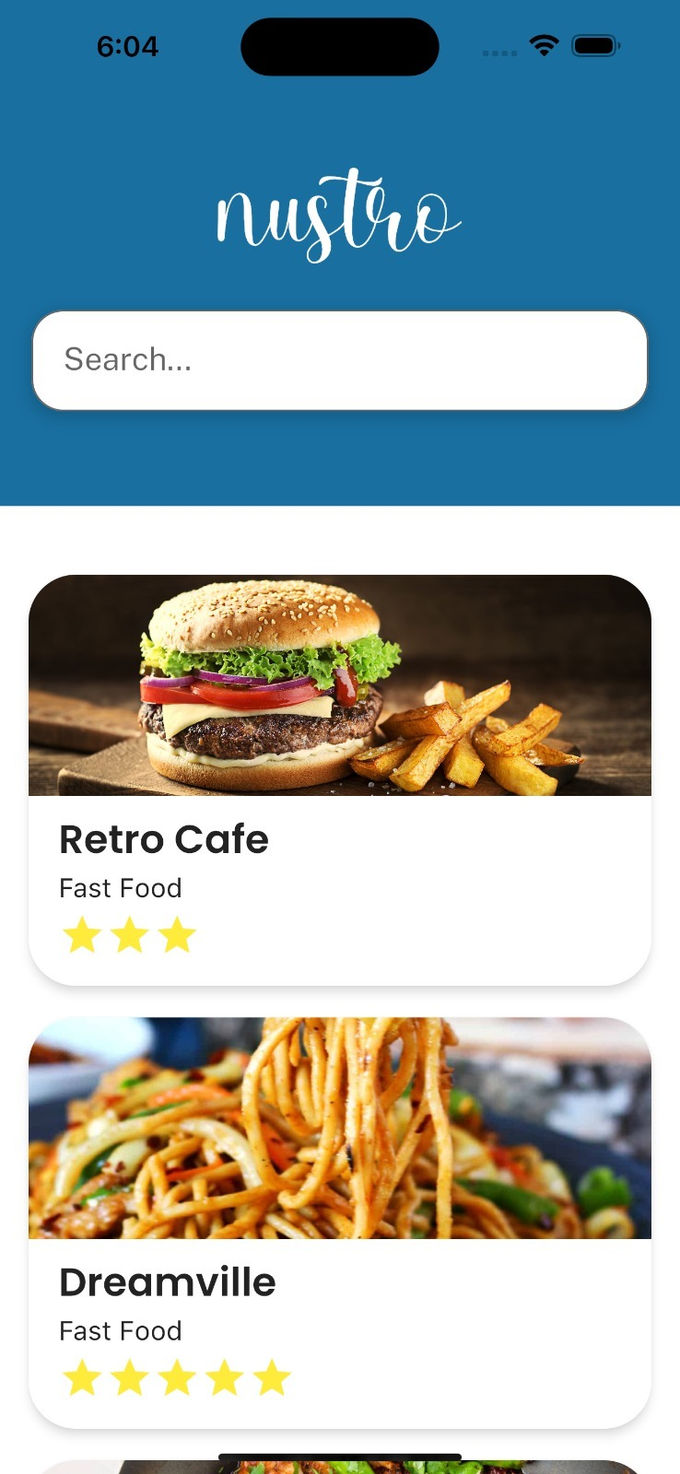

**Cafe Details and reviews**

* Access detailed information about a specific cafe.
* View the cafe's cover image to get a visual representation.
* Browse the menu of the cafe, including item names and prices.
* Read reviews and ratings submitted by other users.
* Share your experience and opinions by writing reviews for cafes.
* Rate the cafe based on your satisfaction.
* Leave comments to provide more detailed feedback.
* Contribute to the community and help others make informed decisions.

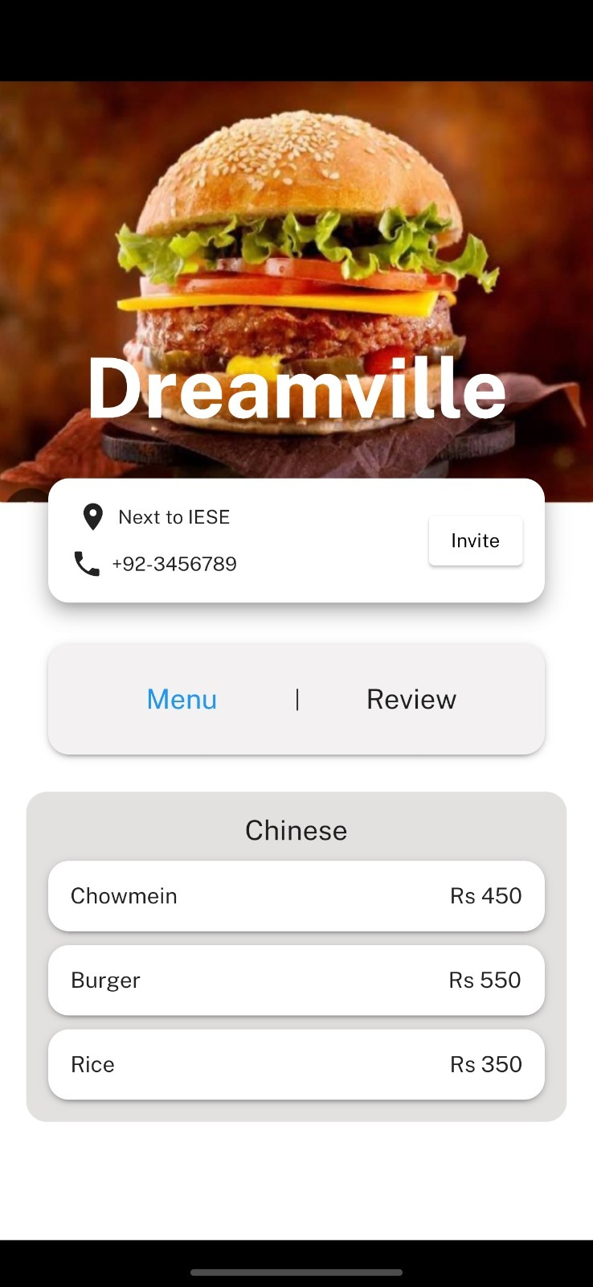

1. **Architecture Overview**

**Flutter Framework**

NUSTRO is built using the Flutter framework, which follows a reactive and declarative programming model. Flutter provides a rich set of pre-designed widgets that facilitate the creation of visually appealing and responsive user interfaces. It also offers a hot-reload feature that allows developers to quickly iterate and see the changes in real-time.

The key components of the Flutter framework used in the NUSTRO app are:

* **Widgets**: Flutter's building blocks for constructing UI elements. These include both basic and complex widgets that define the app's layout, interactivity, and visual appearance.
* **State Management**: Flutter offers various state management approaches such as setState, Provider, BLoC (Business Logic Component), and MobX. These allow developers to handle and update the app's state efficiently.
* **Networking**: Flutter provides libraries like **http** and **dio** for making HTTP requests to fetch data from APIs or interact with Firebase services.

**Firebase Integration**

NUSTRO integrates with Firebase to leverage its powerful backend services for user authentication and database management. Firebase provides a suite of tools and services that simplify app development and enable real-time data synchronization.

The key Firebase services utilized in the NUSTRO app are:

* **Firebase Authentication**: This service manages user authentication, allowing users to sign up and log in securely using their email addresses and passwords. Firebase Authentication provides a simple and secure way to authenticate users.
* **Firebase Firestore**: Firestore is a NoSQL cloud database provided by Firebase. It stores structured data in the form of documents within collections. NUSTRO uses Firestore to store information about cafes, user reviews, and user profiles. Firestore enables real-time data synchronization across devices and offers powerful querying capabilities.
* **Firebase Storage**: Firebase Storage is used to store and retrieve images, such as cafe cover images and user profile pictures. It provides scalable cloud storage infrastructure with easy access and management of files.

**Data Structure**

The data structure in Firebase Firestore for the NUSTRO app is organized as follows:

* **Users Collection**: Contains user profiles and authentication information.
  + User ID
    - Name: User's name.
    - Email: User's email address.
    - Profile Picture URL (optional): URL of the user's profile picture stored in Firebase Storage.
* **Cafes Collection**: Stores information about each cafe.
  + Cafe ID
    - Name: Name of the cafe.
    - Rating: Average rating of the cafe based on user reviews.
    - Type of Food: Category or type of food served by the cafe.
    - Cover Image URL: URL of the cafe's cover image stored in Firebase Storage.
    - Menu
      * Item ID
        + Name: Name of the menu item.
        + Price: Price of the menu item.
* **Reviews Collection**: Contains user reviews for each cafe.
  + Cafe ID
    - Review ID
      * User ID: ID of the user who wrote the review.
      * Rating: Rating provided by the user.
      * Comments: User's comments or feedback about the cafe.

1. **Future Improvements**

To enhance the NUSTRO app further, consider implementing the following features:

* Favorites: Allow users to mark cafes as favorites for quick access.
* Pre-order: Allow users to pre-order so that their food is ready to pick when they get there.
* Filtering and Sorting: Implement options to filter and sort cafes based on rating, type of food, or other criteria.
* User Profiles: Enable users to customize their profiles with additional information and profile pictures.
* Social Sharing: Integrate social media sharing to allow users to share their favorite cafes or reviews.
* Notifications: Implement push notifications to keep users updated on new cafes, menu updates, or reviews.

1. **Conclusion**

The NUSTRO app provides a convenient way for NUST University students and staff to discover and explore the cafes available on campus. With its intuitive interface, users can access detailed cafe information, menus, and reviews. The app's integration with Firebase ensures seamless user authentication and efficient data management. With the provided documentation, users can easily navigate the app's features and utilize its full potential.