**Artificial Intelligence Model Lab**

**Name :** Srinidhi V

**Reg No :** 18C102

**Slot :** A

**Date :** 30.04.2021

**Implement Object Detection (MNIST Semi-supervised Image Recognition) using Convolutional Networks**

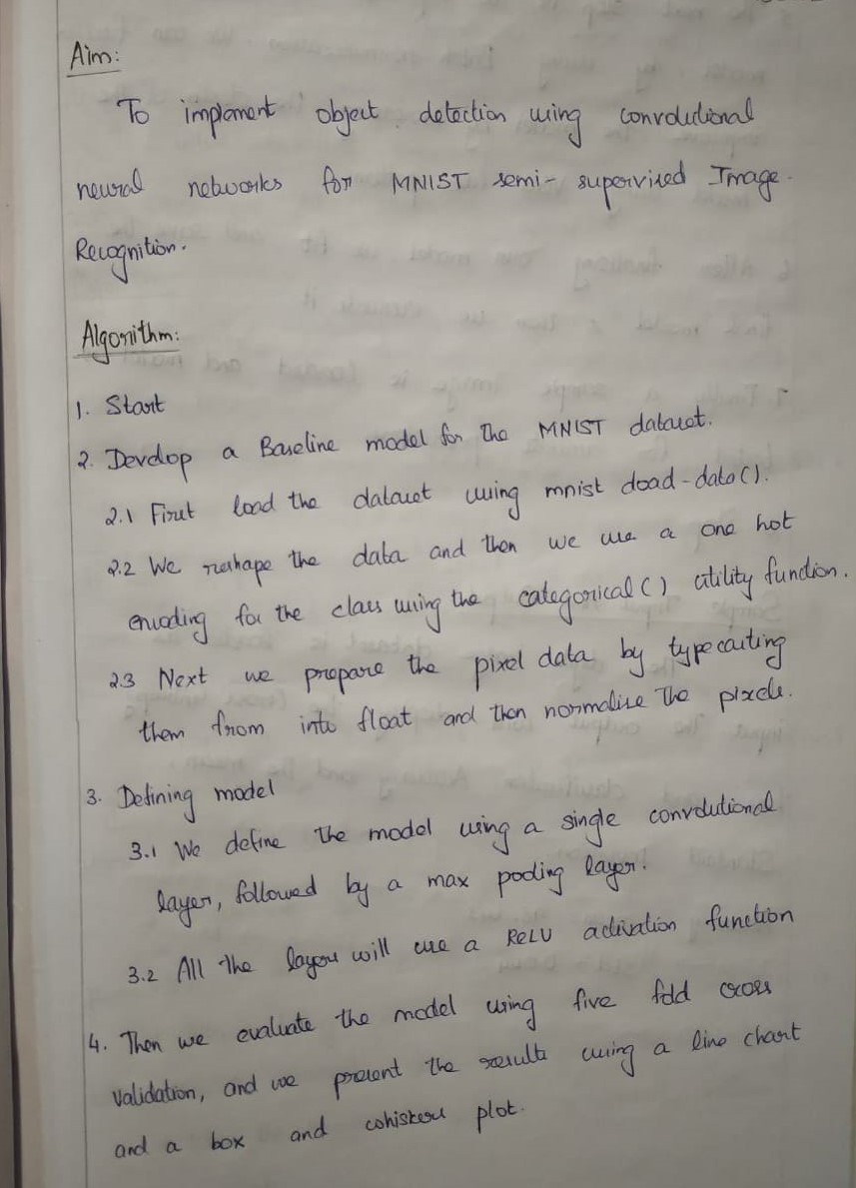

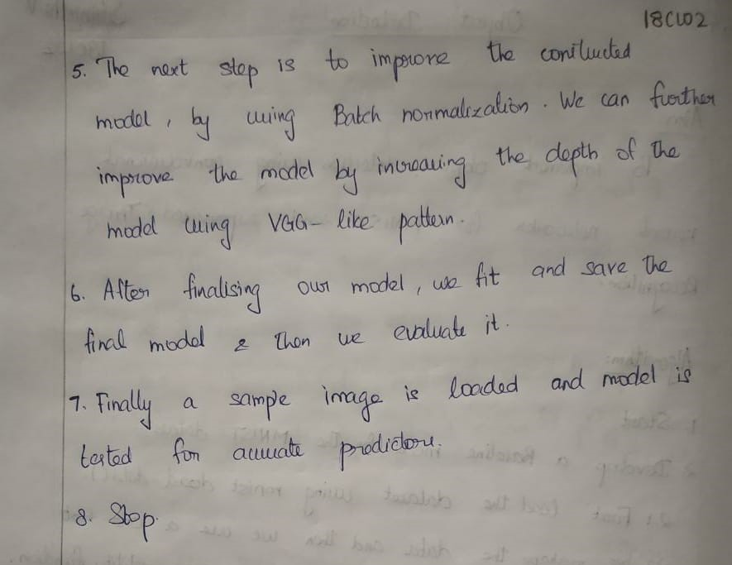

**Output:**

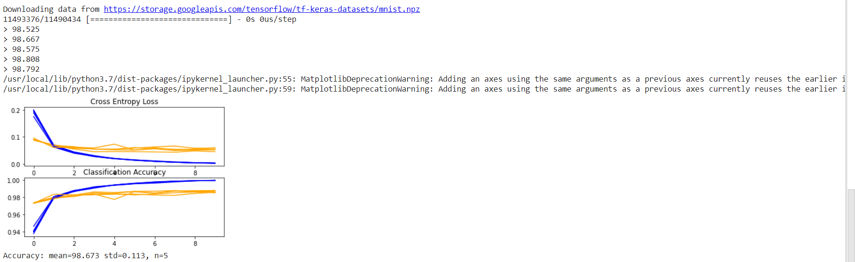

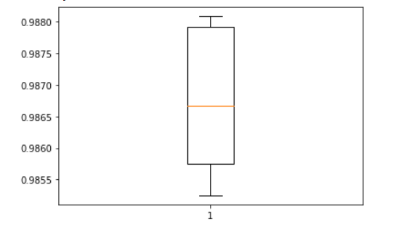

**Result:**

Thus we have implemented object detection using convolutional networks for semi-supervised Image Recognition.