A project report

On

# PTJAGIR

Submitted in partial fulfillment of the requirement of

Project – III (BEG)

Of

Bachelor of Computer Engineering

Biratnagar, Nepal



**Submitted to**



Purbanchal University



# Submitted By

Maryada Karki

Samjhana Khatri

Srijana Chaudhary

# KANTIPUR CITY COLLEGE

Putalisadak, Kathmandu

Aug 17, 2022

A project report On

# PTJAGIR

Submitted in partial fulfillment of the requirement of

Project–III (BEG)

Of

Bachelor of Computer Engineering

## Submitted to

Purbanchal University Biratnagar, Nepal

## Submitted By

Maryada Karki

Samjhana Khatri

Srijana Chaudhary

**Project Supervisor**

# KANTIPUR CITY COLLEGE

Putalisadak, Kathmandu

Aug 17, 2022

# TOPIC APPROVAL SHEET

It is hereby informed that the topic selected by Maryada Karki, Samjhana Khatri and Srijana Chaudhary of Bachelor of computer engineering, Semester VII for their semester project has been found suitable and as per the credit assigned by Purbanchal University (PU), Biratnagar, Nepal.

The project committee has approved the following topic for the above mention students.

Topic Assigned: PTJAGIR

___________________

ER. Subash Raj Karnikar

Head Of Computer Department

# CERTIFICATE OF APPROVAL

The Evaluation Committee has approved and recommended to the Department of

Science and Technology for acceptance of this project report entitled “PTJAGIR” submitted by:

Maryada Karki

Samjhana Khatri

Srijana Chaudhary

## Evaluation Committee

ER. Subash Raj Karnikar

Head of Computer Department,

Kantipur City College

(---------------------------------------)

External Examiner

Er. Subash Rajkarnikar

Head of the Department of IT and Computer Engineering

Kantipur City College Date:

Aug 15, 2022

# ABSTRACT

Our project topic is **“PTJAGIR”** is a database-driven web application. A part-time job is one that usually requires a person to work fewer hours per workweek than their employer deems [full-time employment.](https://www.thebalancecareers.com/how-many-hours-a-week-is-full-time-employment-2063404)

Using this application, we are able to find part time job for someone who is searching for a job and also find employee for someone who are looking for a worker.

The web application is developed using HTML are CSS for the frontend and PYTHON for the backend.

**TABLE OF CONTENT**

CHAPTER 1: INTRODUCTION .................................................................................. 1

1.1 Project Introduction...................................................................................................1

1.2 Problem Statement ................................................................................................... 1

1.3 Objective...................................................................................................................2

1.4 Project Features.........................................................................................................2

1.5 Assignment of roles and responsibilities……………………………………….….3

1.6 Documentation Organization………………………………….…………………...4

CHAPTER 2: LITERATURE REVIEW....................................................................... 5

2.1 Overview of existing System ...................................................................................5 2.2 Limitations ...............................................................................................................5

CHAPTER 3: SYSTEM ANALYSIS ............................................................................6

3.1 System Development Model…………………………………………….….……...6

3.2 Feasibility Study......................................................................................... …........8

CHAPTER 4: CONCLUSION ....................................................................................10

**LIST OF FIGURES**

Figure1 System development model…………………………………………. …...6

Figure2 Use Case Diagram……………………………………………………. ….9

# LIST OF TABLE

Table 1 Documentation and Organization.................................................................4

# CHAPTER 1: INTRODUCTION

## 1.1 Project Introduction

“PTJAGIR”, as a term, covers the concepts of part time job for someone who is searching for a job and also find employee for someone who are looking for a worker.

A key distinction for defining different types of part-time work is between voluntary and involuntary. Voluntary refers to workers who have decided to work part-time rather than seek full-time employment, while involuntary refers to workers who cannot find full-time employment.

In a struggling economy, full-time jobs may become rarer. It may therefore be the case that they have to take a part-time job as full-time work isn’t available. In this economy, employers may choose to offer part-time work over full-time, as they are not usually required to offer the same health and personal benefits.

## 1.2 Problem Statement

The trend of employment among university students has been increasing rapidly the last decade. Some suggest that economic reasons are mainly the factor for this trend. With an increase in the number of students taking part-time job outside campus, its’ effect on student’s academic performance of students has been questioned by many researchers.

## 

## 1.3 Objective

The objectives of PTJAGIR are: -

* To find suitable part time job.
* To find part time employee for any type of work.

## 1.4 Project Features

Some of the useful and important features of PTJAGIR are:

* Find job, find employee and search for nearby job.
* Job notification according to your CV skills.
* To rate and add review the works of the employee.

## 1.5 Assignment of roles and responsibilities

Our team is a group of three people and each member carried out certain roles and responsibilities:

### 1. Srijana Chaudhary

* Documentation and coding.
* Report preparation.
* Program concept and designing.

### 2. Samjhana Khatri

* Feature adding.
* Coding program.
* Program concept designing.

### 3. Maryada Karki

* Coding program and code integration.
* Features adding.
* Program concept designing

## 1.6 Documentation Organization

Documentation is an important part of any software project. It informs both software developers and users. The documentation of personal finance manage was developed throughout the life cycle of the project. The documentation has been separated into the following 3 chapters.

|  |  |  |
| --- | --- | --- |
| **Chapter** | **Heading** | **Contents (Topic)** |
| Chapter-1 | Introduction | 1.1 Project introduction  1.2 Problem statement  1.3 Objectives  1.4 Project Features  1.5 Assignment role and responsibilities  1.6 Document Organization |
| Chapter-2 | Literature Review | 2.1 Overview of the existing system  2.2 Limitation |
| Chapte-3 | System Analysis | 3.1 Requirement Gathering  3.2 Feasibility Study |

Table 1: Documentation and Organization

# CHAPTER 2: LITERATURE REVIEW

## 2.1 Overview of existing System

By observing the existing system in the context of Nepal, we get to know that determining whether a [job is considered part-time](https://www.thebalancecareers.com/how-many-hours-is-a-part-time-job-5206437) depends on the company's policy and practice of defining employees and the hours required to be considered full-time. Part-time positions can sometimes work their way into full-time work, depending on the structure of the company.

Sites like Mero Job, JobsNepal are leading job portals of Nepal. Along with jobs and services they do offer some kind of part time jobs. But due to lack of regulations of companies those services are not effective.

**2.2 Limitations**

* Not effective for part-time jobs.

# CHAPTER 3: SYSTEM ANALYSIS

System analysis is the process of studying a procedure in order to identify its goals and purposes and create system and procedures that will achieve them in an efficient way. It is phase of software development where a system requirement, initial investigation, requirement analysis and feasibility study are performed.

## 3.1 System development model

This web application based on spiral model because in this model is designed to include the best feature from waterfall and prototyping model.

Clients can observe the full process of development from the initial stage to the completion stage. The risk management feature is one of the best development characteristics of the spiral model. Good for large and mission critical projects. Additional function can be added at a later date. Strong approval and documentation control.

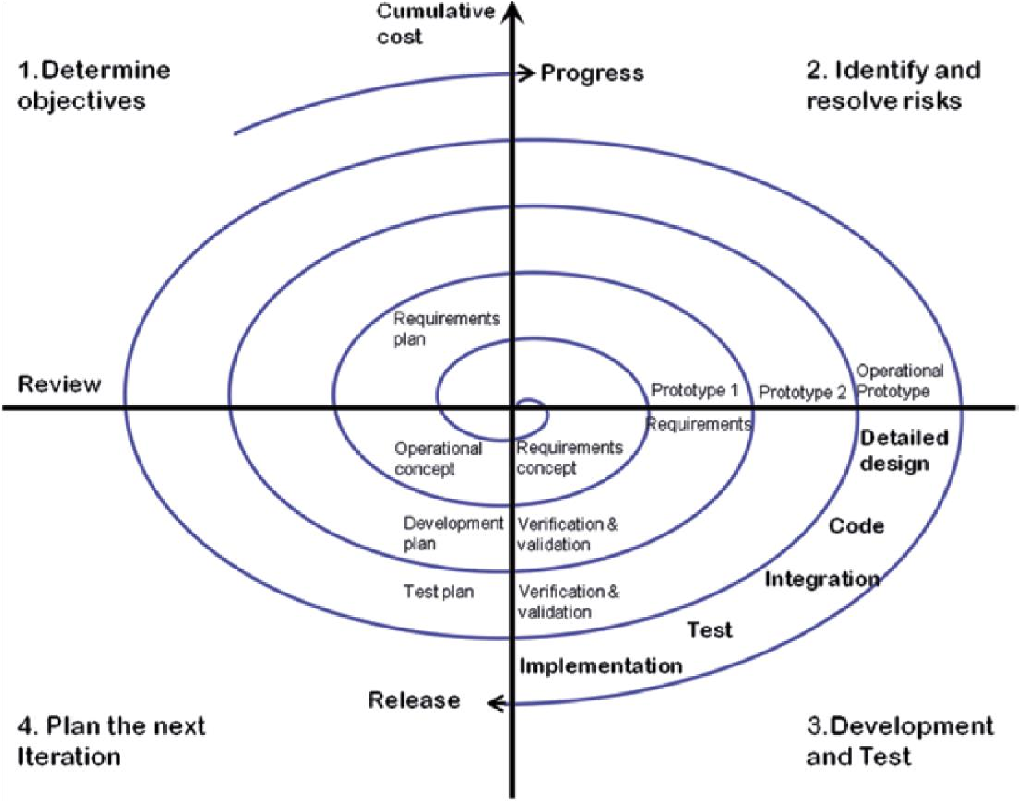

## Fig: Spiral model

1. **Determine objective:**

This phase starts with the gathering of requirements. In the subsequent spirals as the product matures, identification of system requirements and unit requirements are done in this phase.

1. **Identify and resolve risk:**

Risk analysis includes identifying, estimating, and observing technical feasibility.

1. **Development and test:**

This phase includes the actual implementation of the different features. All the implemented features are then verified with thorough testing.

1. **Plan the next iteration:**

In this phase,the software is evaluated by the customer. It also includes risk identification and monitoring like cost overrun or schedule slippage and after that planning of the next phase is start.

## 3.2 Feasibility Study

### 3.2.1 Feasibility Study

The feasibility study for the project involved studying whether the project is feasible technically, economically, ethically and how to complete the project within the scheduled deadline.

### 3.2.2 Technical Feasibility

Technically, it is possible to design this system as a web application. The backend is a MySQL database which will be accessed using PHP. The frontend will be designed in HTML, CSS and JavaScript. Additional libraries like Bootstrap, will be used to provide additional features.

### 3.2.3. Operational Feasibility

Operational feasibility is a measure of how well the system solves the problems and how it satisfies the requirements identified in the analysis. This project is definitely able to satisfy all the requirements.

### 3.2.4 Economic Feasibility

The project does not require any special costs to develop. For the user, the only investment required is a machine to run the software. Hence, the system is economically feasible.

### 3.2.5 Ethical Feasibility

This project is ethically feasible as any immoral, unethical or criminal activity cannot be possible with appropriate security mechanisms.

### 3.2.6 Schedule Feasibility

The project will be completed according to a planned schedule. The planned schedule is displayed in the form of a Gantt chart.

## 3.2 Use Case Diagram

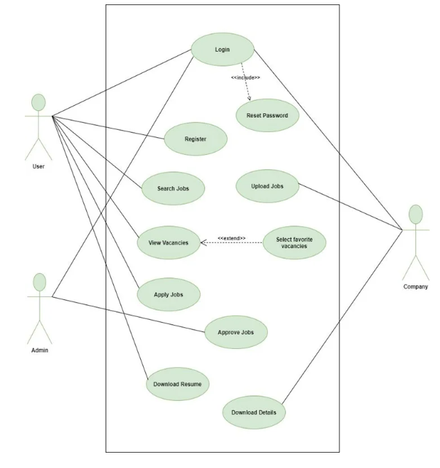

Fig: Use Case Diagram

**CHAPTER 4: CONCLUSION**

It helps to find part time job for someone who is searching for a job. It also helps to find employee for someone who are looking for a worker.