DOES SOCIAL MEDIA, ESPECIALLY INSTAGRAM, NEGATIVELY IMPACT THE MENTAL WELLBEING OF TEENS AND YOUNG ADULTS

Gargi Rajadnya, Maryam Amir Ahmed and Bhavya Shetty

School of Science, NMIMS, Navi Mumbai, India

Abstract
This research is conducted to examine the addiction of social media, especially Instagram and its impact on the mental and emotional wellbeing of teenagers and young adults.
To obtain primary data, we conducted a survey consisting of questions to understand levels of social media addiction, self-esteem, and loneliness through verified scales in psychology. We have acquired 20 responses from the respondents belonging to the age group of 16-21.
We plan to test the association between Instagram addiction and self-esteem and loneliness. Further, investigate if it affects the two negatively.
We intend to test the relationship between Instagram usage and self-esteem and loneliness.
We evaluated the P-Value with the help of Microsoft Excel.
We have then worked on finding the correlation between excessive Instagram usage with levels of self-esteem and loneliness through Microsoft Excel and IBM SPSS via Pearson’s Correlation Coefficient.
Our findings were in the direction of what we originally expected in the alternate hypothesis.

Key Words: Instagram, Loneliness, Self-Esteem, Correlation

Introduction
In the light of rapid proliferation of social media apps, Instagram is the new Facebook for teenagers and young adults.
Loneliness may be defined as "a state that reflects an individual's own perception of deficiencies in his or her network of social associations."
Self-esteem clears as feelings of self-worth and self-respect (Rosenberg,1965).
Hypothesis testing is an act in statistics whereby an analyst tests an assumption regarding a population parameter.
P value is the evidence against a null hypothesis. The smaller the p-value, the stronger the evidence that you should reject the null hypothesis.
Correlation or dependence is any statistical relationship, whether causal or not, between two random variables or bivariate data.
As much as Instagram is a source of communication, sharing memories and socializing; with the easy access to internet, it has become more and more addictive; to the extent that it has social, physical, and mental impact on the users’ lives.
A study conducted by Hou,Y., Xiong, D., Jiang, T., Song, L., & Wang, Q. in 2019 was to investigate the Social media addiction: Its impact, mediation, and intervention. The results proved that higher usage of social media impacts negatively on the mental health of the users and further tested the effectiveness of intervention by creating two groups, control and experimental.
This study will narrow it down to one application, i.e., Instagram and investigate its impact on the self esteem and loneliness in teenagers and young adults.

Methodology
The study we conducted had a correlational research design/ Cross-sectional/Survey design. The data was collected via a questionnaire and the sampling method is convenience sampling.
We evaluated the P-Value with the help of Microsoft Excel and were able to prove that our sample from the age group of 16-21 was addicted to using Instagram.
We have then worked on finding the correlation between excessive Instagram usage with levels of self-esteem and loneliness through Microsoft Excel and IBM SPSS via Pearson’s Correlation
We tested the association between Instagram usage and self-esteem and loneliness; then investigated if it affects the two negatively.
The Null Hypothesis was that Instagram does not have a negative impact on self-esteem and loneliness.
The alternate hypothesis was that using Instagram for long hours affects us badly and that it influences the self-esteem and loneliness of its users adversely.
Coefficient and our findings were in the direction of what we originally expected in the alternate hypothesis.

Results and Discussions
Our findings were in the direction of what we originally expected in the alternate hypothesis.
We were able to prove that
- Our sample was addicted to Instagram.
- Instagram did negatively affect the self-esteem and Loneliness levels.
Descriptive statistics were used within the analysis to obtain certain information from the acquired survey sample.
A sample of 10 females and 10 males, both having percentages of 50% which provided a total of 20 respondents. The sample had an age range 16-21 with 18.5 as the mean.
The Rosenberg self-esteem scale indicated a mean result of 10.5 and Standard Deviation of 2.312439.
The UCLA Loneliness scale resulted in a mean score of 12.7 and Standard Deviation of 2.260530.
The Instagram daily usage resulted in a mean 144 hrs and Standard Deviation of 93 hrs.
 | Mean | Standard Deviation | Max | Min
Self-esteem | 10.5 | 2.312439 | 16 | 7
Loneliness | 12.7 | 2.260530 | 19 | 8
Instagram | 144 | 93 | 360 | 0

With reference to the above table, for checking the level of Instagram addiction, we performed a hypothesis test on the data. We calculated the p-value via excel.
We checked our p-value against the expected p-value that was 0.82. The values we got while calculating the observed p-value were as follows:
Total expected mean: 0.8 days
Total observed mean: 14.3 days
Expected standard deviation: 1 day
Standard Deviation: 0.2236068
Z score: -63.951554413
Expected p value: 0.82
Observed p value: 9.657E-38
Since, observed p value < expected p value, we rejected the null Hypothesis.

A Pearson’s correlation was used to test if there was an association between Self-esteem/Loneliness and Instagram Addiction.
By Pearson’s Correlation Coefficient:
The correlation between Instagram addiction and self-esteem is -0.2890485 which is negative. This means as the addiction/usage of Instagram increases, the user’s self-esteem decreases.
The correlation between Instagram addiction and loneliness is 0.10947755, which is positive. This means as the addiction/usage of Instagram increases, the user’s level of loneliness also increases.

Excel Sheet Screenshots
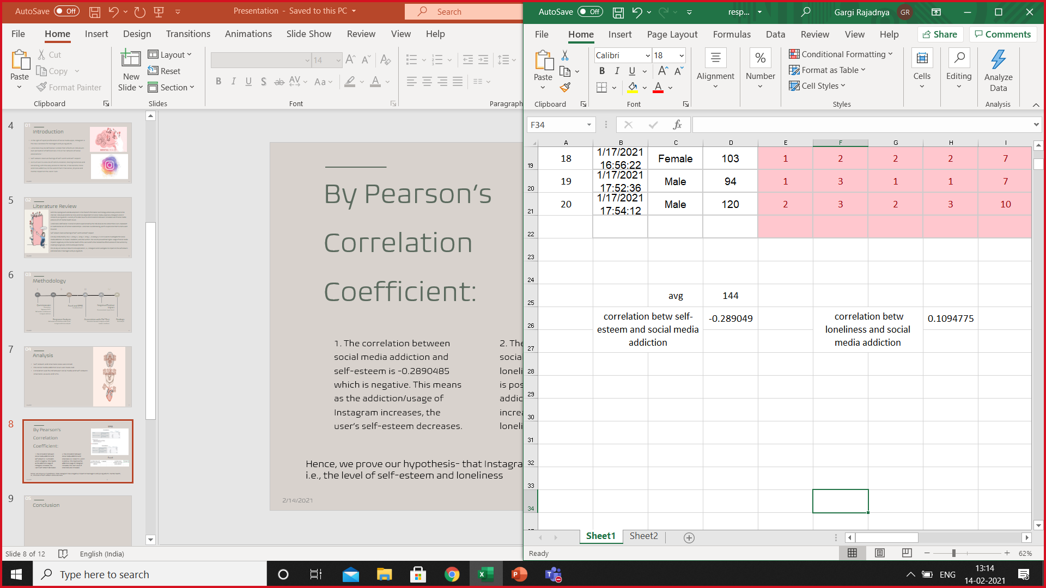

SPSS screenshots
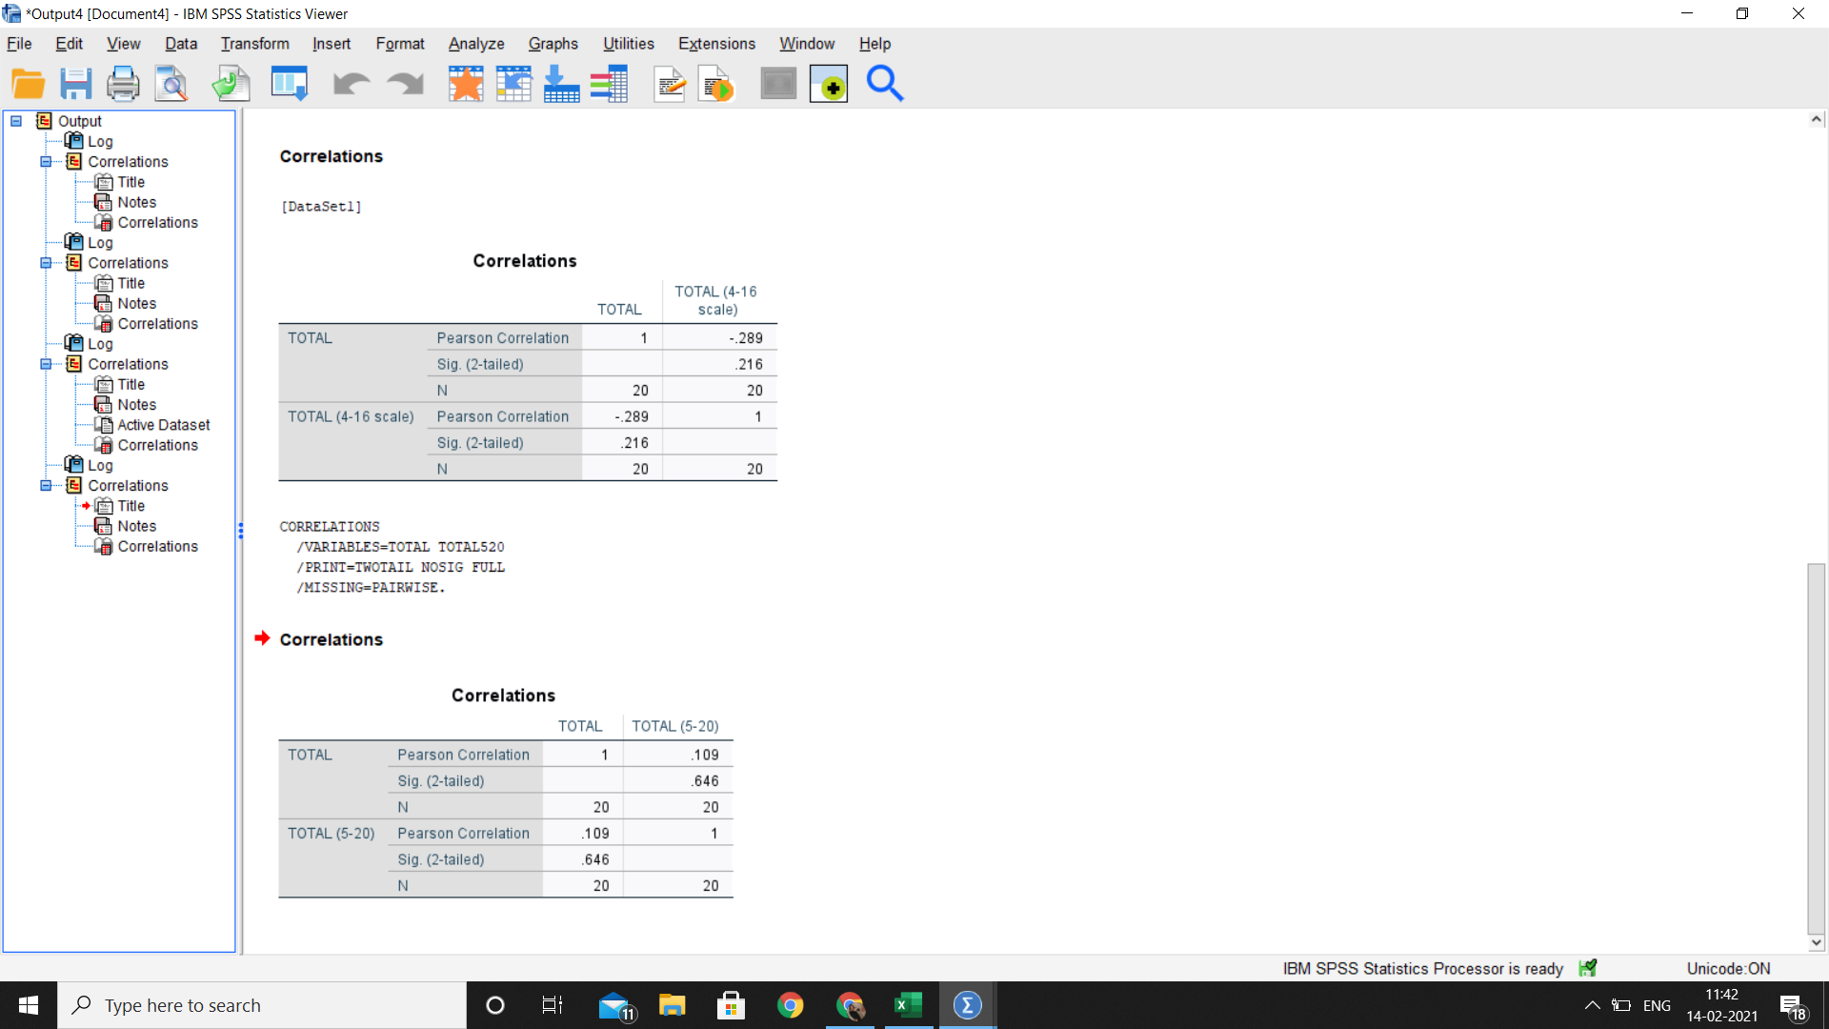

Conclusion
Since, the correlation between social media addiction and self-esteem is -0.2890485 which is negative, it can be concluded that as addiction/usage of Instagram increases, the user’s self-esteem decreases.
The correlation between social media addiction and loneliness is 0.10947755, which is positive, meaning as the addiction/usage of Instagram increases, the user’s level of loneliness also increases.
Hence, we reject the null hypothesis- that Instagram does not have a negative impact on teenagers’ and young adult’s mental health, i.e., the level of self-esteem and loneliness.

Although, there can be many reasons for increased levels of loneliness and decreased levels of self-esteem, we can also infer that Instagram does negatively influence mental health of teenagers and young adults.

Acknowledgement
This paper and the research behind it would not have been possible without the exceptional guidance and constant support of our Research Writing professor, Amrita Banerjee. Her enthusiasm and knowledge kept our work on track.
We are grateful for our professors, Sagar Sankeshwari Sir and Hemant Kulkarni Sir, who shared with us invaluable information and insights.
We would like to thank NMIMS deemed to be university for introducing us to the opportunity and for providing us with almost all the necessary resources that were essential for carrying out this research.
Finally, it is with true pleasure that we acknowledge the contributions of our amazing respondents who took out the time to fill our survey so that we could get primary data and helped us get the responses that were generated.

References
Przybylski, A. K., Murayama, K., DeHaan, C. R., & Gladwell, V. (2013). Motivational, emotional, and behavioural correlates of fear of missing out. Computers in Human Behaviour, 29, 1814-1848.

Social Media and Loneliness - Forever connected? Roman Yavich2, Nitza Davidovitch1 & Zeev Frenkel2

Instagram and its Relationship Between Self-Esteem and Depression Amongst Young Adults. Cheyanne, El Khouly

Yang, C. (2016). Instagram Use, Loneliness, and Social Comparison Orientation: Interact and Browse on Social media, But Do not Compare. Cyber psychology & Behavior. 703 – 708

Greenwood, S. Perrin, A & Duggan, M (November., 2016). Social Media Update. Facebook Usage and Engagement is on The Rise, While Adoption of Other Platforms Hold Steady.

Bhat, S. A. (2017). Social Networking Sites and Mental health: a review. International Journal of Advanced Educational Research 2 (5), 357-360.

The Social media addiction: Its impact, mediation, and intervention. Hou, Y., Xiong, D., Jiang, T., Song, L., & Wang, Q. in 2019

Bibliography
https://pubmed.ncbi.nlm.nih.gov/25489985/
http://www.integrativehealthpartners.org/downloads/ACTmeasures.pdf#page=61 :Self-Esteem
https://docs.google.com/document/d/12s39QphZCqI2fNi10Fn75cl3F_Hr7o2-yk-cU4C_LTc/edit :Loneliness
https://osf.io/jcwb9/download :Social Media
https://www.researchgate.net/publication/271880765_State_Self-Esteem_Loneliness_and_Life_Satisfaction
https://cyberpsychology.eu/article/view/11562/10369
https://uxdesign.cc/the-psychology-of-why-social-media-is-so-addictive-67830266657d

