Name: Maryam

Id: u3183735

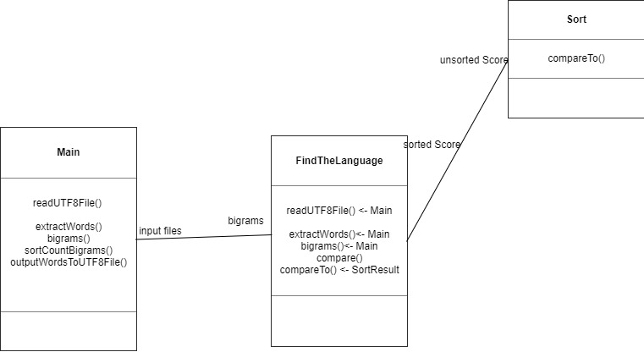class Diagram