Assignment no 2

Name :
Maryam Riaz
Roll no:
Fa23-bcs-296
Subject:
Advance Database system
Submitted to:
Sir Anwar Mehdi

Load the data into MongoDB.

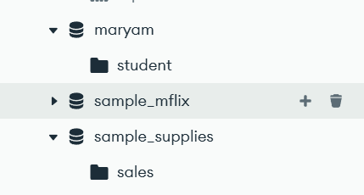
Queries to Run:

db.collection.insertOne({})

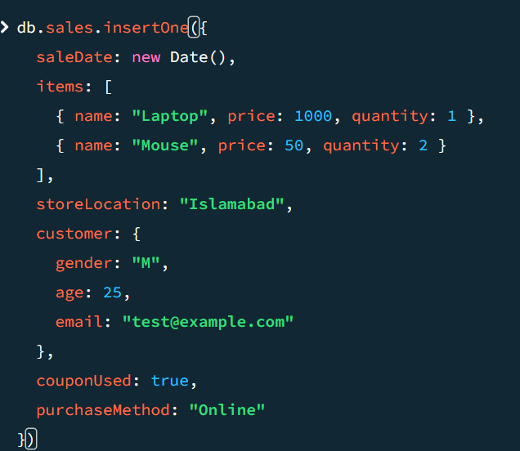

db.collection.insertMany([])

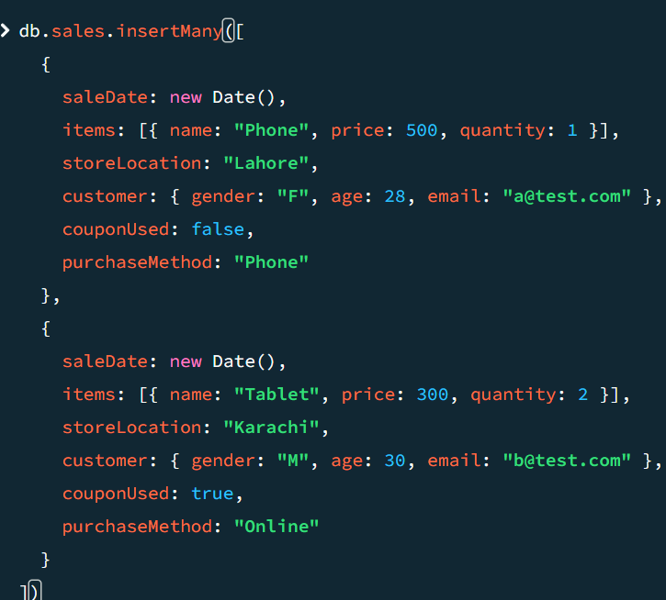

db.collection.findOne()

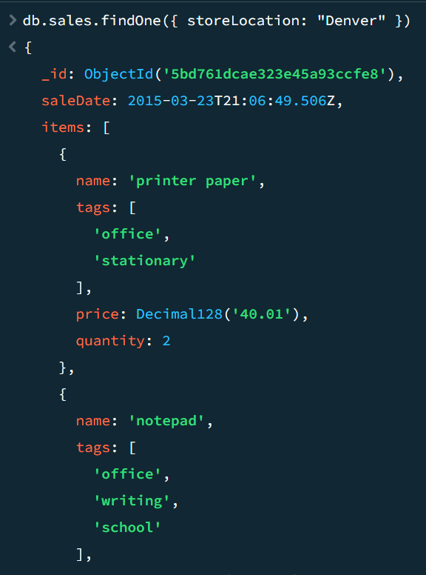

db.collection.find({})\

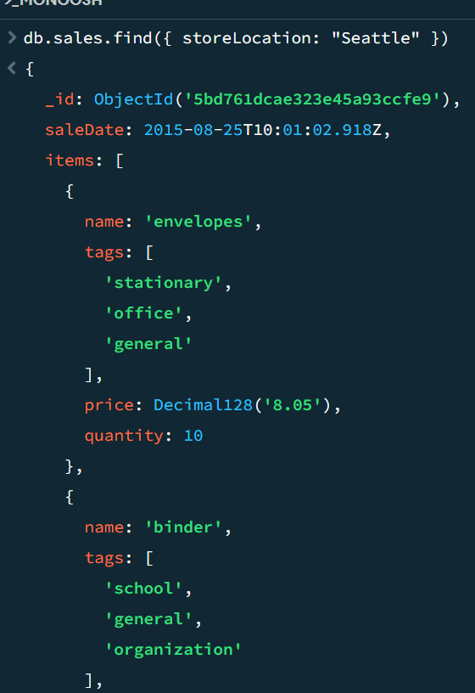

db.collection.find({}).pretty()
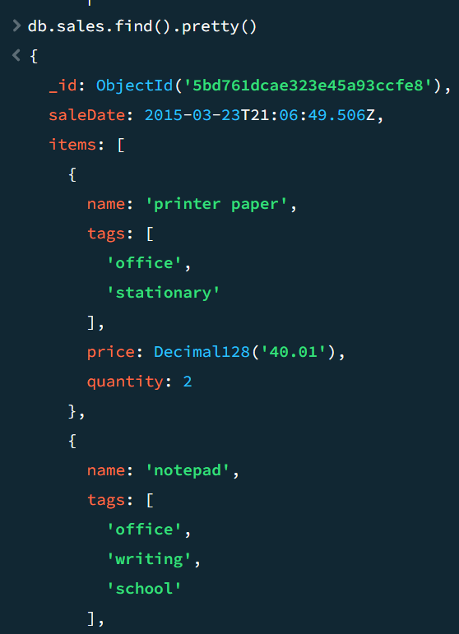

db.collection.find().count()

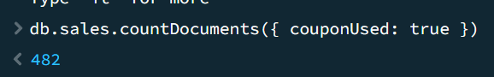

db.collection.updateOne

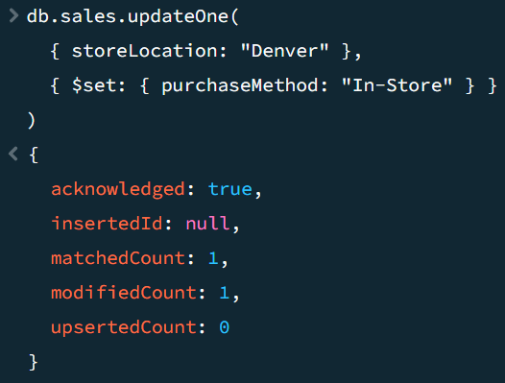

db.collection.updateMany

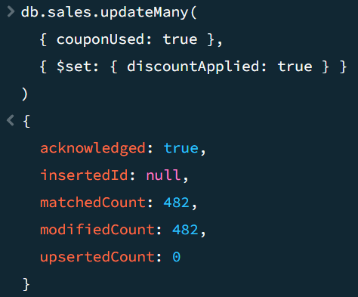

db.collection.replaceOne
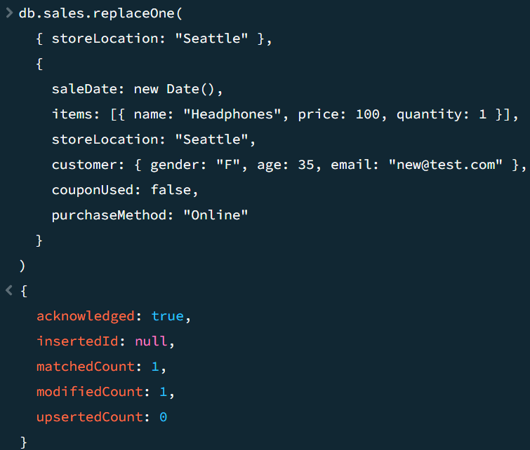

db.collection.deleteOne
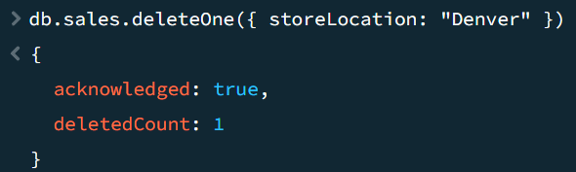
db.collection.deleteMany
