

Course code: 4170207

Course Name: Software Engineering theory

Phase 2: Software Design Document Team Name

Full Name: Maryam Mohamed Sobhy 203104

Engy Ahmed Attia 203025

Sawsan Ahmed Ishak 203062

Dec 2020

Month & Year

Contents

Instructions ………………………............................................................................................................................. 3

Team ................................................................................................................................................................ 3

Document Purpose and Audience ................................................................................................................... 3

System Models ................................................................................................................................................... 4 I. System Decomposition ............................................................................. Error! Bookmark not defined.

1. Class diagrams ......................................................................................................................................... 4
2. Sequence diagrams .................................................................................................................................. 5

Class - Sequence Usage Table ................................................................................................................... 7 IV. Physical Entity-Relationship Diagram ...................................................................................................... 8

1. User Interface Design ............................................................................................................................... 8
2. Algorithms and Data Structures ............................................................................................................. 10

Ownership Report ........................................................................................................................................... 10

Policy Regarding Plagiarism: ............................................................................................................................ 10

References .......................................................................................................... Error! Bookmark not defined. Authors ............................................................................................................... Error! Bookmark not defined.

# Instructions [To be removed]

* IMPORTANT. Rename this document to TeamName-Topic-SDD.docx • Remove the following notes and any red notes.

# Team

|  |  |  |  |
| --- | --- | --- | --- |
| ID | Name | Email | Mobile |
| 203104 | Maryam Mohamed Sobhy | Sim.mariammohamed3104@alexu.edu.eg | 01286649259 |
| 203025 | Engy Ahmed Attia |  |  |
| 203062 | Sawsan Ahmed fathi |  |  |

# Document Purpose and Audience

* The document is software design document (SDD) shows the Design of our project According to the functions and operations that will done by the system and that will be implemented by Class Diagram which shows many classes each class has attributes and operations special for it, and sequence diagram and also ERD
* This documented expected to read by stakeholders who interested to the topic of this software which is Automated parking garage (APS).
* Target Audience are: Project manager – stakeholders -customers -users.

# System Models

## I. Class diagrams

|  |  |  |  |
| --- | --- | --- | --- |
| Class ID | Class Name | Subsystem ID | Description & Responsibility |
| 1 | Customer | vehicle | Information of the vehicle can be the same for more than one vehicle, so there is an Association relationship between the Customer and the vehicle. |
| 2 | Administration | stuff | Administration check the information that send from stuff and check their Salaries |
| 3 | payment | Customer | Customers choose the payment method, if he chose pay with credit card he must enter the credit card type then the card number |
| 4 | Parking garage | vehicles | Parking garage search for empty spot to occupy the vehicles |
| 5 | reservation | Customer | Many customers can make reservations on the system to park in the Automated parking garage. |

## Sequence diagrams

### Class - Sequence Usage Table

• In this table, we will list EVERY class in class diagram and which sequences used this class diagram. This helps in avoiding either unused classes or extra classes appears in sequence diagrams. In "Overall used methods" section, put all functions appeared in all sequences.

|  |  |  |
| --- | --- | --- |
| Class Name | Sequence Diagrams | Overall used methods |
| E.g. Employee | 1, 3, 5 (means Seq Ids 1, 3, 5 used Employee class) | Save, GetData |
|  |  |  |

## III. Physical Entity-Relationship Diagram

## IV. User Interface Design

* Use a prototyping tool like [https://app.moqups.com,](https://app.moqups.com/) [http://Infragistics.com](http://infragistics.com/) or NinjaMock or using a GUI builder (like the one in NetBeans) to build your interface.
* Develop a prototype for each screen / page that your application will have and relate them to each other showing which one leads to which one.
* For each screen specify the buttons, menus, etc. that will be on it and their functions.
* An example is shown below.
* Screen 1 – Login Screen (example)

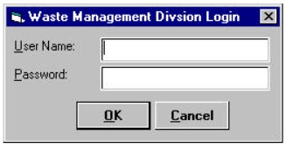

* Screen 2 – Main Interface (example)

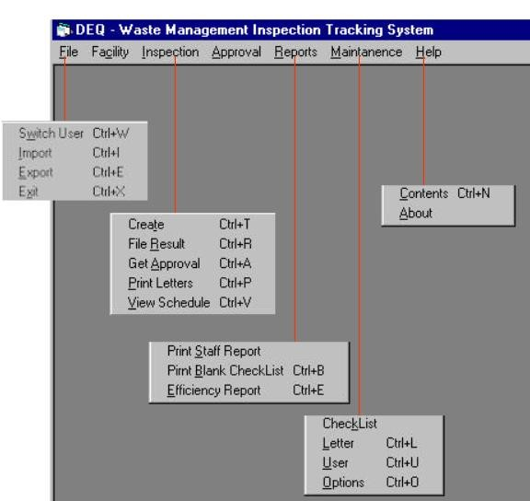

* Navigation tree: Login Screen |
* Navigation tree: Main Screen

V. Dataflow diagram (DFD)

• Provide the DFD

## VI. Algorithms and Data Structures

* Specify what algorithms you need in order to build the application. If it is an existing one, just refer to it. If it is one you will develop, then write in detail in mathematical notation, pseudo code, or as a flowchart. Example of such algorithms:
  + The steps for calculating if there is winner in a two-player game.
  + The steps for calculating the salary in a payroll program.
  + The algorithm for deciding which posts to show first in a social network application.
* Specify which data structures (DS) you will use to store which data in memory, other than regular arrays and array lists. Justify your choice and explain the reasons behind it.
* In the rare occasion that no existing data structures supports your requirements and you need to create a new one or implement a non-implemented one, include the design of this new DS.

# Ownership Report

* Remove the following notes and any red notes
* For every item in this document, write the owners. If someone is owner of something, s/he understands it 100.%
* Team leader must verify the table with the team members.

|  |  |
| --- | --- |
| Item | Owners |
|  |  |
|  |  |

# Policy Regarding Plagiarism:

Students have collective ownership and responsibility of their project. Any violation of academic honesty will have severe consequences and punishment for ALL team members.

1. تشجع الكلية على مناقشة الأفكار و تبادل المعلومات و مناقشات الطلاب حيث يعتبر هذا جوهريا لعملية تعليمية سليمة 2. ساعد زملاءك على قدر ما تستطيع و حل لهم مشاكلهم فى الكود و لكن تبادل الحلول غير مقبول و يعتبر غشا.

1. أى حل يتشابه مع أى حل آخر بدرجة تقطع بأنهما منقولان من نفس المصدر سيعتبر أن صاحبيهما قد قاما بالغش.
2. قد توجد على النت برامج مشابهة لما نكتبه هنا أى نسخ من على النت يعتبر غشا يحاسب عليه صاحبه.
3. إذا لم تكن متأكدا أن فعلا ما يعد غشا فلتسأل المعيد أو أستاذ المادة. 6. فى حالة ثبوت الغش سيأخذ الطالب سالب درجة المسألة ، و فى حالة تكرار الغش سيرسب الطالب فى المقرر.