Mindflex Rehabilitation



**BS (CS) Final Year Project Report**

**Submitted by**

**Maryam Raza 2021/Comp/BS(CS)/26981 2126364**

**Bushra Jamal 2021/comp/BS(CS)/26957 2126340**

**Nameera Siddiqui 2021/Comp/BS(CS)/26984 2126367**

**Hiba Ghazal 2021/Comp/BS(CS)/26968 2126351**

**13 May 2024**

**Department of Computer Science and Software Engineering**

**Jinnah University for Women**

1. **C Nazimabad, Karachi 74600**



**Department of Computer Science and Software Engineering**

**JINNAH UNIVERSITY FOR WOMEN**

**PROJECT APPROVAL**

Project Title: Mindflex Rehabilitation

By

Bushra Jamal 2021/comp/BS(CS)/26957 2126340

Hiba Ghazal 2021/Comp/BS(CS)/26968 2126351

Maryam Raza 2021/Comp/BS(CS)/26981 2126364

Nameera Siddiqui 2021/Comp/BS(CS)/26984 2126367

Approval Committee:

___________________________

Ms.Hafiza Anisa Ahmed

Designation:

(Internal Advisor)

___________________________

(Head of the Department)

# ABSTRACT

A rehabilitation project designed to integrate artificial intelligence (AI), virtual technology using Kinect, and telehealth features. The project aims to revolutionize rehabilitation by offering personalized therapy, interactive exercises, and remote telehealth sessions, providing users with a more accessible and engaging approach to their rehabilitation journey.

The AI component provides personalized guidance through a chatbot that interacts with users, answering questions and recommending exercises. The virtual technology, enabled by Kinect, allows users to engage in immersive rehabilitation exercises with real-time feedback and motion tracking. Telehealth features enable users to connect with healthcare professionals remotely, facilitating continuous care and support.

# TABLE OF CONTENTS

ABSTRACT ii

LIST OF FIGURES v

LIST OF TABLES Error! Bookmark not defined.

ACKNOWLEDGEMENT vi

CHAPTER 1 - INTRODUCTION 1

1.1 Overview 1

1.2 Purpose 1

1.3 Stakeholders 1

1.4 Benefits 2

1.5 Background Study 3

CHAPTER 2 - REQUIREMENTS Error! Bookmark not defined.

2.1 Functional Requirements **Error! Bookmark not defined.**

2.2 Non-Functional Requirements **Error! Bookmark not defined.**

CHAPTER 3 - ANALYSIS AND DESIGN 9

3.1 System Architecture with Diagram 10

3.2 Entity Relationship Diagram 11

3.3 Project Flow Diagram 12

3.4 Use Cases 13

3.5 Activity Diagram 14

3.6 User Interface Design 15

CHAPTER 4 - PROJECT PLAN 23

4.1 Process Model (Agile) 24

4.1.1 User Stories 29

4.1.2 Sprints Planning 30

4.1.3 Sprints Sizing 35

4.2 Timeline with Milestones 36

CHAPTER 5 - TEST PLAN 39

5.1 Test Cases 41

5.2 Automated Testing Tools 43

CHAPTER 6 - IMPLEMENTATION DETAILS 44

6.1 Tools and Technology 44

6.2 Data Dictionary 45

6.3 Version Control 46

6.4 Web APIs / Web Services 46

6.5 Website Development 47

6.6 Mobile Application Development 49

6.7 Deployment 50

6.7.1 Website Hosting 51

6.7.2 Mobile Application Deployment 51

CHAPTER 7 - CONCLUSION AND FUTURE WORK 53

REFERENCES 55

APPENDIX A - SCREENSHOTS 56

APPENDIX B - ABBREVIATION 63

**LIST OF FIGURES**

Figure 3. 1 System Achitecture 11

Figure 3. 2 ERD 12

**LIST OF TABLES**

# ACKNOWLEDGEMENT

We would like to express our deepest gratitude to everyone who contributed to the success of the rehabilitation project integrating AI, virtual technology with Kinect, and telehealth features. Without the support, expertise, and dedication of the following individuals and groups, this project would not have been possible.

**Project Team**

* **Project Manager**: Special thanks to Ms. Hafiza Anisa Ahmed for her outstanding leadership, coordination, and commitment to the project's success.
* **Development Team**: Our sincere appreciation goes to the front-end and back-end developers, AI specialists, and VR experts who brought this project to life with their skills and creativity.
* **QA and Testing Team**: We thank the quality assurance team for ensuring the project's reliability and quality through rigorous testing and validation.
* **UI/UX Designers**: We acknowledge the design team for creating an intuitive and user-friendly interface that enhances the user experience.

**Healthcare Professionals**

We are grateful to the physiotherapists, occupational therapists, and doctors who provided invaluable insights into rehabilitation practices and helped shape the project's telehealth features. Your guidance and feedback were instrumental in ensuring that the application meets the needs of users and healthcare professionals.

# CHAPTER 1

# 

# INTRODUCTION

Mindflex rehabilitation is an innovative project that brings mental and physiotherapy rehabilitation to individual’s homes through Kinect-based virtual reality (VR). This platform integrates an AI chat features, acting as a virtual friend to provide initial solutions for mental and physical health inquiries. The application and web interface include a personalized dashboard for users to track their progress, fostering engagement and empowerment. Additionally, the platform offers the convenience of online virtual doctor appointments, ensuring accessible healthcare support.

## Overview

Mindflex rehabilitation is an innovative project that brings mental and physiotherapy rehabilitation to individual’s homes through Kinect-based virtual reality (VR). This platform integrates an AI chat features, acting as a virtual friend to provide initial solutions for mental and physical health inquiries. The application and web interface include a personalized dashboard for users to track their progress, fostering engagement and empowerment. Additionally, the platform offers the convenience of online virtual doctor appointments, ensuring accessible healthcare support.

## 1.2 Purpose

This rehabilitation project is to create an innovative software application that integrates artificial intelligence (AI), virtual reality (VR) technology with Kinect-based interaction, and telehealth features to provide personalized rehabilitation solutions. The project aims to improve the rehabilitation experience for users by offering a more engaging, flexible, and accessible approach to therapy. project's purpose is to enhance the effectiveness of rehabilitation, improve patient outcomes, and increase the accessibility of therapeutic services through technology-driven solutions. It is designed to support users in their rehabilitation journey by offering personalized, and convenient options for therapy.

## 1.3 Stakeholders

Here's a list of potential stakeholders and their respective roles:

## Users/Patients

Individuals undergoing rehabilitation, who are the primary users of the application. They benefit from personalized exercises, telehealth sessions, and AI chatbot guidance.

## Healthcare Professionals

Physiotherapists/Occupational Therapists and psychologist provide professional guidance, design rehabilitation programs, and conduct telehealth sessions.

## 3. Family Members/Caregivers

Family members and caregivers who support users during their rehabilitation journey.They might use the app to monitor progress or facilitate telehealth sessions.

## 4. Project Development Team

Ensures smooth project execution, manages Agile processes, and facilitates team collaboration.

## 5. Academic and Research Institutions

Institutions involved in rehabilitation research or technology development that collaborate with the project to improve outcomes and explore new approaches.

## 1.4 Benefits

The benefits of the rehabilitation project that integrates AI, virtual technology with Kinect, and telehealth features are significant.Here is a concise explanation of these benefits:

1. **Improved Accessibility to Rehabilitation Services**

The project allows users to access rehabilitation exercises and telehealth sessions remotely, reducing geographical and mobility barriers. This is especially valuable for users who live in remote areas or have limited access to traditional healthcare facilities.

1. **Personalized Rehabilitation and Feedback**

The AI-based chatbot provides personalized guidance, while the Kinect technology enables real-time motion tracking, allowing users to receive tailored exercise recommendations and feedback. This personalization enhances the effectiveness of rehabilitation and helps users meet their individual therapy goals.

1. **Enhanced Engagement and Motivation**

Using virtual technology and interactive elements, the project creates a more engaging rehabilitation experience. Gamification and immersive environments can motivate users to adhere to their rehabilitation programs, leading to better outcomes.

1. **Cost-Effectiveness**

By reducing the need for frequent in-person therapy sessions, the project can lower healthcare costs for both users and providers. Telehealth sessions and at-home rehabilitation exercises reduce travel and associated expenses.

1. **Continuity of Care and Remote Monitoring**

The telehealth features enable healthcare professionals to remotely monitor user progress and provide ongoing support. This continuity of care helps users maintain momentum in their rehabilitation journey and ensures that they receive timely assistance when needed.

1. **Improved User Outcomes**

The combination of personalized rehabilitation, enhanced engagement, and continuous support contributes to improved user outcomes, such as increased mobility, strength, and flexibility, and overall better quality of life.

## Background Study

Rehabilitation is a critical component of recovery for millions of people worldwide, whether recovering from injuries, surgeries, or chronic conditions. However, traditional rehabilitation methods often face significant challenges, including limited accessibility, high costs, and difficulty maintaining patient engagement and adherence to therapy programs.

**The Idea**

The goal was to create an innovative software application that would bring personalized rehabilitation into the homes of those in need, overcoming barriers to access and providing a more engaging and cost-effective approach to therapy.

**Inspiration from Technology**

The inspiration for the project came from advances in AI, virtual reality (VR), and telehealth, as well as the success of Kinect-based technology in the gaming industry. The Kinect's ability to track body movements and gestures in real-time offered a unique opportunity to create immersive rehabilitation experiences, allowing users to engage in therapeutic exercises from the comfort of their home.

# CHAPTER 2

# REQUIREMENTS

outlining the core functionalities and objectives of the rehabilitation project, guiding its development and ensuring that it meets the needs of users and stakeholders effectively. aiming to provide users with a comprehensive and effective rehabilitation experience while ensuring security, compliance, and scalability.

## 2.1 Functional Requirements

1. **AI Chatbot**:
   * An AI-driven chatbot that provides users with personalized assistance, answers questions, and offers guidance on rehabilitation exercises and telehealth sessions. The chatbot uses natural language processing (NLP) to understand and respond to user inquiries.
2. **Virtual Technology with Kinect**:
   * Integration with Kinect-based devices allows users to interact with the application through body movements and gestures. This component provides real-time motion tracking and feedback, enabling users to perform rehabilitation exercises in a virtual environment.
3. **Telehealth Module**:
   * A telehealth module that facilitates remote therapy sessions with healthcare professionals. It includes video conferencing capabilities, secure communication, and tools for healthcare providers to monitor user progress and provide personalized guidance.
4. **User Interface and Interaction**:
   * A user-friendly interface that allows users to navigate the application, access rehabilitation exercises, interact with the AI chatbot, and participate in telehealth sessions. The interface is designed for ease of use and accessibility.
5. **Back-end Infrastructure**:
   * The back-end infrastructure includes servers, databases, and APIs that support the application's functionality. It ensures data storage, processing, and communication between the various components of the system.

**Interfaces and Interconnections**

The rehabilitation application interfaces with several external systems and components:

1. **External APIs**:
   * The application may use external APIs for accessing AI chatbot frameworks, telehealth services, or data analysis tools. It interfaces with these APIs to ensure seamless communication and integration.
2. **Healthcare Providers**:
   * The telehealth module interfaces with healthcare providers, allowing them to connect with users for remote therapy sessions, monitor progress, and adjust treatment plans as needed.
3. **User Devices**:
   * The application interfaces with various user devices, such as Kinect-based sensors, smartphones, tablets, and computers. It ensures compatibility with these devices to provide a consistent user experience.
4. **Data Storage and Security**:
   * The application interfaces with secure data storage systems to maintain user data and comply with privacy regulations. It ensures secure communication and data encryption to protect user information.

## 2.2 Non - Functional Requirements

**Performance**

* **Response Time**: The system should respond to user inputs within a maximum of 1 second for most interactions, such as navigating the interface, accessing rehabilitation exercises, and interacting with the AI chatbot.
* **Processing Time**: The system should process rehabilitation exercise recommendations and telehealth session connections within 2 seconds.
* **Load Handling**: The system should be able to handle 15 simultaneous users without significant degradation in performance.
* **Data Transfer**: The system should support efficient data transfer for telehealth sessions, ensuring smooth video conferencing with minimal latency and no packet loss.

**Reliability**

* **System Uptime**: The system should have a minimum uptime of 99.9% per month to ensure consistent availability for users.
* **Error Handling**: The system should gracefully handle errors and provide clear error messages to users. Error handling should include logging for diagnostic purposes and automatic retries for recoverable errors.
* **Data Backup and Recovery**: The system should implement data backup mechanisms to ensure user data is not lost. Data recovery procedures should be in place to restore data in case of system failures or data corruption.

**Availability**

* **Service Availability**: The system should be accessible to users 24/7, with planned maintenance causing minimal disruption. Scheduled maintenance should be communicated in advance to users and should occur during low-usage hours.
* **Telehealth Availability**: The telehealth module should ensure that healthcare professionals are available for scheduled sessions with users. The system should provide mechanisms for rescheduling or notifying users in case of unplanned unavailability.
* **Security**:
  + The system should comply with industry-standard security practices, including data encryption, secure communication, and user authentication.
  + The system should implement role-based access control to ensure that only authorized personnel have access to sensitive data and system functions.
* **Scalability**:
  + The system should be designed to scale as the user base grows, supporting additional users, new features, and increased data storage without significant performance degradation.
* **Maintainability**:
  + The system should be designed with maintainability in mind, allowing for easy updates, bug fixes, and feature enhancements.
  + The system should follow best practices for code quality, documentation, and modularity to facilitate ongoing maintenance and development.
* **Usability**:
  + The user interface should be intuitive, user-friendly, and accessible, meeting industry standards for usability and accessibility.
  + The system should be designed to accommodate users with varying levels of technical expertise and those with disabilities, following accessibility guidelines such as WCAG (Web Content Accessibility Guidelines).

# CHAPTER 3

# 

# ANALYSIS AND DESIGN

The analysis and design phase are crucial steps in the development of the MindFlex Rehabilitation system, providing the framework and direction for the project's implementation. During the analysis phase, we meticulously examine the diverse requirements and needs of our stakeholders, including individuals seeking rehabilitation, healthcare professionals, and system administrators. This deep dive allows us to gain a comprehensive understanding of the functionalities, features, and constraints that will shape the MindFlex platform. Subsequently, the design phase translates these insights into a tangible system architecture and user interface. Through thoughtful design decisions, we aim to create an intuitive and engaging environment that optimizes user experience, fosters user engagement, and empowers individuals throughout their rehabilitation journey. By investing in thorough analysis and design, we establish a robust foundation for the development team to proceed with confidence and clarity in building a transformative solution that enhances mental and physiotherapy services for our users.

## System Architecture with Diagram

In the system architecture diagram for MindFlex Rehabilitation, the layout of hardware and software components is outlined to illustrate how they interact and contribute to the functionality of the system. The diagram comprises several layers, including the UI layer, navigation/application/logic layer, hardware layer, and database layer. The UI layer serves as the interface through which users interact with the system, accessing features such as exercise tracking and appointment scheduling. The navigation/application/logic layer houses the core logic and functionalities of the system, coordinating processes such as user authentication and data processing. The hardware layer includes physical components like VR headsets, enabling users to engage in virtual reality therapy exercises.

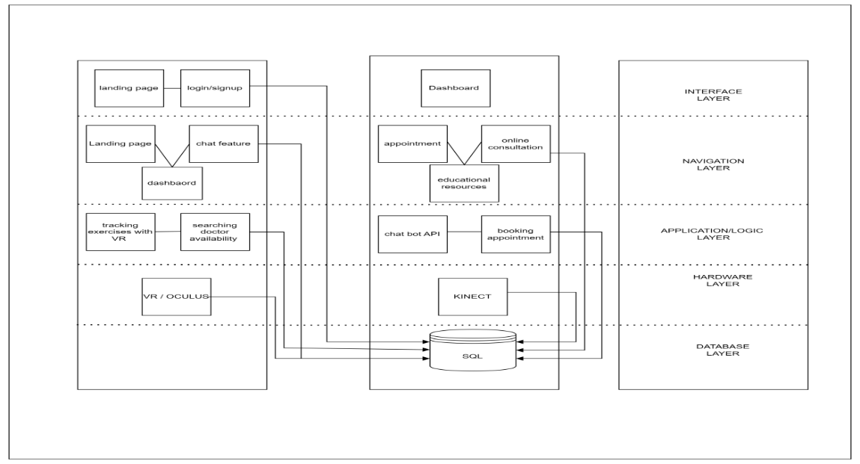Finally, the database layer stores and manages essential data for the system's operation, including user profiles, exercise records, and appointment schedules.

Figure 3. 1 System Achitecture

## 

## Entity Relationship Diagram

In the entity-relationship diagram (ERD) for MindFlex Rehabilitation, the relationships between different entities within the system are illustrated to depict how they interact and exchange data. At the core of the diagram are entities such as Patients, Therapists, Exercise Sessions, Exercise Monitoring, Progress Tracking, and Telehealth. Patients represent individuals seeking rehabilitation services, while Therapists denote healthcare professionals providing therapy. Exercise Sessions capture the sessions where patients engage in physiotherapy exercises, while Exercise Monitoring tracks their performance during these sessions. Progress Tracking monitors and records patients' progress throughout their rehabilitation journey. The Telehealth entity facilitates online consultations between patients and therapists. Relationships between these entities, such as appointments scheduled by Patients with Therapists, exercise recommendations provided by Therapists to Patients, and progress tracked by Exercise Monitoring and Progress Tracking, are depicted to illustrate the flow of data and interactions within the MindFlex Rehabilitation system. This ERD serves as a blueprint for understanding the structure of the system and how different components collaborate to support rehabilitation processes and patient care.

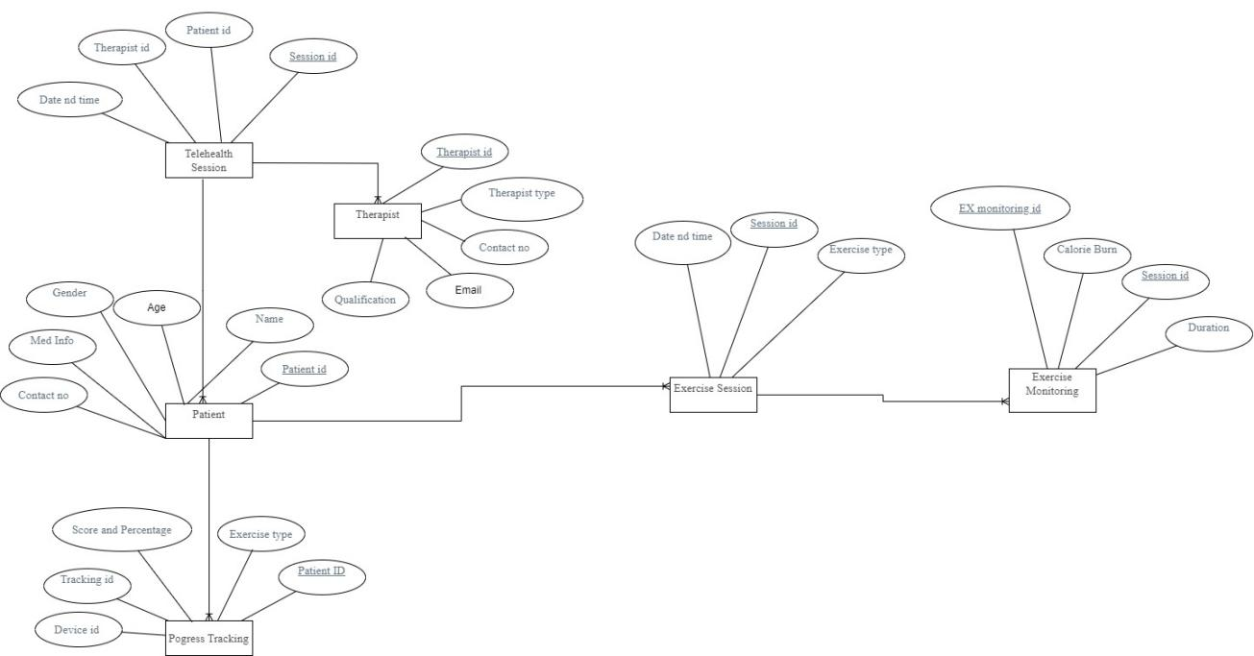

Figure 3. 2 ERD

figure 3.2 Relationship Diagram

## Project Flow Diagram

In the Data Flow Diagram (DFD) for MindFlex Rehabilitation, the flow of data and processes within the system is depicted to illustrate how information moves through different components and interactions. External entities such as Patients, Therapists, and the Telehealth System interact with the system to perform various tasks. Processes like User Authentication, Appointment Scheduling, Exercise Monitoring, and Progress Tracking manage the flow and processing of data within the system. Data stores such as Patient Database, Therapist Database, Exercise Data Repository, and Appointment Database store relevant information used by the system. Data flows represent the movement of data between external entities, processes, and data stores, illustrating how information is exchanged and processed within the MindFlex Rehabilitation system.

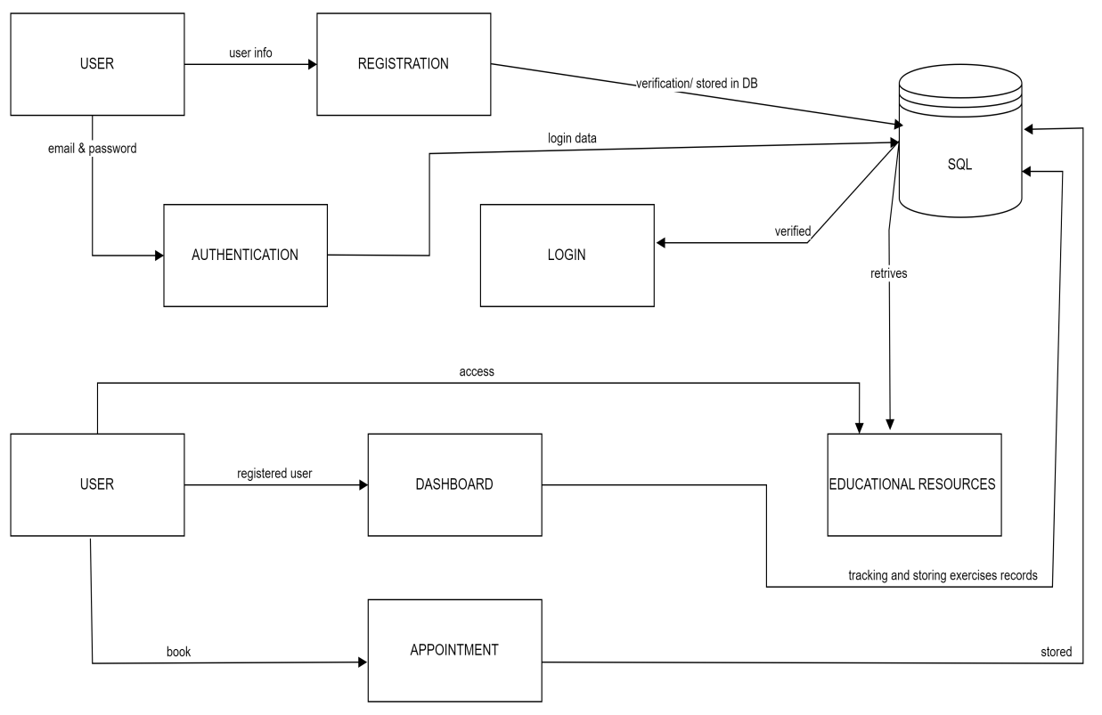

Figure 3.3 Project Flow

## Use Cases

In the Use Case Diagram for MindFlex Rehabilitation, several actors interact with the system to accomplish specific tasks. Patients can register accounts, log in, schedule telehealth appointments, track progress, engage in exercises, and access educational resources. Therapists, on the other hand, can log in, view patient information, schedule appointments, provide exercise recommendations, monitor patient progress, and conduct telehealth consultations. Additionally, system administrators have capabilities such as logging in, managing user accounts, generating reports on system usage and patient outcomes, and performing system maintenance tasks. These use cases represent the core functionalities of the MindFlex system and illustrate how different actors interact with the platform to facilitate mental and physiotherapy rehabilitation.

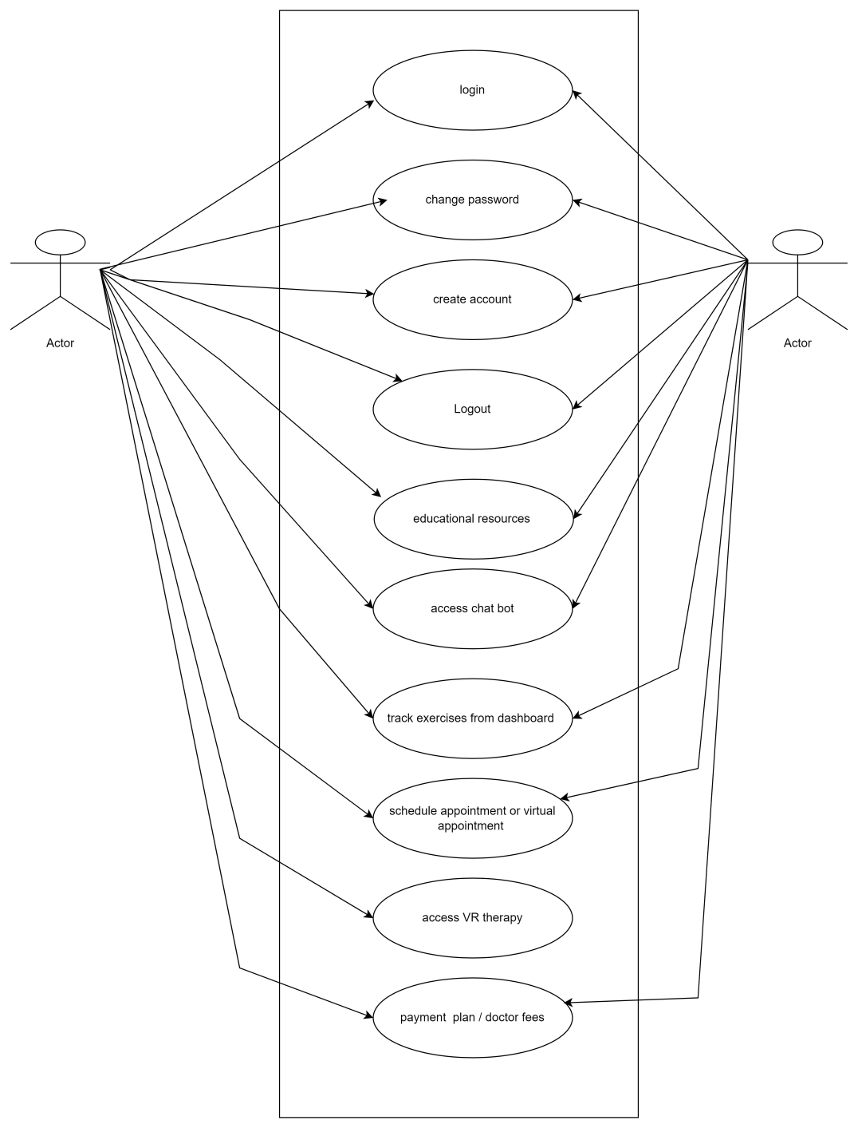

Figure 3.4 Use Case Diagram

## Activity Diagram

In the activity diagram for MindFlex Rehabilitation, the flow of activities within the system is depicted to illustrate the sequential steps involved in various processes. At the outset, the process initiates with the landing page, where users, whether new or returning, can navigate to different sections like account registration, login, or access the chatbot and educational resources. Upon successful login, registered users are directed to their personalized dashboard, where they can view exercise recommendations, track their progress, and schedule telehealth appointments. Simultaneously, therapists can access patient profiles, recommend exercises, monitor progress, and conduct telehealth consultations. The activity diagram further illustrates how users interact with the system, engage in exercises through VR technology, and input data for progress tracking. Ultimately, the diagram provides a comprehensive visualization of the sequential flow of activities within the MindFlex Rehabilitation system, aiding in understanding the user journey and system functionality.

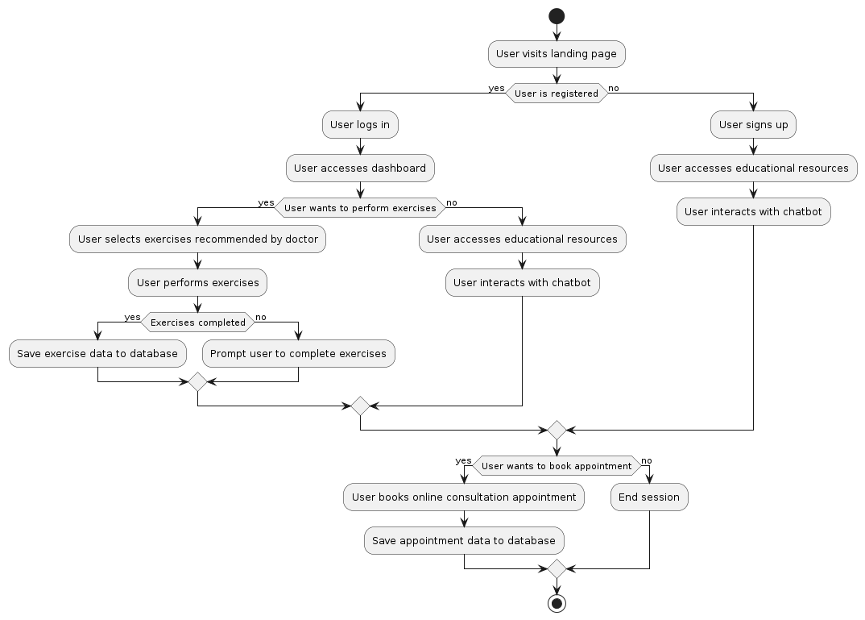

Figure 3.5 Activity Diagram

## 3.6 User Interface Design

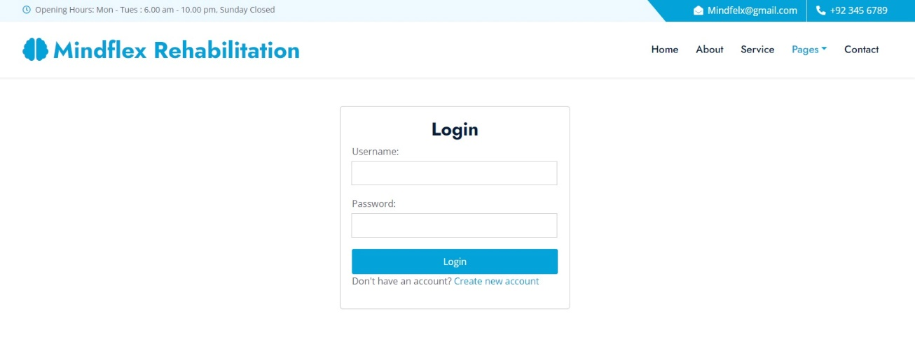

Figure 3.6 Login Page. inviting users to access their personalized rehabilitation experience.

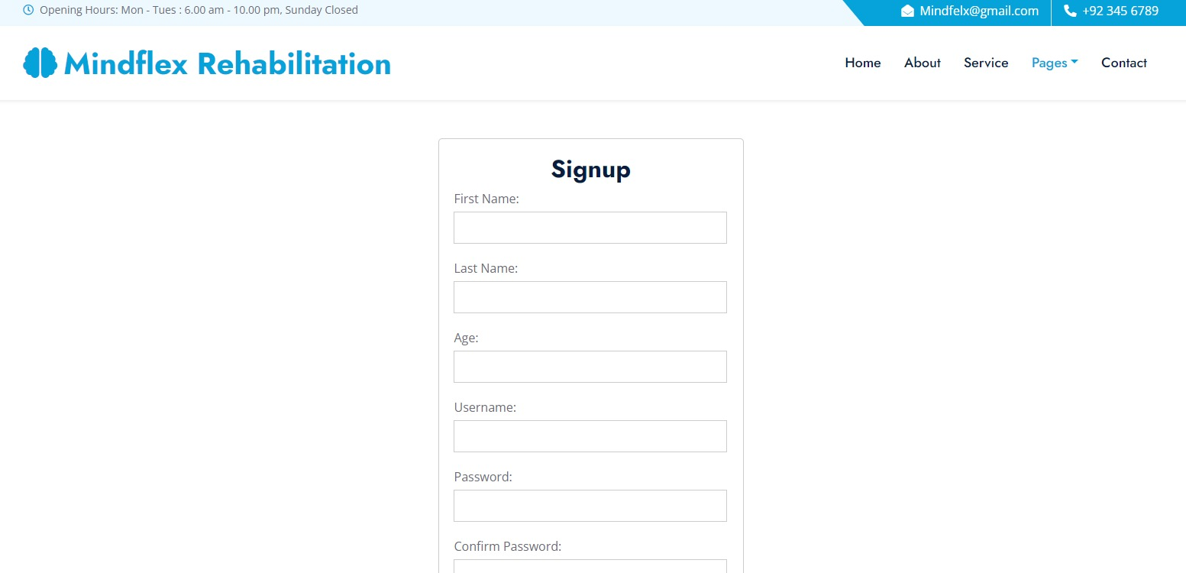

Figure 3.7 Signup page for users to create account and manage their personalized dashboards.

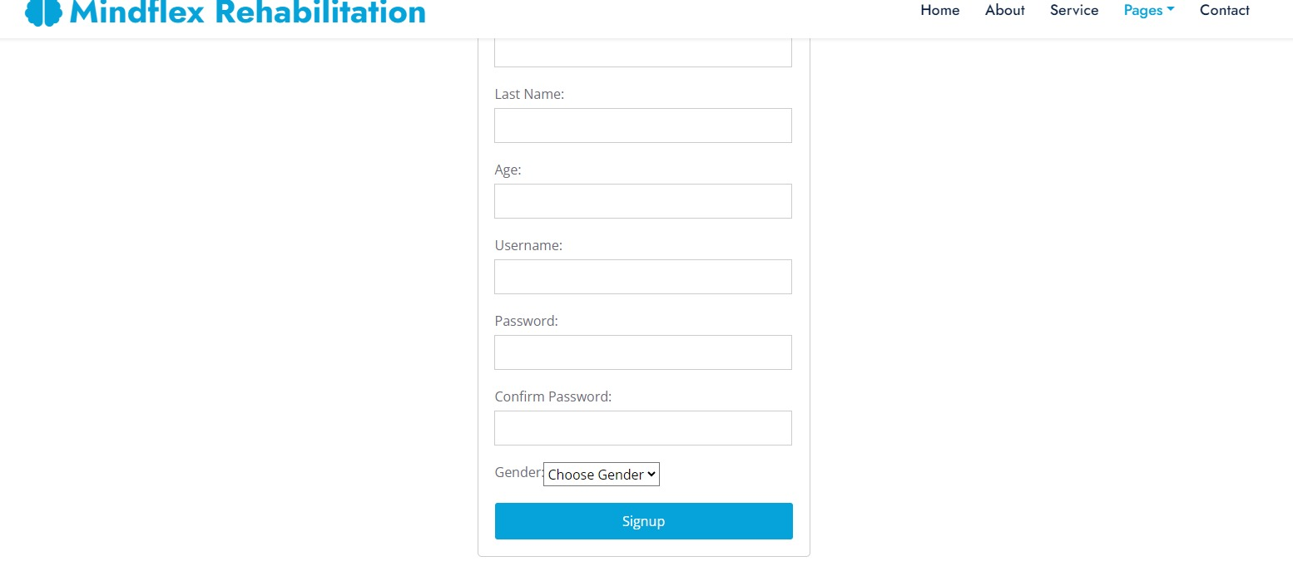

Figure 3.8

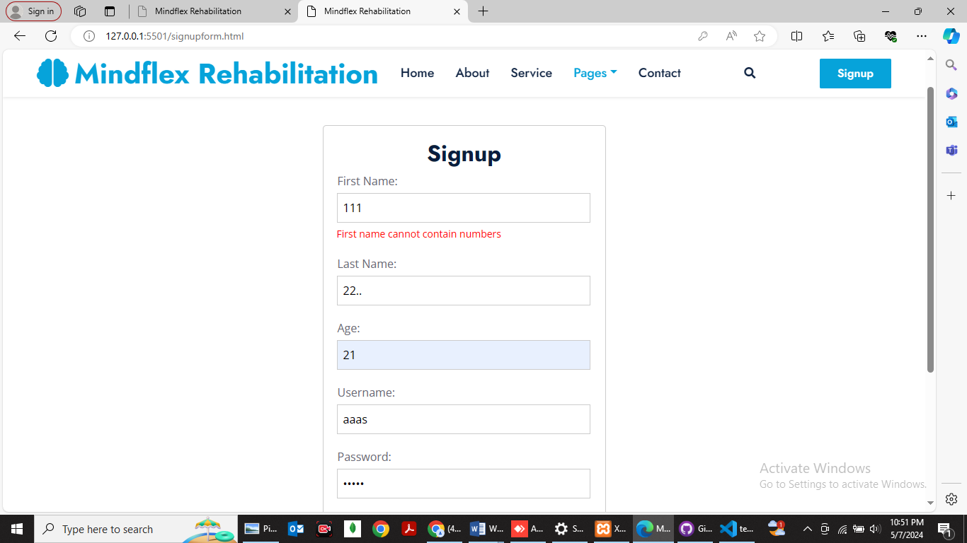

Figure 3.9

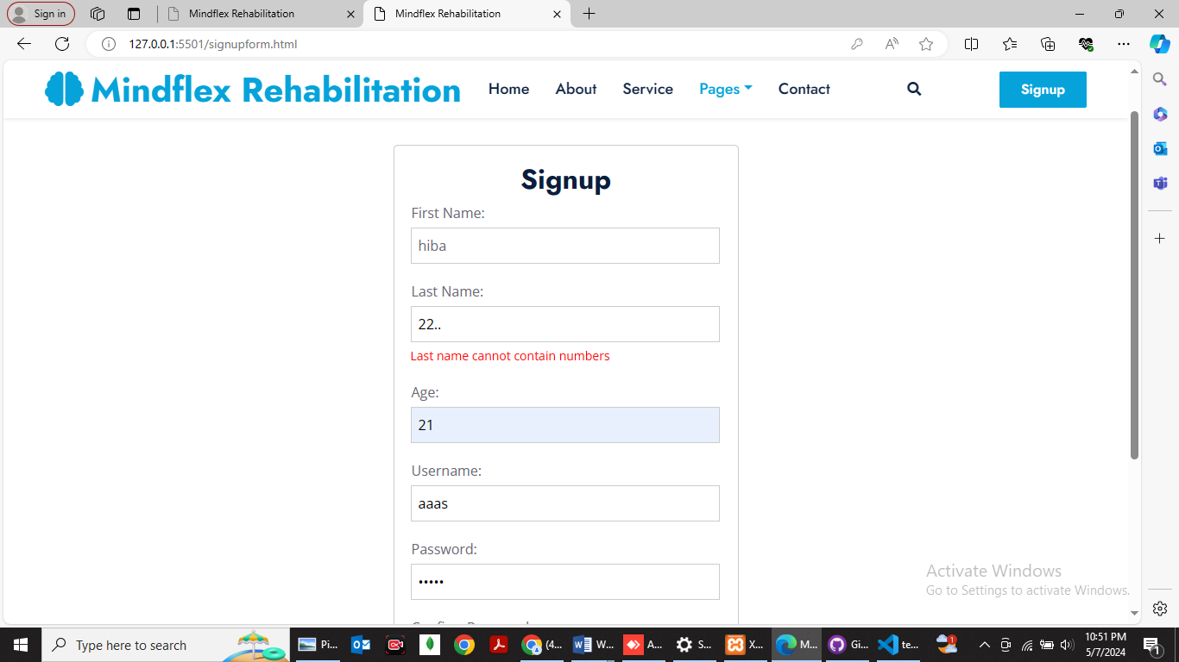



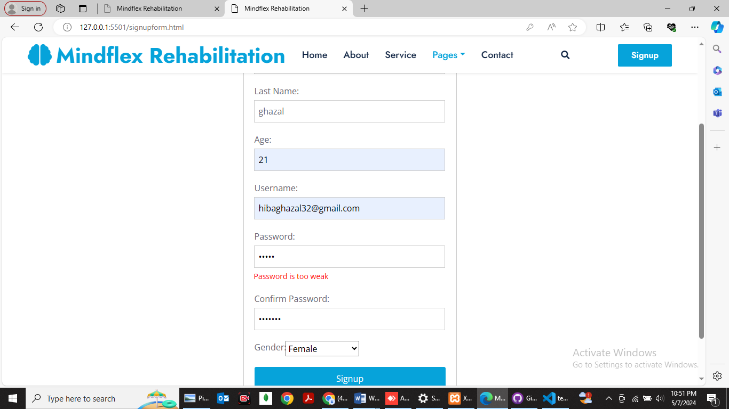

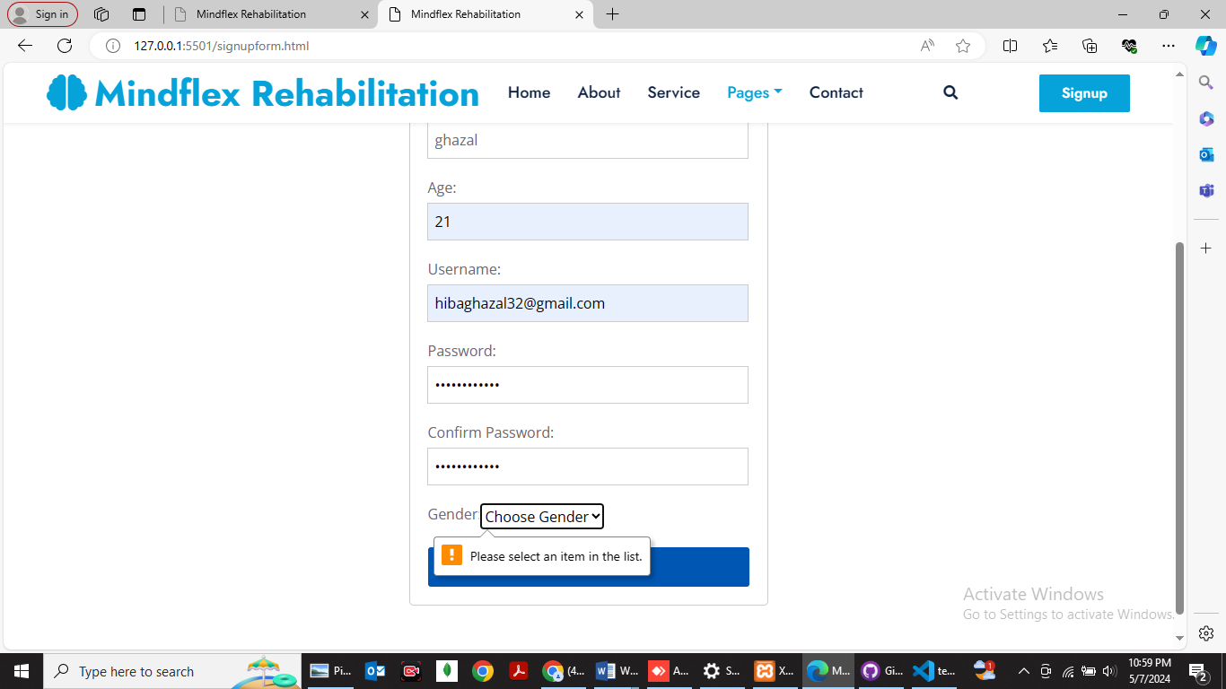

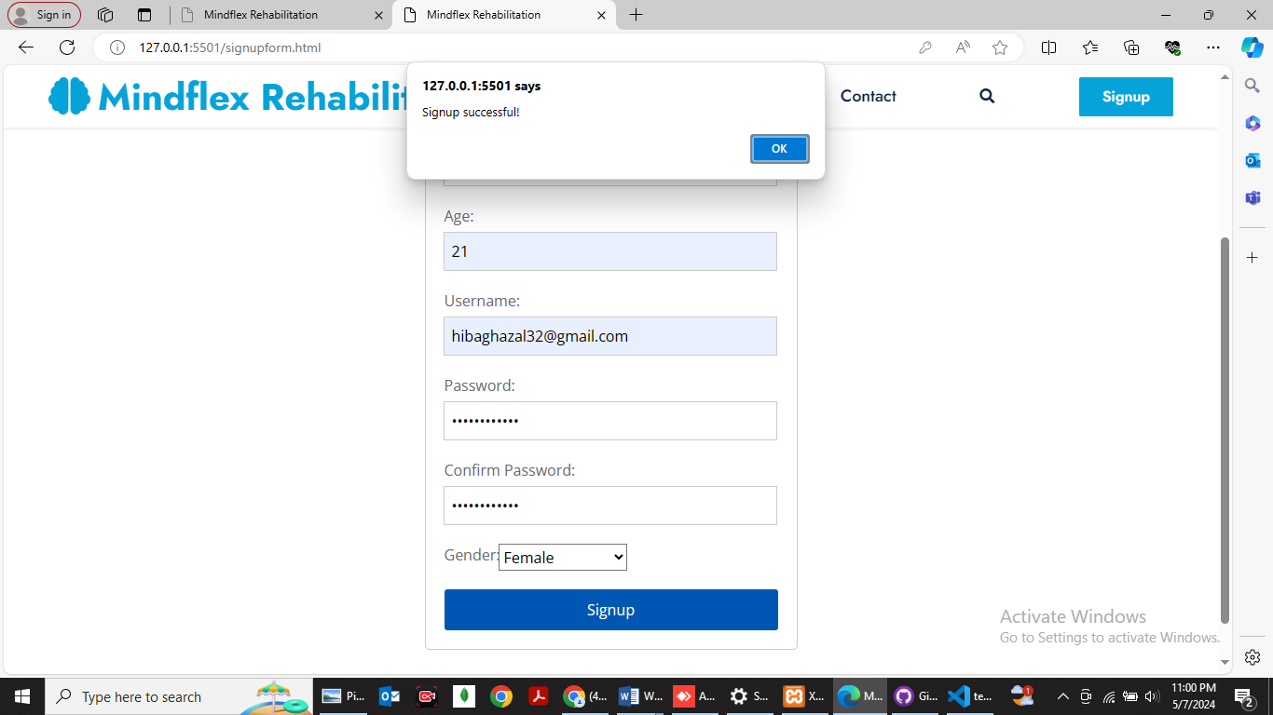

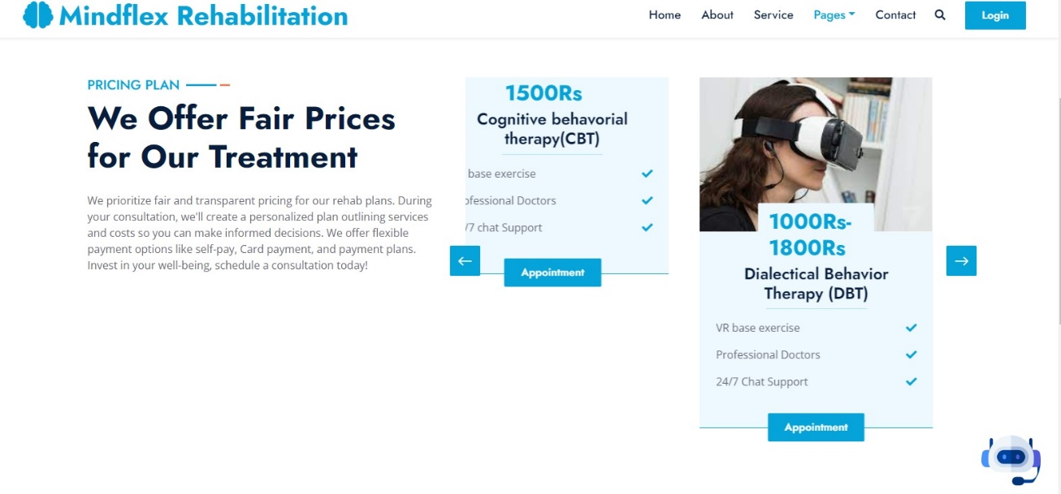

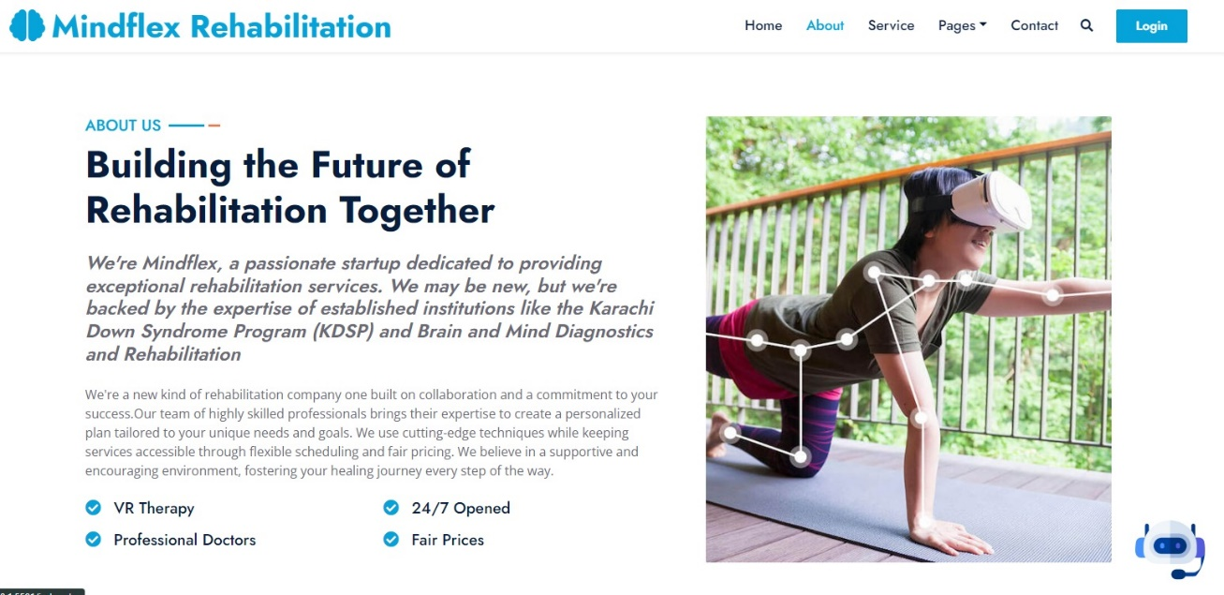

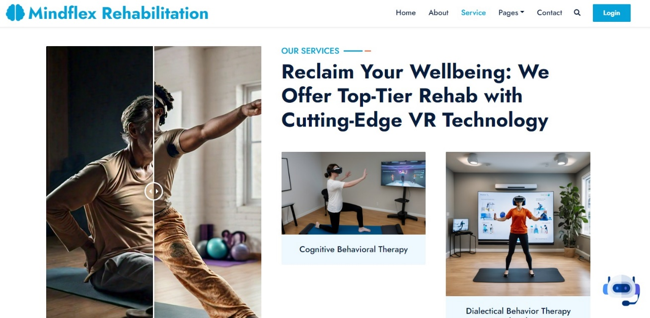



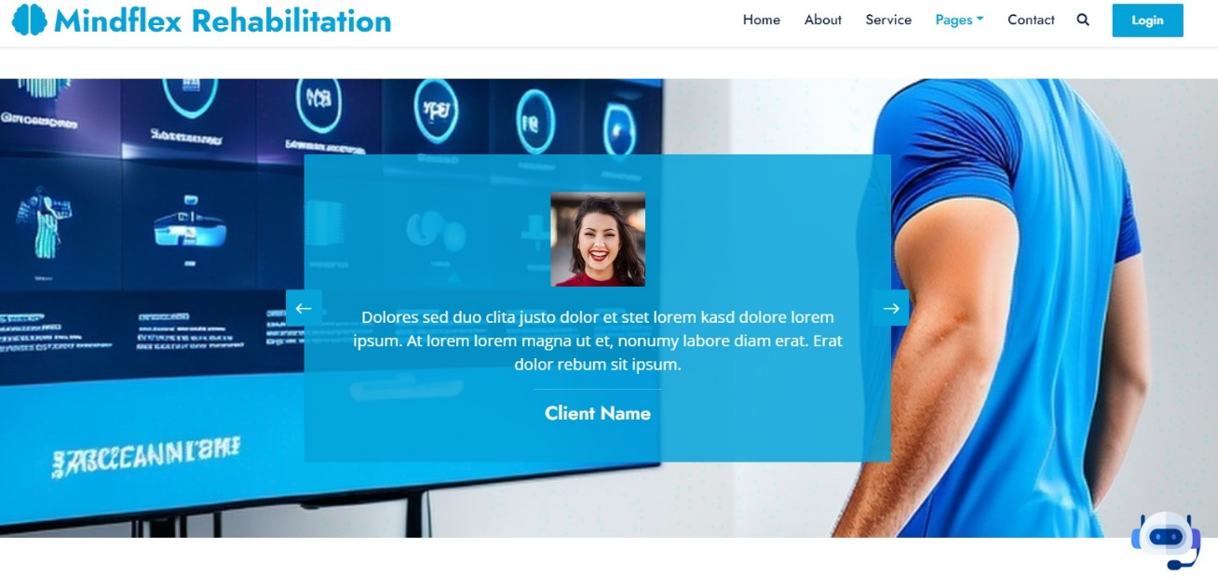

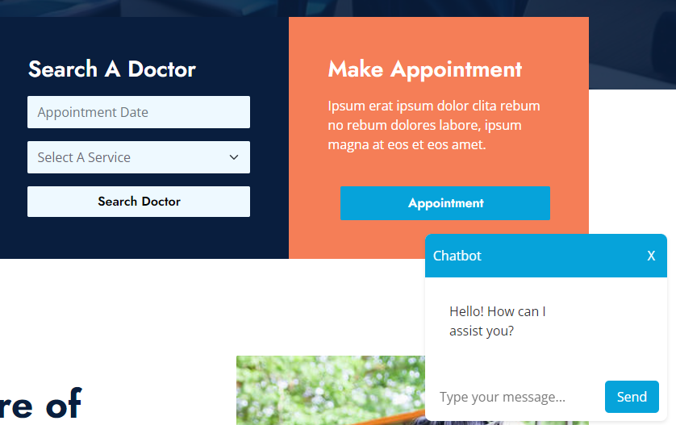

Contact Form for further guidance about Mindflex.

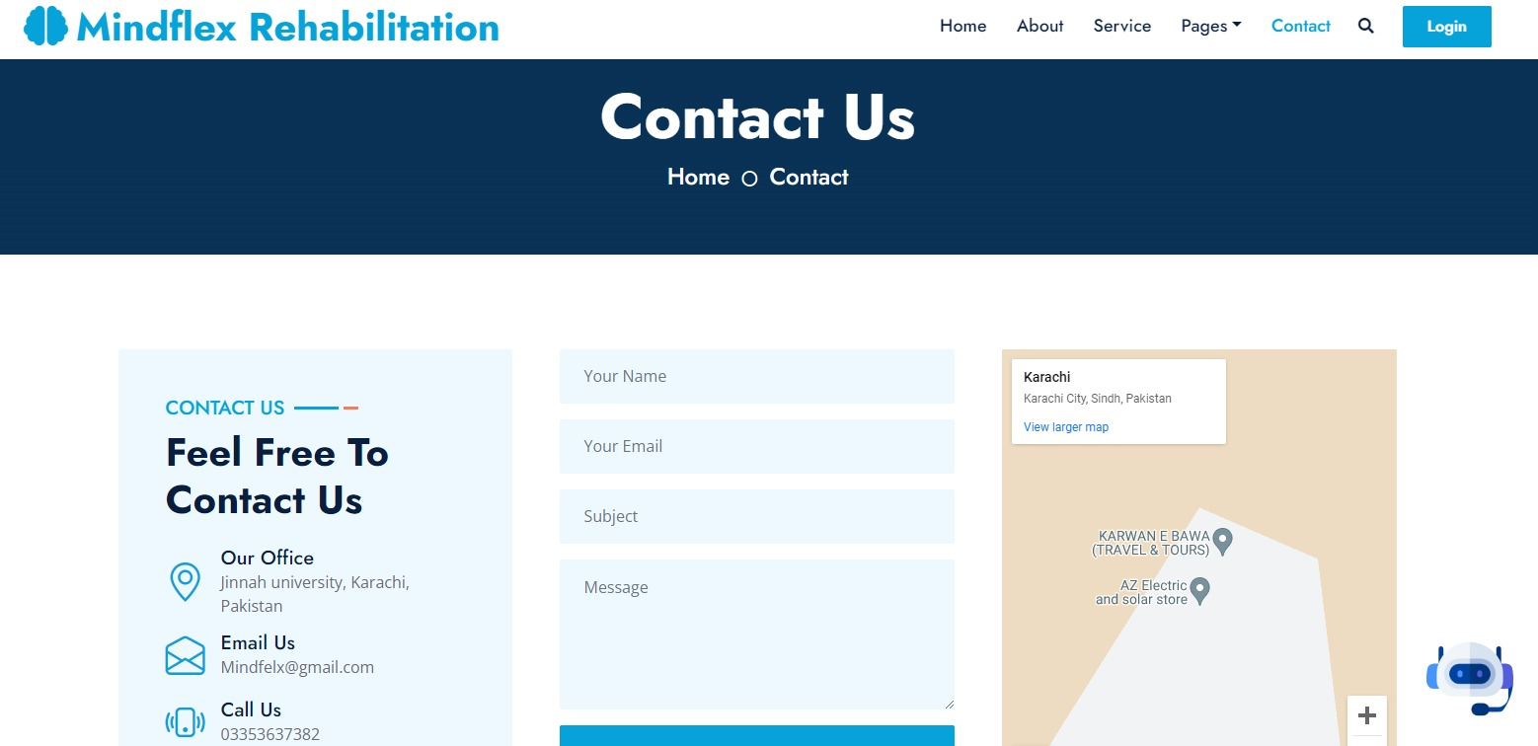

# CHAPTER 4

# PROJECT PLAN

**1. Project Scope and Objectives**

* **Scope**: Develop a rehabilitation application with AI-based chatbot, VR Kinect technology, and telehealth features.
* **Objective**: Provide personalized rehabilitation, interactive exercises, and telehealth capabilities to users for improved accessibility, engagement, and outcomes.

**2. Methodology**

* **Development Approach**: Agile, with 2-week sprints.
* **Roles**:
  + **Product Owner**: Defines project vision and manages product backlog.
  + **Scrum Master**: Facilitates Agile practices and sprint events.
  + **Development Team**: Implements features and functionality.
  + **QA/Testers**: Ensures product quality through testing.
  + **UX/UI Designers**: Focus on user interface and experience.

**3. Key Milestones and Deliverables**

* **Milestone 1: Project Planning**
  + Define project scope, objectives, and stakeholder requirements.
  + Deliverables: Project definition, work plan, and project timelines.
  + **Timeline**: Week 1-2
* **Milestone 2: AI Chatbot Integration**
  + Integrate AI chatbot for personalized assistance and guidance.
  + Deliverables: AI chatbot module, chatbot interactions, and initial testing.
  + **Timeline**: Week 3-4
* **Milestone 3: VR Kinect Integration**
  + Develop VR-based exercises and integrate Kinect technology.
  + Deliverables: VR exercise module, Kinect motion tracking, and initial testing.
  + **Timeline**: Week 5-6
* **Milestone 4: Telehealth Features**
  + Implement telehealth module for remote therapy sessions.
  + Deliverables: Telehealth module, video conferencing capabilities, and security testing.
  + **Timeline**: Week 7-8
* **Milestone 5: User Testing and Feedback**
  + Conduct user testing, gather feedback, and implement improvements.
  + Deliverables: User testing reports, updated application, and performance metrics.
  + **Timeline**: Week 9-10
* **Milestone 6: Final Deployment and Launch**
  + Complete final testing and deploy the application to production.
  + Deliverables: Deployed application, compliance certification, and post-launch support plan.
  + **Timeline**: Week 11-12

**4. Risk Management**

* **Identify Risks**: Technical issues, compliance challenges, and delays.

**5. Quality Assurance and Testing**

* **Testing Strategy**: Unit testing, integration testing, user acceptance testing (UAT), and security testing.

**6. Deployment and Maintenance**

* **Deployment Strategy**: Continuous Integration/Continuous Deployment (CI/CD).
* **Post-Launch Support**: Customer support, bug fixes, and ongoing updates.

## Process Model (Agile)

**Agile Framework**

Agile Methodology: Scrum

Sprint Duration: 2 weeks

Sprint Structure: Planning, Execution, Review, and Retrospective

**Project Backlog**

The project backlog contains a prioritized list of tasks and user stories that need to be completed. Examples include:

* + AI chatbot integration
  + VR Kinect Integration and Exercise Recommendation System Development
  + Telehealth functionality
  + User interface design
  + User testing and validation
  + Documentation and user guides

**Sprint Planning**

|  |  |  |  |  |  |  |
| --- | --- | --- | --- | --- | --- | --- |
| Website development | | | | | |  |
|  |  |  |  |  | Website content populated, including information about the rehabilitation project, features, benefits, and Database details |  |
|  |  |  |  |  | Website tested across various browsers and devices for compatibility and responsiveness |  |
| Mobile Application Development | | | | | |  |
|  |  |  |  |  | Design and development of the mobile application |  |
|  |  |  |  |  | allowing users to access personalized assistance and guidance |  |
|  |  |  |  |  | Testing conducted to ensure performance,reliability, and security of the mobile application |  |
| AI Chatbot Integration | | | | | |  |
|  |  |  |  |  | AI chatbot integrated into the rehabilitation application |  |
|  |  |  |  |  | Natural language processing implemented |  |
|  |  |  |  |  | Basic chatbot functionality tested and validated |  |
| VR Kinect Integration | | | | | |  |
|  |  |  |  |  | VR Kinect technology integrated into the application |  |
|  |  |  |  |  | Kinect sensors calibrated and tested |  |
|  |  |  |  |  | Motion tracking algorithms implemented and validated |  |
| Rehabilitation Exercise Development | | | | | |  |
|  |  |  |  |  | Range of rehabilitation exercises developed and tested |  |
|  |  |  |  |  | Exercise programs targeting specific goals implemented |  |
|  |  |  |  |  | Usability testing conducted with target user groups |  |
| User Testing and Iterative Improvement | | | | | |  |
|  |  |  |  |  | User acceptance testing conducted |  |
|  |  |  |  |  | Feedback gathered and prioritized for iterative improvements |  |

**Sprint Reviews and Retrospectives**

* **Sprint Review**: Showcase completed work to stakeholders and gather feedback. Update the project backlog as needed.
* **Sprint Retrospective**: Review team performance and Agile processes. Identify what went well, what could be improved, and actionable steps for the next sprint.

**Collaboration and Communication**

* **Tools**: Git (version control), and Zoom (video conferencing).

**Final Project Delivery**

* Prepare for deployment, user training, and post-launch support.

### User Stories

In mindflex rehabilitation, three users are involved. Each users require different functionality according to their need.

|  |  |  |  |
| --- | --- | --- | --- |
| **No.** | **As a** | **I want to/a …** | **So that …** |
| 1 | user | be able to access mental and physiotherapy rehabilitation services from the comfort of my home using Virtual Reality technology | I can undergo therapy without needing to travel to a physical location. |
| 2 | User | have the option to engage with an AI chat feature that acts as a virtual friend, providing initial solutions for my mental and physical health inquiries | I can receive immediate support and guidance whenever I need it. |
| 3 | user | a personalized dashboard where I can track my progress in mental and physiotherapy rehabilitation, view upcoming appointments, and access educational resources | I can stay motivated and informed throughout my rehabilitation journey |
| 4 | Therapist | platform where I can remotely monitor and support my patients' progress in mental and physiotherapy rehabilitation, communicate with them through virtual consultations and chat, and adjust their treatment plans as needed | I can provide accessible and personalized care to my patients. |
| 5 | Therapist | I want the ability to schedule and conduct virtual appointments with my patients online | I can provide ongoing therapy sessions, monitor their progress, and adjust their treatment plans remotely |

### Sprints Planning

Table 1.3 Sprint Planning

|  |  |  |  |  |  |  |  |  |  |  |  |
| --- | --- | --- | --- | --- | --- | --- | --- | --- | --- | --- | --- |
| Project Name | Project Manager | | | | Start Date | | End Date | | | Overall Progress | |
| Mindflex  Rehabilitaion | Ms.Hafiza Anisa  Ahmed | | | | 1/1/2024 | | 30,Decembe, 2024 | | | Prototypes, surveys and Documentation done | |
| Project Deliverables | | Deliverables produced:   1. User Interface Design:   elements for the rehabilitation application, including screens, navigations, and interactive components.   1. AI Chatbot Module:   A fully functional AI chatbot module integrated into the rehabilitation application's interface.   1. VR-Based Exercise System:   A VR-based exercise system accessible within the rehabilitation application.   1. Software Development Kit (SDK) Integration:   Integration of the VR Kinect device's SDK into the project's software framework.  Enables communication between the project's software and the VR Kinect device for data exchange, sensor calibration, and motion tracking.   1. Virtual Environment Creation:   Development of virtual environments compatible with the VR Kinect device.  3D modeling, texturing, lighting, and physics simulations to create realistic and engaging virtual spaces.   1. Integration of AI and VR Technologies:   Seamless interaction between the AI chatbot and VR-based exercise recommendation system,  API integration, data exchange protocols, synchronization of user data and preferences between AI and VR modules.   1. Rehabilitation Exercise Modules:   Development of rehabilitation exercises tailored for use with the VR Kinect device.  Exercise selection menu, exercise instructions, real-time feedback on user performance, progress tracking.   1. Tele-rehabilitation Features:   Remote monitoring and tele-rehabilitation functionalities integrated into the rehabilitation application.  Users can participate in tele-rehabilitation sessions with healthcare professionals.   1. User Education Resources:   Educational resources and instructional materials accessible within the rehabilitation application.  Users can access videos, tutorials, articles, and FAQs through the AI chatbot and VR interface to learn about rehabilitation techniques, self-care strategies, and general health-related topics. | | | | | | | | | |
| Scope Statement | | The project scope of MindFlex Rehabilitation encompasses the development of a groundbreaking platform that brings mental and physiotherapy rehabilitation directly into individuals' homes through Virtual Reality (VR). This comprehensive platform integrates various key features, including an AI chat feature designed to act as a virtual friend, offering initial solutions for mental and physical health inquiries. The application and web interface are equipped with personalized dashboards, enabling users to track their progress seamlessly. MindFlex revolutionize rehabilitation by combining advanced technology, personalized tracking mechanisms, and professional support, ultimately making mental and physiotherapy services more accessible, engaging, and effective for individuals seeking rehabilitation from the comfort of their homes. | | | | | | | | | |
| Task Name | | | Start Date | End Date | | Team | | Sizing | Acceptance Criteria / Definition of  Done | | Priority |

|  |  |  |  |  |  |  |
| --- | --- | --- | --- | --- | --- | --- |
| Website development | | | | | |  |
|  | May/  1/24 | June/15/24 | Web developers | High | Website content populated, including information about the rehabilitation project, features, benefits, and Database details | High |
|  |  |  |  |  | Website tested across various browsers and devices for compatibility and responsiveness |  |
| Mobile Application Development | | | | | |  |
|  | June/18/24 | August/30/24 | Mobile developers | Medium | Design and development of the mobile application | Medium |
|  |  |  |  |  | allowing users to access personalized assistance and guidance |  |
|  |  |  |  |  | Testing conducted to ensure performance,reliability, and security of the mobile application |  |
| AI Chatbot Integration | | | | | |  |
|  | Sept/1/24 | Sept/25/24 | AI development | Medium | AI chatbot integrated into the rehabilitation application | High |
|  |  |  |  |  | Natural language processing implemented |  |
|  |  |  |  |  | Basic chatbot functionality tested and validated |  |
| VR Kinect Integration | | | | | |  |
|  | Sept/26/24 | Oct/30/24 | VR development | High | VR Kinect technology integrated into the application | High |
|  |  |  |  |  | Kinect sensors calibrated and tested |  |
|  |  |  |  |  | Motion tracking algorithms implemented and validated |  |
| Rehabilitation Exercise Development | | | | | |  |
|  | Nov/1/24 | Nov/25/24 | Rehab Team | High | Range of rehabilitation exercises developed and tested | High |
|  |  |  |  |  | Exercise programs targeting specific goals implemented |  |
|  |  |  |  |  | Usability testing conducted with target user groups |  |
| User Testing and Iterative Improvement | | | | | |  |
|  | Nov/26/24 | Dec/28/24 | QA Team | Medium | User acceptance testing conducted | Medium |
|  |  |  |  |  | Feedback gathered and prioritized for iterative improvements |  |

### Sprints Sizing

**Website Development**

* **Start Date**: April 26, 2024
* **End Date**: May 5, 2024
* **Team**: Web developers
* **Sizing**: High

**Mobile Application Development**

* **Start Date**: May 7, 2024
* **End Date**: June 30, 2024
* **Team**: Mobile developers
* **Sizing**: Medium

**AI Chatbot Integration**

* **Start Date**: July 1, 2024
* **End Date**: July 4, 2024
* **Team**: AI development
* **Sizing**: Medium

**VR Kinect Integration**

* **Start Date**: July 4, 2024
* **End Date**: September 30, 2024
* **Team**: VR development
* **Sizing**: High

**Rehabilitation Exercise Development**

* **Start Date**: October 1, 2024
* **End Date**: October 25, 2024
* **Team**: Rehab Team
* **Sizing**: High

**User Testing and Iterative Improvement**

* **Start Date**: October 26, 2024
* **End Date**: December 28, 2024
* **Duration**: 4.5 weeks
* **Team**: QA Team
* **Sizing**: Medium

## Timeline with Milestones

1. **Project Overview**

* **Project Name**: MindFlex Rehabilitation
* **Project Manager**: Ms. Hafiza Anisa Ahmed
* **Start Date**: January 1, 2024
* **End Date**: December 30, 2024

**2. Key Milestones**

* **Milestone 1: Project Planning**
  + **Start Date**: January 1, 2024
  + **End Date**: January 14, 2024
  + **Deliverables**: Project definition, work plan, project timelines, and stakeholder identification.
* **Milestone 2: User Interface Design**
  + **Start Date**: January 15, 2024
  + **End Date**: February 28, 2024
  + **Deliverables**: User interface components, including screen layouts, navigation, and interactive elements.
  + **Key Activities**: Design prototyping, user feedback, and revisions.
* **Milestone 3: Website Development**
  + **Start Date**: May 1, 2024
  + **End Date**: June 15, 2024
  + **Deliverables**: Website with content, responsive design, cross-browser compatibility.
  + **Key Activities**: Content creation, design and development, testing, and deployment.
* **Milestone 4: Mobile Application Development**
  + **Start Date**: June 18, 2024
  + **End Date**: August 30, 2024
  + **Deliverables**: Mobile application for iOS and Android platforms.
  + **Key Activities**: Design and development, testing, and performance validation.
* **Milestone 5: AI Chatbot Integration**
  + **Start Date**: September 1, 2024
  + **End Date**: September 25, 2024
  + **Deliverables**: AI chatbot module integrated into the rehabilitation application.
  + **Key Activities**: Natural language processing implementation, testing, and validation.
* **Milestone 6: VR Kinect Integration**
  + **Start Date**: September 26, 2024
  + **End Date**: October 30, 2024
  + **Deliverables**: VR Kinect technology integrated into the application.
  + **Key Activities**: Calibration, motion tracking, and VR exercise development.
* **Milestone 7: Rehabilitation Exercise Development**
  + **Start Date**: November 1, 2024
  + **End Date**: November 25, 2024
  + **Deliverables**: Rehabilitation exercises tailored for VR Kinect.
  + **Key Activities**: Exercise program design, testing, and usability validation.
* **Milestone 8: Tele-rehabilitation Features**
  + **Start Date**: November 26, 2024
  + **End Date**: December 28, 2024
  + **Deliverables**: Tele-rehabilitation module for remote therapy sessions.
  + **Key Activities**: Video conferencing implementation, security checks, and telehealth scheduling features.
* **Milestone 9: User Testing and Iterative Improvement**
  + **Start Date**: November 26, 2024
  + **End Date**: December 28, 2024
  + **Deliverables**: User acceptance testing, feedback reports, and iterative improvements.
  + **Key Activities**: User testing, feedback gathering, and iteration.
* **Milestone 10: Project Conclusion**
  + **Start Date**: December 29, 2024
  + **End Date**: December 30, 2024
  + **Deliverables**: Project closure, final documentation, and project review.
  + **Key Activities**: Final deployment checks, stakeholder review, and project handover.

# CHAPTER 5

# TEST PLAN

**1. Testing Strategy**

* **Testing Methodologies**:
  + **Unit Testing**: Test individual components and modules to ensure they work as expected.
  + **Integration Testing**: Test interactions between components to verify seamless integration.
  + **Functional Testing**: Validate that the application meets the defined functional requirements.
  + **Usability Testing**: Assess the user interface for ease of use and accessibility.
  + **Performance Testing**: Test application responsiveness, load handling, and scalability.
  + **Security Testing**: Ensure data privacy, secure communication, and compliance with regulations.
  + **User Acceptance Testing (UAT)**: Validate the application with real users to ensure it meets their needs.

**2. Testing Schedule**

* **Unit Testing**: Throughout development, conducted by the development team.
* **Integration Testing**: After major components are integrated, typically during Milestone 3-4.
* **Functional Testing**: During Milestone 5, ensuring all features work as intended.
* **Usability Testing**: After UI design is complete, during Milestone 2 and Milestone 7.
* **Performance Testing**: Conducted in Milestone 6 to validate VR Kinect performance and during Milestone 8 for telehealth features.
* **Security Testing**: Conducted before deployment and after significant changes.
* **User Acceptance Testing (UAT)**: During Milestone 9 to gather feedback and validate functionality.

**3. Test Resources and Roles**

* **Test Teams**:
  + **Development Team**: Responsible for unit testing and integration testing.
  + **QA Team**: Oversees functional, usability, performance, and security testing.
  + **User Testing Team**: Manages user acceptance testing and feedback gathering.

**4. Acceptance Criteria**

* **Unit Testing**: All unit tests must pass without errors.
* **Integration Testing**: Components must interact without issues, with no breaking changes.
* **Functional Testing**: All functional requirements must be met.
* **Usability Testing**: The application must achieve a predefined usability score.
* **Performance Testing**: The application must meet performance benchmarks, including response time and scalability.
* **Security Testing**: The application must pass security checks and comply with regulations.
* **User Acceptance Testing**: UAT must confirm that the application meets user expectations and is ready for deployment.

**5. Testing Completion and Project Deployment**

* **Final Testing and Sign-off**: All test results must meet or exceed the acceptance criteria before the project is deployed.
* **Project Deployment**: After successful testing, the application is deployed to production, with post-launch support and monitoring in place.

## Test Cases

**Test Case 1: AI Chatbot Interaction**

* **Test Case ID**: TC001
* **Preconditions**: AI chatbot module is integrated into the application.
* **Test Steps**:
  1. Launch the rehabilitation application.
  2. Interact with the AI chatbot by asking a basic question (e.g., "What exercises are recommended for back pain?").
  3. Observe the chatbot's response.
* **Expected Outcome**: The AI chatbot provides a relevant response and offers exercise recommendations.

**Test Case 2: VR Kinect Motion Tracking**

* **Test Case ID**: TC002
* **Preconditions**: VR Kinect integration is complete, with calibrated sensors.
* **Test Steps**:
  1. Launch the VR-based rehabilitation exercise.
  2. Perform a specific motion (e.g., arm raises).
  3. Observe the accuracy of motion tracking.
* **Expected Outcome**: The system accurately tracks the user's movements, providing real-time feedback.

**Test Case 3: Telehealth Session Connection**

* **Test Case ID**: TC003
* **Preconditions**: Telehealth module is integrated into the application.
* **Test Steps**:
  1. Schedule a telehealth session with a healthcare professional.
  2. Connect to the telehealth session at the scheduled time.
  3. Test audio and video quality during the session.
* **Expected Outcome**: Successful connection to the telehealth session with clear audio and video.

**Test Case 4: Rehabilitation Exercise Functionality**

* **Test Case ID**: TC004
* **Preconditions**: Rehabilitation exercise modules are integrated into the application.
* **Test Steps**:
  1. Launch a specific rehabilitation exercise.
  2. Follow the exercise instructions.
  3. Complete the exercise and track progress.
* **Expected Outcome**: The exercise runs without errors, and progress is tracked correctly.

**Test Case 5: User Interface Navigation**

* **Test Case ID**: TC005
* **Preconditions**: User interface components are designed and integrated.
* **Test Steps**:
  1. Launch the rehabilitation application.
  2. Navigate through the application to access different features.
  3. Test standard functions like help, settings, and account management.
* **Expected Outcome**: The user interface is intuitive, with smooth navigation between features.

## Automated Testing Tools

* **Testing Tools**:
  + **Unit Testing**: JUnit (for Java), Pytest (for Python), or Mocha (for JavaScript).
  + **Integration Testing**: Postman for API testing.
  + **Functional Testing**: Selenium for automated UI testing.
  + **Usability Testing**: Observation and user feedback.
  + **Performance Testing**: JMeter for load testing.
  + **Security Testing**: OWASP ZAP for security assessment.
  + **UAT Tools**: Custom test scripts, feedback forms.

# CHAPTER 6

# IMPLEMENTATION DETAILS

implementation details cover the technology stack, system architecture, development process, security measures, deployment strategy, and maintenance plan for the rehabilitation project.

## Tools and Technology

* **Microsoft Kinect Sensor**: The core hardware component used for tracking body movements and gestures. It provides depth sensing, skeletal tracking, and RGB camera functionalities.
* **Kinect for Windows SDK (Software Development Kit)**: Microsoft provides an SDK specifically designed for developing applications using Kinect sensors. It includes APIs for accessing Kinect's features such as skeletal tracking, depth sensing, and audio processing.
* **Programming Languages**: Depending on the platform and requirements, programming languages such as C#, C++, or even Python could be used for application development.
* **3D Modeling and Animation Software**: Tools like Blender, Autodesk Maya, or 3ds Max might be used for creating 3D models of virtual environments, characters, and objects.
* **User Interface (UI) Design Tools**: Software like Adobe XD, Sketch, or Figma could be used for designing the user interface and user experience of the application.
* **Database Management System**: The application involves user profiles, progress tracking or data analytics, a database management system such as MySQL, SQLite, or MongoDB might be used for data storage.
* **Testing and Debugging Tools**: Various debugging and testing tools are used to ensure the application functions properly across different environments and scenarios.
* **Documentation Tools**: Tools for documenting the project, such as Confluence or Microsoft Word, are essential for maintaining project requirements, design documents, and user manuals.

## Data Dictionary

#### User Information

| **Field Name** | **Data Type** | **Description** | **Constraints** |
| --- | --- | --- | --- |
| **user_id** | UUID | Unique identifier for each user | Primary key, Not Null |
| **username** | String | User's unique username | Unique, Not Null |
| **email** | String | User's email address | Unique, Not Null |
| **password_hash** | String | Hashed password for authentication | Not Null |
| **first_name** | String | User's first name | Not Null |
| **last_name** | String | User's last name | Not Null |
| **date_of_birth** | Date | User's date of birth | Not Null |
| **phone_number** | String | User's contact phone number |  |

#### Rehabilitation Exercises

| **Field Name** | **Data Type** | **Description** | **Constraints** |
| --- | --- | --- | --- |
| **exercise_id** | UUID | Unique identifier for each exercise | Primary key |
| **exercise_name** | String | Name of the rehabilitation exercise | Not Null |
| **exercise_type** | String | Type of exercise (e.g., stretching, strength, balance) | Not Null |
| **difficulty_level** | Integer | Difficulty level of the exercise (e.g., 1-10) |  |
| **instruction** | Text | Detailed instructions for performing the exercise |  |
| **created_at** | Timestamp | Timestamp when the exercise was created |  |
| **updated_at** | Timestamp | Timestamp when the exercise was last updated |  |

#### Telehealth Sessions

| **Field Name** | **Data Type** | **Description** | **Constraints** |
| --- | --- | --- | --- |
| **telehealth_id** | UUID | Unique identifier for each telehealth session | Primary key |
| **user_id** | UUID | Identifier for the user participating in the session | Foreign key, Not Null |
| **therapist_id** | UUID | Identifier for the healthcare professional conducting the session | Foreign key, Not Null |
| **scheduled_at** | Timestamp | Scheduled time for the telehealth session | Not Null |
| **status** | String | Status of the session (e.g., scheduled, completed, canceled) |  |

#### AI Chatbot Interactions

| **Field Name** | **Data Type** | **Description** | **Constraints** |
| --- | --- | --- | --- |
| **interaction_id** | UUID | Unique identifier for each chatbot interaction | Primary key |
| **user_id** | UUID | Identifier for the user involved in the interaction | Foreign key, Not Null |
| **message_text** | Text | Text of the user's message to the chatbot |  |
| **response_text** | Text | Text of the chatbot's response |  |
| **timestamp** | Timestamp | Time when the interaction occurred | Not Null |

#### User Progress Tracking

| **Field Name** | **Data Type** | **Description** | **Constraints** |
| --- | --- | --- | --- |
| **progress_id** | UUID | Unique identifier for each progress record | Primary key |
| **user_id** | UUID | Identifier for the user whose progress is tracked | Foreign key, Not Null |
| **exercise_id** | UUID | Identifier for the completed exercise | Foreign key, Not Null |
| **completion_time** | Timestamp | Time when the exercise was completed |  |
| **performance_score** | Integer | Score indicating the user's performance |  |

## Version Control

<https://github.com/maryamR143/Mindflex-reahb-maiN>

## Web APIs / Web Services

**AI and Chatbot APIs**

* **Dialogflow**: An AI-powered conversational interface that enables natural language understanding and chatbot functionality.

**Virtual Technology and Kinect Integration**

* **Kinect for Windows SDK**: Provides APIs for interacting with Kinect devices, including sensor data, motion tracking, and calibration.
* **Unity 3D Web API**: Enables integration of 3D virtual environments and interactions in web-based applications.

**Telehealth APIs**

* **Zoom SDK**: Offers APIs for integrating Zoom's video conferencing features into custom applications.

**User Management and Authentication APIs**

* **JWT (JSON Web Tokens)**: A method for securely transmitting information between parties, often used for user authentication and session management.

**Security and Compliance APIs**

* **OWASP ZAP**: An open-source security tool that offers APIs for security testing and vulnerability assessment.

**Analytics and Monitoring APIs**

* **Google Analytics**: Offers APIs for tracking user behavior and application usage, providing insights into user interactions.

**Collaboration and Communication APIs**

* **Slack API**: Allows integration with Slack for team collaboration and communication within the project.
* **Trello/Jira APIs**: APIs for integrating task management and project tracking tools with custom applications.

## Website Development

**1. Planning and Design**

* **Objectives**: Define the primary goals of the website, such as providing information about the rehabilitation application, enabling user registration, and offering support for telehealth sessions.
* **Target Audience**: Identify the key users of the website, which may include patients, healthcare professionals, and family members.
* **Wireframes and Mockups**: Create visual representations of the website's layout, structure, and user interface elements.
* **User Experience (UX)**: Design the website to be intuitive and user-friendly, focusing on ease of navigation and accessibility.

**2. Front-end Development**

* **Technologies**:
  + **Languages**: HTML, CSS, JavaScript.
  + **Frameworks**: React.js or Vue.js for building interactive user interfaces.
* **Key Components**:
  + **Home Page**: Overview of the rehabilitation project, key features, and benefits.
  + **About Page**: Information about the project, its purpose, and the team behind it.
  + **Features Page**: Detailed descriptions of AI chatbot, VR Kinect integration, telehealth features, and other services.
  + **Contact Page**: Contact information and support channels for users.
  + **User Account Management**: Options for user registration, login, and account settings.
* **Responsive Design**: Ensure the website is optimized for various devices, including desktops, tablets, and smartphones.
* **Accessibility**: Design with accessibility in mind, following guidelines such as WCAG (Web Content Accessibility Guidelines).

**3. Back-end Development**

* **Technologies**:
  + **Languages**: Node.js or Python.
  + **Frameworks**: Express.js for building RESTful APIs, Django or Flask for Python-based back-ends.
* **Key Components**:
  + **User Authentication**: Implement secure user authentication (e.g., OAuth or JWT).
  + **API Development**: Create RESTful APIs to facilitate communication between the front-end and back-end components.
* **Security**: Implement security measures, including data encryption and access control.

**4. Testing and Quality Assurance**

* **Testing Strategy**: Include unit testing, integration testing, and end-to-end testing to ensure website functionality and reliability.
* **Tools**: Selenium or Cypress for automated testing, and Jest or Mocha for unit testing.
* **User Acceptance Testing**: Gather feedback from users to validate usability and functionality.

**5. Deployment and Maintenance**

* **Deployment Strategy**: Use continuous integration/continuous deployment (CI/CD) pipelines to automate the deployment process.
* **Hosting**: Choose a reliable hosting provider, such as AWS, Azure, or Google Cloud, for deploying the website.
* **Monitoring and Maintenance**: Implement monitoring tools to track website performance, and establish a maintenance schedule for updates and bug fixes.

## Mobile Application Development

**1. Planning and Design**

* **Objective**: Create a mobile application that supports the rehabilitation project's features, including AI chatbot interactions, VR-based exercises, and telehealth sessions.
* **Target Platforms**: Android.
* **User Experience (UX) Design**: Design an intuitive and user-friendly interface, focusing on accessibility and responsiveness.
* **Wireframes and Mockups**: Create visual layouts and mockups to outline the user interface and application flow.

**2. Technology Stack**

* + **Android**: Kotlin or Java with Android Studio for native Android development.
  + **Back-end Technologies**:
  + **Node.js with Express.js**: For back-end development and RESTful APIs.
  + **Databases**: MongoDB or PostgreSQL for data storage.
  + **Cloud Services**: AWS, Azure, or Google Cloud for back-end infrastructure.

**3. Core Features**

* **AI Chatbot Integration**: Include an AI chatbot that provides personalized guidance and assistance to users.
* **Telehealth Functionality**: Enable users to participate in telehealth sessions with healthcare professionals via video conferencing.
* **User Accounts and Authentication**: Implement secure user authentication and account management.
* **User Progress Tracking**: Allow users to track their rehabilitation progress, including completed exercises and telehealth sessions.

**4. Security and Compliance**

* **Data Encryption**: Use TLS/SSL for secure data transmission.
* **User Authentication**: Implement OAuth or JWT for secure login and access control.
* **Compliance**: Ensure compliance with regulations like HIPAA and GDPR to protect user data and privacy.

**5. Testing and Quality Assurance**

* **Testing Strategy**: Include unit testing, integration testing, and end-to-end testing.
* **Automated Testing**: Use tools like Appium or Espresso for automated mobile application testing.
* **Manual Testing**: Conduct manual tests to validate user interface and functionality.
* **User Acceptance Testing (UAT)**: Test the mobile application with real users to ensure it meets their expectations.

## Deployment

**Staging Environment:** Deploy the application to a staging environment for final testing and validation. This step helps catch any issues before the application goes live.

**Load Balancing and Scaling:** Implement load balancers to distribute traffic and ensure high availability. Use horizontal scaling to handle increased user load as needed.

**Deploy to Production:** Deploy the application to the production environment, ensuring minimal downtime. Schedule deployment during low-traffic periods to reduce user impact.

**Post-Deployment Monitoring:** Implement monitoring tools (e.g., Prometheus, Grafana, New Relic) to track application performance, uptime, and error rates. Set up alerting for critical events.

## Website Hosting

**Site hosting link**

[**http://www.godaddy.com**](http://www.godaddy.com)

**Key Considerations for Hosting**

**Performance and Scalability:** Choose a hosting solution that can handle the expected load and scale with increased traffic. Cloud hosting is often preferred for its ability to scale resources as needed.

**Reliability and Uptime:** Ensure the hosting provider offers high uptime (99.9% or higher) to minimize downtime and disruptions.

**Security:** Hosting providers should offer robust security features, including data encryption, secure sockets layer (SSL) certificates, firewalls, and intrusion detection systems.

**Compliance:** Ensure the hosting provider complies with relevant regulations (such as HIPAA and GDPR), especially if handling sensitive healthcare data.

Technical Support: Look for a hosting provider that offers reliable technical support, preferably 24/7, to address issues quickly.

## Mobile Application Deployment

**Deployment to App Stores**

* **Platform-Specific Deployment**:
  + **Android Deployment**: Android Studio to build the application for Android. Submit to the Google Play Store for review.
* **App Store Submissions**:
  + **App Information**: Provide detailed app information, including name, description, screenshots, and app icons.
  + **Metadata**: Add metadata such as version number, build information, and release notes.
  + **App Review and Approval**: Undergo the app review process by Apple and Google. Address any issues or requests for changes to ensure approval.
* **Beta Testing and Early Access**: Consider releasing a beta version of the application for testing and feedback before the official launch. Use platforms like TestFlight for iOS and Google Play's internal test tracks for Android.

# CHAPTER 7

# CONCLUSION AND FUTURE WORK

**Conclusion**

The rehabilitation project that integrates AI, virtual technology with Kinect, and telehealth features aims to revolutionize rehabilitation by providing personalized, interactive, and accessible therapy options for users. The project leverages advanced technologies to create a comprehensive platform that supports physical rehabilitation, remote therapy sessions, and AI-driven guidance. This innovative approach offers several key benefits:

* **Accessibility**: The project enables users to access rehabilitation services from their homes, reducing barriers related to mobility, transportation, and location.
* **Personalization**: AI chatbot functionality allows for personalized guidance, while VR technology provides tailored exercise recommendations and feedback.
* **Interactivity and Engagement**: Kinect-based motion tracking and immersive virtual environments enhance user engagement and motivation during rehabilitation.
* **Telehealth Integration**: The ability to conduct remote therapy sessions with healthcare professionals ensures continuity of care and ongoing support.

Overall, the project has the potential to improve rehabilitation outcomes, increase user adherence to therapy programs, and reduce healthcare costs. It also aligns with broader trends toward telehealth and technology-driven healthcare solutions.

**Future Work**

While the project represents a significant step forward, there are several areas for future work to further enhance its impact and reach:

1. **Expanded AI Capabilities**: Enhance the AI chatbot's natural language processing (NLP) capabilities to provide more sophisticated responses and recommendations. Incorporate machine learning to improve the chatbot's performance over time.
2. **Additional VR Features**: Expand the range of virtual exercises and environments to cater to a wider variety of rehabilitation needs. Explore the use of augmented reality (AR) for additional interactive experiences.
3. **Advanced Telehealth Services**: Integrate additional telehealth features, such as remote monitoring of vital signs and real-time data sharing with healthcare professionals. Explore the use of wearable devices to collect additional health data.
4. **Accessibility and Inclusivity**: Further enhance accessibility features to accommodate users with different abilities. Ensure compliance with accessibility standards such as WCAG (Web Content Accessibility Guidelines).
5. **User Engagement and Retention**: Develop strategies to increase user engagement and retention, such as personalized progress tracking, gamification, and loyalty programs.
6. **Collaboration and Integration**: Explore opportunities for collaboration with healthcare providers, insurance companies, and other stakeholders to broaden the reach and adoption of the project. Integrate with electronic health record (EHR) systems to streamline data sharing.
7. **Internationalization and Localization**: Adapt the application for use in different regions and languages to reach a global audience. Consider cultural differences and local regulations in the design and functionality of the application.
8. **Regulatory Compliance and Data Privacy**: Continue to monitor and ensure compliance with healthcare regulations and data privacy laws. Implement robust security measures to protect user data.

# REFERENCES

<https://www.frontiersin.org/research-topics/56881/advances-in-technology-assisted-rehabilitation>

<https://www.mdpi.com/1424-8220/23/6/2987>

<https://jneuroengrehab.biomedcentral.com/articles/10.1186/s12984-019-0552-6>

# APPENDIX A

# SCREENSHOTS





















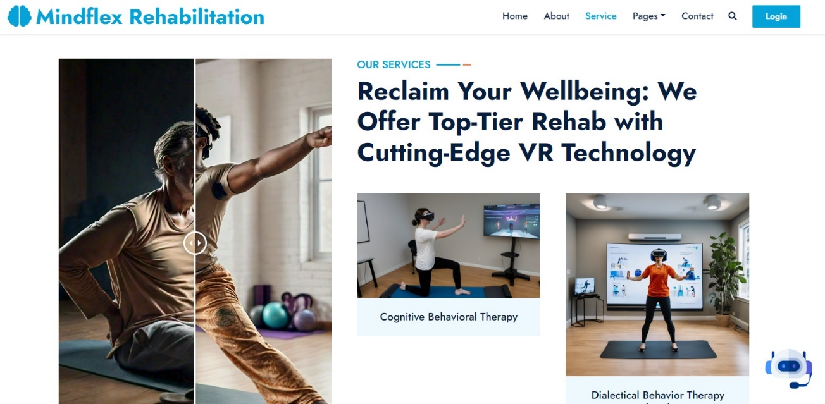







# APPENDIX B

# ABBREVIATION

| **Abbreviation** | **Full Term** |
| --- | --- |
| AI | Artificial Intelligence |
| VR | Virtual Reality |
| SDK | Software Development Kit |
| CI/CD | Continuous Integration/Continuous Deployment |
| NLP | Natural Language Processing |
| QA | Quality Assurance |
| UAT | User Acceptance Testing |
| HIPAA | Health Insurance Portability and Accountability Act |
| GDPR | General Data Protection Regulation |
| WCAG | Web Content Accessibility Guidelines |
| EHR | Electronic Health Record |
| UUID | Universally Unique Identifier |
| TLS/SSL | Transport Layer Security/Secure Sockets Layer |