Point | Flat File System | Relational Database
Structure | Data stored in one single table or file (e.g., Excel, text file) | Data stored in multiple tables linked together
Data Redundancy | High redundancy (same data repeated many times) | Low redundancy (data stored once and reused)
Relationships | No relationship between data | Tables are related using primary and foreign keys
Example Usage | Small files, simple lists, CSV files | Banking systems, university databases, business systems
Drawbacks | Data inconsistency, hard to update, not scalable | More complex to design and manage
- Comparison: Flat File Systems vs. Relational Databases

- DBMS Advantages – Mind Map
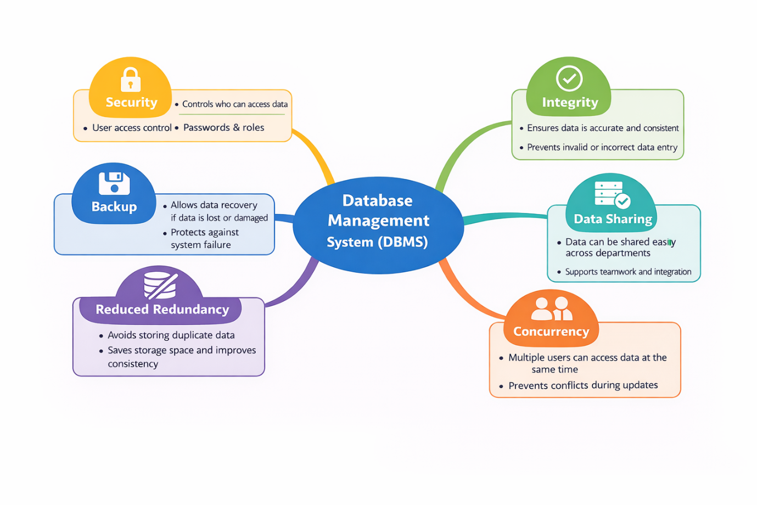
- Roles in a Database System
1. System Analyst
- Understands business requirements
- Translates user needs into system specifications

2. Database Designer
- Designs the database structure (tables, keys, relationships)
- Creates ER diagrams and schemas
3. Database Developer
- Writes SQL queries, views, and stored procedures
- Implements the database design
4. Database Administrator (DBA)
- Manages database security, backup, and performance
- Ensures the database runs smoothly
5. Application Developer
- Builds applications that use the database
- Connects the user interface to the database
6. BI (Business Intelligence) Developer
- Analyzes data and creates reports and dashboards
- Helps management make data-driven decisions

- Types of Databases
1. Relational vs. Non-Relational Databases
Relational Databases
- Data stored in tables (rows & columns)
- Uses SQL
- Strong structure and relationships
Use Case:
- Banking systems
- Student records
- Payroll systems
Non-Relational Databases (NoSQL)
- Data stored as documents, key-value, or columns
- Flexible structure (no fixed schema)
- Handles large and fast-changing data

Examples:
- MongoDB – document-based database
- Apache Cassandra – column-based database
Use Case:
- Social media apps
- IoT systems
- Real-time analytics
2. Centralized vs. Distributed vs. Cloud Databases
Centralized Database
- Stored in one location
- Easy to manage
- Single point of failure
Use Case:
- Small organizations
- Single-office systems
Distributed Database
- Data stored across multiple locations
- Faster access and high availability
- More complex to manage
Use Case:
- Banking networks
- Large enterprise systems
Cloud Database
- Hosted on the cloud
- Scalable and accessible online
- Pay-as-you-use
Use Case:
- Web applications
- Startups and online services

- Cloud Storage and Databases
1. What is Cloud Storage and how does it support databases?
- Cloud storage is online storage provided by cloud providers.
- Databases use cloud storage to save data, backups, and logs.
- It allows databases to be scalable, reliable, and always available.
In short:
Cloud storage is the foundation that stores database data safely in the cloud.

2. Advantages of Cloud-Based Databases
Examples:
- Azure SQL
- Amazon RDS
- Google Cloud Spanner
Advantages:
- No need to manage physical servers
- Automatic backup and recovery
- Easy scalability (grow or shrink as needed)
- High availability and reliability
- Pay only for what you use

3. Disadvantages / Challenges
- Requires stable internet connection
- Ongoing cost over time
- Data security and privacy concerns
- Limited control compared to on-premise databases
- Vendor lock-in (hard to switch providers)

