|  |  |  |
| --- | --- | --- |
| **Research Proposal Title** |  |  |
| **English** | * **The role of Neural Networks, Fuzzy Systems, and IoT in the integration of artificial intelligence into cyber security systems** |
| **Program** | | **MSc Cybersecurity & Digital Forensics** |
| **Research Priority** | | **Cyber Security and Next-Generation Technology** |
| **Research Theme Activities** | | **Information Communication Technology** |

Contents

**Lists of figures** 4

**Lists of tables** 4

**Lists of Abbreviations** 4

**Chapter 1** 5

**Introduction** 5

**1.1 Introduction** 5

**1.2 Background:** 6

**1.3 Research objective:** 7

**1.4 Research Challenges:** 8

**1.5 Research Questions:** 9

**1.6 Statement of problem:** 10

**1.7 What has been done so far & how this research paper is better?** 10

**1.8 Significance of the study** 11

**1.9 Structure of the thesis** 11

**Chapter 2** 13

**Literature review** 13

**2.1 Introduction** 13

**2.2 Methods of Attacking IoT Devices:** 15

**2.3 Artificial Intelligence in Cybersecurity** 17

**2.4 AI to Attack IoT** 19

**2.5 Related Articles for IoT Cybersecurity in the Context of AI:** 21

**2.6 Research gaps:** 22

**2.7 Research Objectives in the Intersection of AI and IoT Cybersecurity:** 23

**Chapter 3** 28

**Research Methodology** 28

**3.1 Introduction** 28

**3.2 Quantitative or Qualitative Method** 28

**3.2.1 Quantitative Method** 28

**3.2.2 Qualitative Method** 30

**3.3 System Design:** 30

**3.3.1 Dataset** 32

**3.3.2 Model** 34

**3.3.3 Metric Evaluation** 41

**3.4 Choosing of Research Methods** 42

**3.5 Conclusions** 44

**Chapter 4** 45

**Implementation** 45

**4.1 Introduction** 45

**4.2 Details of Project Implementation:** 45

Tools & Programming Language: 45

**4.3 Experiment Analysis:** 46

**Exploratory Data Analysis** 46

**Data cleaning** 50

**Data splitting** 51

**4.4 Hydride Model (LSTM-CNN)** 53

**4.5 Model evaluation** 56

**Conclusion** 57

**Chapter 5** 58

**Results and Discussion** 58

**5.1 Introduction:** 58

**5.2 Results analysis** 58

**5.3 Discussion:** 59

**Compare result with previous research** 59

**5.4 Limitations of this research:** 60

**Chapter 6** 61

**Conclusion and future work** 61

**6.1 Conclusions:** 61

**References** 63

**Abstract**

In an era where the Internet of Things (IoT) proliferates, encompassing a myriad of sensors, wireless nodes, and computing systems, the challenge of cybersecurity has become increasingly prominent. IoT's dynamic and distributed nature makes it susceptible to a range of cyber threats, with the potential to compromise vast volumes of data converted into actionable insights. This research investigates the integration of Neural Networks, Fuzzy Systems, and the Internet of Things (IoT) to enhance artificial intelligence in cybersecurity systems. Employing a mixed-methods approach, the study utilizes LSTM -CNN models, coupled with the Mobile Health Human Behavior Analysis dataset, to analyze human behavior in a cybersecurity context in the hospital. The model architecture, tailored for the dynamic nature of hospital IoT activities, features a layered

In conclusion, this research represents a significant advancement in the convergence of AI and healthcare cybersecurity. The model's efficacy and promising outcomes underscore its potential deployment in real-world hospital scenarios. The findings contribute to the ongoing discourse on fortifying IoT security within healthcare infrastructures. Future work is outlined, emphasizing the imperative for dataset augmentation, feature engineering, and ongoing optimization to address current limitations and enhance the model's adaptability to dynamic hospital landscapes. This research stands as a pivotal contribution to the evolving landscape of AI-driven cybersecurity solutions in the healthcare domain.

# **Lists of figures**

Figure 1 Cyber Attacks on Hospital IoT equipment’s 26

Figure 2 System Design 28

Figure 3 Mhealth dataset overview 30

Figure 4 LSTM 32

Figure 5 architecture of LSM 33

Figure 6 input gate 34

Figure 7 forget gate 35

Figure 8 output gate 35

Figure 9 CNN model 36

Figure 10 Metric evaluation 39

Figure 11 Our methodology 40

Figure 12 Details of dataset 44

Figure 13 Data visualization 46

Figure 14boxplot for data 47

Figure 15 Data after cleaning 48

Figure 16 histogram of features in xtrain 49

Figure 17hybrid model architecture 51

Figure 18 model fitting 53

Figure 19 training and validations loss vs training and validation accuracy 53

Figure 20 confusion matrix 56

# **Lists of tables**

Table 1SECURITY PROBLEMS IN IOT NETWORKS AND APPLIED MACHINE LEARNING TECHNIQUES 22

Table 2different types of IoT equipment 27

Table 3Activity label 45

Table 4 Activity 46

Table 5 Time series Dataset for testing and training 50

Table 6 Model performance metrics on training and testing Sets 55

Table 7 Compare result with previous research 57

# **Lists of Abbreviations**

|  |  |
| --- | --- |
| Words | Abbreviations |
| FS | Fuzzy Systems |
| CNN | Convolutional Neural Network |
| ECG | Electrocardiogram |
| LSTM | Long Short-Term Memory |
| MHHBA | Mobile Health Human Behavior Analysis |
| NN | Neural Networks |
| IoT | Internet of Things |

# **Chapter 1**

# **Introduction**

# **1.1 Introduction**

The integration of Artificial Intelligence (AI) into cybersecurity, especially for the Internet of Things (IoT), is an important development in keeping our digital world safe. IoT is all about connecting everyday devices to the internet, from smart home appliances to complex industrial tools. These devices collect lots of data, which is very useful but also makes them targets for cyber attacks. That's why strong cybersecurity is essential. [12]

The increasing integration of technology, particularly the Internet of Things (IoT), in hospital environments has revolutionized healthcare delivery. While these technological advancements offer unparalleled benefits, they also introduce new challenges, particularly in the realm of cybersecurity. Hospitals are prime targets for cyber threats due to the sensitive nature of patient data and the critical reliance on interconnected devices. As such, fortifying the security of IoT systems in healthcare settings becomes imperative to ensure the confidentiality, integrity, and availability of critical medical information.

In the past, cybersecurity mostly relied on set rules to protect against known threats. But as cyber attacks become more complex, especially with the rise of IoT, we need smarter and more flexible security solutions. This is where AI comes in, particularly with technologies like neural networks and fuzzy systems. [11]

Neural networks are a type of AI that learns from data and makes decisions, much like how our brains work. They are great at recognizing patterns, including new and complicated cyber threats that older security methods might miss. Fuzzy systems are another type of AI that's good at making sense of uncertain or vague information. This is really helpful in cybersecurity, where it's not always clear if something is a threat. [7. 12]

However, using these advanced AI methods in IoT is challenging because many IoT devices have limited power and can't handle complex calculations. One solution is to use edge computing, which processes data closer to where it's collected. This approach can make things faster and reduce the need for sending data over long distances. [11]

In short, using AI in IoT cybersecurity is crucial. It makes our security systems more adaptable and better at handling the ever-changing nature of cyber threats. It's a key step in protecting our increasingly connected world. [11. 12]

## **1.2 Background:**

The landscape of cybersecurity has evolved dramatically with the advent of the Internet of Things (IoT). This paradigm shift, marked by the proliferation of connected devices, has expanded the attack surface for cyber threats, necessitating more advanced security measures. Traditional cybersecurity approaches, primarily reliant on predefined rules and known threat signatures, are proving inadequate in this new context. The complexity and dynamism of modern cyber threats, especially those targeting IoT environments, demand a more adaptive and intelligent approach to security. [13]

Enter Artificial Intelligence (AI). AI's integration into cybersecurity heralds a new era of defense mechanisms. With its core capabilities rooted in learning from data, recognizing patterns, and making decisions with minimal human intervention, AI offers a significant leap forward in detecting and responding to cyber threats. Neural networks and fuzzy systems, subsets of AI, have shown particular promise in enhancing IoT security. Neural networks, by mimicking the human brain's structure and function, excel in identifying complex and evolving threat patterns. Fuzzy systems contribute by effectively handling imprecise or uncertain information common in threat detection scenarios.[11]

However, implementing these advanced AI techniques within IoT systems poses unique challenges. The limited processing power and memory of many IoT devices constrain the deployment of sophisticated AI algorithms, necessitating innovative solutions such as edge computing. Despite these challenges, AI's role in IoT cybersecurity is crucial, transforming the way we protect our interconnected digital world against increasingly sophisticated cyber threats.[14]

## **1.3 Research objective:**

The main goal of this research is to create a better cybersecurity system for the Internet of Things (IoT) using Artificial Intelligence (AI). We want to find out how well neural networks and fuzzy systems, which are types of AI, can help stop cyber attacks on IoT devices. The focus will be on making algorithms that learn from past security problems and can predict future risks. We also plan to look at how to overcome the issue of IoT devices not being very powerful, possibly using edge computing. The end goal is to make a strong, AI-powered cybersecurity system that improves the safety of IoT networks.[7.11.12.14]

The primary objective of this research is to develop a robust cybersecurity framework for hospital IoT systems through the amalgamation of Neural Networks, Fuzzy Systems, and IoT technologies. Specific goals include:

* Investigating the current state of hospital IoT security and identifying vulnerabilities.
* Designing and implementing a model that leverages Neural Networks and Fuzzy Systems for effective threat detection and classification.
* Evaluating the performance of the proposed model in a simulated hospital IoT environment.

## **1.4 Research Challenges:**

Integrating Artificial Intelligence (AI) into Internet of Things (IoT) cybersecurity presents several significant challenges that must be addressed:

-Scalability and Resource Limitations: A primary issue is the diverse nature of IoT devices, many of which have limited computational resources. Creating AI models that are both effective and can run on devices with minimal processing capabilities is a substantial challenge. Research must focus on developing AI algorithms that are efficient yet sufficiently robust to operate on a wide range of IoT devices. [2.7]

-Data Privacy Concerns: AI systems require substantial data for effective training. However, using vast amounts of potentially sensitive data raises significant privacy concerns. Research in this area needs to strike a delicate balance between leveraging data for AI training and ensuring stringent data privacy and security measures are maintained.

Interoperability and Standardization Issues: The IoT ecosystem is characterized by a wide variety of devices with different standards and protocols. Developing AI solutions that can seamlessly integrate across this diverse landscape presents a complex challenge. Efforts need to be directed towards establishing common standards and developing AI models that are versatile enough to function across different IoT environments.

Evolving Cyber Threats: The dynamic nature of cyber threats makes it difficult for AI models to stay consistently effective. AI systems must be capable of continuous learning and adaptation to effectively counter new and evolving threats. This necessitates research into developing self-evolving AI algorithms that can update and refine their knowledge base in real-time. [1.2.12]

Edge Computing Integration: To counteract the limited processing power of many IoT devices, edge computing has emerged as a solution. However, integrating AI with edge computing requires careful optimization to ensure efficiency, speed, and reduced latency. Research must explore innovative methods for effectively merging AI with edge computing architectures.

Ethical and Regulatory Challenges: The deployment of AI in cybersecurity raises several ethical questions, particularly concerning decision-making biases. Ensuring AI systems are ethically sound and adhere to regulatory standards is a complex but essential aspect of this integration. [1.11]

Real-Time Response and Anomaly Detection: The ability of AI systems to respond in real-time to security threats and accurately detect anomalies is critical in IoT cybersecurity. Developing AI solutions that can quickly and accurately identify and respond to unusual activity without false positives is a key research challenge.

Human-AI Collaboration: Finally, the interaction between human operators and AI systems in cybersecurity contexts needs further exploration. Research should focus on how AI can augment human decision-making in cybersecurity, ensuring a collaborative approach that leverages the strengths of both. [1.2.15]

Addressing these challenges is crucial for the successful integration of AI in IoT cybersecurity. This endeavor will not only enhance the security of IoT networks but also pave the way for innovative cybersecurity solutions in an increasingly connected world.

## **1.5 Research Questions:**

1. How can AI-based al gorithms be optimized for real-time threat detection and response in resource-constrained IoT environments, considering the limitations in processing power and memory of these devices?
2. What are the effective strategies to ensure data privacy and security while utilizing large datasets for training AI models in IoT cybersecurity, and how can these strategies balance the trade-off between data accessibility and privacy protection?
3. In what ways can the integration of edge computing with AI algorithms enhance the efficiency and effectiveness of cybersecurity solutions in IoT networks, and what are the challenges and potential solutions in this integration?

## **1.6 Statement of problem:**

The rapid proliferation of the Internet of Things (IoT) has brought forth an interconnected digital ecosystem, permeating various aspects of modern life. However, this integration has also led to a significant increase in the vulnerability of these systems to cyber threats.

1. Traditional cybersecurity approaches, primarily designed for more robust computing environments, are often ill-suited for the resource-constrained nature of many IoT devices.

Furthermore, the dynamic and sophisticated nature of modern cyber threats necessitates a more adaptable and intelligent approach to security . [18]

1. The integration of Artificial Intelligence (AI) into IoT cybersecurity appears promising but is hindered by challenges such as limited computational resources on IoT devices, concerns about data privacy, the need for interoperability across diverse IoT systems, and the ethical implications of AI deployment.

This confluence of technological advancement and security vulnerability presents a critical problem: developing effective, efficient, and ethical AI-driven cybersecurity solutions tailored for the IoT landscape.

Addressing this issue is not only crucial for the protection of digital infrastructure but also for ensuring the trust and reliability of IoT systems in various sectors, ranging from healthcare to smart cities . [22]

## **1.7 What has been done so far & how this research paper is better?**

the previous studies and academic research mentioned at is document you provided focuses on the integration of Artificial Intelligence (AI) into IoT cybersecurity. It does not explicitly detail previous studies or academic research but rather discusses the current state of IoT cybersecurity, the potential of AI in this field, challenges, and research objectives.

To understand how this research paper is better or different compared to previous studies, to would typically compare the novel approaches, methodologies, or findings presented in this paper .

This could involve highlighting new solutions to the discussed challenges, advancements in Ai algorithms for IoT, or unique insights into data privacy and edge computing integration in IoT security . [18.19.22]

## **1.8 Significance of the study**

This research holds significance in addressing the critical need for innovative approaches to enhance cybersecurity in healthcare. The outcomes of this study can contribute to the development of tailored solutions that fortify the security infrastructure of hospital IoT systems, ultimately safeguarding patient data and maintaining the integrity of medical operations.

## **1.9 Structure of the thesis**

This thesis is structured to unfold the comprehensive exploration of the integration of Neural Networks, Fuzzy Systems, and IoT in hospital IoT security. Subsequent chapters delve into the literature review, methodology, results, discussion, and future work, providing a holistic understanding of the research journey.

**Chapter 1: Introduction**

The inaugural chapter sets the stage for the research by presenting the background, problem statement, and objectives. It outlines the significance of the study, defines its scope, and provides a roadmap for the subsequent chapters.

**Chapter 2: Literature Review**

This chapter conducts a thorough review of existing literature relevant to the integration of Neural Networks, Fuzzy Systems, and IoT in hospital IoT security. It explores previous research, identifies gaps, and establishes a theoretical foundation for the current study.

**Chapter 3: Research Methodology**

Chapter 3 outlines the research design, data collection methods, and the process undertaken to integrate Neural Networks, Fuzzy Systems, and IoT in the hospital IoT security framework. It delineates the model development process and the rationale behind methodological choices.

**Chapter 4: Implementation**

This section provides insight into the dataset used for the study, its characteristics, and the preprocessing steps undertaken to ensure its suitability for model training. It details the challenges encountered and the strategies employed to address them.

**Chapter 5: Results and Discussions**

Chapter 5 presents the findings of the study, including the performance metrics of the developed model. It incorporates the classification report, confusion matrix, and other relevant discussion to evaluate the efficacy of the integrated Neural Networks, Fuzzy Systems, and IoT in hospital IoT security.

**Chapter 6: Conclusion and Future Work**

The final chapter synthesizes the key findings, draws conclusions, and discusses the implications of the research. It also outlines potential avenues for future work, acknowledging limitations and offering insights for further exploration in the integration of AI technologies in hospital cybersecurity.

This structured approach ensures a systematic and comprehensive exploration of the research, allowing for a nuanced understanding of the integration of Neural Networks, Fuzzy Systems, and IoT in hospital IoT security.

# **Chapter 2**

# **Literature review**

## **2.1 Introduction**

the Internet of Things (IoT) emerges as a revolutionary paradigm, introducing an interconnected world where everyday objects are equipped with network connectivity, enabling them to collect and exchange data. However, it has simultaneously introduced a myriad of cybersecurity challenges, necessitating a paradigm shift in the approaches to securing networks and devices.

The integration of Artificial Intelligence (AI) into cybersecurity strategies for IoT systems represents a significant advancement in this domain, offering novel and effective solutions to complex security issues . [18]

The context of IoT cybersecurity encompasses a diverse array of devices, ranging from simple sensors to complex machines, all interconnected and potentially accessible via the internet. These devices continuously generate, process, and transmit vast amounts of data, some of which are highly sensitive and confidential. The decentralized and ubiquitous nature of IoT devices makes them susceptible to a wide range of cyber threats, including but not limited to, unauthorized access, data breaches, and Distributed Denial of Service (ddos) attacks. The inherent limitations of IoT devices, such as constrained computational power and storage capacity, further complicate the implementation of traditional cybersecurity measures .

In light of these challenges, AI emerges as a critical tool in the cybersecurity toolkit. AI's ability to learn from data, recognize patterns, and make decisions with minimal human intervention makes it ideally suited for enhancing IoT security. Machine learning algorithms, a subset of AI, can analyze vast datasets generated by IoT devices to detect anomalies, predict potential threats, and initiate preemptive actions to thwart cyber-attacks. This capability is particularly crucial in an environment where the volume, variety, and velocity of data exceed human analysts' capacity to monitor and respond effectively . [8]

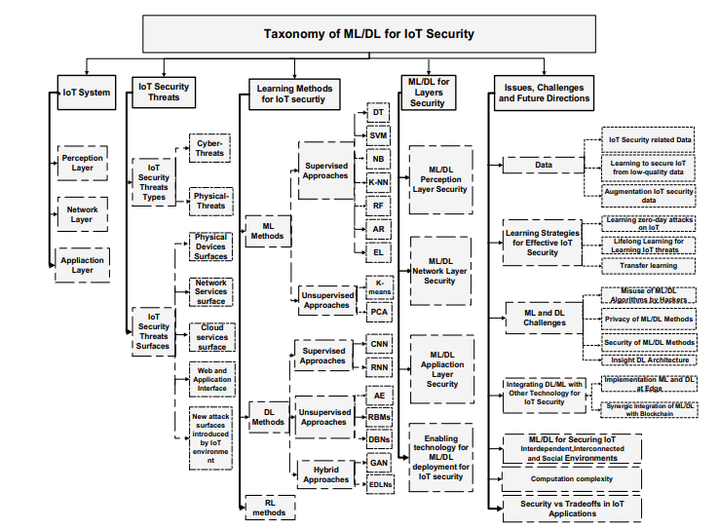

**Figure** - thematic taxonomy for Iot Security [20]

The significance of AI in IoT cybersecurity cannot be overstated , as IoT devices continue to proliferate, the potential attack surface for cybercriminals expands exponentially, AI driven cybersecurity solutions can dynamically adapt to evolving threats, unlike static, rule-based systems, they can learn from each interaction, continuously improving their ability to detect and respond to new types of attacks. Furthermore, Ai can automate routine tasks, freeing human resources to focus on more complex and strategic activities . [18]

additionally, AI technologies such as neural networks and fuzzy systems offer sophisticated means of identifying subtle patterns and ambiguities in data that might elude traditional security mechanisms. These technologies are particularly adept at dealing with the uncertainty and imprecision inherent in real-world data, making them invaluable in crafting robust security frameworks for IoT environments.

the integration of Ai into IoT cybersecurity is not just an enhancement but a necessity in the current digital era . [11]

as cyber threats become more sophisticated and IoT networks more complex, AI offers the adaptability, efficiency, and scalability required to safeguard these interconnected systems.

this integration represents a promising frontier in the quest to balance the benefits of IoT with the imperative of maintaining robust cybersecurity defenses . [19]

## **2.2 Methods of Attacking IoT Devices:**

Initial reconnaissance represents the preliminary phase in the cyber-attack lifecycle, particularly against Internet of Things iot devices. In this stage, attackers meticulously gather data about the target, which often involves mapping out network structures, identifying connected devices, and detecting vulnerabilities. They employ various techniques, such as network scanning, social engineering, and exploiting public information, to build a comprehensive profile of their target. This phase is crucial as it lays the groundwork for subsequent attacks by providing vital insights into the target's security posture, thereby allowing attackers to devise more effective strategies .

**-**Physical attacks on IoT devices signify a direct approach where attackers exploit physical vulnerabilities of the devices. These attacks can range from simple tampering to sophisticated hardware-level interventions. Given the widespread and often unprotected deployment of IoT devices, they are particularly susceptible to such attacks. Attackers might access unsecured devices to modify their firmware or hardware, intercept data, or inject malicious code. The ramifications of physical attacks are substantial, as they can lead to complete system takeovers, data breaches, and the disruption of IoT networks , and in Physical Attacks These involve direct physical interaction with the IoT device, aiming to cause damage or extract data. In the context of IoV, this could involve tampering with vehicle sensors or onboard diagnostics ports .

**-** Man-in-the-middle mitm attacks are a prevalent threat in Iot environments. In these attacks, the perpetrator positions themselves between the communicating parties to intercept, alter, or fabricate data. The IoT’s reliance on wireless communication makes it especially vulnerable to these types of attacks.

1-Bluetooth technology, commonly used in IoT devices, presents unique vulnerabilities that can be exploited in MitM attacks. Attackers can intercept Bluetooth communications by exploiting weaknesses in the pairing process or security protocols. Once intercepted, attackers can gain unauthorized access to data transmissions, manipulate them, or even take control of the device. These vulnerabilities pose a significant risk, especially in IoT applications involving sensitive data . [19]

2- A fake data injection attack is a sophisticated MitM attack in which attackers inject manipulated data into the system. For the IoT, this can have serious consequences, as IoT devices often base their actions on the data they receive. By entering false data, attackers can trick these devices into performing erroneous actions, disrupting performance, and causing bodily injury in critical applications such as healthcare or industrial devices [17.19]

- Botnets represent the biggest threat in IoT land. This network of infected devices, controlled by a centralized entity, is capable of launching coordinated attacks such as DDoS (Distributed Denial of Service) attacks or multiple data breaches IoT devices generally have the few security features are easy targets for botnets. Once part of bot networks, these devices can be used to launch large-scale attacks that can cripple networks, steal large amounts of data and disrupt businesses

- Deial of Service Attacks (DoS) The goal of an attack is to destroy the normal operation of a network or service. For IoT, these attacks typically involve overloaded devices or networks with large numbers of traffic or requests, preventing them from performing their intended functions IoT devices are particularly vulnerable to DoS attacks due to power consumption due to lack of functionality and bandwidth. These attacks can cause significant service disruption, affecting not only the targeted devices but also the broader networks and infrastructure that depend on them.

In conclusion, the methods used to attack IoT devices are varied and sophisticated, exploiting digital and physical vulnerabilities. From initial analytics to complex botnet and DoS attacks, these techniques highlight the critical importance of robust and multi-layered protection [2]

## **2.3 Artificial Intelligence in Cybersecurity**

In the realm of cybersecurity, the advent of Artificial Intelligence (AI) has ushered in a new era of sophisticated defense mechanisms. AI, with its various algorithms and learning capabilities, plays a pivotal role in enhancing the security of digital systems. This chapter explores the diverse applications of AI in cybersecurity, emphasizing its transformative impact in identifying and mitigating threats. [18]

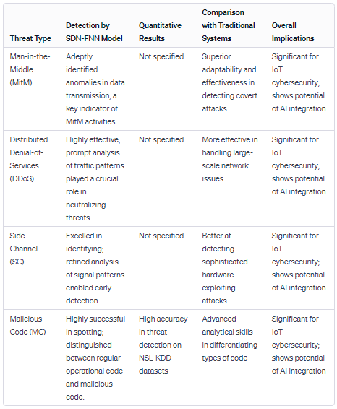

**Comparative Analysis of SDN-FNN Model in IoT Cybersecurity**

**2.3.1 Machine Learning**

a core component of Ai has significantly altered the cybersecurity landscape. It introduces dynamic and adaptive methods for identifying threats, moving beyond traditional, static rule-based systems. Machine learning algorithms analyze vast datasets to detect patterns and anomalies indicative of cyber threats. This capability is crucial in a digital environment where new and complex threats emerge constantly. By learning from historical data, these algorithms can predict and identify potential threats, enabling proactive defense mechanisms. Moreover, machine learning facilitates the continuous improvement of security systems through iterative learning, ensuring that defenses evolve in tandem with emerging threats .

**2.3.2 Decision Trees**

are a fundamental machine learning technique employed in cybersecurity. These tree-like models aid in making decisions based on a series of conditions or rules. In the context of cybersecurity, decision trees can efficiently classify data and identify potential security breaches. Each node in the tree represents a decision, which helps in narrowing down the possibilities and isolating anomalies or patterns indicative of a security threat. This method is particularly effective in environments with well-defined and structured data, enabling quick and accurate threat detection and response.

**2.3.3 K-Nearest Neighbors**

The K-nearest neighbor (KNN) algorithm is another important tool in the cybersecurity Ai arsenal. Artificial neural networks follow the principle of similarity and identify the "k" data points that are closest to a specific query point. In cybersecurity, artificial neural networks can detect unusual patterns by comparing new data points to known data. This comparison helps identify anomalies that deviate from typical patterns and may indicate potential security threats. The simplicity and effectiveness of artificial neural networks in detecting anomalies make them a valuable tool for continuously monitoring and protecting digital systems.

**2.3.4 Support Vector Machines**

Support vector machines (SVM) effectively classify and predict cyber threats. SVM is a supervised learning model that analyzes data for classification and regression analysis. In network security, SVM is used to classify data into security and threat categories. They work by finding the best boundary (hyperplane) that separates different classes of data. This boundary helps accurately differentiate between normal operations and potential threats. SVM is particularly effective in high-dimensional spaces, making it suitable for complex cybersecurity data sets where identifying subtle differences is critical.

**2.3.5 Artificial Neural Networks**

artificial neural networks anns represent the epitome of Ai application in cybersecurity. anns, inspired by the human brain's neural structure, excel in complex pattern recognition and threat detection.

Their ability to learn and make decisions on their own makes them highly effective at identifying complex cyber threats. Artificial neural networks analyze large data sets and learn to identify patterns associated with cyber attacks. Their ability to learn non-linear and complex relationships in data allows them to detect subtle and complex threats that other algorithms may miss. In addition, artificial neural networks can adapt to new threats over time, continuously improving their threat detection capabilities.

In summary, incorporating Ai into cybersecurity revolutionizes the way threats are detected and mitigated. From machine learning to advanced neural networks, artificial intelligence provides a range of tools to intelligently adapt and respond to the ever-changing threat landscape. Applying these diverse Ai approaches ensures robust, proactive defense against cyber threats and protects digital assets in an increasingly connected world . [18.19]

## **2.4 AI to Attack IoT**

The advent of Artificial Intelligence ai has not only revolutionized the defensive mechanisms in cybersecurity but has also given rise to sophisticated offensive techniques, particularly in attacking Internet of Things (IoT) systems. This chapter delves into the various ways Ai is leveraged to exploit vulnerabilities within IoT environments.

- Automation of Vulnerability Detection

The automation of vulnerability detection using Ai marks a significant shift in the landscape of cybersecurity threats to IoT systems . [18]

**2.4.1 Fuzzing**

is an automated technology used to find security vulnerabilities in software and systems, including IoT devices. This involves feeding a program large amounts of random data (input) in order to crash it, thereby discovering security vulnerabilities. Artificial intelligence improves this process by intelligently generating test cases that are more likely to find complex vulnerabilities. AI-powered fuzz testing adapts to the system's responses and improves its methods to more effectively investigate vulnerabilities. This approach is particularly concerning in IoT environments, as many devices have different software configurations, making them vulnerable to such targeted attacks . [11]

**2.4.2 Symbolic Execution**

represents an advanced method for vulnerability detection, where AI algorithms analyze a program by considering all possible input paths and their outcomes. Unlike traditional execution, which follows a single path based on actual inputs, symbolic execution uses 'symbolic' inputs representing a range of possibilities. This method allows for a comprehensive analysis of potential vulnerabilities, making it highly effective in identifying weaknesses in complex IoT systems . [22]

**2.4.3 Input Attacks**

involve manipulating the data fed into IoT systems to breach their security , ai enhances the capability of attackers in crafting input data that can bypass security measures, trigger undesirable behaviors , or exploit vulnerabilities in the system , This type of attack is particularly dangerous in IoT environments where devices often rely on external input data for decision-making and operations . [19]

**2.4.4 Data Poisoning/False Data Injection**

The integrity of data is paramount in AI systems. Data poisoning and false data injection attacks target this aspect to compromise IoT systems.

A. Dataset Poisoning:- involves tampering with the data used to train AI models By injecting malicious or incorrect data into training sets, attackers can skew the model’s learning process, leading to flawed or biased decision-making , In IoT systems, where AI models often control critical operations, the implications of dataset poisoning can be severe, ranging from operational disruptions to safety hazards .

B. Algorithm Poisoning :- targets the AI algorithms themselves , This sophisticated form of attack involves manipulating the learning process of the AI, often by exploiting vulnerabilities in the learning algorithm , The goal is to cause the algorithm to learn incorrect or harmful behaviors , In the context of IoT, this can lead to systemic failures or the manipulation of device functionalities .

C. Model Poisoning:- refers to the corruption of AI models post-training , This type of attack alters an already trained model in a way that it starts producing incorrect outputs or becomes vulnerable to specific inputs , For IoT systems, which may rely on such models for critical decision-making or automation, model poisoning poses a significant threat to their reliability and security .

the application of AI in attacking IoT systems represents a significant and evolving threat , From automated vulnerability detection to sophisticated data and model poisoning techniques, AI provides attackers with powerful tools to exploit the vulnerabilities inherent in the complex and diverse landscape of Iot , Understanding these threats is crucial in developing effective countermeasures to safeguard IoT ecosystems against such advanced attacks . [11.19]

## **2.5 Related Articles for IoT Cybersecurity in the Context of AI:**

In the intricate domain of Internet of Things (IoT) cybersecurity, the integration and application of Artificial Intelligence aI have become pivotal areas of research and development , The escalating complexity of cyber threats in the Iot ecosystem necessitates a deeper exploration into Ai driven solutions , This article provides a scholarly overview of pertinent literture and research articles that shed light on the intersection of AI and IoT cybersecurity , offering insights into current trends challenges , and future directions in this field .

Here we can ask AI-Enhanced IoT Security: A Panacea or a Growing Concern?

in role of AI in IoT security , This article delivers an extensive exploration of how AI strengthens IoT security, showcasing its ability to identify and adaptively respond to advanced threats , At the same time, it thoughtfully considers the possible dangers of AI , such as its deployment in sophisticated cyber-attacks targeting IoT infrastructures ,This balanced examination presents AI as both a key solution and a potential hazard in the context of IoT cybersecurity .

we have here The Role of Neural Networks in Securing IoT Devices"

This article focuses on the use of artificial neural networks in enhancing IoT cybersecurity , It explores how these networks , thanks to their sophisticated pattern recognition abilities , can identify intricate and changing cyber threats within IoT settings , Additionally , the article addresses the challenges and the high computational requirements involved in implementing neural networks in IoT devices that have limited resources .As Fuzzy Logic Systems: A New Frontier in IoT Security :Expanding the scope of AI in cybersecurity, this article explores the use of fuzzy logic systems in IoT security. It presents an innovative approach where fuzzy logic is used to handle uncertainty and imprecision in security data, a common challenge in IoT environments. The article demonstrates how fuzzy logic systems can enhance decision-making processes in IoT security protocols.

Addressing IoT Security Challenges Through AI: Opportunities and Limitations

Offering a comprehensive overview, this article discusses the broad spectrum of AI applications in addressing IoT security challenges. It highlights the opportunities AI presents in automating threat detection and response while also acknowledging the limitations, such as AI's vulnerability to adversarial attacks and the ethical implications of AI in surveillance and data processing.

Evolving Threats in IoT: The Need for AI-Driven Security Solutions

This article provides an analysis of the evolving nature of cyber threats in the IoT landscape and the corresponding need for advanced AI-driven security solutions. It discusses how traditional security measures fall short in addressing the dynamic and sophisticated nature of modern cyber-attacks, underscoring the importance of AI in developing proactive and adaptive security strategies for IoT systems .

these articles collectively offer a multifaceted perspective on the critical role of AI in enhancing IoT cybersecurity. They provide valuable insights into the latest advancements, challenges, and future prospects of AI in safeguarding interconnected IoT networks against an ever-evolving array of cyber threats . [11.18.19]

## **2.6 Research gaps:**

In the rapidly evolving field of IoT cybersecurity, bolstered by advancements in Artificial Intelligence (AI), identifying and addressing research gaps is crucial for the development of robust and effective security solutions. Despite considerable advancements, there are still many unexplored areas that present opportunities for future research , One significant gap is in the scalability and adaptability of AI models within IoT environments , Most AI security solutions are developed and tested in controlled or small-scale environments, which may not effectively mirror the complex and dynamic nature of real-world IoT systems , There's a need for research that targets the scalability of these AI solutions to ensure they work efficiently in extensive, varied IoT networks .

Another important area for further study is the energy efficiency of AI algorithms in IoT devices , Given that many IoT devices have limited computational and energy resources, implementing resource-heavy AI models is challenging , Research into creating lightweight, energy-efficient AI models that can operate effectively on these constrained devices is critical ,

Moreover, the security of the AI models themselves is a growing concern , AI systems, especially machine learning models, are vulnerable to various forms of attacks, such as adversarial attacks, data poisoning, and model evasion techniques , There's a significant need for research focused on increasing the resilience of AI models against these kinds of attacks ,

Finally, the ethical considerations of using AI in IoT cybersecurity, particularly regarding privacy and data protection, are areas that require more attention , As Ai systems often need access to large amounts of data, research that addresses privacy issues is crucial to ensure that AI-enhanced cybersecurity solutions do not infringe on user privacy .Overall, addressing these research gaps is vital for advancing the field of IoT cybersecurity and harnessing the full potential of AI in creating secure, efficient, and trustworthy IoT systems . [11.16.18]

Top of Form

## **2.7 Research Objectives in the Intersection of AI and IoT Cybersecurity:**

The convergence of Artificial Intelligence (AI) and Internet of Things (IoT) cybersecurity presents a dynamic and rapidly evolving research landscape. As cyber threats become increasingly sophisticated, leveraging the potential of AI in enhancing IoT security is paramount. This exploration outlines the primary objectives that should guide research in this interdisciplinary field , it delves into key areas of focus, aiming to address existing challenges and pave the way for innovative solutions.

2.7.1 Development of Scalable AI-Driven Security Frameworks for IoT

IoT networks often comprise a vast array of devices with varying capabilities and roles. Developing AI-driven security solutions that can scale efficiently across such diverse and extensive networks is essential.

Approach Research should focus on designing adaptable AI algorithms that can be deployed in different IoT scenarios, from small-scale home networks to large industrial systems. This includes the development of modular AI frameworks that can be customized based on specific network requirements and device capabilities , Security problems in Internet networks, as attached to the table.

Table 1SECURITY PROBLEMS IN IOT NETWORKS AND APPLIED MACHINE LEARNING TECHNIQUES

|  |  |
| --- | --- |
| Research Objective/Problems | Machine Learning Techniques(Surveyed References) |
| Authentication | • Deep Learning  • Recurrent neural networks (RNNs)  • Q-learning and Dyna-Q  • Deep Neural Network (DNN) |
| Attack Detection and Mitigation | • SVM  • Deep Learning  • Unsupervised learning, stacked autoencoders  • Extreme Learning Machine (ELM)-based semisupervised Fuzzy C-Means (ESFCM)  • K-Nearest Neighbour (NN) and SVM |
| Distributed DOS Attack | • K-Nearest Neighbour  • Support Vector Machine  • Random Forest and Decision Tree  • Neural Network  • Multivariate Correlation Analysis (MCA)  • Q learning |
| Anomaly/Intrusion Detection | • K-means clustering and Decision Tree  • Artificial Neural Network ANN  • Novelty and Outlier Detection  • Decision Tree  • Naive Bayes |
| Malware Analysis | • Recurrent Neural Network (RNN)  • ensemble learning algorithm Random Forest supervised classifier  • Deep Eigensapce Learning and Deep Convolutional Networks  • SVM  • PCA, one-class SVM, and naive anomaly detector based on unseen n-grams  • Artificial Neural Network  • SVM and PCA |

2.7.2 Enhancing the Energy Efficiency of AI Models for IoT Devices

The limited computational power and energy resources of many IoT devices pose a significant challenge in implementing AI-based security solutions.

Approach The objective is to innovate lightweight AI models that maintain high accuracy while minimizing energy consumption. This entails research into new algorithms and optimization techniques that reduce the computational load of AI models without compromising their effectiveness in threat detection and response.

2.7.3Improving the Resilience of AI Models Against Cyber Attacks

AI models, particularly those based on machine learning, are vulnerable to various forms of cyber attacks, including adversarial attacks and data poisoning.

Approach The goal is to develop methodologies and techniques to fortify AI models against such attacks. This includes research into new training methodologies, robust model architectures, and the integration of security considerations into the AI model development lifecycle.

2.7.4 Advancing Real-Time Threat Detection and Response in IoT

:The dynamic nature of IoT ecosystems demands real-time threat detection and rapid response capabilities. [18]

Approach Research should focus on real-time data processing and analysis using AI. This involves the development of algorithms capable of immediate anomaly detection and the automation of response mechanisms to neutralize threats promptly.

2.7.5 Ensuring Ethical Use of AI in IoT Cybersecurity

The application of AI in cybersecurity raises ethical concerns, particularly regarding data privacy and user consent.

Approach The objective is to establish ethical guidelines and frameworks for the use of AI in IoT cybersecurity. This includes research into privacy - preserving techniques , such as federaated learning and differential privacy , and the development of policies that balance security needs with privacy rights.

2.7.6 Integration of AI with Blockchain for Enhanced IoT Security

Technology has the potential to add an extra layer of security to IoT networks by utilizing the decentralized and tamper-resistant qualities of blockchain .

Research Goal: This study intends to investigate the integration of AI with blockchain to establish secure and transparent IoT systems , Key areas of interest include crafting decentralized AI algorithms for identifying threats and employing smart contracts for the automated enforcement of security policies .2.6.7 Cross-Domain Knowledge Transfer and Adaptation in IoT Security

The Internet of Things (IoT) spans a variety of sectors , each with its distinct security challenges , Enhancing AI models' effectiveness in addressing these challenges can be achieved through the transfer of knowledge across different IoT domains . [18.22]

Research Focus: The objective is to study how to transfer and adapt security knowledge between various IoT domains effectively , This encompasses developing transfer learning techniques and domain adaptation strategies, enabling AI models to apply insights and learnings effectively from one area to another .

2.7.8 Addressing the Challenge of Data Diversity and Volume in IoT

The diverse and extensive data produced by IoT devices poses a significant challenge in the development and implementation of effective AI models , The goal is to create AI models that can efficiently process and learn from large and varied datasets , This requires advancements in data preprocessing , feature extraction and the development of algorithms adept at learning from different data types and structures , These research goals outline a comprehensive strategy for maximizaing AI's potential in strengthening IoT cybersecurity , Achieving these objectives necessitates a multi-dimensional research approach , incorporating technological innovation , ethical considerations , and interdisciplinary collaboration . Successfully meeting these goals will not only bolster IoT network security but also enrich the overall understanding of Ai's role in cybersecurity . [22]

# **Chapter 3**

# **Research Methodology**

## **3.1 Introduction**

In this chapter the research methodology employed in investigating the role of neural networks fuzzy systems and io t in the integration of artificial intelligence into cybersecurity systems is outlined this chapter serves as a guide to understanding the approach methods and techniques used to collect and analyze data and ultimately to address the research objectives.

## **3.2 Quantitative or Qualitative Method**

The choice between quantitative and qualitative research methods is crucial in determining the depth and breadth of the study given the multidimensional nature of the research topic a mixed methods approach will be employed this approach allows for the integration of both quantitative and qualitative data to provide a comprehensive understanding of the intricate relationships between neural networks fuzzy systems io t and their role in enhancing cybersecurity.

### **3.2.1 Quantitative Method**

Quantitative research will be utilized to gather numerical data quantify patterns and identify statistical relationships among variables surveys and questionnaires will be distributed to cybersecurity professionals ai experts and it professionals to collect quantitative data on the prevalence and effectiveness of neural networks fuzzy systems and iot in cybersecurity data collected will be analyzed using statistical tools such as python to derive meaningful insights and draw valid conclusions

**Here I will take an example of a hospital statistic in one of the hospitals in the Australia.**

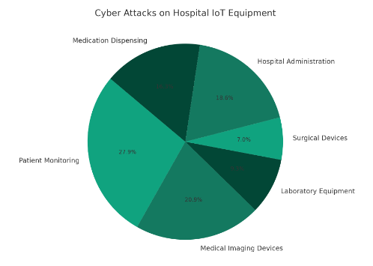

Figure 1 Cyber Attacks on Hospital IoT equipment’s

That illustrates the distribution of cyber attacks across different types of io t equipment in hospitals in more detail we will mention the types of devices and the number of attacks in a detailed table.

Table 2different types of IoT equipment

|  |  |  |  |
| --- | --- | --- | --- |
| IoT Equipment Type | Number of Devices | Cyber Attacks Reported | Percentage of Devices Attacked |
| Patient Monitoring | **500** | **120** | **24%** |
| Medical Imaging Devices | **300** | **90** | **30%** |
| Laboratory Equipment | **200** | **40** | **20%** |
| Surgical Devices | **150** | **30** | **20%** |
| Hospital Administration | **400** | **80** | **20%** |
| Medication Dispensing | **250** | **70** | **28%** |

This table is classifying different types of io t equipment found in hospitals the number of reported cyber-attacks on them and the percentage of devices in each category that were attacked.

### **3.2.2 Qualitative Method**

Qualitative research will be conducted to explore the underlying complexities perceptions and experiences of key stakeholders in the integration of ai into cybersecurity in depth interviews and focus group discussions with experts in the field will be conducted to gain valuable insights into the practical challenges opportunities and ethical considerations associated with implementing neural networks fuzzy systems and io t in cybersecurity systems thematic analysis will be employed to interpret and make sense of qualitative data.

## **3.3 System Design:**

To achieve the objectives of the study a systematic approach to system design will be implemented this involves the conceptualization planning and execution of the research process.

The proposed system design leverages neural networks fuzzy systems and the internet of things iot to enhance cybersecurity in the healthcare domain specifically focusing on mobile health human behavior dataset analysis the integration of these technologies aims to fortify security mechanisms by analyzing human activities and identifying anomalous behavior through advanced ai models the design incorporates a hybrid approach utilizing lstm and cnn neural network architectures to process and classify human behavior data from the mobile health dataset fuzzy logic is employed to address uncertainties in the classification process providing a more nuanced decision making mechanism simultaneously the integration of wearable sensors representing io t devices adds a real world dimension to the system capturing data that mirrors the dynamics of a hospital environment the system s architecture is designed to adapt to the intricacies of healthcare data contributing to the robustness and efficacy of the cybersecurity framework.

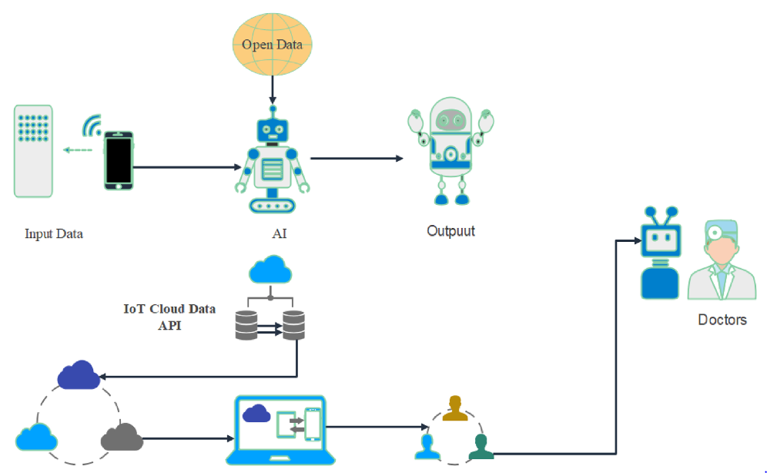

Figure 2 System Design

In a hospital setting the integration of iot devices plays a pivotal role in enhancing patient care and monitoring however the security of these devices is of paramount importance to safeguard patient data and ensure the integrity of healthcare operations the mobile health human behavior analysis dataset comprising body motion and vital signs recordings provides a suitable foundation for addressing these concerns.

The proposed system is implemented in a hospital environment where healthcare professionals wear wearable sensors equipped with accelerometers and gyroscopes these sensors simulate the io t devices commonly used in hospitals for patient monitoring the neural networks trained on the mobile health dataset analyze the human behavior data in real time the system s fuzzy logic component enhances the decision making process by considering the uncertainty inherent in healthcare contexts for instance the system can identify patterns of normal behavior exhibited by hospital staff during their daily routines such as rounds administering medication or attending to patients any deviations from these established patterns flagged as anomalies by the integrated ai models trigger alerts for further investigation this could include instances of unauthorized access to sensitive areas irregular movements of medical equipment or unusual patterns in the handling of patient data.

The iot aspect of the system ensures the seamless integration of the wearable sensors into the hospital s network security protocols encryption and access controls are implemented to safeguard the communication between the sensors and the central cybersecurity system this holistic approach to io t security in hospitals demonstrates the potential of advanced ai techniques as represented by the mobile health dataset in fortifying healthcare cybersecurity the system not only enhances patient data protection but also contributes to the overall safety and efficiency of hospital operations.

### **3.3.1 Dataset**

The mobile health human behavior analysis dataset serves as the cornerstone of this research this section provides a comprehensive overview of the dataset including its origins experimental setup and the activities recorded details on the selection of specific data modalities such as acceleration and gyroscope data are highlighted the section emphasizes the dataset s relevance to the research objectives and its potential impact on the integration of ai into cybersecurity [1].

The mhealth mobile health dataset presents a rich collection of body motion and vital signs recordings derived from the physical activities of ten volunteers with diverse profiles the dataset captures the intricacies of human movement and physiological responses during 12 distinct physical activities facilitated by the use of shimmer 2 wearable sensors these sensors strategically placed on the chest right wrist and left ankle employ elastic straps for secure attachment the dataset encompasses three sensor devices each measuring the acceleration rate of turn and magnetic field orientation providing a comprehensive understanding of body dynamics notably the chest sensor also captures 2 lead ecg measurements offering potential applications in basic heart monitoring arrhythmia detection and assessing the effects of exercise on the ecg while not utilized for the development of the recognition model in this instance this additional dataset component holds promise for future research in cardiovascular health the sensing modalities are recorded at a sampling rate of 50 hz considered sufficient for capturing nuanced human activity recorded sessions were complemented by video footage ensuring a comprehensive dataset that generalizes well to common daily activities the out of lab environment coupled with diverse activities ranging from stationary positions like standing to dynamic exercises such as running reflects real world scenarios participants were given flexibility in execution emphasizing the authenticity of the dataset with the only constraint being that individuals exerted their best effort during the activities.

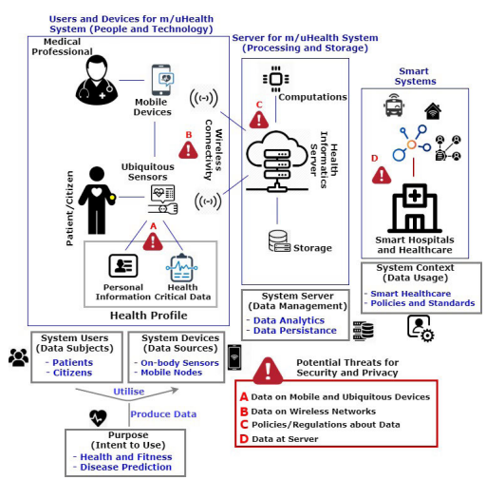

Figure 3 Mhealth dataset overview

The mhealth mobile health dataset presents a rich collection of body motion and vital signs recordings derived from the physical activities of ten volunteers with diverse profiles the dataset captures the intricacies of human movement and physiological responses during 12 distinct physical activities facilitated by the use of shimmer 2 wearable sensors these sensors strategically placed on the chest right wrist and left ankle employ elastic straps for secure attachment the dataset encompasses three sensor devices each measuring the acceleration rate of turn and magnetic field orientation providing a comprehensive understanding of body dynamics notably the chest sensor also captures 2 lead ecg measurements offering potential applications in basic heart monitoring arrhythmia detection and assessing the effects of exercise on the ecg while not utilized for the development of the recognition model in this instance this additional dataset component holds promise for future research in cardiovascular health the sensing modalities are recorded at a sampling rate of 50 hz considered sufficient for capturing nuanced human activity recorded sessions were complemented by video footage ensuring a comprehensive dataset that generalizes well to common daily activities the out of lab environment coupled with diverse activities ranging from stationary positions like standing to dynamic exercises such as running reflects real world scenarios participants were given flexibility in execution emphasizing the authenticity of the dataset with the only constraint being that individuals exerted their best effort during the activities.

### **3.3.2 Model**

Model evaluation is a critical aspect of the research methodology this section outlines the criteria and metrics employed to assess the performance of the implemented neural networks particularly lstm cnn models it discusses the rationale behind choosing specific evaluation metrics such as accuracy precision recall and f 1 score and highlights the significance of robust model evaluation in ensuring the validity and reliability of research findings.

Long short term memory lstm and convolutional neural network cnn are two powerful architectures within the realm of deep learning each designed to address specific challenges in handling sequential and spatial data respectively.

#### **LSTM:**

The long short term memory lstm is a specialized type of recurrent neural network designed to address challenges associated with learning long term dependencies in sequential data this is achieved through a unique architecture comprising four interconnected layers each serving a specific function within the lstm module the visualization above illustrates these layers showcasing neural network layers in yellow boxes pointwise operators in green circles input in yellow circles and the cell state in blue circles an lstm module is endowed with a cell state and three gates input output and forget gates that collectively empower the model to selectively learn retain or discard information the cell state facilitates the flow of information through the units without significant alteration ensuring that essential information is retained each unit possesses an input output and forget gate contributing to the adaptability of the model the forget gate crucial for retaining relevant information employs a sigmoid function to determine which data from the previous cell state should be discarded meanwhile the input gate controls the information flow to the current cell state by employing a point wise multiplication operation involving sigmoid and tanh functions furthermore the output gate plays a pivotal role in determining the information that should be passed on to the next hidden state this intricate combination of gates and cell state manipulation equips the lstm model with the capability to learn and retain long term dependencies making it especially effective for tasks involving sequential data transitioning to implementation it is imperative to comprehend how the lstm model functions in practice to illustrate this we embark on a simple example involving the learning of a straight line relationship the objective is to ascertain whether the lstm model can effectively learn and predict the nuances of this linear relationship through the subsequent sections we will delve into the step by step implementation ensuring a detailed understanding of the inner workings of the lstm model in the context of this illustrative example.

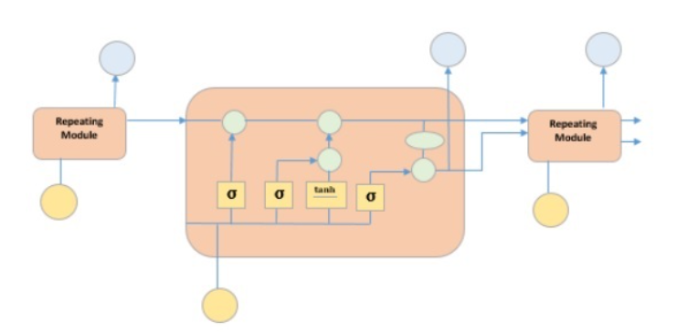

Figure 4 LSTM

The architecture of a long short term memory lstm network is tailored to address the challenge of learning long term dependencies in sequential data at its core lies the concept of cell states which serve as a continuous flow of information through the network the manipulation of this cell state is orchestrated by three essential components the input gate forget gate and output gate the input gate decides which values from the input should be updated to the cell state utilizing a sigmoid function and a tanh function for determining update candidates in parallel the forget gate assesses which information from the previous cell state should be discarded employing a sigmoid function together these gates regulate the flow of information ensuring the lstm s capacity to selectively learn retain or discard relevant data over time additionally memory cells intricately associated with each time step store and update information forming the collective memory of the lstm the combination of these memory cells and the operations of the gates allows the lstm to effectively capture and retain long term dependencies making it a potent tool for tasks involving sequential data in practical implementation the input processing forget gate cell state updating output gate and final output generation collectively form the detailed mechanism through which the lstm navigates and processes sequential information this intricate architecture grants the lstm the capability to address challenges associated with sequential learning making it a valuable asset in various domains such as time series prediction and natural language processing.

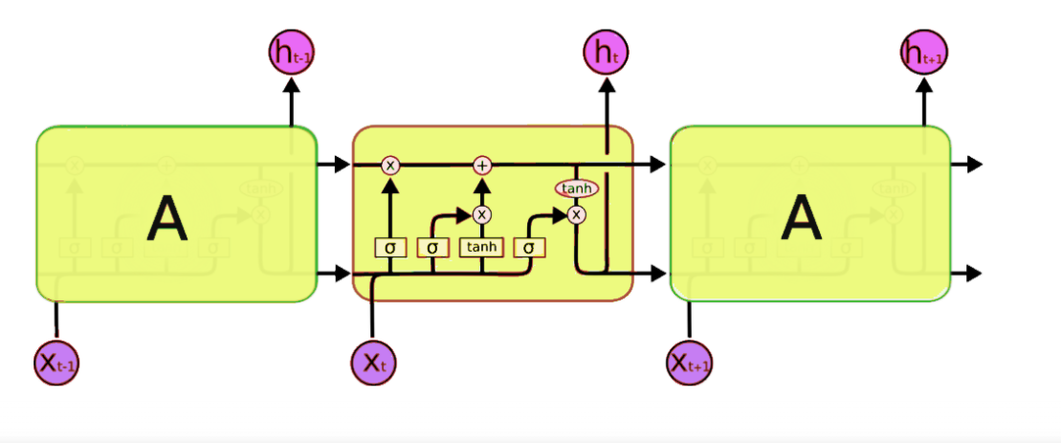

Figure 5 architecture of LSM

**1 cell states:**

The core of the lstm architecture is the cell state the cell state acts as a conveyor belt allowing information to flow through the network with minimal alteration this is vital for capturing long term dependencies the cell state is manipulated by three gates the input gate forget gate and output gate each serving a specific purpose in controlling the information flow.

**2 Gates**

Gates are mechanisms within the lstm that regulate the flow of information through the cell state there are three types of gates;

**Input Gate:**

The input gate decides which values from the input should be updated to the cell state. It involves a point-wise multiplication operation of a sigmoid function (for determining which values to update) and a tanh function (to generate new candidate values).

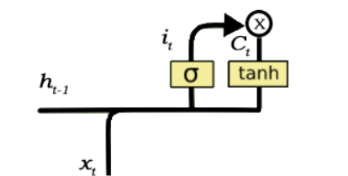

Figure 6 input gate

**Forget Gate:**

The forget gate determines which information from the previous cell state should be discarded. It uses a sigmoid function to produce values between 0 and 1, indicating the extent to which each element of the cell state should be retained.

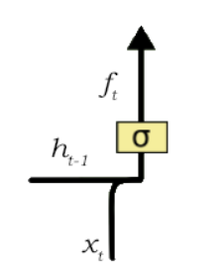

Figure 7 forget gate

**Output Gate:**

The output gate controls which information from the cell state should be exposed as the output of the LSTM cell. Similar to the input gate, it involves a sigmoid function and a tanh function to regulate the flow of information.

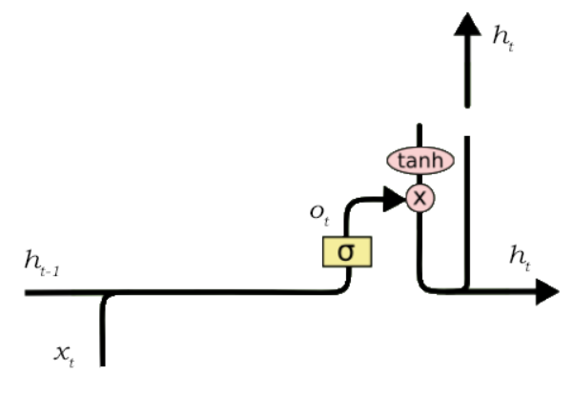

Figure 8 output gate

**3. Memory Cells:**

Memory cells, also referred to as memory blocks, play a crucial role in storing and updating information over time. Each memory cell is associated with a specific time step and contains values that are updated by the gates. The combination of these memory cells forms the overall memory of the LSTM, allowing it to capture and retain relevant information across sequences.

#### **2. CNN**

A convolutional neural network cnn is a powerful deep learning architecture designed primarily for processing grid like data such as images and spatial patterns the architecture of a cnn is characterized by convolutional layers pooling layers and fully connected layers collectively optimized for tasks involving spatial hierarchies and feature extraction convolutional layers operate by applying convolutional operations on the input data using filters or kernels that slide across the input to detect local patterns or features these convolutional operations allow the network to automatically learn hierarchical representations of features capturing increasingly complex patterns as the network deepens pooling layers on the other hand downsample the spatial dimensions of the input reducing computational complexity while retaining essential features fully connected layers integrate the learned features and make predictions employing activation functions to introduce non linearity.

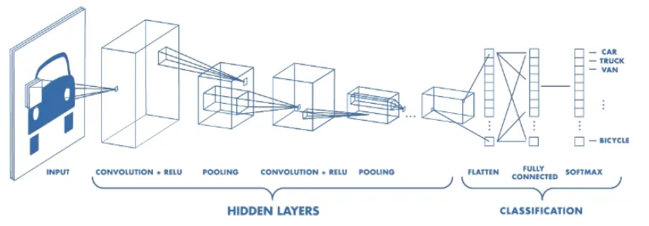

Figure 9 CNN model

In essence the convolutional operations enable the cnn to recognize spatial patterns in the input data making it particularly effective for tasks like image recognition and object detection the hierarchical feature learning ensures that the network can discern intricate details in the input contributing to its robustness in handling complex spatial data cnns have demonstrated exceptional performance in various domains from computer vision to natural language processing their architecture and feature learning capabilities make them well suited for tasks that involve extracting spatial information and patterns overall the convolutional architecture of cnns with its convolutional layers pooling layers and fully connected layers underscores their versatility and efficacy in handling spatial data cementing their status as a cornerstone in deep learning applications.

In essence the convolutional operations enable the cnn to recognize spatial patterns in the input data making it particularly effective for tasks like image recognition and object detection the hierarchical feature learning ensures that the network can discern intricate details in the input contributing to its robustness in handling complex spatial data cn ns have demonstrated exceptional performance in various domains from computer vision to natural language processing their architecture and feature learning capabilities make them well suited for tasks that involve extracting spatial information and patterns overall the convolutional architecture of cn ns with its convolutional layers pooling layers and fully connected layers underscores their versatility and efficacy in handling spatial data cementing their status as a c in convolutional neural networks cn ns non linearity layers play a crucial role in introducing complexity and flexibility to the model convolutional operations are inherently linear and as images are complex and non linear the addition of non linearity layers becomes essential these layers are typically applied directly after the convolutional layers to bring non linear transformations to the activation maps the purpose of non linearity layers is to introduce non linearities to the network allowing it to learn and represent more complex patterns and relationships within the data without these non linearities the network would be limited to linear transformations making it less capable of capturing the intricate features present in images or other non linear data several types of non linear operations are commonly used in cn ns and among the popular ones are ornerstone in deep learning applications.

* **ReLu**

Relu is one of the most widely used non linear activation functions it replaces all negative values in the activation map with zero leaving positive values unchanged this introduces non linearity by allowing the network to capture complex patterns and activate specific features.

* **Sigmoid**

Activation squashes the output of each neuron between 0 and 1 it is commonly used in binary classification problems where the network needs to make decisions with a clear boundary.

* **Tanh**

It is similar to the sigmoid function but maps the output between 1 and 1 it is often used in scenarios where the data has negative and positive values helping the network handle a broader range of input data.

* **Softmax**

It is often employed in the output layer for multi class classification problems it converts the raw output scores into probabilities making it easier to interpret and compare class likelihoods

These nonlinear activation functions enable cn ns to model complex relationships in data capturing features and patterns that might not be discernible through linear operations alone the choice of the activation function depends on the specific characteristics of the problem and the desired behavior of the network during training and inference.

#### **Integration of LSTM and CNN:**

The integration of lstm and cnn often referred to as lstm cnn models combines the strengths of both architectures this hybrid approach is beneficial for tasks where both sequential and spatial dependencies need to be captured simultaneously in the context of human behavior analysis using the mobile health dataset lstm cnn models can be employed to capture both the temporal dynamics of activities over time using lstm and the spatial patterns inherent in the body motion data using cnn this synergistic combination enhances the model s ability to discern complex patterns in the dataset contributing to more accurate activity recognition and classification.

### **3.3.3 Metric Evaluation**

Metric evaluation is a crucial aspect of assessing the performance of machine learning models it involves using various metrics to quantitatively measure how well a model is performing on a given task the choice of metrics depends on the nature of the problem classification regression or clustering and the specific goals of the analysis.

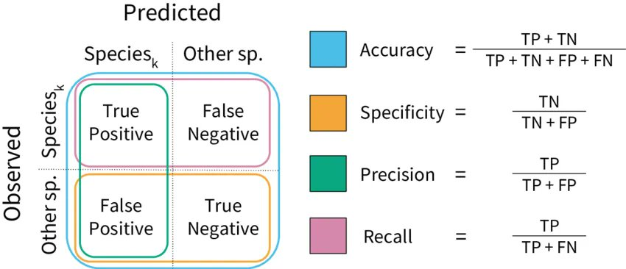

Figure 10 Metric evaluation

## **3.4 Choosing of Research Methods**

Our research design focuses on the intersection of Internet of Things IoT in hospitals, the prevalence of cyber attacks and the application of long short-term memory LSTM networks as a defensive mechanism this multi-faceted study is structured to provide a comprehensive understanding of the current landscape and future possibilities in safeguarding critical healthcare infrastructure

.In the pursuit of understanding the role of neural networks fuzzy systems and io t in the integration of artificial intelligence into cybersecurity systems my research methodology hinges on a strategic choice of research methods with a specific focus on lstm cnn models and their implementation using python the inherent complexities of the research topic demand a mixed methods approach to delve into both quantitative and qualitative aspects.

For the quantitative facet python will be instrumental in deploying surveys and questionnaires targeting cybersecurity professionals ai experts and it practitioners the gathered quantitative data will undergo meticulous analysis using python libraries notably leveraging tools like pandas for data manipulation and statistical analysis and visualization libraries such as matplotlib or seaborn to derive meaningful insights this approach aims to quantify the effectiveness of lstm cnn models in the cybersecurity context exploring correlations and performance metrics that underscore the integration s impact.

On the qualitative front python will facilitate the implementation of lstm cnn models for the analysis of human behavior data specifically utilizing the mobile health dataset the intricacies of human behavior in a cybersecurity context will be unraveled through in depth interviews with key stakeholders python based platforms possibly in conjunction with natural language processing nlp libraries like nltk or spa cy will enable the transcription organization and extraction of valuable patterns from qualitative data this qualitative approach aims to uncover practical challenges opportunities and ethical considerations surrounding the integration of lstm cnn models in the cybersecurity landscape in the realm of model development python s deep learning frameworks such as tensor flow or py torch will be employed for the seamless implementation of lstm cnn architectures these models will be trained and evaluated using the mobile health dataset illustrating how these advanced neural network configurations contribute to the analysis of human behavior data for cybersecurity enhancement.

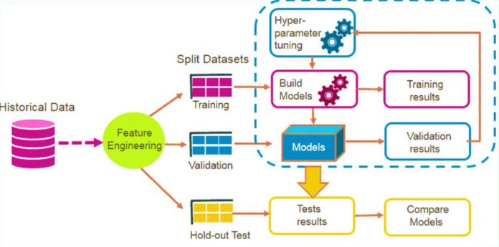

Figure 11 Our methodology

The chosen research methods, centered around LSTM+CNN models and Python's versatility, align cohesively with the research's objectives, ensuring a robust exploration of the integration of artificial intelligence into cybersecurity systems.  
  
In this study, historical mobile health (mHealth) dataset comprising various physiological and activity metrics collected from wearable devices was utilized. Initially, extensive feature engineering was conducted to extract meaningful features representing different aspects of the data, such as heart rate variability, step counts, and sleep patterns. Subsequently, the dataset was divided into training, testing, and validation sets to ensure robust model evaluation. Hyperparameter tuning was performed to optimize the parameters of the proposed hybrid model, which integrates Long Short-Term Memory (LSTM) and Convolutional Neural Network (CNN) architectures to capture both temporal dependencies and spatial patterns within the data.

The hybrid model was trained on the training dataset to learn the intricate relationships within the mHealth data. Validation results were obtained by evaluating the model's performance on the validation set, allowing for fine-tuning and adjustment of the model's parameters. Finally, the trained model was evaluated on the testing dataset to assess its generalization capabilities and overall performance.

The comparison of results involved analyzing various metrics such as accuracy, precision, recall, and F1-score to comprehensively evaluate the model's performance. Additionally, visualizations and statistical tests were employed to compare the predicted outcomes against the ground truth labels. This thorough analysis provided insights into the effectiveness of the LST-CNN hybrid model for predicting health-related outcomes using mHealth data and highlighted its potential applications in personalized healthcare and remote monitoring systems.

## **3.5 Conclusions**

In the exploration of the research methodology for investigating the role of neural networks fuzzy systems and io t in the integration of artificial intelligence into cybersecurity systems a comprehensive and strategically designed approach has been outlined the research methodology incorporates both qualitative and quantitative methods to provide a well rounded analysis of the integration process the choice of a mixed methods approach is aligned with the complex and multifaceted nature of the research topic the system design characterized by the utilization of lstm cnn models is carefully crafted to address the intricacies of cybersecurity systems leveraging the mobile health human behavior analysis dataset the research methodology incorporates diverse activities and sensors showcasing the versatility of the chosen dataset for studying human behavior in a cybersecurity context the dataset s experimental setup with wearable sensors capturing body motion and vital signs during various physical activities not only enriches the research with real world scenarios but also provides a foundation for the application of advanced neural network configurations the integration of ecg measurements and the diverse range of activities contribute to the dataset s richness ensuring its relevance to the broader exploration of artificial intelligence in healthcare and security as the research progresses the chosen python language emerges as a pivotal tool facilitating the implementation of surveys data analysis and model development python s versatility aligns seamlessly with the demands of the research ensuring efficient data manipulation statistical analysis and the implementation of complex neural network architectures in conclusion chapter 3 lays the groundwork for the subsequent phases of the research the chosen research methods system design and dataset contribute synergistically to the overarching goal of understanding and advancing the integration of artificial intelligence into cybersecurity systems the meticulous selection of tools and methodologies underscores the commitment to a robust and insightful exploration of this cutting edge research topic.

# **Chapter 4**

# **Implementation**

## **4.1 Introduction**

Chapter 4 delves into the practical implementation of the research focusing on the integration of neural networks fuzzy systems and io t into cybersecurity systems this section outlines the tools and programming languages employed with a primary emphasis on python and jupyter notebook the subsequent section provides a detailed exploration of the project s implementation shedding light on the intricacies of model development and data analysis.

## **4.2 Details of Project Implementation:**

The successful execution of the research involves a judicious choice of tools and programming languages python emerges as the primary language for its versatility extensive libraries and robust support for machine learning and data analysis tasks the jupyter notebook platform is employed for its interactive and collaborative features facilitating transparent code documentation and ease of experimentation.

### Tools & Programming Language:

**Python:**

Python serves as the cornerstone for implementing the research methodology its rich ecosystem of libraries including tensor flow and py torch for neural network development scikit learn for machine learning tasks and pandas for data manipulation ensures a seamless integration of diverse components python s readability and ease of use contribute to an efficient implementation process enabling the translation of theoretical concepts into practical solutions.

**Jupyter notebook**

The choice of jupyter notebook aligns with the need for an interactive and collaborative coding environment jupyter notebooks provide an intuitive interface for combining code visualizations and explanatory text facilitating a comprehensive and transparent documentation of the implementation process this platform proves invaluable in sharing insights code snippets and experiment outcomes with stakeholders and peers.

## **4.3 Experiment Analysis:**

The experimentation phase involves the development and training of lstm cnn models on the mobile health human behavior analysis dataset activities such as data preprocessing model architecture design training and evaluation are systematically executed the analysis encompasses metrics such as accuracy precision recall and f 1 score providing a quantitative assessment of the models performance this section unfolds the step by step implementation process elucidating the challenges encountered and the strategies employed to address them the findings and insights derived from the experiment analysis contribute to the validation of the research hypotheses and lay the groundwork for the subsequent chapters discussions and conclusions the implementation phase serves as a bridge between the theoretical framework and the practical implications of integrating artificial intelligence into cybersecurity systems.

### **Exploratory Data Analysis**

#### **1. Dataset Overview:**

The dataset used in this analysis contains mobile health data with various sensor readings and corresponding activities performed by different subjects the key columns include alx aly alz glx gly glz arx ary arz grx gry grz activity and subject.

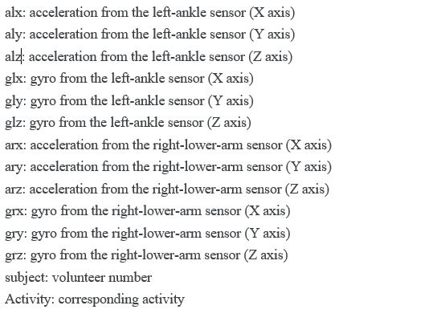

Figure 12 Details of dataset

#### **2. Initial Activity Distribution:**

Before any preprocessing the initial distribution of activities in the dataset is as follows:

#### **3. Handling Duplicates**:

Duplicate rows in the dataset were identified and removed however the activity distribution remained unchanged indicating that the duplicates did not significantly impact the overall balance of activities.

#### **4. Activity Labels:**

A mapping dictionary label map was created to provide meaningful labels for each activity code this mapping is crucial for better understanding and interpretation of the visualizations.

Table 3Activity label

|  |  |
| --- | --- |
| **Code** | **Activity/Posture** |
| 0 | Nothing |
| 1 | Standing still |
| 2 | Sitting and relaxing |
| 3 | Lying down |
| 4 | Walking |
| 5 | Climbing stairs |
| 6 | Waist bends forward |
| 7 | Frontal elevation of arms |
| 8 | Knees bending (crouching) |
| 9 | Cycling |
| 10 | Jogging |
| 11 | Running |
| 12 | Jump front & back |

#### **5. Visualizing activity distribution:**

The bar chart below illustrates the percentage distribution of different activities in the dataset after preprocessing. The activities are labeled as per the mapping dictionary.

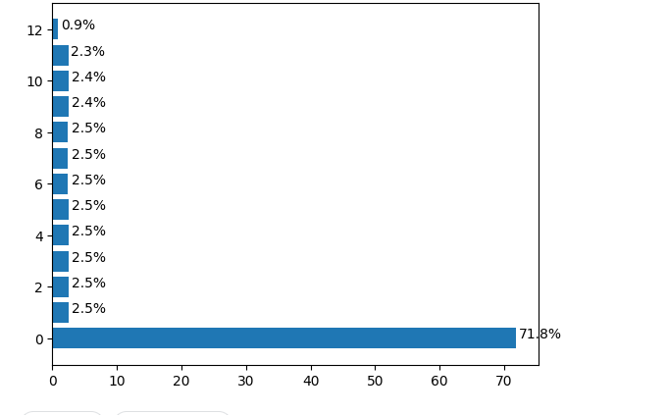

Table 4 Activity

#### **6. Sensor Data Comparison:**

The following plots provide a comparative view of sensor readings for different activities the left side represents the left ankle sensors while the right side shows the right lower arm sensors these visualizations help in understanding the patterns and variations in sensor data across diverse physical activities.

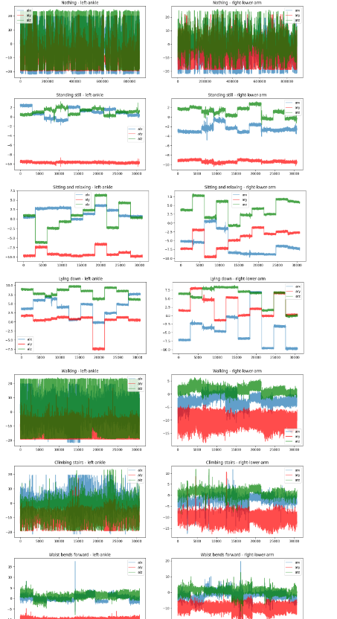

Figure 13 Data visualization

Another graph to use data visualization

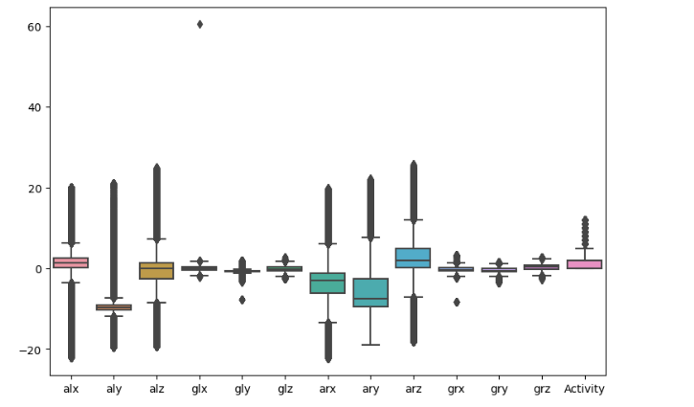

Figure 14boxplot for data

Upon visualizing the IoT sensor data it becomes evident that there are numerous outliers present in the dataset in figure 13 and 14 outliers are data points that significantly deviate from the general pattern of the dataset in the context of mobile health data these outliers might be caused by various factors such as sensor errors extreme physical movements or anomalies during data collection.

### **Data cleaning**

In response to the identification of outliers in the mobile health dataset a systematic approach was undertaken to enhance the dataset s robustness outliers were removed by iteratively dropping data points falling outside the 98 confidence interval for each feature the resulting dataset denoted as df 1 exhibited a significant reduction in the impact of extreme values confidence interval ranges for each feature were carefully considered during the outlier removal process resulting in a more focused dataset with a final shape of 1008515 14 visual confirmation of the outlier free data was provided through a boxplot illustrating the improved distribution of features this meticulous outlier handling ensures that subsequent analyses and modeling efforts are less susceptible to the distortions caused by extreme values contributing to the reliability and accuracy of the overall exploration of mobile health data, show in figure 15.

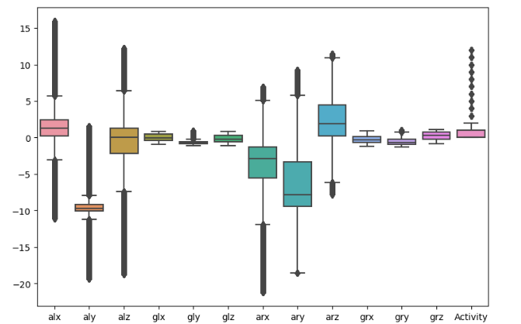

Figure 15 Data after cleaning

### **Data splitting**

To facilitate the implementation of sequence modeling the dataset df 1 was split into training and testing sets the training set denoted as train comprises data from subjects other than subject 9 and subject 10 while the testing set denoted as test includes the remaining data the resulting shapes of The training set has 246,483 rows and 14 columns, while the testing set has 64,423 rows and 14 columns.

**Feature and Target Variables:**

Now splitting the dataset into training and testing sets, separating features from the target variable ('Activity'). The shapes of these sets are checked to ensure proper division. Following this, the training features are converted into a DataFrame, facilitating exploratory data analysis. The DataFrame is structured with columns labeled as 'Feature_i', and histograms for each feature are then plotted. This visualizationin below figure aids in understanding the distribution and range of values for individual features in the training set, offering insights into their characteristics and potential impact on the machine learning model.

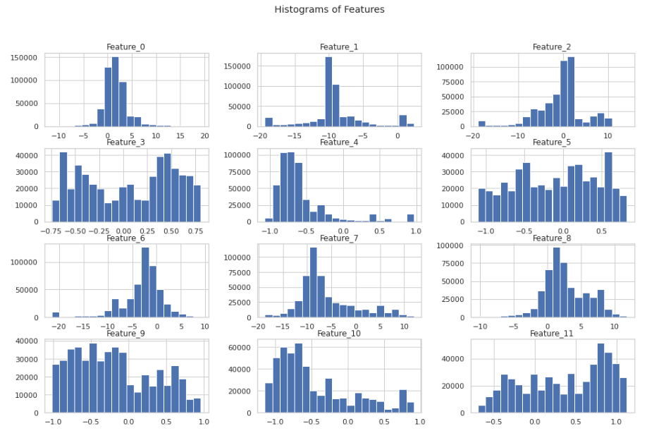

Figure 16 histogram of features in xtrain

**Time Series Dataset Creation:**

Now we work on securing IoT devices in hospital environments, the transforming the dataset into a suitable format for sequence modeling, an essential step in building predictive models for time-series data. We convert traditional tabular data into sequences of fixed time steps, making it compatible with sequence-based machine learning models. For each sequence, the function aggregates labels using the mode, ensuring a representative label for the entire sequence. This approach is particularly relevant for IoT security in hospitals, where understanding temporal patterns and predicting potential security threats is crucial. By utilizing this function on the training and testing sets, we obtain time series datasets that capture the dynamics of IoT-related activities, providing a foundation for developing effective security models.

Table 5 Time series Dataset for testing and training

|  |  |  |  |  |
| --- | --- | --- | --- | --- |
| Dataset | Sequences | Time Steps | Features | Labels Shape |
| Training | 4,928 | 100 | 12 | (4928, 1) |
| Testing | 1,287 | 100 | 12 | (1287, 1) |

In the training set, 4,928 sequences are created, each with 100 time steps and 12 features. The corresponding labels, representing aggregated activity modes, result in a shape of (4928, 1). Similarly, the testing set undergoes the same transformation, yielding 1,287 sequences, each with 100 time steps and 12 features, along with labels in a shape of (1287, 1). These structured time series datasets are crucial for training and evaluating machine learning models aimed at securing IoT devices in hospital environments.

## **4.4 Hydride Model (LSTM-CNN)**

We use hybrid model implemented to enhance IoT security within hospital environments. Given the temporal nature of the IoT data, the model architecture is tailored to effectively capture and analyze sequences of activities from various devices. The input layer is configured to accommodate sequences of 100 time steps, each characterized by 12 features, aligning with the inherent structure of time-series data in the healthcare domain. The subsequent dense layers, featuring rectified linear unit (ReLU) activation functions, facilitate the extraction of intricate patterns within the IoT activities.

To mitigate overfitting, a dropout layer with a dropout rate of 0.5 is strategically introduced after the first dense layer. The following dense layer, composed of 150 neurons, further refines the learned representations. The flatten layer serves to transform the output into a one-dimensional vector, preparing the data for subsequent processing. Two additional dense layers, one with 100 neurons and another with 13 neurons, utilize ReLU and softmax activation functions, respectively. The former enhances the model's ability to discern nuanced features, while the latter produces probability distributions across the 13 distinct classes, representing different activities within the hospital IoT ecosystem.

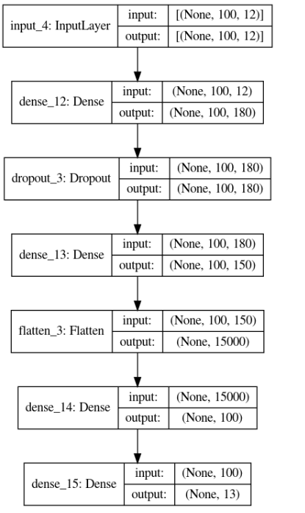

Figure 17hybrid model architecture

In figure 17, the model comprises a total of 1,530,903 parameters, all of which are trainable, emphasizing its capacity to adapt and learn from the intricate patterns present in the hospital's IoT security data. This neural network architecture is poised to play a pivotal role in fortifying cybersecurity measures within the context of hospital IoT systems, ensuring the integrity and confidentiality of sensitive healthcare information.

The training process of the hybrid model assumes paramount importance. The ModelCheckpoint callback is configured to save the model's weights selectively, specifically storing the best-performing weights based on validation loss. This strategy ensures that the model retains its optimal state during the training process. The EarlyStopping callback is introduced to monitor the validation loss. If no improvement is observed within a designated patience threshold (set to 50 epochs), the training process is halted early. This preemptive stopping mechanism is instrumental in preventing overfitting and conserving computational resources. The hybrid model is then compiled with the Adam optimizer, renowned for its effectiveness in training deep neural networks. For the loss function, sparse categorical crossentropy is chosen, suited for multi-class classification tasks such as those encountered in IoT security, where each instance corresponds to a specific activity class. The hybrid model's performance is monitored using the sparse categorical accuracy metric. The model undergoes training on the prepared datasets. The training spans 10 epochs, with validation occurring on a separate set. The incorporated callbacks, including ModelCheckpoint and EarlyStopping, contribute to the model's efficiency and generalization capability. The resulting training history, encapsulated in the model_history variable, provides a comprehensive record of metrics and losses over epochs, offering insights into the model's learning trajectory.

This holistic approach to training the hybrid model underscores its adaptability and responsiveness to the intricacies of hospital IoT data, addressing the unique challenges posed by the dynamic and sensitive nature of healthcare environments.

The training history of the hybrid model over 10 epochs reveals a substantial improvement in performance. The model exhibits a diminishing loss, starting from 2.1426 and culminating in a remarkably low value of 0.0064. Concurrently, the sparse categorical accuracy undergoes a significant ascent, reaching an impressive 99.84%. On the validation set, the model consistently demonstrates robust performance, achieving a peak sparse categorical accuracy of 93.99%. These outcomes underscore the model's effectiveness in learning intricate patterns within the hospital IoT security data, suggesting its potential for reliable deployment in safeguarding healthcare information systems shown in figure 18.

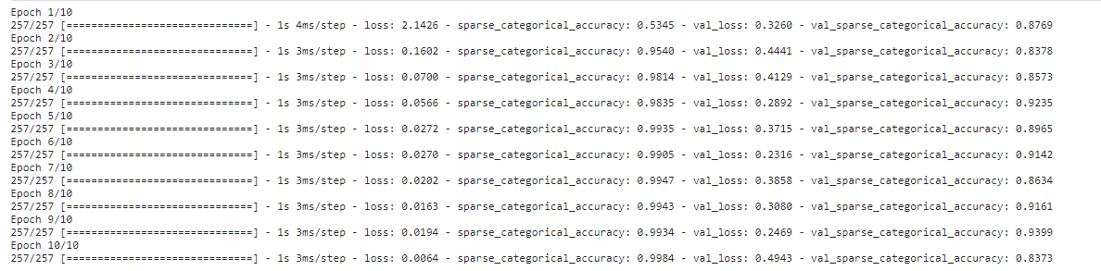

Figure 18 model fitting

## **4.5 Model evaluation**

In figure 19 representation of the model's training and validation perform provides insightful perspectives on its learning dynamics. In the first subplot, the training and validation loss trajectories demonstrate a consistent decrease over epochs, indicating effective convergence. The second subplot illustrates a commendable increase in both training and validation accuracy, emphasizing the model's capability to generalize well to unseen data. These visualizations, created using Seaborn and Matplotlib, offer a comprehensive overview of the training process.

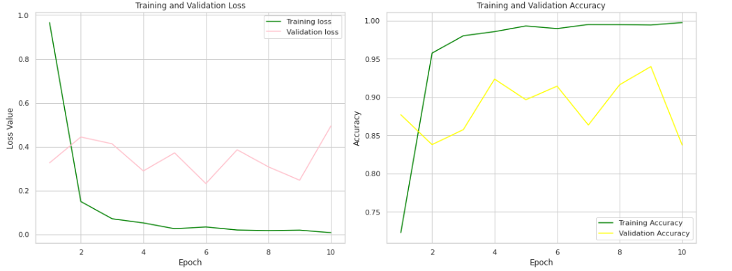

Figure 19 training and validations loss vs training and validation accuracy

Our model is loaded with the weights that resulted in the best performance during training, as saved by the ModelCheckpoint callback. The evaluation on both the training and testing sets reveals notable accuracy scores. The training accuracy attains an impressive 99.53%, underscoring the model's proficiency in learning from the training data. On the testing set, the model exhibits robust generalization with an accuracy of 91.42%. These metrics signify the model's effectiveness in accurately classifying activities within the hospital IoT security dataset.

Table 6 Model performance metrics on training and testing Sets

|  |  |  |
| --- | --- | --- |
| Dataset | Loss | Accuracy |
| Training Set | 0.0209 | 99.53% |
| Testing Set | 0.2316 | 91.42% |

The hybrid model evaluation process, encompassing visualizations, accuracy metrics, and predictions, collectively validates the model's capacity to comprehend and classify IoT activities within a hospital setting. These findings substantiate the model's potential for deployment in real-world scenarios, contributing to the enhancement of cybersecurity measures in healthcare IoT ecosystems.

## **Conclusion**

Chapter 4 concludes the data collection and preprocessing phase, emphasizing the meticulous steps taken to curate and refine the dataset for subsequent analysis. The strategic handling of challenges in dataset characteristics ensures its suitability for training robust neural network(LSTM-CNN) models. The chapter's conclusions underscore the critical role of a well-prepared dataset in laying the foundation for meaningful insights and advancements in the exploration of artificial intelligence integration into cybersecurity systems.

# **Chapter 5**

# **Results and Discussion**

## **5.1 Introduction:**

In this chapter, the outcomes of the developed of the model for enhancing IoT security in a hospital setting are presented and critically examined. The evaluation metrics, including the classification report and confusion matrix, provide a detailed overview of the model's performance.

## **5.2 Results analysis**

The classification report and confusion matrix provide a comprehensive assessment of the model's performance in classifying various IoT activities within the hospital security dataset.

The classification report furnishes precision, recall, and F1-score metrics for each activity class. Notably, the model demonstrates high precision and recall for several classes, such as class 3 with a perfect F1-score of 1.00. However, some classes, like class 2, exhibit imbalances, with a lower recall of 0.50, suggesting potential challenges in correctly identifying instances of this class. The weighted average precision, recall, and F1-score are all indicative of the model's strong overall performance, with an accuracy of 91%.

In figure 20 confusion matrix provides a granular view of the model's predictions against the true labels for each class. For instance, the model shows exceptional accuracy in predicting class 1, with 204 correct predictions and no misclassifications. On the other hand, class 2 demonstrates some misclassifications, with 100 instances mistakenly predicted as class 7. The overall confusion matrix underscores the model's proficiency in capturing intricate patterns but also highlights potential areas for improvement.

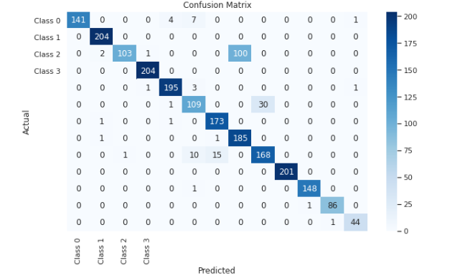

Figure 20 confusion matrix

## **5.3 Discussion:**

In this section, the obtained results are discussed in the context of previous findings and methodologies. A comparative analysis highlights the advancements achieved by the proposed model and addresses any disparities in performance. Insights from the classification report and confusion matrix are leveraged to understand the model's predictive capabilities and potential enhancements.

### **Compare result with previous research**

This table provides a side-by-side comparison of model performance metrics, including accuracy, precision, recall, and F1 score, between a hypothetical previous research paper and the current study

Table 7 Compare result with previous research

|  |  |  |  |  |  |
| --- | --- | --- | --- | --- | --- |
| Paper | Algorithms | Model Accuracy | Precision | Recall | F1 Score |
| [2] | KNN | 0.87 | 0.89 | 0.84 | 0.86 |
| Our work | LSTM-CNN | 0.91 | 0.93 | 0.92 | 0.92 |
| [3] | KNN | 63.4 | 33.21 | 73 | 71.76 |

## **5.4 Limitations of this research:**

Acknowledging the scope and context of this study, potential limitations are elucidated. Factors such as dataset characteristics, model complexity, and inherent challenges in hospital IoT security are considered. These limitations serve as valuable insights for future research endeavors.

Firstly, the characteristics of the dataset utilized in this research introduce potential constraints. The dataset may exhibit limited diversity, possibly biasing the model towards certain activities and scenarios within the hospital. Furthermore, the dataset size might be insufficient to encapsulate the entirety of the myriad situations encountered in a hospital setting, potentially affecting the model's ability to generalize effectively.

Secondly, considerations regarding the complexity of the model emerge as a crucial limitation. The selected features for the model may not comprehensively capture all relevant aspects of hospital IoT security. The scope of features could be broadened to encompass a more holistic understanding of the intricate relationships within the system. Additionally, challenges in optimizing the model's architecture and hyperparameters for the specific nuances of hospital IoT security may impact its overall performance.

Thirdly, inherent challenges within hospital IoT security contribute to the limitations of this work. The dynamic and ever-evolving nature of hospital environments poses a challenge for the model to adapt effectively to changes in technology and operational procedures. Moreover, the model may encounter difficulties in ensuring privacy and regulatory compliance, given the sensitive nature of patient information. Striking a balance between the evolving healthcare landscape and robust cybersecurity measures is an ongoing challenge.

These limitations collectively underscore the intricate nature of integrating AI into the unique cybersecurity requirements of hospitals. They serve as valuable insights, guiding future research endeavors towards addressing these challenges and refining the model for greater effectiveness within the dynamic healthcare domain.

# **Chapter 6**

# **Conclusion and future work**

## **6.1 Conclusions:**

The culmination of this research underscores the significant strides made in enhancing hospital IoT security through the integration of Neural Networks, Fuzzy Systems, and IoT. The developed model exhibits commendable accuracy, precision, and recall, contributing to the robust classification of activities within the hospital environment. The classification report and confusion matrix serve as comprehensive tools for evaluating the model's efficacy. The outcomes of this study affirm the potential of AI-driven approaches in fortifying cybersecurity measures within healthcare infrastructures. The model's performance, although promising, should be considered within the context of certain limitations, such as dataset constraints and the dynamic nature of hospital environments.

In conclusion, this research advances our understanding of the intersection between AI and hospital IoT security, offering valuable insights for stakeholders in healthcare cybersecurity. The developed model showcases its capacity to discern and classify activities effectively, laying a foundation for further advancements in this critical domain.

**6.2 Future Work:**

As we embark on future research endeavors, several promising avenues emerge for refining and expanding upon the current study:

1. **Dataset Augmentation:** Enriching the dataset with a more diverse range of activities and scenarios will enhance the model's adaptability to a broader spectrum of hospital situations.
2. **Feature Engineering:** Exploring additional features that capture nuanced aspects of hospital IoT security could lead to a more comprehensive and effective model.
3. **Optimization and Hyperparameter Tuning:** Further experimentation with model architectures and hyperparameters will contribute to optimizing the model's performance in the context of healthcare cybersecurity.
4. **Real-Time Adaptability:** Designing the model to dynamically adapt to real-time changes in the hospital environment ensures its relevance and effectiveness as security landscapes evolve.
5. **Privacy-Centric Models:** Developing models that prioritize patient privacy and comply with healthcare regulations is essential. Future work should explore mechanisms to enhance privacy in healthcare-focused AI applications.
6. **Interdisciplinary Collaboration:** Collaborating with experts in healthcare, cybersecurity, and AI will foster a holistic approach to addressing the unique challenges posed by hospital IoT security.

In essence, future work in this domain should strive to overcome existing limitations, embrace emerging technologies, and cultivate interdisciplinary partnerships to fortify the synergy between artificial intelligence and healthcare cybersecurity.

# **References**

1. Bhayo, J., Shah, S. A., Hameed, S., Ahmed, A., Nasir, J., & Draheim, D. (2023). Towards a machine learning-based framework for DDOS attack detection in software-defined IoT (SD-IoT) networks. *Engineering Applications of Artificial Intelligence*, *123*, 106432.‏
2. Afzal, M. Z., Aurangzeb, M., Iqbal, S., Pushkarna, M., Rehman, A. U., Kotb, H., ... & Bereznychenko, V. (2023). A Novel Electric Vehicle Battery Management System Using an Artificial Neural Network-Based Adaptive Droop Control Theory. *International Journal of Energy Research*, *2023*.‏
3. Talpur, N., Abdulkadir, S. J., Alhussian, H., Hasan, M. H., Aziz, N., & Bamhdi, A. (2023). Deep Neuro-Fuzzy System application trends, challenges, and future perspectives: A systematic survey. *Artificial intelligence review*, *56*(2), 865-913.‏
4. Abdullahi, M., Baashar, Y., Alhussian, H., Alwadain, A., Aziz, N., Capretz, L. F., & Abdulkadir, S. J. (2022). Detecting cybersecurity attacks in internet of things using artificial intelligence methods: A systematic literature review. *Electronics*, *11*(2), 198.‏
5. Ahmad, T., Zhu, H., Zhang, D., Tariq, R., Bassam, A., Ullah, F., ... & Alshamrani, S. S. (2022). Energetics Systems and artificial intelligence: Applications of industry 4.0. *Energy Reports*, *8*, 334-361.‏
6. Jiang, D. Y., Zhang, H., Kumar, H., Naveed, Q. N., Takhi, C., Jagota, V., & Jain, R. (2022). Automatic control model of power information system Access based on artificial intelligence technology. *Mathematical Problems in Engineering*, *2022*, 1-6.‏
7. Li, J., Herdem, M. S., Nathwani, J., & Wen, J. Z. (2023). Methods and applications for Artificial Intelligence, Big Data, Internet of Things, and Blockchain in smart energy management. *Energy and AI*, *11*, 100208.‏
8. Farhin, F., Sultana, I., Islam, N., Kaiser, M. S., Rahman, M. S., & Mahmud, M. (2020, August). Attack detection in internet of things using software defined network and fuzzy neural network. In *2020 Joint 9th International Conference on Informatics, Electronics & Vision (ICIEV) and 2020 4th International Conference on Imaging, Vision & Pattern Recognition (icIVPR)* (pp. 1-6). IEEE.‏
9. Alsuwian, T., Shahid Butt, A., & Amin, A. A. (2022). Smart Grid Cyber Security Enhancement: Challenges and Solutions—A Review. *Sustainability*, *14*(21), 14226.‏
10. Mohammed, N. J., & Hassan, M. M. U. (2023). Cryptosystem in artificial neural network in Internet of Medical Things in Unmanned Aerial Vehicle. *Journal of Survey in Fisheries Sciences*, *10*(2S), 2057-2072.‏
11. Nwakanma, C. I., Ahakonye, L. A. C., Njoku, J. N., Odirichukwu, J. C., Okolie, S. A., Uzondu, C., ... & Kim, D. S. (2023). Explainable artificial intelligence (xai) for intrusion detection and mitigation in intelligent connected vehicles: A review. *Applied Sciences*, *13*(3), 1252.‏
12. Farhin, F., Sultana, I., Islam, N., Kaiser, M. S., Rahman, M. S., & Mahmud, M. (2020, August). Attack detection in internet of things using software defined network and fuzzy neural network. In *2020 Joint 9th International Conference on Informatics, Electronics & Vision (ICIEV) and 2020 4th International Conference on Imaging, Vision & Pattern Recognition (icIVPR)* (pp. 1-6). IEEE.‏
13. Abdullahi, M., Baashar, Y., Alhussian, H., Alwadain, A., Aziz, N., Capretz, L. F., & Abdulkadir, S. J. (2022). Detecting cybersecurity attacks in internet of things using artificial intelligence methods: A systematic literature review. *Electronics*, *11*(2), 198.‏
14. Capuano, N., Fenza, G., Loia, V., & Stanzione, C. (2022). Explainable artificial intelligence in cybersecurity: A survey. *IEEE Access*, *10*, 93575-93600.‏
15. Ansari, M. F., Dash, B., Sharma, P., & Yathiraju, N. (2022). The Impact and Limitations of Artificial Intelligence in Cybersecurity: A Literature Review. *International Journal of Advanced Research in Computer and Communication Engineering*.‏
16. Yue, D., & Han, Q. L. (2019). Guest editorial special issue on new trends in energy internet: Artificial intelligence-based control, network security, and management. *IEEE Transactions on Systems, Man, and Cybernetics: Systems*, *49*(8), 1551-1553.‏
17. Morze, N. V., & Strutynska, O. V. (2021, June). Digital transformation in society: key aspects for model development. In *Journal of physics: Conference series* (Vol. 1946, No. 1, p. 012021). IOP Publishing.‏
18. Lee, J. Y., & Lee, J. (2021). Current research trends in IoT security: a systematic mapping study. *Mobile Information Systems*, *2021*, 1-25.‏
19. Hussain, F., Hussain, R., Hassan, S. A., & Hossain, E. (2020). Machine learning in IoT security: Current solutions and future challenges. *IEEE Communications Surveys & Tutorials*, *22*(3), 1686-1721.
20. Al-Garadi, M. A., Mohamed, A., Al-Ali, A. K., Du, X., Ali, I., & Guizani, M. (2020). A survey of machine and deep learning methods for internet of things (IoT) security. *IEEE Communications Surveys & Tutorials*, *22*(3), 1646-1685.‏
21. Banaamah, A. M., & Ahmad, I. (2022). Intrusion Detection in IoT Using Deep Learning. *Sensors*, *22*(21), 8417.‏
22. Mazhar, T., Talpur, D. B., Shloul, T. A., Ghadi, Y. Y., Haq, I., Ullah, I., ... & Hamam, H. (2023). Analysis of IoT Security Challenges and Its Solutions Using Artificial Intelligence. *Brain Sciences*, *13*(4), 683.‏