SafeLocker(Smart locker for file protection)


BS-Information Technology
Session: 2023-2026

Final Year Project Report
Submitted By:
Amal kaleem 085339
Maryam fatima 085315

Project Advisor: Ms. Umaira Nazar Hussain
__________________________________________ Department of Information Technology
Govt.Graduate College for Women,
Wahdat Colony, Lahore.

Safelocker(A smart digital locker for secure file protection)

A project presented to
University of Punjab, Lahore.

In partial fulfillment
Of the requirement for the degree of

Bachelor of Science in Information Technology Session (2023-2026).
By
Amal Kaleem 085339

Maryam Fatima 085315

Department of Information Technology
Govt.Graduate College for Women,
Wahdat Colony, Lahore

DECLARATION
We honestly declare that this software project has not been copied from anywhere. We have made this project and written this report completely by ourselves, using my own effort. If any part of this project is found to be copied in the future, we will take full responsibility and accept any punishment. Also, we confirm that we have never submitted this work before for any other degree or course at this university or any other institute.
Signature: --------------------------- Signature: ---------------------------

Amal Kaleem [085339] Maryam Fatima [085315]

CERTIFICATE OF APPROVAL
This is to certify that the Final Year Project titled Safelocker(A smart digital locker for secure file protection) has been successfully completed by Amal kaleem and Maryam Fatima, students of BS Information Technology, Session 2023 to 2026 under the supervision of Ma'am Umaira Nazar Hussain. In my opinion, this project meets all the required standards in both quality and scope. It is suitable for the award of the degree of Bachelor of Science in Information Technology.

Signature: ---------------------------------------
FYDP Supervisor: Ms. Umaira Nazar Hussain
Signatures (Faculty Advisory Committee FAC)
Signatures
Name
 | FAC1 | FAC2

Signature: ---------------------------------------

Head of FYDP Coordination Office: Ms Rabia Khalil

Signature: --------------------------------------- Dated: __________
Head of Department, Information Technology: Ms Rabia Khalil

Executive Summary
SafeLocker is a secure mobile application designed to protect a user’s personal files such as photos, videos, documents, and audio using AES encryption. In today’s world, data privacy has become extremely important, and SafeLocker aims to ensure that sensitive files always remain safe, private, and protected from unauthorized access.
The app is easy to use. After installing the app, a user creates an account and selects the files they want to secure. SafeLocker encrypts each file using a unique random AES key, which means every file has its own separate protection. Even if one key is ever compromised, the rest of the files remain completely secure.
SafeLocker also provides a secure file-sharing feature. When a user shares an encrypted file, it is never sent in plain form. Instead, the receiver gets the encrypted file along with a time-limited OTP/password that is required to decrypt it. This OTP expires after a short period, ensuring that only the intended person can access the file within the valid time window.
For cloud backup, SafeLocker uses Supabase Storage. This allows users to store their encrypted files online so they can recover their data if their phone is lost, damaged, or reset. The app also includes a Data Wipe technique, giving users full control to permanently delete their encrypted data from both the device and the cloud whenever they want.
Overall, SafeLocker provides a simple, fast, and highly secure solution for anyone who wants to protect, store, and securely share their personal files. With a user-friendly interface and strong security measures, the app is well-suited for real-world privacy and data-protection needs.

Acknowledgment
We would like to thank Allah Almighty for giving us the strength and ability to complete our
Final Year Project successfully. We are very thankful to our respected supervisor, Ma’am Umaira Nazar Hussain, for her kind guidance, support, and helpful suggestions throughout this project. Her encouragement and feedback helped us improve our work. We are also grateful to our teachers and university, who gave us the knowledge and skills needed for this project. Lastly, we want to thank our families and friends for always supporting and motivating us during this journey.

Signature: --------------------------- Signature: ---------------------------

Amal kaleem [085339] Maryam Fatima [085315]




Table of Contents

Chapter 1 ................................................................................................................................. 12
Introduction ............................................................................................................................. 12
1.1. Introduction .................................................................................................................................. 13
1.2. Background: ................................................................................................................................. 13
1.3. Problem Statement: .................................................................................................................. 13
1.4. Stakeholders & Interest: ......................................................................................................... 13
1.5. Objectives: .................................................................................................................................... 14
1.6. Scope .............................................................................................................................................. 14
1.7. Assumptions ................................................................................................................................ 14
1.8. Risks ................................................................................................................................................ 15
1.9. Success Criteria ......................................................................................................................... 16
1.10. Tools, Libraries & Technologies ...................................................................................... 17
1.11. Related System Analysis / Related Work .................................................................... 18
1.12. How MetalX Provides a Better Solution ....................................................................... 19
1.13. Project Planning ..................................................................................................................... 19 1.14. Conclusion: .............................................................................................................................. 19
Chapter 02 ............................................................................................................................... 20
Requirement Analysis ............................................................................................................. 20
2.1. Analysis.......................................................................................................................................... 21
2.2. User classes and characteristics ........................................................................................ 21 2.3. Requirement Identifying Technique ................................................................................... 21 Use Case Analysis ........................................................................................................... 21
2.4. Functional Requirements ....................................................................................................... 22
2.5. Non-Functional Requirements ............................................................................................. 25
- Reliability ............................................................................................................. 25
- Usability ................................................................................................................ 25










- Performance ......................................................................................................... 25 4. Security ................................................................................................................. 25 2.6. External Interface Requirements......................................................................................... 25
- User Interface Requirements .............................................................................. 26
- Software Interface Requirements ...................................................................... 27
- Hardware Requirements for MetalX ................................................................. 28
- Communication Interfaces for MetalX .............................................................. 29
2.7. Use case Analysis...................................................................................................................... 30
- Use Case: Player Shoots Enemy ......................................................................... 30
- Use Case: Player Reloads Weapon ..................................................................... 31







- Use Case: Enemy Attacks Player ....................................................................... 32 5. Use Case: Main Menu Navigation ...................................................................... 34
2.8. UseCaseDiagram ........................................................................................................................ 35 2.9. Summary ........................................................................................................................................ 38
Chapter 3 ................................................................................................................................. 39
Design and Architecture ......................................................................................................... 39
System Design ..................................................................................................................... 40
  - Design considerations ............................................................................................................. 40

  - Design Models ............................................................................................................................. 41 1. Design Class Diagram (DCD) ............................................................................. 41
2. Interaction Diagram ....................................................................................................................... 43
3.3. Data Design .................................................................................................................................. 47
3.4. User Interface Design ............................................................................................................... 48
3.5. Design decision .......................................................................................................................... 53 3.6. Summary ........................................................................................................................................ 54
Chapter 4 ................................................................................................................................. 55
Implementation ....................................................................................................................... 55
4.1. Implementation: .......................................................................................................................... 56
4.2. Algorithm ....................................................................................................................................... 56
4.3. External APIs/SDKs ................................................................................................................... 58
4.4. Code Repository ......................................................................................................................... 58 4.5. Summary ........................................................................................................................................ 58
Chapter 5 ................................................................................................................................. 59
Testing and Evaluation ........................................................................................................... 59
5.1. Introduction .................................................................................................................................. 60
5.2. Unit Testing (UT) ......................................................................................................................... 60
5.3. Functional Testing (FT)............................................................................................................ 64
5.4. Integration Testing (IT)............................................................................................................. 65
5.5. Performance Testing (PT) ....................................................................................................... 66 5.6. Conclusion .................................................................................................................................... 67
Chapter 06 ............................................................................................................................... 68
System Conversion .................................................................................................................. 68
6.1. Conversion Method ................................................................................................................... 69
6.3. Training .......................................................................................................................................... 70
6.4. Post Deployment Testing ....................................................................................................... 70
6.5. Challenges .................................................................................................................................... 71 6.6. Summary ........................................................................................................................................ 71
Chapter7 .................................................................................................................................. 72
Conclusion ............................................................................................................................... 72
7.1. Introduction .................................................................................................................................. 73
7.2. Evaluation ..................................................................................................................................... 73
7.3. Traceability Matrix ..................................................................................................................... 74
7.4. Conclusion .................................................................................................................................... 75 7.5. Future Work .................................................................................................................................. 75 References ............................................................................................................................... 76
- Books ......................................................................................................................................................... 77
- Articles in a Journal .............................................................................................................................. 77
- World Wide Web .................................................................................................................................... 77
- Conference Paper ................................................................................................................................... 77
- ChatGPT .................................................................................................................................................. 77

List of Tables TABLE 1(STAKEHOLDER INTEREST) 13
TABLE 2(SUCCESS CRITERIA) 16
TABLE 3(TOOLS, LIBRARIES & TECHNOLOGIES) 17
TABLE 4(RELATED SYSTEM ANALYSIS) 18
TABLE 5(FR-1) 22
TABLE 6(FR-2) 23
TABLE 7(FR-3) 24
TABLE 8(EXTERNAL INTERFACE REQUIREMENTS)) 25
TABLE 9(USER INTERFACE REQUIREMENTS) 26
TABLE 10(SOFTWARE INTERFACE REQUIREMENTS) 28
TABLE 11(HARDWARE REQUIRMENTS) 29
TABLE 12(COMMUNICATION REQUIREMENTS) 29
TABLE 13(UC-1) 30
TABLE 14(UC-2) 31
TABLE 15(UC-3) 32
TABLE 16 (UC-4) 33
TABLE 17(UC-5) 34
TABLE 18(RISK AND MITIGATIONS) 40
TABLE 19(DATA DICTIONARY) 48
TABLE 20(DESIGN DECISION) 53
TABLE 21 (ALGORITHM 1) 56
TABLE 22 (ALGRITHM 2) 56
TABLE 23 (ALGRITHM 3) 57
TABLE 24 (ALGRITHM 4) 57
TABLE 25 (EXTERNAL APIS AND SDK) 58
TABLE 26(TESTIING) 60
TABLE 27 (UT1) 60
TABLE 28 (UT2) 61
TABLE 29 (UT3) 62
TABLE 30 (UT4) 63
TABLE 31 (UT5) 63
TABLE 32 (FUNCTIONAL TESTING) 64
TABLE 33 (INTEGRATION TESTING) 65
TABLE 34 (PERFORMANCE TESTING) 66
TABLE 35 (CHALLENGES) 71
TABLE 36 (EVALUATION) 73
TABLE 37 (TRACABLITY MATRIX) 74

Chapter 1
Introduction

  - Introduction
In the modern digital world, almost every person stores important and personal information on their mobile phones—such as photos, videos, documents, and audio files. While smartphones make storage easy, they also create serious risks. If a device is lost, stolen, hacked, or accessed by someone else, private data can be exposed within seconds. This growing concern about privacy and data security has created the need for a reliable and user-friendly protection system.
SafeLocker is designed to solve this problem. It is a mobile application that allows users to securely store and share their personal files using advanced AES encryption technology. Instead of keeping files openly in the phone’s gallery or folder, SafeLocker converts them into unreadable encrypted form, ensuring that no one can view or misuse them without proper authorization.
The app is built with simplicity in mind. Users can easily select the files they want to secure, and SafeLocker automatically encrypts and saves them. To make the experience even safer, the app also offers secure sharing. When a user shares a file, it is sent in encrypted form along with a time-limited OTP/password, which ensures that only the intended receiver can decrypt it.
For additional safety, SafeLocker uses Supabase cloud storage to create encrypted backups, so users can restore their data even if their phone is damaged or lost. The app also includes a Data Wipe feature, giving users complete control to permanently delete their encrypted files from both the device and the cloud.
Overall, SafeLocker provides a modern, secure, and convenient way to protect personal data. It combines strong encryption with easy usability, making it a practical solution for everyday users who value their privacy.
  - Background:
The rapid growth of mobile usuage ,today people store their most personal and sensitive information like photos,video,audio, documents, and private files on their mobile devices. Despite this dependency data privacy and protection often remain weak. Many smartphones include basic features like hidden albums or secure folders , but these tools majorly rely on app-level hiding or simple password protection. In such systems, if someone gains access to the password or to the device backup they can easily view all hidden files because those files are not truly encrypted they are only hidden from the gallery view.
To solve this issue our SafeLocker App introduces a more reliable and more secure approach through encryption and decryption mechanisms. Instead of just hiding files, the app converts them into an unreadable format using AES (Advanced Encryption Standard) encryption. Once encrypted these files cannot be opened, viewed or restored by any unauthorized person not even if they extract the files from internal storage or cloud backup.
Our SafeLocker app integrates fingerprint authentication and password verification to add multiple layers of protection. Users can encrypt their personal photos or files these files will automatically become unreadable in the users phones gallery. When users want to restore them they can decrypt the files within the app and recover the original version back into the gallery safely.
Additionally our app is designed with an optional backup feature, where files can be backed up in encrypted form only. This means even if a phone is lost or stolen the data cannot be read or accessed by anyone else
  - Problem Statement:
Nowdays every smartphones have become the primary storage medium for personal and sensitive data such as photos, videos and private files. The availability of hidden folders secure albums and app locks but true the privacy of data still remains a major concern for users.The existing privacy tools and mobile features only try to hide the files visually rather than securing them through actual encryption. This means that if someone gains access to the device or its backup all files can still be easily seen by unauthorized user.
Another serious problem is dependency of password once any other person knows or guesses the password they can see the whole private folder without any disturbance. There is no further layer of encryption or device-level binding to protect from unauthorized decryption.
Further many built-in secure folders or third-party apps store data without any advanced cryptographic protection and are still vulnerable to:
1. Many phones do not support secure folders or hidden album leaving users without any built-in privacy features.
2. Most of the apps only hide files instead of encrypting them so anyone can still access them easily.
3. They depend on one password only if it’s known all private files can be seen.
4. Most of the apps lack biometric or 2factor authentication for extra security.
5. Hidden files sometimes appear in cloud backups whichs can expose private data.
6. No option for secure file sharing or extra PIN for sensitive photos.
.
  - Stakeholders & Interest:

1. End Users (App Users)
They are the main people who will use the SafeLocker app.They want their personal pictures, video,audio or any type of data and files to stay private and completely encrypted.Users need an impressive interface that allows them to encrypt and decrypt their files or any document safely.They are also interested in a system and application that protects their data even if their phone is lost or stolen.
2.Developers (Project Team / App Creators)
These are group of people that are responsible for designing, coding and testing the application.They are responsible for building the whole app.Their major purpose is to create a secure, smooth and secure app that works properly without any bugs. They also aim to use modern encryption techniques to make the app more stronger and useful than the existing ones.
3. Project Supervisor / Instructor
The supervisors main aim is to see how students apply their technical knowledge in real-world problems. They are majorly interested in the completeness,uniqueness and practical usefulness of the project.They also try to ensure that the app is built with proper planning, documentation and implementation.
4. Mobile Device Owners / Smartphone Users (General Public)
They represent the potential audience. They are interested in a trustworthy tool or application that protects their private data and files without slowing down their device or risking data privacy.

  - Objectives:
1.To provide complete data security:
The main objective of our SafeLocker app is to protect users personal images and files through advanced encryption and decryption methods so that no unauthorized person can access them.
2.To ensure privacy even if the device is lost or stolen:
The app uses strong encryption algorithm and device binding which make files unreadable and inaccessible even if someone gains physical access to the device.
3. To generate a unique master key for every user:
Each user will have a randomly generated master key that will be encrypted using their password, ensuring that even the app developer cannot see the users private files.
4.To encrypt each file with a separate key:
Every image or document will be encrypted using a unique file key which will increases security and prevents all the users files and data from being compromised even if one key is exposed.
- To provide fingerprint and password-based access:
Our app also includes biometric verification (fingerprint) and password login to make the system more secure and user-friendly providing multi-layer encryption and authentication.
6.To give users full control over file visibility:
Users can also choose to remove or restore the original version of any file in their gallery allowing flexibility without compromising security.
7. To store encrypted files safely within the app:
All the Encrypted files or folders will be save in a secure internal directory of the app keeping them separate from other phone data or galleries.
  - Scope
• The project focuses on creating a secure mobile application that protects personal files such as photos, videos, audio, and documents using strong AES encryption.
• The app will allow users to register, log in, and verify their identity using a password and fingerprint for enhanced security.
• Users can select files from their device, encrypt them, store them safely in the app’s private directory, and decrypt them when needed.
• SafeLocker will support secure file sharing using encrypted files and OTP-based access to ensure only authorized users can open shared content.
• The system will include a password recovery option to help users regain access without compromising data security.
• Device binding will ensure that encrypted files can only be decrypted on the same device, making stolen or copied files useless to attackers.
• The app will work entirely offline, eliminating risks related to internet-based attacks or cloud storage leaks.
• The frontend will be developed using Flutter for a smooth experience, while Supabase will handle user authentication and metadata storage.

  - Assumptions
• It is assumed that users will have a basic understanding of using mobile apps and can manage simple tasks like selecting files or entering passwords.
• It is assumed that the user’s device supports biometric authentication (fingerprint sensor) for secure login.
• Users are expected to remember their login details or use the password recovery option if needed.
• It is assumed that the device running the app has enough storage space to save encrypted files in the private users want a secure and offline storage system instead of cloud-based file storage.
• It is assumed that users will not try to modify or delete app data manually directory.
• The app assumes that the device remains free from malware, as severe malware could affect any security system.
• It is assumed that files once encrypted will only be used on the same device because of device-binding security.
• The project assumes that Supabase servers will remain available for handling user account data and authentication.
• It is assumed that future enhancements like cloud backup and AI-based security will be considered only after the basic system is stable.
1.8. Risks
• Device Loss or Damage:
Since files are stored offline on the device, losing or damaging the phone may result in loss of encrypted files if backup is not enabled.
• Forgetting Password:
If users forget both their password and recovery options, they may lose access to their encrypted data permanently.
• Biometric Sensor Failure:
If the fingerprint sensor stops working, users may face difficulty logging in, depending on device conditions.
• Malware or Rooted Devices:
If the user’s phone is infected with malware or is rooted, the device’s security may be compromised despite the app’s protection.
• User Mistakes:
Accidental deletion of encrypted files or uninstalling the app may result in data loss.
• Supabase Downtime:
If Supabase faces temporary downtime, users may not be able to log in or access their account information (files will still be offline).
• Brute Force Attempts:
Attackers may try brute force to guess passwords, though strong password rules and 2FA reduce this risk.
• Hardware Limitations:
Some older devices may not support strong encryption efficiently, causing performance delays.
• Inconsistent OS Permissions:
Android updates or permission changes may affect file access, storage, or biometric functions.
• User Sharing Errors:
If users share OTP or encrypted files carelessly, unauthorized people may attempt to access the data.
1.9. Success Criteria
The success of SafeLocker depends on the presence and proper functionality of the following features. The table below outlines the key acceptance criteria for the system.

Table 2(Success Criteria)
Feature | Description
Secure Storage | All images, videos, and files are stored in fully encrypted form without errors.
 | Files encrypt and decrypt quickly when the user accesses them.
  Fast Encryption/Decryption
Working 2FA | Two-factor authentication sends and verifies codes correctly.
Data Privacy | No unauthorized user can access the stored files.
Smooth App Performance | App runs without lag or crashes on all supported Android devices.
 | Users can easily navigate and understand the app.
  User-Friendly Interface
Strong Login Security | Username, password, and 2FA must all validate correctly.
Safe Backup/ Restore | Backup and restore features work without exposing or losing data.
No Data Loss | Files remain safe during app updates or unexpected shutdowns.
Efficient Performance | Encryption processes do not slow down the app or device.

1.10. Tools, Libraries & Technologies

Table 3(Tools, Libraries & Technologies)
Tools,  Libraries, And | Tools | Version | Rationale
Tools,  Libraries, And | Unity | Latest | Primary tool for game development
Tools,  Libraries, And | Libraries | Version | Rationale
Tools,  Libraries, And | AI- Basics | Latest | For developing AI behavior
Technologies
Technologies | Technology | Version |  | Rationale
Technologies | Blender  Photoshop | Latest | •  • | For creating custom game assets.  Designing UI elements and textures.

1.11. Related System Analysis / Related Work
Shooting games are very popular these days. Famous games like Call of Duty, CounterStrike, and PUBG have great graphics, strong enemies, and multiplayer features. But these games need powerful computers, a lot of space, and internet to work. Also, they are not easy for students to understand or make.
MetalX is made to solve these problems. It is an offline single-player shooting game. It is built in Unity and is simple enough for students to create and learn from. The coding and design are easy, and the game works on normal PCs.

Table 4(Related System Analysis)
Game | What It Has | Problems
Counter-Strike 1.6 | Multiplayer shooting, different weapons | No single-player mode, needs good PC, hard for students
Call of Duty | Advanced graphics, smart AI, story levels | Very big file size, difficult to edit, not for learning
Unity Microgame | Basic enemy and shooting system | No sound, no weapon switch, no blood effects or health
1.12. How S Provides a Better Solution
SafeLocker improves upon existing solutions in the following ways:
- Strong AES-256 encryption for each file individually.
- Device-based decryption, so files cannot be opened on another device.
- Offline working, which eliminates online hacking risks.
- Encrypted sharing with OTP, which is not available in most apps.
- Private app directory storage, so files stay invisible to gallery or file manager.
- Optional cloud backup (future) with end-to-end encryption.

  - Project Planning
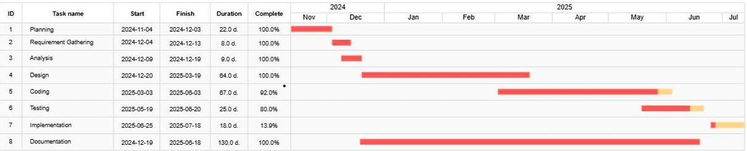
  - Conclusion:
SafeLocker is designed to provide a secure, reliable, and user-friendly solution for protecting personal files like photos, videos, audio, and documents. Unlike existing apps, it ensures that every file is individually encrypted using AES-256, stored in a private app directory, and can only be decrypted by the authorized user on the same device.The app also adds additional security layers such as password protection, fingerprint authentication, and OTP-based file sharing. Working completely offline, SafeLocker protects users from online threats and cloud-based attacks. SafeLocker addresses the major challenges of file security, privacy, and safe sharing, providing users with a trustworthy platform to store and manage their sensitive data efficiently and securely.

Chapter 02
Requirement Analysis

  - Analysis
In this chapter, we will explain how we planned and understood the features of our game. We studied who will use the game, what the game should do, and how it should look and work. This chapter helped us know clearly what we needed to build.
  - User classes and characteristics
User Class | User Characteristics
Player | Controls the character, fights enemies, collects weapons, and progresses through levels.
  - Requirement Identifying Technique
To define the requirements for MetalX, we use Use Case Analysis .These techniques help in understanding how the player will interact with the game and how the gameplay experience will be structured.
Use Case Analysis
Use Case Analysis helps describe how the player interacts with the game by breaking down different actions they can perform. It includes Use Case Descriptions (detailed steps of player actions) and Use Case Diagrams (visual representation of interactions).
Use Case: Player Gameplay
Description: This use case describes how the player will play the game and interact with the game environment.
Requirements:
- The player should be able to move, aim, and shoot.
- The game should track player progress, including health, ammo, and score.
- The player should be able to complete levels by defeating enemies.

2.4. Functional Requirements
MetalX is a single-player game. To understand the software requirements of this game, Use Case Modeling will be used. This will help clearly explain different features of the game, such as player actions, enemy AI behavior. Use Case Modeling makes it easier to organize and present the functional requirements in a clear way.

Table 5(FR-1)
Identifier | FR-1
Title | Shooting Mechanic
Requirement | The player shall be able to shoot a weapon using the left mouse button, reducing the enemy’s health on impact.
Source | Game Design Document
Inputs | Weapon selected, Ammo count
Destination | Game screen
Outputs | Bullet is fired, enemy takes damage, ammo count is reduced
Rationale | Allows combat and gameplay progression
Dependencies | FR-3 (Enemy AI)
Priority | High

Table 6(FR-2)
Identifier | FR-2
Title | Enemy AI
Requirement | Enemies shall be able to detect the player within a certain radius and attack if the player is within range.
Source | AI Logic
Inputs | Player position
Destination | Game screen
Outputs | Enemy chases and attacks the player
Rationale | Increases game challenge
Dependencies | FR-1 (Shooting), FR-3(Health System)
Priority | High

Table 7(FR-3)
Identifier | FR-3
Title | Health System
Requirement | The player shall have a health bar that decreases when hit by an enemy or other damage sources.
Source | Game Design
Inputs | Damage received
Destination | Game screen, Health Bar UI
Outputs | Health bar updates, Player death on 0 HP
Rationale | Balances gameplay difficulty
Dependencies | FR-2 (Enemy AI)
Priority | High

2.5. Non-Functional Requirements
This section describes the quality-related requirements of the game that are not related to specific features. These requirements help ensure a good experience for players. All nonfunctional requirements should be clear, measurable, and testable.


1. Reliability
The game should run smoothly without crashing again and again. It should automatically save the player's progress after short intervals. If the game crashes, it should restart from the same level where it stopped, so no data is lost.


2. Usability
The game should be easy to understand and play. Players should learn the controls quickly and use the game without confusion. The design should help users avoid mistakes and easily fix them if they happen. The user interface should be clean and simple, so players can find everything easily without too many clicks.


3. Performance
The game should run fast and smoothly on the system. All actions like shooting, or picking up the weapon should happen quickly, without delay. The game should not use too much memory or processing power, so it works well even on average computers. Good performance helps keep the game fun and responsive, so players don’t feel frustrated. Example: When the player presses the shoot button, the bullet should fire within 10 second.


4. Security

The game should be safe and protected from any kind of misuse or hacking. Player data, like game progress or collected items, should be kept secure. Only the person playing the game should be able to access or change the data. No one should be able to cheat, hack, or damage the game easily. Security can be measured by how much time, skill, or effort it would take for someone to break into the system.
2.6. External Interface Requirements
This section explains how MetalX will interact with users and other hardware or software components. It ensures that all parts of the game work smoothly together. If the game requires complex integrations, a separate document may be created for technical details.

Table 8(External Interface Requirements))
Identifier | Requirement Description | Priority
NFR-01 | The game should have a user-friendly and responsive interface for desktop. It should be easy to use, and players should be able to navigate smoothly with simple and clear controls. | High
NFR-02 | The game should work best on devices that have at least:  - 4GB RAM  - Windows 10 or 11 | High
NFR-03 | The game will be made using Unity Engine and will use external assets from:  - Mixamo  - Sketchfab  - Freesound | High
NFR-04 | The game will save data like player progress, game settings, and high scores using file-based storage on the computer. | Medium


1. User Interface Requirements
The user interface (UI) of MetalX should look good, be easy to use, and work smoothly on all desktop screens. Players should find everything clear and simple while playing the game.

Table 9(User Interface requirements)

Identifier | Requirement Description | Priority
NFR-01 | The game screen should work fast and smoothly on desktop. | High
NFR-02 | The screen should always show: health bar, crosshair, bullet count, and weapon. | High
NFR-03 | The main menu should have these options like Play, Settings, and Exit. | High
NFR-04 | The game should be easy to control using a keyboard and mouse. | High



2. Software Interface Requirements
This section describes the software components required for MetalX, including the game engine, libraries and tools that are necessary for development and execution.

Table 10(Software Interface Requirements)
Component | Software/Tool | Purpose | Integration Details
Game Engine | Unity | Game development | Uses Unity’s graphics and physics
Development Tools | Visual Studio | Write and fix game code | Works together with Unity
Assets & Animations | Mixamo, Sketchfab  Unity asset store | 3D character models, animations | Importing and modifying assets
Audio & Sound | FMOD, Freesound | sound effects, background music | Used for 3D sound and game music
Database | Json | Saves player progress and scores | Keeps game data safe and permanent



3. Hardware Requirements for MetalX
This part explains what hardware is needed to play the game smoothly.

Table 11(Hardware Requirments)
Component | Supported Device | Purpose | Communication Protocols
Desktop PC | Windows 10/11 | Runs the game, display graphics | DirectX 11+
Input Devices | Keyboard, Mouse | Player movement, aiming, shooting | Unity Input System
Audio System | 3D Sound | Makes shooting and sounds more realistic | Unity Audio API, FMOD,Freesound



4. Communication Interfaces for MetalX
MetalX is a single-player game, it doesn’t need online communication. But if we add multiplayer later, these will be needed:

Table 12(Communication Requirements)
Communication Type | Description | Protocol/Technologies Used
Game Data | Saves player progress, Reward | Json file
Multiplayer (Future Scope) | Real-time player interactions | Web Sockets, Unity Netcode
Cheat Codes (Future Scope) | Allows players to enter special codes to unlock weapons, ammo, health, or hidden features | Key Input Detection + JSON
2.7. Use case Analysis


1. Use Case: Player Shoots Enemy

Table 13(UC-1)
UC Identifier | UC1
Requirements Traceability | Shooting mechanics, enemy AI interaction
Purpose | Allow the player to fire a weapon and damage enemies
Priority | High
Preconditions | Player must have a gun and ammo.
Postconditions | The enemy takes damage or dies if health reaches zero.
Actors | Player (Main), AI Enemy (game)
Success Scenario | - Player presses the fire button.  - System checks if ammo is available.  - If ammo exists, a bullet is fired.  - If the bullet hits, enemy takes damage.  - If enemy’s health reaches zero, it dies.
Alternate Flows | If ammo is empty, player must reload
Exceptions | If no weapon is ready, the player cannot fire.
Includes | UC2 - Reload Weapon


2. Use Case: Player Reloads Weapon

Table 14(UC-2)
UC Identifier | UC2
Requirements Traceability | Weapon mechanic
Purpose | Allow the player to reload their weapon when out of ammo.
Priority | Important for gameplay
Preconditions | Player has a gun and extra bullets
Postconditions | Gun is reloaded and ready to shoot
Actors | Player (Main), Game System
Success Scenario | - Player presses reload button.  - Game checks for bullets.  - Reload animation plays  - Gun is reloaded
Alternate Flows | If no extra bullets, reload fails
Exceptions | If weapon is already full, reloading is not possible


3. Use Case: Enemy Attacks Player

Table 15(UC-3)
UC Identifier | UC3
Requirements Traceability | Enemy AI, attack system
Purpose | Allow enemies to detect and attack the player
Priority | High
Preconditions | Player must be near the enemy.
Postconditions | Player loses health if enemy hits
Actors | AI Enemy (Main), Player
Success Scenario | - Player comes close.  - Enemy sees player  - Enemy attacks  - Player loses health
Alternate Flows | If player hides or moves out of range, enemy stops attacking.
Exceptions | If enemy has no ammo, it stops firing
Includes | UC4 - Health Bar Update


4. Use Case: Player Completes Level

Table 16 (UC-4)
UC Identifier | UC4
Requirements Traceability | Level completion system
Purpose | To move player to next level after completing tasks
Priority | Ensures game progression
Preconditions | The player must complete all required objectives in the level
Postconditions | The next level is unlocked, and the player moves forward
Actors | Player (Main), Game System
Success Scenario | - Player completes Tasks  - System checks if tasks are finished.  - Level completion screen appears.  - Player moves to next level.
Alternate Flows | If task are incomplete, level remains active.
Exceptions | If system fails to detect completion, level does not progress.
Includes | UC5 - Save Progress

5. Use Case: Main Menu Navigation

Table 17(UC-5)
UC Identifier | UC5
Requirements Traceability | Main Menu System, UI Navigation
Purpose | Allow player to navigate the game through the main menu options (Start, Help & Guide, Exit)
Priority | High
Preconditions | 1.  2. | Game must be launched successfully.  Main Menu screen must be displayed.
Postconditions | 1. | If player selects Start, the gameplay scene begins.
 | 2. | If player selects Help & Guide, instructions screen opens.
 | 3. | If player selects Exit, the game application closes.
Actors | Player (Main), Game System
Success Scenario | - Game launches and displays the Main Menu.  - Player uses keyboard/mouse to navigate menu options.  - Player selects an option:
- Start: Game begins.
- Help & Guide: Instruction and guide page opens.
- Exit: Game closes.
Alternate Flows | - If player does not select any option, the menu remains idle.  - If player presses Esc, the game exits directly.
Exceptions | If any scene file is missing or corrupted, the menu may fail to load the next screen.

2.8. UseCaseDiagram

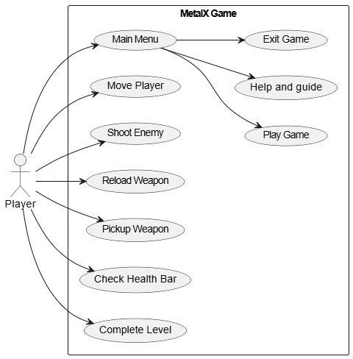

Use case 1:

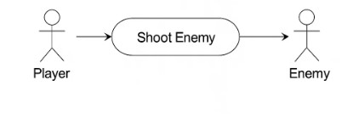

Use case 2:
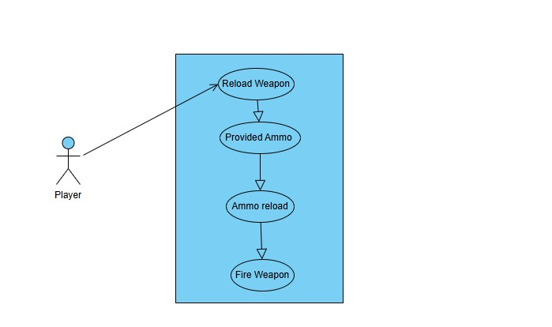

Use case 3:

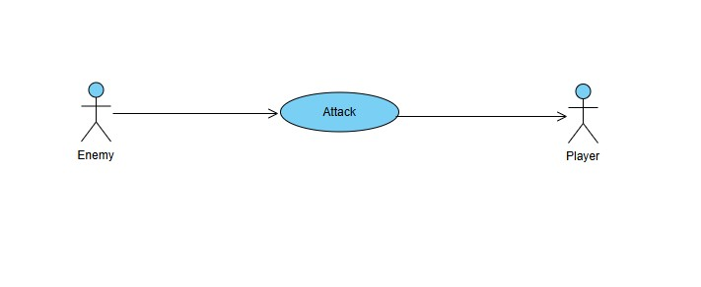
Use case 4
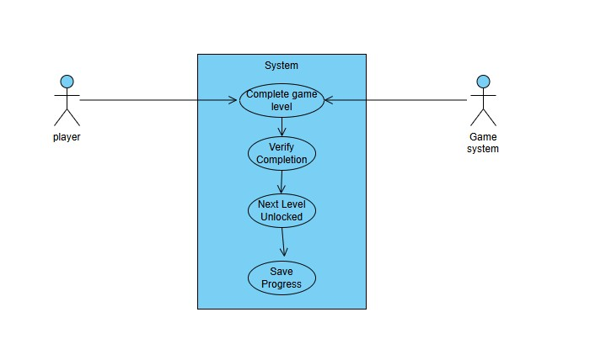

Use case 5
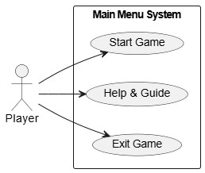
2.9. Summary
The requirements and use case analysis for MetalX were done carefully to create a wellplanned and fun shooting game. The process included studying how players interact, how enemies behave, how weapons work, and how levels progress. The game design followed best practices to make sure the gameplay is smooth and enjoyable. The requirements were divided into different categories like functional, non-functional, software, hardware, communication, and external interfaces. Everything was documented clearly using tables and diagrams, and double-checked to ensure everything was correct and possible to build.
The use case analysis described important actions like shooting, reloading, enemy attacks, level completion. Each action was explained with conditions, success steps, alternate situations, and possible errors to understand how the game should behave. MetalX ensures simple game mechanics, fair gameplay, smooth performance, and a fun experience for players. This process helps avoid mistakes, make development easier, and create a shooting game that meets player expectations.

Chapter 3
Design and Architecture

System Design
The design of METAL-X is made to give players a fun and exciting shooting experience. It focuses on smooth gameplay, realistic environments, and interesting combat. The main goals are:
- Easy Player Control: Players can move, run, jump, and shoot easily to make the action smooth.
- Smart Enemy AI: Enemies react to what the player does, making the fights more fun and hard.
- Realistic Game Environment: The game has a city with things players can interact with, making it feel real.
- Simple Interface: A user-friendly menu which include Start, Help & Guide, and Exit for easy navigation.
This design makes sure that METAL-X is fun to play, looks great, and works well on most systems.
3.1. Design considerations
Assumptions and Dependencies:

- The player will use a keyboard and mouse to play
- Game will run on Windows 10 or 11
- Unity Game Engine will be used for development
- Visual Studio is used for writing C# scripts
- Asset dependencies include Mixamo, Freesound, and Sketchfab

Limitations:

- No multiplayer support in this version
- Works only on Windows platform
- No save/load system using cloud or database
- Game does not support mobile devices or VR

Risks and Mitigation:

Table 18(Risk and Mitigations)
Risk | Mitigation
Lack of Unity knowledge | Watched YouTube tutorials and followed Unity docs
Asset compatibility issues | Used only supported assets and checked formats
Game lag on some PCs | Optimized graphics and limited effects

3.2. Design Models
The design of METAL-X follows a structured system where different components work together. The player system controls movement, shooting, and interactions. The enemy AI tracks and attacks the player based on their action. The weapon system allows the player to use a gun with basic shooting mechanics and ammo management. The game includes environment, interactive objects, and lighting effects. The UI system provides menus, health bars, and ammo count for a smooth user experience.



1. Design Class Diagram (DCD)
The MetalX Class Diagram shows the structure of the game’s classes, their attributes, operations, and relationships between objects. The main classes of METAL-X include Game Manager, Enemy, Player, Weapon, and Bullet.
Class Diagram Components:
- Upper section: Contain the name of the class.
- Middle section: Contain attributes of the class.
- Lower section: Includes Class Functions.

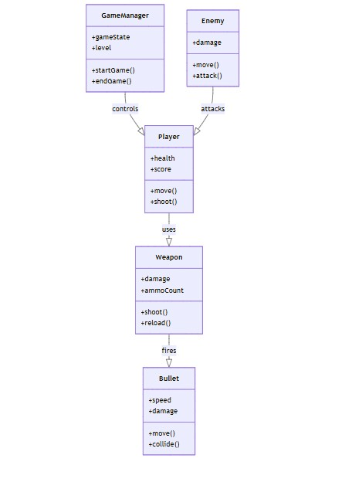

- Interaction Diagram

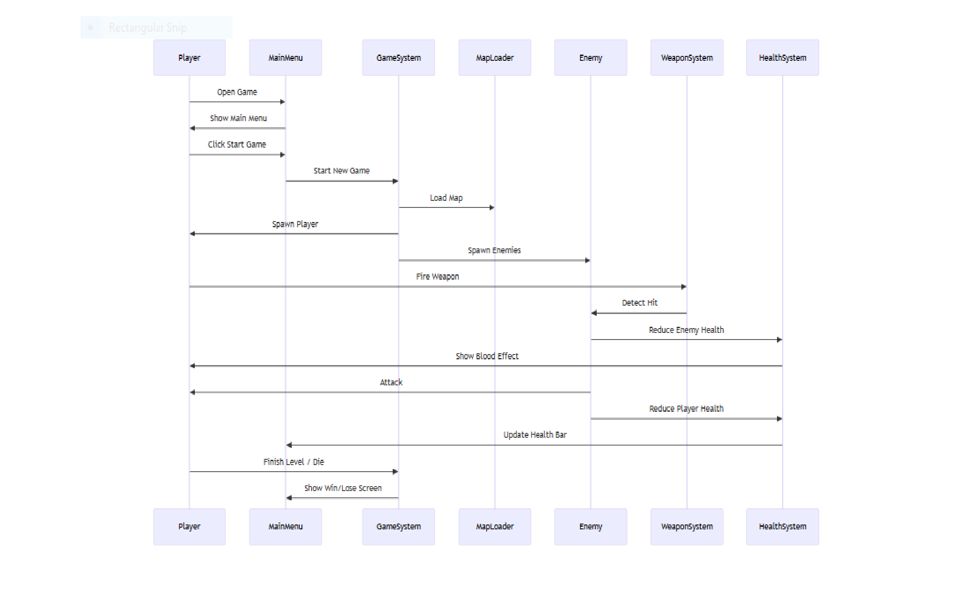

- State Transition Diagram

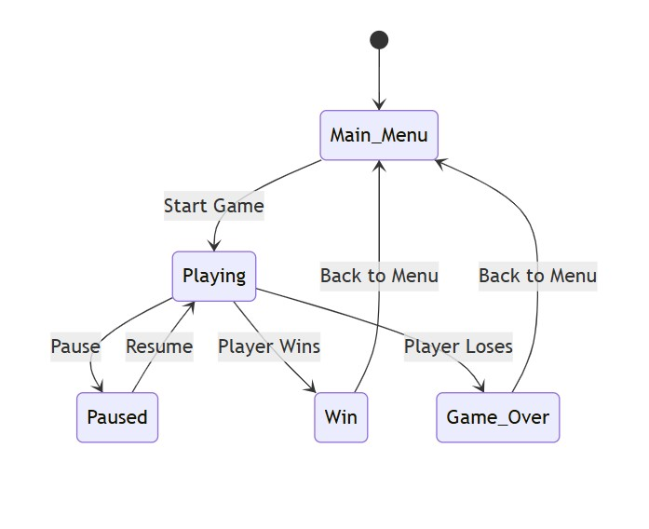

- Architectural Diagram
The architecture of METAL-X is designed in small parts so that the game runs smoothly and is easy to improve in the future. The Player System controls how the player moves, shoots, and keeps health. The AI System manages how enemies behave and attack the player. The Weapon System handles different guns, bullets, and how the shooting works. The UI System shows the game menus, health bars, and settings. The Environment System adds objects, lights, and other things to make the game world look real and interesting.
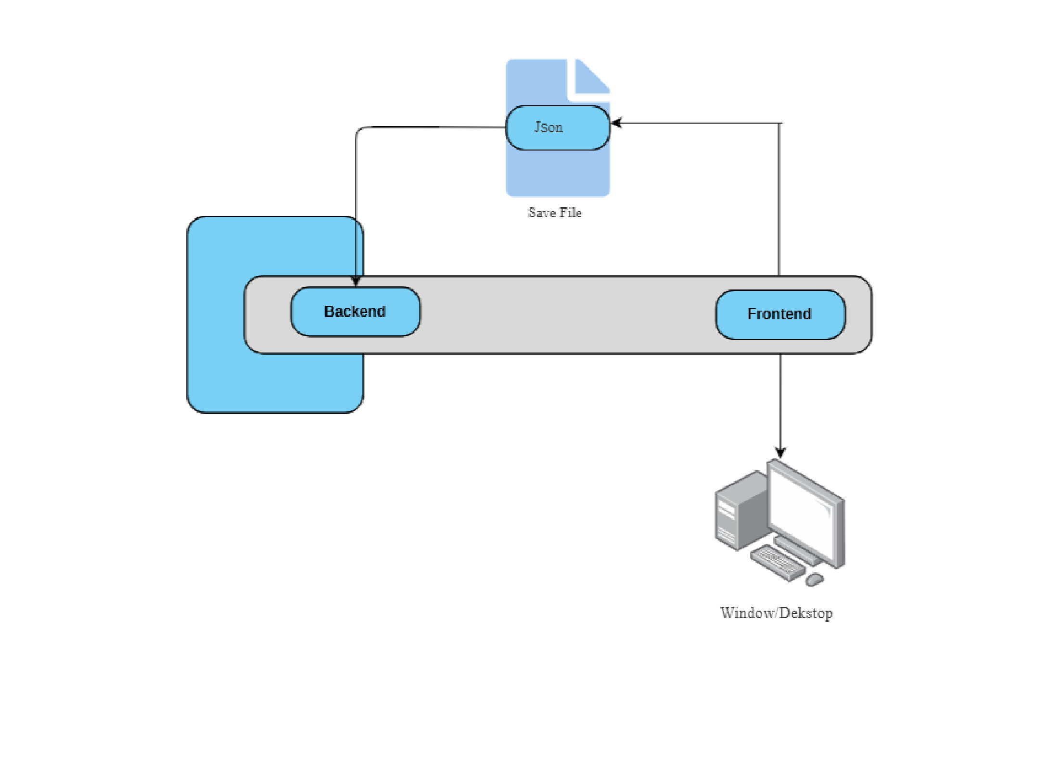

- UML Component diagram

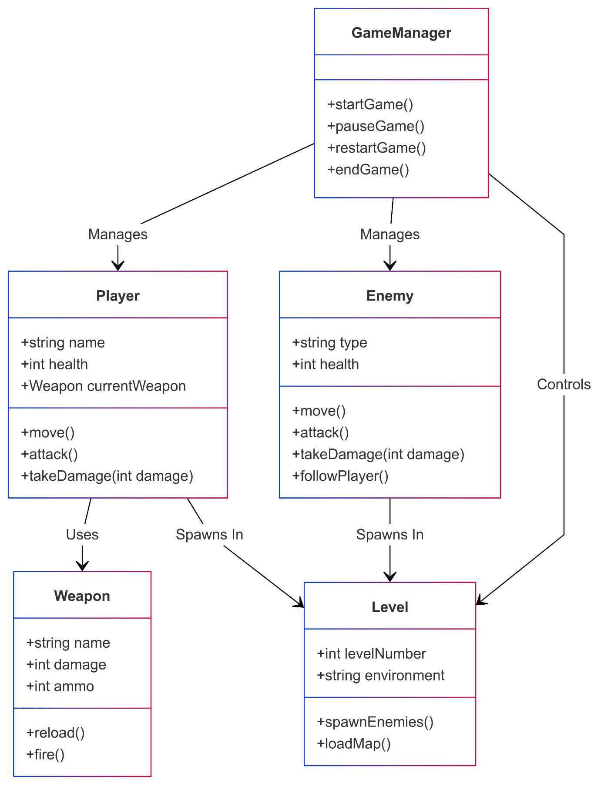
3.3. Data Design
The data design of METAL-X focuses on how game data is structured, stored, and managed for smooth gameplay. The key components of data design include:

1. Player Data
Stores player information like health, ammo, position, and current weapon. Tracks player actions such as movement, shooting, and taking damage.
2. Enemy Data
Includes enemy health, position, attack patterns, and AI behavior.

3. Game State Data
Manages the current level, player progress, score, and game status like win or lose.Saves and loads data when needed.

4. UI and HUD Data
Updates health bars, ammo count, mission objectives, and notifications in real time. 5. Environment Data
Handles level design, obstacles and interactive objects.

6. Audio and Visual Data
Controls sound effects, background music, and visual effects for an immersive experience.

The data is managed efficiently to ensure fast performance, smooth gameplay, and easy updates in METAL-X.

Data Dictionary:

Table 19(Data Dictionary)
Term | Data Type | Description
PlayerHealth | Float | Stores the player's health from range 0 to 100
Ammo | Integer | Current bullets in  weapon
EnemyHealth | Float | Stores the enemy's health
Reward | Integer | currency
LevelNumber | Integer | Indicates the current game level

3.4. User Interface Design
This is a nighttime city scene built for METAL-X, a shooting game in Unity3D. The streets have streetlights, and tall buildings stand on both sides, creating a realistic and immersive setting. Trees add some life to the environment, while shadows give it a dramatic feel. Everything in the scene, from buildings to lights and props, is well-organized, making it easy to manage and modify. It looks like a perfect place for exciting battles and action.
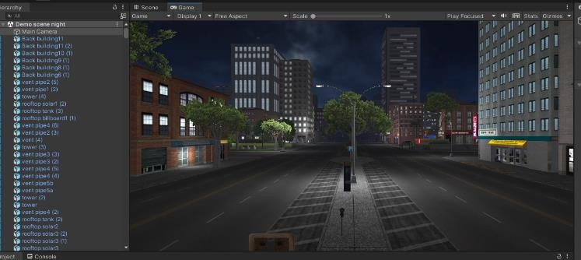

Scene 1:

City Night Scene
This scene is a nighttime city for METAL-X, a shooting game made in Unity3D. The city has tall buildings with bright digital billboards, wide roads, and a futuristic feel. The glowing lights and reflections on the glass buildings make the scene look real. The open streets give plenty of space for moving and fighting, making it a great place for exciting gunfights. The environment is made to support dynamic gameplay. This scene is a key location in METALX, providing players with an exciting and immersive experience.
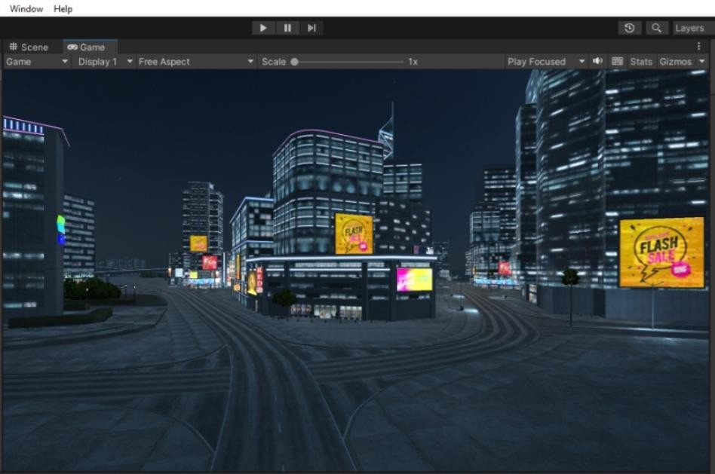
Scene 2:
Player Character:
This is the main player model used in METALX. The player can move freely in the game world and perform various actions like
- Walking: Move around the environment.
- Running: Increase speed for quick movement.
- Jumping: Jump over obstacles or reach higher areas.
- Shooting: Attack enemies using different weapons.
The player will fight, explore different areas, and complete missions. This character is made to give a smooth and easy gameplay experience.

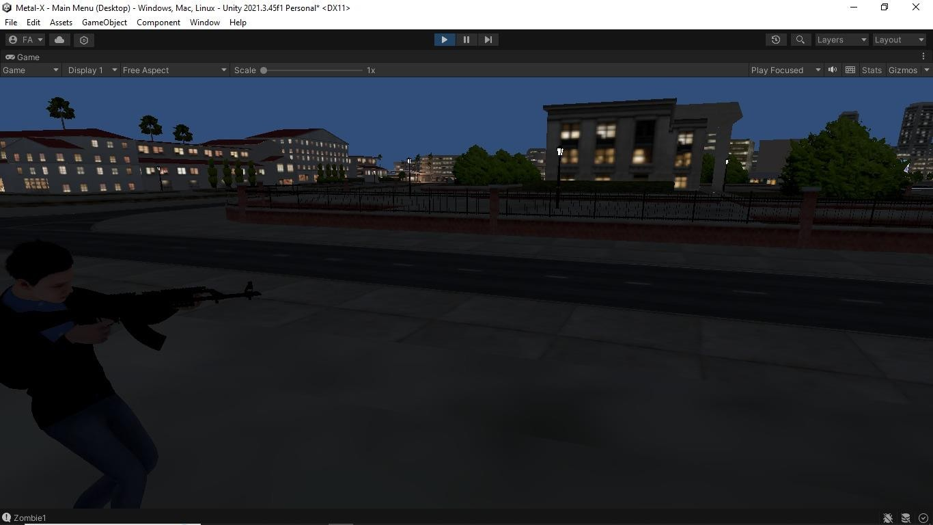
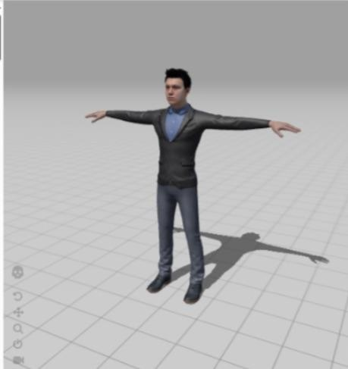
Scene 3:
Weapons in METAL-X
In METALX, players can use different weapons to fight enemies. The weapons are designed for fast and powerful shooting.
Weapon Features:
- Strong Power: Can defeat enemies fast.
- Accurate: Helps you hit targets easily.
- Realistic Look: Looks and feels real.
- Can Be Used in Many Ways: Good for different fights.

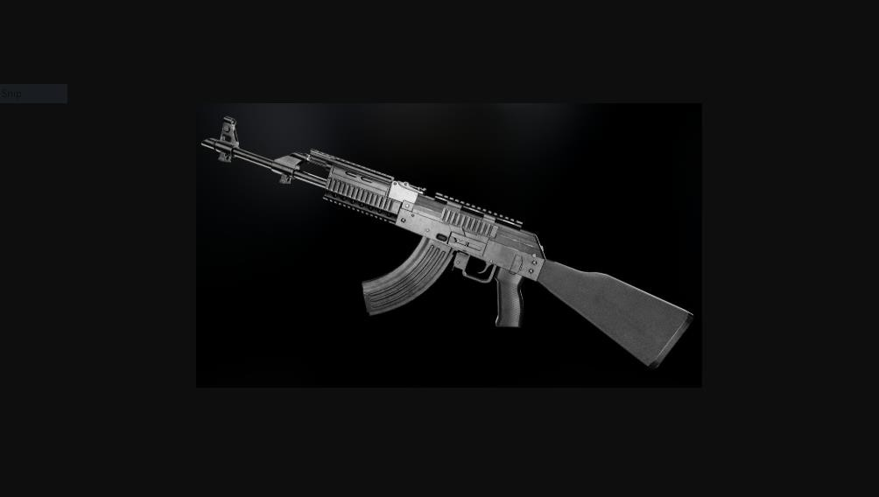

Scene 4:
Loading Screen
The loading screen in MetalX shows up while the game and level are getting ready. It has the game logo and a progress bar to show how much time is left. It gives players a short break before the game starts and can also show tips or controls to help players play better.
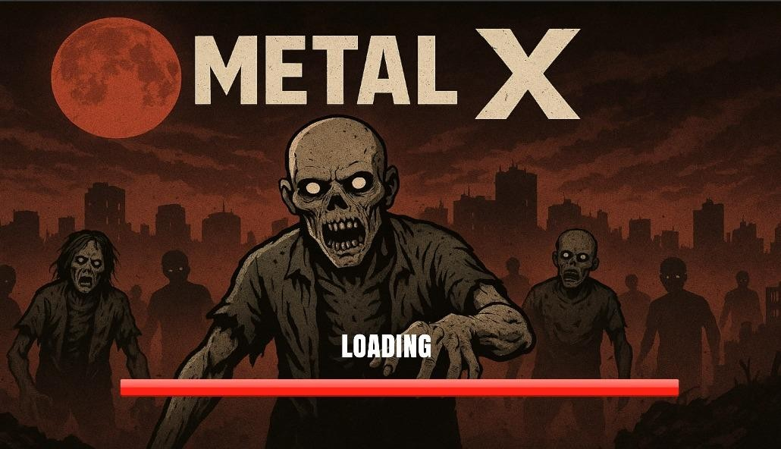

Main Menu UI - METAL-X
The main menu in MetalX is simple and easy to use. It includes a Start button to begin the game, a Help & Guide button to show instructions, and an Exit button to close the game. This makes it easy for players to navigate and start playing without any confusion.


3.5. Design decision

Table 20(Design Decision)
Design decision | Chosen Approach | Approach
Game Engine | Unity3D | Unity3D is chosen because it helps create 3D graphics, has a good physics engine, and works on many devices, making it perfect for a shooting game.
Player System | Movement, jumping, Shooting | This makes sure the controls are easy and fun to use for the player.
Enemy AI | Path finding and Attack Behaviors | Make enemies react intelligently and challenge the player.
UI and HUD Design | Healthy and  Ammo, display | This keeps the player updated on their health, ammo, and progress in the game.
State  Transitions | Idle, Running,  Shooting,  Reloading,  Taking damage | This helps the player’s actions feel smooth and natural in the game.
Optimization | Balance graphics and perform tuning | Ensure smooth gameplay on normal Pc’s.

3.6. Summary
METAL-X is a shooting game made with Unity3D. In the game, players fight enemies using different weapons. The goal is to survive, defeat enemies, and complete missions. Players can move, jump, run, shoot, and reload, making the game fun and interactive. The enemies are smart and challenge the player with their attacks. The weapons are used in game and how they reload, adding variety to the game. The game keeps track of actions like walking, running and shooting. The heads-up display shows the player’s health, ammo, and mission progress. The environment is realistic, with many areas to explore. The game is made to run smoothly on different devices, without delay. Sound effects and music make the game feel exciting. METAL-X offers a fun and exciting experience for players who like action games.

Chapter 4
Implementation

4.1. Implementation:
This chapter explains how the main parts of the game were developed. It gives details about the logic and core functions of the system using pseudocode. It does not include actual source code but explains the working of important features step by step. We also describe the tools, APIs, and version control system used to manage and implement the project.
4.2. Algorithm
Below are the core algorithms used in our project, written in pseudocode for easy understanding.

Algorithm 1: Shooting Mechanism

Table 21 (Algorithm 1)
Algorithm 1: Shooting Mechanism
Input: Mouse left click
Output: Enemy takes damage if hit
1:When player clicks left mouse button
2: Cast a ray from camera to crosshair direction
3: If the ray hits an enemy
4: Reduce enemy health by weapon damage
5: If enemy health <= 0
6: Destroy enemy


Algorithm 2: Reloading Mechanism

Table 22 (Algrithm 2)
Algorithm 2: Reloading Mechanism
Input: Key : R
Output: Gun reloads with available ammo
1: If player presses "R" OR ammo in magazine == 0
2: Check if reserve ammo > 0
3: Refill magazine up to max capacity
4: Subtract used ammo from reserve
5: If reserve ammo == 0 → Show "No Ammo"

Algorithm 3: Enemy AI Behavior

Table 23 (Algrithm 3)
Algorithm 3: Enemy AI Behavior
Input: Player enters enemy range
Output: Enemy follows and shoots player
1: Check distance between enemy and player
2: If distance < attack range:
3: Move towards player
4: Face the player
5: Shoot at player every few seconds



Algorithm 4: Health System

Table 24 (Algrithm 4)
Algorithm 4: Health System
Input: Player or enemy gets hit
Output: Reduce health and check for death
1: On collision with bullet:
2: Subtract bullet damage from health
3: If health <= 0:
4: Trigger death animation or destroy object

4.3. External APIs/SDKs

Table 25 (External APIs and SDK)
Name of API and version | Description | Purpose of Usage | Used In
Unity (LTS Version) | Game development platform | Main engine for developing game logic and UI | Entire project
Unity Input System | Handles keyboard and mouse input | To detect weapon picking and shooting  actions | Weapon picking movement
Unity NavMesh | Navigation for enemies | Helps enemies follow and reach the player | Enemy AI behavior
Unity Animator | Animation system in Unity | To animate shooting, running, walking | Player and enemy animations
Unity AudioSource | Manages sound effects | Used for gunshots, background music | All sound-related components

4.4. Code Repository
We used Visual Studio for coding and project management. Although a full Git repository was not used, version tracking was done manually using local backups and dated folders. For future improvements, Git-based tools like GitHub are recommended for better version control and collaboration.
4.5. Summary
This chapter explained how we implemented the most important parts of our game. We discussed core functionalities using pseudocode such as shooting, enemy AI, weapon reloading mechanism, and health system. We also mentioned the external APIs and tools used in Unity. These implementation details are directly related to our objectives and show how we successfully built the game step by step.

Chapter 5
Testing and Evaluation

5.1. Introduction
To make sure our game MetalX works correctly and meets its goals, we performed different types of software testing. Testing helps we check that each part of the game gives the right result, works well with other parts, and runs smoothly on different systems.
Although automated testing is preferred in many software projects, our game is interactive and visual, so we used manual testing for all features. We also followed these best practices:
- Independent Tests: Each test works on its own
- Clear Results: Every test has a clear expected and actual result
- Repeatable Tests: All test steps can be run again without failure
- No Hardcoding: We used variables for ammo, health, and damage
- Simple Test Data: Each test uses fresh data

Table 26(Testiing)
ID | Feature | Input | Expected Result | Actual Result | Status
UT1 | Player Shooting | Mouse Left Click | Bullet fires and hits target | Bullet fires correctly | pass
UT2 | Player Running | Shift +  W/A/S/D | Player moves faster | Player runs smoothly | pass
IT3 | Enemy Damage System | Shoot enemy | Enemy loses health or dies | Health reduces correctly | pass

5.2. Unit Testing (UT)
Unit testing means checking one small part of the game separately to make sure it works perfectly. Instead of testing the whole game at once, we test one specific feature like shooting.

Table 27 (UT1)
Test case ID | UT1
What to Test | Player shooting bullets
Why | To check if shooting works properly
Before Starting | Game should be running, player has a weapon
Steps | - Start the game  - Click left mouse button
Input | Mouse click
Expected | Bullet should come out and move forward
Actually Happened | Bullet fired correctly
Result | Passed
Notes | Test is simple and can be done again anytime

Table 28 (UT2)
Test case ID | UT2
What to Test | Player movement in all directions using keyboard
Why | To ensure player moves correctly with input keys
Before Starting | Game must be running, player character is in the scene
Steps | - Use W, A, S, D keys to move  - Observe movement in each direction
Input | Keyboard input (W, A, S, D)
Expected | Player moves smoothly in the direction of the key pressed
Actually Happened | Player movement was responsive and without lag
Result | Passed
Notes | Movement system is functioning well

Table 29 (UT3)
Test case ID | UT3
What to Test | Player picks up a weapon using the F key
Why | To verify that the new key input for pickup is working correctly
Before Starting | The game must be running, weapon must be present in the scene, and player should be close to the weapon
Steps | - Move the player near the weapon  - Press the F key
Input | Keyboard input F key
Expected | Weapon should be picked up and disappear from the ground, and get equipped by the player
Actually Happened | Weapon was picked up successfully using the F key
Result | Passed
Notes | Pickup system works fine with the key F

Table 30 (UT4)
Test case ID | UT4
What to Test | Enemy detects the player and starts attack
Why | To test if enemy AI works properly
Before Starting | Enemy and player both must be active in the scene
Steps | - Move player into enemy’s vision range  - Observe enemy behavior
Input | Player movement
Expected | Enemy should detect and chase the player, then attack
Actually Happened | Enemy successfully detected and attacked the player
Result | Passed
Notes | Enemy AI logic is functional and reliable

Table 31 (UT5)
Test case ID | UT5
What to Test | Player’s health reduces when attacked by an enemy
Why | To ensure health system is working as expected
Before Starting | Player should have full health, and enemies should be active
Steps | - Allow enemy to hit the player  - Observe health bar or value
Input | Enemy attack
Expected | Player’s health should decrease on hit
Actually Happened | Health bar decreased accurately and player died at 0 health
Result | Passed
Notes | Health reduction and death logic are working perfectly

5.3. Functional Testing (FT)
Functional testing is used to make sure all features and parts of MetalX work as expected. It helps confirm that the player can perform all game actions like shooting, picking up the weapons, and moving through levels.

Table 32 (Functional Testing)
ID | Title | Objective | Steps | Expected Result | Actual Result
FT1 | Player Shooting | Make sure player can shoot | Start game ,  Press left click ,  Bullet fires | Bullet shoots and damages enemy | Pass
FT2 | Pick up the Weapons | Ensure player pick up the weapon | Press key F | Weapon show in hand of player | Pass
FT3 | Reload Weapon | Ensure reloading works | Press reload ,Ammo fills | Weapon  reloaded | Pass
FT4 | Health System | Check if health reduces when hit | Get attacked by enemy | Health bar reduces | Pass
FT5 | Complete  Level | Verify level progression | Finish all enemies or tasks , Level complete screen | Next level unlocked | Pass
5.4. Integration Testing (IT)
Integration testing checks how different parts of the game like player, enemies, bullets, and UI work together. It helps us make sure that the full game system runs smoothly from start to finish.

Table 33 (Integration Testing)
ID | TITLE | Description | Steps | Expected Result | Actual Result
IT1 | Shoot + Enemy AI | Check bullet damage and enemy reaction | Player shoots enemy, Enemy loses health or dies | Bullet hits, enemy health decreases or enemy dies | Pass
IT2 | Player Damage + Health Bar | Player gets hit by enemy and health is updated | Enemy attacks player ,Player health reduces | Health bar shows damage | Pass
IT3 | UI + Gameplay | Health, ammo, and crosshair update correctly | Player shoots and moves | UI updates correctly in real-time | Pass
IT4 | Level Completion  Flow | Test level transition system | Complete level tasks ,Go to next level | Level ends and new one starts | Pass

5.5. Performance Testing (PT)
To check how fast, stable, and smooth MetalX runs on different systems. We also tested how well the game responds during gameplay like shooting, reloading, and moving.

Table 34 (Performance testing)
TC ID | Performance Area | Title | Objectiv  e | Metri c | Expected Time | Observed | Resul t
PT1 | Responsiveness | Shooting Delay | Bullet should fire  immediately after click | Time | 5s | 3S | Pass
PT2 | UI Smoothness | Health &  Ammo  Update | UI must update during combat | Visual  Response | < 300ms | Smooth | Pass
PT3 | Load Time | Game  Start-up Time | Game loads  in  reasonable time | Time | > 20s | ~10s | Pass
PT4 | Frame Rate | Gameplay  Frame Rate | Test stable Shooting during game | FPS | < 30 FPS | ~45 FPS | Pass
PT5 | Level Transition Speed | Change Between Levels | Level loads quickly after completion | Time | 20s | ~15s | Pass

5.6. Conclusion
We tested all major parts of MetalX to make sure everything works properly. This included unit testing (small features), functional testing (full actions), integration testing (how different parts work together), and performance testing (how fast and smooth the game runs).
All the tests were done manually because the game is visual and interactive. We checked features like shooting, weapons, health updates, and level completion and all of them passed without errors.
Testing gave us confidence that the game is stable and ready to be played. We also learned how important it is to test each feature separately and together, so no bugs appear later. This chapter showed us how useful testing is in any software project, especially in games.

Chapter 06
System Conversion

6.1. Conversion Method
For MetalX, we used the Pilot Conversion method. Our game is a single-player shooting game made in Unity for desktop. First, we tested it on a few laptops (our own and classmates’). This helped us check for small bugs, test shooting, enemy AI, and health system, and also get feedback. By testing on a small group, we were able to fix issues early. It also gave us a chance to improve the game’s performance and controls before showing it in the final presentation and viva.
6.2. Deployment
MetalX was developed using Unity and deployed on Windows PCs. The following steps were followed during deployment:
- Build Game Executable:
Unity was used to build the game in Windows format .exe.

- Folder Setup:
All game files like MetalX.exe and required data folder were packaged together.

- Sharing the Game:
We copied this folder to other PCs using USB or email. No setup was required the game starts by just double-clicking the .exe file.

- System Requirements:
  - Windows 10 or 11 (64-bit)
  - At least 4GB RAM • Keyboard and mouse input
- Unity Settings:
The game was built with Unity’s PC settings. We adjusted graphics and screen resolution for smooth play.

- Testing:
We tested the game on 3 or 4 different computers to make sure it runs properly everywhere.
6.2.1 Data Conversion
MetalX is an offline game and does not use an external database, the only data saved is:
- Player progress
- Basic settings
These were saved in local files JSON or PlayerPrefs during gameplay. When moving the game to another PC, these files can be copied to maintain progress.
6.3. Training
We created a simple guide to help new users understand how to play MetalX.
Use Case 1: How to Shoot and Defeat Enemies
- Start the game and select a weapon
- Aim with the mouse and click to shoot
- Bullet hits the enemy and reduces health
- Player completes the level after defeating all enemies
Use Case 2: How to Use Weapons
In MetalX, players can pick and use different weapons during gameplay. Each weapon has a limited ammo system.
- Pick Up Weapon: Move near the weapon to collect it. • Shoot: Left mouse button is used to fire.
- Reload: Press “R” key to reload when ammo is low.
- Ammo Display: Remaining bullets are shown on the screen.
This system makes the game more realistic and challenging because players must manage their ammo carefully while fighting enemies.
6.4. Post Deployment Testing
After deploying MetalX, we performed post-deployment checks to ensure everything was working properly:
- Tested all functional features like shooting, weapons, and enemy behavior
- Verified health system, level completion, and health mechanism
- Checked game on different systems for performance and resolution issues
- Run integration testing for UI and gameplay interaction • Ensured smooth loading and no crashes
All tests were successful, confirming the game was deployed correctly.

6.5. Challenges

Table 35 (Challenges)
Challenge | Description | Solution
Game lag on low-end PCs | Game slowed down on older systems | Reduced graphics quality and optimized effects
Asset size too large | Some game objects made the build too heavy | Used compressed textures and removed unused assets
Input delay in some systems | Slight delay in shooting on certain laptops | Adjusted input handling in Unity settings
UI didn’t fit all resolutions | UI elements looked broken on smaller screens | Made UI elements scale using Canvas Scaler in Unity
6.6. Summary
The deployment of MetalX was done using the Pilot Conversion method. The game was tested on multiple systems before full use, which helped reduce bugs and improve performance. Deployment involved building an .exe file using Unity, copying files to test systems, and verifying game performance.
All major features like shooting, enemy AI, level transition, and the health worked successfully after deployment. A few challenges were encountered but were fixed through testing and adjustments. Overall, MetalX was successfully converted from a Unity project to a working game ready for players.



Chapter7
Conclusion

7.1. Introduction
This chapter ends the MetalX project by reviewing the goals and features we planned in the beginning. It checks which features were successfully added, how well they worked, and what future improvements can be made. It also highlights the value of the game and how it meets the expected gameplay experience for users.
7.2. Evaluation
The following table lists the main objectives from Chapter 1 and shows whether they were achieved in the final version of the game:

Table 36 (Evaluation)
Objective | Status
Add smart enemy that detects and attacks the player | Completed
Create an engaging environment with obstacles, cover, and realistic surroundings | Completed
Add features like health bar, blood effect, crosshair, and weapons | Completed
Ensure smooth performance on normal PCs | Completed
Design level-based gameplay that becomes harder with progress | Completed
Add easy-to-use controls and a simple, clear UI | Completed

7.3. Traceability Matrix
This table shows how each requirement from the SRS is linked with the design, coding, and testing steps.

Table 37 (Tracablity Matrix)
Requirement  ID | Requirement Description | Design Specification | Code File | Test ID
FR-1 | Shooting with left click | Bullet System, Weapon  Manager | ObjectToHit.cs | UT1
FR-2 | Enemy AI attacks player | Enemy Controller, AI Scripts | Zombie.cs | IT1
FR-3 | Health system for player and enemies | Health Bar, Health Manager | HealthBar.cs | FT5
FR-4 | weapons | Pick up the weapon | RiflePickup.cs | FT3
UC-1 | Player shoots enemy | Game Flow | Rifle.cs | UT1
UC-4 | Complete level and move to next | Level Manager | Levelmanager.cs | FT6
NFR-01 | Smooth game performance | Optimized Assets and Scripts | Unity Build Settings | PT1
NFR-02 | Clean UI interface | Canvas Design, UI Scripts | UI.cs | FT7

7.4. Conclusion
MetalX is a small shooting game that we designed for our Final Year Project. We wanted to make a game that is simple but still fun to play. It includes features like enemy AI, weapons, health system, and level progression.
Our team faced some challenges while learning Unity and C#, but we managed to build all the features step by step. We tested each part to make sure the game works well. The final version of MetalX runs smoothly on Windows PCs and does not need an internet connection.
This project helped us improve our coding skills and understand how games are planned, designed, tested, and deployed. We also learned how to work as a team and solve problems during development.
7.5. Future Work
Although MetalX is fully working, we have some ideas to improve or expand the game in the future:
- Multiplayer Mode
Allow two or more players to play together or against each other via LAN or internet.
- Story Mode and Missions
Add a proper storyline with missions, cutscenes, and a progress tracker..
- Weapon Upgrades and Customization
Let players improve weapons with scopes, skins, or extra damage.
- Improved Enemy AI
Make enemies smarter with more advanced behavior like hiding, surrounding the player, or working in groups.
- Cheat Codes
Add secret cheat codes for unlimited ammo, health, or unlocking all weapons, to make gameplay more fun for players who want to experiment.

References

References
- Books
  - Ramez Elmasri & Shamkant B. Navathe, Fundamentals of Database Systems, 6th Edition, Addison-Wesley, 2010.
  - Roger S. Pressman & Bruce R. Maxim. Software Engineering: A Practitioner’s Approach. McGraw-Hill Education, 2014.
  - Daniel Galin. Software Quality Assurance: From Theory to Implementation. Pearson Education, 2003.
- Articles in a Journal
  - Cynthia Dwork, "Differential privacy: A survey of results," Theory of Cryptography Library, vol. 38, no. 6, pp. 1–19, 2008.
- World Wide Web
  - Unity Technologies. “Unity Manual: Shooting Game Setup.” https://docs.unity3d.com/
  - Epic Games. “Game Development Best Practices.” https://www.unrealengine.com/
  - NVIDIA. “Optimizing Graphics for Games.” https://developer.nvidia.com/ • OpenAI. “ChatGPT Help on MetalX Shooting Game.” Internet:
https://chat.openai.com, [Accessed: May 2025].
- Conference Paper
Jonathan Blow, "Game Engine Design," Game Developers Conference (GDC), San Francisco, USA, 2019,ui ggbv pp. 112–130.
- ChatGPT
OpenAI, ChatGPT, “ChatGPT help on METAL-X Shooting Game. https://chat.openai.com/

