Architecture Documentation
Enterprise Document Intelligence Platform
Maryam Fatima
Track: NLP and AI Agents
This document explains how the Enterprise Document Intelligence Platform is built, one step at a time. The app lets a person upload documents and ask questions about them in plain language. Behind the scenes, a request travels through ten stages before an answer comes back. The diagram below shows that path; the explanations after it describe what each stage actually does in this project.
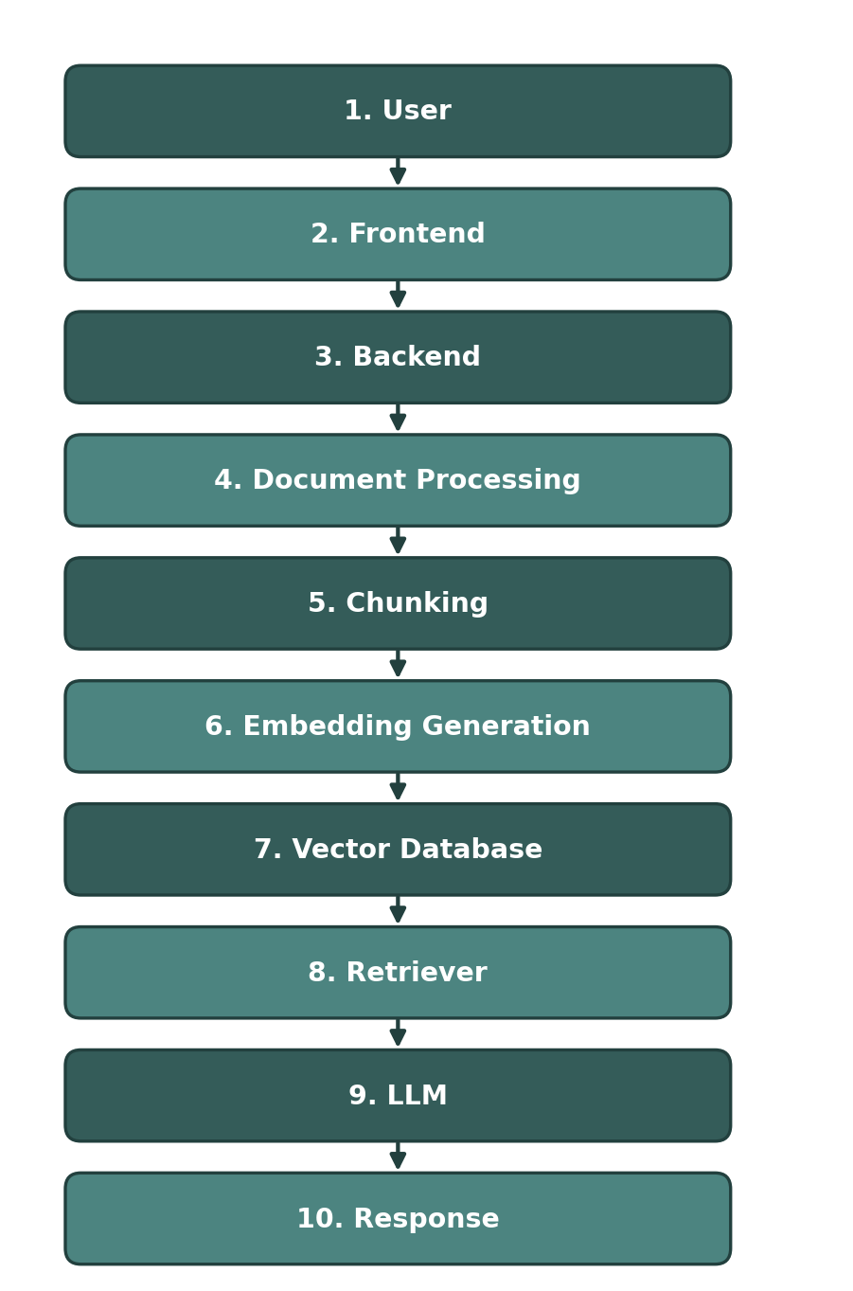
Figure 1: The path a request takes, from the user's action to the final response.

Component Explanations
1. User — the person using the app
- Opens the app in a browser, uploads a PDF/DOCX/TXT/Markdown file, or types a question into the chat box.
- Never talks to the AI or the database directly — every action goes through the frontend first.
2. Frontend — index.html, style.css, app.js
- The dashboard, chat window, and document list the user actually sees and clicks on.
- Sends the user's action to the backend using fetch() calls (for example, POST /chat or POST /upload), and displays whatever comes back.
3. Backend — Flask, app.py
- Receives every request from the frontend and decides which service should handle it.
- Does not process documents or talk to the AI model itself — it calls the right function in the services/ folder and returns the result as JSON.
4. Document Processing — processor.py
- Opens the uploaded file and pulls out its plain text (using PyPDF2 for PDFs, python-docx for Word files, and plain reading for text/Markdown).
- This is the step that turns a file into text the rest of the pipeline can actually work with.
5. Chunking — processor.py
- Splits that text into smaller overlapping pieces, since a whole document is too large to search or embed as one block.
- Overlap between chunks keeps a sentence from being cut in half at a chunk boundary.
6. Embedding Generation — rag.py, Gemini gemini-embedding-001
- Turns each chunk of text into a list of numbers (an embedding) that represents its meaning.
- The same embedding step is used again later on the user's question, so both can be compared fairly.
7. Vector Database — ChromaDB
- Stores every chunk's embedding, along with which document and file it came from.
- Chosen because it runs locally, saves data to disk between restarts, and needs no separate server to manage.
8. Retriever — rag.py
- Takes the question's embedding and searches the vector database for the chunks whose meaning is closest to it.
- Only the top few matches (the most relevant chunks) are kept and passed forward, not the whole document.
9. LLM — Google Gemini, gemini-2.5-flash
- Receives the user's question together with the retrieved chunks, and is instructed to answer using only that information.
- This is what keeps answers grounded in the real documents instead of the model guessing from general knowledge.
10. Response — back through the Backend and Frontend
- The answer, along with which documents and chunks it came from, is sent back to the frontend as JSON.
- The chat window displays the answer with its source citations, so the user can see exactly where it came from.

