SUPPORTING INFORMATION

Effect of cysteine oxidation in SARS-CoV-2 Spike protein on its conformational changes: insights from atomistic simulations

Maryam Ghasemitarei1,2,*, Hoda Taeb3,1, Tayebeh Ghorbi1, Maksudbek Yusupov4,5, Annemie Bogaerts2, Mohammad Reza Ejtehadi1,*

1 Department of Physics, Sharif University of Technology, 14588-89694 Tehran, Iran

2 Research group PLASMANT, Department of Chemistry, University of Antwerp, 2610 Antwerp, Belgium

3 Department of Physics, Simon Fraser University, Burnaby, Canada

4 Institute of Fundamental and Applied Research, National Research University TIIAME, 100000 Tashkent, Uzbekistan

5 Department of Information Technologies, Tashkent International University of Education, 100207 Tashkent, Uzbekistan

**Computational details**

Generally, N-linked glycans are bound to the N atom of asparagine (Asn) and O-linked glycans are bound to the O atom of threonine (Thr) or serine (Ser) residues. In this study, based on literature [1, 2], 19 N-linked glycans are attached to Asn residues of each monomer, and only one O-linked glycan is attached to Thr323. Table S1 shows the type of each glycan used in this study.

***Table S1.*** *Glycan structures for the monomers of the SARS-CoV-2 S trimer. The filled blue and yellow squares represent the N-acetyl-D-glucosamine and N-acetyl-D-galactosamine, respectively. The filled green and yellow circles are related to D-mannose and D-galactose, respectively. The filled red rectangle represents L-fucose and the purple rhombus is related to N-acetyl-D-neuraminic acid.*

|  |  |
| --- | --- |
| **Amino acid residues** | **Glycan Structure** |
| Asn1134,  Asn657, Asn616,  Asn331, Asn149 |  |
| Asn61,  Asn122, Asn603,  Asn709, Asn717,  Asn801 |  |
| Asn1098 |  |
| Asn234 |  |
| Asn17,  Asn74, Asn165 |  |
| Asn343 |  |
| Asn282 |  |
| Thr323 |  |

**Equilibration**

Figure S1 illustrates the root mean square deviation (RMSD) of all three replicas for the down and up states of the native (A) and oxidized (B) SARS-CoV-2 S trimer. It is clear that all systems reached their equilibrated state after 100 ns of simulation (Figure S1).

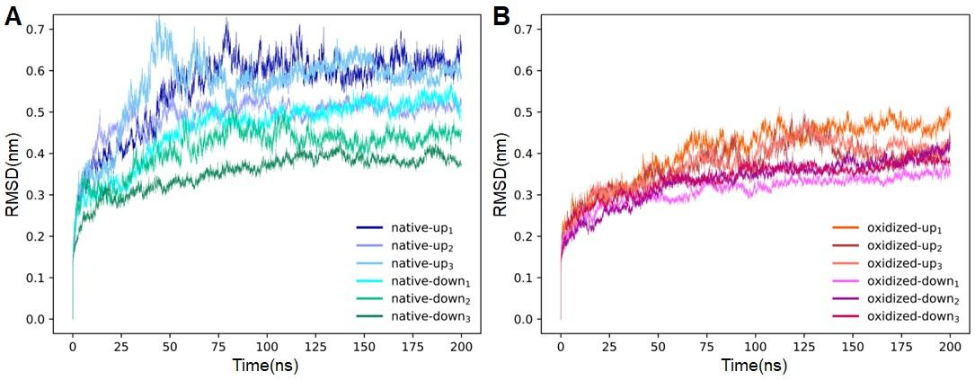

***Figure S1.*** *RMSD of three replicas for the down and up states of the native (A) and oxidized (B) SARS-CoV-2 S trimer. All systems reach their equilibration after 100 ns.*

**Transitions**

Figure S2 shows the averaged RMSD of the RBD during the transition from the down to the up conformation for the native and oxidized systems.

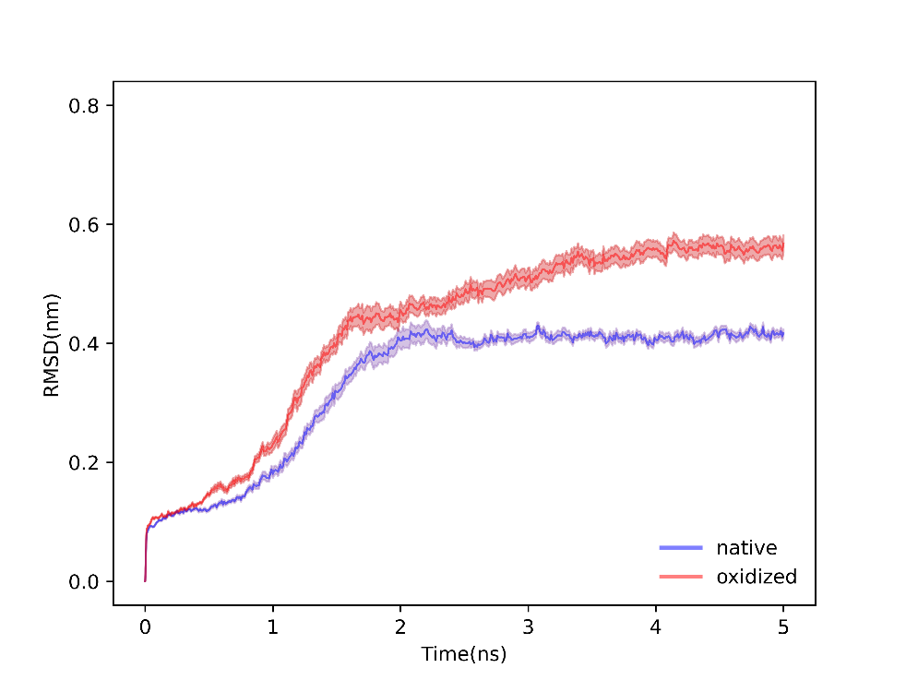

***Figure S2.*** *RMSD of the RBD of the SARS-CoV-2 S trimer during the transition from the down to the up conformation of the native (blue) and oxidized (red) systems, averaged over 9 replicas.*

**H-bonds and salt bridges**

Tables S2, S3, and S4 show the number of most probable H-bonds between amino acid residues or glycans of the RBD and the three chains of the SARS-CoV-2 S trimer (i.e., chains A, B, and C), with an abundance of more than 10%, in the native and oxidized complexes.

***Table S2.*** *Number of H-bonds formed between residues (or glycans) of the RBD and chain A in the native and oxidized SARS-CoV-2 S trimer. Values represent the average count per MD frame over the last 100 ns of the simulation, where only bonds with a prevalence exceeding 10% in all frames are considered.*

|  |  |  |
| --- | --- | --- |
| **RBD-chain A** | **Native** | **Oxidized** |
| Arg328-Asp578 | 1.17 ± 0.17 | 1.33 ± 0.13 |
| Val539-Gly550 | 0.80 ± 0.04 | 0.80 ± 0.05 |
| Asn536-Leu552 | 0.40 ± 0.02 | 0.55 ± 0.05 |
| Phe541-Gly548 | 0.54 ± 0.04 | 0.47 ± 0.10 |
| Lys353-Glu554 | 0.49 ± 0.01 | 0.43 ± 0.04 |
| Arg328-Asn542 | 0.38 ± 0.01 | 0.33 ± 0.05 |
| Phe541-Thr547 | 0.20 ± 0.03 | 0.29 ± 0.10 |
| Asp389-Asn542 | 0.22 ± 0.04 | 0.27 ± 0.01 |
| Asn536-Thr553 | 0.11 ± 0.01 | 0.21 ± 0.06 |
| Phe329-Gln580 | 0.15 ± 0.04 | 0.19 ± 0.01 |
| Arg328-Asn544 | 0.14 ± 0.06 | 0.15 ± 0.10 |
| Lys535-Glu583 | 0.20 ± 0.09 | 0.15 ± 0.05 |
| Val320-Ser591 | 0.12 ± 0.06 | 0.13 ± 0.12 |
| His519-Phe562 | 0.13 ± 0.07 | 0.12 ± 0.08 |
| His519-Gln564 | 0.13 ± 0.04 | 0 |
| Ile326-Asn542 | 0.12 ± 0.04 | 0 |
| N331A-Arg577 | 0.12 ± 0.05 | 0 |

***Table S3.*** *Number of H-bonds formed between residues (or glycans) of the RBD and chain B in the native and oxidized SARS-CoV-2 S trimer. Values represent the average count per MD frame over the last 100 ns of the simulation, where only bonds with a prevalence exceeding 10% in all frames are considered.*

|  |  |  |
| --- | --- | --- |
| **RBD-chain B** | **Native** | **Oxidized** |
| Ser383-Asp985 | 0.27 ± 0.03 | 0.35 ± 0.08 |
| Ser383-Arg983 | 0.26 ± 0.02 | 0.30 ± 0.02 |
| Ser383-Glu988 | 0.41 ± 0.21 | 0.49 ± 0.14 |
| Glu465-Asn234 | 0.27 ± 0.18 | 0.42 ± 0.21 |
| Glu516-Tyr200 | 0.58 ± 0.06 | 0.41 ± 0.19 |
| Thr385-Asp985 | 0.47 ± 0.06 | 0.38 ± 0.08 |
| Arg319-Asp737 | 0.20 ± 0.19 | 0.29 ± 0.18 |
| Thr415-Tyr369 | 0 | 0.21 ± 0.10 |
| Tyr489-Asp364 | 0 | 0.20 ± 0.19 |
| Asp405-Ser375 | 0.16 ± 0.15 | 0.22 ± 0.21 |
| Arg403-Phe374 | 0.11 ± 0.08 | 0.19 ± 0.10 |
| Tyr505-Ser373 | 0.12 ± 0.10 | 0.19 ± 0.18 |
| Lys462-Asp198 | 0.27 ± 0.09 | 0.18 ± 0.17 |
| Asn460-N234B | 0.10 ± 0.05 | 0.18 ± 0.02 |
| Thr500-N343B | 0.13 ± 0.12 | 0.17 ± 0.10 |
| N331A-Pro225 | 0 | 0.17 ± 0.16 |
| Glu471-Lys113 | 0 | 0.17 ± 0.09 |
| Tyr453-Ala372 | 0.11 ± 0.10 | 0.13 ± 0.12 |
| Asn450-N343B | 0 | 0.12 ± 0.06 |
| Arg466-Gln115 | 0.12 ± 0.07 | 0.12 ± 0.06 |
| N331A-Gln173 | 0 | 0.11 ± 0.05 |
| Lys417-Asn370 | 0 | 0.11 ± 0.04 |
| Ser383-Arg983 | 0.26 ± 0.02 | 0 |
| Gln474-N234B | 0.20 ± 0.17 | 0 |
| Gly381-Arg983 | 0.26 ± 0.02 | 0 |
| Thr470-N165B | 0.20 ± 0.14 | 0 |
| Glu484-N165B | 0.15 ± 0.05 | 0 |
| Glu471-N165B | 0.13 ± 0.10 | 0 |
| Arg319-Gly755 | 0.14 ± 0.13 | 0 |
| Gly502-N343B | 0.11 ± 0.10 | 0 |

***Table S4.*** *Number of H-bonds formed between residues (or glycans) of the RBD and chain C in the native and oxidized SARS-CoV-2 S trimer. Values represent the average count per MD frame over the last 100 ns of the simulation, where only bonds with a prevalence exceeding 10% in all frames are considered.*

|  |  |  |
| --- | --- | --- |
| **RBD-chain C** | **Native** | **Oxidized** |
| Ser375-Asp405 | 0.10 ± 0.05 | 0.27 ± 0.13 |
| Asp364-Thr478 | 0 | 0.22 ± 0.20 |
| Tyr369-Thr415 | 0.22 ± 0.08 | 0.15 ± 0.14 |
| Asn370-Lys417 | 0.12 ± 0.04 | 0 |
| N343A-Thr500 | 0.18 ± 0.09 | 0 |

Figure S3 shows the time evolution of the distance between donor and acceptor atoms of amino acid pairs, selected from Tables S2, S3, and S4, during the transition from the down to the up state for the native (Figure S3A) and oxidized (Figure S3B) systems, respectively. These values are averaged over all nine replicas. To prevent confusion, the error bars for each plot are not shown in the figure. The results are obtained by averaging over nine trajectories of TMD simulations from the down to the up state for the native and oxidized systems.

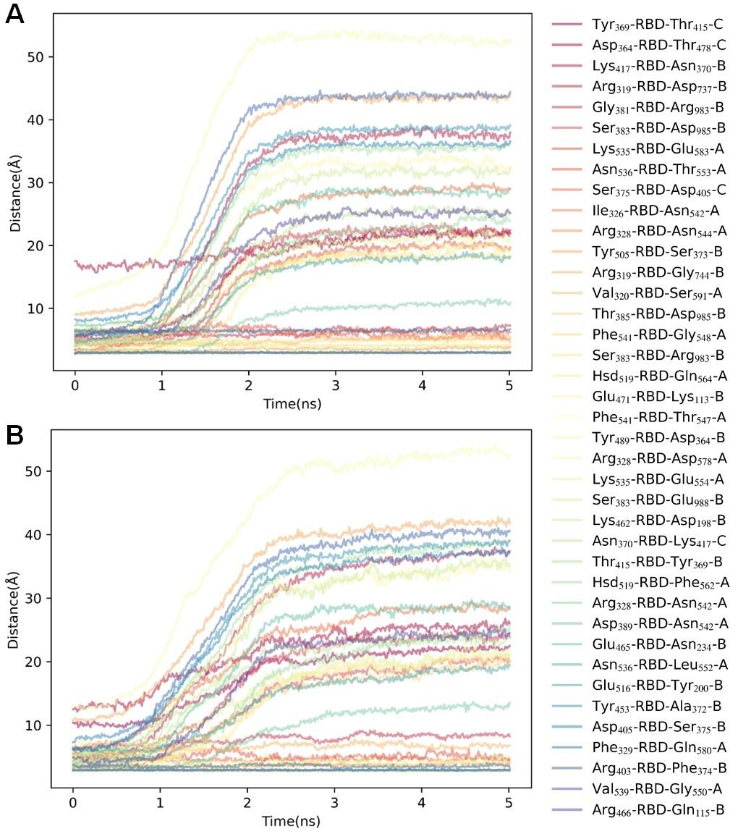

***Figure S3.*** *Time evolution of distances between donor and acceptor atoms of selected amino acid pairs forming H-bonds between the RBD and its surrounding SARS-CoV-2 S trimer during the transition from down to up conformation. Panels (A) and (B) depict data for the native and oxidized systems, respectively. The chosen amino acid pairs form H-bonds in the down state which are selected from table S2, S3 and S4.*

Table S5 shows the number of the most probable salt bridges between amino acid residues of the RBD and the three chains of the SARS-CoV-2 S trimer (i.e., chain A, B, and C), with an abundance of more than 10%, in the native and oxidized complexes.

***Table S5.*** *Number of salt bridges formed between residues of the RBD and the remaining SARS-CoV-2 S trimer (i.e., chain A, B, and C) for the native and oxidized systems. The values represent the average number of salt bridges observed in the last 100 ns of MD simulations, normalized to the total number of frames with a prevalence exceeding 10% in all frames.*

|  |  |  |  |
| --- | --- | --- | --- |
|  | **RBD-remaining SARS-CoV-2 S trimer** | **Native** | **Oxidized** |
| **chain A** | Arg328-Asp578 | 1.00 ± 0.00 | 1.00 ± 0.00 |
| Lys535-Glu583 | 0.40 ± 0.02 | 0.29 ± 0.10 |
| Lys535-Glu554 | 0 | 0.65 ± 0.09 |
| **chain B** | Lys462-Asp198 | 0.49 ± 0.11 | 0.33 ± 0.30 |
| Arg319-Asp737 | 0.21 ± 0.21 | 0.41 ± 0.29 |
| Glu471-Lys113 | 0 | 0.37 ± 0.13 |
| **chain C** | Asp427-Lys986 | 0.18 ± 0.13 | 0.12 ± 0.06 |

Figures S4 illustrates the time evolution of the distance between O and N atoms of amino acid pairs, selected from Table S5, during the transition from the down to up state for the native (Figure S4A) and oxidized (Figure S4B) systems, respectively. These values are averaged over all nine replicas.

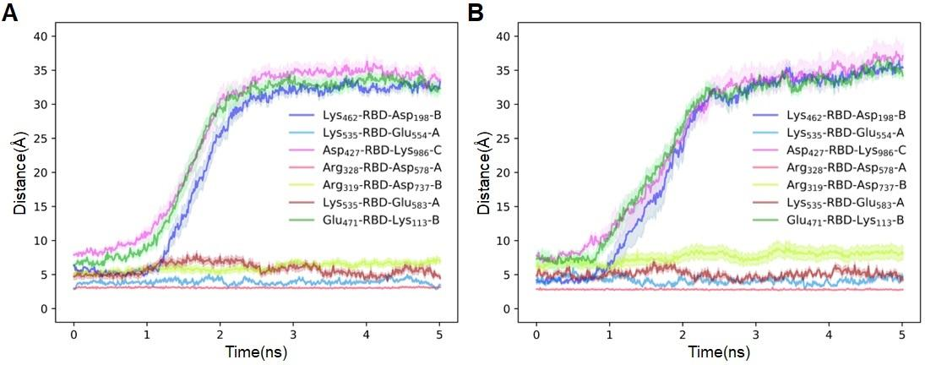

***Figure S4.*** *The time evolution of distance between N and O atoms of RBD and its surrounding SARS-CoV-2 S trimer during the transition from down to up conformation for the native (A) and oxidized (B) system. The selected amino acid pairs form salt bridges in the down state, as listed in Table S5.*

**References:**

[1] A. Shajahan, N.T. Supekar, A.S. Gleinich, P. Azadi, Deducing the N-and O-glycosylation profile of the spike protein of novel coronavirus SARS-CoV-2, Glycobiology 30(12) (2020) 981-988.

[2] Y. Watanabe, J.D. Allen, D. Wrapp, J.S. McLellan, M. Crispin, Site-specific glycan analysis of the SARS-CoV-2 spike, Science 369(6501) (2020) 330-333.